Student Name: Toni Davies Student Number: 1502373

Write a case study which critically analyses the inclusive intervention and support provided for a pupil in your setting. Refer to theory, policy and practice citing reputable and appropriate sources.

Introduction
School A is a relatively small establishment, situated in a rural town in West Glamorgan. The main school educates the infants and juniors, and there is also a separate, well-resourced early years building located a short distance from the main school, which provides a safe, secure learning environment. Welsh is taught as a second language.
Child A is a generally happy four-year-old, living with both parents and a younger sibling. He enjoys playing in construction, and has a fondness for round objects, music and dancing. He is well liked by his peers and enjoys playing alongside them at times, although usually prefers playing alone. Child A has a diagnosis of Global Developmental Delay (GDD) with significant speech and language difficulties and displays several behaviours that are suggestive of Autism Spectrum Condition (ASC), as stated in his Final Statement of Special Educational Needs (see Appendix 1).

Global Developmental Delay defines children who fall significantly behind their peers in two or more of their developmental milestones, namely gross motor, fine motor, language, socioemotional and cognitive skills (Mithyantha et al., 2017). GDD is further classified as mild (functional age is less than thirty-three percent of the child’s chronological age), moderate (functional age is between thirty-four percent and sixty-six percent of the child’s chronological age) and severe (functional age is more than sixty-six percent of the child’s chronological age). Global Developmental Delay is one of the most common conditions presenting in paediatric clinics, affecting between one and three percent of children under the age of five (Majnemer and Shevell, 1995).

Bale et al. (2012) states that a cause for GDD can be found in up to sixty percent of cases, where symptoms are recognised early, and supportive treatments are initiated to maximise a child’s motor, social and cognitive outcomes. Common causes of GDD include ‘foetal alcohol syndrome, congenital infection, chromosomal anomalies and autism spectrum conditions’ (Bale et al., 2012, p88). The cause of Child A’s Global Developmental Delay, or his other learning needs, have not yet been determined.

According to Hoffman (2009, p36), Autism Spectrum Condition (or ‘Disorder’ as it was then described) can be defined as a neurodevelopmental disorder “characterised by dysfunction in three core areas of early childhood development, namely social interaction, communication and language skills, and behaviour”. Common characteristics of individuals with autism include engagement in repetitive or stereotyped behaviours or movements, restricted interests or obsessions, resistance to change, and abnormal responses to sensory stimulation (Hardman et al., 2008).

Child A experiences difficulties in all areas of development, including expressive and receptive language difficulties, delayed processing of information, difficulties with social communication and sensory sensitivities. He is regularly aggressive towards staff and his peers, often through frustration, and he soils himself daily. Child A struggles to engage with classroom activities, and adult-led tasks, as these cause angry outbursts and bouts of violence. Child A’s Annual Review was brought forward by five months due to the extent of his escalating aggressive behaviour, frustration, and inability to immerse himself into almost any aspect of the school day without adult support. Therefore, this case study asks the question, “Is it equitable for a child who has Global Developmental Delay and autistic traits to attend a mainstream primary school, rather than a special school?” This assessment is supported by MacBeath et al. (2006) who studied the inclusion policies and practices of primary, secondary and special schools in England.

Methodology
This is a qualitative study carried out by a participant researcher. The author is employed as a level two teaching assistant at School A, working directly with Child A. For ethical reasons, the author feels it is important to disclose she has built a good relationship with Child A over a six-month period, which has provoked a personal level of disappointment for the author, at being unable to always meet Child A’s needs and support him fully. In addition to this information, it should be noted that one of Child A’s parents is a non-teaching member of staff at School A. For the purpose of this case study, the child, school and staff have been anonymised.

Findings
School A asserts an inclusive ethos; that all children have an entitlement to the school curriculum and that every child should be able to attain the highest possible level of achievement for them as individuals. The School Prospectus (2018) states that ‘every aspect of a child’s development will be catered for; social, emotional, physical, intellectual and moral’. Unfortunately, the school is unsuccessful in meeting some of these needs for Child A, specifically social and emotional, although not through lack of effort.

When the author started working with Child A in September 2018, it was with limited knowledge of the child and limited experience of working directly with children who have GDD. The author believes that Child A’s statement does not paint an accurate picture of his needs. There is no mention of his personal care requirements, for example soiling himself daily, sometimes twice a day. Also, it became evident very early on that fifteen hours support would not be enough. MacBeath et al. (2006, p63) declares ‘Outward expression of unmet needs often takes the form of extreme forms of behaviour’. This is apparent whenever Child A does not have an adult with him. Child A can be very disruptive, not only disturbing other children but also causing staff to worry about risk of harm, as he regularly hurts anyone within close proximity, throws objects, climbs on top of furniture, and becomes frustrated, resulting in loud shouting and/or extreme upset. It is not always clear if these behaviours are a result of his needs, or general challenging behaviour. The ABC (Antecedent, Behaviour, Consequences) analysis of behaviour stems from Skinner’s theory of operant conditioning (1938), however is adapted and applied to education (Webster, 2018). This approach is constructed around the idea that making changes leading up to the behaviour and/or the consequences of the behaviour can effect a change in the behaviour itself (Welsh Assembly Government, 2010). ABC (no date) states that any attempts to prevent negative reactions from recurring must begin with the questions; ‘what triggered the behaviour?’ and ‘how is Child A reinforced for behaving this way?’ These questions contribute to the understanding of the likelihood of Child A repeating this behaviour in the future. Of course, there are times when it is clear Child A has become frustrated, triggering unacceptable reactions. For example, Child A loves playing in construction but cannot always manipulate the magnetic blocks or the threading of plastic nuts and bolts, which results in shouting and attempts to throw the objects. In these instances, the author has tried sitting with Child A and supporting him in the activity, or has encouraged another child to help, however this does not always prevent the frustration occurring and often results in the author, and sometimes the other child, being scratched or pinched by Child A.

The Individual Education Plan (IEP) for Child A has four targets (see Appendix 2), focusing on developing gross motor skills, social communication skills, and improving fine motor skills. Various interventions have been put in place to support Child A, some more successful than others. To establish a better chance of supporting Child A, a multi-sensory approach to teaching has been established, using different modalities.
Busy Feet (Health Matters Education, 2012) is an educational resource which benefits children’s health, fitness and well-being through music and dancing. Child A enjoys daily sessions of Busy Feet, sometimes with a friend to encourage social interaction, however he becomes overwhelmed when Busy Feet is used as a whole-class tool for physical development; bearing in mind there are only twelve children in his class. Participation is on his terms; sometimes Child A will join in with all actions and sing along with the words, although on other occasions he refuses to join in at all and attempts to pinch or scratch the author. During these instances he does not seem frustrated or upset, so it is difficult to interpret whether Child A is purely being badly behaved.

Dough Disco (Shonette Bason Limited, 2010) involves moulding dough in time to music, helping to strengthen children’s fine motor muscles, enabling them to improve their pencil grip, which in turn helps to develop their writing skills. Child A participates on a daily basis with four friends, however participation is, again, on his terms. Child A loves circular objects so will take part in the ‘rolling’ aspect of Dough Disco, but rarely joins in with the other actions.

Colourful Semantics (1997) is an approach created by Alison Bryan, a speech and language therapist. The resource involves reassembling sentences by cutting them up into their thematic roles and is used in stages to help children develop language and vocabulary, in addition to grammatical structure. Colourful Semantics is recommended for use with children who have a range of Speech, Language and Communication Needs including developmental delays and autism spectrum condition. The use of flash cards as a supporting resource also encourages increased speech and language use. Flash cards appeal to visual learners, who generally retain information more successfully if they can see it, rather than hear it (VARK Learn Limited, 2016).

Child A has shown progress in his speech. Baseline notes, taken while using Colourful Semantics (see Appendix 3) and Flash Cards of Everyday Objects (see Appendix 4) show that Child A would use single words and very short phrases to communicate and his speech was very unclear. Delayed processing of information was evident as Child A never responded immediately when spoken to. After six weeks of using the resource, Child A was using longer sentences and some expressive language. Currently, Child A demonstrates the use of longer sentences, and his speech is easier to understand when he is calm, although can become incoherent when he is upset or frustrated. Delayed processing of information is still apparent although often Child A is actually ignoring the person speaking, hence the difficulty in assessing when this is a ‘need’, and whether it is ‘defiance’?

Parental perspective has evolved over the six-month period of working with Child A. Initially, Child A’s mother had unreasonable expectations of what fifteen hours of support entailed, and would have preferred one-to-one support all day, every day. After Child A hurt another child during lunch time, his mother asked the question, “Where was the TA? This wouldn’t have happened if he’d had someone with him like he’s entitled to”. In fact, the author had stayed with Child A through part of her own lunch hour to ensure he had eaten enough and had already worked more than the allocated hours. Currently, Child A’s mother is more understanding of the work the author and other staff members do with Child A, in part because she admits his behaviour has escalated at home too, and he regularly tries to hurt his parents and younger sibling. Child A’s father was initially of the mindset that he would ‘catch up eventually’ and was not entirely accepting of his disabilities. However, recently Child A’s father has had conversations with the author admitting he ‘knows Child A isn’t like the other children, and probably never will be’. As hard as this must be for any parent to admit, it has made the parent-school relationship much stronger, as all parties involved in the care of Child A are sharing a consistent approach to behaviour and committed to attaining the best possible outcome for his educational requirements and personal well-being. A home-school book is used between parents and staff to aid consistency and provide a better insight into Child A’s behaviour.

Conclusion
All parties involved in the care and education of Child A are doing everything possible to meet his educational needs. Following the social model of disability (Oliver, 1983), the author acknowledges that Child A has the right to belong and be valued in School A, but recognising that fact does not automatically make School A the best option for this child. The Children Act (1989) states that the welfare of the child must, at all times, be considered, so it is important to remember that even though the author has tried, and is still trying, several interventions to improve his well-being, Child A is not having his personal well-being needs met. Meeting these needs could be more achievable at a special school. According to Ingersoll and Schreibman (2006) and Williams, Johnson et al. (2005), fully inclusive classrooms are an ideal location for the implementation of social interaction interventions and behavioural interventions because of the availability of peers to interact with in a natural location. This is a generalisation that does not seem to apply to Child A, as whenever he is included in group activities, whether it be in a learning or fun capacity, Child A throws objects, repeats phrases, shouts, removes his footwear, or attempts to hurt staff or other children. Child A’s class teacher, the additional learning needs co-ordinator (ALNCO), headteacher, the parents and the author all believe School A is not the most suitable environment for Child A. Child A needs to receive special, individualised support before inclusion can become a reality. Although being educated alongside typically developing peers may be the eventual goal, a self-contained special education class may be more realistic early on. Child A is more than capable of certain requirements expected of other children his age such as orally sounding out and blending CVC (consonant, vowel, consonant) words and basic mathematics, however this is only achieved sporadically, on a one-to-one basis and usually in an unconventional way such as while playing in construction or doing a physical activity at the same time. Child A cannot cope with sitting at a desk with his peers writing in a book. Ultimately, students are placed in special education because they require extra aid or academic support, that cannot necessarily be provided in a mainstream school. However, special education can function as an opportunity for students to learn their strengths, how to use them, and then ideally, return to mainstream education (Getschow, 2011). This is an avenue that the author would definitely like to see considered for Child A.

Wiele (2011, p45) is of the opinion that “although expecting everyone to succeed academically is a lofty goal, it may be somewhat unrealistic in regard to students in special education”. The author strongly disagrees, as every child is an individual. Categorising children who attend special schools as ‘unlikely to succeed academically’, is as unreasonable a notion as believing that all children who attend mainstream will be successful.

Referring back to the question “Is it equitable for a child who has Global Developmental Delay and autistic traits to attend a mainstream primary school, rather than a special school?” the author is of the opinion that ultimately, the decision of whether or not a child should be placed in an inclusive mainstream school should be made on an individual, case-by-case basis, especially as the signs of being on the spectrum of autism vary so greatly. Mann (2014) states there is a common misconception that “equity and equality mean the same thing, when the truth is they are similar but the difference between them is crucial”. Of course, it can be argued that Child A is entitled to attend a mainstream school and have access to the same learning experiences as his peers, however this is not necessarily the best option for Child A. Is it more important to provide Child A with equal opportunities or equitable ones? The theory is that with the right training, strategies and support, “nearly all pupils with special educational needs can be included in mainstream education successfully” (Burnham and Baker, 2010, p239). In reality, inclusion should not rely on individual schools struggling to support children with special needs (MacBeath, et al. 2006). Inclusion should be a positive experience; it should not be forced at the expense of the child.

Reference List

Additional Learning Needs Co-ordinator, School A (2019) In conversation with Toni Davies. (1/2/19).
Bale, J. F., Bonkowsky, J. L., Filloux, F. M., Hedlund, G. L., Nielsen, D. M. and Larsen, P.D. (2012) Pediatric Neurology. London: Manson Publishing. p88. (Accessed: 2.2.19).
Bryan. A. (1997) Colourful semantics. In: Chiat, S., Law, J. and Marshall, J. (eds) Language disorders in children and adults: psycholinguistic approaches to therapy. London: Whurr, 143-61. (Accessed: 2.2.19).
Burnham, L. and Baker, B. (2010) Supporting Teaching and Learning in Schools. Essex: Pearson Education Limited. Pp 234-5 (Accessed: 15.2.19).
Children Act 1989 (c.41), London: The Stationery Office. (Accessed: 1.3.19).
Class Teacher, School A (2019) In conversation with Toni Davies. (1.2.19).
Getschow, D. (2011). What makes special education so special? [online] Available at: http://www.huffingtonpost.com/derek-getschow/whatmakes-special-educat_b_807319.html (Accessed: 16.2.19).
Hardman, M., Drew, C. and Egan, M. (2008) Human exceptionality: School, community, and family. (10th ed.). Boston, MA: Allyn & Bacon. (Accessed: 16.2.19).
Headteacher, School A (2019) In conversation with Toni Davies. (1.2.19).
Health Matters Education (2012) Busy Feet. Liverpool: Ditto Music. (Accessed: 8.10.18).
Hoffman, E. (2009) Clinical features and diagnosis of autism and other pervasive developmental disorders. Primary Psychiatry 16(1), 36-44. (Accessed: 16.2.19).
Ingersoll, B. and Lalonde, K. (2010) The impact of object and gesture imitation training on language use in children with autism spectrum disorder. Journal of Speech, Language & Hearing Research, 53(4), 1040-1051. (Accessed: 16.2.19).
MacBeath, J., Galton, M., Steward, S., MacBeath, A. and Page, C. (2006) The Costs of Inclusion: A study of inclusion policy and practice in English primary, secondary and special schools. Cambridge: Victoire Press. (Accessed: 2.2.19).
Majnemer A. and Shevell M. I. (1995) Diagnostic yield of the neurologic assessment of the developmentally delayed child. J Pediatr; 127:193–9. (Accessed: 2.2.19).
Mann, B. (2014) Equity and Equality are not Equal. [online] Available at: https://edtrust.org/the-equity-line/equity-and-equality-are-not-equal/ (Accessed: 2.2.19). Mithyanatha, R., Kneen, R., McCann, E. and Gladstone, M. (2017) Current evidence-based recommendations on investigating children with global developmental delay. Archives of Disease in Childhood,102:1071-1076. (Accessed: 2.2.19).
Oliver, M. and Sapey, B. (1983) Social work with disabled people. London: The Macmillan Press Limited. (Accessed: 1.3.19).
Parent A, School A (2018) In conversation with Toni Davies (08.10.18).
Parent B, School A (2018) In conversation with Toni Davies (12.12.18).
School A (2018) School Prospectus. (Accessed: 2.2.19).
Shonette Bason Limited (2010) Dough Disco. Durham: Shonette Bason Limited. (Accessed: 5.11.18).
Skinner, B. F. (1938) The Behaviour of Organisms: an experimental analysis. New York: Appleton-Century. (Accessed: 23.2.19).
VARK Learn Limited (2016) The VARK Modalities. [online] Available at: http://vark-learn.com/introduction-to-vark/the-vark-modalities/ (Accessed: 23.2.19).
Webster, J. (2018) ABC: Antecedent, Behaviour, Consequence. [online] Available at: https://www.thoughtco.com/abc-antecedent-behavior-and-consequence-3111263 (Accessed: 22.2.19).
Welsh Assembly Government (2010) Practical Approaches to Behaviour Management in the Classroom. Cardiff: Crown Copyright. pp81-83. (Accessed: 22.2.19).
Wiele, L. J. V. (2011) The Pros and Cons of Inclusion for Children with Autism Spectrum Disorders: What Constitutes the Least Restrictive Environment? [online] Available at : https://digitalcommons.liberty.edu/cgi/viewcontent.cgi?article=1265&context=honors (Accessed: 2.2.19).
Williams, S. K., Johnson, C., and Sukhodolsky, D. G. (2005) The role of the school psychologist in the inclusive education of school-age children with autism spectrum disorders. Journal of School Psychology, 43, 117–136. (Accessed: 16.2.19).

BIBLIOGRAPHY

Additional Learning Needs Co-ordinator, School A (2019) In conversation with Toni Davies.
Bale, J. F., Bonkowsky, J. L., Filloux, F. M., Hedlund, G. L., Nielsen, D. M. and Larsen, P.D. (2012) Pediatric Neurology. London: Manson Publishing.
Bryan. A. (1997) Colourful semantics. In: Chiat, S., Law, J. and Marshall, J. (eds) Language disorders in children and adults: psycholinguistic approaches to therapy. London: Whurr.
Burnham, L. and Baker, B. (2010) Supporting Teaching and Learning in Schools. Essex: Pearson Education Limited.
Children Act 1989 (c.41), London: The Stationery Office.
Class Teacher, School A (2019) In conversation with Toni Davies.
Getschow, D. (2011). What makes special education so special? [online] Available at: http://www.huffingtonpost.com/derek-getschow/whatmakes-special-educat_b_807319.html.
Hardman, M., Drew, C. and Egan, M. (2008) Human exceptionality: School, community, and family.
Headteacher, School A (2019) In conversation with Toni Davies.
Health Matters Education (2012) Busy Feet. Liverpool: Ditto Music.
Hoffman, E. (2009) Clinical features and diagnosis of autism and other pervasive developmental disorders. Primary Psychiatry.
Ingersoll, B. and Lalonde, K. (2010) The impact of object and gesture imitation training on language use in children with autism spectrum disorder. Journal of Speech, Language & Hearing Research.
MacBeath, J., Galton, M., Steward, S., MacBeath, A. and Page, C. (2006) The Costs of Inclusion: A study of inclusion policy and practice in English primary, secondary and special schools. Cambridge: Victoire Press.
Majnemer A. and Shevell M. I. (1995) Diagnostic yield of the neurologic assessment of the developmentally delayed child. J Pediatr.
Mann, B. (2014) Equity and Equality are not Equal. [online] Available at: https://edtrust.org/the-equity-line/equity-and-equality-are-not-equal/. Mithyanatha, R., Kneen, R., McCann, E. and Gladstone, M. (2017) Current evidence-based recommendations on investigating children with global developmental delay. Archives of Disease in Childhood.
National Assembly for Wales (2017) Research Briefing: Additional Learning Needs and Education Tribunal (Wales) Bill. Cardiff: National Assembly for Wales Commission Copyright.
National Assembly for Wales (2015) Research Paper: Special Educational Needs (SEN)/Additional Learning Needs (ALN) in Wales. Cardiff: National Assembly for Wales Commission Copyright.
Oliver, M. and Sapey, B. (1983) Social work with disabled people. London: The Macmillan Press Limited.
Parent A, School A (2018) In conversation with Toni Davies.
Parent B, School A (2018) In conversation with Toni Davies.
School A (2018) Additional Learning Needs Policy.
School A (2018) School Prospectus.
Shonette Bason Limited (2010) Dough Disco. Durham: Shonette Bason Limited.
Skinner, B. F. (1938) The Behaviour of Organisms: an experimental analysis. New York: Appleton-Century.
VARK Learn Limited (2016) The VARK Modalities. [online] Available at: http://vark-learn.com/introduction-to-vark/the-vark-modalities/.
Webster, J. (2018) ABC: Antecedent, Behaviour, Consequence. [online] Available at: https://www.thoughtco.com/abc-antecedent-behavior-and-consequence-3111263.
Welsh Assembly Government (2010) Practical Approaches to Behaviour Management in the Classroom. Cardiff: Crown Copyright.
Welsh Assembly Government (2004) Special Educational Needs Code of Practice for Wales. Cardiff: Crown Copyright.
Welsh Government (2016) Inclusion and pupil support. Cardiff: Crown Copyright.
Wiele, L. J. V. (2011) The Pros and Cons of Inclusion for Children with Autism Spectrum Disorders: What Constitutes the Least Restrictive Environment? [online] Available at : https://digitalcommons.liberty.edu/cgi/viewcontent.cgi?article=1265&context=honors.
Williams, S. K., Johnson, C., and Sukhodolsky, D. G. (2005) The role of the school psychologist in the inclusive education of school-age children with autism spectrum disorders. Journal of School Psychology.
List of Appendices

- Appendix 1 – Final Statement of Special Educational Needs
- Appendix 2 – Individual Education Plan
- Appendix 3 – Colourful Semantics notes
- Appendix 4 – Flash Cards of Everyday Objects notes

Appendix 1 – Final Statement of Special Educational Needs
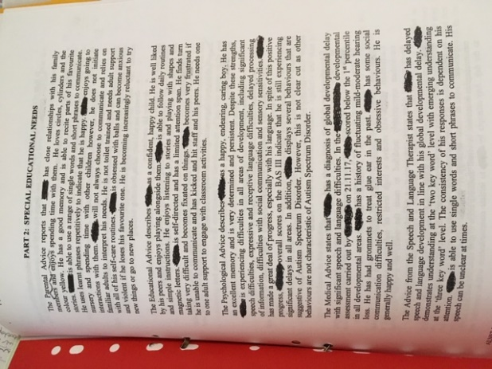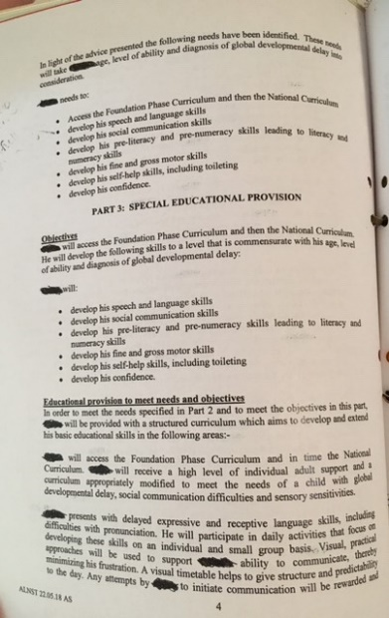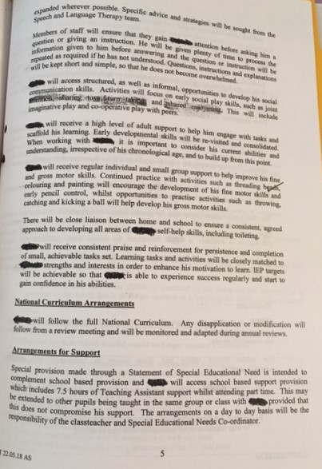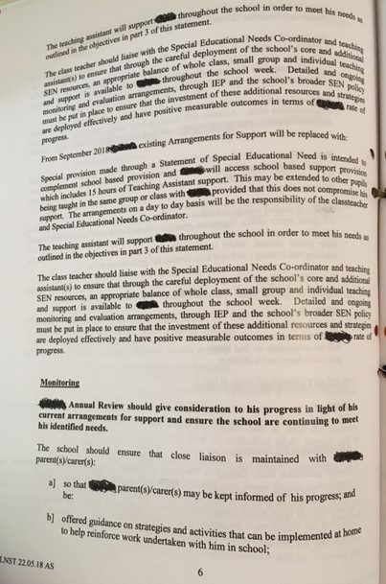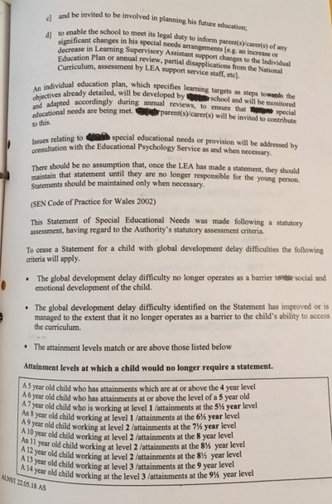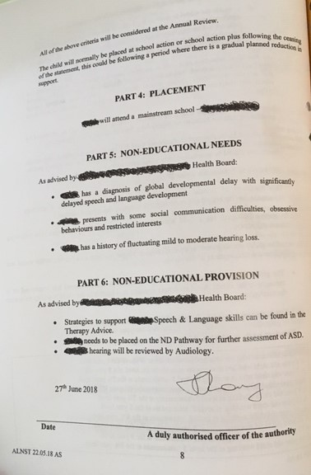

Appendix 2 – Individual Education Plan
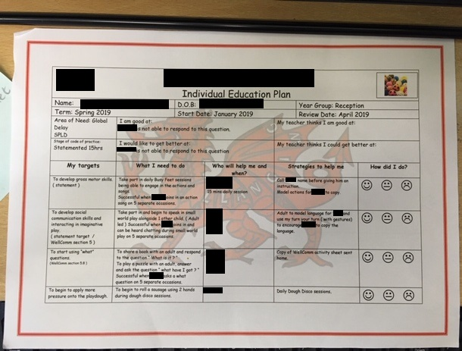

Appendix 3 – Colourful Semantics notes
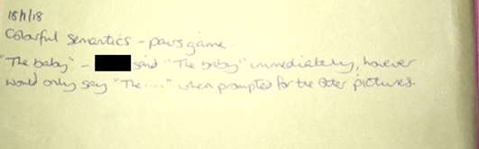
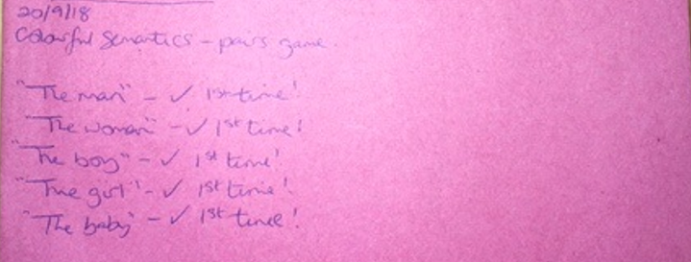
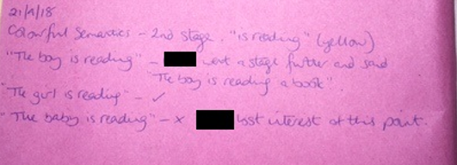
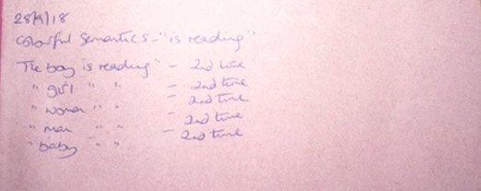

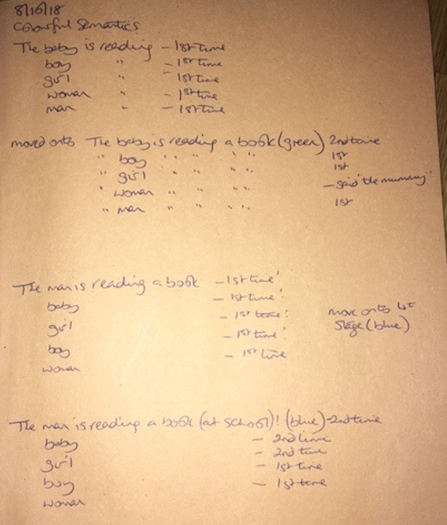
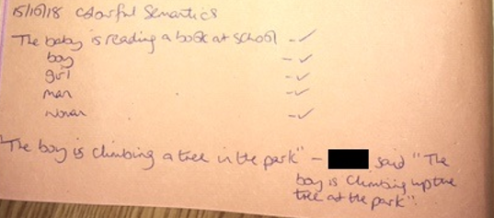

Appendix 4 – Flash Cards of Everyday Objects notes


