
Skills for the Workplace
Module Assignment Submission
Student Name: | Azizul Hoque
Student Number: | 1818767
Module No: | BMSK4001 Group 7
Module Title: | Academic and Employability Skills
Lecturer: | Anita Nan

Statement of Confirmation of Authenticity
By the act of making this submission, the student declares that this is the work of the student named above. The work has not, in whole or in part, been knowingly presented elsewhere for assessment, or where assessment has been built on a previous assessment, this has been identified. Where materials have been used from other sources it has been properly acknowledged. If this statement is untrue, the student acknowledges that an assessment offence has been committed.
Attention is drawn to the plagiarism and unfair practice policies of the University.

Table of Contents
- Introduction
- Time management
- Note Taking
- Paraphrasing
- Summarising
- Problem Solving
- Leadership
- Conclusion
- Refernces
- Appendix 1

Introduction

I will be discussing in this report the Importance of time management whilst also thinking about how to implement this ability in using it to our advantage in our day to day duties. I will be writing on what the definition of paraphrasing and summarising with thorough detail also stating that note taking is very essential in the academic and employment World.
Problem solving/Decision making is one of the key skills that will be explained in this assignment. I am going to speak about the experience in the university and what I have acquired from the classes. I am also going to write about the experiences in the past when I was employed and give some examples of situations where I’ve been in at a workplace.
Leadership is a very important skill that needs more elaborating in this research and how It can be practised by learning the steps needed to acquire this ability, then I will be concluding this assignment with a brief conclusion and Harvard referencing.

Section 1

Time Management:
I’ve read this in a book that stated, “In Reality, there is no such thing as time management”. Time is not something that can be controlled or managed – it is there regardless of what we do, it will continue to be there regardless of whether we think we can ‘manage’ it or not. By saying that it can neither be taken away or added from it, time is a finite resource. (Morgan, 2017)
However, it is crucial that we prioritise our time efficiently for example being in a workplace because certain days we might arrive late to a meeting which is important, you have team members that count on your attendance, But, you lose that opportunity to gain a future leadership position, the company will then look at that individual as a liability towards the organisation.
Good time management is vital in many ways where in fact research shows that ‘being good’ is more than influential. (Britton and Tesser, 1991)
In another research it shows that by George et.al. (2008) the link between the students or employees’ skills to manage time and their goals to achievements.
I will list a few points of time management skills below:
Prioritization:
This skill is one of the most important ability in time management where it helps you to identify tasks that require immediate attention. It aids people to plan their work in advance also it is a great way to lessen the tension in meeting the deadlines in time.
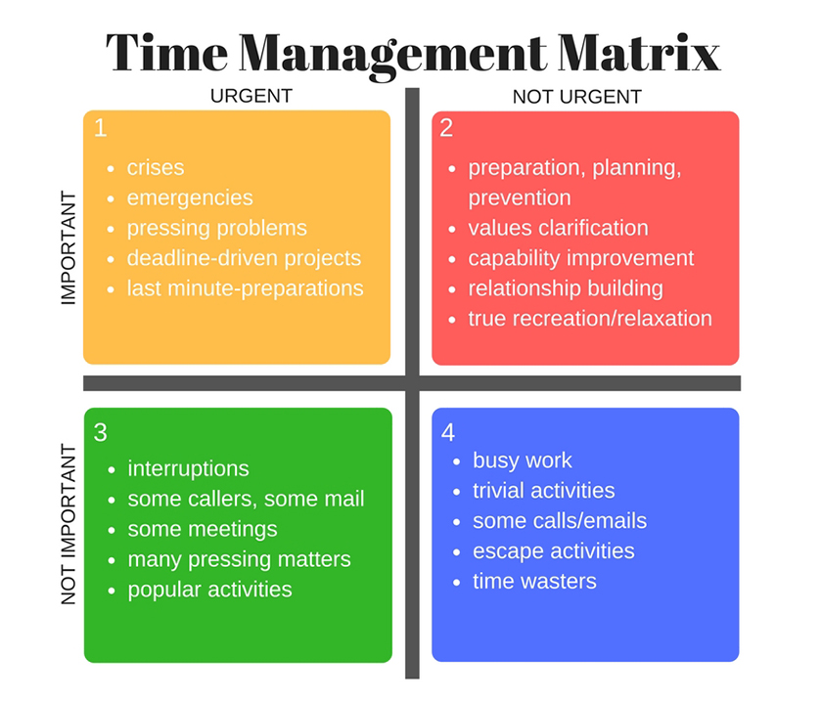
In the figure above, I have inserted a tool that was developed by Stephen Covey in the year (1989). The table teaches you to manage time the appropriate way where you can distinguish between the urgent and the important tasks.
Delegation:
Delegating tasks to another person even though you are or not capable of completing but instead focus on the task that you are certain to accomplish efficiently in a fast period.
Therefore, we should be delegating often if it means it will save time and energy for everyone in the group or workplace.
Self-awareness:
Self-aware is another time management skill where it trains a person to find out their strength and weaknesses. Hence, we can discover if it is possible to complete a goal or either delegate the mission over to colleagues.

Section 2

Note-Taking
It is an ability that aids a person to gather information from other resources then noting it down on paper, you don’t have to go back and forth for the specific point also assisting you to understand the text in depth. It will help us stay focused on the subject by generating confidence to participate in the topics.
In this article, I will be explaining 5 types of note-taking methods which is going to be stated below:
The Outline method: This method is commonly used by academic students, you can arrange the notes put together by putting down bullet points to represent various topics also outlining the one that is most important then the seconds and thirds with indents.
The Cornell method: Due to the page layout this theory stands out more than the other strategies, the page is divided into three or four sections beginning from one row at the top for the title/date (optional), one at the bottom for summarising and then two columns in the middle while 30% width should be kept on the left also 70% for the right.
The Boxing method: All notes that are regarding the same topic is boxed in to one, thus, there is a specific box that is assigned to each part so that it cuts down time to read and review the work. Modern technology has a big part to play where there are apps that can reordered and resize the content of the information gathered.
The Charting method: The information will be patterned in several columns the same as a table or a spreadsheet. Each column presents a rare category which makes the rows equivalent. The theory comes in handy in terms of jotting down important content which consists of stats and relevant data.
The Mapping method: This strategy best works when in a meeting or lecturers’ class and then you need to list down the main points. You will have to organise the notes then divide them in to branches.

Section 3

Paraphrasing
A paraphrase is where an individual takes a statement of a meaning from a text or a content and changing it in to his/her own words. However, when you are paraphrasing you need to change the words but keep the structure and meaning the same. When you paraphrase another person’s work you will need to enter the in-text citation after finishing the proclamation.
There are a couple techniques that could be used for rewriting another authors report by using synonyms, switching up the word class and the word order.
In addition, when you paraphrase someone else’s evidence do not only change the synonyms and leave the structure the same, you will be blamed for plagiarism.
Here is 8 to paraphrasing table shown below:
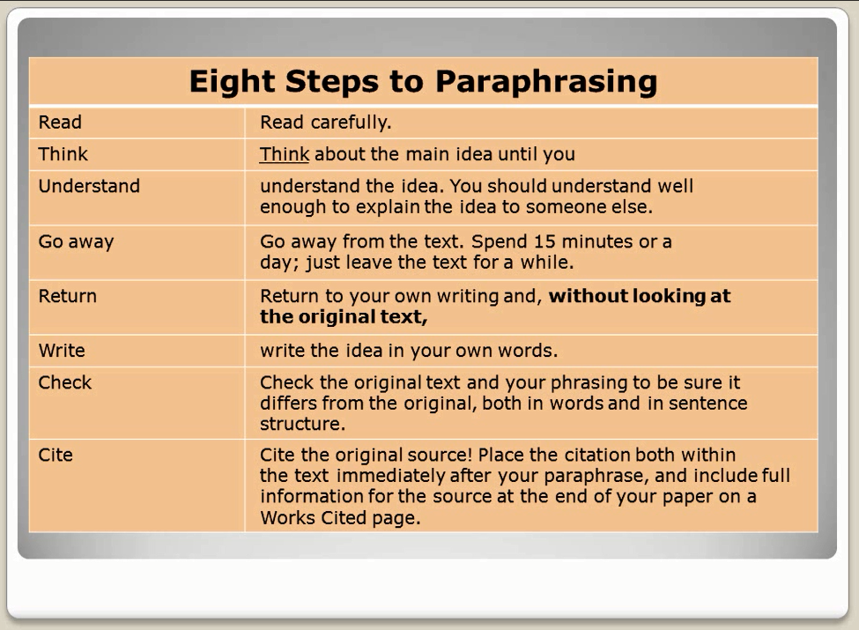

For more, paraphrasing can be done online where you can get hold of many links to website for rewriting an article, But In my opinion, I suggest people practice this set of skills for themselves for self-improvements and focusing on a career that could involve the needing to paraphrase.

Section 4

Summarising
A summary is when a person takes the main idea of the report and states it down in their own way just like paraphrasing but straight/short to the point of view. When you summarize the work, you must make sure the original statement is not being copied and provide the sources details in the assignment.
Summarising teaches an individual to discern the main part of the ideas in the text, practising the skills will enable a person to get rid of irrelevant data and consolidating the objective in a meaningful way.
It improves one’s memory by getting to practise how to summarise the work that is read from an article. This skill has three characteristics for a good summary that is conciseness, accuracy and objectivity.

Section 5

Problem solving
When a problem arises at a place of work then you in a predicament where you must come up with a solution and theories learnt from previous training. There is seven effective ways to problem solving such as: recognise the issue, making sure we understand the persons views on the issue, point out solutions for the arguments, analyse the options, pick the correct formula for the issue at hand, either make a verbal or written agreement for a truce and then get to sympathise regarding the incident, monitor the affair, set an evaluation in place.
Active listening is an attribute for problem solving skills due to it being the biggest factor of the ability because the resolver with the solution will first listen to the person who is in problem then give them options.
Communication is a second component in the problem solving/decision making experience, it allows a person to get to know their subject to an extent where they can resolve the matter in a professional manner.
Leadership
Leaders have various structures while there are some similar qualities such as: producing a vision for yourself and others, activating the monitoring process connected to the success of that target.
Anyone can develop the qualities of a leading member by only taking part in the training and going through the experience in the field. Persuasion/influence goes a long way when it comes to running an organisation, motivating the team member will create that different situations.
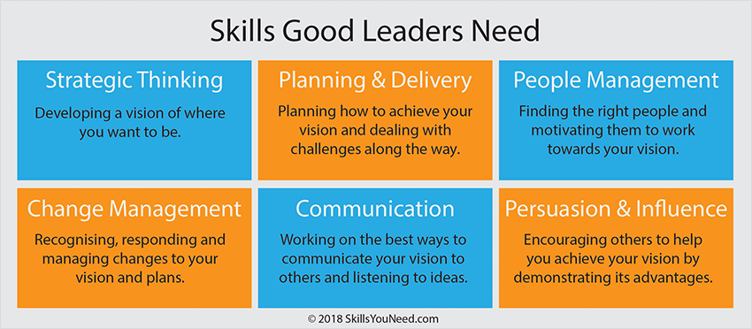

Accepting all the challenges that befall a leader whilst trying to reach the target, hence, we must learn how to listen to ideas given by the colleagues, negotiating terms in the business and It’s all about generating the positive environment/culture for the action plan to succeed.

Conclusion

By now, I have learnt how to analyse, produce the correct information taken from the original source then writing it down in my own words in the report, referencing the part on where I retrieved the data.
Para-phrasing /summarising is my strongest set of skills after training myself to improve for the future. I have been trying to implement time management whilst studying at the university which I was weak in the beginning of the semester regarding attendance by focusing on the methods that was taught to me I have been practising this in my workplace.
I am more confident in note taking in class or out where as before I used to lose focus on the target at hand. I will be submitting the in-class exercises with this assignment so that you can evaluate the improvements practised by myself.
I used to have issues in problem solving/decision making whereas now that I have taken part in this module regarding the theories needed to resolve a matter.
In Addition, I would like to state that working as a team helped me a lot in terms of being able to communicate more effectively, sorting out issues within the group, taking part in class activities and producing extreme motivation towards the team members and giving them confidence.

References

Bailey, S. (2011). Academic writing for international business students. London: Routledge.
UEFAP (2019). ‘Academic Writing: Reporting - paraphrase, summary & synthesis’. Online. http://www.uefap.net/writing/writing-reporting/writing-reporting-paraphrase (accessed 6 July 2019)

https://www.theexceptionalskills.com/time-management-skills/

https://www.google.com/search?q=time+management+matrix&rlz=1C1GGRV_enGB785GB788&source=lnms&tbm=isch&sa=X&ved=0ahUKEwjC8fLrxKDkAhUSqXEKHePbCQMQ_AUIESgB&biw=1366&bih=657#imgrc=XmZ_H-MS4gchbM:

https://medium.goodnotes.com/the-best-note-taking-methods-for-college-students-451f412e264e

https://www.google.com/search?q=leadership+skills&rlz=1C1GGRV_enGB785GB788&tbm=isch&source=iu&ictx=1&fir=5yDmqGRfAClk_M%253A%252CZ7j2vLecPt4ZRM%252C_&vet=1&usg=AI4_-kS_LzOsZ2sDWOffz3oNjxa5NiWflQ&sa=X&ved=2ahUKEwiUksjIg6HkAhVlUBUIHcnTBfUQ9QEwAHoECAMQAw#imgrc=JrZR4uzJEeyLcM:&vet=1

Maund, A. (2017). Certificate of Higher Education. 1st ed. Sage Publication, p.229.

Morgan, P. (2017). The Business students guide to study and employability. 1st ed. Sage Publications, pp.49, 201, 219, 296.

Appendix 1

