LCBB4005 GLOBAL BUSINESS MANAGEMENT
Abstract
Businesses' actions have a significant impact on the surrounding business environment. This essay looks at how company practices in areas like corporate governance, ethics, CSR, pay/wage structures, technology adoption, and altruism affect the larger external environment. The driving forces underlying these behaviours, such as maximising profits, ensuring customer happiness, managing one's reputation, and exercising social responsibility, are examined. Fairness, honesty, and openness principles govern corporate conduct. Businesses that adopt responsible practices advance industry norms, spur innovation, and tackle social and environmental problems. In the end, companies have the potential to create a corporate environment that is more inclusive, sustainable, and socially responsible.

Table of Contents
Introduction 4
Main Discussions 4
Corporate Governance 4
Ethics 6
“Corporate Social Responsibility” (CSR) 7
Altruism 8
Pay/Wage structures 10
Adoption of New Technology 11
Motivations and Principles 12
Conclusion 13
References 14

Introduction
In today's corporate world, the impact of organisational behaviour on the outside world of business is a subject of great significance. Businesses are influenced by external variables, but they also have the ability to shape and have an impact on the bigger context in which they operate since they operate within an intricate web of stakeholders. The goal of this essay is to investigate and assess the ways in which firms' practises in a range of areas, including wages/pay structures, corporate governance, ethics and social responsibility, adoption of new technologies, and altruism, might affect the surrounding business environment. Besides that, it can be also mentioned that pay structures and salaries are significant factors that affect the labour market as a whole as well as employees. In particular, the COVID-19 pandemic's effects caused a 3.5% decrease in the global GDP in 2020. Fair wages and fair pay structures are only two examples of ethical business practices that can improve the working environment, attract top talent, and increase employee happiness. On the other side, unethical pay practices can cause societal unrest and have a negative effect on the labour market as a whole.
On the other hand, the researcher will look at how company practices can affect the larger external business environment in this essay. Furthermore, the responsible researcher will dive into a number of important topics, such as salaries and compensation structures, corporate governance, ethics and social responsibility in business, uptake of new technological advances, and altruism. For being specific, businesses are able to make a good impact on society because of altruism, which is displayed through charity and community development programmes. Businesses can promote an environmentally friendly and inclusive outside world by making investments in social programmes, promoting schooling, and addressing environmental challenges. Such initiatives boost stakeholder connections, improve their reputation, and foster a prosperous corporate environment.

Main Discussions

Corporate Governance
The system of laws, customs, and procedures used to direct, control, and manage organisations is known as corporate governance. It covers the interactions between different stakeholders, including shareholders, management, staff, and the members of the board and it attempts to uphold openness, responsibility, and equity in decision-making. In particular, for the business sector to continue to function with trust and confidence, efficient corporate governance is essential. It offers a framework that directs and controls how companies behave, ensuring that they act in the most beneficial interests of their stakeholders and shareholders. Furthermore, due to the pandemic's effects, the volume of merchandise traded globally decreased by about 5.3% in 2020. Corporate governance structures encourage effective and accountable management by providing clear lines of power, duties, and decision-making procedures. Additionally, the makeup and function of the board of directors are two important facets of corporate governance. The board is in charge of directing the company's strategic direction, keeping an eye on performance, and defending the interests of shareholders (Agarwal, 2022). A well-organized and impartial board may offer direction, monitoring, and transparency, to guarantee the leadership team acts in the organization's and its stakeholders' best interests.
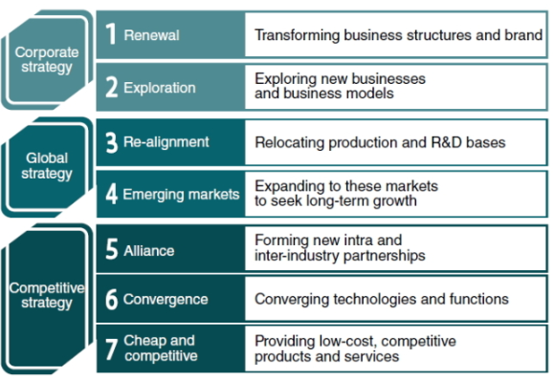
Figure 1: Seven ultimate trends concerning worldwide business management
(Source: Ogunlusi and Obademi, 2021)
However, the core principles of business governance also include disclosure and transparency. Companies are required to give the stockholders, regulators, and the general public accurate and timely information. Financial statements, yearly reports, and disclosure of significant information are only a few examples of transparent reporting practices that enable stakeholders to hold companies accountable and make well-informed decisions. In addition, corporate governance encourages moral conduct and thoughtful decision-making. It promotes an atmosphere of integrity and moral accountability by urging firms to uphold moral standards, numbers, and codes of conduct. In addition to preserving stakeholder trust, ethical behaviour is crucial for avoiding financial and reputational problems. Notwithstanding, positive effects on the external business environment can be achieved by using effective corporate governance practices (Alharbi et al. 2022). Businesses that prioritise and put effective corporate governance procedures in place are more likely to draw investment because they give investors’ confidence in the openness and dependability of the organisation. This in turn encourages economic expansion and market stability.

Ethics
In the context of business, ethics refers to the moral principles, values, and rules of conduct that influence how people act and make decisions in the workplace. The development of an atmosphere of confidence, honesty, and social responsibility depends on ethical practises, which also have a big impact on the outside world of business. For being specific, integrity is a crucial component of corporate ethics. Businesses that value integrity treat their stakeholders with honesty, fairness, and transparency. They follow the rules set forth by laws and regulations, and they are dedicated to disseminating truthful information and meeting their commitments. Integrity promotes trust, which is essential for preserving a favourable external business environment, among clients, staff members, investors, and the general public (Lutfi et al. 2020). In addition, a crucial aspect of ethics is ethical conduct in the workplace. Businesses that practise responsible behaviour take into account the economic, environmental, and social implications of their choices.
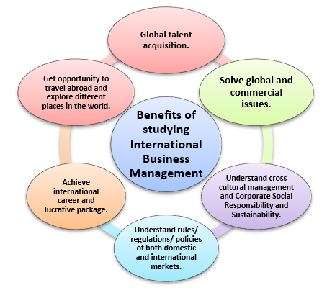
Figure 2: Factors associated with the worldwide business administration
(Source: Self-developed)
Furthermore, they take action to reduce harm, advance sustainability, and make a constructive contribution to society. This can entail implementing eco-friendly practices, encouraging diversity and inclusion, aiding neighbourhood communities, and taking part in charitable and social endeavours. In addition to helping society, ethical business practices also improve a company's reputation and long-term profitability. In particular,
relationships and exchanges in the workplace are impacted by ethics as well. Businesses that place a high value on ethics cultivate and uphold just and courteous interactions with their staff, vendors, and business partners. They refrain from abusive commercial agreements and other forms of labour law abuse. Businesses contribute to a better and more fair external business environment by encouraging ethical business partnerships. In other words, it is impossible to exaggerate the value of morals in the external corporate environment. Businesses that act unethically risk losing the public's faith, harming their brand, and facing legal and financial repercussions.

“Corporate Social Responsibility” (CSR)
“Corporate Social Responsibility” (CSR) is the umbrella term for the voluntary efforts and projects that companies undertake to tackle ecological, social, and ethical concerns outside of the bounds of the law. It entails moving beyond profit maximisation and taking into account how company operations affect stakeholders and society in general. The outside world of business is significantly influenced by CSR. For being specific, sustainability in the environment is a crucial component of CSR. Environmentally conscious companies work to limit their ecological footprint, waste and emissions, use resources sparingly, and encourage sustainable business practices. Businesses can help to mitigate climate change and safeguard the environment by implementing energy-efficient practices, adopting environmentally friendly equipment, and encouraging renewable energy sources. This has a favourable effect on the outside business environment and improves not only the natural environment but also industry standards and other companies' adoption of comparable practices.
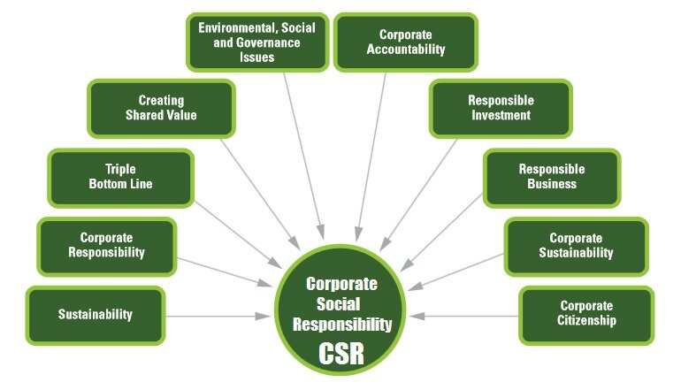
Figure 3: Terms related to CSR
(Source: Self-developed)
Besides that, a crucial component of CSR is social responsibility. Businesses that place a high priority on social responsibility take into account how their operations affect local populations, staff members, and customers. This can entail actions like promoting human rights, guaranteeing safe working conditions, fostering inclusion and diversity, and treating employees fairly. Businesses can also benefit communities by participating in philanthropic endeavours and funding initiatives related to community development, healthcare, and education. These initiatives promote social harmony, address societal issues, and raise stakeholder standards of living, all of which improve the external business environment. Additionally, CSR and ethical business practices go hand in hand (Matias and Hernandez, 2021). Maintaining moral standards, integrity, and openness in commercial dealings are all aspects of ethical conduct. Businesses that place a high priority on ethics connect with stakeholders fairly, maintain truthful and accurate reports, and shun unethical behaviours like corruption or exploitation. In particular, CSR programmes have the power to change how other companies act. When one business displays the benefits of ethical behaviour, it can influence and motivate others to follow suit. This has a compounding impact and aids in the general shift towards more ethical and sustainable corporate practices.

Altruism
In the world of business, altruism refers to the readiness to act through actions that help society in addition to one's own interests in making a profit. Even while businesses are essentially set up to make money, including charitable activities in their everyday operations may have a significant impact on the surrounding business climate. Furthermore, Philanthropy is one facet of business altruism. Altruistic companies participate in philanthropic endeavours by contributing money, materials, or services to a range of causes and programmes. This may entail aiding initiatives for disaster relief, environmental protection, poverty reduction, healthcare, and education. Moreover, with the help of tackling important social and humanitarian issues, philanthropic acts immediately improve the external environment. In other words, altruistic businesses frequently participate in community improvement projects. Through assisting with infrastructure projects, career training programmes, or entrepreneurship activities, they make an investment in the neighbourhood. Companies assist in revenue growth, employment creation, and social stability by supporting community development. This not only improves the surrounding business climate but also forges solid ties with regional stakeholders.
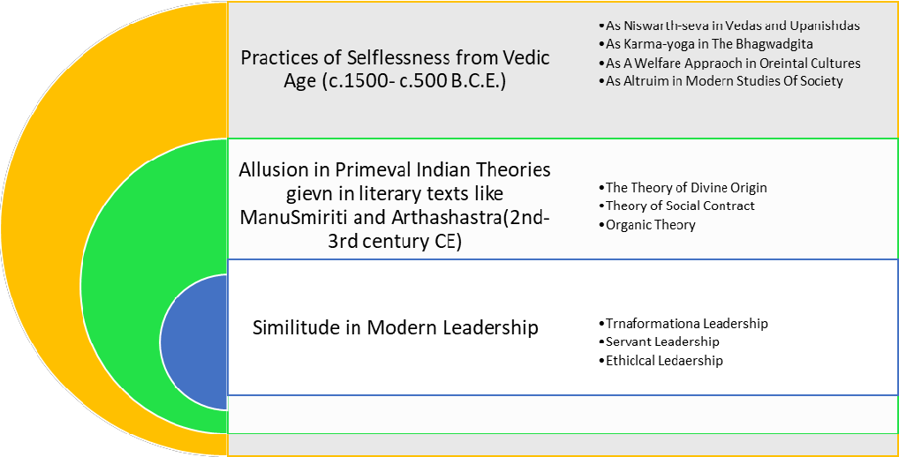
Figure 4: Altruism in the Context of Business
(Source: Islam et al. 2020)
Besides that, Altruism in business encompasses moral supply chain procedures as well. Businesses that place a high priority on fair trade, ethical sourcing, and responsible production practices help to enhance working conditions, guarantee fair wages, and safeguard human rights across their supply chains (Ahmed et al. 2020). Businesses that uphold high ethical standards have an impact on the environment by encouraging suppliers and their counterparts in the same sector to conduct themselves responsibly. Moreover, businesses' charitable deeds can motivate people in their sector and the larger business community. Businesses that exhibit the advantages of altruism and social responsibility inspire others to do the same. This has a good snowball effect and promotes a business environment that is more socially and ethically driven. In particular, businesses frequently discover that altruism has long-term benefits, despite some detractors' claims that such behaviour may contradict with goals of generating a profit. Altruistic deeds can improve a company's brand, draw in socially aware customers, and strengthen ties with stakeholders. These advantages help the company's overall success and long-term viability in the marketplace.

Pay/Wage structures
The system and procedures in place for establishing employee salary and remuneration are referred to as pay/wage structures in business. Businesses' pay and compensation structures can have a big impact on the outside world of business, in addition to the general welfare of workers and the labour market. In addition, fairness and equality are two important factors in compensation and salary arrangements. Businesses that place a high priority on fair pay practices guarantee that workers get paid in line with their qualifications, responsibilities, and experience. Encouraging social and economic equality, not only promotes a sense of justice within the organisation but also helps to create a favourable business environment outside of it. Fair pay procedures can lessen economic inequality, boost worker morale, and strengthen societal cohesiveness. Notwithstanding, businesses may recruit and keep talented individuals by paying competitive compensation (Khan et al. 2020). Employees can be encouraged to excel in their positions via a well-designed pay/wage structure that promotes performance, skill acquisition, and experience. This leads to a staff that is more productive and skilled, which in turn improves the outside world of business by spurring innovation and competitiveness.
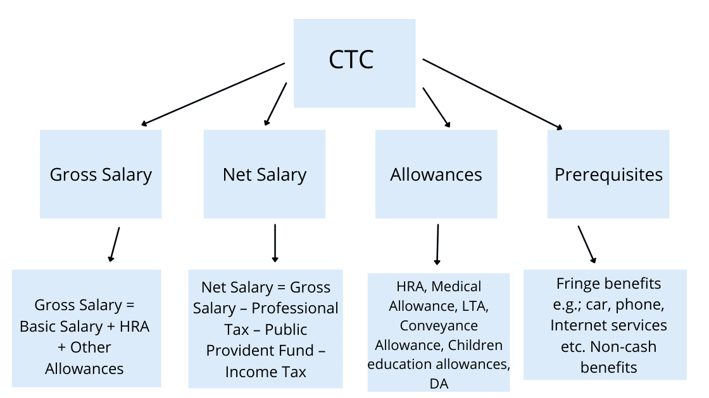
Figure 5: Components of Pay or wage structures
(Source: Self-developed)
However, businesses that go above and above the minimum criteria and provide extra perks and incentives, such as healthcare, pension schemes, and work-life balance initiatives, foster a more desirable workplace. Increased job satisfaction, staff loyalty, and a great employer reputation can result from this. These procedures not only promote a happier and more healthy workplace, but they also have an impact on the surrounding business environment by establishing industry standards and motivating other companies to follow suit. In other words, businesses' adoption of minimum wage rules may have broader effects on the labour market and society (Alharahsheh and Pius, 2021). Companies that pay their workers more than the required minimum wage show that they care about ensuring a reasonable level of living. Lowering poverty, enhancing staff well-being, and encouraging consumer spending, can have a good societal impact. Moreover, with the help of lowering income inequality and fostering general economic growth, higher salaries may also contribute to a healthier and more successful economy.

Adoption of New Technology
A significant element that might have a significant impact on the outside business climate is the widespread utilisation of new technologies. Technological discoveries and improvements have the power to change sectors, boost productivity, and alter market dynamics. Businesses can obtain an edge over their competitors and influence beneficial modifications to the external environment by properly implementing and leveraging new technology. For being specific, the introduction of technology has substantial effects on operations efficiency and productivity. Modern technologies frequently automate work, simplify procedures, and improve efficiency and accuracy (Ahmed et al. 2020). This enables companies to manufacture products and services more cost-effectively while increasing total productivity. Through promoting economic growth and opening up new job opportunities, increased productivity has positive effects on the external environment in addition to the firm itself.
Notwithstanding, the adoption of new technologies can spur creativity and the creation of fresh goods, services, or business models.
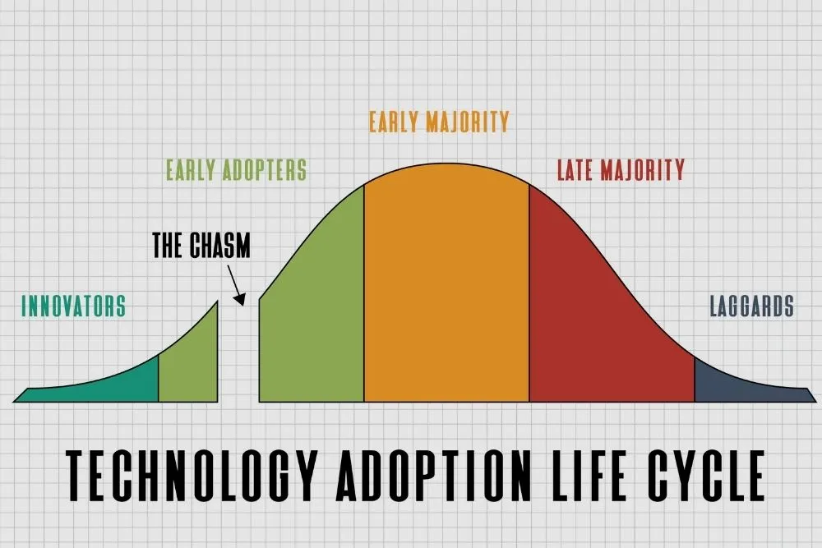
Figure 6: Life span of technology adoption
(Source: Hamdan et al. 2021)
Businesses that use cutting-edge technology can spot fresh markets and meet changing consumer demands. They can upend established industries, encourage competition, and promote an innovative culture in the larger business environment by proposing novel ideas. In addition, the adoption of new technology also makes it easier to collaborate and communicate more effectively. Businesses can connect and work with stakeholders across regional boundaries thanks to cutting-edge communication tools, managing project software, and cloud-based platforms. As a result, supply chains are more effective, remote work is made possible, and international collaboration is made easier. An external corporate environment that is more connected and integrated benefits from improved communication and collaboration.

Motivations and Principles
Depending on a number of variables, different organisations may have different goals and guiding principles when it comes to issues like wages/pays buildings, ethics, “corporate social responsibility”, corporate governance, the adoption of new technologies, and philanthropy. There are, nevertheless, some widespread drives and guiding ideas. Besides that, additionally, essential motivations include customer retention and happiness. Businesses understand how crucial it is to satisfy customer expectations, deliver high-quality goods and services, and uphold loyal clientele (Lim et al. 2022). The goal to maintain customer loyalty and improve brand reputation can be the driving force behind decisions about pay, ethics, and social responsibility.

Conclusion
In summary, firms' actions have a significant impact on the larger external business environment where they operate. Businesses influence industry practises, have an impact on stakeholders, and improve society through their decisions and actions in areas like corporate governance, ethics, "corporate social responsibility", pay/wage structures, embracing new technologies, and philanthropy. Furthermore, transparency, accountability, and efficient decision-making are all guaranteed by corporate governance practices. Trust, honesty, and fair treatment for stakeholders are fostered by ethical behaviour. Initiatives for corporate social responsibility deal with social and environmental issues, helping communities and improving the surrounding business environment.
On the other hand, Profit maximisation, client fulfilment, management of reputation, and social responsibility are frequent elements that drive these measures, while the reasons behind them can differ. Businesses think about the effect they have on society and the natural world as well as their economic viability, customer loyalty, and reputation. Their actions are guided by values like justice, integrity, and transparency, which promote moral behaviour and long-term sustainability.

References
Agarwal, S., 2022. Deep learning-based sentiment analysis: Establishing customer dimension as the lifeblood of business management. Global Business Review, 23(1), pp.119-136. < 10.1177/0972150919845160>
Ahmed, U., Kura, K.M., Umrani, W.A. and Pahi, M.H., 2020. Modelling the link between developmental human resource practices and work engagement: The moderation role of service climate. Global Business Review, 21(1), pp.31-53. <10.1177/0972150919837813>
Ahmed, U., Kura, K.M., Umrani, W.A. and Pahi, M.H., 2020. Modelling the link between developmental human resource practices and work engagement: The moderation role of service climate. Global Business Review, 21(1), pp.31-53. <https://doi.org/10.1177/0972150919895348>
Alharahsheh, H.H. and Pius, A., 2021. Exploration of employability skills in business management studies within higher education levels: Systematic literature review. Research Anthology on Business and Technical Education in the Information Era, pp.1147-1164. <10.4018/978-1-7998-5345-9.ch064>
Alharbi, I.B., Jamil, R., Mahmood, N.H.N. and Shaharoun, A.M., 2022. Exploring the relationships between organizational culture, management control system and organizational innovation. Global Business Review, 23(3), pp.662-675. <https://doi.org/10.1177/0972150919870341>
Hamdan, N.H., Kassim, S.H. and Lai, P.C., 2021. The COVID-19 Pandemic crisis on micro-entrepreneurs in Malaysia: Impact and mitigation approaches. Journal of Global Business and Social Entrepreneurship (GBSE), 7(20), pp.52-64. <https://doi.org/10.1017/CBO9781107415324.004>
Islam, M.A., Jantan, A.H., Yusoff, Y.M., Chong, C.W. and Hossain, M.S., 2020. Green Human Resource Management (GHRM) practices and millennial employees’ turnover intentions in tourism industry in malaysia: Moderating role of work environment. Global Business Review, p.0972150920907000. <https://doi.org/10.1177/0972150920907000>
Khan, S., Haleem, A. and Khan, M.I., 2020. Enablers to implement circular initiatives in the supply chain: a grey DEMATEL method. Global Business Review, p.0972150920929484. <https://doi.org/10.1177/0972150920929484>
Lim, W.M., Chin, M.W.C., Ee, Y.S., Fung, C.Y., Giang, C.S., Heng, K.S., Kong, M.L.F., Lim, A.S.S., Lim, B.C.Y., Lim, R.T.H. and Lim, T.Y., 2022. What is at stake in a war? A prospective evaluation of the Ukraine and Russia conflict for business and society. Global Business and Organizational Excellence, 41(6), pp.23-36. <https://doi.org/10.1002/joe.22162>
Lutfi, A., Al-Okaily, M., Alsyouf, A., Alsaad, A. and Taamneh, A., 2020. The impact of AIS usage on AIS effectiveness among Jordanian SMEs: A multi-group analysis of the role of firm size. Global Business Review, p.0972150920965079. <https://doi.org/10.1177/0972150920965079>
Matias, J.B. and Hernandez, A.A., 2021. Cloud computing adoption intention by MSMEs in the Philippines. Global Business Review, 22(3), pp.612-633. <https://doi.org/10.1177/0972150918818262>
Ogunlusi, O.E. and Obademi, O., 2021. The Impact of behavioural finance on investment decision-making: A study of selected investment banks in Nigeria. Global Business Review, 22(6), pp.1345-1361. <https://doi.org/10.1177/0972150919851388>

