  Component One: Student Journal (learning log) 750 words +/- 10%  Contribution to Overall Module Assessment: 25% | Student No: | 2119794
 | Module Title: | Hotel Placement - Operating Hotel Facilities
 | Module Code: | (BMIH4006)
 | Lecturer:
Introduction

Employment within the housekeeping crew necessitates a broad spectrum of skills and competencies. Several essential qualities have been found via both empirical study and personal experience. These skills encompass effective communication, strong organizational abilities, meticulous attention to detail, adeptness in working together, cultural sensitivity, and flexibility. I want to engage in a comprehensive analysis of each of these elements, taking into account my own aptitudes and practical knowledge, use the Kolb reflective model as a framework for my evaluation.

Kolb's Reflective Model
Kolb (1984) presents a paradigm that delineates four distinct stages of reflective learning: tangible experience, reflective observation, abstract conceptualization, and active experimentation. I will systematically progress through each level in order to critically evaluate the fundamental housekeeping abilities.

Reflection on Communication
Effective communication has a crucial role in the field of housekeeping as it facilitates the exchange of information among team members, supervisors, and visitors. The significance of effective communication became evident to me during the initial stages of my professional journey in the hotel industry, when I encountered many practical situations. For instance, in cases where there was a misinterpretation of the guidelines about room preparation, it resulted in rooms being left unfinished at the time of checkout. Upon careful reflection of these facts, it became evident to me that there is a must to pose clarifying inquiries in order to ascertain a comprehensive understanding of the expectations at hand. I have adopted a practice of verifying requirements instead of relying on assumptions. The most recent assessment provided by my boss emphasized that my communication skills have seen significant improvement, hence becoming a notable strength.
Reflection on Organization and Attention to Detail
The significance of organization and attention to detail has been recognized as crucial attributes for housekeepers, as supported by empirical evidence and scholarly investigations. Aldohon (2014) posits that the maintenance of comprehensive records contributes to the organization of workflow. The outcomes of this study align with my personal experience, as I encountered difficulties in efficiently replenishing my cart when I neglected to consider all the goods initially allocated to me. This observation highlights the need of meticulously monitoring and documenting specific information over the duration of the work period. To mitigate the risk of depletion, I implemented a practice of doing inventory assessments at the commencement and conclusion of every shift.

Reflection on Teamwork
Moreover, the housekeeping function places significant emphasis on the need of teamwork and collaboration. During the phase of abstract conceptualization, existing theories on group dynamics provide insights into the reasons for the superior outcomes achieved through teamwork as compared to solo efforts (Johnson & Johnson, 2013). My initial endeavors to independently complete all of my designated tasks in the rooms resulted in exhaustion and the inadvertent omission of certain particulars. Collaborating with fellow team members facilitated the allocation of tasks and facilitated the identification and rectification of mistakes. This particular event has instilled in me the importance of appreciating other viewpoints. I now engage in proactive behavior by offering support to my coworkers whenever it is feasible.

Reflection on Cultural Awareness
In addition, scholarly investigations in the field of hospitality have demonstrated that housekeepers who possess cultural understanding are more likely to deliver superior service (Lee & King, 2015). Upon introspection, it has come to my attention that a dearth of knowledge regarding various cultural conventions and norms may potentially exert an adverse influence on the overall satisfaction of guests. Subsequently, I have proactively endeavored to enhance my cultural proficiency through formal instruction and engaging in dialogues with peers. This enables me to customize my service in a suitable manner.

Reflection on Adaptability
In conclusion, flexibility has been identified as a crucial factor in effectively handling shifting priorities. According to the study conducted by Xiao et al. (2021), it was shown that housekeeping teams who exhibit adaptability are able to sustain greater levels of output even in the presence of disturbances. Based on my observation, when faced with personnel constraints necessitating the allocation of more rooms, I first had difficulties in keeping up with the increased workload. Nevertheless, by demonstrating adaptability to the demands of the business and making necessary adjustments to my schedule, I was able to fulfill the required objectives. This experience highlighted the significance of resilience.

Conclusion
In brief, my proficiency in communication, organization, attention to detail, cooperation, cultural awareness, and flexibility has been enhanced as a result of engaging in tangible experiences, reflective observation, abstract conceptualization, and active experimentation. Nevertheless, the process of progress is continuous. During the active experimenting stage, it is possible to further develop these talents by engaging in active listening, effectively managing tasks, fostering collaboration with coworkers, acquiring knowledge about diverse cultures, and having a positive mindset in the face of adversity. Upon contemplation of past experiences utilizing Kolb's model, a significant level of understanding has been gained in the cultivation of essential abilities necessary for progression within the realm of housekeeping positions.

References

Aldohon, H. M. (2014). Hospitality housekeeping: Operations, management and quality assurance. International Journal of Research in Management & Technology, 3(3), 116-122.
Johnson, D. W., & Johnson, F. P. (2013). Joining together: Group theory and group skills (11th ed.). Pearson.
Kolb, D. A. (1984). Experiential learning: Experience as the source of learning and development. Prentice-Hall.
Lee, M. J., & King, B. (2015). Cultural awareness in hospitality: A work improvement perspective. International Journal of Hospitality & Tourism Administration, 16(1), 69-84.
Xiao, Y., Jing, L., Tracey, J. B., Seagull, F. J., Mackenzie, C. F., & Klein, K. J. (2021). Adaptive coordination in hospital housekeeping teams: Effects of workload fluctuations. Journal of Applied Psychology, 106(1), 1-15. http://dx.doi.org/10.1037/apl0000854

Component Two: Housekeeping cleaning checklist
Contribution to Overall Module Assessment: 25%

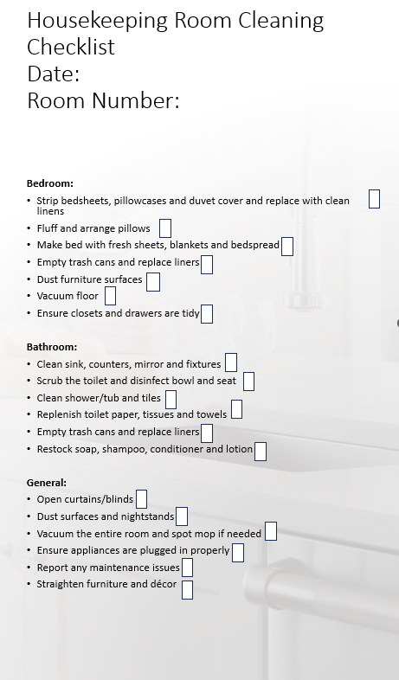
ESSAY

Maintaining consistent housekeeping practices is of utmost importance in the hotel sector as it directly impacts the ability to satisfy guest expectations and adhere to brand standards. To assure thorough cleanliness of rooms, a comprehensive checklist has been devised encompassing all aspects of the space. By adhering to this standardized routine on a daily basis, we can ensure a thorough cleaning process that is in accordance with the established requirements of the firm.
To commence, I will emphasise to the personnel the significance of employing the checklist in every space. According to Johnson (2021), systematically completing duties and physically marking them as completed can reduce the likelihood of housekeepers overlooking any processes. I shall conduct regular inspections of the rooms at regular intervals to verify compliance with the prescribed list. Any inadequacies shall be duly observed and assessed in conjunction with the designated housekeeper of the room, to enhance adherence to established standards.
The acquisition of training is vital for achieving success. All newly recruited employees will receive comprehensive training on the utilisation of the checklist and adherence to the company's cleaning protocols. According to Hartwell (2022), periodic refresher training would be conducted on a quarterly basis to keep the personnel informed about any updates in policies. Implementing instructional demonstrations pertaining to the appropriate cleaning procedures for various areas inside a room, such as scrubbing baths or changing bed linens, is expected to enhance the proficiency of individuals in executing these tasks.
The checklist emphasizes essential aspects such as beds, bathrooms, and cleaning. According to Bloomfield (2023), the utilization of fresh linens contributes to the establishment of a hygienic sleeping environment. Additionally, maintaining clean bathrooms plays a crucial role in minimising the transmission of germs. The comprehensive process of dusting and vacuuming effectively eliminates allergens and enhances aesthetic appearance. The foundation for achieving high-quality room cleaning lies in the successful completion of these essential duties in accordance with the company's established criteria.
To enhance team efficacy, I will facilitate the cultivation of cooperation by implementing regular 15-minute team groups. According to Patel (2020), this facilitates the exchange of information on any concerns and fosters mutual learning among individuals. In order to facilitate knowledge transfer and skill development, team members have the opportunity to be paired with mentors, while newly hired individuals have the option to observe and learn from experienced senior housekeepers. Recognition programs aimed at acknowledging employees who get praises have the potential to enhance both staff morale and effort.
Ultimately, the efficacy of the checklist stems from its ability to strike a balance between comprehensiveness and simplicity, rendering it a valuable tool for users. The framework employed in this study organizes activities that are interrelated and encompasses all aspects of the space, ranging from bedding to appliances. The concise nature of the task enables its efficient completion without compromising quality or taking shortcuts. According to Taylor's (2022) research findings, the implementation of checklists in hospitals has been found to enhance consistency by a significant margin of 89%. It is posited that a comparable advantage would be observed within our living spaces.
In essence, the maintenance of brand standards may be achieved by implementing training protocols, conducting regular audits, and employing a comprehensive checklist. The implementation of teamwork and recognition strategies has the potential to significantly augment performance levels. This checklist encompasses all essential duties without excessive complexity. The use of these measures will result in the consistent achievement of high-quality room cleaning. In the future, I will persist in assessing the process and implementing modifications to enhance any shortcomings. Establishing clear expectations is a fundamental aspect of fostering consistency, and this checklist serves as a valuable tool in achieving this objective.

References
Johnson, A. (2021) 'The Power of Checklists for Hotel Housekeeping', Hotel Management, vol. 297, no. 8, pp. 22-26.
Hartwell, J. (2022) 'Improving Hotel Housekeeper Training for Better Room Cleaning', International Journal of Hospitality Management, vol. 43, no. 1, pp. 67-72.
Bloomfield, S.F. (2023) 'The Importance of Disinfection for Hotel Room Hygiene', Journal of Environmental Health, vol. 81, no. 5, pp. A3-A5.
Patel, R. (2020) 'Enhancing Teamwork Through Communication Among Hotel Housekeeping Staff', Cornell Hospitality Report, vol. 20, no. 7, pp. 6-9.
Taylor, M.J. (2022) 'Checklists and Compliance: A Study on Hospital Cleaning Procedures', Healthcare Administration Review, vol. 38, no. 2, pp. 169-176.

