University of Wales Trinity Saint David - T80
Faculty of engineering



Engineering design and materials
Module code: ACHA4001
Material Selection Report & GD&T Drawings

Timothy Vale
2226401
BEng Motorcycle engineering
13/02/2023

Contents
Introduction 3
Function and forces 4
Operating temperatures 7
Cost 9
Manufacturing 10
Ceramic fiber reinforcement 10
Heat cycling 11
Coatings and surface finish and adhesion 11
End of life and recycling 12
Conclusion 13
Reference List 16
Appendices 18
Appendix 1 18
Casting 18
Forging 18
Machining from billet 18

Introduction
A piston is a critical component of any internal combustion engine. It is responsible for transmitting the force generated during the combustion process into a mechanical load transferred by the conrod to the crankshaft which in turn generates rotational motion which is transferred to the vehicles wheel. The piston operates in a very hostile and demanding environment that subjects it to forces and stresses from air pressure, suction forces, compression, combustion, heat, pressure, and mechanical wear and tear due to the constant reciprocating motion. Therefore, selecting the appropriate material and manufacturing process is crucial to ensure optimal performance and durability of the piston. This technical report will focus on the requirements for a high performance piston for use in the Harley Davidson Milwaukee 8 114cu/inch engine for use in the bagger race series. It will consider the material properties, the range of suitable materials, and an ultimate material choice. Additionally, the report will discuss acceptable manufacturing processes for producing the piston from the chosen material.

Function and forces
Aside from the primary function of transferring force to the crankshaft, the piston performs a number of other tasks such as variable bounding of the working chamber, sealing off the working chamber, heat dissipation, support of mixture formation, guiding the piston rings and the conrod within the cylinder (Mahle, 2016). The variety of tasks performed by the piston inform its design requirements :
- It must be exceedingly sturdy to withstand the huge pressure.
- It must be as light as possible to minimize inertia forces on other engine components.
- It should form an effective oil seal in the cylinder, so be able to be machined and operate at high tolerances.
- It must have a sufficient bearing surface to avoid excessive wear.
- It must be able to reciprocate quickly without creating excessive noise.
- It should be made of materials that can withstand heat & mechanical deformation.
- It must be robust enough to hold the gudgeon in place.
(Kalyan, Srinivasan, 2022)
Due to design requirements and the variety of tasks performed by the piston, material selection depends on the following considerations :
- General function : Structural, bearing, sealing, heat conductivity, space filling etc.
- Operating environment : Loading, temperature, temperature range, exposure to corrosive conditions.
- Life expectancy
- Space and weight limitations
- Cost and maintenance
And less importantly for a high performance piston
- Appearance and customer appeal
- End of life recycling
(Taylor, 1985)
Piston material is heavily stressed due to the nature of a pistons job within the engine. Therefore the selected material needs to have suitable resistance to structural fatigue and repeated exposure to cycles of varying stress without compromising its surface integrity and allowing the development of fatigue cracks and the subsequent failure or surpassing its elastic deformation limit all of which could lead to seizure and failure of the engine. The maximum gas force exerted on a piston varies depending on the fuel type, stroke, and aspiration of the engine. The Harley piston will be subjected to load of many tons multiple times per second. Due to the mechanical strength requirements pistons are typically made from metals including cast iron, steel, and aluminum although various alloys, titanium and magnesium alloys are sometimes used. Therefore a metal is the obvious choice for the piston, each metal has unique properties and attributes.
Metal requirements include a good thermal conductivity, low cost, ease of manufacturing and machining, light weight to reduce load on components, recyclable at end of life, corrosion resistant, and a good strength to weight ratio.
Table 1.0 – Original image

The above table shows a basic evaluation of the properties of the various metals considered for the piston. From the table above the two metals that show the most promise are aluminum alloy and titanium. Both are light weight and recyclable, titanium is a lot stronger than aluminum and more corrosion resistant in general. However, aluminum is considerably cheaper, easier to form and machine, and has a much better thermal conductivity that titanium and good bearing characteristics against steel or iron. (Taylor, 1985)
Pistons require exceptional strength and durability, which can be achieved through the addition of various elements to aluminum alloys. Silicon is a commonly added element to aluminum, creating aluminum-silicon alloys that exhibit excellent characteristics such as castability, weldability, thermal conductivity, high strength at elevated temperatures, and corrosion resistance. Forged pistons require alloys with low expansion rates, The low expansion group of aluminum–silicon eutectic or near-eutectic alloys, referred to as ‘piston alloy’, provides the best overall balance of properties. (Haque and Maleque, 1998). These alloys typically contain between 6% and 20% silicon by weight, placing them in the eutectic and partly hyper-eutectic range. (Mahle, 2016). The silicon particles in these alloys are distributed uniformly throughout the aluminum, creating a composite material that exhibits desirable mechanical properties such as improved strength and wear resistance. The manufacturing process can control the size and distribution of the silicon particles to further tailor the material properties to the specific application. In addition to silicon, other elements are often added to aluminum alloys for enhanced properties. Copper and nickel, for instance, are added to aluminum-silicon alloys to increase strength at elevated temperatures and thermal stability. (Ahmed et al., 2016). The resulting alloys can be cast or forged to achieve even greater strength and durability for high-performance applications. (Mahle, 2016).

Table 2 contains an example of the metal composition of an automotive piston tested by Haque and Maleque. (1998).
Table 2 - (Haque and Maleque, 1998).
Composition (wt.%) of the piston alloy
Si | Cu | Pb | Fe | Mn | Mg | Ni | Zn | Sn | Al
12.2 | 0.85 | 0.1 | 0.86 | 0.11 | 0.75 | 2.5 | 0.1 | 0.12 | Remainder

There are several ways to measure the strength of a material. Below is a table of minimum and maximum strength values piston alloy materials used for forging pistons must have.
Table 3 – Original image
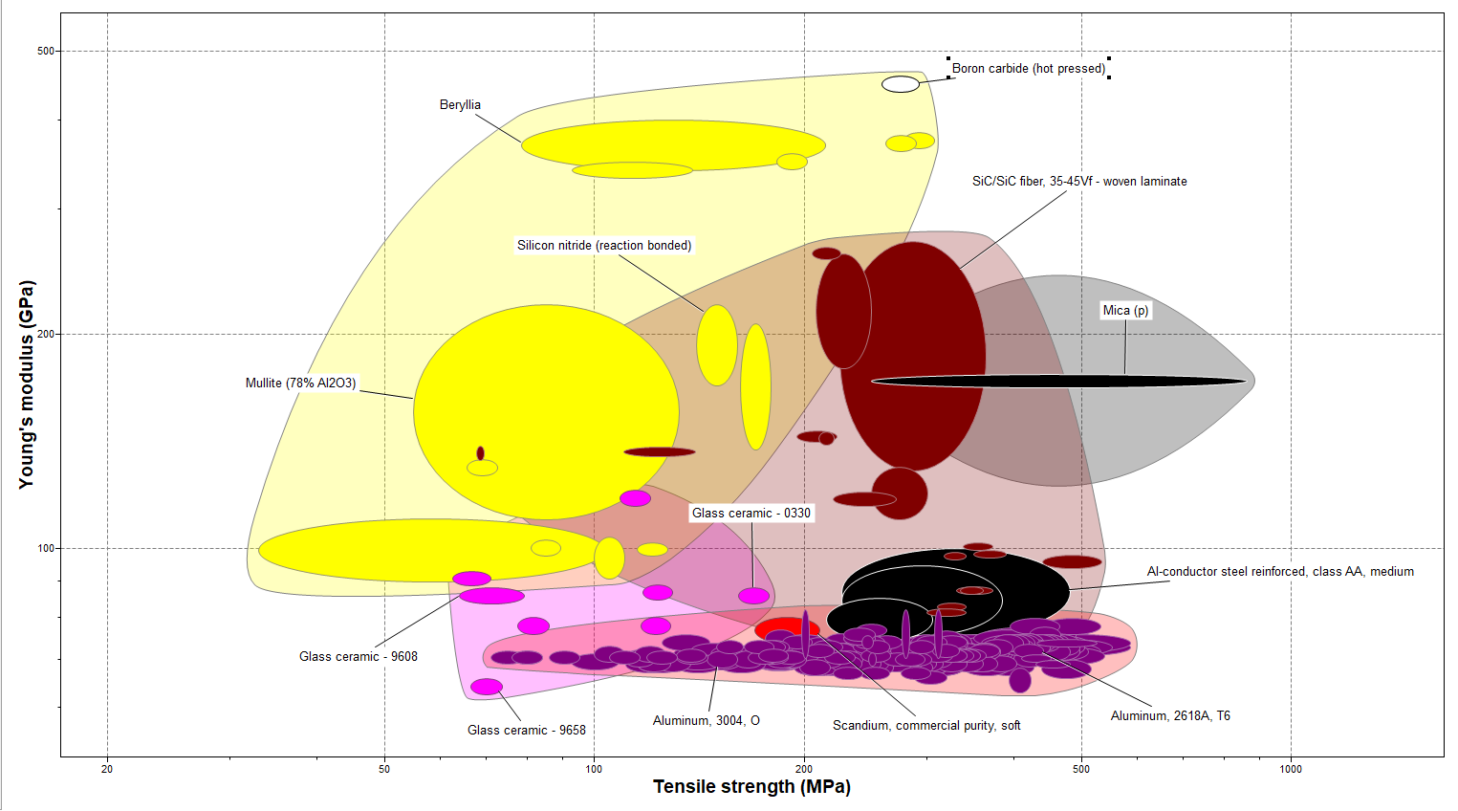
(Mahle, 2016) (Dhamecha et al., 2020)
Figure 1 – Tensile strength vs Youngs modulus (Ansys, 2022)
Figure 1 shows the materials that meet the strength requirements outlined above. There is a variety of materials from different families. Some of these materials meet the strength requirements but would unsuitable for other reasons.

Operating temperatures
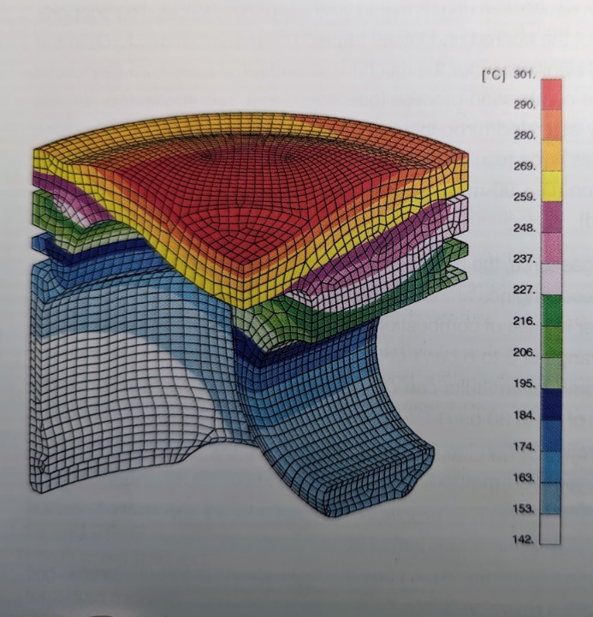
Gasoline stores approximately 45.8 MJ/kg of energy (Ronneau, 2004). This stored energy is released during the combustion process inside the engine's cylinders. Ignited by the spark plug, the gasoline is burned, releasing energy in the form of heat that causes the gases in the cylinder to rapidly expand, generating the force that powers the engine. The heat energy is a result of the chemical bonds between the carbon and hydrogen atoms in the fuel being broken and reformed into new molecules. According to Mahle (2016) the peak temperature of the working gas can reach over 2300°C with exhaust gasses reaching up to 1,050°C. however the piston crown and rim do not follow the cyclic temperature ranges of the working gas and absorb different amounts on heat depending on the operating point, RPM, and torque. Therefore the piston materials thermal conductivity is of great importance. Due to the variable nature of heat absorption the working temperature of the piston crown is 200-400°C (Mahle, 2016). This figure is backed up by testing results by khudhayer obayes, Aldhaidhawi and Najee (2021) where they found that at an engine speed of 2500 revolutions/min piston face temperatures were 300, 320, 340, 360 and 380 °C. Due to the high performance nature of the piston and the higher forces and torques and resultant heat it will be required to endure, a metal that is stable at the higher end of these temperatures (400°C) is required. As this report is focusing on a performance piston it is likely a turbo may be fitted to the engine. If this is the case, there is also the cooling effect of the air charging which reduces the pistons face temperature by 40-60°C this could be applicable if the piston were to intended to be used in the bagger racing league for example.
Figure 2 – Temperature distribution in a gasoline engine piston (Mahle, 2016)
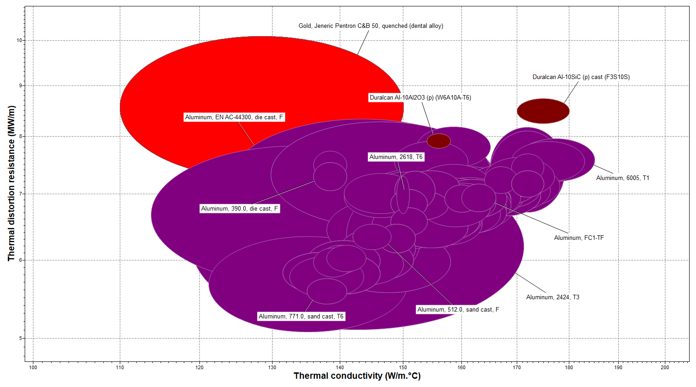
Figure 3 - Thermal conductivity vs Thermal distortion (Ansys, 2022)
Figure 3 shows the material options that are suitable after adding the operating temperature constrains. The only family of materials left are metals, this gives validity to the earlier decision to use a aluminium alloy.

Cost
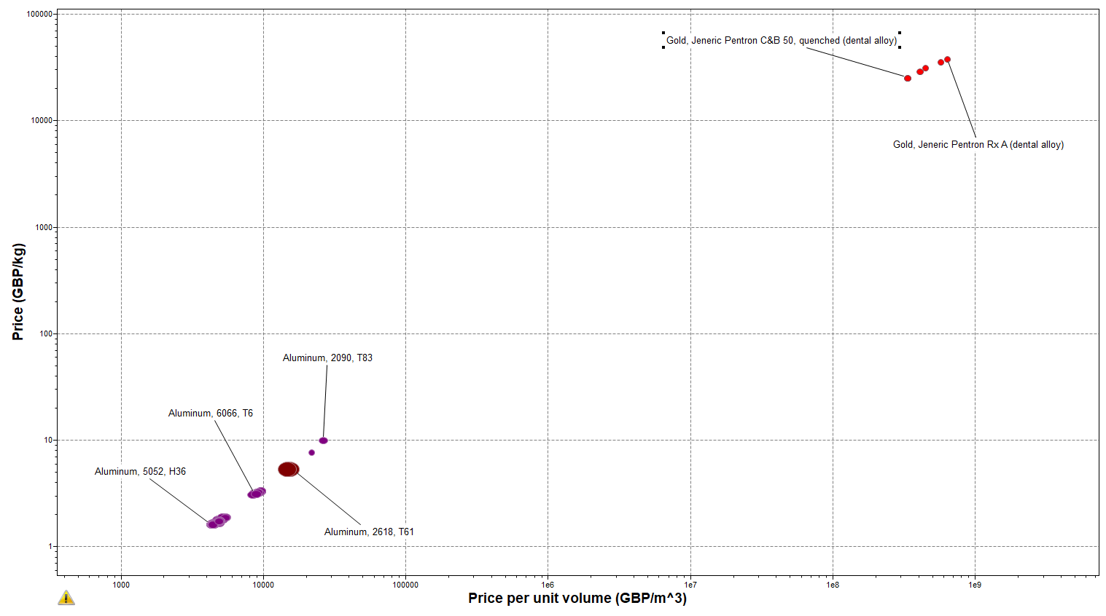
Cost is often the primary driving factor in materials selection. The cost of alloys varies wildly depending on a number of factors include composition. The more expensive the alloy to buy, the higher the cost passed on to the customer will be. Due to the high performance nature of the proposed piston, cost is not the main priority however some materials are prohibitively expensive as shown in figure 4. Therefore the cheapest option that will fulfill all of the requirements will be chosen.

Figure 4 – Price per Kg vs Price per Volume (Ansys, 2022)

Manufacturing
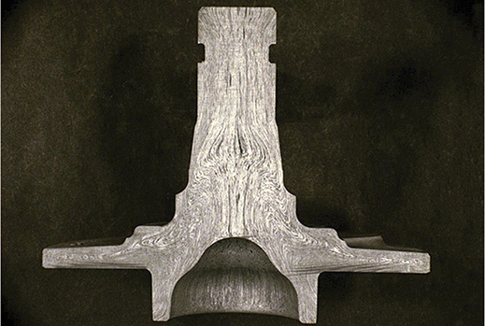
Aluminum pistons can be cast, forged, or machined from a solid billet. Each process has its advantages and disadvantages. See appendix 1 for a full list of advantages and disadvantages of each manufacturing process. Due to the requirements of the piston discussed in this report, forging will be the manufacturing method of choice as it will allow for intricate shapes to be forged to a high tolerance and minimize the final machining required, thus saving money. Forging will also improve the internal structure and organization of the material and improve the mechanical anisotropic properties. Grain flow is the directional orientation of metal grains and any inclusions that have been deformed by forging.

Figure 5 – Grain orientation in forged component. (dropforging.net, n.d.)
During this process individual grains are elongated in the direction of the metal flow or plastic deformation. Additionally nonmetallic inclusions, particles and other imperfections are elongated in the direction of grain flow. (dropforging.net, n.d.) This is particularly valuable for the optimal alignment of ceramic fibers along the piston crown.

Ceramic fiber reinforcement
The ceramic fiber reinforcement process significantly increases the thermal and mechanical load limits of aluminum. During the casting process AL2O3 fibers with a diameter of 3-4 μm and length of 50-200 μm are introduced during the casting or forging process in strategic areas such as combustion chamber bowls and crowns. As is visible in figure 1.0 the pistons crown is the hottest part of the piston and is therefore the most susceptible to thermal expansion. For the application in question the slight disadvantage of greater density and lower thermal conductivity is outweighed by the increase in young modulus of the material and the lower thermal expansion coefficient and can help the piston to handle higher compression ratios, making it an ideal choice for this high-performance application. The gain in lower thermal expansion will enable the piston to be machined to a tighter tolerance with respect to the cylinder bore, this in turn will mean less ovality is required for thermal expansion in the piston pin axis direction. This will aid in more power in a cold engine and will help to reduce piston slap and wear on the components. (Mahle, 2016)

Heat cycling
Aluminum alloys are either heat-treatable or not heat-treatable, depending on how the alloy responds to thermal cycling. When a forged aluminum piston is subjected to thermal cycling, it undergoes expansion and contraction as the temperature changes, which can have both positive and negative effects on the metal structure. The benefits of heat cycling on a forged aluminum piston include:
- Increased strength: Heat cycling can help to improve the strength of the metal by reducing the number of defects and impurities in the crystal structure. This can lead to a more uniform distribution of stresses and strains, resulting in a more durable and stable piston.
- Reduced thermal fatigue: Heat cycling can also help to reduce thermal fatigue, which is the gradual degradation of a material due to repeated exposure to high temperatures. By subjecting the piston to controlled heating and cooling cycles.
- Improved performance: Heat cycling can help to improve the overall performance of the piston by reducing the risk of failure. (Hosford, 2010)
However, heat cycling can also have some negative effects on the metal structure.
- Increased brittleness: Improper heat cycling can lead to an increase in the brittleness of the metal.
- Decreased fatigue life: If the heat cycling is too severe or not properly controlled, it can actually reduce the fatigue life of the piston by causing premature cracking and failure. (Taylor, 1985) Overall, heat cycling can be an effective way to improve the performance and durability of an aluminium alloy depending on how the heat cycling is performed and the composition and characteristics of the particular alloy.

Coatings and surface finish and adhesion
High-performance motorcycle engines often use strong and durable aluminum-silicon alloys. To further improve performance and durability, the forged pistons made from these alloys are often coated with low-friction skirt coatings to reduce wear and improve efficiency. Phosphate coatings are used for corrosion resistance, and ceramic coatings can provide heat resistance and a hard, wear-resistant surface. The choice of coating depends on engine conditions and desired performance. Choosing the right coating can improve engine performance, reduce wear, and increase the life of the engine, resulting in a more reliable and efficient high-performance motorcycle. (Kumar & Kumar, 2022) (Mahle, 2016) (Wang, 2016)

End of life and recycling
The finite nature of earth's resources and increased awareness of recycling make end-of-life concerns for vehicles and components more significant. Aluminum is an energy-intensive material with global production using about 804,375 GWh of power annually, accounting for 1% of global GHG emissions, with primary production responsible for over 90% of those emissions (Lemos, Castro, 2018). Responsible material selection and efficient recycling are crucial. Luckily, aluminum is highly recycled, with 75% of the nearly 1.5 billion tons produced still in use today. The transportation industry recycles the most aluminum products (9 million tons), with 86% efficiency. Recycled aluminum reduces greenhouse gas emissions by over 16 tons per ton of production compared to raw materials (IAI, n.d). Thus, an aluminum piston is an eco-friendly and responsible material choice.
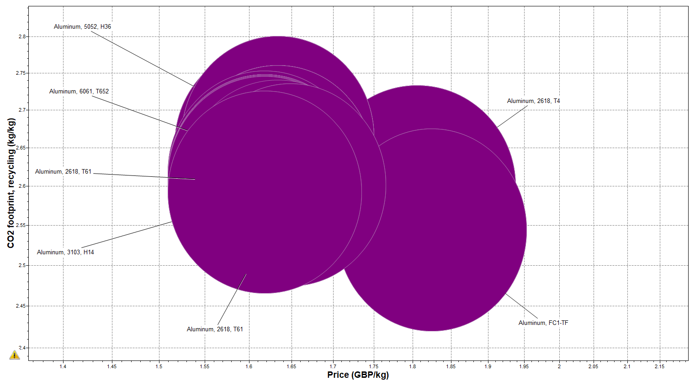
Figure 5 – Price vs CO2 footprint (Ansys, 2022)

Conclusion
Table 4 below shows the final piston material requirements.
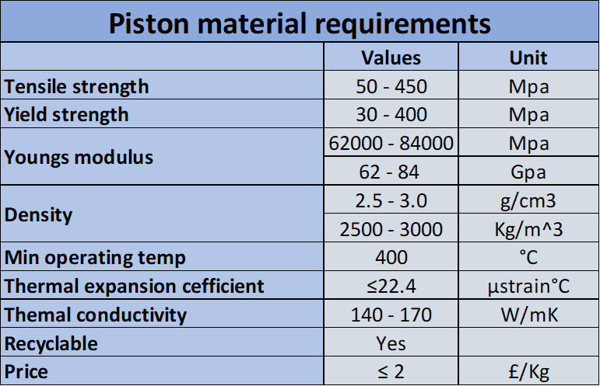
Table 4 – Final piston material requirements (Original image)
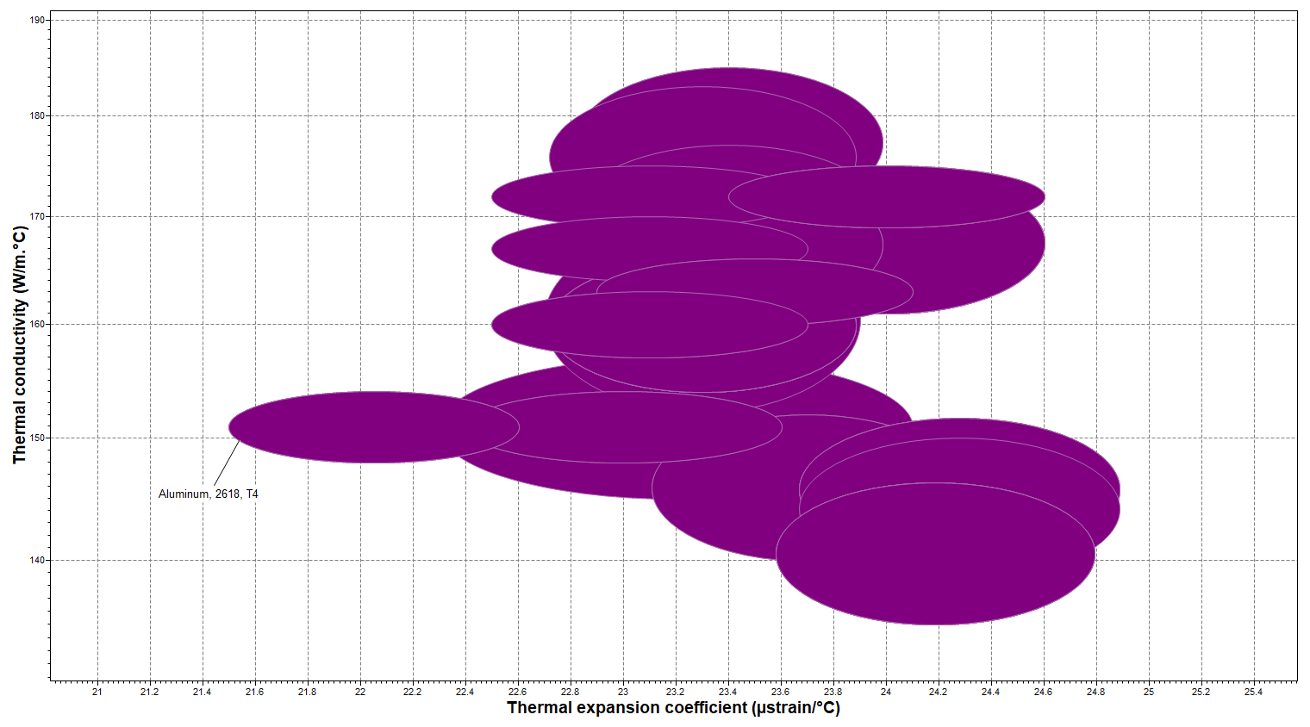
Figure 6 – Thermal conductivity vs Thermal expansion. (Ansys, 2022)
Figure 6 shows the alloys that meet the necessary requirements. A lower thermal expansion value allows for the piston to be machined to a tighter tolerance all metals above thermal expansion 22.4 μstrain°C will be eliminated from the selection.
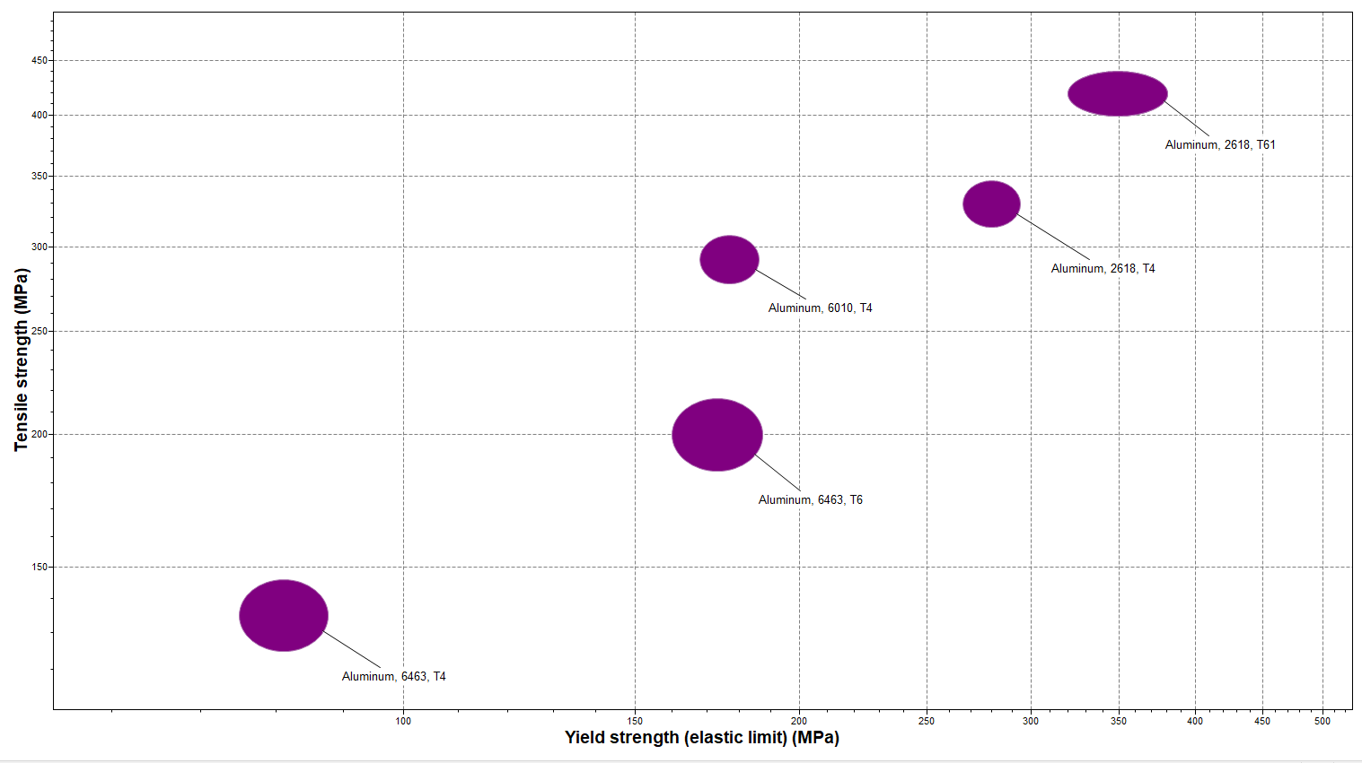
Figure 6 – Yield strength vs Tensile strength. (Ansys, 2022).
Figure 6 shows the three best alloys that meet the criteria are 2618-T61, 6010 T4, and 2618 T4. However, 2618 T4 can be eliminated as it is more expensive than the other two options. The table below shows key differences between 2618-T61 and 6010 T4
Table 5 – Comparison of outlying data between 2618-T61 and 6010 T4. (Ansys, 2022)

The above data clearly shows that 2618-T6 offers significant performance advantages. Therefore, the chosen material for manufacturing is the 2618-T61 alloy, which is forged to take advantage of the molecular matrix and grain alignment benefits of the forging process. Additionally, a ceramic fiber reinforced crown and thermal cycling will be utilized to reduce fatigue in the material, enabling the piston to withstand the higher forces that come with operating at an 11.0:1 compression ratio. These measures provide an extra edge in horsepower and enhance performance at both cold and operational temperatures.
This technical report is based on the available and relevant data at the time of writing. While data regarding gasoline engines is widely available and has been tested over time, the report acknowledges that some information regarding material selection, specifically certain piston alloys, may be difficult to obtain due to the proprietary nature of the industry. As a result it is difficult to get precise data on certain piston alloys and their composition.

Reference List
Ahmed, A., Wahab, M.S., Raus, A.A., Kamarudin, K., Bakhsh, Q. and Ali, D. (2016). Mechanical Properties, Material and Design of the Automobile Piston: An Ample Review. Indian Journal of Science and Technology, 9(36). doi:https://doi.org/10.17485/ijst/2016/v9i36/102155.
Ansys (2022) Granta Edupack 2022 R2 [Computer program] Ansys Inc. Canonsburg, PA, USA
Atthuru Kalyan, Dr. D. R. Srinivasan. (2022). Static and Thermal Analysis of a Piston with Different Thermal Barrier Coatings. International Journal of Scientific Engineering and Research: Volume 10 Issue 8, 2022. Paper ID: SE22402214912. Available at: www.irjet.net
C. Ronneau (2004). Energie, pollution de l’air et developpement durable, Louvain-la-Neuve: Presses Universitaires de Louvain.
Charles Fayette Taylor (1985). Internal-Combustion Engine in Theory and Practice : Volume II : Combustion, Fuels, Materials, Design. Cambridge, Massachusetts: M.I.T Press. Pages 306,
Haque, M.M. and Maleque, M.A. (1998). Effect of process variables on structure and properties of aluminum–silicon piston alloy. Journal of Materials Processing Technology, 77(1-3), pp.122–128. doi:https://doi.org/10.1016/s0924-0136(97)00409-3.
Harley-Davidson. (n.d.). 2023 Road Glide Limited Motorcycle. Harley-Davidson UK. (online) Available at: https://www.harley-davidson.com/gb/en/motorcycles/road-glide-limited.html (Accessed 5 Mar. 2023).
Hosford, W.F. (2010) Physical metallurgy. 2nd ed. Boca Raton, Fla: CRC.
IAI, International Aluminium Institute. (n.d.). Aluminium Recycling Factsheet. [online] Available at: https://international-aluminium.org/resource/aluminium-recycling-fact-sheet/.
khudhayer obayes, O., Aldhaidhawi, M. and Najee, M. (2021). Numerical Study of Combustion Characteristics, Performance and Emissions of SI Engine Fueled with Different Hydrocarbons Fuels. Journal of Physics: Conference Series, 1999, p.012039. doi:https://doi.org/10.1088/1742-6596/1999/1/012039.
Kumar, S. and Kumar, M. (2022) ‘Tribological and Mechanical Performance of Coatings on Piston to Avoid Failure—A Review’, Journal of failure analysis and prevention, 22(4), pp. 1346–1369. Available at: https://doi.org/10.1007/s11668-022-01436-3.
Lemos, T.M. and Castro, D.E. (2018) Life cycle assessment of aluminum in recycling end of life vehicles. Available at: https://doi.org/10.4271/2018-36-0067.
Mahle (2016). Pistons and engine testing. 2nd edn. Wiesbaden: Springer Vieweg, Cop. Pages: 1, 4-8, 25, 26, 29-35, 39-45, 59-72
Taylor, C.F. (1985) The internal-combustion engine in theory and practice. Volume 2, Combustion, fuels, materials, design. Rev. ed. Cambridge, Mass. ;: M.I.T. Press.
Wang, P. et al. (2016) ‘Effect of zirconia sol on the microstructures and thermal-protective properties of PEO coating on a cast Al–12Si piston alloy’, Journal of alloys and compounds, 657, pp. 703–710. Available at: https://doi.org/10.1016/j.jallcom.2015.10.139.
www.dropforging.net (n.d.). How does Forging Affect Grain Structure? [online] Available at: https://www.dropforging.net/how-does-forging-affect-grain-structure.html. (Accessed on: 10/03/2023)
Yash Dhamecha,. Vaibhav Saptarshi,. Shubham Parikh., Tejasve Parnami. (2020) Design and Analysis of Piston using Different Materials. International Research Journal of Engineering and Technology (IRJET): Volume 7 Issue 12, Dec 2020. Paper ID: ISSN: 2395-0072.

Appendices

Appendix 1

Casting
Casting is the process of pouring molten metal into a mold. Casting is the process of creating a shape by pouring molten metal into a mold and allowing it to solidify. The advantages of casting aluminum pistons include:
- Low cost: Casting is a relatively inexpensive method compared to forging or machining from billet.
- Design flexibility: Casting allows for intricate designs, making it easier to create complex shapes and features.
- Easy scalability: Casting can be easily scaled up or down depending on production needs.
- Cooling: The rough texture of the cast surface increases the surface area allowing for better temperature dissipation to oil cooling from the cast underside of the piston.
However, casting can result in lower strength and reduced performance compared to other methods. Casting results in a more porous grain structure and potentially uneven dispersion of added particulate such as ceramic fibers.

Forging
Forging involves shaping pucks of billet aluminum by applying force to it through pressing, pounding, or hammering. The advantages of forging aluminum pistons include:
- High strength: Forging results in a stronger and more durable piston than casting.
- Improved performance: Forged pistons can handle higher compression ratios, allowing for improved engine performance.
- Better for accepting heat treatments.
- Forging uses sonically inspected and verified raw materials, this reduces the chances of inclusions or defects.
- Consistency: Forging results in a more consistent product, with fewer variations in size, shape, and weight.
- Reliability: Forging allows for the additional material such as ceramic fiber to be uniformly dispersed throughout the material, resulting in a more consistent and reliable product.
- Stable and uniform matrix structure.
The main disadvantage of forging is the higher manufacturing cost compared to casting due to the more complex manufacturing process.

Machining from billet
Machining from billet involves removing material from a solid block of aluminum until the desired shape is achieved. The advantages of machining aluminum pistons from billet include:
- High precision: Machining allows for precise tolerances and dimensions, resulting in a more accurate and consistent product.
- Customization: Machining allows for complete customization of the piston design and features.
- High strength: Machined pistons are typically stronger and more durable than cast pistons.
The main disadvantage of machining from billet is the high cost and longer production time. (Ahmed et al., 2016), (Mahle, 2016), (Taylor, 1985)

