

Assessment 1 – Reading Task Template
PART 1: Upload your photo of your A3 in-class notes here:
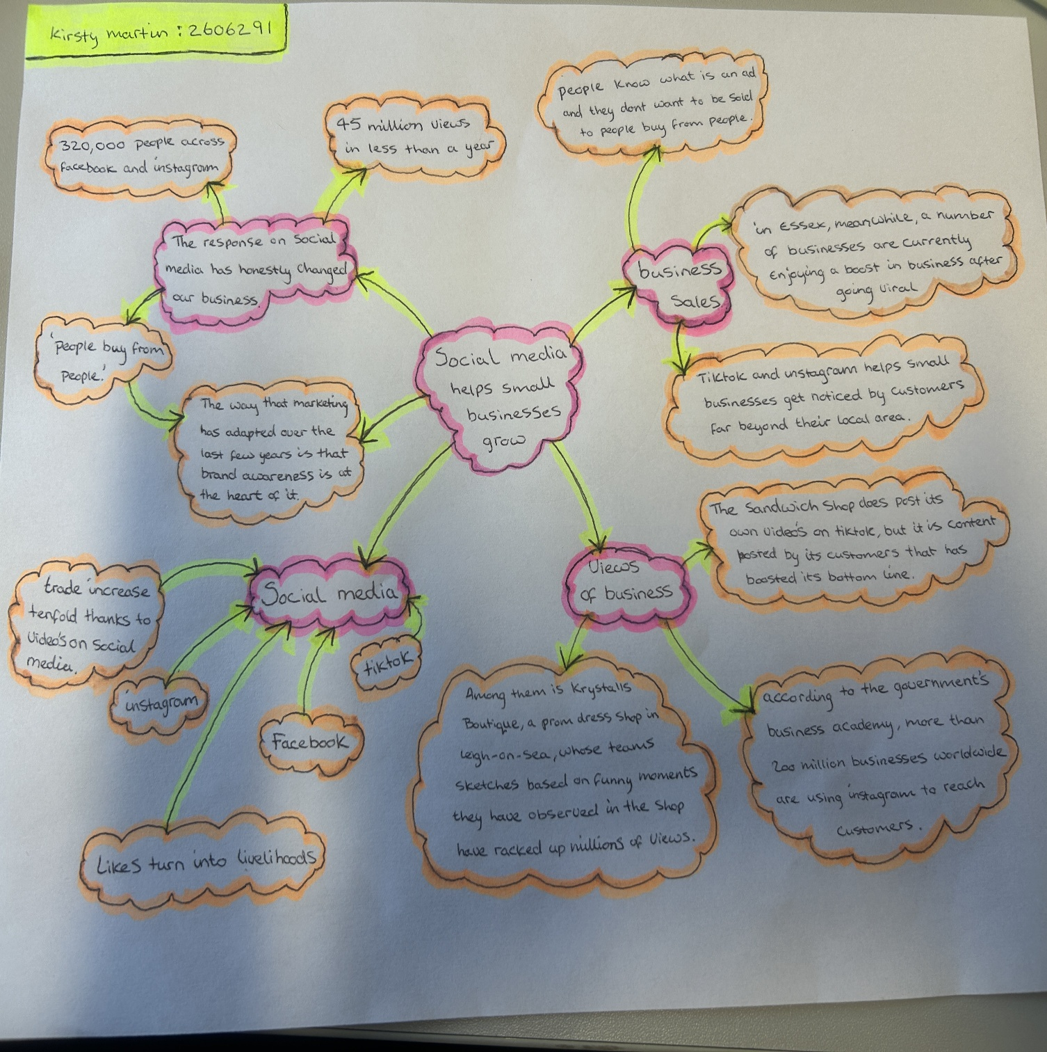

PART 2:
- Answer every question below in 1-3 full sentences.
- Use your own words. Do not use generative AI to answer these questions.
- Include a specific detail from the text when asked.
REMINDER
- The main idea is the overall message of the whole text.
- A key point helps to explain the main idea.
- A specific detail or example from the text shows that the key point is true.

- What is the main idea of the whole text?
The main idea of these articles shows that social media such as “TikTok and Instagram “helps small businesses become more noticed to new customers far and wide.
- What is one key point that supports the main idea, and which specific example from the text shows this?
This example “krystalls boutique: teenagers travel from the Channel Islands and Cyprus for prom dresses after seeing TikTok skits” shows that through social media, even a small local business like this can become nation wide through customers sharing content online.

- What is a different key point that supports the main idea, and which specific example from the text shows this?
A specific clear example of “spudman-aka Ben Newman – saw his jacket potato stall besieged with customers after his own videos went viral” he created his own videos and posted them on social media, and they made him go viral on TikTok.

- Which part of the text do you think is most important, and why?
The whole article is based on small businesses growing on TikTok and Instagram. This quote “people like real videos” shows that social media platforms work worldwide.

Reflection:
- What did you find difficult in this task (including in-class components), and why was it difficult?
I personally found pulling out different information of the article harder than expected because you must right and match the correct quote with the correct information that fits the question. Working in the classroom with others as a team was difficult to compromise and explain opinions because everyone had a different opinion and perspective to different point of views.

- What helped you with this difficulty, and how did it help you?
I found that underlining key facts, note taking and writing down different quotes and pairing information to it until it matches and makes sense helped me a lot more than just reading and going through the text little by little. When in the classroom it was easier to find out what to do with the work provided because we could ask our lecturer questions if we needed a deeper explanation so that I could work on the assignments when I got home to do individual work from my notes taken in class.

