Media and Cyberbullying

Link for presentation: Media Presentation.pptx
Slides for presentation:
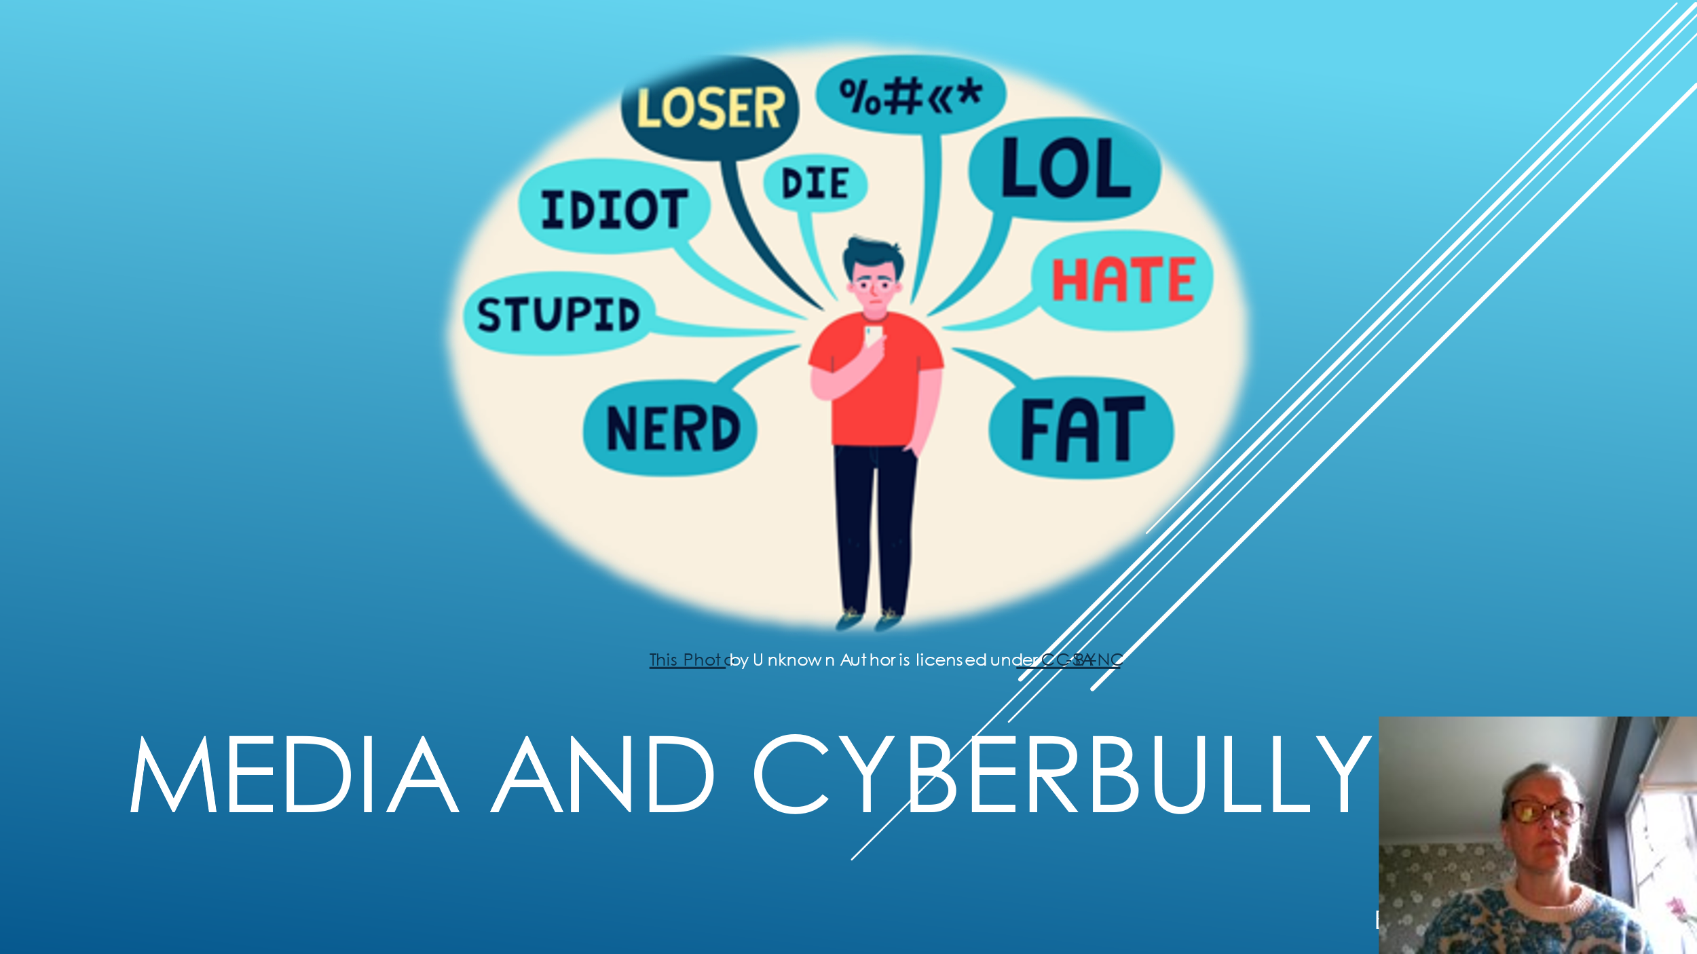
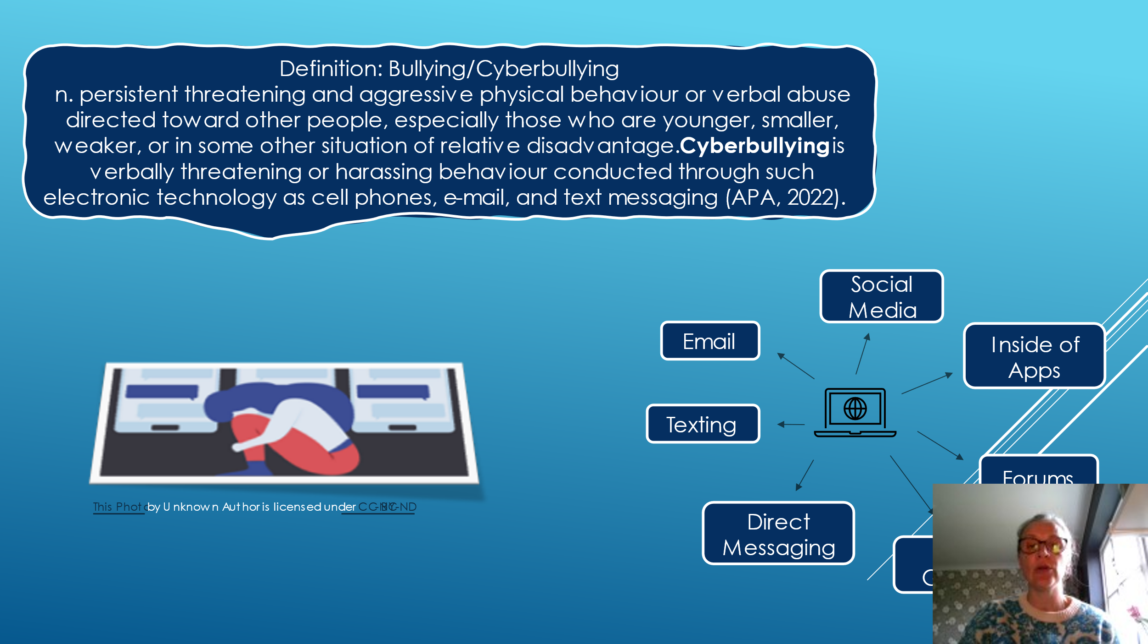
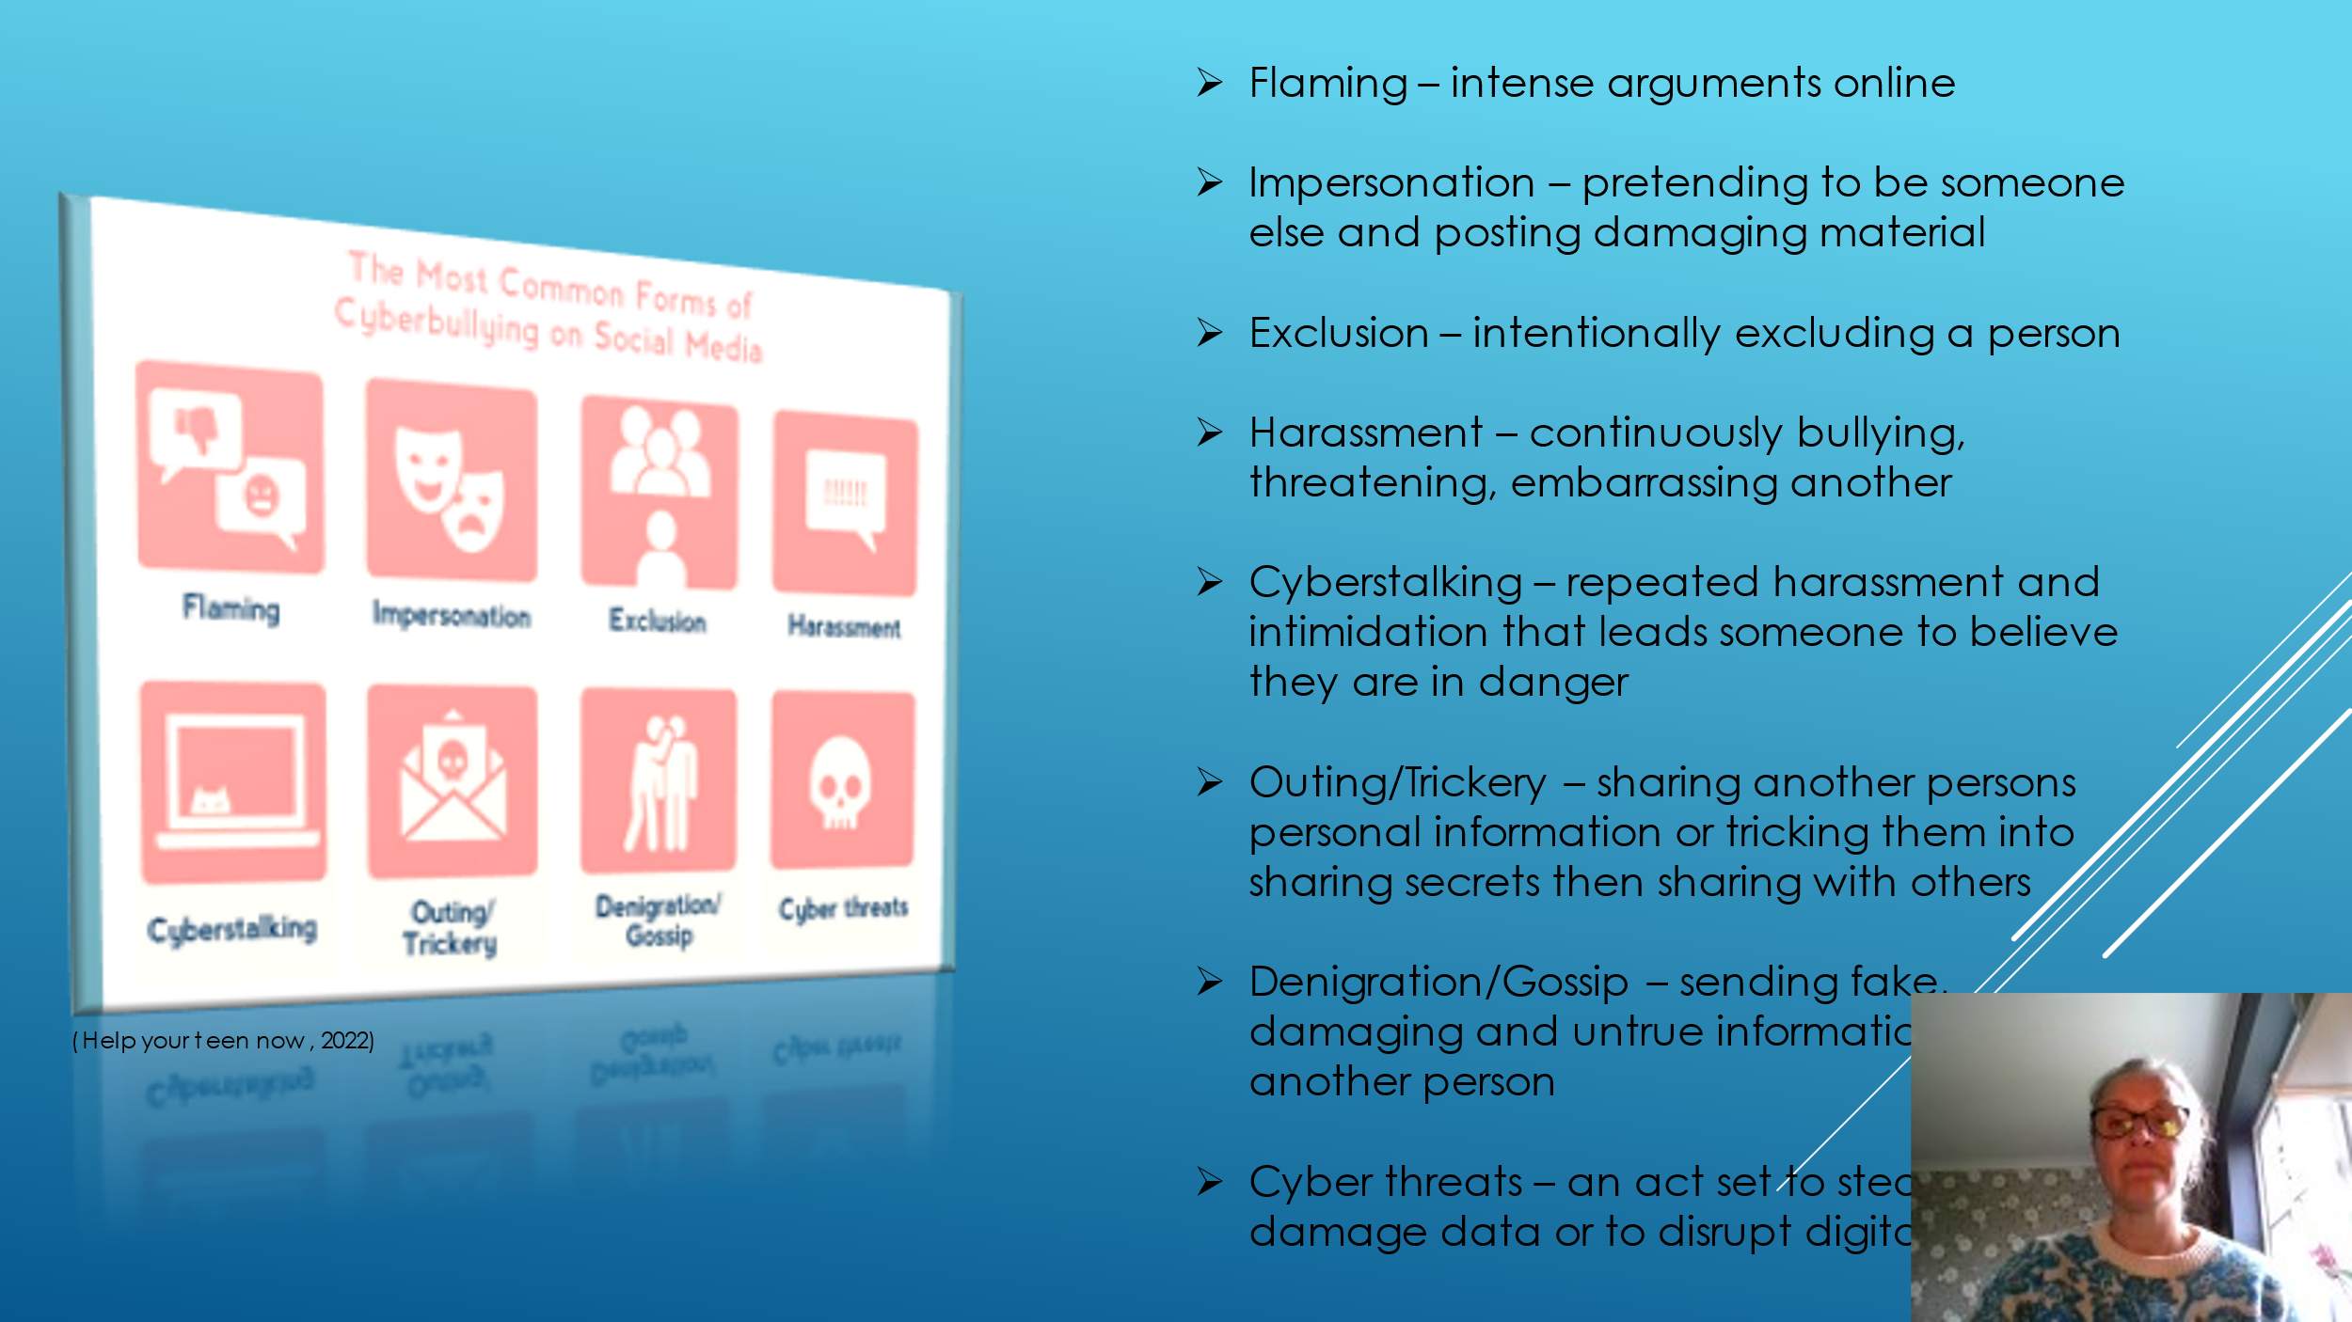
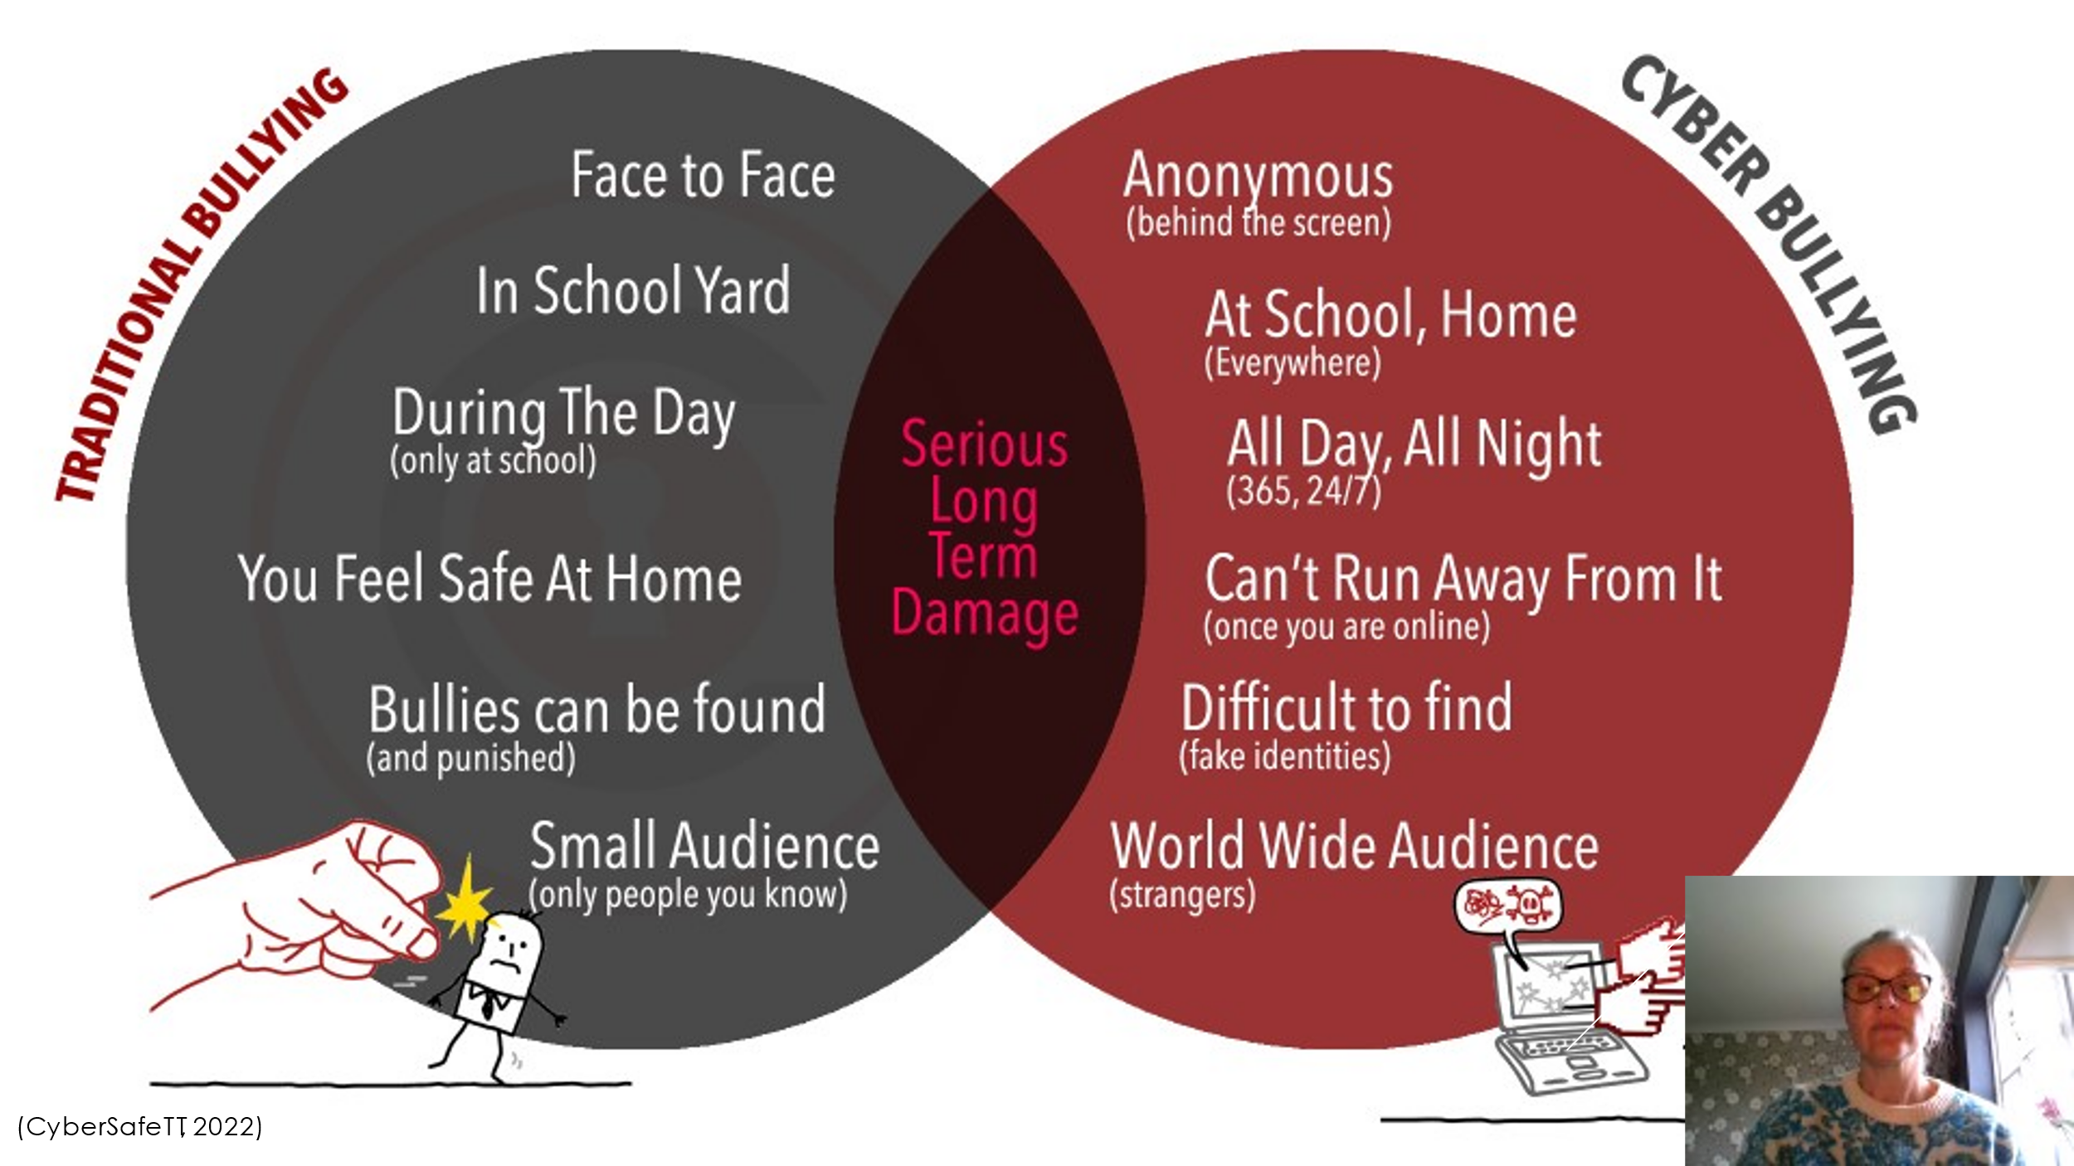
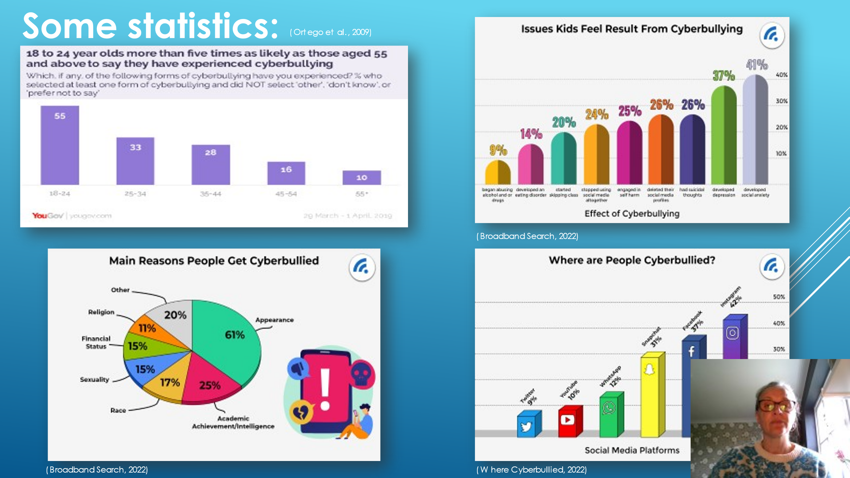
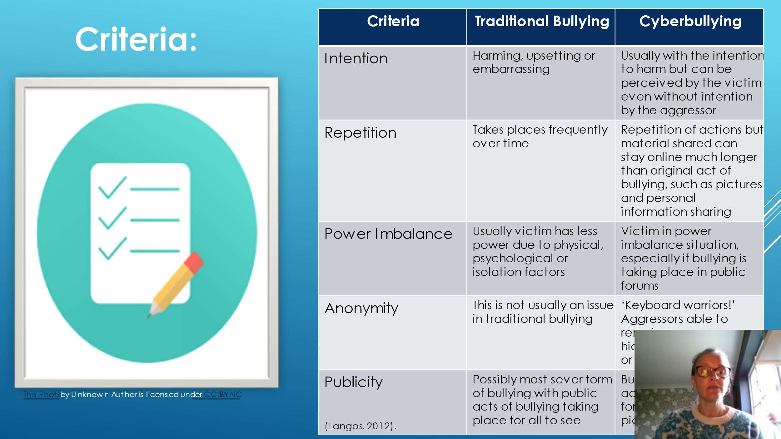
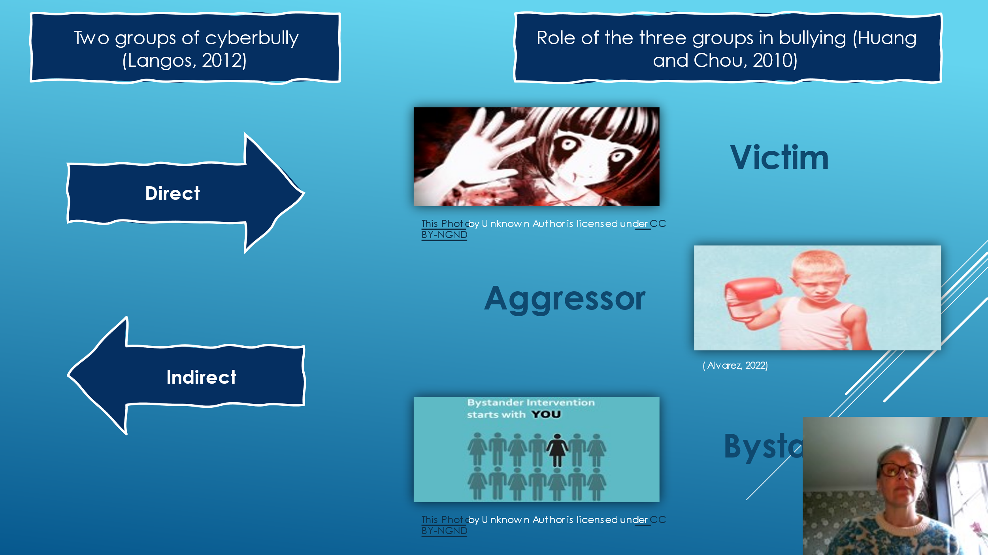
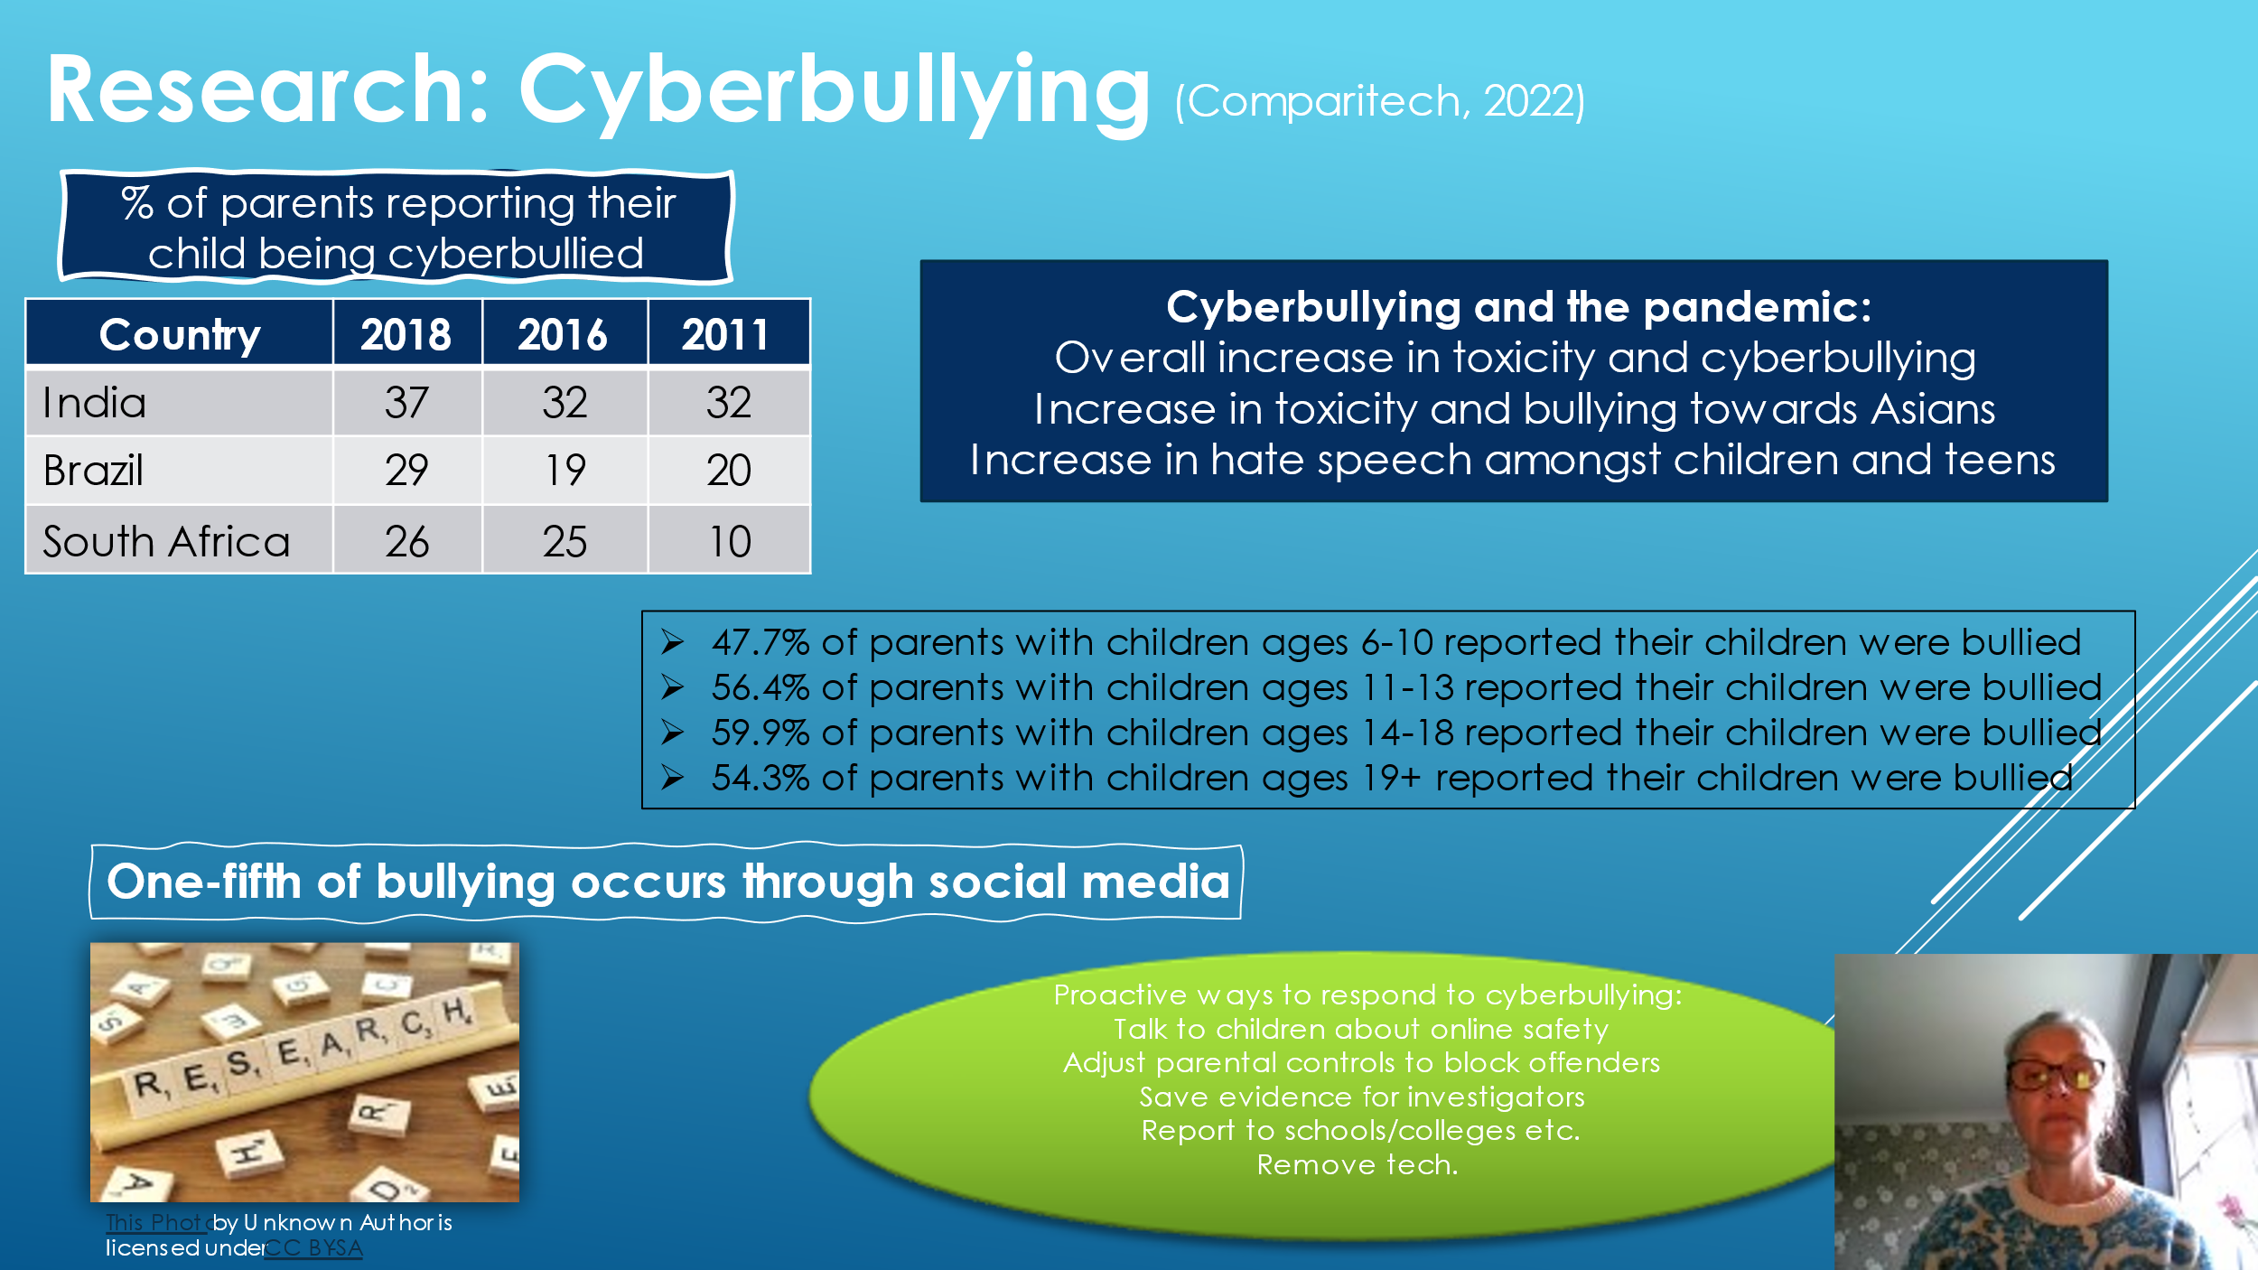
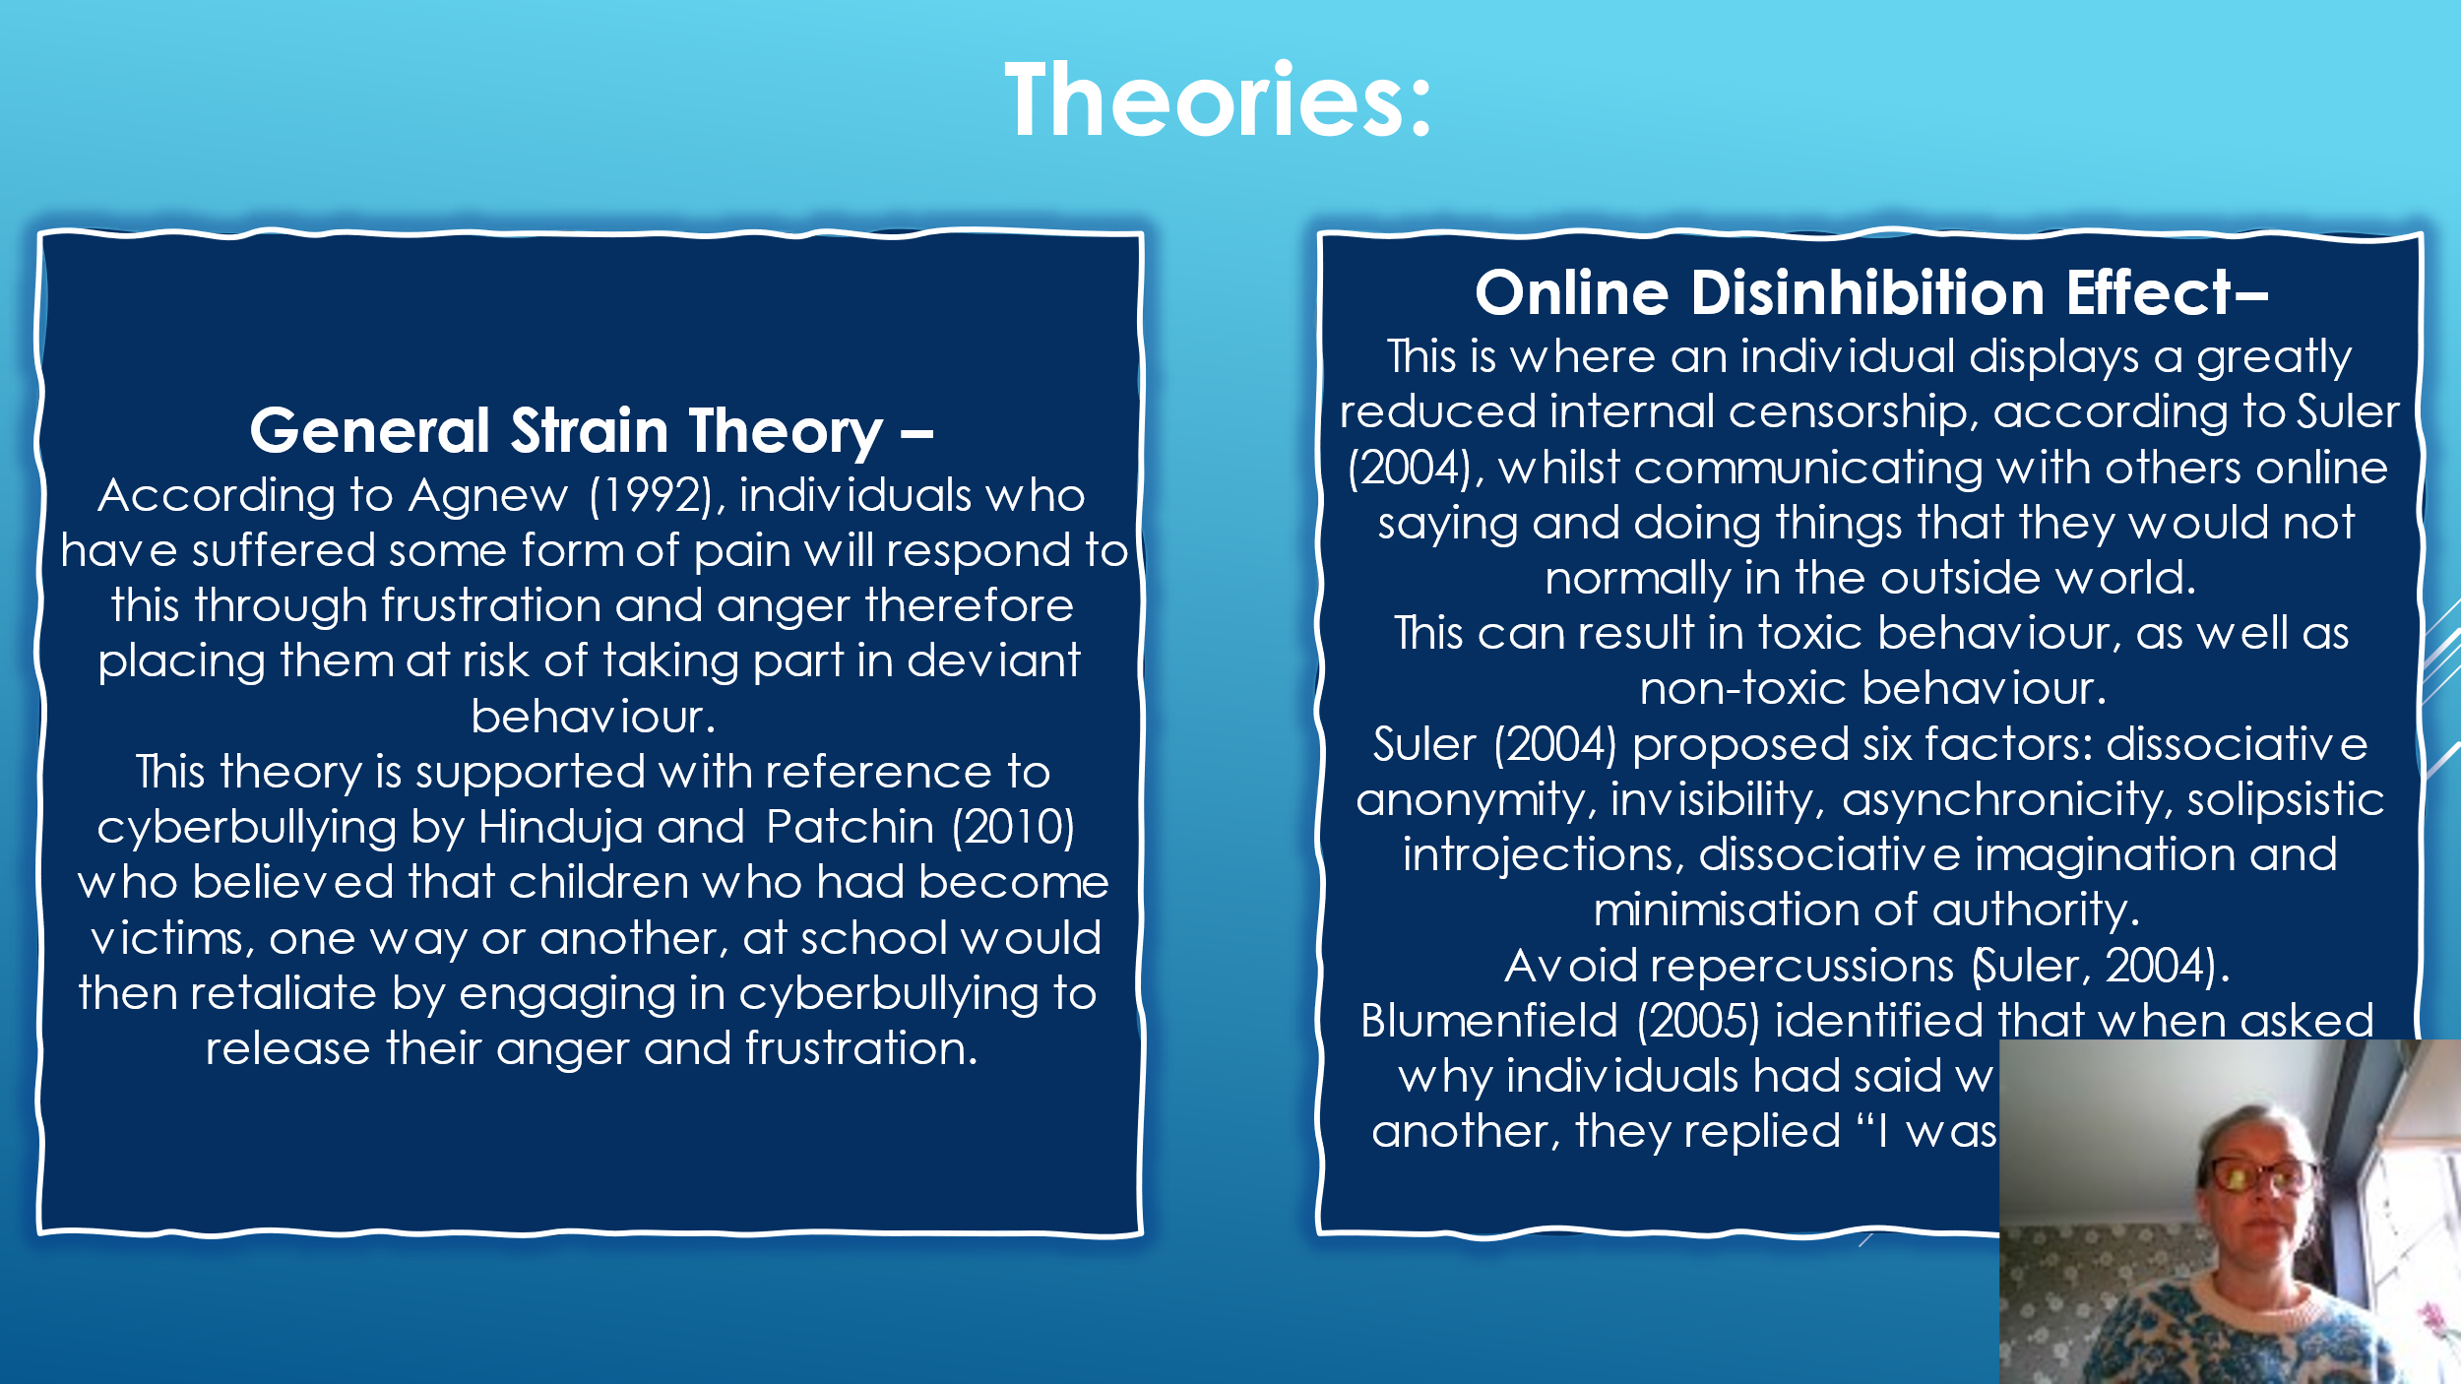
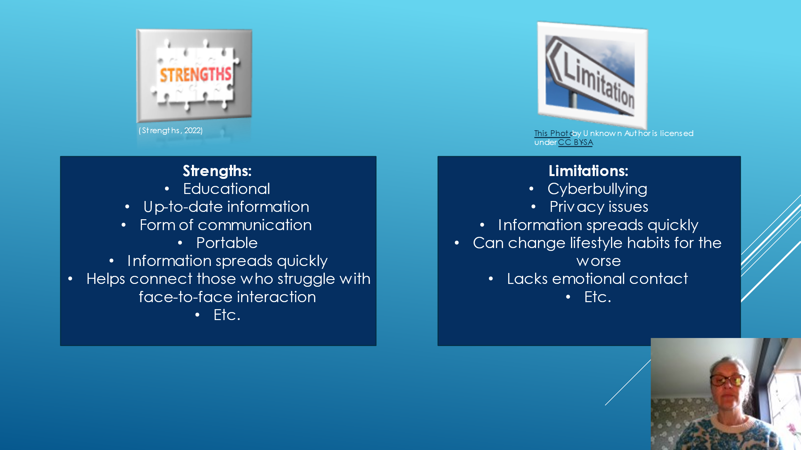
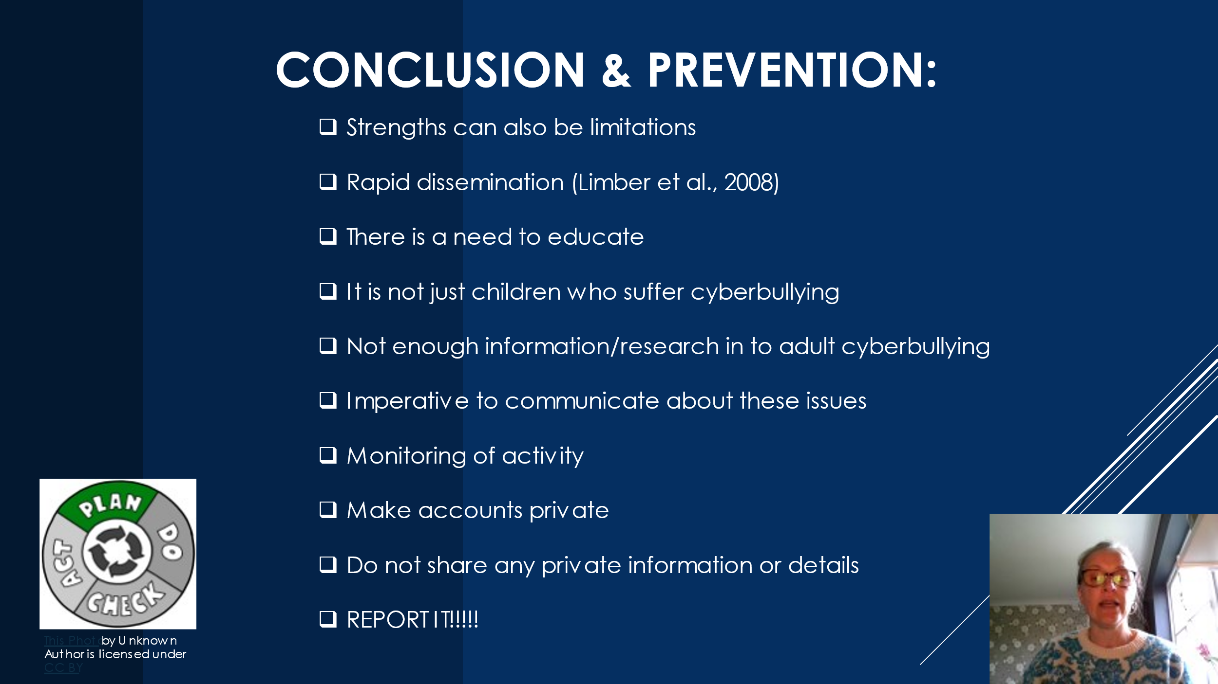
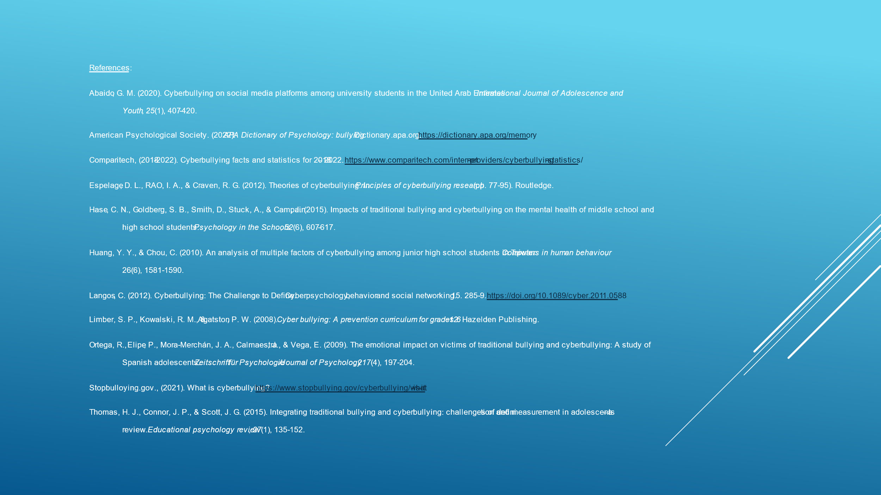

References:
Abaido, G. M. (2020). Cyberbullying on social media platforms among university students in the United Arab Emirates. International Journal of Adolescence and Youth, 25(1), 407-420.
American Psychological Society. (2022). APA Dictionary of Psychology: bullying. Dictionary.apa.org. https://dictionary.apa.org/memory
Comparitech, (2018-2022). Cyberbullying facts and statistics for 2018 – 2022. https://www.comparitech.com/internet-providers/cyberbullying-statistics/
Espelage, D. L., RAO, I. A., & Craven, R. G. (2012). Theories of cyberbullying. In Principles of cyberbullying research (pp. 77-95). Routledge.
Hase, C. N., Goldberg, S. B., Smith, D., Stuck, A., & Campain, J. (2015). Impacts of traditional bullying and cyberbullying on the mental health of middle school and high school students. Psychology in the Schools, 52(6), 607-617.
Huang, Y. Y., & Chou, C. (2010). An analysis of multiple factors of cyberbullying among junior high school students in Taiwan. Computers in human behaviour, 26(6), 1581-1590.
Langos, C. (2012). Cyberbullying: The Challenge to Define. Cyberpsychology, behavior and social networking. 15. 285-9. https://doi.org/10.1089/cyber.2011.0588
Limber, S. P., Kowalski, R. M., & Agatston, P. W. (2008). Cyber bullying: A prevention curriculum for grades 6-12. Hazelden Publishing.
Ortega, R., Elipe, P., Mora-Merchán, J. A., Calmaestra, J., & Vega, E. (2009). The emotional impact on victims of traditional bullying and cyberbullying: A study of Spanish adolescents. Zeitschrift für Psychologie/Journal of Psychology, 217(4), 197-204.
Stopbulloying.gov., (2021). What is cyberbullying? https://www.stopbullying.gov/cyberbullying/what-is-it
Thomas, H. J., Connor, J. P., & Scott, J. G. (2015). Integrating traditional bullying and cyberbullying: challenges of definition and measurement in adolescents–a review. Educational psychology review, 27(1), 135-152.

