The New Norming

This section has three sub-sections. These are:
Sub-section 1: Feedback
Sub-section 2: Valued team members
Sub-section 3: Reflecting on teamwork

Sub-section 1: Feedback

Upon completion of this sub-section, you will be:
- More aware of how effective feedback can help you function and work together as a team.

Introduction
During this session, you will be looking at providing constructive feedback and using radical candor to help you work effectively with others in your team.

Characteristics of Norming
During the norming stage, team members start to resolve their differences and begin to form an understanding of each members strengths and weaknesses. They will also feel more committed to the team's objectives. ​
The team also begins to gain a sense of who the leaders are and what the roles of the other members of the team are. However, harmony could be temporary if disagreements begin to arise again.
​ Here are some examples of things that occur within a team during the norming stage:​
- Members avoid conflict​
- Members wish to conform​
- Members start to trust others​
- Members concerned with needs of the rest of the team​.
(Mullins, 2019)​​

Introductory activities:
- Consider how team members may start to resolve their differences in the norming stage of team development.

- How do you visualise ‘norming’? If you were asked to describe 'norming' using an image, what would it be?

During the following sub-sections, you will be focusing on the third and fourth dysfunctions of Lencioni’s five behaviours, commitment and accountability. You will be looking at ways to function and work together as a team by offering constructive feedback before co- creating something that demonstrates the outcome of your groupwork.​

Commitment and Accountability
As discussed in the last session, conflict avoidance leads to a lack of commitment and accountability. People are driven by a desire to be heard. However, to be able to do this effectively, team members must have the ability to challenge directly and show empathy at the same time.

Radical candour
‘Radical Candor is caring personally while challenging directly. At its core, Radical Candor is guidance and feedback that’s both kind and clear, specific and sincere.’ (Radical Candor, 2021)

Watch the following video on radical candour: https://www.youtube.com/watch?v=YLBDkz0TwLM

How to use radical candour
If done correctly, radical candour will help you surround yourself and other people with the best work. It will also help build trusted relationships within your team. The image can be quite daunting for those who have never seen this before.
Here are some tips on how to put radical candour into practice:
- Always ask questions
- Have a holistic approach
- Make sure that the person understands that the feedback is to help them
- Ensure that the feedback that you receive/give is outcome orientated – for example, “X is more likely to be the outcome if we do Y”.
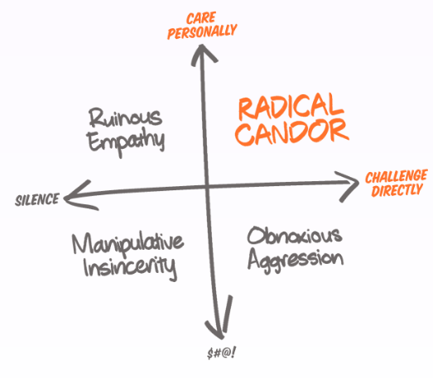

(Radical Candor, 2021)

Stop and Think

Remembering and recalling key learning
Look at what your team members consider to be their preferred roles.​

Application :
- How could their strengths create opportunities for your team?​
- Are their weaknesses your strengths?
- ​Think about ways to encourage members of your team so that they feel valued
- Decide what roles needed to be taken up
- Give your team a team name.

Developing depth
- How well did you value the advice and guidance of team members?​
- Did they offer radical candour?

Further Research
Click on the link to learn more about radical candour:
Read here: https://www.radicalcandor.com/rolling-out-radical-candor-part-one/ | Or | Watch here:  How to lead with radical candor | Kim Scott | TEDxPortland

Let’s Summarise:
1. List two examples of things that occur within a team at the norming stage.
2. Fill in the blanks.
Conflict avoidance leads to a lack of_____ and ______.
3. In your own words, explain what is meant by radical candour:

Sub-section 2: Valued team members

Introduction
During the previous sub-section, you looked at ways to help you function and work together as a team​. But how much do you value your team members?
Introductory activity
Choose four words from the list that best describes how you would feel about losing a team member and gaining a new one. ​
Eager, Cautious, Excited, Alarmed, Confident, Threatened, Curious, Inquisitive, Fearful, Agreeable, Worried, Disappointed, Frustrated, Determined, Flustered, Insecure, Keen, Passive, Empowered, Vulnerable, Productive, Motivated​

The rest of this sub-section was completed during the creation of a Mind-map activity.

Sub-section 3: Reflecting on teamwork

Upon completion of this sub-section, you will be able to:
- Reflect on the application of your new knowledge gained throughout the course of this topic.

Activity
List 3 positive or negative descriptive words (adjectives) to describe teamwork. Think about what you have learnt and experienced over the course of this unit to inspire you.
* An adjective is a word that describes an attribute of a noun e.g. a sweet red apple.
* A noun is a word that refers to something e.g. a fruit (apple), an animal (dog), a place (Swansea), a quality (softness).

Further Reading
- Mullins, L. J. (2019) Organisational behaviour in the workplace. 12th edn. Harlow: Pearson Education.
- Radical Candor (2021) A new management philosophy. Available at: https://www.radicalcandor.com/our-approach/ (Accessed:1 April 2021).

