  Component One:  What are the key skills required when working in the housekeeping team? 750 words (+/- 10%) | Student No: | Nicoleta Florea  2129101
 | Module Title: | Operating Hotel Facilities
 | Module Code: | BMIH4006
 | Lecturer: | Laurence Blake
When working in a housekeeping team, there are several key skills that are necessary for success. These skills include attention to detail, time management, good communication, teamwork, and adaptability.

Attention to detail is important in housekeeping because it ensures that rooms are thoroughly cleaned and that nothing is missed. This includes making sure that all surfaces are wiped down, linens are changed, and trash is emptied. Attention to detail also involves checking for any damages or items that need repair in the rooms and reporting them to the supervisors (Cottrell, 2019). For example, at the Ritz Carlton, housekeeping staff are trained to perform tasks such as fluffing pillows and turning down bedspreads in a specific way to ensure that the room is as comfortable and inviting as possible.

Time management is critical in housekeeping because the team is often responsible for cleaning multiple rooms in a short amount of time. This requires the ability to prioritise tasks and work efficiently in order to meet deadlines. Effective time management also helps to reduce stress and ensure that guests receive prompt service (Mullins and Dossor, 2013). For example, at the InterContinental Hotel Group, housekeeping staff are trained to clean rooms in a timely and efficient manner, with a focus on completing each task as quickly and thoroughly as possible.

Good communication is essential in housekeeping because it allows team members to work together effectively and efficiently. This includes communicating with guests to address any issues or concerns they may have, as well as communicating with supervisors and other staff members to ensure that everyone is on the same page. Good communication skills can also help to build trust and foster positive relationships within the team. For example, at the Hilton Hotels & Resorts, housekeeping staff are trained to communicate effectively with guests to address any concerns or requests they may have in a prompt and professional manner (HotelOwner, 2023).

Teamwork is crucial in housekeeping because the team is responsible for cleaning a large number of rooms in a limited amount of time. Each team member must be able to work together and support each other in order to get the job done. This also includes helping each other with tasks, covering for each other when necessary, and sharing information about any challenges that may arise (Raghubalan and Raghubalan, 2016). For example, at Marriott International, housekeeping teams work together to ensure that rooms are cleaned and made ready for guests in a timely and efficient manner, with each member of the team playing a specific role to ensure a seamless process.

Adaptability is important in housekeeping because the team may encounter unexpected situations, such as guests requesting additional services or last-minute changes to the cleaning schedule. The team must be able to adapt to these changes and find solutions in a timely and effective manner (Casado, 2012). For example, at Premier Inn Hotels, housekeeping staff are trained to be adaptable and flexible, responding to changes and requests in a professional and efficient manner.

I can apply my theoretical knowledge of these key skills by implementing them in my daily work routine as a housekeeper. For example, I can pay close attention to detail when cleaning rooms to ensure that I don't miss anything and that the room is left in a spotless condition. I can also prioritise my tasks and work efficiently to manage my time effectively and meet deadlines. I can also practice effective communication by speaking clearly and respectfully to guests and colleagues, and by actively listening to their concerns. Additionally, I can strive to work well with others on my team by helping each other with tasks, being flexible and adaptable to changing situations, and working together to resolve any challenges that may arise (Lieter and Bakker, 2010).

In the hospitality industry, understanding these skills is important because they directly impact guest satisfaction. A clean and well-maintained room can enhance a guest's experience and create a positive impression of the hotel. Effective communication and teamwork can lead to a more efficient and seamless experience for guests, while attention to detail and adaptability can help to resolve any issues that may arise during their stay. In the hospitality industry, the housekeeping team is responsible for creating a clean and comfortable environment for guests, which is essential for their overall satisfaction and enjoyment of their stay (Vallen and Vallen, 2012). These skills can also help to reduce stress and conflicts among team members, leading to a more positive work environment. Furthermore, these skills are critical for ensuring that any issues or concerns that may arise during a guest's stay are handled in a timely and professional manner. For example, the ability to adapt to unexpected situations can help the team to respond effectively to last-minute requests or changes, while effective communication can help to resolve any conflicts or misunderstandings that may arise (Wood, 2013).

Word Count | 813

Component Two:
In this scenario – You have just been promoted to team leader for a floor within the hotel. A guest complains that on their arrival, their room had not been properly cleaned. Create an action plan and answer the following questions.

Problem | Why did it happen? | What are you going to do? | How will you prevent this from happening in the future? | What measures would you introduce to improve team effectiveness?
Staff training and supervision | Lack of proper training or supervision resulted in housekeeping staff not following proper procedures and standards, leading to rooms that are not properly cleaned. | I will incorporate regular training and supervision into the daily operations of the housekeeping team, to ensure that all staff are up-to-date on procedures and standards. | I will prevent this by shadowing experienced staff members, and intake staff training sessions and will incorporate performance evaluation measures. | I will provide ongoing training and development opportunities for the team members, to ensure that they are up-to-date on industry standards, procedures, and best practices. It will include both formal training sessions and on-the-job learning opportunities.
Time Constraints | Housekeeping staff have been working under time constraints that do not allow them to properly clean each room, resulting in missed areas or a rush job. | I will regularly review the staffing levels, schedules, and workloads of the housekeeping team, to ensure that they have adequate time to properly clean each room. | I will invest in time-saving equipment and supplies to prevent this from happening in future. | I will Empower the team members to make decisions, solve problems, and take ownership of their work. This can include delegating responsibilities, providing clear decision-making guidelines, and encouraging the team to provide feedback and suggestions for improvement.
High-Occupancy Rate | A high volume of guests has put additional pressure on the housekeeping team, leading to missed cleaning or mistakes. | I will ensure that the housekeeping team is adequately staffed during the busy period with adjustments in staffing levels and schedules as needed. | I will establish regular communication with other departments, such as the front desk or sales, to anticipate high-occupancy periods. | I will encourage open and regular communication among the team members, as well as promote teamwork, collaboration, and mutual support.
Inadequate supplies and equipment | The housekeeping team does not have the proper equipment or supplies to effectively clean the rooms, which resulted in a lack of thoroughness or consistency in the cleaning process. | I will ensure that staff have the proper tools and resources to effectively clean the rooms and will regularly maintain and replace equipment and supplies as needed. | I will regularly review and update the equipment and supplies used by the housekeeping team. | I will recognise and reward the efforts and achievements of the team members, to motivate and inspire them and also ensure that they communicate effectively in order to fulfil needs and demands.
Inconsistent standards | The standards for room cleanliness were unclear or inconsistent, which lead to confusion among the housekeeping staff, resulting in inconsistent or subpar cleaning. | I will regularly review and update the standards for room cleanliness, to ensure that they are clear and consistent across the entire team. | I will ensure regular quality control inspections, regular training sessions, and feedback from guests. Additionally, I will incorporate technology, such as cleaning checklists and task management software. | I will establish clear expectations and goals for the team and regularly review and update them to ensure that they are relevant and achievable.

Component Three:
Your task is to create and prepare a presentation following the detailed scenario provided below.

As the floor housekeeping manager and given the recent guest complaints you need to put together a basic training presentation for your colleagues within the housekeeping team to get the best out of them, ensure that brand standard is being achieved and that Health and Safety procedures are also being followed.

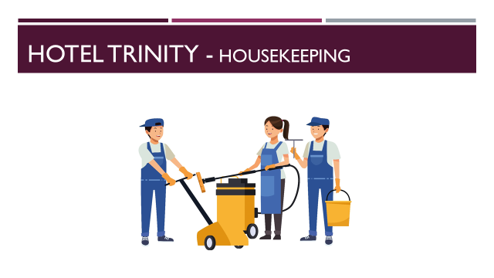

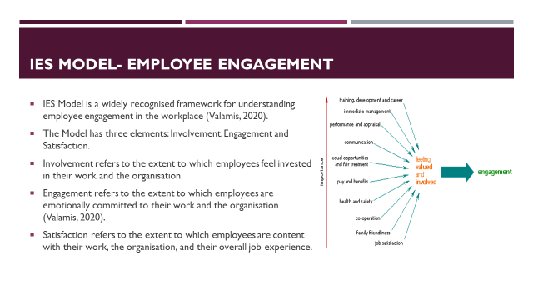

The IES (Involvement, Engagement and Satisfaction) model of employee engagement is a widely recognised framework for understanding employee engagement in the workplace. The IES model suggests that there are three key elements of employee engagement: Involvement, Engagement, and Satisfaction (Valamis, 2020).
Involvement: Involvement refers to the extent to which employees feel invested in their work and the organisation. This can be achieved through opportunities for professional development, meaningful work tasks and a clear understanding of their role and responsibilities (Valamis, 2020).
Engagement: Engagement refers to the extent to which employees are emotionally committed to their work and the organisation. This involves having a positive attitude towards the work and a desire to contribute to the success of the organisation.
Satisfaction: Satisfaction refers to the extent to which employees are content with their work, the organisation, and their overall job experience. This includes factors such as job security, fair treatment and a supportive work environment (Valamis, 2020).

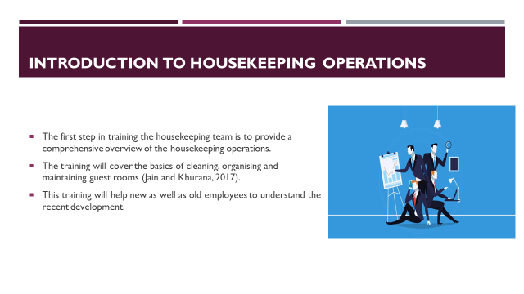

Introduction to Housekeeping Operations: The first step in training the housekeeping team is to provide a comprehensive overview of the housekeeping operations, including the roles and responsibilities of each member of the team. The training will cover the basics of cleaning, organizing and maintaining guest rooms, public areas and back of house areas. The introduction is aimed to provide a comprehensive overview to the team in relation to the housekeeping services. This training will help new as well as old employees to understand the recent development in regards to the housekeeping services within the hotel (Jain and Khurana, 2017).

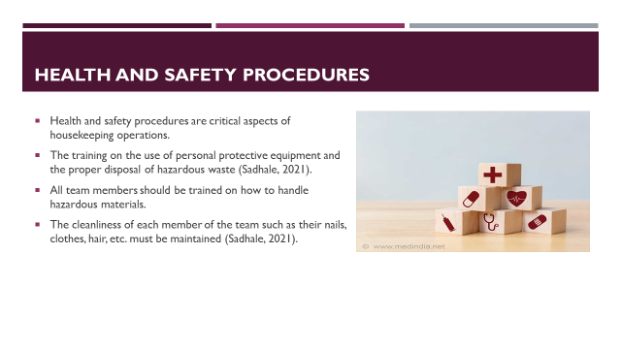

Health and Safety Procedures: Health and safety procedures are a critical aspect of housekeeping operations. All team members should be trained on how to handle hazardous materials, how to prevent injuries and what to do in case of an emergency. This includes training on the use of personal protective equipment and the proper disposal of hazardous waste. Moreover, the team will be introduced to the recent developments of hotels in relation to health and wellness. The cleanliness of each member of the team such as their nails, clothes, hair, etc. must be maintained by providing comprehensive understanding to the members of the team (Sadhale, 2021).
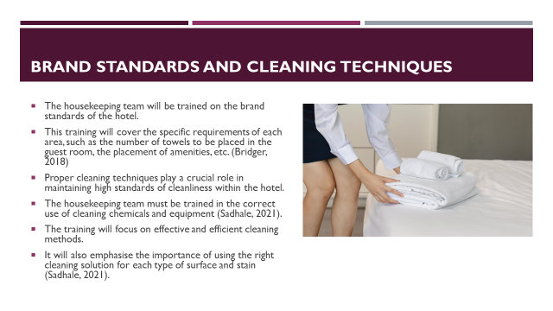

Brand Standards: The hotel's brand standards, including those for guest rooms, public areas, and back-of-house areas, will be covered in training for the housekeeping staff. The exact needs for each area will be covered in this course, such as the amount of towels to be placed in the guest room and the location of amenities. Each team member will make sure that there are enough amenities in each room and will respond as quickly as they can if there are any inadequacies. This training will aim to improve brand standards and enhance customer satisfaction with an effective approach towards employee engagement (Bridger, 2018).
Cleaning Techniques: Proper cleaning techniques play a crucial role in maintaining high standards of cleanliness within the hotel. To achieve this, the housekeeping team must be trained in the correct use of cleaning chemicals and equipment. The training will cover the proper procedures for cleaning different types of surfaces and furniture, including carpets, upholstery, and hard surfaces. The training will focus on effective and efficient cleaning methods, such as using microfiber cloths and mops to prevent the spread of bacteria and other harmful particles. It will also emphasise the importance of using the right cleaning solution for each type of surface and stain and will include cleaning techniques such as deep cleaning and stain removal (Sadhale, 2021).

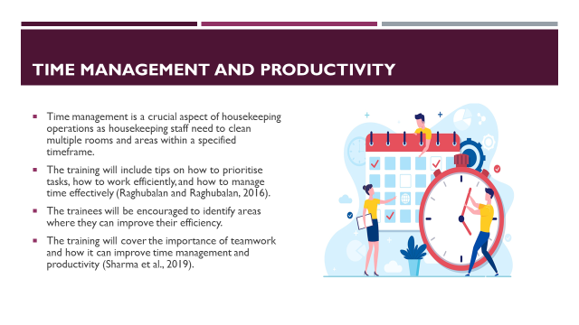

Time Management and Productivity: Time management is a crucial aspect of housekeeping operations as housekeeping staff need to clean multiple rooms and areas within a specified timeframe. The training will include tips on how to prioritise tasks, how to work efficiently, and how to manage time effectively (Raghubalan and Raghubalan, 2016). The training will start with a discussion on the importance of time management and its impact on guest satisfaction. The trainees will be encouraged to identify areas where they can improve their efficiency and be provided with suggestions and techniques for improvement. The training will cover the importance of teamwork and how it can improve time management and productivity. The team members will be encouraged to communicate with each other, share ideas and best practices, and support each other in completing tasks (Sharma et al., 2019).

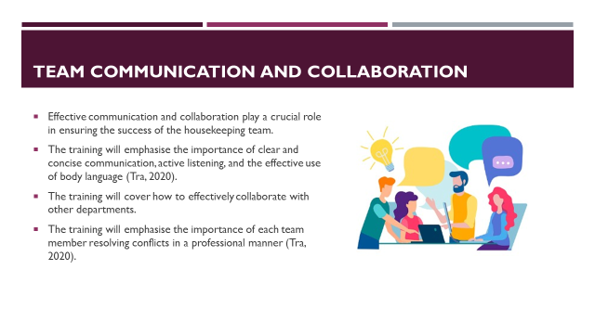

Team Communication and Collaboration: Effective communication and collaboration play a crucial role in ensuring the success of the housekeeping team. In order to achieve this, the training will emphasise the importance of clear and concise communication, active listening, and the effective use of body language. In addition, the training will cover how to effectively collaborate with other departments, such as the front desk or maintenance, to ensure that guests receive the best possible experience. The training will emphasise the importance of each team member working together to achieve common goals, and how to resolve conflicts in a professional manner (Tra, 2020).

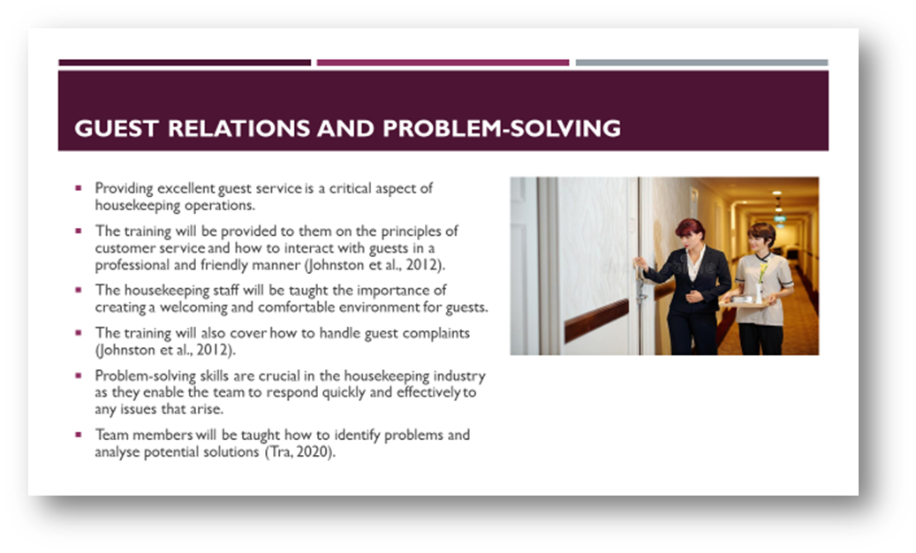

Guest Relations: Providing excellent guest service is a critical aspect of housekeeping operations, as it directly impacts the guest experience and overall satisfaction. To ensure that the housekeeping team delivers the best possible service to guests, training will be provided to them on the principles of customer service and how to interact with guests in a professional and friendly manner. During the training, the housekeeping staff will be taught the importance of creating a welcoming and comfortable environment for guests. They will learn how to anticipate guests’ needs, listen to their concerns, and provide prompt and effective solutions. The training will also cover how to handle guest complaints, such as addressing and resolving issues in a timely and professional manner (Johnston et al., 2012).
Problem-Solving: Problem-solving skills are crucial in the housekeeping industry as they enable the team to respond quickly and effectively to any issues that arise. During training, members will be taught how to identify problems and analyse potential solutions. They will also be equipped with the necessary tools and strategies to make informed decisions and find the best solution to a problem. Working under pressure is a common experience for housekeeping staff, especially during busy periods. The training will equip employees with techniques for staying calm and focused under pressure. This will include stress management techniques, mindfulness practices and effective time management strategies (Tra, 2020).

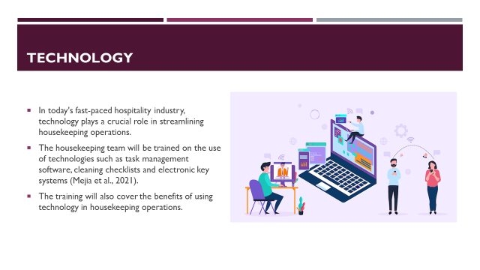

Technology: In today's fast-paced hospitality industry, technology plays a crucial role in streamlining housekeeping operations. The use of task management software, cleaning checklists and electronic key systems will help housekeeping teams to be more efficient and productive. Therefore, the housekeeping team will be trained on the use of these technologies. The training will cover how to use these technologies effectively, including how to access and use the software, how to input data accurately, and how to troubleshoot common problems. The training will also cover the benefits of using technology in housekeeping operations, such as improved efficiency, reduced human error and increased guest satisfaction (Mejia et al., 2021).

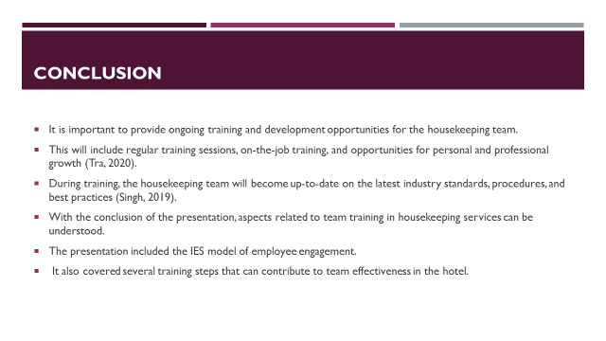

Finally, it is important to provide ongoing training and development opportunities for the housekeeping team. This will include regular training sessions, on-the-job training, and opportunities for personal and professional growth (Tra, 2020). By providing ongoing training and development opportunities, it can be ensured that the housekeeping team is up-to-date on the latest industry standards, procedures, and best practices (Singh, 2019).
With the conclusion of the presentation, aspects related to team training in housekeeping services can be understood. The presentation included the IES model of employee engagement. It also covered several training steps that can contribute to team effectiveness in the hotel.

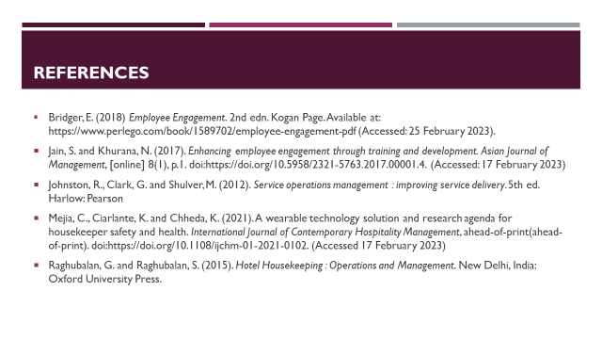

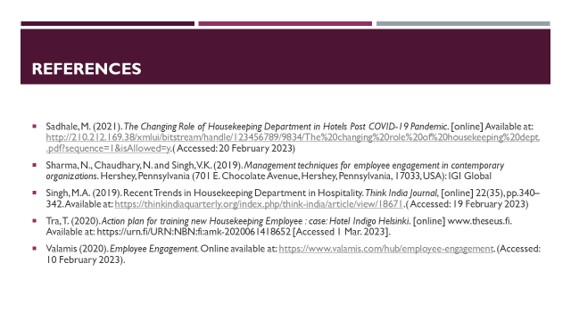

References
- Bakker, A.B. and Leiter, M.P. (2010) Work engagement a handbook of Essential Theory and Research. New York: Psychology Press.
- Bridger, E. (2018) Employee Engagement. 2nd edn. Kogan Page. Available at: https://www.perlego.com/book/1589702/employee-engagement-pdf (Accessed: 25 February 2023).
- Casado, M.A. (2012) Housekeeping management. Hoboken: Wiley.

- Cottrell, S. (2019). The Study Skills Handbook. 5th ed. London: Red Globe Press.
- Mullins, L & Dossor, P (2013), Hospitality Management and Organisational Behavior. 5th ed. Pearson, Harlow.
- Quick, L. (2020) Managing Events. 1st edn. SAGE Publications. Available at: https://www.perlego.com/book/3013639/managing-events-real-challenges-real-outcomes-pdf (Accessed: 15 February 2023).
- Raghubalan, G. and Raghubalan, S. (2015). Hotel Housekeeping : Operations and Management. New Delhi, India: Oxford University Press.
- Sharma, N., Chaudhary, N. and Singh, V.K. (2019). Management techniques for employee engagement in contemporary organizations. Hershey, Pennsylvania (701 E. Chocolate Avenue, Hershey, Pennsylvania, 17033, USA): IGI Global
- Hotel Owner (2023). About Us. Online available at: https://www.hotelowner.co.uk/. (Accessed: 9th February 2023).
- Vallen, G.K. and Vallen, J.J. (2018) Check-in check-out: Managing hotel operations. Boston: Pearson.
- Wood, R.C. (2013) Key concepts in hospitality management. London: SAGE.

