

The Impact of Integrated Marketing Communication on Consumer Behaviour: An Analysis of Adidas

Master of Business Administration Programme
Dissertation (LCMB7035)

Student Name: Md Faysal Mia
Student ID: 2434754
Supervisor : Tushara Balendran

Date of submission:17th July 2026
Table of Contents
1. Introduction 4
1.1 Rationale of the Study 4
1.2 Research Aim 5
1.3 Research Objectives 5
1.4 Research Questions 5
2. Literature Review 5
2.1 Integrated Marketing Communication 5
2.2 Consumer Attitude 6
2.3 Consumer Perceptions of Adidas’s Integrated Marketing Communications 6
2.4 Integrated Marketing Communication, Consumer Attitude and Purchase Intention 7
2.5 Integrated Marketing Communication and Brand Loyalty 7
2.6 Literature Gap and Shannon–Weaver Model 7
3. Methodology 9
3.1 Research Method 9
3.2 Research Onion 10
3.3 Type of Investigation: Primary Research 10
3.4 Methodological Choice 10
3.5 Time Horizon: Cross-Sectional 11
3.6 Data Collection and Analysis 11
Data Collection Method 11
3.7 Research Ethics and Data Protection 12
3.8 Resources and Planning 12
4. Conclusion 13
References: 14

1. Introduction
Integrated Marketing Communication (IMC) is a clustering of several tools to form an integrated message and communicate with consumers. Tools include: advertising, social media, sponsorship, public relations, sales promotion, influencer marketing, email communication and in-store promotion (Momen, Sultana and Haque, 2020). There are four stages to consumer behaviour: Recognition, Searching, Buying and Loyalty after buying. The factors influencing consumers' behaviour in the sportswear area are: product quality, fashion, lifestyle, sport identity, price, trust, celebrity endorsement, online reviews and social groups.
This study is appropriate for Adidas as it is a world-famous sports brand that is, at a global level, communicating to consumers via numerous methods. Adidas utilises enlisting, football sponsorship exercises, substance based promoting, product launches, eco-conscious messages, shopping displays and digital ads (Butkouskaya, Llonch-Andreu and Alarcón-del-Amo, 2024). But there is stiff competition for Adidas as well, and that certainly involves Nike, Puma and more. Adidas reports that it gets to consumers on a regular basis, so it's necessary to be systematic and effective at reaching out (Šerić and Vernuccio, 2020). This postulation is about how the attitude, intention to buy and loyalty of consumers are affected by Adidas' IMC strategies.

1.1 Rationale of the Study
The study is beneficial because Adidas is fighting in the saturated sportswear market, where consumers are unable to give much attention due to the heavy competition. In a technical sense, a sound IMC can result in the development of awareness, trust and relationship building with Adidas consumers (Pimentel, Gomes and Didonet, 2023). The research can give information about the reaction of consumers to the communication tools Adidas uses now and which tools can be developed. It also allows Adidas to learn how to communicate without issues, like ambiguously communicating, posting bad reviews online, taking in so much information that it confuses them, and being overwhelmed by competitors' voices. Adidas' results could guide their future designs when it comes to how applicable they would be to their campaign and how engagement might increase, as well as adding to the lift on purchase intent (Byon and Phua, 2021). The study is also of value to academic understanding due to the incorporation of a communication model between IMC and consumer behaviour.

1.2 Research Aim
This research aims to assess the relationship between consumers’ perceptions of Adidas’s integrated marketing communications and their attitude, purchase intention and brand loyalty among UK consumers.

1.3 Research Objectives
- To assess consumers’ perceptions of the consistency, credibility, relevance and interactivity of Adidas’s integrated marketing communications.
- To determine the relationship between consumers’ perceptions of Adidas’s integrated marketing communications and their attitude and purchase intention towards the brand.
- To evaluate the relationship between consumers’ perceptions of Adidas’s integrated marketing communications and their brand loyalty.

1.4 Research Questions
- How do consumers perceive the consistency, credibility, relevance and interactivity of Adidas’s integrated marketing communications?
- What relationship exists between consumers’ perceptions of Adidas’s integrated marketing communications and their attitude and purchase intention towards the brand?
- What relationship exists between consumers’ perceptions of Adidas’s integrated marketing communications and their brand loyalty?

2. Literature Review

2.1 Integrated Marketing Communication
Integrated marketing communication (IMC) has been described as a strategic coordination of promotional tools and channels that exhibits a persuasive, clear and consistent brand message. According to Rehman, Gulzar, and Aslam (2022), IMC is an audience-centred business process in which the interrelated and interdependent elements of stakeholders, content, channels, and measurable results are managed to support strategies that achieve business goals. In the same way, Lee (2021) consider IMC to be the coordinated performance of communication activities, which aims to achieve the consistency of consumer touchpoints. The first definition is based on strategic planning and accountability, while the second is based on consumers’ perceptions of message consistency (Zhou et al., 2026). For this study, IMC will refer to Adidas's advertising, social media, sponsorship, influencer communication, public relations, sales promotion, e-mail, and retail communication efforts coordinated to create a recognisable brand message.

2.2 Consumer Attitude
Consumer attitude is an overall evaluation that an individual makes of a product, brand or marketing stimulus. According to Lin, Xu and Tao (2020), attitude is a learned disposition to react favourably or unfavourably towards an object in a consistent manner. It is an enduring evaluation, a way of thinking and feeling and a behavioural intention according to Rai et al. (2021). According to these definitions, “attitude" contains not only the cognitive aspects, but also emotional aspects that can lead to action. In this research, a favourable or unfavourable attitude of the respondent towards Adidas after exposure to the integrated communications will be termed as ‘consumer attitude’ (Suay-Pérez et al., 2022). It will be analysed in conjunction with product purchase intention (whether consumers consider purchasing or actually purchase the Adidas product) and brand loyalty (whether they prefer the brand, recommend it or intend to repurchase the brand).

2.3 Consumer Perceptions of Adidas’s Integrated Marketing Communications
As listed in the literature, advertising, digital media, sponsorship, public relations, sales promotion, direct marketing, influencer endorsement and retail communication are all important instruments of IMC (McLean et al., 2020). At Adidas, product storytelling is integrated with athlete partnerships, creator partnerships, football partnerships, social media content, collaborations, product releases, in-store presentations and digital ad campaigns. Sponsorship is the connection between Adidas and teams, sports, athletes and sporting identities (Zhou et al., 2020). This mix also helps to facilitate global visibility, allowing campaigns to be tailored to each local market and interest, and also to support local culture. In literature, what is important is channel quantity as well as coordination of channel content, timing, tone and purpose (Mills et al., 2022). This means that one promotional strategy is not necessarily solely relied upon by the company Adidas. It's a multi-channel IMC system which includes paid, owned, earned and retail communication (Butkouskaya, Llonch-Andreu and Alarcón-del-Amo, 2021). The presence of multiple channels is not in itself an indication of integration, however. They will be effective if consumers see them as part of a brand, hear a consistent story, believe it's true and see it as relevant pieces of information at every touchpoint.

2.4 Integrated Marketing Communication, Consumer Attitude and Purchase Intention
Through IMC, it becomes possible to increase reach, enhance awareness, personalise messages, get consumers to participate, and establish relationships. What helps is consistent communication, since there are mutually reinforcing messages for consumers between the channels, which leads to improvement in trust and engagement (Šerić, Ozretić-Došen and Škare, 2020). Social media also makes it possible for feedback, user-generated content, comments and sharing. Sponsorships and endorsers could tie Adidas with sporting achievement and lifestyle communities, and co-ordinated sustainability communication could help set Adidas apart. However, there are also threats from IMC (Kim and Oh, 2020). There can be problems of information overload, contradictory messages, too much commercialisation and scepticism about claims about the environment. Negative reviews and criticism on social media platforms can quickly spread and mean that controversy surrounding endorsers can harm the meaning of the brand (Joo, Koo and Nichols, 2021). Competitors like Nike and Puma make noise with communication, and messages might be understood differently and differently in various cultures throughout the world. It thus seems that although IMC can provide relationship-building opportunities, it might be that inconsistencies, risk and competitors, as well as low consumer credibility, might affect consumer responses as well.

2.5 Integrated Marketing Communication and Brand Loyalty
Increased communication consistency and interaction have been related to positive customer-brand consequences in past studies. Frequent, at least coherent messages can increase brand awareness and decrease consumer uncertainty (Trivedi, 2020). While messages that are credible and relevant can enhance consumers' evaluations. A favourable attitude can in turn have an impact on purchase intentions as consumers are more likely to encounter a brand that they like and trust. Interactive campaigns can also induce feelings, suggestiveness and subsequent preference (Koronios et al., 2022). Communication, however, will not be the major factor in behaviour alone. Other factors that might influence decisions can include price, product quality, availability, prior information, peer pressure, and rivals' bids.

2.6 Literature Gap and Shannon–Weaver Model
There have been some studies on integrated marketing communication, social media, advertising, sponsorship, celebrity endorsement and consumer behaviour in various industries (Butkouskaya, Llonch-Andreu and Alarcón-del-Amo, 2020). Much of the research, however, focuses on a single one of these communication tools and not on how it might be viewed as part of an umbrella message from Adidas. Limited studies also reveal the way in which listening noise. Such as messages from competitors, negative online reviews, or internal communication noises (inconsistencies, crowded messages), affects how consumers interpret the message (Kunkel and Biscaia, 2020). Further, there is not enough brand-specific data that demonstrates the combined effect of Adidas' IMC on its attitude, purchase intention and brand loyalty. This study aims to fill this gap with primary quantitative research that will be conducted among 50 consumers of Adidas.
Model Explanation: It deals with sender, encoder, message, channel, noise, decoder, receiver and feedback in communication. For this research, Adidas will be the sender, and its marketing team will utilise news about its product, lifestyle, promotion and sustainability as messages (Khadija and Omar, 2023). Communication channels will be advertising, social and influencers and retail stores. These messages will be decoded by consumers, and their attitude, purchase intention, and loyalty will become behavioural feedback. Noise will be competitor advertising, negative reviews, cultural differences and inconsistent communication.
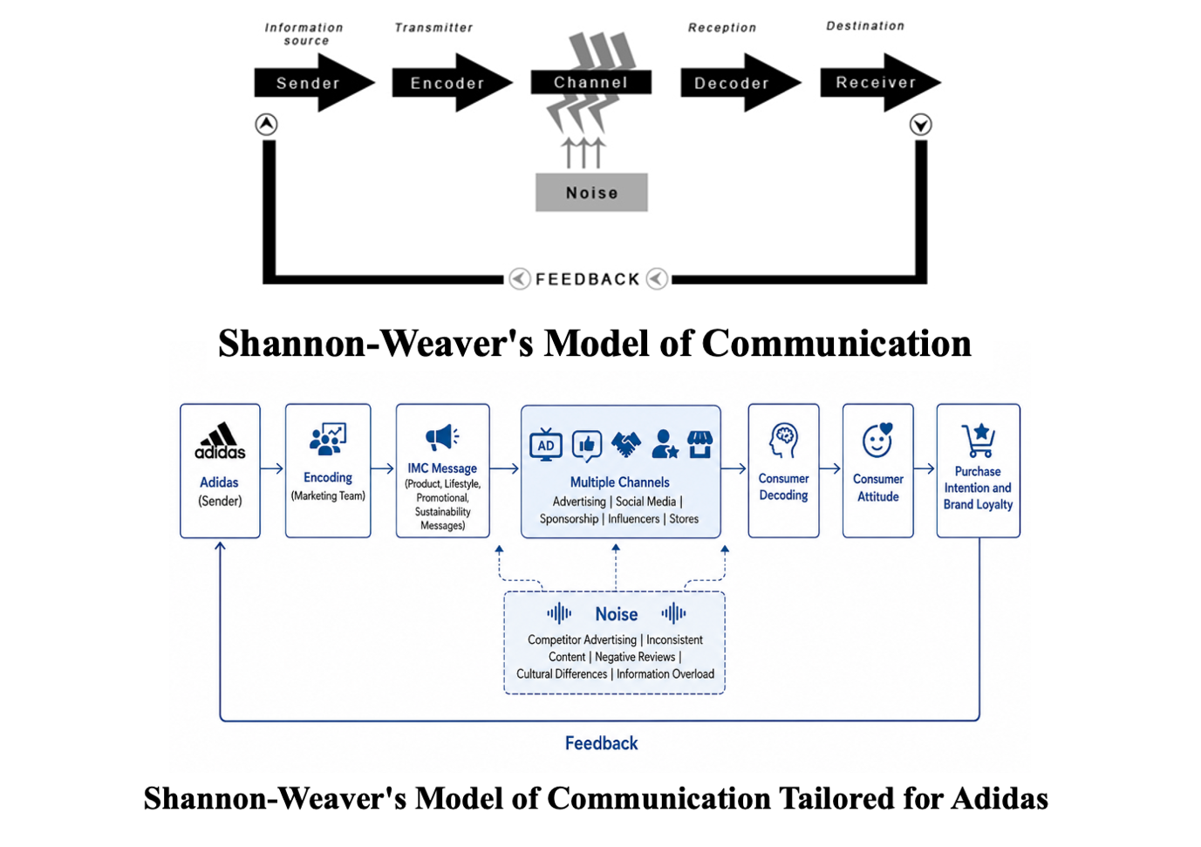
Advantages: the model enables a systematic analysis of the communication process, considering communication channels and communication distortion (Khadija and Omar, 2023). It will also emphasise the potential impact on the effectiveness of communication due to noise.
Disadvantages: The model is quite linear and tends to view consumers as recipients. It cannot adequately account for feelings and emotions, culture and the effect of social contacts or interactive communication with digital means (Khadija and Omar, 2023). However, feedback adaptation is beneficial for the current study.

3. Methodology

3.1 Research Method
The systematic framework that will be the basis of the study to investigate the effect of Adidas' integrated marketing communication on attitude, purchase intention and brand loyalty of consumers is the research methodology (Saunders, Lewis and Thornhill, 2023). The methodology will be based on Saunders, Lewis and Thornhill's Research Onion, which is from philosophy and approach all the way to strategy, methodological choice, time horizon, sampling, data collection, analysis and ethics.
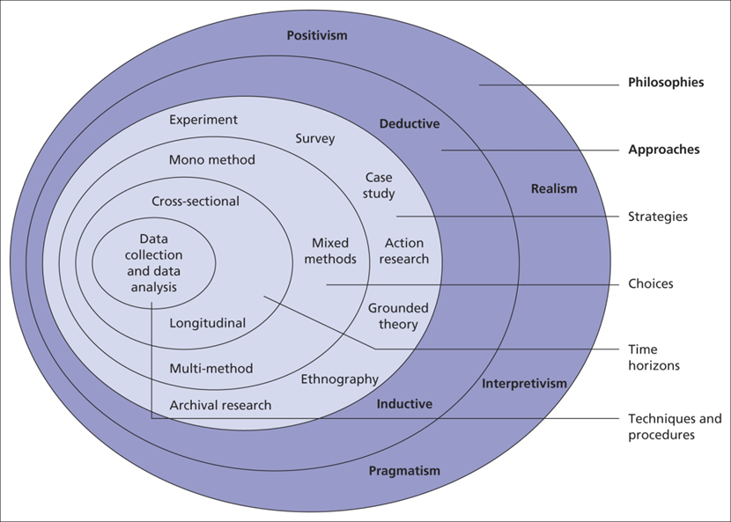
Figure 1: Research Onion Model
Source: (Saunders, Lewis and Thornhill, 2023)

3.2 Research Onion
Research Philosophy: Positivism
Positivism will be adopted because it is observable and measurable. The proposed relationships will be treated in this study. The use of standardised questions and numerical responses will minimise the subjectivity of the researcher (Saunders, Lewis and Thornhill, 2023).
Research Approach: Deductive
A deductive approach is being opted for since the study will start with the theory of IMC and consumer behaviour and test them with the primary data collected (Lock and Seele, 2015). The research will assess whether positive perceptions of Adidas’s integrated marketing communications are associated with consumer attitude, purchase intention and brand loyalty.
Research Strategy: Online Survey
The research technique will be an online survey. By doing this, the same question can be given out efficiently to a relatively available sample of Adidas customers, and it would help us to compare numbers between respondents (Saunders, Lewis and Thornhill, 2019).

3.3 Type of Investigation: Primary Research
The investigation will make use of primary research, in which new data will be gathered from the participants (Saunders, Lewis and Thornhill, 2019). Secondary literature will be applied only in the theoretical background, design and interpretation of the results of the questionnaire.

3.4 Methodological Choice
Qualitative: Qualitative research explores meanings and experiences through non-numerical evidence (Saunders, Lewis and Thornhill, 2019).
Quantitative: Quantitative research measures variables numerically and examines patterns or relationships statistically (Saunders, Lewis and Thornhill, 2019).
The type of research to be used is quantitative as the consumer perceptions will be measured with the aid of standardised items and descriptive statistics will be used to analyse the responses (Lock and Seele, 2015). The research will thus be mono-method quantitative - with only one structured questionnaire to produce the empirical data.

3.5 Time Horizon: Cross-Sectional
The study will adopt a cross-sectional time horizon. All data will be collected from respondents during the research period (Lock and Seele, 2015). This design helps to get UK consumers’ perceptions of Adidas’s integrated marketing communications and their attitudes, purchase intentions and loyalty towards the brand.

3.6 Data Collection and Analysis
Population and Sample Size
The target population will consist of UK residents aged 18 or above who are familiar with Adidas and have seen, considered or purchased its products (Lock and Seele, 2015). There will be 50 consumer respondents living in the UK selected for the sample. Age group, gender, area of residence, occupation, as well as previous purchase experience of Adidas will all be relevant demographic and geographic characteristics.
Sampling Method
Non-probability convenience sampling method will be adopted. In non-probability sampling, all the members of the population may not have an equal opportunity of being selected, and convenience sampling consists of selecting those who are readily available to participate (Saunders, Lewis and Thornhill, 2023). This approach will work given the time and resource constraints for the project. It might, however, lead to selection bias and limit generalisability of results beyond the sample.

Data Collection Method
Microsoft Forms will be used for data collection. The questionnaire will include 8-10 closed questions and a demographic section. The primary items will examine IMC consistency, credibility, relevance, interactivity, consumer attitude, purchase intention, and brand loyalty (Aguinis, Bergh and Molina-Azorin, 2022). A five-point scale, from strongly disagree to strongly agree, will be used. The questionnaire is expected to take approximately 10 minutes to complete.
Analysis of Data
The coding, cleaning and analysis of the data will be conducted using Microsoft Excel. Demographic data and distributions will be summarised by using frequencies and percentages (Aguinis, Bergh and Molina-Azorin, 2022). Mean scores will be used to compare the primary variables, and results will be clearly presented in tables, bar charts and pie charts. Relationships can be explored using simple correlation analysis, and causal statements will not be made.

3.7 Research Ethics and Data Protection
Ethics of research relate to the protection of the participants' rights, dignity and information. Respondents will be informed about the nature of the participation, asked if they wish to take part, and have the right to withdraw prior to the instruments being submitted. Unnecessary identifiers and names will not be gathered (Lock and Seele, 2015). Data will be kept confidential and only used for academic purposes. The study will adhere to the Data Protection Act 2018 and the Principles of Lawfulness, transparency, purpose limitation, data minimisation, storage limitation and security of the UK GDPR. Data will be archived after the duration of the retention period as required by the institution.

3.8 Resources and Planning
Planning, data collection, analysis, writing, revising and submission will be conducted using a 16-week Gantt chart. It is a schedule designed to provide for timely completion and coordinated management of all research activities (Lock and Seele, 2015).
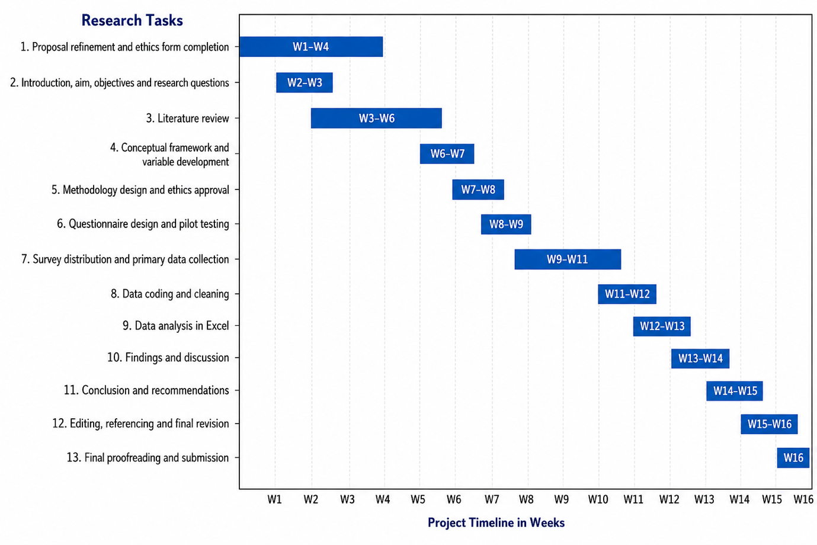
Figure 2: Gantt Chart Source: Author

4. Conclusion
The investigation of this proposal will focus on consumer attitudes, purchase intentions, and brand loyalty towards Adidas’s integrated marketing communication. Based on the research goals as well as the Shannon–Weaver model. The study will look into the consistency, credibility, relevance and interactivity of Adidas’s communication messages (Pourazad, Stocchi and Pare, 2020). A primary mono-method design with a quantitative approach will be adopted, using convenience sampling to obtain a sample of 50 respondents via an online survey. The results will offer a pragmatic perspective for Adidas and advance the understanding of the effectiveness of IMC in a fiercely competitive sportswear market and digital age.

References:
Aguinis, H., Bergh, D. and Molina-Azorin, J.F. (2022) ‘Methodological challenges and insights for future international business research’, Journal of International Business Studies [Preprint]. Available at: https://doi.org/10.1057/s41267-022-00578-8.
Butkouskaya, V., Llonch-Andreu, J. and Alarcón-del-Amo, M.-C. (2024) ‘Market orientation, integrated marketing communications, and small and medium-sized enterprises (SMEs) performance: A comparison between developed and developing economies’, European Research on Management and Business Economics, 30(3), p. 100260. Available at: https://doi.org/10.1016/j.iedeen.2024.100260.
Butkouskaya, V., Llonch-Andreu, J. and Alarcón-del-Amo, M.C. (2020) “Entrepreneurial Orientation (EO), Integrated Marketing Communications (IMC), and Performance in Small and Medium-Sized Enterprises (SMEs): Gender Gap and Inter-Country Context,” Sustainability, 12(17), p. 7159. Available at: https://doi.org/10.3390/su12177159.
Butkouskaya, V., Llonch-Andreu, J. and Alarcón-del-Amo, M.C. (2021) “Inter-Country Customer-Perspective Analysis of Strategic Antecedents and Consequences for Post-Purchase Behaviour in Integrated Marketing Communications (IMC),” Journal of International Consumer Marketing, 33(1), pp. 1–16. Available at: https://doi.org/10.1080/08961530.2020.1731901.
Byon, K.K. and Phua, J. (2021) ‘Digital and Interactive Marketing Communications in Sports’, Journal of Interactive Advertising, 21(2), pp. 75–78. Available at: https://doi.org/10.1080/15252019.2021.1970422.
Joo, S., Koo, J. and Nichols, B.S. (2021) “Understanding consumer attitudes in cause-brand alliances in sports: The role of sport entity attitudes,” International Journal of Sports Marketing and Sponsorship, 22(3). Available at: https://doi.org/10.1108/ijsms-12-2019-0142.
Khadija, E. and Omar, T. (2023) ‘Literature review on knowledge transfer models: From Shannon- Weaver (1949) to Kostova (1999)’, African Scientific Journal, 3(21), pp. 548–548. Available at: https://doi.org/10.5281/zenodo.10434490.
Kim, Y. and Oh, K.W. (2020) “Effects of Perceived Sustainability Level of Sportswear Product on Purchase Intention: Exploring the Roles of Perceived Skepticism and Perceived Brand Reputation,” Sustainability, 12(20), p. 8650. Available at: https://doi.org/10.3390/su12208650.
Koronios, K., Ntasis, L., Dimitropoulos, P. and Ratten, V. (2022) “Not just intentions: Predicting actual purchase behavior in sport sponsorship context,” Sport, Business and Management: An International Journal, 12(1). Available at: https://doi.org/10.1108/sbm-03-2021-0034.
Kunkel, T. and Biscaia, R. (2020) “Sport Brands: Brand Relationships and Consumer Behavior,” Sport Marketing Quarterly, 29(1), pp. 3–17. Available at: https://doi.org/10.32731/smq.291.032020.01.
Lee, J.K. (2021) “The effects of team identification on consumer purchase intention in sports influencer marketing: The mediation effect of ad content value moderated by sports influencer credibility,” Cogent Business & Management. Edited by O. Adeola, 8(1), p. 1957073. Available at: https://doi.org/10.1080/23311975.2021.1957073.
Lin, L., Xu, Y. and Tao, Q. (2020) “Motivational drivers of Chinese consumers’ brand avoidance behaviours: A perspective of sportswear,” International Journal of Fashion Design, Technology and Education, 13(1), pp. 45–57. Available at: https://doi.org/10.1080/17543266.2020.1719435.
Lock, I. and Seele, P. (2015) ‘Quantitative content analysis as a method for business ethics research’, Business Ethics: A European Review, 24(51), pp. S24–S40. Available at: https://doi.org/10.1111/beer.12095.
McLean, G., Osei-Frimpong, K., Al-Nabhani, K. and Marriott, H. (2020) “Examining consumer attitudes towards retailers’ m-commerce mobile applications – An initial adoption vs. continuous use perspective,” Journal of Business Research, 106, pp. 139–157. Available at: https://doi.org/10.1016/j.jbusres.2019.08.032.
Mills, M., Oghazi, P., Hultman, M. and Theotokis, A. (2022) “The impact of brand communities on public and private brand loyalty: A field study in professional sports,” Journal of Business Research, 144, pp. 1077–1086. Available at: https://doi.org/10.1016/j.jbusres.2022.02.056.
Momen, Md.A., Sultana, S. and Haque, A.K.M.A. (2020) ‘Web-based marketing communication to develop brand image and brand equity of higher educational institutions’, Global Knowledge, Memory and Communication, 69(3), pp. 151–169. Available at: https://doi.org/10.1108/gkmc-10-2018-0088.
Pimentel, P.C., Gomes, P.M.L. and Didonet, S.R. (2023) ‘Dealing with Integrated Marketing Communications’ Paradoxes in Social Ventures’, Journal of Nonprofit & Public Sector Marketing, 35(4), pp. 1–37. Available at: https://doi.org/10.1080/10495142.2021.1954130.
Pourazad, N., Stocchi, L. and Pare, V. (2020) “The Power of Brand Passion in Sports Apparel Brands,” Journal of Product & Brand Management, 29(5), pp. 547–568. Available at: https://doi.org/10.1108/jpbm-12-2018-2164.
Rai, J.S., Yousaf, A., Itani, M.N. and Singh, A. (2021) “Sports celebrity personality and purchase intention: The role of endorser-brand congruence, brand credibility and brand image transfer,” Sport, Business and Management: An International Journal, 11(3). Available at: https://doi.org/10.1108/sbm-06-2020-0062.
Rehman, S., Gulzar, R. and Aslam, W. (2022) “Developing the Integrated Marketing Communication (IMC) through Social Media (SM): The Modern Marketing Communication Approach,” SAGE Open, 12(2), pp. 1–23. Available at: https://doi.org/https://doi.org/10.1177/21582440221099936.
Saunders, M.N.K., Lewis, P. & Thornhill, A. (2023) Research Methods for Business Students (9th ed.). Pearson.
Šerić, M. and Vernuccio, M. (2020) ‘The impact of IMC consistency and interactivity on city reputation and consumer brand engagement: the moderating effects of gender’, Current Issues in Tourism, 23(17), pp. 2127–2145. Available at: https://doi.org/10.1080/13683500.2019.1637403.
Šerić, M., Ozretić-Došen, Đ. and Škare, V. (2020) ‘How can perceived consistency in marketing communications influence customer–brand relationship outcomes?’, European Management Journal, 38(2), pp. 335–343. Available at: https://doi.org/10.1016/j.emj.2019.08.011.
Suay-Pérez, F., Penagos-Londoño, G.I., Porcu, L. and Ruiz-Moreno, F. (2022) “Customer perceived integrated marketing communications: A segmentation of the soda market,” Journal of Marketing Communications, 28(4), pp. 1–17. Available at: https://doi.org/10.1080/13527266.2021.1915853.
Trivedi, J. (2020) “Effect of corporate image of the sponsor on brand love and purchase intentions: The moderating role of sports involvement,” Journal of Global Scholars of Marketing Science, 30(2), pp. 188–209. Available at: https://doi.org/10.1080/21639159.2020.1717978.
Zhou, F., Mou, J., Su, Q. and Jim Wu, Y.C. (2020) “How does consumers’ Perception of Sports Stars’ Personal Brand Promote Consumers’ brand love? A mediation model of global brand equity,” Journal of Retailing and Consumer Services, 54, p. 102012. Available at: https://doi.org/10.1016/j.jretconser.2019.102012.
Zhou, Z., Aisihaer, N., Wu, J. and Zhang, S. (2026) “When brand meets sport: A study of the interactive effects of brand perception and sport type on brand attitude,” International Journal of Sports Marketing and Sponsorship, 27(1), pp. 199–217. Available at: https://doi.org/10.1108/ijsms-03-2025-0107.

