

LEVEL 4

SEMESTER 2

MODULE CODE: SHSS4078
Adventure: A Risk worth Taking

aSSESSMENT TYPE: aSSIGNMENT
Assessment/Component: 1 (Part A)
COMPONENT WEIGHTING: 55 %
WORD COUNT: 2000 WORDS
MODULE TUTOR: Denise leonard

Assignment:

With reference to a critical incident case study that we have examined, identify one key contributing hazard. Evaluate your own personal logged experiences in different activities, of risk management in relation to this identified hazard.

You should include a logbook recording every activity session you complete during this module and a synopsis of the critical incident case study as appendices to this submission.

SUBMISSION DETAILS:

Deadline:
Date: 19th April 2019
Time: 3.00pm
Portal: Turnitin

School of Sport, Health & Outdoor Education

Assessment Feedback Sheet

Student No./Name:
Module: SHSS4078
Module Code: Adventure: A Risk Worth Taking

Personal Evaluation – to support your academic progress please complete the section below BEFORE submitting your work.
What do you consider to be the best aspects of this work? |  |  | My writing
Which aspects do you consider could have been improved in this piece of work? |  |  | My Research
What have you found most satisfying whilst undertaking this submission? |  |  | Learning about instructing
ASSESSMENT CRITERIA | Learning  Outcomes |  | GRADE
ASSESSMENT CRITERIA |  |  | Poor  0 – 25% | Unsatisfactory  26-39% |  | Satisfactory  40 – 49% | Good  50 – 59% | Very Good  60 – 69% | Excellent  70 – 85% |  | Exceptional  86– 100% | %
Complete logbook for each session | All |  |  |  |  |  |  |  |  |  |  | 15%
Provide a synopsis of a critical incident case study | All |  |  |  |  |  |  |  |  |  |  | 15%
Identify a specific significant hazard and the risk it poses to undertaking adventurous outdoor activities | 1,2,3,5 |  |  |  |  |  |  |  |  |  |  | 30%
Discuss a range of appropriate measures that might effectively control the identified hazard and consequent risks. | 1,2,3,5 |  |  |  |  |  |  |  |  |  |  | 30%
Appropriate references used and correctly formatted | All |  |  |  |  |  |  |  |  |  |  | 10%
It is expected that students will present work that is proof read, correctly referenced and adheres to the Assessment Checklist. Therefore a range of 0 – 10 marks will be deducted for non-completion of any of the points on the checklist below.
TUTOR COMMENTS:

Submission date:  via Turnitin |  | Return date:  (at least within 4 weeks) |  |  | Tutor: Denise Leonard |  |  |  |  | Mark:

Assignment Checklist

- Please complete the Personal Evaluation section of the Assessment Feedback sheet, add your name and details, and paste the whole of this assignment document into the front of your assignment

- Submission is a single word file, clearly labelled with your name and module code
- Font style - Times New Roman, size -12 for text and 14 for headings
- Ink colour – black only
- Line spacing – 1.5 line spacing and 2cm- 2.5cm page margins
- Quotations more than three lines to be indented 1 line spacing
- One line space between paragraphs, paragraphs must be left aligned
- Pagination (your assignment should have page numbers)
- All tables and figures are internally referenced and have a title
- Word count checked and written at end of text (before references and any appendix)
- Assignment is within 10% of the word limit (excluding references and any appendices)
- All references in the text are included in the reference list
- Correct referencing following the Harvard style, as described in the Palgrave study skills book ‘Cite them Right’.
- Correct spelling using UK English
- Correct use of punctuation
- Grammar and syntax correct- double check anything that has a green line under it
- I have read my assignment out loud to myself and it makes sense and is easy to read
- Somebody else has read my work and it makes sense to him or her!
- I have checked and I have not plagiarised
Failure to follow these guidelines will cost you marks!
Appendix 1- Critical Incident Case Study
March 1993, four school children passed away due to what is known as the Lyme Bay kayaking tragedy. The deaths were preventable, inexperienced leaders, weather, safety protocols were some of the leading causes as why it all happened. Anthony Mann held a one star British canoeing qualification, he was identified as the senior level instructor that day due to his confidence. Junior instructor Karen Gardiner held a one star British canoeing qualification, her water abilities were better than Anthony’s but she has much less confidence. Both instructors had responsibility for taking a group of eight students ages sixteen and seventeen along with a teacher. Kayaking from Lyme bay to Charmouth, on what seemed like nice weather with northerly winds. The instructors and teachers kayaks were a lot more unstable than the students which caused some of the beginning issues of the venue. On the water the condition become rougher and wind changed direction and picked up, this was all forecasted in the weather. Predictably teacher fell in from the word go which lead Anthony to stay with him and help him out. The rest of the group with Karan were separated from the others, so she decided to tie all the kayaks together. The kayaks started floating and sinking because they were not equipped with any bouncy blocks. This left students in the water, wet suits were worn but life jackets were not functional as they weren't blown up ready. Even though the instructors had buoyancy aids, spray decks, whistles and cagoules. The instructors already stood a better chance than the students. With students in the water, Karen had no way of contacting help. Since there were no emergency procedures set up at the centre, the group spent four hours in the water before rescue. At 1pm the group failed to reach Charmouth to the manager of the centre took a boat out to the bay but found no trace of them. Hours later one of the canoes were picked up by a fisherman and was reported to the centre who then realised something bad happened so the help was called. Lifeboats were sent out looking for the party. They found all remaining canoes at 4:10pm and at 4:55pm eight people were saved from the water. 5pm two others washed up on shore taken to hospital. Then the coast guard was informed there was still one person missing. 6:10pm last victim found. The long exposure to the water killed four students. This incident was rather predictable because six months before Joy Cawthorne had warned her employers of the practice standards. The Lyme bay incident lead to corporate manslaughter, centre fined sixty thousand pounds and the introduction of licensing of outdoor adventure centres (AALA). Lyme Bay was a preventable tragedy that has shaped the outdoor world for generations to come.
Appendix 2- Rock Climbing
Before  Activity | Generic Risk Assessment | 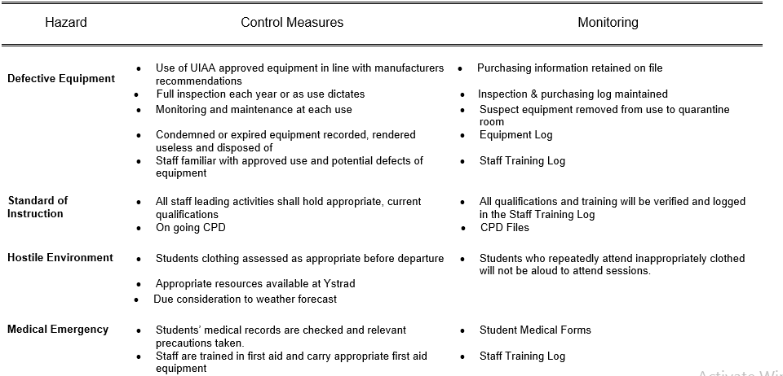  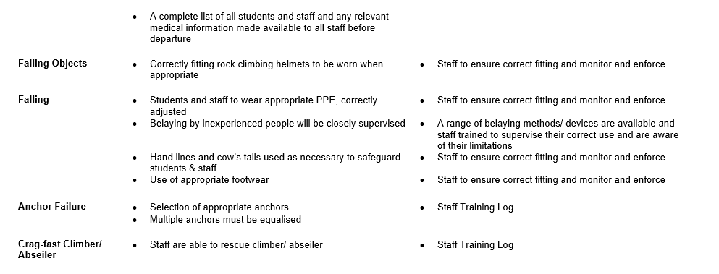
 | Cite Specific Risk Assessment | - Water: Tidal change, looked up high and low tide  - Low- 00:31 = 4.7m  - High- 06:45 = 11.9m  - Low- 12:51 = 4.5m  - High- 19:02 = 11.8m  - Daylight  - Rise- 7:57  - Set- 17:08  - Pathway: 1 mile walk through woodland and dunes  - Appropriate footwear  - Check students shoes  - Driving: Cynefin to Three Cliffs Bay  - Licence required  - Drive responsibly  - Weather: 7 Degrees, chance of rain, 21 mph North wind  - Appropriate clothing  - Check groups gear  - Loose rock  - Helmets fit properly  - Wear helmets under cliff  - Barnacles  - Appropriate footwear  - Take care around them  - Rock pools  - Avoid falling in
 | Relevant Legislation | - British Climbing Association
 | NGB Awards and Remits | - Rock Climbing Instructor (RCI)  - Allows instructor a group top roping, single pitch venues.  - If the venue contained high altitude climbing, multi pitch, lead or trad then  - Mountain Instructor Award would be required
 | Keywords/Terms | - UIAA- International Climbing and Mountaineering Federation  - Half Hitch- Simple overhand Knot  - Belay- Climbing technique used to exert tension on rope, so the climber does not fall far  - Lock-off- Securing the belay device and rope  - ‘Static’ Rigging Rope- Rope used to equalize gear, does not stretch  - Dynamic Single Rope- Climbers main rope that will stretch under pressure  - Single Pitch Venue- There is only one lower off, for the one climb  - Grade- Difficulty of the climb  - Jurassic Limestone- Prehistoric Limestone, containing fossils  - Carboniferous Limestone- Collective term for successions of limestone, the different layers of rock  - Tidal Range- Height difference between low and high  - Rule of the 12ths- Rule of thumb for estimating tidal height  - Three Cliffs Bays- Bay on the South Coast of Gower Peninsula  - Barnacle- Type of Arthropod, sharp and grippy on the side of rocks  - Samphire- White succulent flowers that grow on coastline, edible as well
 | Activity Specific Skills | - Tie in  - Belay  - Outdoor Rock Climbing  - Rope work
 | Issues relating to access and conservation/ environmental sustainability | - Do not damage rock  - Use gear that preserve the rock  - Leave no trace  - Take garbage out  - Leave rocks and plants alone
 | Potential Benefits | - Risk Management  - Assessing situation  - Tidal skills  - Rock climbing skills  - Mental development
 | Health and Safety History of the site/activity | - Lifeguards patrol bay  - Took three drownings
During  Activity | Inspect Kit | - Kit was checked for ware and tare, made sure everything was in working order.  - Made sure everything fit properly  - Got personal kit checked out
 | Events and relevant observations | - We walked single file line on road  - Let group walk to cite alone  - Deep rock pools  - Slippery rocks  - Loose rock  - Barnacles on rocks  - Felt scary scrambling without a belay
 | Dynamic risk assessments/ considerations | - Parked with door facing away from road  - Briefed group on additional emergency exit points  - Assessed the tide levels  - Compared river and tide to last visit  - Discussed planning escape early  - Tried to predict oceans pattern  - Monitored group facticity when setting up crag, kept group active  - On top of Crag Tom kept group safe and away from edges
 | Reflection on own and others preparations | - Should learn to observe and predict tidal patterns  - Do some pre research on the cite  - History  - Nature  - Safety  - Don't play around with rock protection  - Good thing I brought personal Trad key
After  Sessions | Near misses or accidents | - Group walked on the golf zone for a few minutes  - Could have gotten struck by golf ball
 | Review the risk assessments, do they need updating? | - N/A
 | Outline specific learning | - Group Management  - Risk Management  - Outdoor Rock Climbing  - Tidal venue

Appendix 3- Mountain Biking
Before  Activity | Generic Risk Assessment | 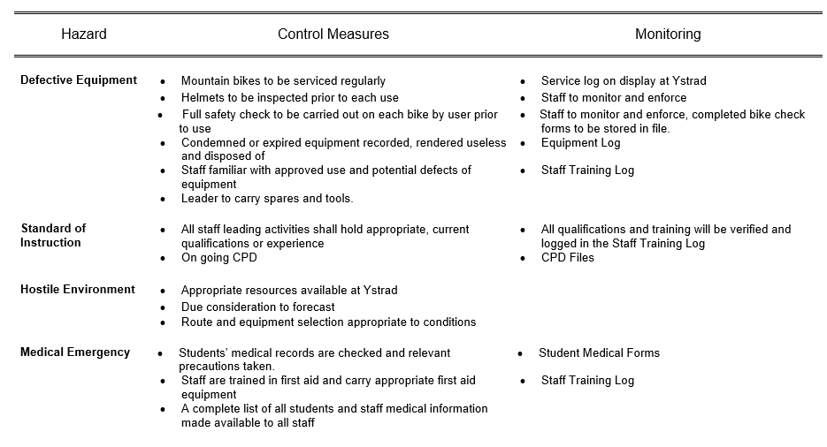  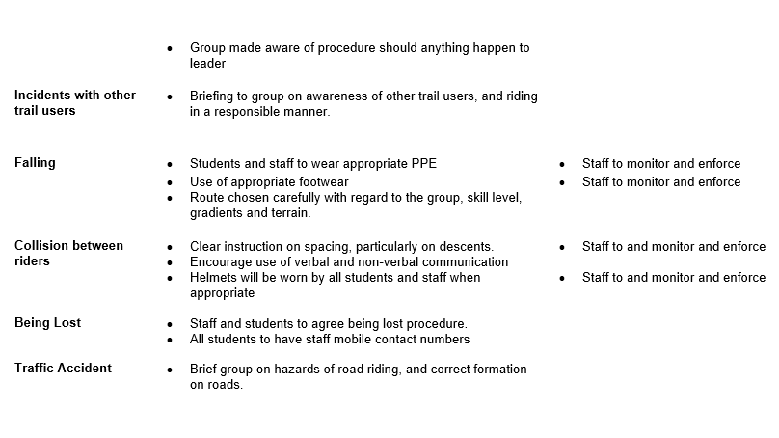
 | Cite Specific Risk Assessment | - Emergency routes  - Gate is locked off so ambulance or van cannot get on fire roads  - Cell service  - Weak, seek elevation  - Driving  - Licence  - Monitor driving  - Trailer  - Check for lights  - Make sure bikes are fastened  - Forrest  - Sheltered  - Weather  - 16C--- 8mph== 10C  - Appropriate clothing  - Monitor participants
 | NGB Awards and Remits | - Mountain Bike Leader level 2  - Instruct groups on technical terrain  - DH or XC  - Level 3  - Mountainous terrain  - Red and Black trails
 | Keywords/Terms | - NRW- National Resource Wales, looks after parks.  - Table Top- A jump that has dirt in the middle so it can be ‘hit’ with any speed or skill level.  - Crank- Metal connecting pedals to frame, be careful when pedalling not to hit them against the ground.  - Attack Position- Also called monkey position, the proper form of riding for anything steep or technical.  - Drop Off- An edge of any kind that drops off on a side, supposed to rid of and land.  - Brechfa Forest- Forest and hills in carmarthenshire.  - Ash Dieback- Chronic Fungal disease of ash trees, causes them to die.  - Rose Bay Willow Herb- Chamaenerion plant, Fireweed, purple plant.  - Fire Track- Wide path, intended for a car, usually a bit of gravel and rocks.  - Grade- Trail difficulty level, green to black.  - Berm- Dirt turn, approach in high come out low.  - BBWLA- British Mountain Biking Leadership awards, aimed to certify instructors.  - MIAS- Mountain Biking instructor award scheme, certify instructors.  - PMBI- Professional Mountain Biking Instructors, Certify instructors  - Cycling UK- Cycling touring
 | Activity Specific Skills | - Basic Bike skills  - Standing on pedals  - Pedalling sitting down  - Turning  - Going over bumps  - Changing gears
 | Issues relating to access and conservation/ environmental sustainability | - Leave no trace  - Take trash out
 | Potential Benefits | - Fitness  - Hand eye coordination  - Fulfilment  - Happiness  - Self-achieving  - New goals  - New skills
During  Activity | Inspect Kit | - M-Check  - Inspected the bikes for any mechanical errors  - Did not check helmets…  - Made sure they fit
 | Events and relevant observations | - Should instructors have more personal protection then participants?  - Keep instructing simple  - Explain in layman's terms  - Last keywords are most important
 | Dynamic risk assessments/ considerations | - High Injury sections  - Warned group  - Informed group  - Have someone standing nearby for helping
 | Reflection on own and others preparations | - When instructing stay simple
After  Sessions | Near misses or accidents | - One participant didn't feel good  - Sent them and another to rest in a shelter until groups finished activity
 | Review the risk assessments, do they updating? | N/A
 | Outline specific learning | - Group Management  - Risk Management  - Self Management

Appendix 4- Paddle Sports Day 1
Before  Activity | Generic Risk Assessment | 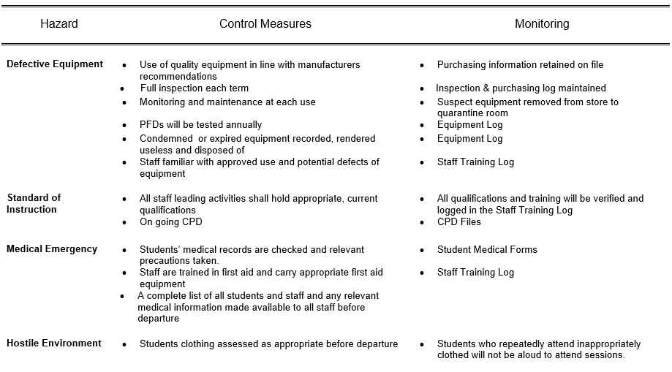  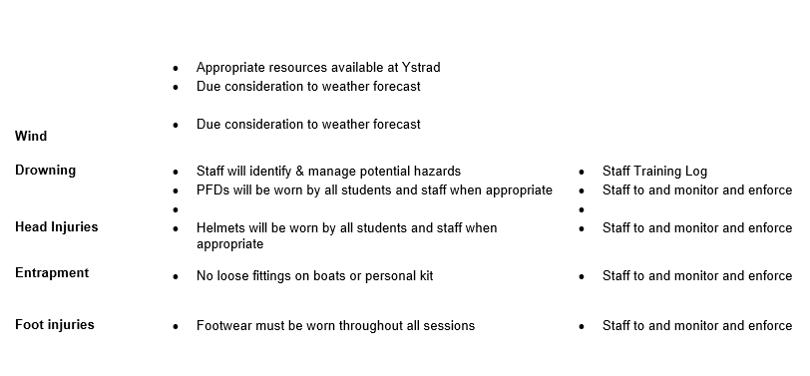
 | Cite Specific Risk Assessment | - Driving  - Licence  - Monitor driving  - Weather  - 10C  - 80% rain
 | NGB Awards and Remits | - Coaching Award- Allows coach to take group onto flowing water  - Specific Leadership award- allowing instructor to take group into Tifi river  - Proficiency awards in craft teaching  - Advance level kayaking would allow instructor to teach in what we did
 | Keywords/Terms | - Kayak- Sit in floating craft, sit on top or closed  - Silurian mudstone- Prehistoric Mudstone, makes up parts of the river bank  - Eddy- Swirling body of water opposite to the current, use them to take a break in the river  - Edge- The border between the mainstream of the river and the eddy, water rushes downward in these spots, making lines in the river  - Breaking in and out- Traveling along the river using the mainstream and side eddies to help break the river up  - CLAP- Acronym to help instructors control the group. Communicate, Line of sight, Avoidance, Position of most usefulness  - Afon Teifi- River in wales, used for recreational practices  - Grade- Classification of rapids in a river, easy and safe to hard and dangerous  - Flow rate- How fast the water is flowing  - Slalom- Poles used for racing down the river, they are hard so be careful when going near them  - Catchment area- Area where rainfall flows into river  - Sewin- Anadromous brown trout, natural fish in river  - Salmon- Ray finned trout, natural fish in river  - Japanese Knotweed- Weed that grows on river banks, invasive species that kills of everything else natural, kills the river banks  - Appropriate Footwear- Protective shoes that will defend against anything in the river
 | Activity Specific Skills | - Basic motor skills  - Balancing skills  - Paddling skills  - Water skills
 | Issues relating to access and conservation/ environmental sustainability
 | Potential Benefits | - Learn about entrapment  - Personal cognitive skills  - Paddling skills
During  Activity | Inspect Kit | - Inspected all personal protective kit  - Made sure it was appropriate  - Working  - Fit  - Inspected personal craft  - Fit for water  - Flotation device was good to go
 | Events and relevant observations | - Spent a lot of time talking about hazards on crafts  - Looking at specific water crafts  - Pointed out all entrapment hazards  - Identified possible action to prevent  - Pointed out other craft hazards  - Potential danger to other in water
 | Dynamic risk assessments/ considerations | - Instructor  - Kept group together  - Monitored temperature  - Cold participants  - Allowed to leave early to change and get warm
 | Reflection on own and others preparations | - Bring snacks next time
After  Sessions | Near misses or accidents | - Cold participant  - Sent to change and get warm  - Handled well
 | Review the risk assessments, do they updating? | N/A
 | Outline specific learning | - Entrapment Hazards  - Other water hazards  - Risk Management

Appendix 5- Hill Walking
Before  Activity | Generic Risk Assessment | 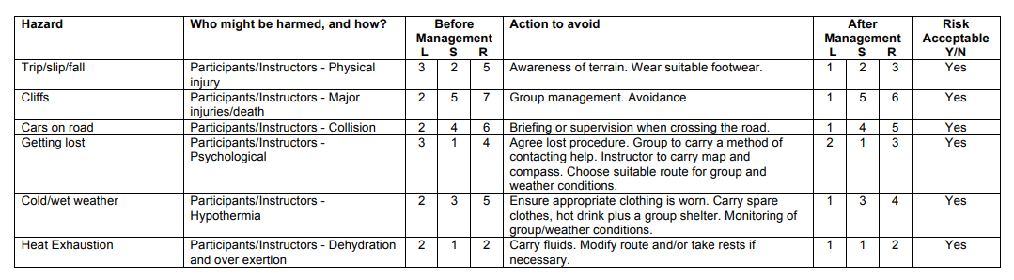  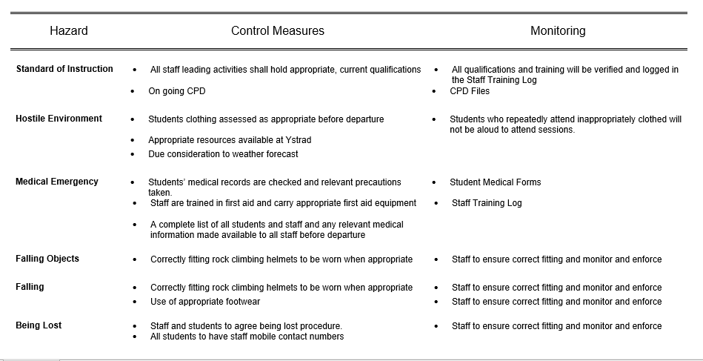
 | Cite Specific Risk Assessment | - Driving  - Licence  - Monitor driving  - Weather  - 8C---12 mph== 4C  - 20% rain  - Appropriate clothing  - Quarry edges  - 100 ft+ cliffs  - Steer group away from edges  - Caves  - Unstable  - Keep groups out
 | NGB Awards and Remits | - Hill and Moorland Leader  - Instruct groups on hilly and rough terrain, no high altitude  - Mountain Leader  - Instruct groups in high altitude extreme environments  - Better qualification for all round instructor
 | Keywords/Terms | - Cold Front- Leading edge of a cooler mass of air.  - Temperature Inversion- When the hot air gets stuck in the middle of two cold fronts above and below.  - Lowland Leader- Qualification to lead a group in country sides and sea side, summer conditions.  - Ordnance Survey- People who map all of the UK.  - Contour Line- Measurement of elevation, each line is 10m.  - Ring Contour- Shows elevation, peak and holes.  - Trig Point- What the ordnance survey use to map the UK.  - Naismith's Rule- Every 10 m of elevation will take an extra minute.  - Grid Lines- Map north lines.  - Moel (Welsh)- Empty Hill, hard to navigate.  - Hill Fog- Fog that rolls over the hills.  - Freezing Level- The level which water freezes.  - Aspect of Slope- Compass direction the hill faces, use it to find yourself on map.  - Mountain Rescue- People whose job is too help in an emergency.  - Wind Chill- The temperature from the wind making it feel colder than it actually is.
 | Activity Specific Skills | - Walking  - Navigating  - Self-monitoring
 | Potential Benefits | - Navigational skills  - Self-monitoring skills  - Walking skills  - Self-Management
During  Activity | Inspect Kit | - Personal kit, good to go  - Waterproofs  - Insulation  - Base layers  - Food  - Water  - Supplies  - Navigation tools
 | Events and relevant observations | - Parked van door away from wind  - Discussed where good points to stop and take breaks where  - At lunch took a poll to see how the group felt  - Most cold and wet  - Decided it would be best to head back
 | Dynamic risk assessments/ considerations | - Wet conditions  - Wet students  - Cold, headed home early
 | Reflection on own and others preparations | - Better Waterproofs  - Insulation that can afford to get wet..  - Instructor  - Carried supplies for themselves  - Carried supplies for the group  - Gloves  - Hats  - Coats  - Survival bags  - Food  - First Aid  - Emergency communication  - Other emergency supplies
After  Sessions | Near misses or accidents | - Cold and wet  - Could have led to hyperthermia
 | Review the risk assessments, do they updating? | N/A
 | Outline specific learning | - Navigation  - Personal Management  - Group Management

Appendix 6- Paddle Sports Day 2
Before  Activity | Generic Risk Assessment
 | Cite Specific Risk Assessment | - Driving  - Licence  - Monitor driving  - Weather  - 10C  - 80% rain
 | NGB Awards and Remits | - Coaching Award- Allows coach to take group onto flowing water  - Specific Leadership award- allowing instructor to take group into Tifi river  - Proficiency awards in craft teaching  - Advance level kayaking would allow instructor to teach in what we did
 | Keywords/Terms | - Kayak- Sit in floating craft, sit on top or closed  - Silurian mudstone- Prehistoric Mudstone, makes up parts of the river bank  - Eddy- Swirling body of water opposite to the current, use them to take a break in the river  - Edge- The border between the mainstream of the river and the eddy, water rushes downward in these spots, making lines in the river  - Breaking in and out- Traveling along the river using the mainstream and side eddies to help break the river up  - CLAP- Acronym to help instructors control the group. Communicate, Line of sight, Avoidance, Position of most usefulness  - Afon Teifi- River in wales, used for recreational practices  - Grade- Classification of rapids in a river, easy and safe to hard and dangerous  - Flow rate- How fast the water is flowing  - Slalom- Poles used for racing down the river, they are hard so be careful when going near them  - Catchment area- Area where rainfall flows into river  - Sewin- Anadromous brown trout, natural fish in river  - Salmon- Ray finned trout, natural fish in river  - Japanese Knotweed- Weed that grows on river banks, invasive species that kills of everything else natural, kills the river banks  - Appropriate Footwear- Protective shoes that will defend against anything in the river
 | Activity Specific Skills | - Basic motor skills  - Balancing skills  - Paddling skills  - Water skills
 | Issues relating to access and conservation/ environmental sustainability
 | Potential Benefits | - Learn about entrapment  - Personal cognitive skills  - Paddling skills
During  Activity | Inspect Kit | - Inspected all personal protective kit  - Made sure it was appropriate  - Working  - Fit  - Inspected personal craft  - Fit for water  - Flotation device was good to go
 | Events and relevant observations | - Spent a lot of time talking about hazards on crafts  - Looking at specific water crafts  - Pointed out all entrapment hazards  - Identified possible action to prevent  - Pointed out other craft hazards  - Potential danger to other in water
 | Dynamic risk assessments/ considerations | - Instructor  - Kept group together  - Monitored temperature  - Cold participants  - Allowed to leave early to change and get warm
 | Reflection on own and others preparations | - Bring snacks next time
After  Sessions | Near misses or accidents | - Cold participant  - Sent to change and get warm  - Handled well
 | Review the risk assessments, do they updating? | N/A
 | Outline specific learning | - Entrapment Hazards  - Other water hazards  - Risk Management

With References to a critical incident case study that we have examined, identify one key contributing hazard. Evaluate your own personal logged experiences in different activities, of risk management in relation to this identified hazard.

Life is full of risk and uncertainty, driving cars, flying planes or shooting bow and arrows. Regardless, any situation I list will always contain hazards, trying to manage these hazards so they do not increase risk can be a nightmare of a task. Today, I shall analyze the Lyme Bay kayaking tragedy that took place march 22nd, 1993 subsequently causing the death of four school children (Waddington, 2018). I will look at this case study and find one of the many hazards that affected this tragedy. Discussing the risks that are in correlation to the hazard that were left uncontrolled. Using Kolb’s ‘experiential learning model’ I will talk about risk management relating to this specific hazard across a range of outdoor adventure activities (Kolb, 1984). Using my own personal experience and instructors inputs, I will discuss this hazard in the activities I participated in, such as mountain biking, paddle sports, hillwalking, and rock climbing. Of the many hazards in the Lyme bay tragedy I believe that inexperienced leaders lead to numerous victims and the whole incident in the first place. Both instructors were not ready for the situation at hand, it was a matter of time before an accident would occur.

The Lyme bay incident has shaped the way outdoor adventure centres facilitate and manage their activities. Due to the loss of four children's lives and the events leading up to the incident (see appendix 1) has caused the Adventure Activities Licensing Agreement (AALA). Centres must follow strict guidelines and procedures before they are allowed to take groups out on any activity (Woollven, Allison and Higgins, 2007). This involves someone who has high qualifications in the activity and centres must also have emergency plans meaning they need to be prepared out on the activity. Analysing the Lyme Bay incident for a hazard is rather easy as there were so many that were not addressed. Which one had the majority of control though? Was it a single hazard or a situation where the lemons lined up (Haddock, 1993)? After analysing the case study (see appendix 1) I have proof that the inexperience of the instructors and students was the main contributing hazard. For instance, instructors Anthony Mann and Karen Gardiner only held one star British canoeing paddle sport (see appendix 1, Woollven, Allison and Higgins, 2007, BCU, 2019) although this does not allow them to take groups out. So in theory Anthony and Karen should have never taken the school group out because according to the BCU (2019) the two leading only had personal achievements, not an actual qualification. Geary (1996, p.6) wrote
‘There was no specific recruitment criteria to become an instructor at the centre and that the two “instructors” were not qualified to lead a sea trip. Indeed, the only canoeing qualification that they held was the British Canoe Union One star certificate the lowest level of competence that can be awarded and which is generally regarded as a mere encouragement test.’
Due to inexperience Anthony and Karen took the students across an ocean bay, outside of their knowledge and experience. Since they had no qualification they had not realised the danger they were putting themselves and others in, this is a lack of their inexperience. The inexperience of instructors was a key contributing hazard that lead to the downfall of this kayaking adventure. If the instructors held BCU level 2 qualifications then they would have been experienced and qualified to lead the Lyme Bay to Charmouth trip (BCU, 2019). This is why the AALA regulates centres, the standard of the industry clearly shows that the instructors where not experienced for this excursion. So to wrap up, the hazard in this case would be the instructor’s incompetence which increases the risk of emergencies or other situations that could have been avoided. Even a qualification is not always good enough with today's standards. Companies usually want to see a level of competence and logged hours to prove they have the satisfactory experience level.

The inexperience of Anthony and Karen poses many risks to themselves and others. For instance when they undertook the venue of leading the students they did not mention to the students how to blow up their inflatable life vests (Waddington, 2018). The hazard of incompetent ‘instructors’ posed the first risk to the students before they even stepped off the shore. If they had known how to inflate their life-jackets and not get them waterlogged then the risk would have been managed.
Having an inexperienced instructor poses many more risks to undertaking adventurous outdoor activities. Since ‘a hazard is anything that may cause harm’ (HSE, No Date). The risk is only the chance of this hazard causing harm (HSE, No Date). So having an incompetent, inexperienced and unqualified instructor only increases a chance for risks. Whether that means participants are not given appropriate items for a task or not instructed how to safely complete the activity. Looking at the risk assessment created by UWTSD outdoor adventure education for rock climbing (see appendix 2). There are obviously risks of a medical emergency so in the control measure they have put staff training log which means they have an experienced leader who knows how to deal with the situation. It's simple as that, having someone who is experienced in the outdoor field when completing these adventurous activities dims the hazard and lowers risk in the meantime.

An inexperienced leader can be the demise of any operation, with experience comes knowledge and leaders use this to help protect their participants. So when participating in adventurous activities how can having an experienced instructor help lower hazards and risks? Looking into the excursions I took with my module we analysed this risk management aspect, and looked into all the little things the experienced instructors did to help protect us participants. For instance during the hill walking trip (see appendix 5) we looked into the gear the instructors carried. Finding that they had all the necessary supplies for themselves and the group. Spare gloves, hats, coats and lots of emergency equipment. Clearly the experience the instructors had was enough to realise that if something were to happen they were fully capable and ready to make the right choices with correct supplies. If the Lyme bay instructors had only had this knowledge and experience to realise that they had not prepared well enough for a situation that could occur. Being experienced would mean the instructor is prepared which is a range of appropriate measures that effectively control the hazard subsequently controlling the risk. As seen in (see appendix 3) mountain biking, the instructors were experienced with the venue that they could warn us about any risks on the trail. By having this knowledge passed onto the participants we were able to monitor ourselves in these risky areas, whether we were to slow down or walk the bike through the section. The risk was managed by an experienced instructor, so the chances of hurting ourselves was minimized. So where does this managing start? The risk assessment is the first line of defence because it states (see appendix 2-6) qualified instructors teaching the facticity. This control measure stops any inexperienced instructors from leading a group. This control measure of instructor competency is also monitored by the AALA, they have standards that if someone wants to instruct an activity they have a level of experience, knowledge, and qualifications. Unlike the instructors in the Lyme Bay tragedy. This is why there are laws and governing bodies saying that ‘part of managing the health and safety of your business you must control the risks in your workplace… taking reasonable steps to prevent harm’ (HSE, No Date). So the best step of defence against inexperience is too have instructors who have many logged hours and have received the qualifications. This would allow enough experience so that good decisions our made, this is reinforced in a risk assessment before and during. (See appendix 2) When the instructor arrived at the venue they parked the van door facing the pavement, this might seem basic but it meant that chances of getting hit by a car were minimized. An experienced instructor might have not thought of this and thus the hazard of inexperience increases the risk of harm. So by having an experienced instructor the hazard is controlled and the risk is minimized. Parking facing the curb was not written in the risk assessment but the instructor dynamically risk assessed the situation and due to experience they knew the best plan of action to address the hazard and minimize the risk. When it comes to Adventurous activities a range of control measures for the hazard of inexperience. It all starts with the AALA regulations and risk assessment. With both of these rules set up it leaves little room for an instructor to be incompetent. Thus the instructor teaching these adventurous activities will be experienced in the field and can respond dynamically to situation before they become an emergency. If only the Lyme Bay case had the AALA regulating there centre and a proper risk assessment, because they would have clearly not let Anthony or Karen take the group out, due to inexperience and lack of qualifications. If I ever am put into a situation of power where I do not feel experienced enough to instruct appropriately, I now realise that this can increases the risk of harm dramatically to the participants. Lucky for myself and others this would go against the regulations put in place, as the range of control measures stops me from instructing out of my ability and experience.

To conclude, the evidence from the incident case study suggests that the one key contributing hazard on March 22, 1993 was the incompetence of Anthony Mann and Karen Gardiner. The evidence clearly shows that both instructors were under qualified and it showed in their instructing when four students died. To think that the Lyme Bay tragedy was easily preventable is almost sickening, innocent lives died from the cause of someone else being lazy and ill competent at their jobs. If only the three were regulations back in 1993 to prevent Anthony or Karen from leading these students. Instructors have such a big responsibility when they decide to take a group out under their supervision. They should understand and respect the environment they venture out into. Always being ready for dynamic assessment to protect the group, Mother Nature is never predictable. Being ready is the best plan of action, I know that I can rely on my tutors/lecturers to always have my back when they take me out on these adventurous. I've seen her performance on days out and that's just the tip of the iceberg when it comes to the amount of time, effort they have put in to become instructors and teachers of this degree.

Word Count: 1804

Reference List
British Canoeing Union (2019) 1 Star Award. Available: https://www.britishcanoeing.org.uk
/course-providers-information/1-star-award (Accessed: 11 April 2019).
Geary, R. (1996) The Lyme Bay Canoeing tragedy and criminal law: Journal of Adventure Education and Outdoor leadership.
Kolb, D. (1984) Experiential Learning: Experience as the source of learning and development. New Jersey: Prentice-Hall, Inc.
Haddock, C. (1993) Managing Risks in Outdoor Activities. Wellington: New Zealand Mountain Safety Council, Inc.
Health and Safety Executive (No Date) Risk. Available at: www.hse.gov.uk/risk
(Accessed: 15 April 2019).
Waddington, S. (2018) Lyme Bay Tragedy: Parents describe their pain 25 years on. Plymouth live. Available at:https://www.plymouthherald.co.uk/news/plymouth-news/lyme-bay-tragedy-
Parents-describe-1364914 (Accessed: 10 April 2019).
Woollven, R. Allison, P. and Higgins, P. (2007) Perception and Reception: The Introduction of Adventure Activities in Great Britain. University of Edinburgh.

