

BMSW4004
Problem Solving and Decision Making
Report

Table of Contents

Introduction 3
Impact of Complex Problems on Employees and Organizations 4
PESTLE Analysis on Micro Environment 5
Political 5
Economical 5
Social 5
Technological 5
Legal 6
Environmental 6
Cause and Effect with Fishbone Diagram 6
Evolution on Alternative Solution to Staff Problem 7
Implementing the Decisions 8
Measuring the Effectiveness 9
Conclusion 10
References 11

Introduction
Staffing shortages are a significant problem for the healthcare sector in England and can hamper the delivery of appropriate services to patients. This report discusses various aspects of England's labor shortage problem and discusses the problems that this problem may have for workers and their organizations in the sector. On the other hand, this report has carried out a needs analysis process where the various micro-environments related to this problem have been reviewed by using the PESTLE process and an attempt has been made to identify which sectors are influencing them (Lapan, S., Quartaroli, M. and Riemer, F., 2012). At the same time, this report attempts to understand this complex issue and its implications using Phis Bone Diagrams. On the other hand, it has been discussed how different solutions can be found for this problem. Finally, a discussion of how the solutions found in this report can be employed will contribute significantly to finding the cause and solution to this problem.

Impact of Complex Problems on Employees and Organizations
After Brexit, a large number of employees migrated from England and this affected the National Health Care Service in England. A survey shows that about 1.1 billion people have gone back to their own countries (Iacobucci, G., 2019). This has affected the ability of the National Health Care Service in England to provide services as many employees have been working in various posts in the health service and their departure has led to staff shortages. Due to this problem, the staff working in the National Health Service in England are facing multifaceted problems and their organizations are experiencing various problems at the same time. Due to this problem, the crisis in the nursing department is much greater than the staffing crisis in the health care service in England (Khalil, H., 2015). It can be seen that there are about 41 thousand vacant posts of nurses and one out of every eight posts is vacant. All these factors have created shortages not only in nursing but also in medicine and various specialist positions, and this has had a significant impact on the credibility of England's healthcare services in delivering meetings and managing their general operations. All these problems have had a significant impact on the employees of the organization and the work pressure on them has increased due to working on a small number of employees. Due to this problem, the employees of the organization have to work in extra shifts and there is a need to maintain work continuity over time. All these problems are not only affecting the quality of their work but it is also affecting their physical and mental health and the balance they have between their work and daily life. As a result, their limited capacity is decreasing and this is negatively affecting the health care service in England (Merriam, S. and Tisdell, E., 2016). For this reason, the pathways available to nurses in Healthcare England and their associated organizations are outlined below.
- Due to this problem organizations and employees of organizations do not have adequate manpower and resources through which they can provide better services and bring about the required results through these services.
- Due to this problem, nurses and other related professions are subjected to heavy workloads and this has affected their quality of life and work.
- Nurses working in this sector often have to take on long workloads and work long hours, which disrupts the balance they have between their personal and work lives.
- At the same time, this problem is creating a huge number of vacant posts and it is affecting the recruitment process in this sector.
- Due to this problem, there is a huge workload and it is not possible to get the required manpower to serve the patients. As a result, the quality of medical care is affected.

PESTLE Analysis on Micro Environment
This analysis contributes to a better understanding of the micro-environment of the health care problem in England. Related details are provided.

Political
The issue is then productively related to the issue of staffing shortages in the National Health Care Service in England. The political decision that Brexit has made has led to the migration of a large number of people. Many of them worked in various positions related to Celsius and used their skills to play an essential role in improving this software. The migration of these people to their countries due to political decisions has led to a manpower crisis in the healthcare sector which is affecting the sector negatively (Johannesson, P. and Perjons, E., 2014).

Economical
Economic factors are playing an important role in the S sector and it is considered important for any sector. Because if it is not possible to give proper financial benefits to the workforce, then it becomes difficult to keep them engaged in the work and to keep them connected with the organization for a long time. A proper economic plan and budget may be necessary to overcome this problem, through which more training programs and recruitment programs can be carried out and efforts can be made to overcome the problems (Hair, J., et al, 2012).

Social
Social issues play an important role in the service delivery of the national healthcare sector. Because social life affects the health of the patients if unhealthy lifestyles exist among the members of society and if their food habits and lifestyles are not healthy then it increases and spreads and at the same time, it provides treatment by the National Health Care Service. This may affect its capacity. As a result, the National Health Care Service has to serve more patients and requires more manpower to provide these services, which can affect the ability to provide treatment (Jessop, J., 2018).

Technological
Technology can play an important role in providing medical care and if it is possible to implement automation through the use of various technological technologies, organizations are able to provide services to a large number of patients quickly with less manpower. It can be considered as an important issue to deal with the manpower crisis and by incrementing various technological automation technologies, the National Health Care Service can improve the quality of their medical care and provide the necessary services to the patients (Lancet, A., 2019).

Legal
The Legal Service can play an important role in providing essential services and this can influence the National Health Care Service. Different types of insurance and different types of policies can be attached to this legal policy which can provide guidelines for providing services properly. By using these legal policies and regulations, the National Health Care Service can develop necessary guidelines that can affect the quality of medical care (Mendes, A., 2019).

Environmental
Environmental factors can play an important role in medical care, and creating an environment that is conducive to both patients and physicians is necessary to provide the necessary medical care. By making effective employment in all these matters and after carrying out the necessary research activities on it, it is possible to take the necessary measures by determining the right environmental conditions and it plays an important role in improving the service delivery capacity of the National Health Care Service (Tesra, M., 2019).

Cause and Effect with Fishbone Diagram
By using fishbone diagrams it is possible to easily understand the problem of staffing shortages in different types of England's healthcare services and to obtain a simple description of its effects. Analyzing this diagram, it can be seen that various factors related to the manpower crisis are affected. These include various management decisions that provide the necessary information about how the organization will use its workforce. The decisions taken by the management are influenced by communication and by using this communication properly it is possible to take necessary decisions by connecting the stakeholders related to the organization (Bulman C and Schutz S,2013). Through this, the right manpower can be used at the right time, which plays an important role in the improvement of the organization.
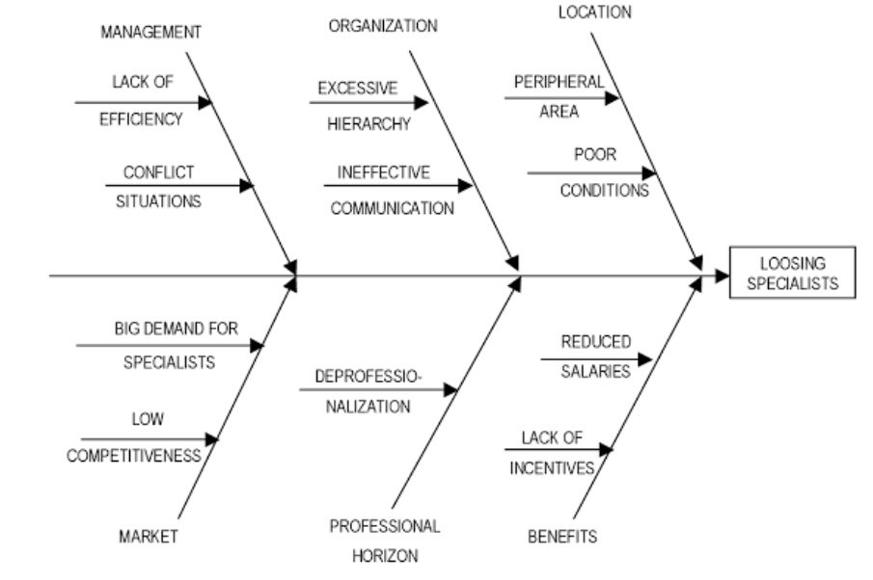
Figure 1 Fishbone Diagram of Employee Shortage (Umfreville and Piñeiro, 2018)

By taking all these measures, the need of the market is felt and at the same time by taking all these activities, it is possible to take the right decision by reviewing the results and it plays an important role in solving the problem. Here it can be seen that if there is no necessary concession in solving the problem and there is excess pressure on the employees of the organization which reduces their confidence then it affects production negatively (Royal Pharmaceutical Society 2016).

Evolution on Alternative Solution to Staff Problem
Various measures can be taken to eliminate staff shortages in the National Health Care Service in England and by taking all these measures efforts can be taken to eliminate the problems related to staff shortages.
One of the things that can play an important role in overcoming the manpower crisis is to create a good working environment for the employees who are currently attached to the organization and at the same time to establish a balance between their work environment and their daily lifestyle. Can review it and arrange additional work for them. To agree on this issue, it is necessary to review the quality of their work and it plays an important role for the improvement of the organization (Jonas, T., 2019).
On the other hand, different types of political decisions can be taken to eliminate the shortage of people in the organization and new types of schemes can be launched by taking these political decisions. These schemes can be used to bring in skilled manpower from other countries and provide them with work visas linked to the National Health Care Service to keep the sector running (NMC 2018).
On the other hand, the National Health Care Service can use a variety of technologies to reduce the pressure on the current workforce. By providing different types of digital health care, the National Health Care Service can provide different types of support and services to their patients. By availing of these services, patients can receive various healthcare consultations using digital devices at their homes, which can prevent them from visiting the nearest healthcare facility. As a result, the pressure on the patients of the hospitals can be reduced and it can be possible to manage the medical care activities with a small workforce (Kozier B 2012).

Implementing the Decisions
Various steps can be taken in making decisions and implementing them. All these steps include creating a good work environment and this work environment should be free from any kind of excessive pressure, harassment, discrimination etc. By adopting all these measures one should adopt a state with whom one can easily interact and feel joy through work. By adopting all these processes, service attitudes should be created among the patients and they should be reviewed whether they are providing the required services. On the other hand, political decisions should be taken regarding the various types of temporary visa systems that can be implemented to overcome the labour shortage and to recruit workers on a temporary basis, and the requirements and guidelines should be developed regarding how this system will be implemented. By using these policies and right lines, skilled manpower related to the medical sector can be linked to the National Health Care Service through government to government agreements with governments in different countries and provide them with the necessary services (Ledlow, G. and Coppola, M., 2017).
Finally, through the use of various digital technologies, healthcare can be provided online to patients and these call centres can be located outside the country of national voluntary service providers. In this way, it may be possible to provide quality services to the patients by using manpower outside the country. This can prevent unnecessary patients from using healthcare facilities and can be used to provide the right quality of care to patients with genuine needs (Gottwald, M. and Lansdown, G., 2014).

Measuring the Effectiveness
It is necessary to review whether all these activities are being conducted properly and whether necessary steps are being taken to implement them. Therefore, a regular planning and review process should be in place and through this regular review will be done to ensure that the necessary steps are being taken to implement the decisions. Through this, if any mistake is found through the process of implementing the decisions, necessary changes will be made to find it and it will be used for the improvement of the organization. All these activities will help the organization to provide the necessary support to the National Health Care Service to deal with the crisis (Lanier, C.R., 2018).

Conclusion
This report discusses various aspects of the National Health Care Service's staffing crisis and reviews measures that can be taken to address staff shortages. By managing the issues, it is seen that in order to deal with the manpower crisis, the organization has to make proper use of the existing workforce and at the same time create a working environment for them (BMA 2018). On the other hand, by properly managing the workforce and using digital infrastructure, connecting human resources with logic, the necessary ideas have been provided on how the National Health Care Service can provide essential services using fewer human resources. All the issues discussed in this report will make important contributions to future activities and research.

References



