BMPS4009 & BMPL4007
Learning in the Digital Era

Galina Zasheva
Student number:2227456

Contents
Reflection 3
Personal Development Plan 6
References 9

Reflection
I can now confidently say that the "Learning in the Digital Era" module has helped me become a better student, adapt to new technology, and develop marketable skills that will serve me well in the future (Gibbs and Brigden, 2018). In this reflective essay, I will apply Gibbs' reflective model to reflect on my experiences during the course of study and pinpoint any areas of improvement.

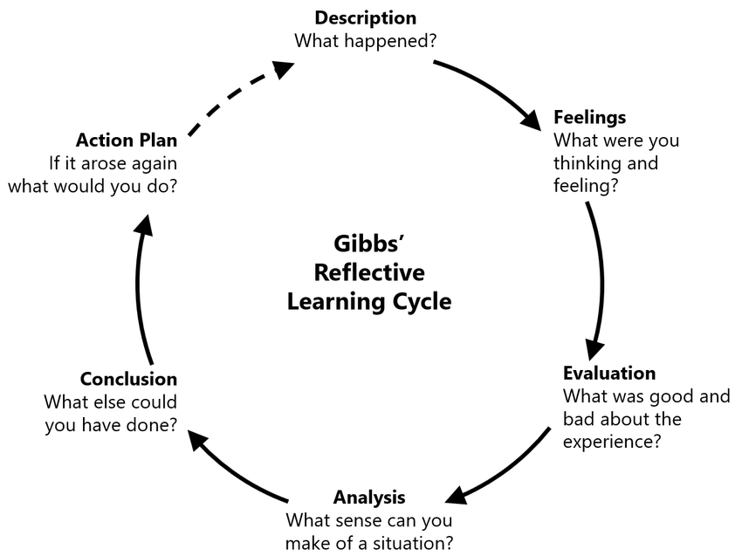
Figure 1: Gibbs’ Reflective Cycle (Brockbank and McGill, 2017).
- Description: The focus of this module, "Learning in the Digital Era," was on building foundational skills, becoming more flexible when learning, and using technology to make learning better (Potter, 2017). As a participant in this module, I have had to take part in a number of activities and complete a number of assignments that have forced me to find out how far my educational skills go and how to adapt to a digital environment that is changing quickly.
- Feelings: During the course of the module, as I learned how to navigate the complicated digital world, I felt a range of emotions, such as excitement, worry, and curiosity. I could not help but feel excited when I realised that I would be able to learn in a new setting and gain some very useful skills because of this chance (Bolton and Delderfield, 2018). During this time, I was worried about how hard it would be to learn how to use new technologies and meet the module's learning goals. In general, I wanted to learn more about how digital tools and strategies could help me grow in both my personal and professional life.
- Evaluation: When I think back on going through the module, I can say with certainty that it changed my life. I have been able to learn basic skills well, which has helped me become a learner who is more resilient and independent (Williams and Spiro, 2020). I have improved my ability to learn quickly and well by doing things like critical thinking exercises, being good with my time, and setting goals for myself. I have also put into practise the learning agility principles of being open to new experiences, actively looking for feedback, and enthusiastically embracing the process of continuing to learn. This has helped me adjust to new situations and learn from my past experiences, which has made me more flexible and useful in a wide range of situations (Bolton and Delderfield, 2018). Also, thanks to the module, I now have the knowledge and skills I need to make good use of technology to supplement my education. By using these tools and platforms, I have learned how to find my way around the digital world and how to use the different digital tools and platforms to improve my learning.
- Analysis: The way this module explained different theories and conceptual frameworks has helped me learn a lot. For example, the idea of having a growth mindset has made it possible for me to welcome challenges and see them as chances to grow as a person. Having this mindset has been very important to my ability to face challenges and push myself to learn new skills (Rushton and Suter, 2012). Also, knowing more about the idea of "learning agility" has helped me understand how important it is to be able to adapt and keep going when things change. I have found that by embracing this idea, I have become more open to learning from my experiences and better able to handle situations that are new or difficult.
- Conclusion: In general, the 'Learning in the Digital Era' module has been a beneficial experience for me that has significantly contributed to both my personal and professional development. I have acquired transferable skills that will assist me in achieving my long-term goals, such as the ability to effectively communicate, to solve problems, and to adapt to new situations. Nevertheless, I am aware that there are still areas in which I can make improvements (Potter, 2017). For instance, in order to maintain my relevance in the face of rapidly advancing technologies and fashions, I need to continue honing my digital skills. In addition, I would like to further develop my collaborative skills because I believe that working with other people is one of the most important aspects of being successful in today's digital era.
- Action Plan: I intend to engage in continuous learning by participating in online courses, webinars, and workshops related to digital technology and collaboration in order to close these skill gaps that I currently have. In both my academic and professional lives, I intend to make it a point to look for instances in which I can work on projects or assignments alongside other people (Taylor, 2010). Following relevant blogs, news sources, and social media accounts will allow me to keep up to date on developing technologies as well as trends in the field. I intend to make it a habit to solicit feedback on a regular basis from my colleagues, teachers, and superiors in order to pinpoint specific areas in which I can advance my skills and develop focused strategies for advancement. I intend to monitor my progress on a regular basis and set SMART goals for the continuous development of my digital and collaborative skills. SMART is an acronym that stands for specific, measurable, attainable, relevant, and time-bound. I intend to build relationships with working professionals in the field that I am interested in entering so that I can gain insights into the practical application of digital skills and collaborative work in the real world (Gibbs and Brigden, 2018). I intend to continue to adopt a growth mindset and to keep an open mind regarding new learning experiences as well as opportunities to further develop my skills. It is my hope that by putting this action plan into motion, I will be able to address the identified gaps in my skills and continue to develop as a capable and versatile learner in this era of digital technology. This will not only assist me in realising my goals for the future, but it will also provide me with the skills I need to thrive in a world that is becoming increasingly digital and interconnected.
The "Learning in the Digital Era" module has been very helpful for me because it has helped me become a more independent learner and given me skills that I can use to reach my future goals. By using Gibbs' reflective model, I was able to figure out where I needed to improve and come up with a plan to do so (Brockbank and McGill, 2017). I was able to move closer to my goals because of this. As I continue on my journey, I am sure that the knowledge and hands-on experience I got from this module will be a solid foundation for my personal and professional growth in the modern world.

Personal Development Plan
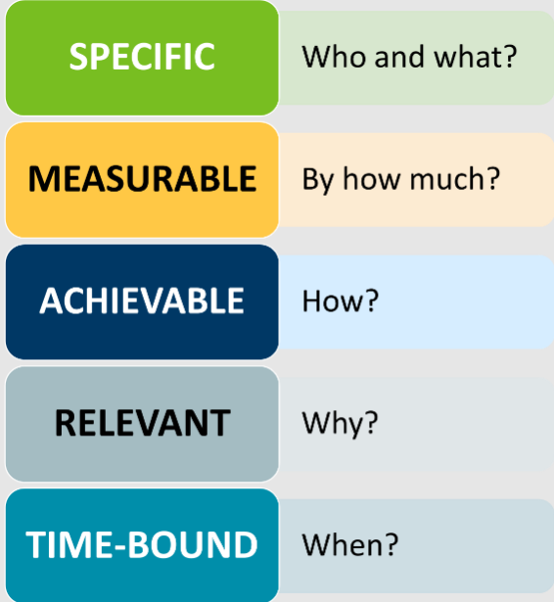
Figure 2: SMART Objectives (Trought, 2017).
Objectives I want to achieve | How I will know I am making progress | Support or resources required | Reflection of individual goals and desires | Timeframe for achieving goals
Specific | Measurable | Achievable | Relevant | Time-bound
- Time management | Create a to-do list and a schedule for the daily activities. | Employing the use of calendars, planners, and wall charts. | Improve time management to finish academic degree to the best of my abilities (Lumley and Wilkinson, 2014). | Meet all deadlines in a timely manner in the days, weeks, and months ahead.
- Referencing | Use citation tools within Microsoft Word and online platforms like citethisforme.com and mybib.com. | Accessible assistance for analysing prior work and giving credit to others' efforts (Gallagher, 2016). | Achieve higher marks by properly citing sources in my work. | Applicable to all assignments and work throughout the remaining three years of my degree.
- Wellness and physical exercise | Increase workout frequency from 2 days per week to 5 days per week. | Local gym, personal workout equipment, and outdoor environment. | Improve fitness, energy levels, and mood. | Implement change gradually over 3 weeks, adding one workout day per week (Cottrell, 2015).
- Reading skills | Increase daily reading time from 2 to 3 hours. | University library and internet resources. | Absorb more relevant information and improve reading comprehension. | Continuously over the next three years as part of academic studies.
- Writing talents | Regularly practice spelling and punctuation, writing by hand, and typing (Anderson and Bolt, 2013). | Dictionary, writing templates, spelling and grammar checker. | Enhance writing abilities and overall quality of work. | Double spelling tests from once a week to twice a week over the next month, then increase by one test per month for the next four months (Gallagher, 2016).
- Competence in Presentations | Utilize platforms that offer a variety of functions to enhance presentations. | Make use of resources from lectures, templates, and applications like PowerPoint (Lumley and Wilkinson, 2014). | Take pride in producing creative and visually appealing work. | Incorporate media into assignments within the next six weeks.
- IT Skills | Utilize the offered applications frequently to become familiar with them. | Utilize Office 365 apps and online resources provided by the university. | Create confidence in using various platforms for work and education online. | Ongoing development throughout the academic journey (Trought, 2017).

References
Anderson, L.E. and Bolt, S.B. (2013). Professionalism : skills for workplace success. Boston: Pearson.
Bolton, G. and Delderfield, R. (2018). Reflective practice : writing and professional development. 5th ed. London: Sage.
Brockbank, A. and McGill, I. (2017). Reflective Learning in Practice. Taylor & Francis.
Cottrell, S. (2015). Skills for Success: Personal Development and Employability. 3rd ed. London: Palgrave Macmillan.
Gallagher, K. (2016). Essential study and employment skills for business and management students. Oxford ; New York, Ny: Oxford University Press.
Gibbs, T. and Brigden, D. (2018). Encouraging reflective practice. South African Family Practice, 47(7), pp.5–7. doi:https://doi.org/10.1080/20786204.2005.10873254.
Lumley, M. and Wilkinson, J. (2014). Developing employability for business. Oxford: Oxford University Press.
Potter, C. (2017). Leadership development: an applied comparison of Gibbs’ Reflective Cycle and Scharmer’s Theory U. Industrial and Commercial Training, 47(6), pp.336–342. doi:https://doi.org/10.1108/ICT-03-2015-0024.
Rushton, I. and Suter, M. (2012). Reflective practice for teaching in lifelong learning. Maidenhead: Open University Press.
Taylor, B.J. (2010). Reflective practice. 3rd ed. Maidenhead: Open University Press.
Trought, F. (2017). Brilliant employability skills : how to stand out from the crowd in the graduate job market. New York: Pearson Education.
Williams, K. and Spiro, J. (2020). Reflective writing. Houndmills, Basingstoke, Hampshire ; New York: Palgrave Macmillan.

