Discuss how art and architecture were used as a medium of communication to convey political and ideological messages in the Roman Empire.

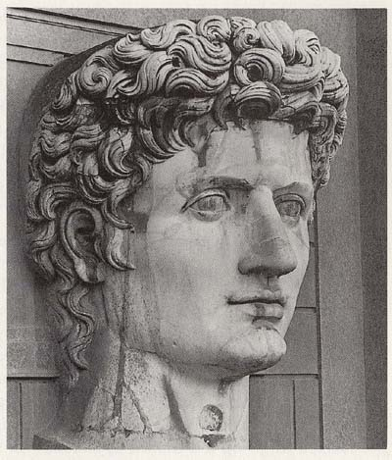
This essay will focus primarily on Augustus of Prima Porta as an ideological statement. A key place to start when discussing artistic propaganda in the Roman Empire is Emperor Augustus (Gaius Octavian), nephew of Julius Caesar. After seizing power in 31BC, Octavian imposed several cultural reforms, pushing Rome into a new era of peace, the Pax Romana. During his reign, Octavian focussed heavily on the “construction of magnificent public monuments and buildings”. Early statues of Octavian, (see Figure 1) often show him in a militaristic sense, displaying the “youthfulness and arrogance that defined Octavian's earliest portrait type.“ This could have been due to the importance of the people thinking of him as a strong military leader during his battles with Lepidus and Marc Antony. It was common at the time for Roman leaders to claim they were descended from the gods. Octavian chose Apollo. Combining his affluent use of propaganda to his strong pressure on revitalising religion and virtues, statues of Apollo were a constant reminder of
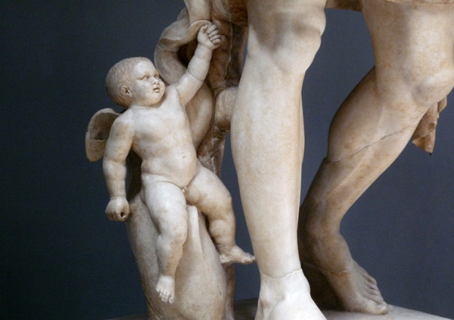
Octavian’s power and presence around the Empire. This is Figure 1 preeminent in one of the most renowned statues of Octavian is the Augustus of Primaporta from 20BC. It has been said that especially in this portrait, Augustus particularly “invoked the power of imagery to communicate his ideology”. With a first look at Augustus of Primaporta, it appears to convey only his militaristic aspects, as did many portraits of Augustus at this time. However, when you look closely, you can see “a distinct resemblance to Polykleitos’ Doryphoros, a Classical Greek sculpture of the fifth century B.C.E.”. By creating a sure contrast to this piece, Octavian attempted to create an idealised version of himself, a ‘perfect model’ of flawlessness, bonding himself to the golden age of the Greek civilisation, when Doryphoros was completed. Octavian also symbolises his ideologies in these statues of Cupid and the dolphin by his right calf (see Figure 2). After Octavian won the naval Battle of Actium in 31BC against the forces of Marc Antony and Cleopatra, the dolphin became a symbol of Octavian’s military prowess and strength. Cupid once more links him to the gods, Figure 2
possibly symbolising the gods approval of his victory and his following leadership of the Roman Empire. Cupid is the son of Venus, goddess of love, that Julius Caesar, Octavian’s uncle and adoptive father, claimed to be descended from. Even Octavian’s breastplate contained propaganda (see Figure 3). There is much debate amongst scholars as to the actual identity of each figure seen on the breastplate, but the
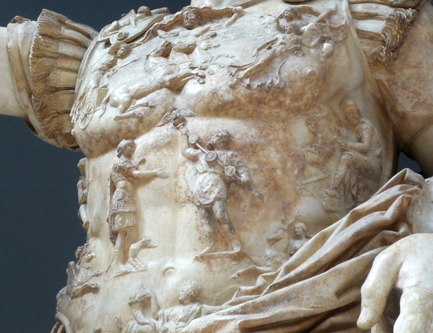
general meaning is clear. “Augustus has the gods on his side, he is an international military victor, and he is the bringer of the Pax Romana, a peace that encompasses all the lands of the Roman Empire”. In this statue, Octavian’s raised right hand indicates that he may be addressing his troops, showing his prowess as a military leader. Another interesting piece of propaganda used in this statue is that the Emperor is portrayed with bare feet. This was usually only done with statues of the gods, another strong comparison
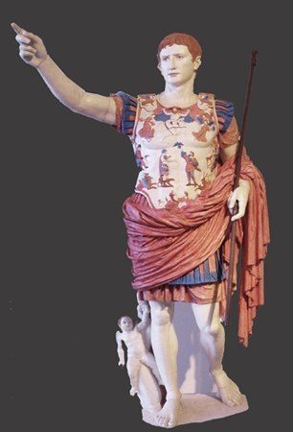
that ties Octavian’s image to that of the gods. Figure 3
It has been said that the “iconography of both military leadership and divinity are combined on a youthful body to cast the Emperor as an exceptional man – the best to rule Rome.” Ultraviolet photography was used to attempt to reconstruct the original colour on the statue (see Figure 4). The extensive use of colour on this statues signifies Octavian’s wealth and power. Octavian also used coins to spread his image and popularise himself. Around 40BCE, a sestertius was produced with the image of Julius Caesar on one side, the “divine Julius”, and Octavian on the other side as “son of the deified Julius”. These coins were used to influence the collective mentality of the Roman people, following Octavian’s method of disguising his propaganda as art to subtly influence the citizens. “Art works,” wrote Ovid, “when it is hidden.”. Octavian used this frequently as he disseminated his influence and ideologies amongst the Roman populace. He had to use less obvious methods due to the high levels of illiteracy in the Roman Empire, as well as the variety of languages used as the Empire Figure 4
acquired new principalities. Octavian used many sculptures and artworks to promote his ideologies, as well as construction of buildings such as the Res Gestae mausoleum to reinforce his authority over all of his opposition.

Bibliography
Zanker, P. The Power of Images in the Age of Augustus. University of Michigan Press, 1990

Fischer, J. Augustus of Primaporta. https://www.khanacademy.org/humanities/ap-art-history/ancient-mediterranean-ap/ap-ancient-rome/a/augustus-of-primaporta [Accessed 8/12/2018]

Dowson, T. AUGUSTUS OF PRIMA PORTA.
https://archaeology-travel.com/friday-find/augustus-prima-porta/ [Accessed 8/12/2018]

McIntosh, M. Augustus: The Use of Propaganda to Establish and Maintain Legitimacy and Power. Brewminate, 2016

