BMSW4003
Digital Skills and Research Methods
(Assessment 2)
Student Name: Yasmeen Malik
Student ID: 1917200
Tutor Name: Rula Alousi

Impact of Virtual Learning Environment (VLE) – Moodle on Students’ Learning Experience at the University of Wales Trinity Saint David London Campus.

Abstract
The research aims to assess the impact of VLE especially Moodle on the learning process of students at the University of Wales Trinity Saint David London Campus. In order to assess the impact, both primary and secondary research was carried out. For the primary research data were collected from 60 students of the London Campus in a random sampling method. These data were analyzed using data visualization tools to excel. Secondary research was also conducted on relevant books, journals to discover past research on the impact of VLEs on student’s learning experience. Both primary and secondary research showed that VLEs have a significant impact on the learning experience of students as these platforms enhance flexibility, accessibility and support traditional classroom learning. However, VLE platforms face certain challenges that should be controlled by putting more discipline and procedures in place to enhance the learning experience of the students.

Table of Contents
Introduction 1
Research Preliminaries 1
Research Aims and Objectives 1
Research Questions 2
Rationales of the Research 2
Scope of the Research 2
Literature Review 3
Designing Research – Methodology and Ethical Issues 4
Ethical Issues 5
Primary Data Analysis 5
Analyzing Benefits and Challenges 5
Analyzing Questionnaire 6
Conclusion 10
References 11
Appendix 12

Introduction
A virtual learning environment or VLE is a system made of digital, web-based teaching and learning tools usually offered within an educational institution. VLE might include tools like curriculum maps, learning tracker, online supporting material, database access to curriculum resources, communication medium etc. (Becnel, 2019). VLEs are designed to interact with students, engage and involve them in activities, report on performance and integrate course structures in the overall learning system of an educational institution. At present, VLEs have become an integral part of higher studies programs in schools and universities. VLEs typically offer the following functionalities (Almpanis, 2009).
- Planning and managing lessons with the help of curriculum maps.
- Offering digital solutions for learning, as in – vlogs, animations, podcasts, documents, etc.
- Discussion within forums and real-time feedback on lessons.
- Online submission of assessments, tasks, reports.
- Tracking and reporting student performance.
- Offering live sessions.
As stated in the abstract, the report aims to assess the impact of VLE especially Moodle on the learning process of students at the University of Wales Trinity Saint David London Campus. Moodle is basically an open-source VLE platform based on pedagogical principles that offer e-learning opportunities alongside traditional learning platform the students.

Research Preliminaries

Research Aims and Objectives
The research report is prepared under the consideration of some specific and general objectives. The fundamental objective of this report is to assess the impact of VLE on the learning experience of students. The research tried to discover the perceptions of respondents on the benefits and challenges such as e-learning platform offers. Apart from this, the research aims to achieve the following general objectives.
- To know different aspects of VLE platforms, their activities, and how universities coordinate with these platforms to offer e-learning opportunities to the students (Chou and Liu, 2005).
- Developing data management skills, such as – data collection, research, analysis, etc. by conducting primary research.
- Exploring existing literature to discover research on the virtual learning environment and developing an understanding of these.
- Creating new knowledge of e-learning and filling gaps in the existing literature.

Research Questions
Based on the objectives stated above, the report provides answers to the following specific questions –
- Whether VLE platforms, as in – Moodle have a positive impact on the learning experience of the students of the University of Wales Trinity Saint David London Campus.
- Whether these platforms offer uninterrupted yet effective learning opportunities in extraordinary situations like coronavirus pandemic.
- Whether there is any room of improvement in the overall e-learning process.

Rationales of the Research
Virtual learning platforms are becoming increasingly popular in higher studies programs at present. These platforms allow students to design the self-learning process and offer a range of strategies to engage students and ensure their participation in the learning process. As these platforms have become an integral part of the learning environment, it has become necessary to assess their effectiveness in imparting quality education (Shandilay, 2018). The research attempts to assess the effectiveness of such VLEs particularly in the case of Moodle and University of Wales Trinity Saint David London Campus. Besides, as the coronavirus pandemic has brought everything in a state of lockdown, the use of these platforms has increased to ensure uninterrupted learning for the students. So it has become necessary to assess whether Moodle is successful in ensuring such an uninterrupted yet effective learning environment to the students. Finally, the research attempts to outline best practices in the e-learning environment so that students can get the maximum value and develop the necessary skills for applying in the workplace.

Scope of the Research
Though a range of VLE platforms is available to students as part of their learning environment, the research is particularly based on Moodle, an open-source VLE platform and students of the University of Wales Trinity Saint David London Campus. The research conducted is theoretical social research of investigative nature on the impact of the virtual learning environment. Though the research is limited in scope, it is intended to fill the gap in the existing literature and develop a further scope of research on this particular subject matter. The research is unique in the sense that not much research can be found on the impact of Moodle on the learning experience of students at the University of Wales Trinity Saint David London Campus.

Literature Review
The literature review section is mainly concerned with the analysis of secondary sources to depict the findings of some of the best research available on the virtual learning environment. Though much research has been conducted on different aspects of education and e-learning, VLE platforms and their impact on the learning environment still offer much scope for further research.
According to Becnel (2019), a virtual learning environment is a system that offers digital resources to the students and instructors for enhancing the learning experience. VLEs, as a part of the learning management system (LMS) of an institution, supplement traditional classroom learning by leveraging on technologies.
Shandilay (2018) defined VLEs as elegantly designed space and pointed out the reasons for their relative popularity. According to him, VLEs help students to design their learning process, opportunities to use diverse resources and receive real-time feedback. VLEs promote coordination by allowing both students and instructors to co-create a sustainable learning environment.
Gerrard (2007) researched the trends of the virtual learning environment and found that traditional learning and development efforts lacked the quality of engagement. VLE platforms today offer a range of options and strategies to engage learners. For example – video-based learning, webinars, microlearning, action learning etc. According to the study, VLEs offered the following benefits over traditional learning – flexibility, accessibility, engagement and affordability.
Iqbal, Saleem, Naseer, and Kim (2017) conducted research on the students of some universities and took responses on the impact of VLE platforms like Blackboard, Moodle etc. on the learning environment. According to the study, 87% of the students found VLEs very useful in terms of flexibility, management and accessibility. 45% of these students were foreigners and part-time job holders and they rated flexibility as the single-most-important benefit of VLEs.
As stated by Almpanis (2009), VLEs not only offer easy access to educational resources etc. but also facilitates a dialogue between students and instructors with the help of discussion forums. Besides, VLEs help to create a multicultural community of the students by offering various specialized courses online.
VLE platforms were criticized by many for making a social activity like learning anti-social. Deng, Sun, Chen, and Yang (2019) in their research studied students from different universities and found that VLEs were not anti-social rather they enhanced the social space within a classroom by promoting engagement. According to them, VLEs are the hub of unlimited interlinked educational resources at the same time, they offered a gateway for building connection, share contents for mutual benefits.
In their study, Cole and Watson (2013) pointed out some challenges of the VLE platforms. According to him, though VLEs offer a great deal of flexibility, lack of self-discipline and weak motivation can hamper the learning process. The study found that the use of VLEs has increased the cheating mentality of students by 35%.
Again, (Gerrard, 2007) in his research on VLE, MOOC, and LMS platforms stated that the most crucial problem according to 23% of the participants in these platforms is the lack of face-to-face engagement. Though VLE platforms offer a range of communication tools, these tools do not have the same appeal as F2F communication. As a result, tracking performance and behaviour become ineffective.

Designing Research – Methodology and Ethical Issues
The research process is divided into two sections – primary and secondary research. For secondary research, a range of books, articles and blogs were collected and analyzed both online and offline. The findings from secondary research are illustrated in the literature review section.
The primary research, on the other hand, focused on the responses of students of the London campus. Information was collected online with the help of google forms as physical data collection was not possible due to government-imposed lockdown.
Sampling Method: Data were collected from 60 students of London Campus using a random sampling method. Google form was posted in different groups, forums of students and no classification was made whatsoever.
Data Analysis: The collected data were analyzed using data visualization tools. These data are presented in this report with the help of graphs and charts. Respondents were asked to rate the benefits and challenges of Moodle that they think are most crucial. These data are summarized and presented in the report.

Ethical Issues
The research was conducted keeping the following issues in mind to ensure integrity.
- No inducement either monetary or psychical were made in the process of collecting data.
- The data collection process was unbiased and free from any kind of stereotype.
- Data collection and analysis were subjective, however, no unfair means were adopted in the whole research process.

Primary Data Analysis
This section presents a graphical analysis of the collected data from the respondents.

Analyzing Benefits and Challenges
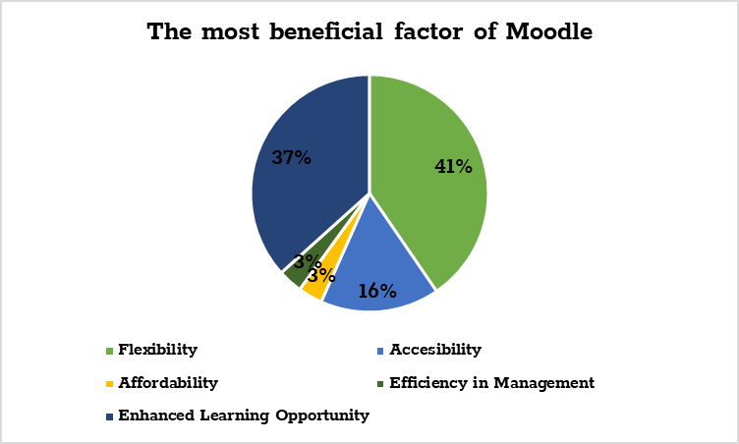
When respondents were asked to rate factor in a scale of (1-5) that they think is the most beneficial in using Moodle, around 41% of the respondents rated flexibility while another 37% rated enhanced learning opportunity. This shows that students are more likely to use Moodle to save their time and to learn new things in MOOCs and other platforms (Panconesi and Guida, 2017).
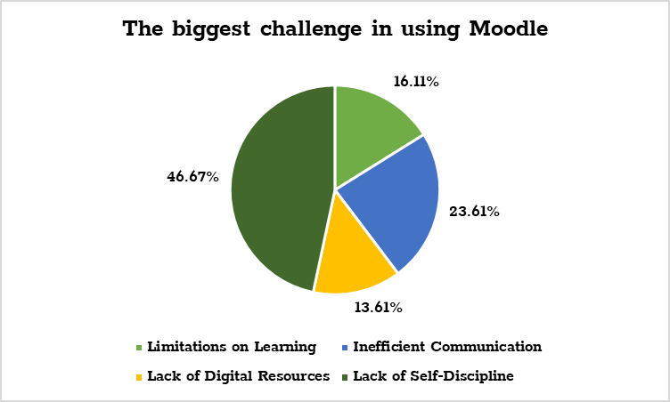
On the other hand, when the students were asked to rate factors that they think are the biggest challenge in using VLEs like Moodle, around 47% of them rated lack of self-discipline and weak motivation as the biggest challenge. Again, another 24% think that inefficient communication and lack of real-time feedback are the biggest challenges.

Analyzing Questionnaire
In the Google Form, there were ten statements, and students were asked to provide their opinion selecting an option out of five ranging from strongly agree to strongly disagree. Some of these crucial statements and their analysis are given below while the rest are summarized in a table.
Moodle offers Flexibility and saves time for both Students and Instructors
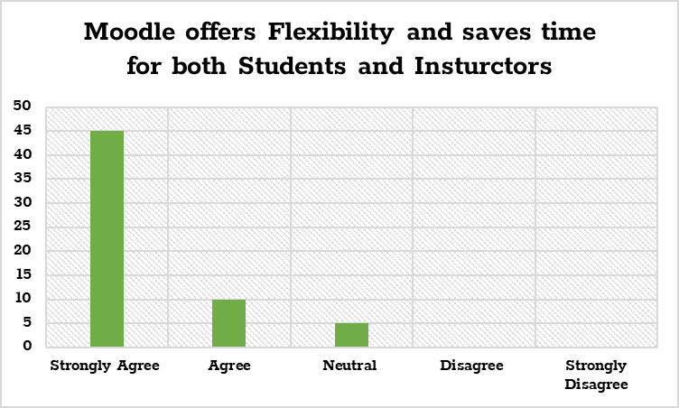
Out of 60, roughly 45 respondents strongly agree that Moodle offers flexibility and saves time for both students and teachers while 10 of the respondents quoted agree. This means around 92% of the respondents think Moodle offers flexibility.
Moodle provides access to course-related Digital Resources easily
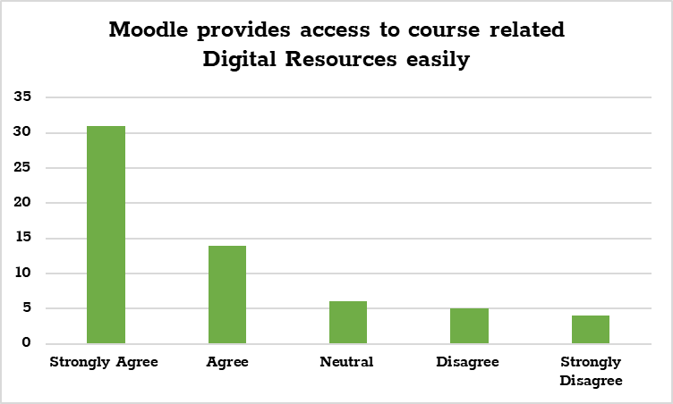
Around 31 respondents out of 60 stated they strongly agree that Moodle provides access to course-related digital resources easily. Among the rest, 14 quoted agree, 6 were neutral and 9 of them think Moodle does not offer enough digital solutions.
Moodle is easily accessible
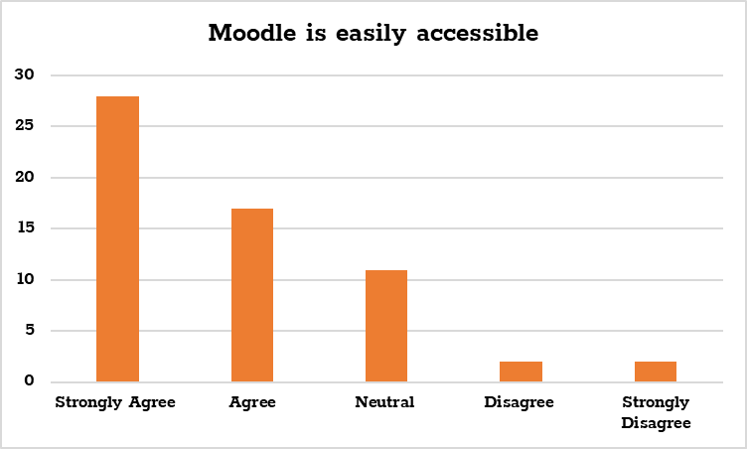
When respondents were asked whether they think Moodle is easily accessible, around 75% of the respondents quoted they more or less agree on this point. However, 19% of the respondents neither agreed nor disagreed.
There is a great deal of opportunity to cheat in a VLE like Moodle
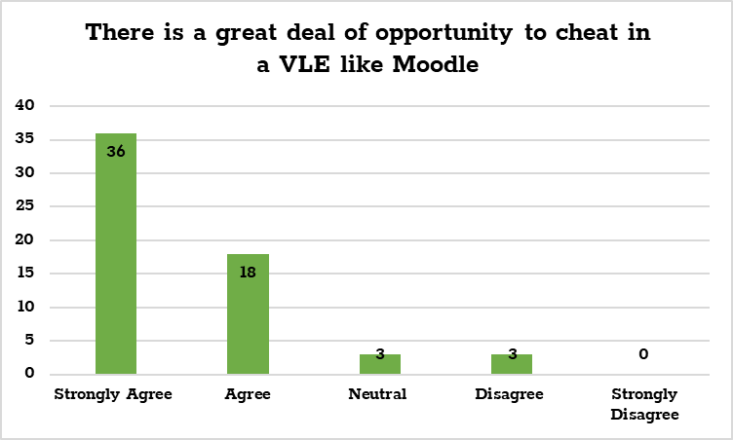
Respondents were asked whether they think VLEs like Moodle offer the opportunity to adopt unfair means in course lessons and assignments. Roughly 90% of the respondents stated that they more or less agree that VLEs offer the opportunity to cheat as performance and behaviour tracking is somewhat ineffective.
Using Moodle reduces Collaboration and Team Mentality among Students
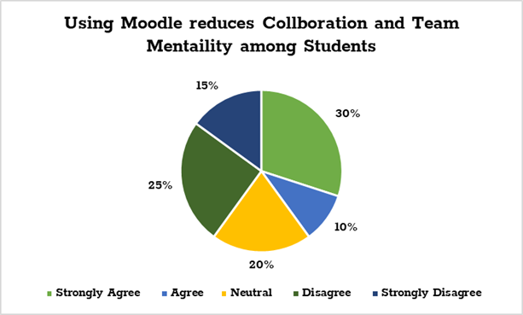
Students were also asked whether they think the use of VLEs like Moodle reduces collaboration and team mentality among students. The result was somewhat scattered as around 40% of the respondents stated they agreed on this point while another 40% disregarded the statement.
Using VLEs like Moodle can develop important Technological Skills
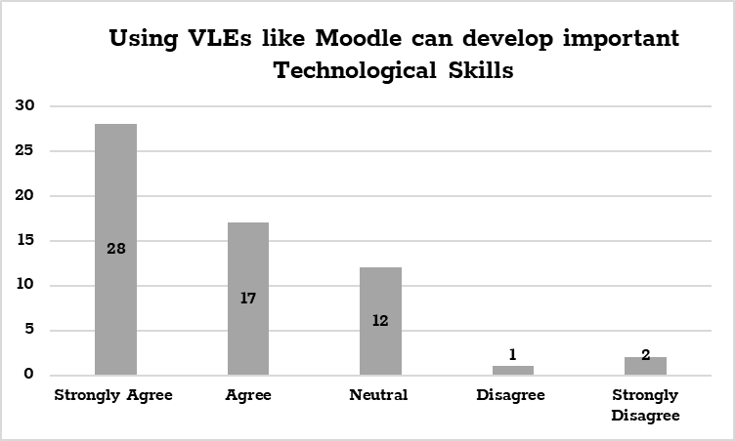
When asked whether Moodle can help students develop important technological skills making practical learning available, around 75% of the respondents agreed on this point. However, 20% of the respondents neither agreed nor disagreed on this statement.
The following table summarizes the rest of the question and their responses.
Questions | Strongly Agree | Agree | Neutral | Disagree | Strongly Disagree
Moodle has a rich database of learning materials | 47% | 36% | 12% | 5% | 0%
Moodle serves as an effective MOOC | 28% | 20% | 4% | 35% | 13%
Moodle is effective in tracking Performance and Behavior of Students | 15% | 18% | 7% | 43% | 17%
VLEs like Moodle offer effective Communication and Real-time Feedback | 55% | 27% | 15% | 3% | 0%

Conclusion
From the analysis of primary and secondary data sources, a few points can be made regarding the impact of VLE – Moodle on the learning experience of the students. These are –
- The primary data analysis on the students of the University of Wales Trinity Saint David London Campus supports the findings of secondary sources. The analysis found flexibility and learning support as the most important benefits of VLEs (Gerrard, 2007). Besides, lack of self-discipline and weak motivation of the students were found to be the biggest challenge in the learning process.
- The analysis also found that there is a mixed review regarding the communication and social cohesion effect of VLEs. However, this problem can be solved by engaging students in online discussion forums, tracking performance and providing immediate feedback (Deng, Sun, Chen and Yang, 2019).
- Again, these VLEs should be made more affordable and rich in terms of contents. For example – Moodle can be built to provide MOOC facilities to students just like Coursera, Edx, etc. New strategies should be devised to include digital solutions of Moodle in the traditional learning process. This will enhance the motivation and skills of the students.
- Effective strategies should be devised to control student behaviour in VLE platforms. Strong control procedures should be established to track and monitor performance (Cole and Watson, 2013). For example – students can be invited to video interviews apart from submitting course works to ensure that they get a good understanding of the subject matter.
The analysis made was limited in the scope, however, this paves the way for further analysis of the learning strategy, environment, and challenges of virtual learning environments or VLEs.

References
Almpanis, T., 2009. Virtual Learning Environments (Vles) In Higher Education. 1st ed. Saarbrücken: VDM Verlag Dr. Müller.
Becnel, K., 2019. Emerging Technologies In Virtual Learning Environments. 1st ed. IGI Global.
Chou, S., and Liu, C., 2005. Learning effectiveness in a Web-based virtual learning environment: a learner control perspective. Journal of Computer Assisted Learning, 21(1), pp.65-76.
Deng, Y., Sun, W., Chen, M., and Yang, Y., 2019. Knowledge management and e-learning in virtual learning community based on social network analysis. Library Hi Tech, 37(4), pp.906-917.
Gerrard, C., 2007. Virtual learning environments. Campus-Wide Information Systems, 24(3), pp.199-206.
Iqbal, M., Saleem, Y., Naseer, K., and Kim, M., 2017. Multimedia based student-teacher smart interaction framework using multi-agents in eLearning. Multimedia Tools and Applications, 77(4), pp.5003-5026.
Shandilay, D., 2018. Virtual Learning Environment Scenario in Higher Education (Web-based Learning). International Journal Of Management And Economics Invention, 04(05).

Appendix
Google Form Link: https://forms.gle/XpeRTt2wp6oVvhKQ8


