2022
Steven James (1810370)
AWE plc - UWTSD
1/31/2022
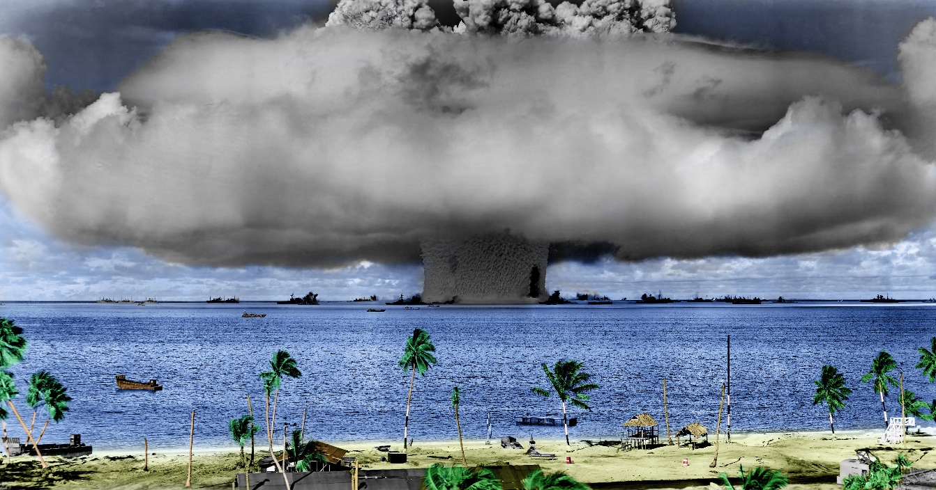
Advanced Systems Engineering Autonomous lawn mower
Contents
Glossary 2
Introduction 3
Key customer requirements 3
Stakeholders 3
Use Case 5
Holistic requirements model 5
Quality Function Deployment 7
Pairwise Matrix 7
Functional Means Analysis 8
Pugh Matrix 8
Quality Function Deployment 2 8
Parameter diagram 8
What-Why table 9
Quality Function Deployment 3 and 4 9
Failure Mode and Effect Analysis 9
Gemba Walk 10
References 11
Appendix 1 12
Appendix 2 14
Appendix 3 15
Appendix 4 16
Appendix 5 17
Appendix 6 18
Appendix 7 19
Appendix 8 20
Appendix 9 21
Appendix 10 22
Appendix 11 23
Appendix 12 24

Glossary
DFMEA | Design Failure Mode and Effect Analysis
DTM | Design To Manufacture
FMA | Functional Means Analysis
FMEA | Failure Mode and Affect analysis
Gemba | Japanese word for “the exact location”
HRM | Holistic Requirements Model
NFI | Non-Functional Implementation
NFP | Non-Functional Performance
NFS | Non-Functional System
P diagram | Parameter Diagram
PW | Pairwise
QFD | Quality Function deployment

Introduction
Schlager [1] suggests ‘systems engineering’ was most likely first coined by Bell Telephone Laboratories due to the complexity of national telephone network systems. At the time, the term systems engineering was used as it included all parts of the system from research and development to field deployment. Early studies found that planning, analysis, optimisation, integration and evaluation best described the systems engineering process.
Modern-day systems engineering can be defined:
“A transdisciplinary and integrative approach to enable the successful realization, use, and retirement of engineered systems, using systems principles and concepts, and scientific, technological, and management methods.” [2]
A request to design an autonomous golf course lawnmower. Whose purpose is to run with human intervention.
This report uses a systems engineering approach to develop solutions from the early concept phase, through to design, and what would eventually be the build phase.
The first thing to establish was the key operational requirement of the mower, which was:
“To cut the grass on the golf course to the required length during periods when the players are not on the course.”
With above defined, systems engineering tools were used to progress the design.

Key customer requirements
The customer initial requirement was simple to establish - design a remote lawnmower for a golf course. However, to assume that the ‘customer’ is the only customer is incorrect. The next step was to establish who the stakeholders were (i.e. key figures who also play the part of a customer),who possible have more influence in the initial design. Local stakeholders gave their requirements through a statement of need:
- The effect on the environment, including the carbon footprint of the club should be minimised (Environmental lead)​
- The system must reduce manpower and payback over three-year period (Secretary)​
- Enhance the playing experience (Captain)​
- Must not interfere with golf matches (Captain)​
- Must not look unsightly (Greens Committee)​
- Must not disturb the neighbours. (Lady’s Captain)

Stakeholders
In order to establish additional stakeholders, a stakeholder influence map was produced, which included the interaction between various stakeholders and who were the most influential, the direction of influence each of the stakeholders has, and the order of importance which their requirements should be included.
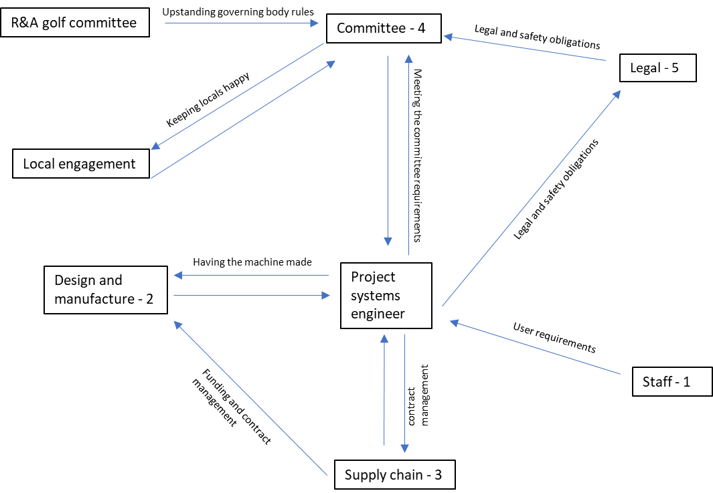
Figure 1 – Stakeholder influence map
The stakeholder influence map shows top level stakeholders and who have the most influence. It was decided that the most influential stakeholder would be the staff who would be using the equipment as they would be the people who had direct interactions with the machine. Once this was completed, a more detailed stakeholders list was.
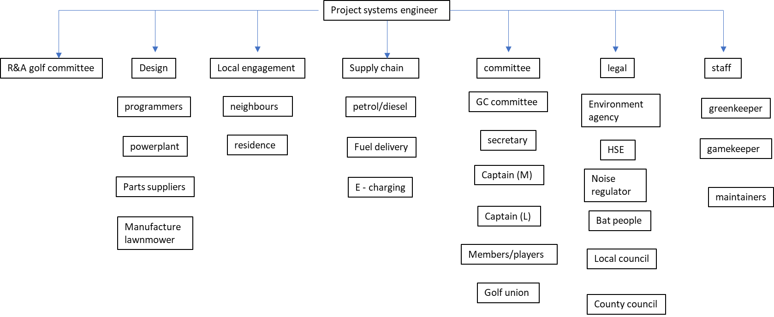
Figure 2 - further detail of stakeholders
As the requirements were still expressed requirements it was important to re-evaluate what had been requested and look in more detail into what was required, captured via an affinity list. In this example only the Committee was considered for the Affinity list.
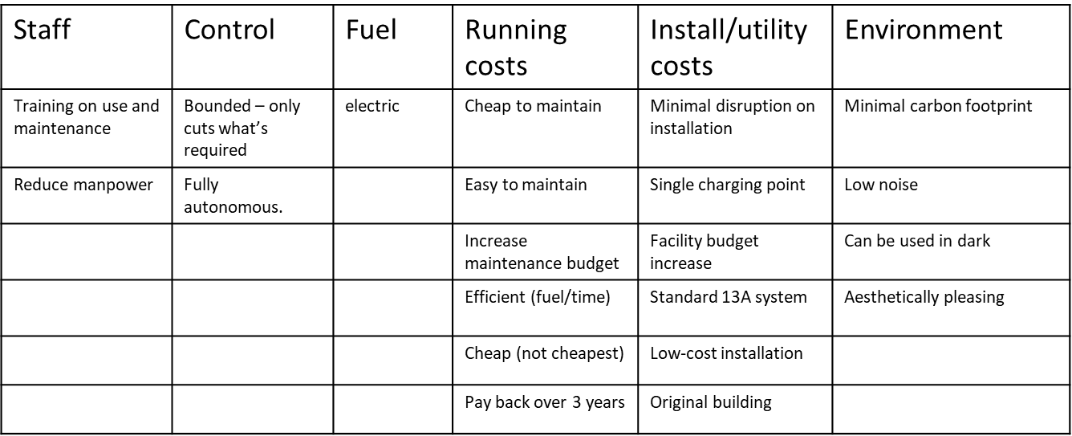
Figure 3 - Committee Affinity list
The affinity list was used because it is a useful tool that was used to break down more direct stakeholder requirements. The individuals in the Committee gave their own versions of what they were looking for in a form of divergent thinking. This allowed a larger list to be captured. The requirements were then categorised, which brought a sense of logic to the list and limited the number of groups, convergent thinking [3] [4]. Now there are both expressed and basic requirements captured.

Use Case
An alternative process for looking at the requirements was to create a Use Case. A Use Case is a description of the events that are being performed set out in sequence, essentially expressing how the system shall be used. Working solely with a list of requirements it’s not always possible to understand what the customer actually wants from the system. The requirements may be quite ambiguous, however following a Use Case can establish what you want the system to do, and when you want it done. It could be considered that this sequence of events is a requirement. Standard requirements may not consider how the system will function, where the use list may open up the opportunity to understand at an early stage what you want the system to do. It can be said that in order to understand what the system is going to do, you have to understand who will be using it, following this, you should look at what the system will provide for the users in order for it to be of use [4] [5].
The Use Case contains actors, the actors are those things which will do something to the system, they are not part of the system. An actor does not have to be a person, it can be a control system, or it could even be a governing body. Only the stakeholders that have an input on the lawn mower are actors [4] [5].
The Use Case for the “Supermow” can be found in Appendix 1. It shows what the system is expected to do in what order, provided the system is working correctly. It also gives possible flaws (how things might not work correctly). This Use Case gives designers areas to focus on and how to prevent situation where the system fails. This means that through design, the chances of having the wrong programming installed and a malfunction of the blade height can be designed out.

Holistic requirements model
With the requirements beginning to take place they must be organised into a systems view. The way this was done was to consider the HRM.

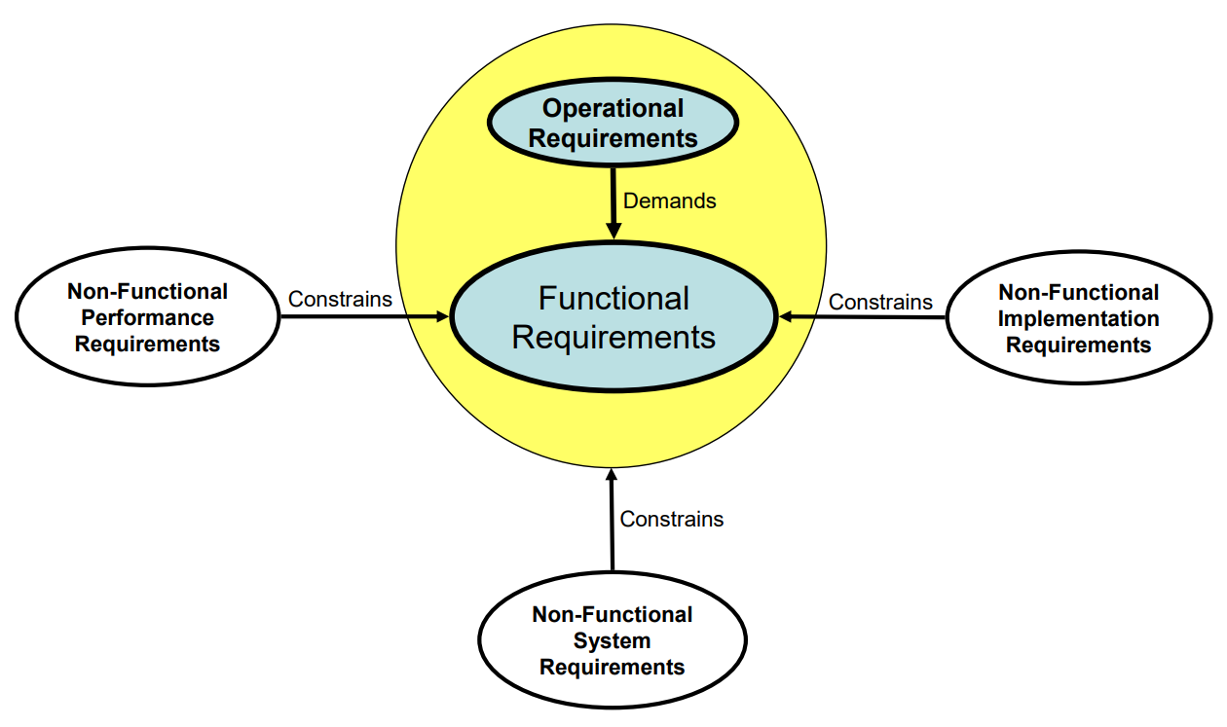
Figure 4 - Holistic Requirements Model (HRM) [6]
The HRM takes the requirements of the complete system and organises them in a consistent manner. There are three types of requirements: operational, functional and non-functional. The non-functional requirements are broken down further into: NFP, NFS and NFI requirements [6].
The operational requirement is a statement of what the system will do and includes any key bounding conditions. The statement should not be vague, for the lawnmower it was established early [6]:
To cut the grass on the golf course to the required length during periods when the players are not on the course.
With the operational requirement established, the functional requirements were considered. Functional requirements define what the system will do to meet the operational requirement. A way of describing what the functional requirements should be is to the use verb-noun expressions that define what the action of the system. For the lawnmower the functional requirements were as follows:
- Deliver energy | - Initiate cutting
- Store energy | - Cut grass
- Input boundaries | - Collect cuttings
- Select mission | - Detect objects
- Decode mission | - Avoid objects
- Download mission | - Monitor cuttings
- Provide motion | - Remain in bounds
- Leave dock | - Dispose cuttings
- Follow track (navigate) | - Select docking height
- Confirm arrival at target | - Return to dock
- Select cut height | - Recharge energy

It should be noted that during the requirements capture, an emergent function was found. The operational requirement was to cut the grass. However, in cutting the grass, grass cuttings are created, therefore collection and disposal of grass cuttings had to be considered.
The non-functional requirements state how the action is to be performed, or how well it is to be performed. To capture the non-functional requirements the affinity list in Figure 3 was expanded to produce a requirements list. The list was broken apart to form a requirements tree and each of the requirements were allocated either system, performance or implementation. The requirements tree can be found in Appendix 2.

Quality Function Deployment
Now, with expressed, basic and assumed decided, a QFD was performed. As a tool, a QFD allowed the customer requirements to be positioned against the functional requirements of what it is the customer was looking for. In the matrix, those requirements were then ranked against one another. This allowed a correlation to be assumed. It determined which of the functional requirements have close relationships to the customers’ requirements. It also considered what the customer perceived as the most important requirements. Within the matrix, those columns which are more densely populated show which requirements may be ‘critical functions’. Where the rows are more densely populated or full, it shows which customer requirements need special attention as they have influence across the whole of the system [7] [8].
The QFD for the mower system can be found in Appendix 3. Here it was seen that the strongest customer requirement must be for the system to be fully autonomous, whilst to be able to cut all the required golf course area to the correct height, not cut outside the required area and to cost less than £22,995 [9], all bare a strong relationship to the functional requirements. These are the requirements that will have to be managed carefully throughout the design process. It also expresses that these requirements may need to be broken down further, there will be more layers as to how these requirements can be fulfilled by the functional requirements. The requirement to keep the maintenance costs low has no relationship with any of the functional requirements, this shows that although it’s a customer requirement, it has no functionality based with it.
It could be assumed that cutting the grass would have been the most critical function. However, the QFD shows us, by having the most densely populated columns and the highest weighting, detecting and avoiding objects are more critical than cutting the grass itself. Although the cost of the system has a relationship with many of the functional requirements, the customer has only given the cost an importance of 3, this shows that there could be ‘leeway’ in the overall cost.

Pairwise Matrix
Besides finding the relationship the functional and non-functional requirements have with each other, it is also important to consider if there is a relationship that the non-functional requirements have against each other. To do this a PW matrix was produced, Appendix 4.
The PW matrix allows for a mechanism to decide which non-functional requirements has the most importance. It helps give values based on the judgement of the participants and translates the judgements to rate their importance. The approach is useful because it gives a scale of exactly how the participants perceive how important one requirement is over the others [10].
The relative importance found in the PW matrix performed is that the most important requirement to be that the system shall not injure humans, followed by the system not entering water hazards and then not injuring wildlife. Cost of the system relative to current system, cost of maintenance and noise level were all found to be of low importance.

Functional Means Analysis
When considering a design of the system, ideas were put together. To begin this an FMA was used. A FMA takes each function in turn and looks at all possible means by which the function can be completed. The means are determined by what the participants understand as all the possible means available to solve the function. An FMA analysis has been produced in Appendix 5. This shows which means the participants thought were available to solve the functions. The FMA, in this instance, also shows which means are available to be used for each function. In doing so, three concepts have been produced using the means which could encompass a solution.

Pugh Matrix
With concepts produced, one way of deciding which concept may be more suitable over other concepts is to use a Pugh matrix. Pugh matrix compares proposed solutions and helps determine if one solution is more valuable than another. The solutions are compared to an existing system, the proposals are then ranked against how each of the solutions, including the existing system meet the customer requirements [11]. The Pugh matrix in Appendix 6, show the three concepts compared to the existing system of the greenkeeper with a standard mower. The result shows that concept 3 has the best score of 89, over 70 and 63 respectively over concepts 1 and 2. Therefore concept 3 will have the most consideration to be taken forward for design.

Quality Function Deployment 2
Concept 3 has been chosen to be taken forward. The next step created a second QFD. QFD2 looks at the system requirements and then compares those requirements against the modes of the solution. The QFD makes the relationship between the requirements and the solution easy to interpret. It shows how the required functions are met by the proposed solutions. Appendix 7 shows the QFD2 for our system. This shows that functionality of mowing the course is met by the majority of the solution. The solution being electric meets the majority of the functional requirements. The cost of the system being less than the current system is not met by any of the solutions, meaning that the solution is inadequate and will require further consideration. A ‘clump’ of outcomes where the design feature meets the function may show a subsystem. The internal processor controls the avoidance of hazards and objects, this indicates that to avoid the hazards by way of the internal processor could be a subsystem for the design.
​

Parameter diagram
When moving forwards with design, it is important to consider where variation in the design may take place. Variation is those parts of the design which could differ from unit-to-unit, that being the whole system or each sub-system or component. Variation is also known as noise. When designing the system, external noise factors are also considered, external noise is not variation between each unit, but factors outside the system which may affect the systems performance. To find the noise factors, a ‘P Diagram’ was implemented Appendix 8. The ‘P diagram’ shows the expected inputs; programming, power and go signal and the required output; cut grass to correct length in required area. The control factors are listed, such as speed of mower. The external noise factors include weather and FOD. Unit-to-unit variation is seen as variation in the control factors. Noise from deterioration were also included, for example corrosion on the blade and wear on the motor. Noting these factors allows for the design to concentrate on how these noises can be controlled through build ensuring a robust design before manufacture.

What-Why table
The ‘P diagram’ shows the influential noise factors but does not give any indication of the relationship of the noise factors and control factors. To find the relationships along with the strength of the relationships, a ‘what-why’ table is used. The ‘what-why’ table in Appendix 9 shows the source of noise most likely to affect the performance; input errors, battery depreciation, position of mower and navigation of mower. It also shows which of the control factors are most likely to be affected by noise; steering rate, speed of cutter, speed of mower and poorly cut grass.

Quality Function Deployment 3 and 4
Once the design solution had been decided upon, a manufacturing solution needed to be developed. A tool available to assist is another QFD. QFD3 takes the proposed solution design and assists developers develop a manufacturing solution. An example of QFD is in Appendix 10. The QFD3 shows the critical features of manufacture and compares to the process solution. It can be seen that manual assembly has a strong relationship to all parts of the motor parts whereas the adhesive plays no real part in the features.
To plan further into the manufacturing process, control of the process must be planned. To do this a 4th QFD was used. QFD4 compares control measures against critical process steps. It considers what needs to be controlled, how to control them. It also suggests measurements that may be required and when to measure, and what to do should a change be required to correct any faults. An example of QFD4 is in Appendix 11. This shows the proposed ease of the operation, how often failure may occur, how bad a failure may be, and how easy it will be to detect if a fault has occurred. Process controls are also compared with the parameters. The comparison shows which controls are used to control the parameters. Operator training and pre-inspection of parts have a large relationship to the parameters. Blade dimensions and blade fixing hole dimensions require a lot of process controls.

Failure Mode and Effect Analysis
FMEAs were used throughout the DTM process to prevent problems, reduce waste and produce a reliable solution. Identification of failure from the outset was key to ensuring a robust system meeting customer requirement. FMEA identifies failure modes, their likelihood, severity and detectability. It then evaluates any actions required to reduce/eliminate such failures [12].
The DFMEA in Appendix 12 shows the funtion of cutting the grass, identifying that no cutting or intermitent cutting due to drive band breaking as the most sever failure, due to its undetectability and frequency of occurrence. Unintended cutting from broken steering is the least severe.

Gemba Walk
A Gemba walk found two mowers were used for the green and fairway seperatly this could be incorperated into the final system solution.

References

[1] | K. J. Schlager, “Systenas Engineering-Key to Modern Development,” IRE TRANSACTIONS ON ENGINEERING MANAGEMENT, pp. 64-66, 1956.
[2] | INCOSE, “Systems Engineeringn Definition,” INCOSE - International Council on Systems Engineering, [Online]. Available: https://www.incose.org/about-systems-engineering/system-and-se-definition/systems-engineering-definition. [Accessed 31 01 2022].
[3] | “Affinity Diagram – Kawakita Jiro or KJ Method,” PROJECT-MANAGEMENT.COM , 1 2 2017. [Online]. Available: https://project-management.com/affinity-diagram-kawakita-jiro-or-kj-method/. [Accessed 1 2 2022].
[4] | D. Holley, Determine and Manage Requirements (presentation), Swansea: UWTSD, 2022.
[5] | K. S. I. Bittner, Use Case Modelling, Boston: Addison - Wesley, 2003.
[6] | S. Burge, “The Systems Engineering Tool Box,” Dr S Burge, 2006. [Online]. Available: https://www.burgehugheswalsh.co.uk/uploaded/1/documents/hrm-tool-box-v1.0.pdf. [Accessed 1 2 2022].
[7] | D. Holley, Performing Functional Analysis (presentation), Swansea: UWTSD, 2022.
[8] | J. B. M. J. W. C. C. A. ReVelle, THE QFD HANDBOOK, NEW YORK: JOHN WILEY & SONS, 1998.
[9] | H. F. G. Ltd, “JOHN DEERE Z997R,” Hunt Forest Group Ltd, [Online]. Available: https://huntforest.com/new_machinery/john-deere-z997r/. [Accessed 2022 02 04].
[10] | S. Burge, “The Systems Egineering Tool Box,” 2009. [Online]. Available: https://www.burgehugheswalsh.co.uk/uploaded/1/documents/pugh-matrix-v1.1.pdf. [Accessed 26 02 2022].
[11] | CIToolkit, “Pugh Matrix,” CIToolkit, 2020. [Online]. Available: https://citoolkit.com/articles/pugh-matrix/. [Accessed 25 2 2022].
[12] | D. H. Stamatis, Failure Mode and Effect Analysis: FMEA from Theory to Execution second edition, Milwaukee: ASQ Quality Press, 2003.

Appendix 1
Use Case for “Supermow”
Use Case: A clear verb/noun or actor/verb/noun that communicates the scope of the use Case
Use case for “Supermow” green keeping system
Author James S | Issue -1 | Reviewed ?? | Date 01/02/22
Actors:- A list of actors who can engage in the activities described in the use case:-

Manufacturer: - Deliver complete product to customer via supply chain.

Green Keeper: -
- Programmes “Supermow” to cut the required areas of grass to the required height
- Maintains “Supermow” system
- Provides fuel to the “Supermow” system
- Operates “Supermow” in a safe and suitable manner
- Daily checks to ensure “Supermow” system is completing tasks as required

Green Committee: -
- Provides the required h
- Length of cut of grass for each area of the course (green, apron, fairway, light rough etc).

Service provider: -
- Provides fuel to the “Supermow” system at the required rate at the required rate and cost.

“Supermow” (Our System) : -.
- Programmed with golf course topographical information and data to instruct regions and cut heights to be achieved
- Performs cutting operation without human intervention.
- Avoids stationary objects.
- Avoids moving objects
- Avoids interaction with living organisms (players, wildlife).
- Avoids Sand trap hazards.
- Avoids water hazards.
- Remains in bounds as required.
- Returns after operation for reprogramming / replenishment of fuel

Pre-conditions:- Anything that can be assumed to be true when the use case begins :-

- “Supermow” is well maintained and fully operational.
- There is no expectation for adverse weather that will prevent “Supermow” from completing mission.
- Details for each part of the course (including required tracks off course) are accurate.
- There are no severe blockers on the course (fallen trees, burned out cars)
- The operators of the system are fully trained and understand how to use the system.
- Clear objectives of each mission are defined within programme.
- Programmes have not been changed from those required.
- No Malware or viruses are present in the system

Post-Conditions:- Anything that must be true when the use case is complete.

- “Supermow” has completed the cutting operation and has returned to the designated endpoint.
- Cutting have been collected and disposed as required.
- “Supermow” is in the same well maintained, undamaged condition that it began the task in.
- Designated areas have been avoided
- There have been no injuries (or worse), human or wildlife.

Basic Flow:- The set of steps the actors take to accomplish the goal of the Use Case. A clear description of what the system does in response to each user action.

- System is in correct start point> The system is in its ‘home position’, its operational start/end point.
- System refuelled> System is powered up and ready for use.
- Programme system > System has full data on required mission. Track to take, where to cut, how much to cut, where to go for cutting disposal and when to end mission.
- Activate system> System ready to operate at the appointed time.
- Conduct diagnostic check > Ensure detection and operating systems functional before leaving device.
- Device starts operation > Mower leaves home point and begins to execute mission.
- Device in operation > Mower follows the programmed route, cuts grass at correct level for each area, disposes of cuttings as required.
- Device completed operation > All required areas of the course have been cut and mission has been completed.
- Device returns to designated end point > Device at designated endpoint ready for refuelling and reprogramming (if required).

Alternative Flow:- Captures alternative user/system interactions, such as what happens if data is entered incorrectly.

- Wrong Programme Loaded :- Wrong cut pattern achieved for designated area. Mission should abort. GPS system could give warning of starting in the wrong place.
- Blade height malfunction:- too high, grass is not cut as blade is too high. Too low, grass cut too short, or blade rammed into soil. Sensor to detect correct height. Mission should abort and return to base, signalling incorrect blade height.

Exception Flow :- The things that can happen to prevent the user from reaching their goal

- Insufficient fuel :- Warning should be given before the start of the operation but if the systems runs out mission aborted, send fuel shortage signal.
- Undetected object damages cutter / motion system.:- Shut down and mission abort.
- Gets stuck:- system to send a signal that it has lost traction and can no longer move. Then shut down and wait.
- Strike with undetected object: Seek to navigate round object. If critical systems damaged the abort mission
- Rain :- Cease operation. Could include a wait function until shower has passed or move to a designated safe location.

Appendix 2
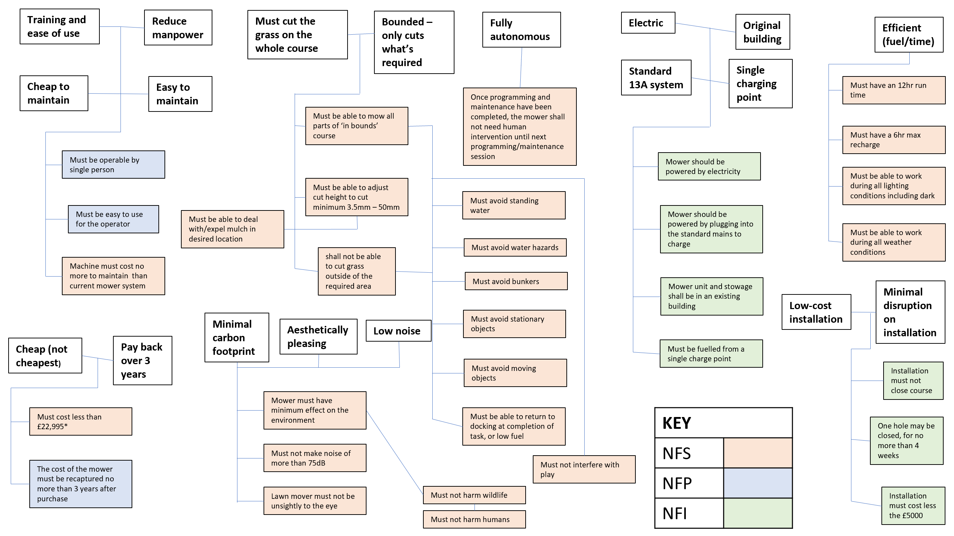
* [9]

Appendix 3

Appendix 4
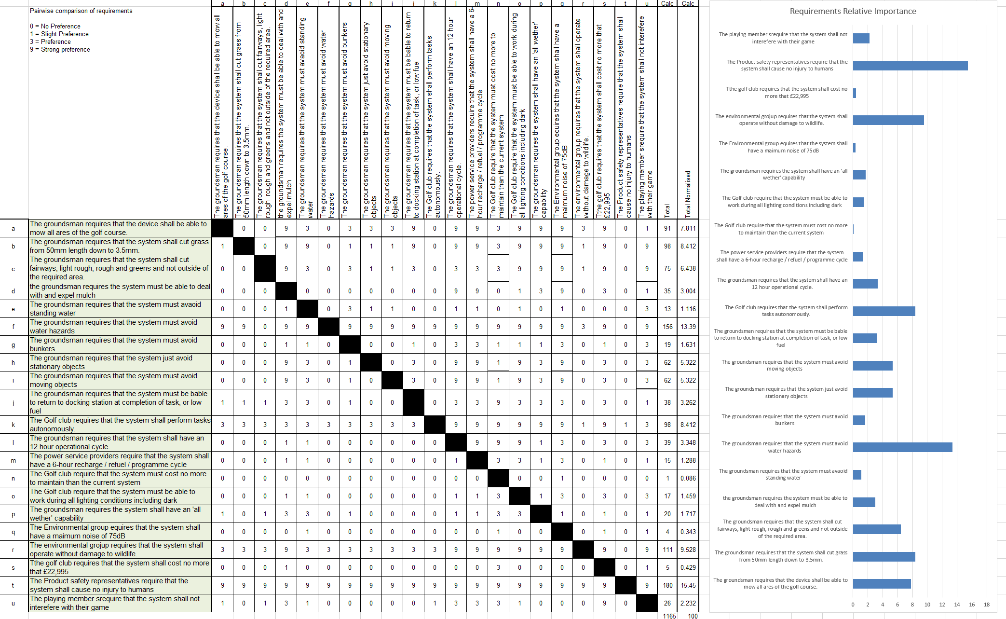

Appendix 5

Appendix 6

Appendix 7

Appendix 8

Appendix 9

Appendix 10

Appendix 11

Appendix 12

