Effective Team Working and Communication
Monika Lapukaite
2119519
Lecture name: Akash Puranik
BMSW4002
Certificate of Higher Education Skills for the Workplace

University of Wales Trinity Saint Davin

Table of Content

Table of Contents
Effective Team Working and Communication 1
Table of Content 2
Introduction 3
Body 3
Overview of Team Working 3
Models of team development 3
Team Roles 4
Discussion 6
Conclusion and Recommendation 6
References 7

Introduction

This report will show effective ways how to increase good teamwork and communication. How we can develop an effective team and theoretical model can be used. What types of roles must be created for effective team? How impact can effective teamworking have on team success. According to author (Eduardo and Scott, 2021) team effectiveness, as we define it, has three components: Sustained performance, team resilience and vitality. Sustained performance generating positive results over time, team resilience working through challenges and bouncing back from adversity and vitality maintaining energy, vibrancy, and resources needed for future success.

Body

Overview of Team Working

What really creates team effectiveness? At every workplace team face challenge what makes them questioned them self’s if they are in the right place and with the right people. Create a good team they must find the people that have the same goals and inters. Effective team need to have it a leader with the right knowledge, mindset and skills how to run the team. We believe anyone who lead a team, works on a team, or supports a team in any way should know what really drives team performance (Eduardo and Scott, 2021). In every article or book about effective teamwork is says that teams facing challenges or fail because of communication. communication is a key in effective teamwork. By communicating between each other they are creating new ideas and performances to succeed. Effective teamwork and communication can help prevent mistakes and decrees risk of failing as a team. The implementation of simple tools and behaviours can greatly enhance safety and improve perceptions of teamwork (Pfrimmer and Twedell, 2009). The team leader is the most important part of the team. team leader can increase team members into collaboration and teamwork by giving difficult tasks. After completing the task, the team leader can reward the team for they ingenious thoughts, quick work and good teamwork. Good and challenging tasks can interest a team for collaboration, curiosity, and a fun time with co-workers. However, over difficult tasks can start to push them away from the interest in the job, team members can begin to be depressed and leave the job unattained (Martine and Mark, 2016).

Models of team development

Often teams come to terms with difficulties at work, not only due to a difficult task, but also cooperation with a colleague or manager. The manager, trying to maintain understanding between the employees and they company’s goal, must take a new action that promotes cooperation. Some of the companies are using “GRPI Model of Team Effectiveness” to create new relationships with employees and increase them to work along with the company to a chive a goal. This model of team effectiveness was created by Bechard’s (1972), but it still functions as an effective tool to plan teamwork and diagnose problem with a team.
Setting goals unites the team and gives them a reason to work together. Purpose gives them a purpose to understand why they are here and what their job is. Without a goal, the team loses its purpose, they get lost and don’t know why they are there. Each team member must know how to share, achieve, and complete tasks. After giving them a goal, it can be not only a team goal but also a personal goal. A team must have roles, roles help assign team members to the appropriate job. Every team member must know his assignment in the team. Team members must understand what they are responsible for and what needs to be done. Processes in organisations are a management tool that helps to overcome inefficiencies in decision-making, control, coordination and communication. they strive to ensure a certain level of repeatability in output quality, while providing enough flexibility to not constrain the work of process users. Five principles of interpersonal relationships can help team effectiveness. They are based on the openness and understanding about what is important to the team but also important personally to every member of the group; Attend to the little thing, keeping commitments, clarifying expectations, show personal integrity, apologise sincerely when you make a withdrawal. Applying these principles will build a high level of trust within the team and communication will be relaxed. Negative behaviours such as showing disrespect, threatening, being harsh or judgmental will limit the options of communicating effectively and cause relationships to deteriorate.

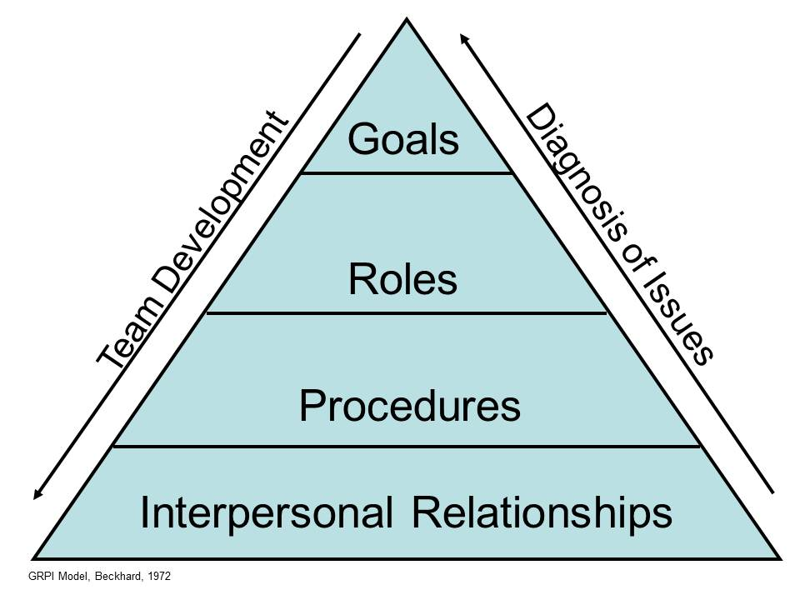

Team Roles

Well-functioning teamwork has frequently been linked to increased work satisfaction and performance. However, there is a paucity of research on the different types of roles in teams. Recently, a new model of role behaviour in teams was proposed (comprising seven such team roles: Idea creator, information gatherer, decision-maker, implementer, influencer, energizer, and relationship manager). The findings support the important role of character strengths in work-related settings and lay ground for further studies on team roles (Fabian G., Tracey P., Jennifer H., 2016). Participation in group and team working can occur for two reasons. First, a person may be a member of a team by virtue of their functional role in the organisation; for instance, because they belong to a particular specialism or grouping, have task skills or because of their position in the organisational hierarchy. Alternatively, or additionally, membership might be given based on an individual’s capacity to generate novel ideas, co-ordinate contributions from others, encourage harmonious relationships or ensure implementation of decisions; in other words, based on their team role as opposed to their functional role (Human Resource Management Journal, 1998). In the job interview, the job role is described, it is not only what role you have to play at work but also what role you must play in the team. The team must have a balance of roles. Author Meredith Belbin discovered eight job roles, role nine was added a bit later, and some role names were changed. Belbin is trying to prove that the team should be diverse team. That each job role would be performed by a person with knowledge in that field. Belbin role research based that is used worldwide to help individuals and teams improve business performance. More than just a theory, Belbin discover, articulate and refine their behavioural strengths at work (Mind Tools, 2016).

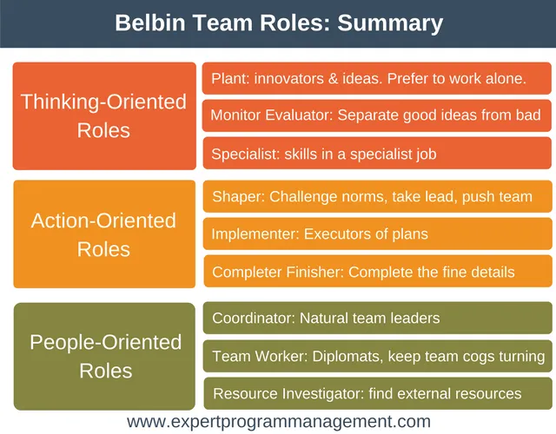

Discussion

In the conducted studies, most of the companies that are looking for an effective way to encourage employees to work in cooperation with others, they not trying the methods discussed in this report. However, some of the companies are already using the efficient work methods, but somehow, it’s not working. Research shows that collaborative problem-solving leads to better outcomes, people are more likely to take calculated risks that lead to innovation if they have the support of a team behind them. Working in a team encourage personal growth, increase job satisfaction, as reduce stress. However, not everyone processes information in the same way. Some people like to jump into problem-solving mode immediately, while others prefer time to gather their thoughts and consider multiple options before contributing. Asking people to provide input asynchronously in a tool like confluence allows everyone the space to work in a way that’s comfortable for them (Tracy Middleton. 2022). The failure of a team can start for several reasons, but the consequences are the same: factions are formed, battle lines are drawn, communication stops, and suspicion rises. Productivity and efficiency drop off sharply and any kind of collaboration or innovation is next to impossible. After experiencing a defeat in the team, employees should encourage the team before they lose hope and the desire to strive for a new challenge. The best way to motivate employees to engage in work and cooperation, is good and promising new future working conditions. Work environment high job security led to better health conditions. Being employed with appropriate working conditions plays a protective role on physical health and psychiatric disorders. (Thomas, et. al, 2016). Employers to keep employees motivated by creating a positive work environment and giving employees opportunities to grow. When employees are motivated, there is retention or reduction in turnover, enthusiasm, and enthusiastic employees out produce and outperform. I know from my personal experience how difficult it is to return to a workplace where you have been disappointed, or you have disappointed someone. The incident happened in Rugby, summer (2018) it was my first day at new workplace. I vas very happy that they gave me a chance, even though they knew that I could not understand them or answer them because of my language skills. I was responsible for orders that day, they thought me for an hour and then left me to work alone because they thought I was ready. That day, not understanding the warning message in the computer screen, I damaged about one hundred different orders. However, when I realized what I had done, it was too late. My boss was very nice and tried to explain in every possible way what not to do next time and that she will take care of it. The next day I was worried about the incident, but the boss and the team were nice and king with me that I felt welcome. With my experience I am trying to make a point that in good workplace where are support, good leader, understanding team and good working conditions they can a accomplish everything.

Conclusion and Recommendation

This report shows ways to increase effectiveness in workplace. Communication is a main tool, no meter what challenges team must face it, they should continue to communicate one with each other. Leader of the team must not only lead the team but also support them on the hard days. Challenges will make them stronger, closer, open to share. Creating right team is not easy, always out there will be better candidates for the work roles, but the trust and commitment will offer not every candidate. In my opinion before hiring new employees for the roles I would use Belbin’s

References

Pfrimmer, D., Twedell, D., (2009). “Teamwork and communication” The Journal of continuing education in nursing, 2009-07, Vol.40 (7), p.294-295 https://librarysearch.uwtsd.ac.uk/discovery/fulldisplay?docid=cdi_proquest_miscellaneous_764398289&context=PC&vid=44WHELF_UWTSD:44WHELF_UWTSD_VU1&lang=en&search_scope=Search_ELEC&adaptor=Primo%20Central&tab=Everything

Davis, B., Welch, K., walsh-Hart, S., Hanseman, D., Petro, M., Gerlach, T., Dorlac< W., Collins, J., Pritts, T., (2014). Military medicine, 2014-08, Vol.179 (8 Suppl), p.19-23
https://librarysearch.uwtsd.ac.uk/discovery/fulldisplay?docid=cdi_proquest_miscellaneous_1552369441&context=PC&vid=44WHELF_UWTSD:44WHELF_UWTSD_VU1&lang=en&search_scope=Search_ELEC&adaptor=Primo%20Central&tab=Everything

Eduardo, S., Scott, T., (2021). 2021; Oxford University Press
https://librarysearch.uwtsd.ac.uk/discovery/fulldisplay?docid=alma99100325534602421&context=L&vid=44WHELF_UWTSD:44WHELF_UWTSD_VU1&lang=en&search_scope=Search_ELEC&adaptor=Local%20Search%20Engine&tab=Everything

Fabian G., Tracey P., Jennifer H. (2016). Team roles : Their relationships to character strengths and job satisfaction
https://www.tandfonline.com/doi/abs/10.1080/17439760.2016.1257051

Human Resources Management Journal (1998). An empirically-based assessment of Belbin’s team roles
https://www.proquest.com/openview/ae50c172f68da4b304dd9d8d7372322d/1?pq-origsite=gscholar&cbl=32736

The George Washington University (1821).
https://www.google.co.uk/url?sa=i&rct=j&q=&esrc=s&source=web&cd=&cad=rja&uact=8&ved=0CAQQw7AJahcKEwiw-onpptv4AhUAAAAAHQAAAAAQAg&url=https%3A%2F%2Fhsrc.himmelfarb.gwu.edu%2Fcgi%2Fviewcontent.cgi%3Freferer%3D%26httpsredir%3D1%26filename%3D0%26article%3D1017%26context%3Delearning%26type%3Dadditional&psig=AOvVaw0fRiy4y5wL218zVhnSrnEF&ust=1656885502478945

By the Mind Tools Content Team (2016). Belbin’s Team Roles

https://www.mindtools.com/pages/article/newLDR_83.htm

Tracy Middleton (2022). The importance of teamwork (as proven by science).
https://www.atlassian.com/blog/teamwork/the-importance-of-teamwork

