Material Science

HND Quantity Surveying

Harri Morgan

1908064

Contents

- Introduction
- Building Choices
- The Leadenhall Building
- The Burj Khalifa
- Durability
- Assembly
- Adaptability
- Environmental Impacts

Introduction
The proposal of this assignment is to report on the original design planning, construction methods and techniques, with consideration to sustainability and their potential environmental impacts of two existing habitable building from around the world. One building is to be concrete construction, and the other steel framed. I aim to analyse the framing material by comparing and contrasting the two buildings. There are three main areas I plan to look into, firstly the environmental conditions the site is exposed to, and how planning ensures their durability and climate resistance. Secondly, the likely impact of the frame materials original production process on the environment. And finally, the frames assembly and its potential ease to adapt to different buildings shape and use.
Building choices
I have decided to focus this assignment on the Burj Khalifa in Dubai, and the Leadenhall Building in the City of London. The Burj Khalifa is a concrete framed construction, with a glass cladding. I decided to use this building as it is the tallest in the world, which had to be designed and planned and constructed by specialists in their field to reach its height. The Leadenhall Building is a steel framed construction, using innovative design to comply with strict building regulations. I decided on these two buildings as they are both one of a kind.

Leadenhall Building. Planning, Construction Techniques
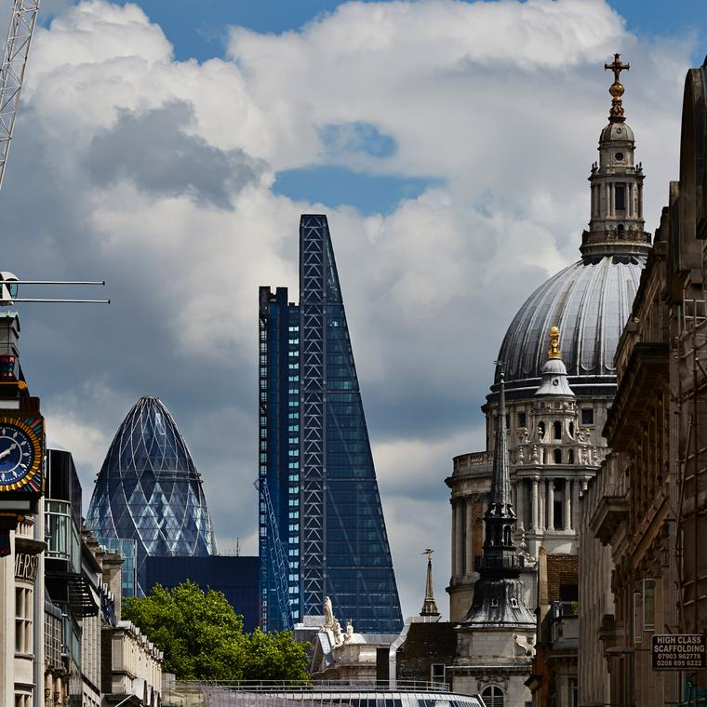

(Google.com, 2015)

The Leadenhall building, located in the city centre of London is a prefabricated steel skyscraper. Its 52 storey’s are used for offices spaces, reaching a height of 736ft tall. The construction of the Leadenhall building started in October 2011, with a 26 month build programme. With over 11,000 pieces of steel to assemble, the time scale for the project was very tight. The Leadenhall buildings tapering shape makes it one of a kind, the design was to ensure it would not interfere or ruin the views of St. Pauls Cathedral.
Every part of the building was prefabricated off site and delivered at the precise moment it needed to be fitted. Due to it being in the city centre, there was no room to store materials, therefore each steel beam was delivered to a strict schedule and fitted immediately. The size on the steel beams also caused issues, to avoid causing mass traffic delay, everything was delivered at night when the road were quiet. This means that the site was working 24 hours of the day.
The 20,000 tonnes of steel, 75,000ft2 of glass panels, concrete floors and labour to complete the project cost $433 million dollars.
The unique shape of the Leadenhall building meant that the upper floors would have less floor area, decreasing the overall profit of the project. In addition to this, due to the shape the design team needed to come up with an innovative design for the services. As there was no central core, all the structural materials were in the steel exoskeleton. The architects on the project created “The North Core”. The north core was built as a separate part of the building holding all of the services, lifts and generators. These like the rest of the building were prefabricated off site, coming fully equipped with all the necessary pipework, plumbing, electrics and floor plates. Due to the north core, there was an enormous weight difference on one side. This caused the building to move out of line up to 20mm, which was known to the planners. To correct this, the building had ‘active alignment’, bracing called ‘notes’ bracing. This enable to entire building to be adjusted by removing or inserting spacers to straighten the building.
To ensure the building would work, and all the steel beams fit perfectly when delivered, the Leadenhall building was created in a 3D model 37 times to avoid costly delays on site. A weekly delay for the Leadenhall building would cost the company $100,000 dollars.
Burj Khalifa. Planning, Construction Techniques
The Burj Khalifa is located in the middle of desert in Dubai, United Arab Emirates. It is the tallest man made building ever, reaching a colossal 828m high. A building of this size costs a large amount to construct. The Burj Khalifa is estimated to cost $1.5 billion dollars. With over 160 storeys, the building is able to accommodate 35,000 people.
Construction on the Burj Khalifa started in 2010, and took 6 years to complete. It was made of reinforced concrete, using a process called ‘Jump Forming’. The process involves a mould for the concrete. Firstly the mould is located where the concrete is going to be poured. Next, steel is inserted in the mould to maximise strength in the concrete. Once the concrete is poured and set, the mould is removed and relocated. This process was repeated the entire way up the building. Due to the high temperature in Dubai, some of the concrete had to be poured at night to avoid it setting too quickly. 165,000m3 of concrete was used in the construction of the Burj Khalifa.
The ‘Y’ shape of the building was inspired by the Hyencallis flower. As the height on the building increased, the building stepped back for the maximum stability and to avoid too much weight.
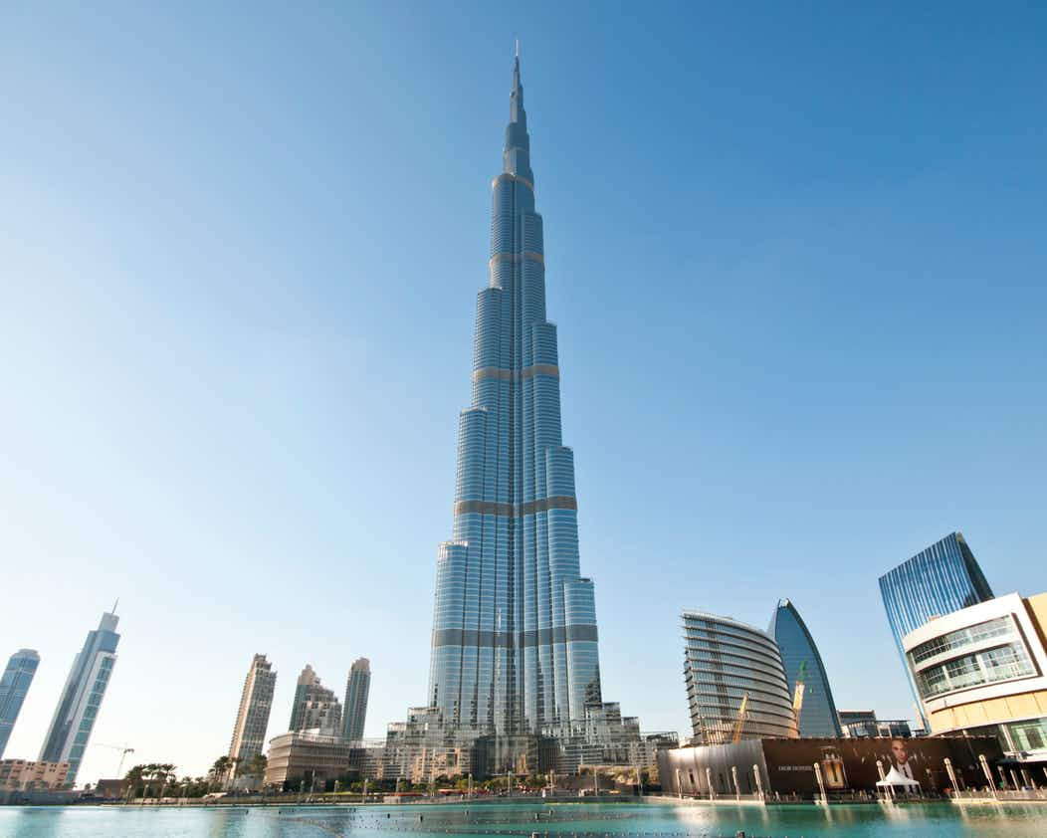
The foundations for the Burj were designed and inserted before the height of the building was finalised. The foundations used were skin friction piles, 192 piles were driven up to 50m into the ground to ensure the building was stable. As the building is located in the desert on soft, sandy ground the foundations needed to be carefully evaluated. When it was decided that the Burj Khalifa would reach 828m, questions were asked whether the foundations would be adequate to sustain the building.
The height of the building caused many problems when it came to considering wind speeds. This caused problems for the crane and the building itself. The Burj Khalifa was designed to withstand high winds at high levels. The shape of the buildings and where the building steps in helps divert the wind around the building. The balcony’s on the building were fitted with wind deflectors to enable to use, and an alarm was fitted in each apartment to warn people when wind speeds were too high for people to go out. Due to the buildings height it could have been exposed to ‘Vortex Shredding’, which an violently move a building, but The Bur Khalifas unusual shape prevented this. The final design change made to the Burj due to wind speeds was the entire building was rotated in line with the prevailing wind direction.
Durability (Google.com, 2014)
The durability of steel is good but can rust and corrode dependant on the buildings location. Salt air and high exposed areas can cause corrosion. As the Leadenhall building is in the city of London corrosion is unlikely. After watching the Leadenhall building documentary it was confirmed that the external steel structure was painted and fire protected, this would increase its life and durability. “Design life predictions for steel framing are in excess of 250 years” (The Steel Construction Institute, 2014). Steel beams have the highest strength-to-weight ratio of any other construction materials, meaning it is incredibly strong without having excess weight.
Similar to steel the durability of concrete can depend on many factors, such as freezing weather, the corrosion of the reinforced steel bars that are put in the concrete. The permeability of the mix will determine concretes durability; if the mix is poor problems can occur. Due to the location of the Burj Khalifa in the deserts of Dubai, it was essential that the cement mix was adequate for the heat. Some of the concrete pours that took place on the Burj Khalifa had to be completed at night when the temperature had reduced. Above 21c the cement begins to dehydrate, gradually weakening the aggregate bond.
Assembly
The assembly of the Leadenhall building was a stressful process. Steel comes pre-fabricated and assembled together on site. Due to its weight, this process involves very large cranes, machinery, and man power to guide the beams into position. The Leadenhall building faced a strict delivery schedule, due to the lack of space on site. The steel beams would be delivered and installed straight away. When the Leadenhall building received deliveries it would be in the middle of the night, to avoid causing city centre traffic. Due to the size of the beams roads would need to be closed for the lorries to be able to make it through the streets of London.
In comparison to steel, concrete is not prefabricated. Concrete is a pourable mixture of cement, sand, coarse aggregates such as gravel and water, therefore assembly can be difficult. Due to concretes little tensile strength, on large scale constructions, reinforced concrete is added to increase its strength. Due to this, the assembly becomes more difficult. There are three stages to concretes assembly, setting, hardening, and hydration. Due to the heat in Duabi where the Burj Khalifa is located a retardant is added to the mixture to help it stay cool, stopping setting to quickly.
Adaptation
The three main principles in a buildings adaptability are;
- Change of buildings use without impacting the structure or flexible building services to enable upgrades.
- Internal flexibility to enable change of use.
- Structural extension to accommodate changing requirements.
The adaptation of steel framed construction can be made rather easy. Due to its assembly and light weight, parts can be taken out, or additional beams put in. As mention earlier in the essay, the Leadenhall building had innovative design for adaptation. The planned ‘active alignment’ ensured that the building could be straightened when the north core was fitted, pulling the building slightly out of line, plus or negative 20mm.
In comparison to steel, concrete is not adaptable. The issue with concrete is once it has set, it cannot be changed, you would need to demolish the building and re-construct if you needed to make drastic adaptions. The main benefit with concrete is that it’s a pourable material, so it can be formed and shaped in any way necessary. If the planning of the building is done with precision and thought, concrete framed structures will serve the purpose of the building and will not need to be adapted.
Environmental Impacts
Due to steels recycling ability it makes it more environmentally friendly in comparison to concrete. Although, steel production does effect the environment in ways such as CO2 air emissions, wastewater contaminations and hazardous waste. “Slag, the limestone and iron ore impurities collected at the top of the molten iron, make up the largest portion of iron-making by-products.” (Anon, 2020). Due to the amount of steel being produced annually, the energy consumption causes a great amount of carbon dioxide emissions, which is not environmentally friendly.
There is now an analyse method to determine the environmental impacts of concrete and steel. “Using the mass of raw material into an operation are quantified and proportioned as to their amounts in either the finished product or in a waste stream. As a result, the portion of the raw materials released into the air can be quantified.” (Bujnak, 2012)
Concrete is one of the most used substances on earth which is not good for the environment. “If the cement industry were a country, it would be the third largest carbon dioxide emitter in the world with up to 2.8bn tonnes.” (Watts, 2020). Concrete is responsible for 4-8% of the worlds CO2, and uses an enormous amount of water. Concrete also increases the heat-island effect by absorbing gases from air-conditioner units and warmth from the sun. In addition to this, the manufacturing process of concrete can cause respiratory diseases such as asthma.
Bibliography
Anon, (2020). Steel Production and Environmental Impacts. [online] Available at: http://www.greenspec.co.uk/building-design/steel-products-and-environmental-impact/ [Accessed 15 Dec. 2019].
Bujnak, J. (2012). Environmental Impacts of Steel and Concrete as Building Materials. [online] p.2. Available at: http://file:///F:/University/Science%20&%20Materials/Assignment%201/Enviromental%20impacts.%20Steel%20and%20concrete.pdf [Accessed 8 Dec. 2019].
Democracy.york.gov.uk. (2015). [online] Available at: https://democracy.york.gov.uk/documents/s4858/Annex%20E%20Sustainable%20Development.pdf [Accessed 19 Dec. 2016].
Google.com. (2014). burj khalifa - Google Search. [online] Available at: https://www.google.com/search?biw=1366&bih=657&tbm=isch&sa=1&ei=AMcdXpz6L9uT8gKMg7CwCQ&q=burj+khalifa&oq=burj+&gs_l=img.3.0.0i67l6j0l4.102857.103374..104193...0.0..0.92.471.6......0....1..gws-wiz-img.Nhd0-In1eTs#imgrc=_ZZXTpZ-Aqw_CM: [Accessed 14 Jan. 2020].
Google.com. (2015). Leadenhall building - Google Search. [online] Available at: https://www.google.com/search?q=Leadenhall+building&source=lnms&tbm=isch&sa=X&ved=2ahUKEwjz7KTtnYPnAhUDonEKHYZjDJIQ_AUoAXoECBEQAw&biw=1366&bih=657#imgrc=j588mGAOi_FZ-M: [Accessed 14 Jan. 2020].
Products, A. (2019). Connections in construction: reinforced concrete frames. [online] Ancon Ltd. Available at: https://www.ancon.co.uk/blog/connections-in-construction-reinforced-concrete-frames [Accessed 2 Dec. 2019].
redbox, R. (2018). The Leadenhall Building - Rogers Stirk Harbour + Partners. [online] Rsh-p.com. Available at: https://www.rsh-p.com/projects/the-leadenhall-building/ [Accessed 16 Dec. 2019].
REINFORCED CONCRETE FRAME CONSTRUCTION Ahmet Yakut, Middle Est Technical University, Turkey.
The Steel Construction Institute (2014). Durability of Light Steel Construciton. Ascot, p.1.
Watts, J. (2020). Concrete: the most destructive material on Earth. [online] the Guardian. Available at: https://www.theguardian.com/cities/2019/feb/25/concrete-the-most-destructive-material-on-earth [Accessed 6 Jan. 2020].
www.steelconstruction.info. (2018). Sustainability. [online] Available at: https://www.steelconstruction.info/Sustainability#Steel_and_sustainable_construction [Accessed 7 Dec. 2019].
Youtube.com. (2017). YouTube. [online] Available at: https://www.youtube.com/watch?v=eg0PqkwPzVA [Accessed 16 Dec. 2019].
Youtube.com. (2017). YouTube. [online] Available at: https://www.youtube.com/watch?v=GA3Ak7ZaNUo [Accessed 7 Dec. 2019].

