Route sample paper

Name :
Student ID :
Date & Time :

This is an group practical lab-test, held under examination conditions. You will be assigned three Routers, you should configure these Routers based on the following specifications.

The routers that you will configure are: Cardiff, London, and ISP.

This paper is marked out of 100.

You will have 2 hours to complete this task.

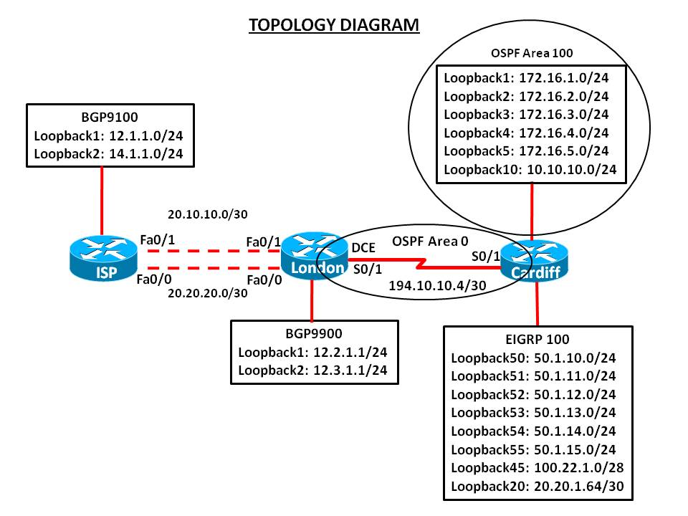

Addressing Scheme Table

Device | Interface | IP Address
CARDIFF | Serial 0/1 | 194.10.10.5 /30
 | Loopback 1 | 172.16.1.1/24
 | Loopback 2 | 172.16.2.1/24
 | Loopback 3 | 172.16.3.1 /24
 | Loopback 4 | 172.16.4.1/24
 | Loopback 5 | 172.16.5.1/24
 | Loopback 10 | 10.10.10.1 /24
 | Loopback 20 | 20.20.1.65/30
 | Loopback 45 | 100.22.1.1 /28
 | Loopback 50 | 50.1.10.1 /24
 | Loopback 51 | 50.1.11.1 /24
 | Loopback 52 | 50.1.12.1 /24
 | Loopback 53 | 50.1.13.1 /24
 | Loopback 54 | 50.1.14.1 /24
 | Loopback 55 | 50.1.15.1 /24
LONDON | Serial 0/1 | 194.10.10.6/30
 | Loopback 1 | 12.2.1.1 /24
 | Loopback2 | 12.3.1.1/24
 | Fast Ethernet 0/0 | 20.20.20.2 /30
 | Fast Ethernet 0/1 | 20.10.10.2 /30
ISP | Fast Ethernet 0/0 | 20.20.20.1 /30
 | Fast Ethernet 0/1 | 20.10.10.1 /30
 | Loopback 1 | 12.1.1.1 /24
 | Loopback 2 | 14.1.1.1 /24

Requirements:

Task 1 – Network Connections (15 marks)

Physically cable the network as shown in the topology diagram.

Configure the router with hostname, Passwords (Console, Vty and privilege EXEC), line description, banner, disable DNS lookup, and synchronous logging.

Configure interfaces on all routers and verify IP addressing.

Task 2 – Configure Routing (60 marks)

CARDIFF

Configure the router to be in EIGRP AS 100. Add all networks as shown in the diagram. Ensure that your network statements are as specific as possible. Disable automatic summarisation.

Configure OSPF Area 0 on the link between Cardiff and London as shown in the diagram. Ensure that your network statements are as specific as possible.

Configure OSPF Area 100 and add all networks as shown in the diagram. Ensure that your network statements are as specific as possible.

Make sure that all Loopback interfaces are advertised with the correct mask in OSPF.

Configure the Cardiff router to always originate a default route into the OSPF domain.

Redistribute OSPF into EIGRP. Use the following metrics: bandwidth 10000, delay 100, reliability 255/255, load 1/255 and MTU 1500

Redistribute EIGRP into OSPF. Use appropriate metrics.

Configure a manual summarization on London’s serial 0/0 interface for all networks in EIGRP 101. Use the most efficient mask.

Configure London router as DHCP server with following details: DHCP pool for the subnet 172.16.111.0/24, domain name: cisco.com, lease time of 1day 20hrs and 40mins and exclude address range 172.16.111.100 to 172.16.111.150.

LONDON

Configure OSPF Area 0 on the link between London and Cardiff as shown in the diagram. Ensure that your network statements are as specific as possible. Disable automatic summarisation

Configure the Cardiff router to be in BGP AS 9900. Peer the ISP router on both Fast-Ethernet links.

Configure London router to use 12.1.1.0/24 as its default network.

Make the London router prefer the 20.10.10.0 /30 link to the ISP for outbound and inbound traffic by modifying the Local Pref and MED attributes.

ISP

Configure the ISP router to be in BGP AS 9100. Peer the London router on both fast-Ethernet links. Disable automatic summarisation.

Configure the ISP router with a static default route to London router on both Fast-Ethernet links. Make sure these route acts a back-up to BGP.

Task 3 – Route Filter (20 Marks)

London
Configure London router with inbound filter to remove BGP advertised network 14.1.1.0/24

Cardiff
Configure cardiff router to filter updates from Cardiff to London, allowing only the EIGRP summary route and loopback 45 and loopback 20 to be advertised. Use more specific prefixes.

Submission Requirements (5 marks):

All documentation for your solution should be submitted. Your name should be clearly printed on the documents, and signed.

At the end of the test a flash memory will be given to you, the configuration files for all routers should be copied to the media and handed in to your instructor.

The file name should be studentname_ID_routername.txt

Show running-configuration
Show ip interface brief
Show ip route
Show ip protocols
Show ip bgp

