Customers Loyalty Program vs Customer Retention Program

Article by the TADA organisation.
Topics:
Customer Behavior
Customer Retention
Nov 5, 2019 •
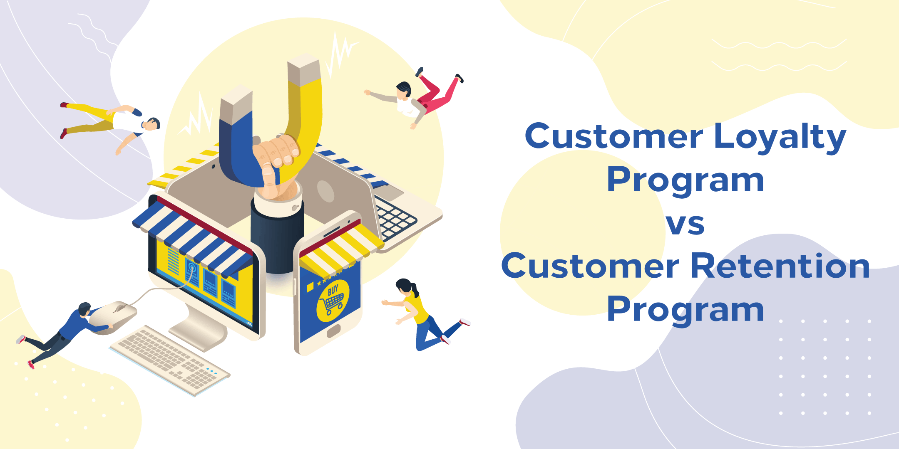
Customers are the lifeline of any business. Undoubtedly new customers are important for the growth of a business, but it is also vital not to ignore prevailing customers.
Nowadays, customer retention is at the lead of every company’s strategy. There are several effective customer retention techniques, and one of them is customer loyalty program.
Many people often get confused between customer retention and customer loyalty program. So in this post, we will read about these two programs in detail.

Customer Loyalty Vs Customer Retention
Customer Loyalty is when a customer will not only buy from you again and again but also encourages others to do the same. This results in positive word-of-mouth reviews and quality referrals. Loyal customers not just vouch for you but also serve as advocates for your business.
On the other hand, customer retention means retaining loyal customers over a while. The percentage of Customer Retention is measured by how many customers a company keeps at a specific period of time and the number impacted by the new customers acquired and the number of churned customers.
While both programs share some similarities, but when defining customers, they can’t be used conversely.

Importance of Customer Loyalty and Customer Retention
According to a Garter Group study, 20% of the existing customer base generates 80% of the business profit. It means a small rise in customer loyalty can boost your profits dramatically. The buying journey of a customer starts before they directly engage with a brand.
Existing customers can endorse a brand and therefore promote it to their friends through word-of-mouth. According to a report of Accenture, 31% of existing customers like to recommend brands to others. This lessens advertising as well as marketing costs.

Best Practice of Loyalty Program
The aim of your customer loyalty program should be precise. Choose the things that will have a significant impact on your customers. The success of your loyalty program depends on your ability to make correct choices. If you define clear goals and choose the right direction during the initial state, the success of your loyalty program falls into place.
The best way to keep your customers engaged is by offering them new and interesting products. Membership and subscription services help customers to decide what to buy and also keep them updated. Moreover, they also encourage personalized engagement and repeat visits.
Building engagement is one of the best strategies to retain customers. So, make sure to create, send and manage digital rewards to your potential customers. When you integrate rewards with your offering, it builds an active and strong engagement.
One of the best ways to win the trust of new customers is word-of-mouth. It is the best sales channel for any business. You can start a referral and reseller program in which your loyal customers refer and sell your products and services in return for rewards like E-gift Card, Corporate Card, Rewards Link or Marketplace API.

