

Name: Vency Deepak Jain
Candidate ID: 2239376
Subject: Digital Marketing
Subject Code: LCMB7010
professor: Amitave Banik
Submission Date: 18th Dec 2023

DIGITAL MARKETING
TK MAXX
1.Introduction 3
1.1 Company overview 3
1.2 Review of the company 4
2.Analyses of company retail business 4
2.1 Digital transformation of company 4
2.2 External and Internal structural Flow 6
3.Digital Assets 8
3.1 Digital marketing Platforms 14
4.Digital marketing plans 18
4.1 SOSTAC Analyses 18
4.2 Segmentation, Targeting and positioning 21
4.3 Marketing Mix 23
4.3 Sweet spot 27
5 AI and ML tools in Digital marketing 27
5.1 Role of AI and ML in digital marketing 27
5.2 Machine learning power 29
5.3 Segmentation in Machine Learning…………………………………………………………………………… …….. 30
5.4 ROI and ROS……………………………………………………………………………………………………………… ……… 31
6 Recommendations 31
7 Conclusions 32
8 References 33

- INTRODUCTION
Digital marketing was first described as an online extension of traditional marketing, complete with tools and strategies. But because of the distinct qualities of the digital realm and the way it is used for marketing, new channels, formats, and languages have been developed, which has resulted in the development of tools and strategies that are unthinkable in the offline world. In the twenty-first century, the majority of firms have established an internet presence. People used email extensively, and because to technology, they could handle it with relative ease. Customer relationship management (CRM) solutions have always included database administration as a feature. When certain firms posted banners on websites, it was analogous to press advertising. Digital marketing has emerged as a distinct trend that blends modification with broad distribution to accomplish marketing goals, no longer being a part of standard marketing. A new concept of digital marketing that is focused on users, more quantitative, ubiquitous, and interactive has been pushed forward by the explosion of gadgets and technological convergence.. (Pineiro et al.2016).

  - Company Overview
The TK Maxx and Home Sense brands are a part of TJX Europe, which also includes TK Maxx. The TJX Companies, Inc. includes TJX Europe. T.K. Maxx is the first brick-and-mortar, off-price clothing and home goods shop of considerable scale in Europe. It was founded in 1994 and brought discount retailing to the United Kingdom and Ireland. In addition to Poland in 2009, Austria and the Netherlands in 2015, T.K. Maxx also opened stores in Germany in 2007(TJX, 2019).

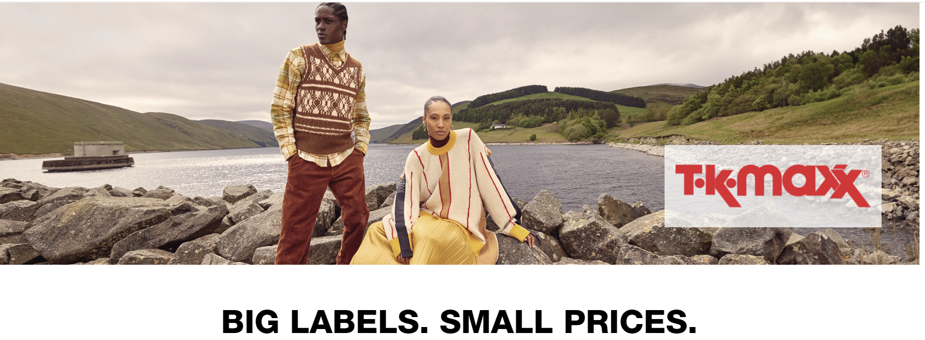Source: TJX (2019)
T.K. Maxx runs online stores in Germany, Austria, and the United Kingdom in addition to its physical locations. There are Home sense outlets in Ireland and the United Kingdom. TK Maxx has grown throughout Europe, during the past 20 years (TK Maxx,2022).
Tk maxx stores across Europe

Source: TK Maxx (2022)
  - Review of the company
TK MAXX has subtly surpassed Topshop to rank as the sixth-biggest fashion group in the UK. The majority of the stock is overstocks, cancelled orders, and surplus manufacturing, and it originates from 21,000 different sources worldwide. A little quantity is produced particularly for the chain's own labels, Arabella, Addison, and Amaryllis, or for brands that it owns (Butler, S., 2020).
- ANALYSES OF COMPANY RETAIL BUSINESS

  - Digital transformation of company

Digital marketing is a type of direct marketing that uses interactive technology like emails, websites, and social networks to electronically link customers and sellers. Online discussion boards in addition to newsgroups, interactive TV, and mobile correspondence, etc (Kotler et al.2009). Because of its high degree of connectedness, digital marketing allows for many-to-many communications and is typically used to sell goods and services in an efficient, timely, pertinent, and cost-effective way (Baines, et al. 2013). The firm launched a digital platform early on, but in order to thrive in the cutthroat industry, it is totally committed to using digital technology to keep in touch with its clients.

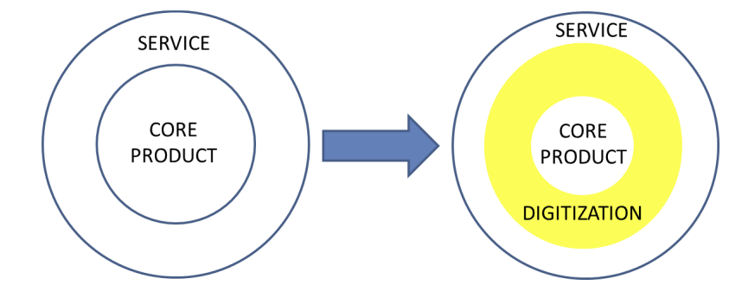
Figure: Digital Augmentation and Transformation of Product
Source: (Rathnayaka, U. 2018).

Figure 1: Mind map for the role played by Digital Marketing
Source: (Rathnayaka, U. 2018)

  - External and internal structural flow

STARTEGY
- Marketing Strategy
- Customer Loyalty Programs
- Store Layout and Design
- Supply Chain Efficiency

PARTNERS
- Government
- Country Branches
- Subsidiary partners
- NGO’s

CULTURAL FACTORS
- Macro analyses
- Suppliers
- Buyers
- Competitors
- Substitutes
- Government
- Marketing Intermediaries

STRUCTURE
- History
- Industry lifecycle
- Stake holders, partners, countries, Company Branches
- Use of Digital Technology
TK Maxx
Sub co.

TJX COMPANY

Parental co.

Company System
- Point of sale
- Inventory management
- CRM
- SEO
- MIS
- Google analytics

CRM
- Contact Info
- Purchase History
- Account Info.
- Customer Interactions
- Customer Support Records

MIS
- Transaction data
- Employee Data
- Financial data
- Marketing data
- Customer feedback
- Sales & supply chain data

Figure: Internal and external structural flow of Company
Source: Myself

- Internal Structural flow
- Strategy
planning strategically by the top management. Cooperation between the finance, sales, operations, and other areas. Coordinating marketing tactics with overarching company objectives. Planning and executing customer loyalty programs will need behavior analysis and strategy development. Choosing the right retail layout will draw in more consumers and boost revenue. To organize a more efficient and successful supply chain

- System
The system, or internal organization of the business, consists of Google Analytics, CRM, SEO, MIS, inventory management, and point of sale.
CRM stores verify corporate data, enabling businesses to stay in touch with their customers and understand their behaviour, both of which boost sales. (Novak, J. 2023)
MIS is another essential business system that houses vital information on the company's finances, personnel, and other aspects.

- Culture
A company's internal components and procedures are carefully examined as part of a micro analysis. To find strengths, shortcomings, and opportunities for growth, this entails closely examining specific departments, teams, and operational procedures. At a detailed level, financial microanalysis evaluates income streams, spending trends, and budget allocation. Micro analysis in marketing is assessing the success of market segments, target audience reactions, and particular campaigns. The micro analysis of human resources explores the contributions, skill sets, and general team dynamics of individual employees (Nguyen, S. 2019).

- External Structural flow
- Culture
Macro analysis is the process of looking at an organization's external environment from a wide angle in order to identify general patterns and elements that may have an influence on its operations. This include researching the state of the economy, market dynamics globally, industry developments, and regulatory changes. An organization may better predict opportunities and risks, match its plans to the state of the market, and adjust to changes in the business environment by conducting a macro-level study. A corporation may remain competitive and resilient in the face of external changes by taking these larger-scale effects into account when making decisions regarding its general direction, investments, and risk management techniques (Nguyen, S. 2019).

- Strategy
One important external component that directly affects a company's contacts with the market and consumers is its marketing strategy. A company's value proposition, target audience engagement, and product or service positioning are all part of its marketing strategy. It includes components that are visible to the outside world, such branding, promotions, price, distribution routes, and advertising. An effective marketing plan may adapt to outside trends and competitive pressures, change market share, and affect customer perceptions. A company's marketing strategy becomes a powerful external force that enhances its overall success and competitiveness in the market by efficiently addressing consumer wants and market expectations.

- Structure
Long-term success for organizations depends on their ability to comprehend and adjust to the influence of digital technology as an external element. It necessitates constant observation of cybersecurity precautions, technical developments, and tactical alignment with market trends in digital technology. Businesses may adapt to changing consumer expectations, obtain a competitive edge, and spur industry innovation by utilizing digital technology well.

- Digital Assets

In general, everything that is digitally generated and saved, recognizable and discoverable, and
valuable is considered a digital asset. Digital assets are becoming more and more valued as technology becomes more and more integrated into both our personal and professional life. For a long time, data, images, videos, written content, as well as others have all been considered
digital assets with ownership rights (Frankenfield, J.2022).

Figure: Digital Assets of company

- Company website

Stores, websites, and mobile applications are operated by TJX Companies, Inc. and its affiliates (collectively, 'TJX', 'we', 'us', or 'our'). The personal data we gather or create about our customers in-store, online, or through mobile apps is covered by this privacy statement. The company's website is its most important asset. Since it serves as the company's face value and the hub for all digital business promotion operations.

- MIS
A marketing information system consists of people, tools, and procedures for gathering, classifying, analysing, evaluating, and distributing accurate, timely, and necessary information to marketing decision makers Source (Kotler et al. 2015).
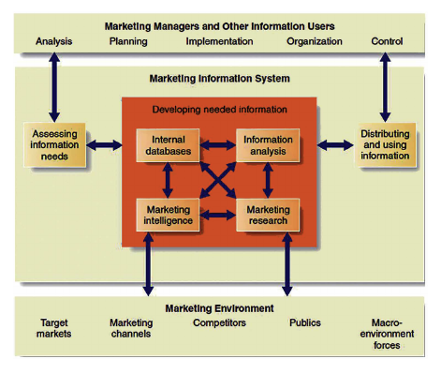
Figure: Marketing Information System Model
Source: Kotler, P., & Keller, K. (2015).

By giving timely and pertinent information, the MIS seeks to assist TK Maxx in improving overall business performance, optimizing marketing tactics, and responding to changes in the market. In order to satisfy changing company demands, regular upgrades and improvements are necessary.

- Google Analytics
A free web analytics tool called Google Analytics offers information and basic analytical capabilities for marketing and search engine optimization (SEO). With Google Analytics, website performance and visitor data are tracked and evaluated.
Google Analytics employs page tags to collect user data from each website visitor. JavaScript page tags have been added to every page's code. Every visitor’s knowledge is gathered by Google's data collecting servers using this tag, which is embedded into their browser. Subsequently, Google Analytics could offer tailored reports that monitor and exhibit data on website traffic, typical session lengths, sessions by route, page views, and additional subjects (Simplilearn, 2022)
By monitoring important onsite behaviour indicators, you may compare the performance of your website to that of your rivals. 14.63 million visitors to tkmaxx.com occurred in November, with an average session lasting 10:13 minutes. Traffic to tkmaxx.com has grown by 16.42% as compared to October. (Semrush,2023)

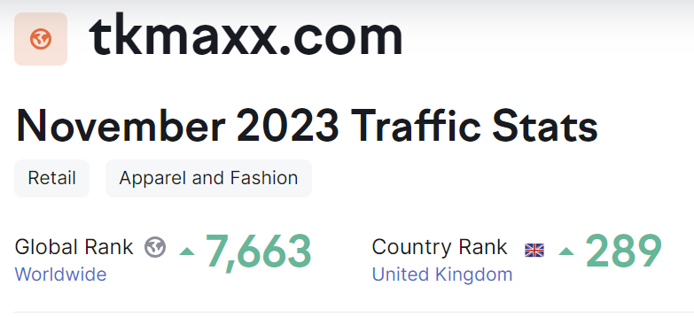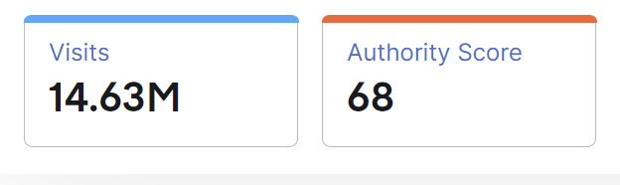

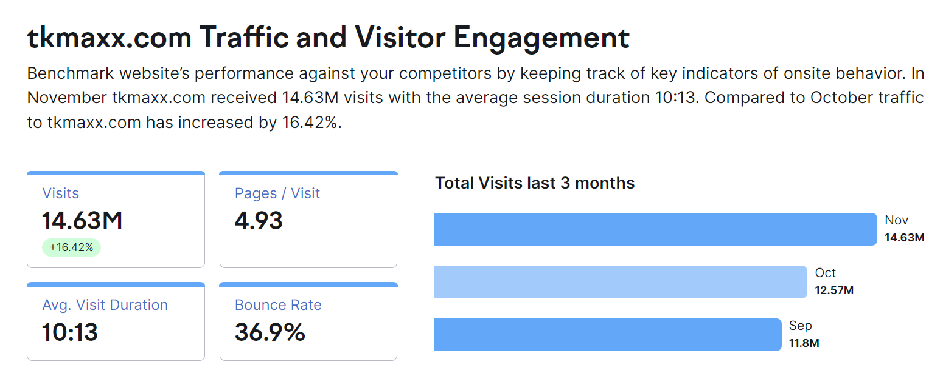
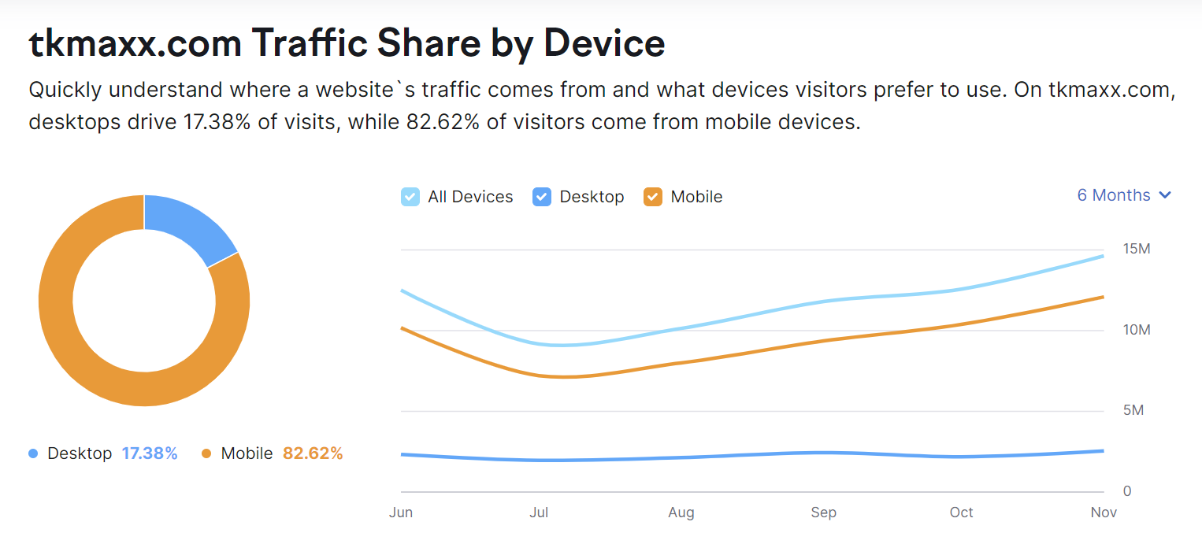
Source: (Semrush,2023)

- SEO

Enhancing your website to appear in search results on Google, Yahoo, Bing, or any other search engine in a natural or sustainable manner is the essence of search engine optimization, or SEO. To guarantee that only relevant results show up, Google updates its algorithms often. A number of experts claim that SEO is no longer relevant and that it is useless. In actuality, though, Google works to stop algorithm manipulation and removes websites that don't belong at the top of search engine results pages (Bala, et al. 2018).
It's critical that TK Maxx keeps informed of algorithm modifications and industry developments in order to modify its SEO approach appropriately. Expert advice or working together with SEO specialists can yield tailored insights based on current trends and particular business objectives.

- Customer relationship management (CRM)

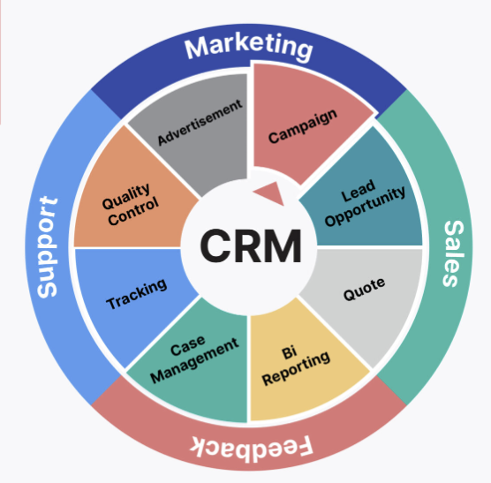
Source: (Rimi 2021).
CRM is an integrated information system that helps businesses organize, manage, and arrange their pre- and post-sale operations. CRM includes contact centers, sales teams, marketing campaigns, technical support, and field service, among other facets of working with potential clients and customers. CRM's main objective is to increase long-term growth and profitability by better comprehending consumer behaviour. CRM seeks to enhance integration and offer more useful feedback so that users may assess the return on investment (ROI) in these areas more accurately (Buttle, et al. 2015)
Businesses must move from transactional marketing, which entails a value exchange between two or more parties, to relationship-based marketing, which focuses on creating a lasting, fulfilling connection between the parties to a transaction. By building a relationship with students, TK Maxx hopes to engage their marketing campaign in a way that will make them feel a connection to the company and encourage them to make purchases from TK Maxx long after they graduate from college (Aka, et al. 2016)

- Digital Security Measures
TK Maxx keep the necessary organizational and technical safeguards in place to guard against accidental or illegal destruction, as well as accidental loss, modification, unauthorised disclosure, and access to personal information. Nothing in this notice should be interpreted as a guarantee, either explicit or implicit, against theft, abuse, or unapproved access, disclosure, modification, or destruction. Nevertheless, we cannot guarantee the efficacy of these protections.
Contractually, service providers who may need access to your information to perform services on our behalf are required to maintain the confidentiality of such information, put in place suitable data security measures, and refrain from using it for any other reason (TK Maxx ,2022).
- Cookies
Like many businesses, we may use "cookies" on our websites. Text files known as cookies are stored on your computer's hard disk when you visit particular websites. Cookies may be used by us to determine things like whether you are a new visitor or if you have visited us previously as well as to determine which site features you would find most interesting.
We may use 'web beacons' on certain of our websites (sometimes referred to as Internet tags, pixel tags, and clear GIFs). These web beacons make it possible for third parties to get data about the computer that downloaded the page with the beacon, the URL of the page with the beacon, the time the page was viewed, the kind of browser used to view the page, and the data contained in third-party cookies (TK Maxx ,2022).
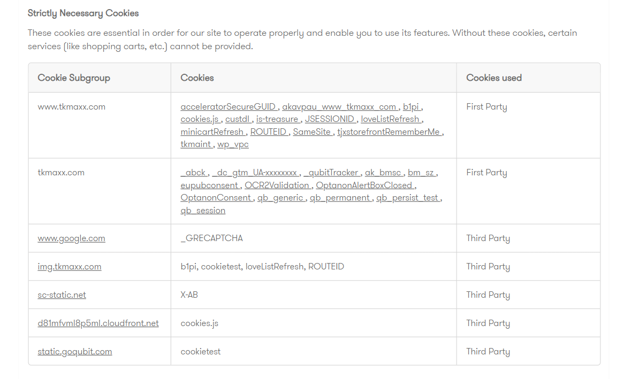
Source: TK Maxx (2022). Privacy & Cookie Policy

  - Digital Marketing Platforms

Figure: Digital marketing Platforms of the company
- Website
Since TK Maxx's devoted customer base will frequent the website often, it will be essential to use it for this campaign A banner advertising the campaign will be shown in the website header, and a "Uni Looks" section featuring readily available merchandise will be included.
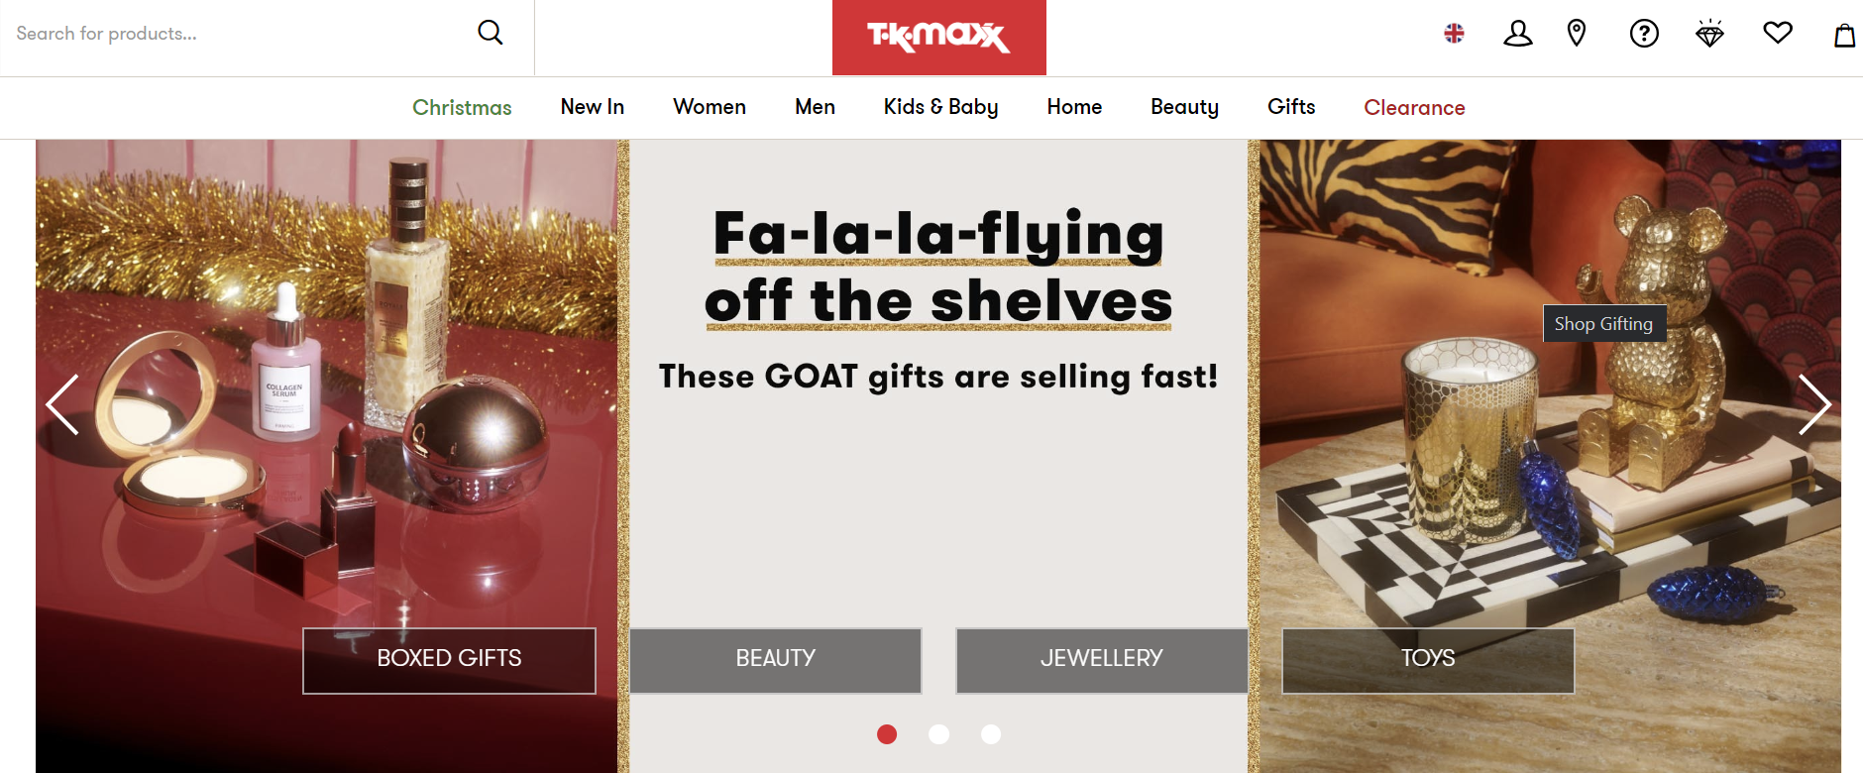

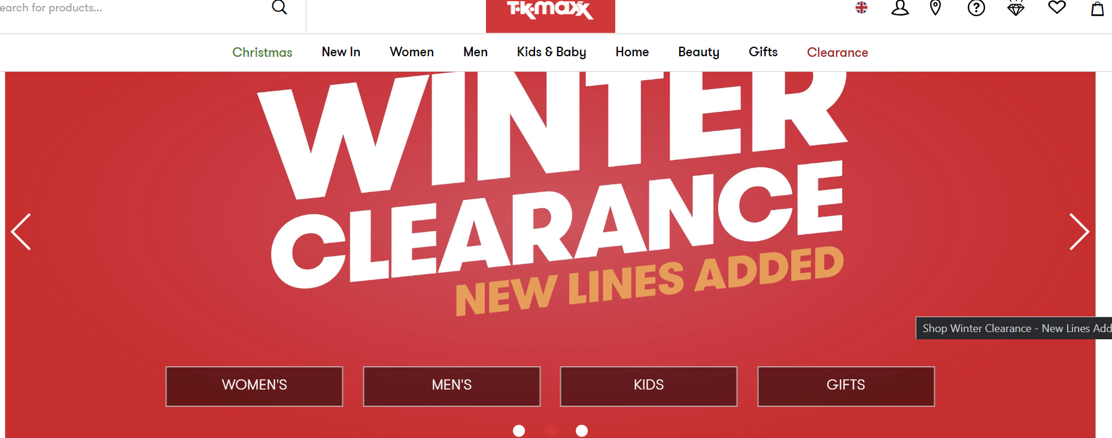
Source: TK Maxx

- Social media marketing

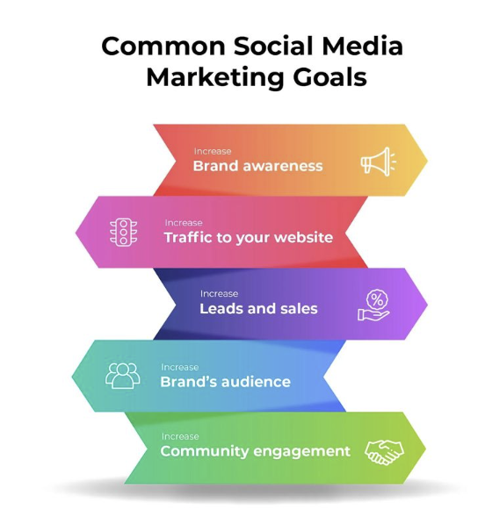
Source: Calvello, M. (2023)

SMM, or search engine marketing's offshoot, social media marketing. It involves using social media sites to drive more people to your websites or enterprises, such as Facebook, Instagram, Twitter, Pinterest, Google+, LinkedIn, and others. Your social media marketing efforts might specifically help with revenues and branding. Because social media has significantly altered the means and methods for communicating with customers, businesses must learn how to utilize social media in a way that is consistent with their company strategy. (Mangold, et al. 2009)
TK Maxx uses marketing extremely well to draw in customers and build brand recognition. Their YouTube channel mostly consists of media coverage, with all of their campaigns trending and rapidly gaining viewers.

- Email marketing

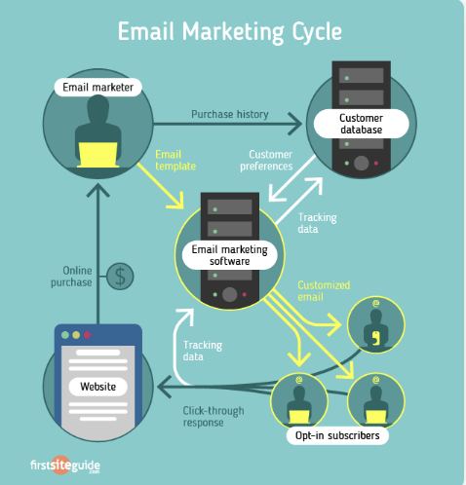
Source:Minaev, A. (2017).
Updates on the student collection and events, such Winchester Fashion Week, will be sent to brand email list subscribers. Email sign-ups will collect customer data from TK Maxx, generating valuable insights for future marketing campaigns.

- Digital Loyalty programme
Through its treasure card loyalty program, TK Maxx cultivates a loyal customer base by offering them incentives and presents.

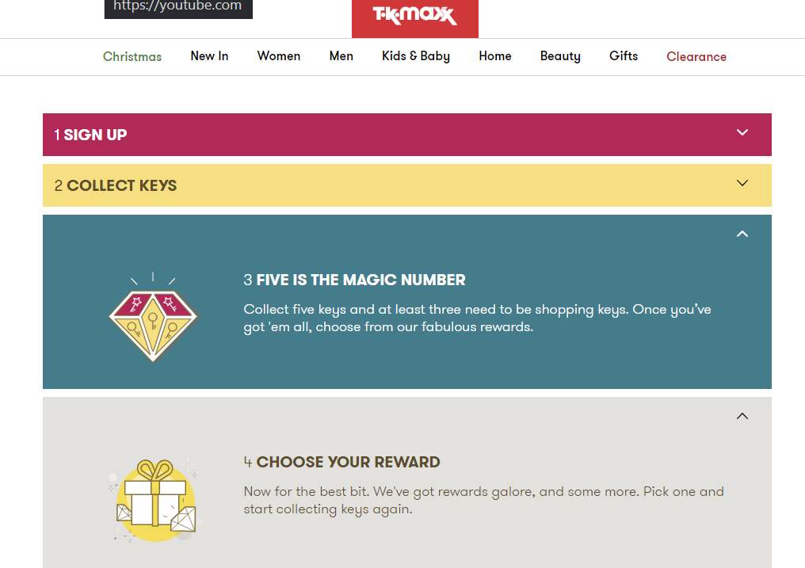

- Influencer marketing
Prioritize real content that showcases influencers' sincere experiences with TK Maxx merchandise. Motivate influencers to produce aesthetically pleasing and captivating content that highlights TK Maxx merchandise. Make use of influencers to weave TK Maxx into their lifestyle by having them share captivating tales about the brand.

- Popup Adds
In order for TK Maxx to establish a direct marketing channel and communicate updates with prospective consumers, certain popups are designed to collect email subscribers. Effectively crafted popups have the potential to improve user experience by offering pertinent information or aiding in navigation.

- DIGITAL MARKETING PLAN

  - SOSTAC Analyses

Source: (Wijaya, et al. 2018).

- Situation
Market Overview: TK Maxx is a retailer in the off-price market that offers a variety of reduced designer and name-brand items at a discount.
Competitive Landscape: Examine rivals like Marshalls, Ross, and additional off-price stores.

- Objectives

The goals of the process strategy model are crucial elements. For businesses to help achieve their goals, they need a foundation. The 5S (Sell, Serve, Speak, Save and Sizzle) Among the tools is the structure we may use to set clear, quantifiable, and attainable objectives.
Sell: Sell describes the strategy used by the brand to generate income and profit. (Chaffey, D. 2018). Tk Maxx does this through its online sales, where it offers countless specials on merchandise. Nevertheless, TK Maxx delivery is more costly than that of its rivals, costing £3.99 for normal delivery and £6.99 for next-day delivery.
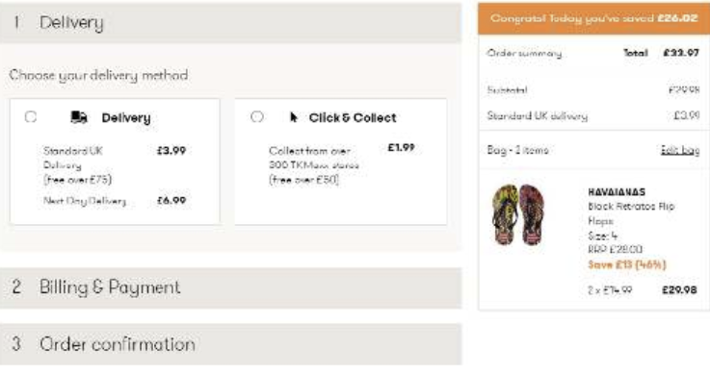
Figure: TK maxx payment

- Speak: The phrase "gets closer to the consumer through dialogue and participation" describes how a brand "speaks." There aren't many ways that TK Maxx "speaks" to its customers; the retailer doesn't have an offline magazine or blog that may drive customers to its website. TK Maxx does, however, offer a YouTube channel with videos like "Last Minute Shopping Tips" and "Beauty Blogger Tips." This makes it possible for customers to get ideas and inspiration from TK Maxx, which then motivates them to visit the store without having to browse the online or in-store (Chaffey, D. 2018).

- Serve: One method that brands may "add value" is by serving. that evaluating your level of customer service proficiency and making additional improvements is a crucial objective. Regarding TK Maxx, they presently allow customers to voice concerns, questions, and general "help" on their Twitter feed. That evaluating your level of customer service proficiency and making additional improvements is a crucial objective (Chaffey, D. 2018). Regarding TK Maxx, they presently allow customers to voice concerns, questions, and general "help" on their Twitter feed.

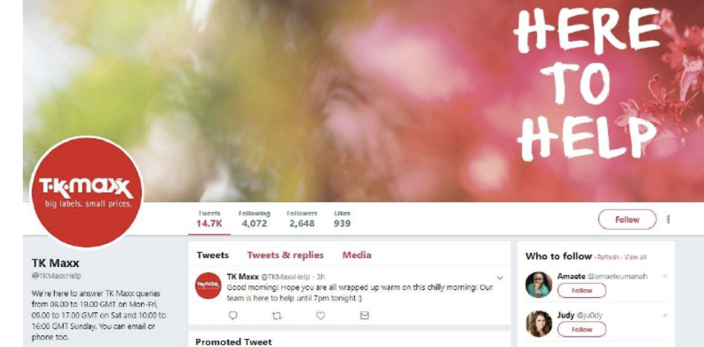
Figure: TK Maxx Twitter page

- Save: There are ways for firms to save money on marketing, such sending out print publications and using the post. Since TK Maxx doesn't have a magazine at the moment, it's possible that the company is already saving money on these expenses; however, spending these funds on web content rather than print can help "build your brand and social media engagement" (Chaffey, D. 2018).

- Sizzle: To establish a "Sizzle" for TK Maxx, there are a few ways to boost the store. One is to allow customers to order with free delivery, or you can create an online blog that inspires and gives idea s all year long. By doing so, you can save money on "print" costs and increase traffic to the TK Maxx website.

- Strategy
The plan that is to be developed has to centre around the previously established objectives. The long-term phase of the e-marketing plan outlines the advancements required to meet the specified objectives. (Wijaya, et al. 2018).

- Tactics
To achieve these aims, tactics must be put into practice after the strategy has been devised as part of the e-marketing planning process (Wijaya, et al. 2018).

- Action
It is the last part of the e-marketing planning process that outlines the tasks that must be completed in line with the methods and approaches that are prepared to be used to carry out the plan (Wijaya, et al. 2018).
- Control
The purpose of this step is to keep track of client thoughts and viewpoints. The control step is carried out by routinely assessing if the deployed e-marketing application has yet to achieve the declared objective (Wijaya, et al. 2018).

  - Segmentation, targeting & Positioning

- Segmentation

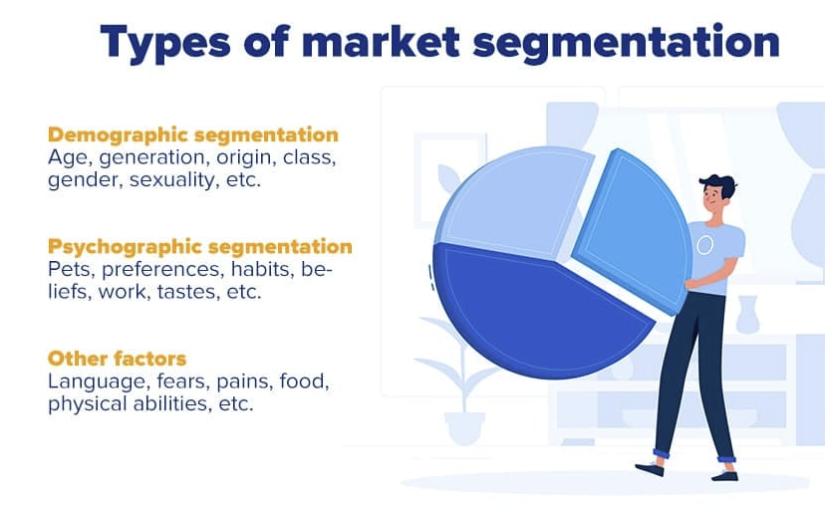
Source: Fleetwood, D. (2018).

When it comes to T.K. Maxx, this segmentation strategy is the most appropriate. As discount merchants, they target customers who are interested in designer and luxury items but have relatively low incomes. Another component is age and gender; although all age groups and genders are addressed, they are targeted differently through the different sections, such as children's, women's, and men's (O’Grady, L. 2015).

- Targeting
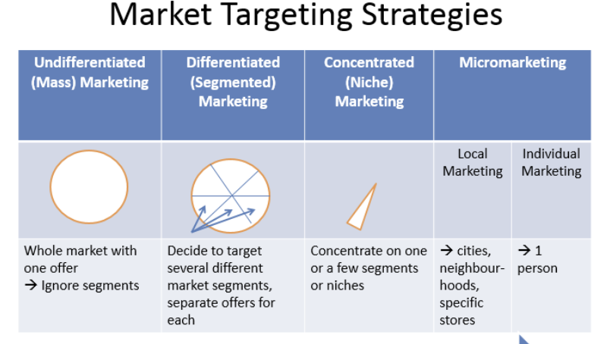
Source: Max (2015).
'Offering a choice of diverse items for the different consumer categories' is the basis of T.K. Maxx's unique marketing strategy. It incorporates homogeneous marketing's greatest elements, which aim to appeal to all groups with the same product and overlooks variations between them, and focused marketing, which specializes in a specific market.
By providing various products for men, women, and children of all ages, the firm employs differentiated marketing, which is evident in the way it uses demographic market segmentation. Targeting teens and young adults, there's also a section called 'modbox' within the men's and women's clothes areas. In addition to clothing, there are sales on toys, household goods, cosmetics, and accessories, each of which caters to a certain clientele. Different strategies are used to market each area in order to align with the preferences of the intended clientele. A portion of this is accomplished by the variously coloured posters and signage that are positioned above each area (O’Grady, L. 2015).
- Positioning

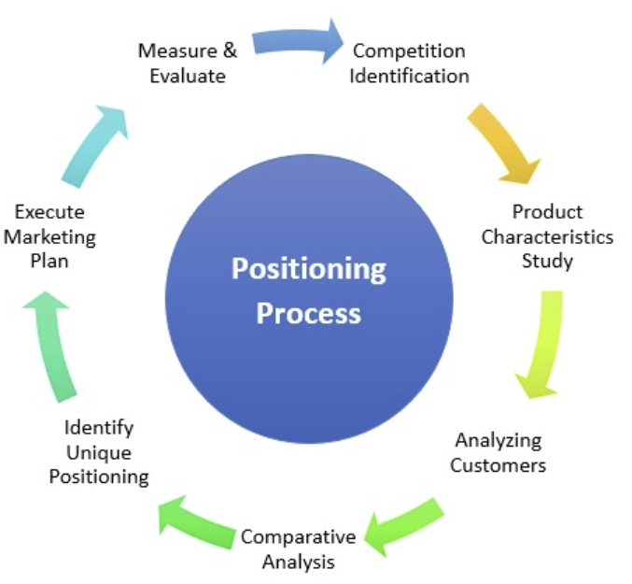
Source: Zigu (2011).

The consumer determines positioning. The client is in charge if they believe that T.K. Maxx's product selection is either too expensive or of low quality. T.K. Maxx, in my perspective, is positioned well overall but in a mixed manner. I discover that some individuals are still ignorant of the T.K. Maxx method and, as a result, believe that things are phony or of inferior quality, even in spite of the retailer's aggressive advertising campaigns. This, in my opinion, is a result of Ireland having so few T.K. Maxx locations.
In the end, T.K. Maxx has chosen its ideal stance and is effectively showcasing its competitive advantages through well-spent advertising. We can gauge T.K. Maxx's positioning by looking at its global success and standing as one of the top bargain retailers for high-quality branded products (O’Grady, L. 2015).

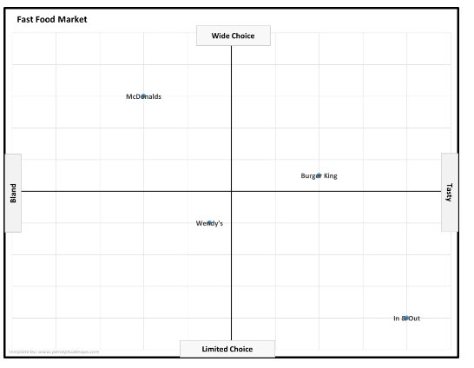
Kitchen and others
Luxury and gifting
Shoes brands
Accessories
Premium Clothing brand
TK Maxx

M

axx
Source: TK Maxx perceptual map

  - Marketing Mix

- Product
As a low-cost store, TK Maxx provides a wide range of items in several categories, such as home goods, cosmetics, footwear, accessories, and trendy clothing. Well-known brands and designer labels are included in the product mix, and the inventory is frequently distinguished by a constantly shifting selection of goods. TK Maxx is committed to giving its consumers value by providing high-quality goods at competitive costs (TK Maxx 2022).

- Price
TK Maxx used Price Points, which are placed across the departments of the stores, to help highlight branded products that are on sale. After the products have been in stock for six weeks, the prices begin to drop. Products are moved to an area designated as "Clearance," where the store frequently lowers the price of items that are purchased by customers. Additionally, the retailer announces a "Final Clearance" in January and August, which results in a significant price reduction. Sales of remaining inventory are the main goal of those events in order to make room for new inventory (TK Maxx 2022).

- Promotion
The reason the campaign was effective was that TK Maxx continued to attract more and more consumers, increase its profits, and eventually start consistently collecting money for charitable causes. Along with social media platforms like Instagram, TV and radio commercials are also used to promote the business. These initiatives seek to raise awareness, advertise the goods, and highlight their unique selling points. The Retailer Bulletin. (2021)


Source: https://www.tkmaxx.com/uk/en/about-tkmaxx/corporate-responsibility

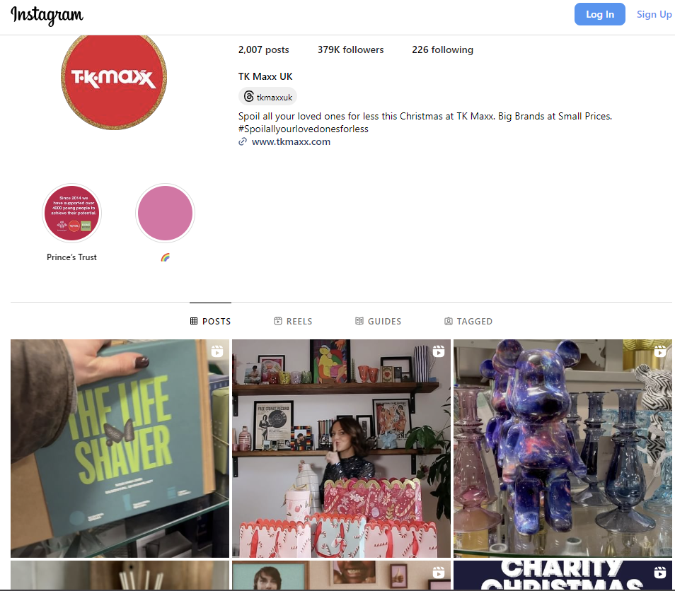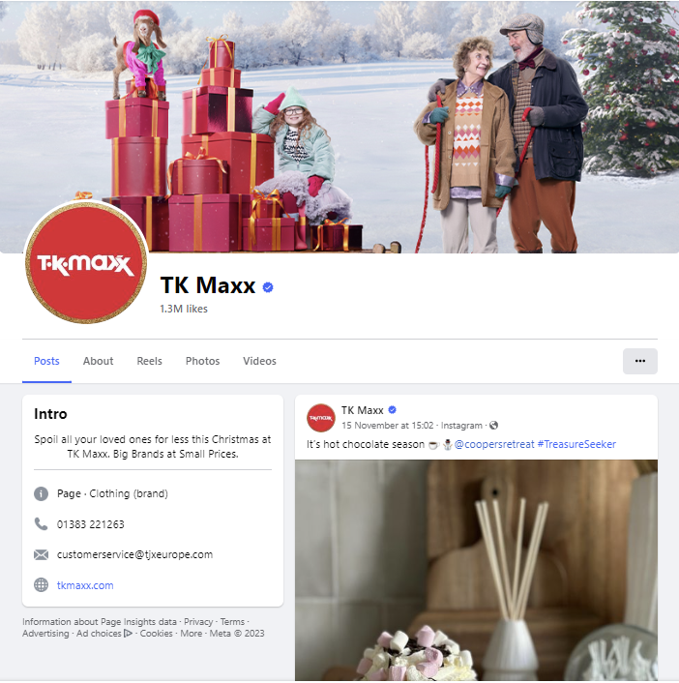
Source: https://www.instagram.com/tkmaxxuk/?hl=en Source: https://www.facebook.com/tkmaxx/

- Place
Customers have the option to purchase their preferred items online in addition to through the company's physical store has opened stores in Ireland, Germany, Poland, Austria, the Netherlands, and other European countries within the past 20 years. Additionally, our UK clients may buy online at tkmaxx.com.

- People
Employees at K Maxx are capable of thinking fast and effectively, and they make good team members and collaborators. Additionally, TK Maxx employees are trained to be adaptable and flexible in a variety of challenging and complex situations.

- Process
Usually on Tuesdays and Thursdays, the lorries arrive. This is the ongoing, planned procedure. The return process policy is also covered in the procedure. Within 28 days, TK Maxx customers may return any item for any reason. The receipt shows the last day of the return. When a customer is unable to provide proof of purchase, TK Maxx is able to confirm the item's information thanks to the installed technology. Employees may view the day and transaction history in the (TK Maxx 2022).

- Physical Evidence
The arrangement, style, and signage of TK Maxx stores' exteriors. Branded shopping bags, boxes, and receipts as tangible proof that consumers remove from the establishment.TK Maxx prides itself on providing a treasure-hunt-style shopping experience where shoppers may discover unusual and affordable merchandise. (TK Maxx 2022).
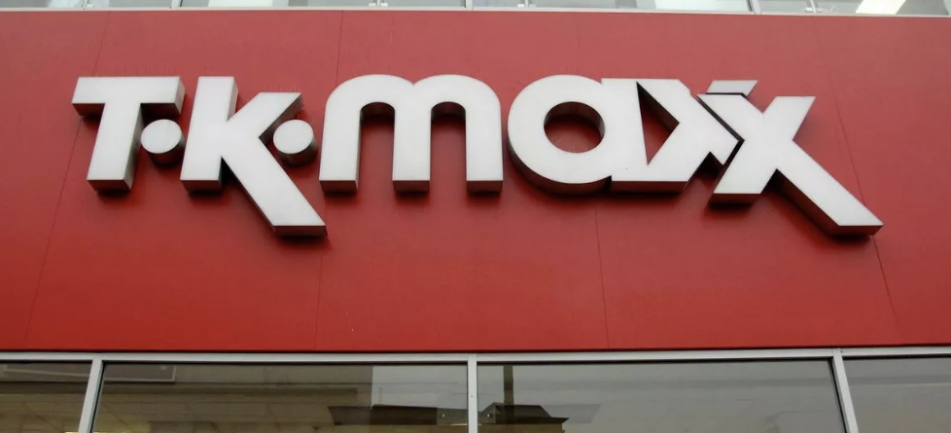
Source: https://www.mirror.co.uk/money/shopping-deals/secrets-hacks-tk-maxx-insiders-12041461
 Source: https://www.tkmaxx.com/uk/en/about-us Source:
https://www.mirror.co.uk/money/shopping-deals/secrets-hacks-tk-maxx-insiders-12041461

  - Sweet Spot

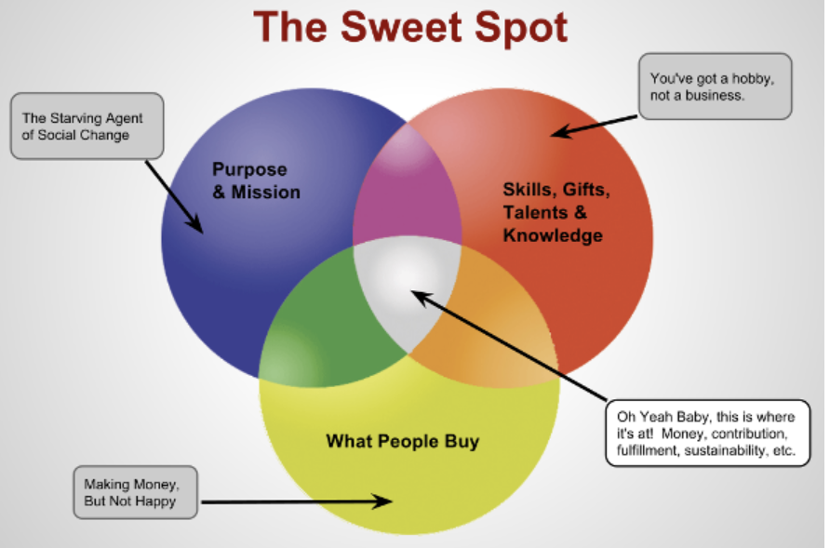
Source: (Eliason, R. 2014)

Basically, you have to develop material on which you are an authority, which fulfils the demands of your audience and precisely matches their search queries. Your content sweet spot is when those three regions come together! (Webb, E. 2021).

TK Maxx's sweet spot is its off-price and discounted retail strategy, which offers high-quality goods at lower costs. By offering substantial discounts to draw in value-conscious customers, TK Maxx seeks to strike a balance between sustaining profitability through cost control and smart sourcing. Finding the sweet spot also entails identifying and serving a target market that enjoys the rush of finding one-of-a-kind products at reasonable costs, both in physical stores and online.

- AI AND ML TOOLS IN DIGITAL MARKETING

  - ROLE OF ARTIFICIAL INTELLIGENCE AND MACHINE LEARNING IN DIGITAL MARKETING
The areas of artificial intelligence (AI) and machine learning (ML), which deal with creating intelligent systems that can carry out activities that normally need human intellect, are intimately connected to one another. Emerging as game-changing technologies, AI and ML are transforming a number of sectors, including internet advertising. These developments might fundamentally alter how businesses engage with their target market. audience, maximize marketing initiatives, and get superior results (Chaitanya, et al. 2023).

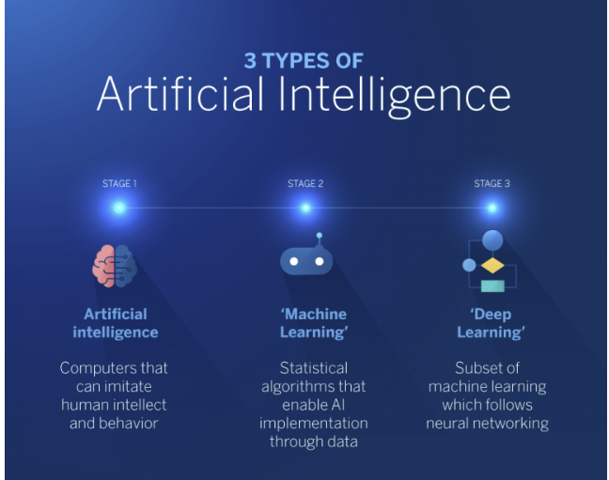
Banafa, A. (2022).
Digital marketers may use AI and ML to automate tedious processes, improve customer experiences, optimize advertising campaigns, and take advantage of data-driven insights. With the help of these technologies, marketers can target more precisely, provide tailored content, make smarter judgments, and perform better in the digital arena. AI and ML have a wide range of effects on digital marketing tactics. Among the main areas of influence is customization. With the use of AI and ML, marketers can provide tailored content, suggestions, and offers by analysing enormous volumes of consumer data, including demographics, preferences, and online behaviour (Chaitanya, et al. 2023).
Through targeted advertising, businesses may enhance their advertising campaigns with the help of AI and ML. In order to maximize the client experience, AI and ML are also quite important. Businesses may find areas for improvement and pain spots in the customer journey by analysing interaction data, sentiment analysis, and customer feedback. Chatbots and virtual assistants driven by AI may offer real-time assistance, respond to consumer questions, and raise overall customer happiness (Chaitanya, et al. 2023).
As per TK Maxx, the organization employs Al and ML significantly.
- Dynamic Pricing: ML algorithms are able to dynamically modify pricing strategies in order to maximize profit margins and competitiveness by analyzing market trends, rival pricing, and consumer behaviour.

- Predictive analytics: To forecast trends, foresee consumer wants, and improve inventory management, predictive analytics may make use of AI and ML.

- Chatbots and virtual assistants: AI-driven chatbots can respond to consumer questions, give product details, and provide help instantly, increasing customer pleasure and engagement.

  - WHY IS MACHINE LEARNING IS POWERFUL

Within the field of artificial intelligence, machine learning is the study of creating algorithms and statistical models that allow computers to become knowledgeable and make choices without the need for specific programming. Machine learning algorithms are created to instinctively get knowledge from data, spot trends, and arrive at well-informed conclusions or predictions.
For gaining insights from massive datasets, they depend on mathematical models and statistical approaches. ML in Online Advertising: The creation of algorithms that let computers learn from data and enhance performance without the need for explicit programming is the main goal of machine learning in digital marketing. To find patterns, preferences, and behaviour in past consumer data, machine learning algorithms may analyse it. They may then use this information to forecast future customer behaviour, tailor content, and improve marketing efforts. Digital marketing frequently makes use of machine learning (ML) techniques including clustering, classification, regression, and recommendation systems (Chaitanya, et al. 2023).

  - SEGMENTATION IN MACHINE LEARNING

The degree to which your segmentation progresses is determined on the customer data you possess, ranging from fundamental details like age or gender to more specific details like "time since the user first visited a given website."

supervised learning, unsupervised learning, and reinforcement learning are the three most popular forms of machine learning.

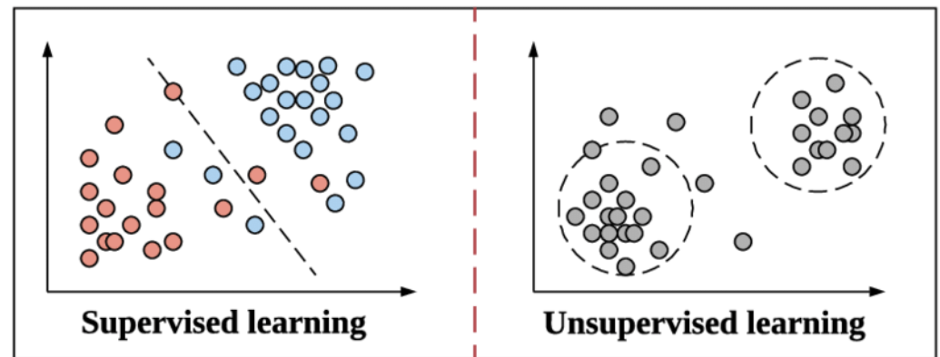
Source: (Lewandowski, M. 2021)

- Supervised learning: I would dare to suggest that supervised learning—in which models are trained by being provided numerous instances with associated labels—is the most lucrative kind of machine learning currently available. (for example, classification tasks – assign to one of the classes, regression problems – estimate housing prices) (Lewandowski, M. 2021).

- Unsupervised Learning: In unsupervised learning, the idea is that given data has a hypothesis that it can be distinguished by some feature, but no label has been assigned (which reduces the cost of dataset preparation compared to supervised learning due to it does away with the necessity of commenting, which is one of the most problematic aspects of machine learning projects) (Lewandowski, M. 2021)

  - APPLICATION OF MACHINE LEARNING IN DM TO MAXIMIZE ROI AND ROS

- Finding practical AI solutions

Chatbot software is the best illustration of an AI solution that yields returns on investment once it is put into use.
These readily available solutions are AI-enabled apps that simulate actual user discussions. They are able to accomplish this by utilizing algorithms for machine learning and natural language processing that find patterns. Chatbots are frequently simple to include into a business's website or customer support program. Most importantly, once formed, they aid in time and cost savings for enterprises (Rambach, P. 2023).

- Segmenting Time Series

Segmentation is the process of breaking down a time series into segments that exhibit different patterns or behaviours in time series analysis. This can be helpful in recognizing patterns across certain time periods, spotting anomalies, and forecasting future trends.

- Clustering

A common segmentation method that puts related data points together is called clustering. K-means clustering, hierarchical clustering, and DBSCAN are examples of common clustering techniques. Numerous data types, such as mixed, categorical, and numerical data, can be clustered.

- RECOMMENDATIONS
TK Maxx may improve their digital marketing approach by emphasizing an easy-to-use and entertaining online purchasing platform. Develop and maintain consumer relationships by optimizing the website and mobile app for easy navigation, utilizing social media platforms for visually stimulating content and customer interaction, and putting targeted email campaigns into action. Collaborate with influencers to highlight TK Maxx's vast range of products and attract a larger audience. To increase online exposure, use smart SEO techniques. Analyse data often to optimize marketing campaigns and be flexible in the face of industry changes.

- CONCLUSIONS
To sum up, digital marketing has become a powerful force that is changing the corporate environment by utilizing a wide range of resources and tools to change the way businesses engage with their customers and spur development. Businesses may connect and interact with a worldwide audience by combining email campaigns, content marketing, social media, and search engine optimization (SEO) into a holistic digital strategy. Personalized consumer experiences, predictive analytics, and automation are made possible by technologies like artificial intelligence (AI) and machine learning, which maximize the efficacy and efficiency of marketing campaigns. With a better grasp of customer behaviour, e-commerce platforms, mobile apps, and data analytics let companies customize their products and marketing plans. As businesses traverse the digital terrain, concerns about privacy, cybersecurity, and ethical behaviour become critical. The success of digital marketing strategies in this dynamic environment will depend on the capacity to adjust to new technology and market trends, thus ongoing innovation and strategic alignment are crucial for maintaining competitiveness in the digital age.

- REFERENCES
Aka, D., Kehinde, O. and Ogunnaike, O. (2016). Relationship Marketing and Customer Satisfaction: A Conceptual Perspective. Binus Business Review, 7(2), p.185
Baines, P., Fill, C. and Page, K. (2013). Essentials of marketing. Oxford: Oxford University Press.
Bala, M. and Verma, D. (2018). A Critical Review of Digital Marketing. [online] papers.ssrn.com. Available at: https://papers.ssrn.com/sol3/papers.cfm?abstract_id=3545505.
Banafa, A. (2022). Intellectual Abilities of Artificial Intelligence. [online] OpenMind. Available at: https://www.bbvaopenmind.com/en/technology/artificial-intelligence/intellectual-abilities-of-artificial-intelligence/ [Accessed 17 Dec. 2023].
Butler, S. (2020). TK Maxx overtakes Topshop in UK despite Covid crisis. [online] the Guardian. Available at: https://www.theguardian.com/business/2020/sep/12/nimble-tk-maxx-overcomes-covid-crisis-to-take-sixth-slot-in-uk-fashion-market [Accessed 9 Dec. 2023].
Buttle, F.A. and Maklan, S. (2015). (PDF) Customer Relationship Management: Concepts and Technologies.[online]ResearchGate. Available at: https://www.researchgate.net/publication/290447911_Customer_Relationship_Management_Concepts_and_Technologies [Accessed 13 Dec. 2023].
Calvello, M. (2023). How the Right Social Media Marketing Plan Can Bring Success. [online] learn.g2.com. Available at: https://learn.g2.com/social-media-marketing [Accessed 11 Dec. 2023].
Chaffey, D. (2018). The Content Marketing Matrix. [online] Smart Insights. Available at: https://www.smartinsights.com/content-management/content-marketing-strategy/the-content-marketing-matrix-new-infographic/ [Accessed 13 Dec. 2023].
Chaitanya, K., Saha, G.C., Saha, H., Acharya, S. and Singla, M. (2023). The Impact of Artificial Intelligence and Machine Learning in Digital Marketing Strategies. European Economic Letters (EEL), [online] 13(3), pp.982–992. doi:https://doi.org/10.52783/eel.v13i3.393.
Eliason, R. (2014). How to Find the Sweet Spot for Your Business. [online] Ryan Eliason. Available at: https://ryaneliason.com/blog/the-sweet-spot/.
Fleetwood, D. (2018). What is Demographic Segmentation? - Definition with Examples | QuestionPro. [online] QuestionPro. Available at: https://www.questionpro.com/blog/demographic-segmentation/ [Accessed 17 Dec. 2023].
Frankenfield, J. (2022). What Is a Digital Asset? [online] Investopedia. Available at: https://www.investopedia.com/terms/d/digital-asset-framework.asp [Accessed 11 Dec. 2023].
Kotler, P., & Keller, K. (2015). Marketing Management (15th ed.). Pearson Education.
Kotler P, Wong V, Saunders J, Armstrong GM (2009). Principles of Marketing. Pearson.
Lewandowski, M. (2021). How to use machine learning for customer segmentation. [online] Whites Agency. Available at: https://whites.agency/blog/how-to-use-machine-learning-for-customer-segmentation/ [Accessed 10 Dec. 2023].
Mangold, Glynn W., and David J. Faulds (2009). Social Media: The New Hybrid Element of the Promotion Mix. Business Horizons.
Max (2015). Market Targeting - Target Segments efficiently and effectively. [online] Marketing-Insider. Available at: https://marketing-insider.eu/market-targeting/?utm_content=cmp-true [Accessed 17 Dec. 2023].
Minaev, A. (2017). Email Marketing Basics - Guide for Beginners (2023). [online] FirstSiteGuide. Available at: https://firstsiteguide.com/email-marketing/ [Accessed 17 Dec. 2023].
Nguyen, S. (2019). Understanding Of Micro And Macro Factors That Affect Your Business. [online] Mageplaza. Available at: https://www.mageplaza.com/blog/micro-and-macro-factors-affect-your-business.html [Accessed 11 Dec. 2023].
Novak, J. (2023). 4 CRM Data Types & How To Use Them – Forbes Advisor. [online] www.forbes.com. Available at: https://www.forbes.com/advisor/business/crm-data/.
O’Grady, L. (2015). Marketing Mix - Tk Maxx. [online] Slideshare.net. Available at: https://www.slideshare.net/LuciaOGrady/marketing-mix-tk-maxx [Accessed 10 Dec. 2023].
Piñeiro-Otero, T. and Martínez-Rolán, X. (2016). Understanding Digital Marketing—Basics and Actions. Management and Industrial Engineering, pp.37–74. doi:https://doi.org/10.1007/978-3-319-28281-7_2.
Rambach, P. (2023). Three ways to secure maximum ROI from AI. [online] TechRadar. Available at: https://www.techradar.com/opinion/three-ways-to-secure-maximum-roi-from-ai [Accessed 16 Dec. 2023].
Rathnayaka, U. (2018). Role of Digital Marketing in Retail Fashion Industry: A Synthesis of the Theory and the Practice. Journal of Accounting & Marketing, [online] 07(02). doi:https://doi.org/10.4172/2168-9601.1000279.
Rimi (2021). What is CRM? [online] iContact. Available at: https://www.icontact.com/define/customer-relationship-management/ [Accessed 16 Dec. 2023].
Semrush. (2023). tkmaxx.com Website Traffic, Ranking, Analytics [September 2022]. [online] Available at: https://www.semrush.com/website/tkmaxx.com/overview/.
Simplilearn (2022). What is Google Analytics and how does it work? | Simplilearn. [online] Simplilearn.com. Available at: https://www.simplilearn.com/tutorials/google-analytics-tutorial/what-is-google-analytics-used-for.
The Retailer Bulletin. (2021) TK Maxx to lunch new brand campaign Available at: https://www.theretailbulletin.com/general-merchandise/tk-maxx-to-launch-new-brand-campaign (Accessed: 4 December 2023).
TJX (2019). Our History | TJX.com. [online] Tjx.com. Available at: https://www.tjx.com/company/history [Accessed 5 Dec. 2023].
TK Maxx (2022). How we do it - TK Maxx. [online] www.tkmaxx.com. Available at: https://www.tkmaxx.com/uk/en/how-we-do-it [Accessed 5 Dec. 2023].
TK Maxx (2022). Privacy & Cookie Policy - TK Maxx. [online] www.tkmaxx.com. Available at: https://www.tkmaxx.com/uk/en/privacy-cookie-policy [Accessed 5 Dec. 2023].
Webb, E. (2021). The Content Sweet Spot - Using content to get more customers. [online] InSynch. Available at: https://www.insynch.co.uk/the-content-sweet-spot-using-content-to-get-more-customers/ [Accessed 10 Dec. 2023].
Wijaya, P.K. and Hermawan, A. (2018). E-Marketing Applications Based On Virtual Reality Using Sostac Planning Method On Sales Property. Tech-E, [online] 1(2), p.16. doi:https://doi.org/10.31253/te.v1i2.29.
Zigu (2011). Positioning Process Definition, Steps, Process & Overview | Marketing Dictionary | MBA Skool-Study.Learn.Share. [online] MBA Skool-Study.Learn.Share. Available at: https://www.mbaskool.com/business-concepts/marketing-and-strategy-terms/17825-positioning-process.html.

