Part One: Professional Learning Templates

- Employing a Broad Range of Teaching Repertoires

After completing a series of lesson focusing on sources of renewable energy, I decided to implement digital competency and design into the next lesson.

At the start of the lesson, I activated prior knowledge by asking the students ways in which we can help improve the environment and cut down the level of carbon dioxide in the atmosphere. I decided to focus on blended learning experiences and students leading the leaning as students were working in pairs to help those who had less experience with Minecraft.

The students were using iPads to create a world that demonstrated at least one way which we could become more sustainable. Some of the ideas that students came up with were planting more trees to prevent deforestation, planting and growing vegetables to promote eating less meat to reduce methane, and some students built wind turbines/ hydropower sources to hi-light the benefits of using sources of renewable energy. Once the students had created their designs, I asked them to create a Minecraft poster to explain what their designs meant for the world. To do this, students recapped prior knowledge of the advantages they had learnt throughout the series of lessons.

Throughout this lesson, I was able to assess the students’ understanding by using digital competency and Minecraft to apply the students’ knowledge from previous lessons in a new setting. Prior to this lesson, I researched Gecer who conducted an experiment that revealed that by introducing electronic activities into the lesson had positive effects on students from a learning and evaluation perspective. Upon reflections, I can see that I do agree with Gercer, and was able to see the benefits of blended learning into the lesson.

This lesson definitely met some of the intended outcomes. Students were able to peer- scaffold each other and express their ideas through Minecraft and design. It was interesting to see some students who were less confident expressing climate change ideas throughout the week become more confident in this lesson.

For next time, I will continue to apply the students’ knowledge using blended learning experiences. Upon reflection, I believe that it was useful introducing a new way for the students to express their ideas and allowed for students who had lacked confidence during the week to thrive in an area where they feel confident. It also allowed for students who do not usually contribute to lessons and those who get distracted easily to become more focused and engaged in the lesson.
However, for next time, I would use a different environment for the students to conduct the lesson in. For example, I would use the school’s sports hall or the hall so that students feel further away from their everyday learning experiences. As mentioned by Boelens in 2017, it is important to pay attention to nurturing social interaction and fostering an effective learning environment when designing Blended Learning.

- Creating Authentic Context for Teaching
After teaching a series of lessons based around factors and multiples, I decided to follow the 'Teach, test, apply' principle set out by ...
The aim of the lesson was to test the learners' knowledge of what we had learnt in the previous series of lessons (factors and multiples) and to apply what the students had learnt to a relatable topic. I decided to use I'm a celebrity as a way of introducing authentic context as this was something that my mentor had recommended to me as he was aware that the learners were interested in this, and it also allowed for me to use the 'Bush Tucker' trials as a way of setting challenges involving factors and multiples to the learners.
I designed 'I'm a Celebrity' 'Top Trumps' Cards which involved questions such as 'Add together all of the factors of 12'. I differentiated the questions based on ability, and I also made a set of cards for two children with additional needs who had an interest in 'My Singing Monsters' to work together.
As suggested by Zoohooian, using authentic context can increase the motivation levels of the students and can act as an opportunity for the students to apply the knowledge to a real- life scenario.
The QTS standards I wanted to focus on throughout this lesson were 'Real- life authentic contexts' and 'Expoliting subject disciplines in areas on learning).
From this experience, I have learnt the importance of introducing and using authentic contexts into lessons, and the impact that this has on the learners.
I have also learnt the importance of developing teaching responses that can be effective under different circumstances (Hammond, Snyder, 2000).
Moreover, I have learnt the importance of linking learning to the wider world. This extends the learner’s cultural, linguistic, religious and socio-economic experience.
The lesson met the intended outcome of lincreasing the level of students' motivation and students seemed to be focused throughout the lesson. The 'Top Trumps' were able to act as an engagement tool at the start of the lesson, which meant that learners were focused and were able to apply the knowledge of factors and multiples to problem scenarios using real-life authentic context.
However, if I was going to do this next time, I would choose to implement authentic context using topics which the students are likely to come across ever day. For example, introducing supermarkets when teaching the concept of money, or using odds when teaching probability.
To further develop learning opportunities, I would embedding authentic context throughout the lessons, for example by asking students how much they believe an iPad is worth, and using this to conduct numbers for an equation. I believe that workshops will be useful in developing authentic contexts, and having a carousel of similar topics could help improve student engagement, particularly with foundation phase.

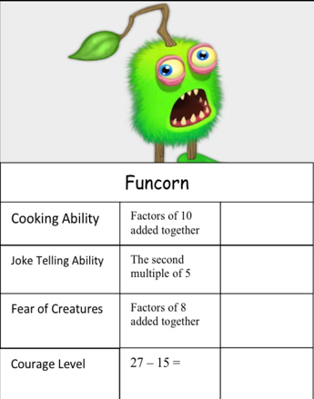


- Reinforcing Cross-Curricular Responsibilities

During this lesson, I was teaching a hot-seating lesson based around the characters, 'The Old Man', 'The Boy' and 'The Donkey'. The students had time to work collaboratively in groups, working with flip chart paper to think of possible questions to ask each of the characters. The students were selected to play the role of the characters, and the rest of the class (the audience) acted as 'The Onlookers' who were asking and answering questions. The children were able to further their understanding of the characters and the story through role play and exploring their understanding deeper through questioning. One student asked the question 'How did you make money if you didn't sell the donkey?’. They mentioned that they had chickens. I then asked the students 'How many chickens do you have?' The student gave the answer, and so I asked the class, 'How much would you be able to sell the donkey for?'. After the students responded, I asked the class, 'If there are fifteen chickens worth £12 each, how much money were you able to make by selling all of the chickens?' As a class, the students then discussed how much money the 'Old Man' was able to make and how this made them as the characters feel.

Throughout this, I have learnt the importance of introducing numeracy across the curriculum and embedding cross- curricular themes and lessons into my teaching. The learners were able to extend their learning by asking and answering numeracy questions. I have learnt the importance of being open minded and being willing to adapt my lessons away from my lesson plans to further develop the children's learning.
Moreover, as stated by Barnes and Shirley, cross- curricular activities can improve student learning, whilst improving creativity for both the students and the teacher.

Through me being flexible, it met the intentions of the children to apply numeracy in a non- typical maths lesson and setting. The learners were able to generate their own context for the lesson by emotionally connecting with the characters from the story.

Learners were able to recognise how numeracy can be used in real- life contexts and scenarios, and were able to think on their feet, using their skills and techniques that we had used and learnt in the previous maths lessons. This lesson enabled me to think on my feet, whilst demonstrating to learners how numeracy can be implemented across the curriculum and related to other areas of learning, such as storytelling.

To further implement cross- curricular elements into my lessons, I will include examples of questioning into my lesson plans at specific points. Hopefully, this will enable me to develop my learners' understanding further and enable me to further encourage cross curricular themes into my lessons.
However, if this was a lesson taught to foundation level learners, this would require me to increase my planning and to further simplify the numeracy levels, potentially introducing numeracy as part of a game.

I will continue to be flexible in my lessons, and not be afraid of tailoring away from my planning if it allows for the learners' understanding and knowledge to be applied and further developed.

- Using Assessment for Learning to Accelerate Progress

This professional experience occurred during a maths lesson where I was teaching inverse operations of addition and subtraction to a Year Five Class.

After delivering the lesson at the start, I monitored how the students were getting on with the work I had set. I noticed that some students were making a common misconception of using the lowest number and subtracting from the highest number.

Therefore, I called the class back to address the common misconception.
Through allowing the students to have time after I had initially delivered the lesson, the children were able to attempt the questions set, allowing me to assess their level of understanding.

By assessing the learners understanding half- way through the lesson instead of the end, I was able to address and common misconceptions and allow the learners to improve their understanding of the topic.

Throughout this experience, I have learnt the importance of AfL in the classroom, as well as ways in which AfL can be embedded into the lesson using natural methods. I have also understood and expanded my knowledge of AfL techniques, and now understand that AfL does not have to take place at the end of a lesson/ series of lessons.
The implications to the learners were that they were able to address the mistake and use their problem- solving skills to notice what had gone wrong during the initial try.
Although this AfL strategy wasn't planned, it met the intended overall outcomes of ensuring that students understood the work that they are presented with. The implications for my colleagues were that they were able to then work with smaller groups and micro-teach to ensure that learners recognised and understood the error so that they were confident that they could move forward accurately.
For next time, I will continue to embed AfL into my lessons, and continue to be flexible and not be afraid to depart from my lesson plans if I think that changing the structure/ stopping the lesson will accelerate the progress of the learners.

However, for next time, I will try to pin-point times in my lesson plans which could be considered appropriate for purposeful questioning and quality of feedback so that I can further assess the learners' understanding of the work before their learning time has begun.
Moreover, I will try my best to involve all students and continue to focus on differentiation when addressing common misconceptions. For example, if I am addressing a mathematical conception, I may wish to give at least two examples from two groups to involve all learners and ensure that they understand.

Part Two:

Critically reflect on your progress in planning, preparing and teaching lessons that incorporate specific pedagogical principles. (This evidence should be taken from you Professional Learning Passport –PLP.) Identify one of these pedagogical principles as an area for development and justify the next steps in your development.

Word Count: 3000

Introduction

Throughout this assignment, I have decided to focus on the QTS standard, ‘Using Assessment for Learning to Accelerate Progress’ as this is an area of focus for my professional teaching experience and I believe that it is instrumental to students’ success and my future practice.

Welsh Assembly Government define AfL as “the process of finding out where learners are within a learning continuum, where they need to go and how best to get there” (2010, p. 3). Described by Bennet, AfL is more commonly known as formative assessment (2011) and is used during the learning phase, rather than at the end of a unit or series of lessons (Boston), 2002). Perenoud elaborates on this by stating that AfL differentiates between ‘traditional’ sequences of activities within lessons and those lessons where the tasks are not ‘imposed on the pupils but [adjusted] once they have been initiated’ (Perrenoud, 1998, p. 88) in order to take the learning forward.

The importance of AFL was highlighted by Donaldson in Successful Futures which outlined AfL as one of the pedagogical principles essential for effective teaching (Donaldson, (See Figure 3).

AfL policy reforms often aims to increase student evaluation of their own progress using targets, and pedagogical interactions with their teachers, with the overall goal of developing self-regulating learners (Leahy, Lyon, Thompson, & Wiliam, 2005).

Recognised by Black et al 2010, (as shown in figure 1) there are four main AFL strategies which allow for students’ learning and academic performance to be improved. These are ‘sharing criteria for learners, quality of questioning/ talk, use and quality of feedback, and peer and self- assessment’.

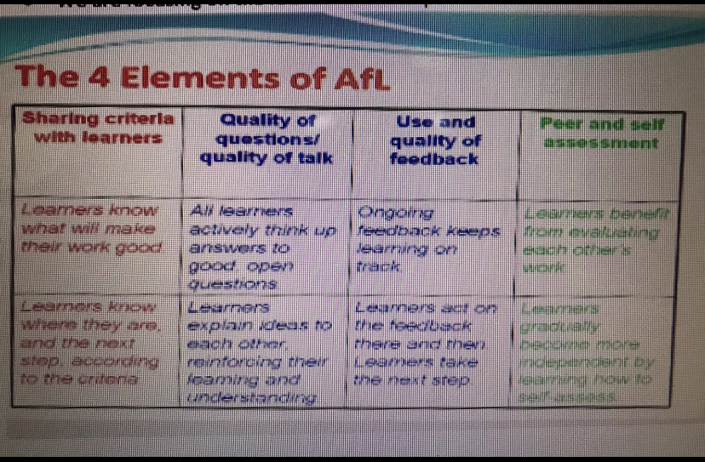

Figure 1: Four strategies of AFL

However, it is frequently illustrated that these areas cannot be effective in isolation; they are interdependent in nature. Instead, they all contribute to supporting the student in furthering learning. Therefore, given its unitary nature, AfL is more complex than teachers adding individual strategies onto existing classroom programmes (James & Pedder, 2006).

Throughout this assignment, I will look closely into and analyse two AFL strategies identified by Black, ‘the effectiveness of use and quality of feedback’, and ‘peer and self- assessment’, looking closely at academic research, including the benefits and implications of using this strategy in practice.
I will also discuss how I will use the elements discussed to inform my future practice.

Literature Review

The aim of this section is to critically analyse and evaluate literature based on the area of discussion. As assessment for learning is central to this QTS standard and assignment, this essay will focus on how peer and self- assessment can impact student learning and development, as well as the impact of purposeful questioning and addressing common misconceptions in the classroom to student development.

Quality of Questioning- Immediate and Ongoing

The first AfL strategy I have chosen to discuss throughout this assignment is the use and quality of questioning. Use and quality of questioning can be defined as feedback that involves purposeful questions that keeps learners on track by allowing the students to immediately act on the feedback given (Black, 2010). Moreover, the feedback is ongoing and has several functions: “correction, reinforcement, forensic diagnosis, benchmarking, and longitudinal development (feed-forward)” (Price et al., 2010, p.278).

While it is acknowledged that all methods of feedback are “a key element in effective teaching and learning” (Tang & Harrison, 2011, p.583), ongoing, dialogic feedback and questioning processes “have positive impacts on student learning” (HEA, 2012, p.9) and allow for students to address any common misconceptions as they happen. This is supported by Black who argues that ‘the quality of the interaction [between pupil and teacher] … is at the heart of pedagogy’ (Black and William (1998a , p.16).

In particular, this AfL strategy allows for feedback to be given with increased consistency and has been proven to double the pace of learning (Donaldson (2015c)). This is supported by Booysen and Grosser who state that questioning enables pupils to be able to reduce the gap between what they currently know and their learning targets (2013). Moreover, if implemented properly, ‘learners can make ‘what was a year of progress within six months’ (ibid, p.68).

On the other hand, because questioning is used so often, teachers may not even realize the types or quality of the questions they use (Crowe, Stanford, 2010). Moreover, although the use of questioning as a strategy is quick and effective, not all students respond well to this. This is echoed by Sardareh, who conducted a study into the effectiveness of questioning as an AfL strategy. It was founded that the questions were ‘usually answered by a specific group of students or the teachers themselves’ (Sardareh, 2014, p.1).

A study carried out by Parker and Hurry shows that questioning is the main method of formative assessment used within the foundation phase (2007) as it is a valuable part of interactive learning. Moreover, quality questioning during the flow of the lesson significantly improves children's learning and thinking skills providing they have the opportunity to respond to questions from the teacher/lead in the class (Wragg and Brown, 2007).

However, in order to improve questioning, techniques must include an increased emphasis on providing the students enough time to think about and formulate adequate responses, and enough time to share these responses with their peers (Blosser, 2000; Wilen, Ishler & Hutchinson, 2000).

To help encourage this throughout my experience during my placement, I implemented Lyman’s idea of thinking pair, share’ (1981). This allows for students to be given time to think of ideas using open- ended questions asked by teachers, to then discuss ideas with peers before sharing ideas as a class. This has shown to be very important with regards to student development and differentiation as it allows for students to develop their learning through both independent learning and collaboration with other peers.
Moreover, Think-Pair-Share encourages student participation from all students whilst promoting individual and peer accountability (Mahmoud, 2013). In turn, this allows for students’ beliefs and background knowledge to be challenged (Petty, 1998).

By questioning students throughout the session and addressing common misconceptions as opposed to a summative assessment at the end of the topic allows for students to continually progress and gives students the opportunity to act on the feedback given. Quality of questioning also allows for the students to become ‘ethically informed citizens’ and ‘ambitious, capable learners’ as they are provided with opportunities to ask questions and think deeply in the flow of the lesson.

Research in classroom behaviour indicates cueing and questioning might account for 80% of what occurs in a given classroom on a given day (Flippione, 1998). This further demonstrates the importance and effectiveness of AFL and questioning in the classroom.
This is further supported by Weiss and Pasley (2004) who state that asserting questioning helps qualify, probe and challenge current ideas and expose misconceptions. Crockett (2004) points out well executed questioning strategies encourage active participation in learning along with enhanced problem solving and concept development.

Nevertheless, because questioning is used so often, teachers may not even realise the types or quality of the questions they use.

In an AfL context, learners play an important role in their learning process (Hilgers, Hussey, & Stitt-Bergh, 2000; Schön, 1995; Wang, 2010). Therefore, it is also important for students to have the opportunity to ask questions. Throughout my placement, I created a ‘Wonder Wall’ (See figure 5) which allowed for students to write down any questions they have or anything that they would like to learn about. Although, ultimately, the practitioner has responsibility of the students’ learning, I wanted to make sure that students felt involved, and I created an atmosphere where students wanted to learn and embraced the ‘growth mindset’.

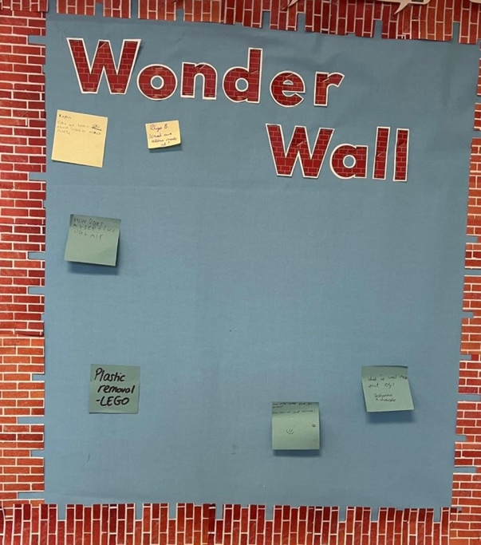
Figure 5: Student Wonder Wall
Ultimately, it is the types of questions posed (Bradley, Thom, Hayer & Hay, 2007), wait time (Tincani & Crozier, 2007), and the purpose of the questions (Hill & Flynn, 2008; Rogers & Abell, 2008) that can accelerate the progress of learners.

Self and Peer- Assessment
Secondly, I will discuss peer and self- assessment as an AfL strategy. Self and peer assessment is widely used and considered an effective AFL tool in monitoring how well students have understood the task set as the feedback comes directly from your students themselves (Sardareh, 2014).
Self- assessment can often be referred to as activating students as owners of their own learning (William 2007). Moreover, peer assessment can be referred to as activating students as resources for one another and is a process through which a student uses success criteria the quality and characteristics of the work (Topping 2013).

Peer and self- assessment are central to AfL because they both involve students in assessment, generates feedback that might be useful to the evaluated peer, and gives the peer assessor insights as to how their own work might be improved (i.e., an indirect self-assessment) (Dochy et al. 1999; Reinholz 2015).

Additionally, peer assessment helps students to become more self-regulating and use more advanced learning strategies when performing a task (Topping 2003).
MacMillan and Hearn (2008) further support this by saying that the use of self-assessment in primary schools, particularly the foundation phase can gain a number of skills such as critical thinking and reflection from a young age, and by including them in the primary curriculum prepares them for the rest of her education lives (Cowan, 2005).

However, William and Black note that while self-assessment has many advantages, self-assessment can be disadvantageous to young people as they can hinder educational progress themselves and therefore affect their long-term development and progress (2006). Similarly, Ginsburg stated that some found it difficult to be objective and discuss their strengths as well as her weaknesses in self-assessment (2009). However, some children as young as five are able to identify strengths and weaknesses in the work of themselves and its peers (Weeden, Winter and Broadfoot, 2002).

Moreover, the use of self and peer assessment is subjective in nature and vary according to level of schooling in which teachers work and their cultural norms. Additionally, teachers do not all negotiate the pressures of the performance culture in the same manner (Pedder, 2006).In turn, in some schools, there is little evidence that teachers provide opportunities for students to engage in peer assessment (Barnes, Fives, and Dacey 2015).
However, many research works established the evidence that students fail to monitor and evaluate their own performance especially their self-assessments (Dunlosky & Lipko, 2007). Instead, it is the responsibility of the teacher to work alongside the students.
However, although peer and self- assessments are deemed crucial to the development of student learning and teaching practice, William suggests that central to this form of assessment is teacher assessment and the use of questioning to assess why students have chosen such feedback (William, 2007). This allows for the teacher to have a deeper understanding of students’ learning by providing open- ended, purposeful questions that allow the students to extend their thinking. The importance of this is highlighted by Ramsden who believes the there should be an increased focus on deep-learning level (Ramsden, 2003) type of questions.

This is supported by Hattie and Timperley who in their review, defined feedback as “information provided by an agent (e.g., teacher) regarding aspects of one’s performance or understanding,” highlighting that feedback legitimately comes from non-teacher sources (2007, p. 81).

William and Thompson (2007) cite key strategies in teacher assessment (See Figure 4). Within this conceptualisation of formative assessment, three important parties in the learning process are recognised; teacher, peer, and learner. Each party has an important role in allowing formative assessment to function effectively (Black and William, 2018), with the concept of providing feedback pinpointed to signpost the learners on ‘how to get there.’

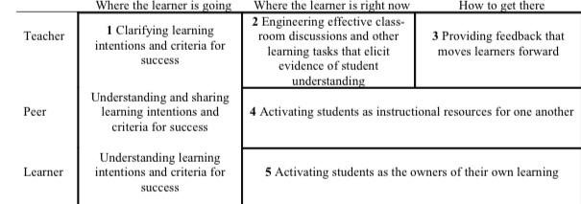

Figure 4. Key strategies in teacher assessment (William and Thompson, 2007)

Peer- and self-assessment practices are viewed by academics as a beneficial tool as it encourage students to identify learning objectives and understand the criteria used to judge their work, with the goal of increasing self-regulation (Andrade, 2010).

However, using students as a source of feedback, can potentially mitigate teacher feedback problems related to timeliness and frequency (Andrade, 2010) and in turn create perceived psychological risks for students (van Gennip, Segers, & Tillema, 2010).

While teacher feedback is conventionally regarded as being ‘more accurate’ (Hawe, Dixon, 2016, p. 1), Topping (2010) has suggested that peer and student feedback is no less reliable and can instead be valuable to students’ learning and progression. However, students still require training in these practices (Andrade, 2010; Brown, & Harris, 2012, Gielen, Peeters, Dochy, Onghena, & Struyven, 2010) and this is the responsibility of the teacher. This further highlights the importance of teacher feedback, and how self and peer assessment is reliant on the feedback of the teacher. Moreover, the nature of this training will be influenced, in part, by the classroom teacher’s understandings of feedback.

Therefore, as practitioners use reflective assessment to support individual learners on an ongoing, daily basis, students will have ‘continuing opportunities to promote the affiliation, autonomy, and agency and hence understand ways in which they can improve. This means that the students over time are able to ‘reflect on their learning journey’ by comparing how they felt at the start of the lesson compared to the end (Welsh Government, 2020, p.3).

Although, whilst both of these AFL strategies are considered extremely useful in developing student learning and creating a reflective environment (Black et al, 1998), ultimately, it is the teacher who is central to both of their strategies. A common characteristic of many classrooms is that teachers do most of the talking (Treffinger & Isakson, 2001). Therefore, the role of the teacher allows for purposeful questioning, which in turn allows for deeper understanding of the students’ understanding. This is supported by Marshall and Drummond who argue that crucial to appreciating the relevance for AfL of Vygotsky and Dewey’s understanding of learning is the notion of progression toward autonomy, and the teachers’ role in facilitating this through the activities in which they encourage pupils to engage (2007).

Conclusion

Throughout writing this assignment and completing my Professional Teaching Experience, I been able to further my understanding and knowledge of AfL and how AfL can be used as an effective tool to enable student development and teaching practice. Through comparing and discussing peer and self- assessment and use and quality of questioning, I have been able to develop my understanding of the effectiveness of AfL and ways in which I can use AFL to develop my teaching practice in the future.

Initially, I believed AfL to be an assessment of the students conducted by the teacher at the end of a lesson/ series of lessons. After thorough reading and experience at my first placement, I realise that AfL is so much more than this. If conducted successfully, AfL has the potential to enable children to thrive, create an atmosphere which allows for all students to feel involved in the lesson, and most importantly, allows for the students to feel involved in their own learning.

Prior to my professional teaching experience, I read the recommendations of Donaldson’s (2015) Successful Futures. This review outlined AfL as one of the pedagogical principles essential for effective teaching (See Figure 3). Despite engagement with the review, I recognised that my knowledge of this concept was still limited, and this was an area which I wished to develop by learning from my class mentor, and through implementing research in practice, for example peer and self- assessment stickers (See figure 4).

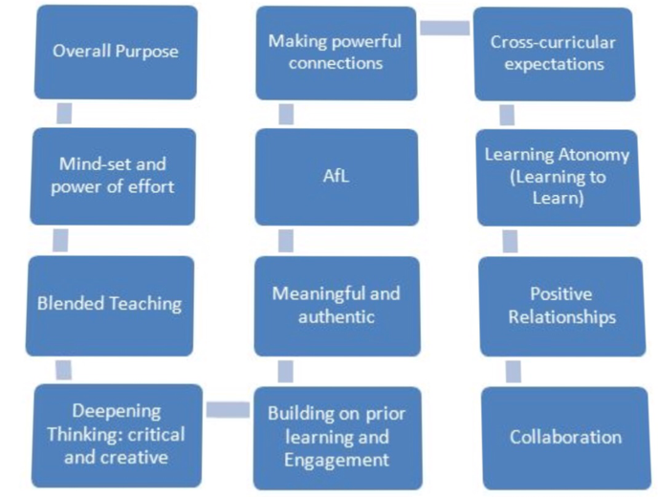

Figure 3: Donaldson 12 Pedagogical Principles

Following this, learning conversations with teaching staff and the lead lecture on AfL further developed my belief that it is essential to implement AfL for a classroom to thrive.

Some academics state that AfL is information that comments on performance or understanding of a task (Hattie and Timperley, 2007, p. 81). Whilst I would have agreed with this prior to the start of my PGCE, I had not considered the importance of promoting a culture where learners’ improvement is centred around effective teacher feedback.

Through reading academic literature and working closely with my class and school mentors, I have understood and seen first- hand how AfL practice can lead to higher levels of cognition, attainment, and learner motivation (Nicol and MacFarlane-Dick, 2006; Black and William, 2009; Clark, 2012). Throughout this placement, I have undertaken a flexible approach to AfL whilst I explored how it could enhance my teaching. As I became more confident with my teaching strategies and pedagogy, I noticed more natural ways in which AFL could be embedded into the lesson and used to improve the learning of the students, as well as taking it one step further by asking the students follow- up questions after they had self-assessed and peer- assessed their work (See figure 4).

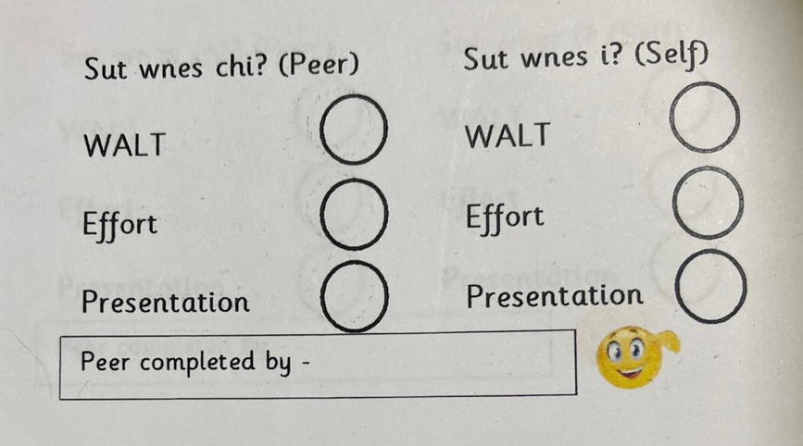
Figure 4: Peer and Self- Assessment Stickers

One way in which I implemented this was by addressing any common misconceptions that I have observed during the learning time. After delivering the lesson, I observed and worked closely with students whilst they completed their work. I noticed that some students were making a common error. I then called the class back together to address the common misconception and asked the class what they think is incorrect with what I displayed on the board. This encouraged the learners to think deeply and question what I had displayed to them. This not only enabled the students to develop their problem-solving skills, but also encouraged the learners to become ‘ambitious, capable learners’ by ‘setting themselves high standards who seek and enjoy a challenge’ (Welsh Government, 2020).

Dewey acknowledges that it is ‘a difficult task to work out the kinds of materials, of methods, and of social relationships that are appropriate’ (p. 29). However, going forward into my teaching practice, I aim to embed AfL into my lessons as naturally as possible. I also believe that similar to Marshall, the four core AfL strategies ‘need revision’ and are interconnected with one another (Marshall, 2007, p. 16). Throughout writing my literature review and implementing these techniques in practice, I increasingly noticed how you cannot implement one strategy without covering another. For example, I often addressed common misconceptions in my lessons (quality of talk), however, to do this, I would ask purposeful questions (quality of questioning).
Ultimately, I will continue to implement and learn more information surrounding AfL, and I will continue to craft a plan to use higher level questions (Hill & Flynn, 2008) and involve the students through peer and self- assessment.

References

Welsh Assembly Government. (2010) Why develop thinking and assessment for learning in the classroom? Retrieved 29th April 2018. Available at URL http://learning.gov.wales/docs/learningwales/publications/130426-why-develop-en.pdf

Leahy, Siobhan & Lyon, Christine & Thompson, Marnie & Wiliam, Dylan. (2005). Classroom Assessment: Minute by Minute, Day by Day In classrooms that use assessment to support learning, teachers continually adapt instruction to meet student needs. Educational Leadership. 63.

Pedder, David & James, Mary. (2012). Professional learning as a condition for Assessment for Learning. 10.13140/2.1.2600.5284.

Joseph C, Conradsson D, Nilsson Wikmar L, Rowe M. Structured feedback on students' concept maps: the proverbial path to learning?. BMC Med Educ. 2017;17(1):90. Published 2017 May 25. doi:10.1186/s12909-017-0930-3

Epstein, M. L., Lazarus, A. D., Calvano, T. B., Matthews, K. A., Hendel, R. A., Epstein, B. B., Brosvic, G. M. (in press) Immediate feedback assessment technique promotes learning and corrects inaccurate first responses. The Psychological Record.

Bennett, R., (2011). Formative assessment: a critical review. Assessment in Education: Principles, Policy & Practice, 18(1), p.5-25.

Boston, C., (2002). The Concept of Formative Assessment. Practical Assessment, Research and Evaluation, [online] 8(9). Available at: <https://scholarworks.umass.edu/cgi/viewcontent.cgi?article=1118&context=pare> [Accessed 15 October 2020].

Black, Paul & Wiliam, Dylan. (2009). Developing the theory of formative assessment. Educational Assessment Evaluation and Accountability. 21. 5-31. 10.1007/s11092-008-9068-5.

Donaldson, G. (2015a). Successful Futures. [online] Available at: < https://gov.wales/sites/default/files/publications/2018-03/successful-futures.pdf [Accessed 8 October 2020].

Donaldson, G. (2015b). Dyfodol Llwyddiannus. Review of curriculum and assessment arrangements. [online] Llywodraeth Cymru, p.31. Available at: <https://gov.wales/sites/default/files/publications/2018-03/successful-futures.pdf> [Accessed 15 October 2020].
Pedder, David & James, Mary. (2012). Professional learning as a condition for Assessment for Learning. 10.13140/2.1.2600.5284.

Taras, Maddalena. (2010). Assessment for learning: Assessing the theory and evidence. Procedia - Social and Behavioral Sciences. 2. 3015-3022. 10.1016/j.sbspro.2010.03.457.

Bloom, B. (1956). Taxonomy of educational objectives: Cognitive domain. New York: David McKay.
Black PJ, Wiliam D. Inside the black box: Raising standards through classroom assessment. Phi Delta Kappan, 1998. 80(2): 139 148.
Stiggins RJ. Assessment for learning: A key to student motivation and learning. Phi Delta Kappa EDGE, 2007. 2(2): 19.
Black P, Harrison C, Lee C, Marshall B, Wiliam D. Assessment for learning: Putting it into practice. Buckingham: Open University Press, 2003.
Vygotsky L. Mind in society: The development of higher psychological process. Cambridge, MA: Harvard University Press, 1978.
Wiliam D. What is assessment for learning? Studies in Educational Evaluation, 2011. 37(1): 3-14.
Wiliam D. Formative assessment: Getting the focus right. Educational Assessment, 2006. 11(3&4): 283-289.
Boston, C., (2002). The Concept of Formative Assessment. Practical Assessment, Research and Evaluation, [online] 8(9). Available at: <https://scholarworks.umass.edu/cgi/viewcontent.cgi?article=1118&context=pare> [Accessed 18 October 2020].

Hall, G., (2016). The Importance Of Questioning. [online] Gary Hall. Available at: <https://garyhall.org.uk/importance-of-questioning.html> [Accessed 20 October 2020].
Hattie, J (2009) Visible Learning: A Synthesis of Over 800 Meta-analyses Relating to Achievement Routledge
Hattie, J., (2012). Visible Learning For Teachers: Maximising The Impact On Learning. New York: Routledge, p.81.

Parker, M. and Hurry, J., (2007). Teachers' use of questioning and modelling comprehension skills in primary classrooms. Educational Review, 59(3), pp.299-314.

Topping, K., (2009). Peer Assessment. Theory Into Practice, 48(1), pp.20-27.

Dochy, F., Segers, M., & Sluijsmans, D. (1999). The use of self-, peer and co-assessment in higher education: A review. Studies in Higher Education, 24(3). Retrieved from http://www.tandfonline.com/doi/abs/10.1080/0307 5079912331379935?src=recsys#.VOGj7S5UMsI
Reinholz, D. (2016). The assessment cycle: A model for learning through peer assessment. Assessment & Evaluation in Higher Education, 41(2), 301-315.
William, D., & Thompson, M. (2007). Integrating Assessment with Learning: What Will It Take to Make It Work?

Bethan Marshall & Mary Jane Drummond (2006) How teachers engage with Assessment for Learning: lessons from the classroom, Research Papers in Education, 21:2, 133-149, DOI: 10.1080/02671520600615638, p.16.

Sardareh, S. A., Saad, M. R. M., Othman, A. J., & Me, R. C. (2014). ESL Teachers' Questioning Technique in an Assessment for Learning Context: Promising or Problematic?. International Education Studies, 7(9), p.1.
Kucey, S, Parsons J. 2010. Connecting Dewey and Assessment for Learning.

