Term
2
08
Fall
Digital Skills and Research Methods
BMSW 4003

Student Name: Ana Maria Stanciu
Student Number: 1909953
Lecturer Name: Fernando Suneth
Table of Contents
1.0 Introduction 3
2.0 Background 3
3.0 Aims and objectives 6
4.0 Methods 6
5.0 Results 8
6.0 Discussions 9
7.0 Conclusion 11
8.0 References 12
9.0 Appendix 14

The impact of Virtual Learning Environment (VLE)-Moodle on University of Wales Trinity Saint David

1.0 Introduction

The reason for choosing this topic is due to the high demand for UK degrees in foreign countries. Therefore, I believe that virtual learning environment gives a great opportunity to foreign students to get an UK degree without having to travel to the UK.
The Virtual Learning Environment (VLE) is defined as an assemblage of software equipment benefiting academic management, schooling and research operating the Internet, mainly the World Wide Web. Because information and communication are increasingly performed online such methods have become an essential role in the academic infrastructure in numerous higher schooling institutions. Virtual Learning Environment (VLE) is just as with email, delivers services that are distributed straight across the establishment mainly to improve existing educational exercises, not to displace them. VLE has the potential to deliver the main guide for learners and stuff alike, irrespective of their geographic location, supporting continuity in schooling and learning process (Trrafford , and Shirota , 2011).

2.0 Background

I higher education, the Virtual Learning Environment (VLE), comprise a significant aid for students. According to Hopkins (2011), in the case of part-time distance students, data on the attention of distance students, and the learner attention with Virtual Learning Environment may be poorer than predicted by the organizations. In order for Virtual Learning Environment to be successful, Navet et al. (2012), suggests that they are five important factors that contribute to it such as; computer quality, recent quality and ease of access and responsive lecturers. Furthermore, Salomon (2002) suggested that the practice of programmed Virtual Learning Environment actions; both synchronised and not synchronised with associated acknowledgement, boost the probability of student concentration with Virtual Learning Environment and adds supplementary importance to students. Risqué et al. (2013), suggested that students engagement with Virtual Learning Environment can have limitations on accessing important lessons materials or upload the material. The case study presented in the article gave information on the cumulative amount of learners who had retrieved the module page and also the number of page views of the particular reserves for every module available. Access comparative to enrolment was well about half of what it was predicted and the average amount of views per learner engagement with Moodle was seven and a half with a complementary average of eight for female and three for males. The number of page views of the most important resources on Moodle is indicated in Figure 1.
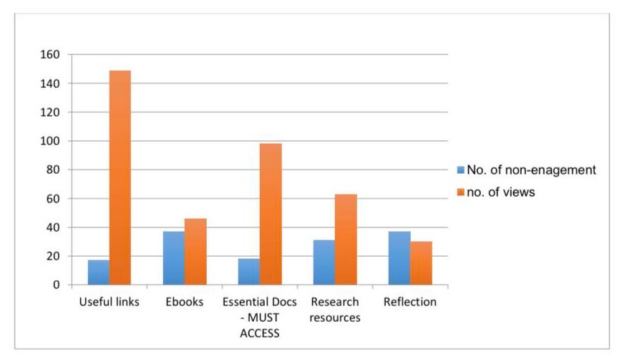
Figure 1 – Page views for five key resources (Davies and Harris, 2018).
This figure suggests that the most accessed links they were the expected necessary examination chores. The lower quantity of accessed pages seemed to be introspection information, however, they were over thirty-access page for this article despite the fact that this theme was disguised fully during and since this theme. The vast length of the group that accessed this module bring about the data collected extremely exquisite. Toole et al. (2015), indicated that the entry for this module will be close to 100%, but the proportions of Virtual Learning Environment entry was close to what se suggested but not quite the same.
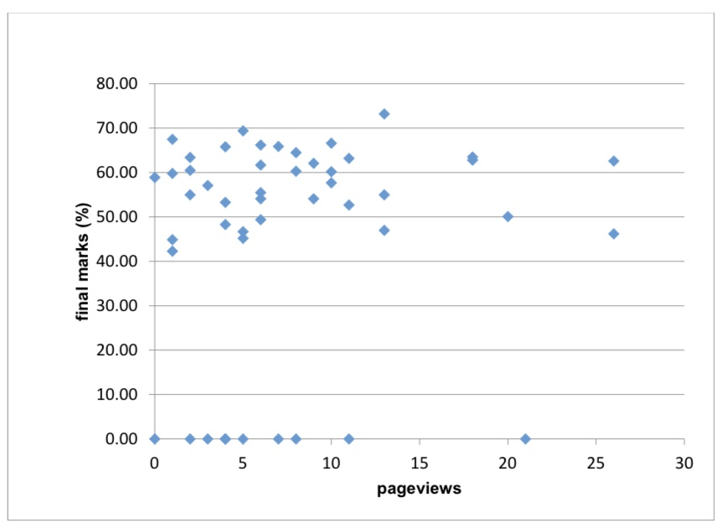 Figure 2 - Relationship between page views and final marks (Davies and Harris, 2018).

Figure 2 is a scatter conspiracy that illustrates the attention of student page views and final module ratings. The sum of page views on Moodle was not very relevant to the decisive mark for this module. Non-submission attributed wit statements for explaining away situations resulted in the majority of zero marks and also the tendencies can become clear when marks accomplished for these tasks will be accessible. Likewise, experienced students can have restricted study time as well, and that may then, be in the way highly strategic to appoint aids, prioritize those constructed as important either by the tutor comments or they can be associated with the examinations, and this is constant with the findings suggested by Risques et al. (2013). Lesse (2009), and Agudo (2014), suggested that tutor feedback and the interaction between the student and the tutor have a significant play in retaining on the Virtual Learning Environment, which is accentuated by the significance of tutor advice and connection with the student that resulted in the findings above. In addition, Bolong et al. (2012), they suggested that Virtual Learning Environment could be impeded by the disconnection and deficiency of ties between tutor and learners. Tutors can help to improve student’s engagement with Virtual Learning Environment by procedures such as; Laurillod (2010), suggested that working on understanding methods and highlight the need for beneficial planning of Virtual Learning Environment format and quality, in the best intersection and advice. Furthermore, Boling (2012) and Borwarninn (2014), suggested that an over-reliance on undue document-type aids should be prevented, and there should be the enormous design of the latitude of Virtual Learning Environment tools accessible. Because of media such as video and audio can frequently attract attention more then an article, and also can be facilitative to students that are looking for methods of research. In addition, Davies (2015), suggested that effective learning can be motivated by using interactive choices such as; tests SCORM-complaint learning topics. On the other hand Risquez (2014), indicated that extremely optimistic facets of Virtual Learning Environment are to promote the previous admission to the lecture statements. According to Bishop and Verleger (2013), a strategy that can be deemed to fund knowledge, that can be entitled as a small example of casting given learning tools before established education session, through to date substantively goal information on this topic has been accessible.

3.0 Aims and objectives

The aim of this report is to gain knowledge about professional learners engagement using Virtual Learning Environment.
- Primary and secondary research was made in order to collect data on the effectiveness of Virtual Learning Environment.
Understanding the effectiveness of Moodle (online platform) at UWTSD.
- Created a questionnaire (survey).
- Send the survey and collected results from colleagues and tutors, universities Moodle users.
- Created a template to see the overall look of the analysis survey on Moodle.

4.0 Methods

A secondary research method was utilized to compile quantitative and qualitative data comprised in the background section. The research was made to find out the efficiency of the virtual learning environment within University Trinity Saint David. The module presented in the background section is Social Work Practice, and it was assessed because implicates a vast number of students enrolled, therefore, they deliver a large quantity of data. However, even if o part of the study is made face to face, a substantial part of the study has been self-directed with the help of materials available at the Universities Moodle as part of a virtual learning environment.

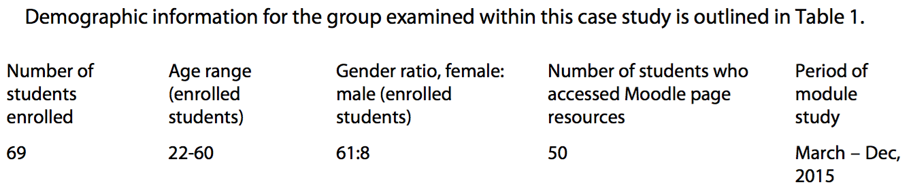
This is demographic data for the group assessed within the case study. Source: Davies and Harris, (2018).

A primary research approach was used to collect quantitative and qualitative data to the case survey (questionnaire). The survey was produced to collect data from colleagues and lectures of UWTSD as they used university Moodle. The survey was created by 10 questions on Moodle and it was distributed among university’s users. Data were collected and stored in different tables for the analysis process.

Questions | Extremely satisfied | Very satisfied | Not satisfied | Not at all satisfied
1. How satisfied are you with the reliability of Moodle?
2.How satisfied are you with the security of Moodle?
3. How satisfied are you with the ability to integrate other apps with Moodle?
4. How satisfied are you with the look and feel of Moodle?
5. Overall are you satisfied with the information on Moodle?

Questions | Strongly agree | Agree | Disagree | Strongly disagree
6. The Moodle portal was easy to find?
7. The Moodle portal was easy to use?
8. The Moodle application process was easy to follow?
9. The Moodle information was reliable to you?
10. Do you find Moodle practical?

Questions | Yes | No
11. The University Moodle was easy to use?
12. The process of University Moodle was easy to follow?
13. The information on Moodle was easy to process?
14. The information on Moodle was helpful to you?
15. Overall, are you satisfied with the outcome of University Moodle?

5.0 Results

University Moodle questionnaire was sent to ten Moodle users and the table below shows the results of the feedback received.

Questions | Extremely satisfied | Very satisfied | Not satisfied | Not at all satisfied
1. How satisfied are you with the reliability of Moodle? | 7 | 3 | 0 | 0
2.How satisfied are you with the security of Moodle? | 6 | 4 | 0 | 0
3. How satisfied are you with the ability to integrate other apps with Moodle? | 6 | 3 | 1 | 0
4. How satisfied are you with the look and feel of Moodle? | 6 | 4 | 0 | 0
5. Overall are you satisfied with the information on Moodle? | 6 | 4 | 0 | 0

Questions | Strongly agree | Agree | Disagree | Strongly disagree
6. The Moodle portal was easy to find? | 5 | 5 | 0 | 0
7. The Moodle portal was easy to use? | 4 | 6 | 0 | 0
8. The Moodle application process was easy to follow? | 5 | 5 | 0 | 0
9. The Moodle information was reliable to you? | 6 | 4 | 0 | 0
10. Do you find Moodle practical? | 5 | 5 | 0 | 0

Questions | Yes | No
11. The University Moodle was easy to use? | 8 | 2
12. The process of University Moodle was easy to follow? | 7 | 3
13. The information on Moodle was easy to process? | 10 | 0
14. The information on Moodle was helpful to you? | 10 | 0
15. Overall, are you satisfied with the outcome of University Moodle? | 8 | 2

6.0 Discussions

Chart 1. Formed with answers from 1 to 5.

Chart 2. Formed with questions 6 to 10.

Chart 3. Formed with questions 11 to 15.

The three charts above are the results of the questionnaire made to collect data from University’s Moodle users. As the results show there is no need of improvement on the University Moodle. However, due to the pandemic COVID 19 University Trinity Saint David London campus had to move on to Virtual Learning Environment therefore, students had to have online class lessons on a portal called Teams. Teams seemed to have some issues foe example the sound and a difficulty for some students to log in to the class lesson. So simpler access to the lesson and sound improvement would be a suggestion of improvement.

7.0 Conclusion

The aim of this report was to find out the effectiveness of the Virtual Learning Environment in University Trinity Saint David, United Kingdom by conducting secondary research and collecting data. Furthermore, conducting primary research (online survey) to collect data in relation to the effectiveness of University Moodle and to find out if there is anything that can be improved. In order to find out the effectiveness of Universities Moodle an online survey was conducted, feedback was collected in tables and results where calculated in Microsoft XL and presented in charts.

8.0 References

Agudo-Peregrina, et al., (2014), ‘Can we predict?’,
Successes from log data in VLEs? Classification of interactions for learning analytics and their relation with
Performance in VLE-supported F2F and online learning. Computers in Human Behaviour, 31, 542-550.

Bishop, J.L. and Verleger, M.A., (2013) ,The Flipped Classroom: A Survey of the Research. Proceedings of the 2013 ASEE, Annual Conference, Atlanta. [Online] Available at:

- http://www.asee.org/public/conferences/20/papers/6219/view (Accessed: 22 April 2020).
Blaschke, L.M., (2012), ‘Heutagogy and Lifelong Learning: A Review of Heutagogical Practice and Self-Determined
Learning’, International Review of Research in Open and Distributed Learning, 13 (1), 56-71 [online] Available at:

- http://www.irrodl.org/index.php/irrodl/article/view/1076/2087 (Accessed: 22 April 2020).
Boling, E.C., et al., (2012), ‘Cutting the distance in distance education:
Perspectives on what promotes positive, online learning experiences’, Internet and Higher Education, 15, 118–
126.

Borwarnginn, P., and Tate, A., (2014). ‘An Investigation into students' perceptions and lecturers' perceptions of a virtual
learning environment’, Proceedings of. EDULEARN14 , [online]. Available at:

- http://www.aiai.ed.ac.uk/project/ix/documents/2014/2014-edulearn-borwarnginn-vle-survey.pdf (Accessed: 22 April 2020).
Cosgrave, R., et al., (2012), ‘Usage and Uptake of Virtual Learning Environments in Ireland: Findings from a Multi Institutional Study’, All Ireland Journal of Teaching and Learning in Higher Education [online]. Available at:

- http://ojs.aishe.org/index.php/aishe-j/article/view/30 (Accessed: 22 April 2020).
Davies, C. and Harris, L. (2018) ‘Engagement of professional learners with the VLE: a case study from social Care’, Wales Journal of Learning and Teaching in Higher Education, 1 (1), pp. 60-65.

Trafford, P. and Shirota, Y. An Introduction to Virtual Learning Environments. Avalible at:

- https://www.gakushuin.ac.jp/univ/eco/gakkai/pdf_files/keizai_ronsyuu/contents/contents2006/4803/4803paul/4803paul.pdf (Accessed: 18 April 2020)

9.0 Appendix



