
APPENDIX GA36c

LEVEL 6 ASSESSMENT SPECIFICATION
Student name: |  | Student ID number: |  | 1800354
Programme: | Primary
Module: | Principles of Pedagogy
Module code: | M6X01438/C |  | Contribution to Overall Module Assessment (%): | 100%
Lecturer: | Siân Brooks |  | Internal Verifier: | Siân Brooks
Assignment Title: | ‘Describe a learning event which has happened during your recent school experience. Reflect upon what took place, connecting events to theories of learning and teaching. Make recommendations about how you could improve your own practice in the light of this. Produce a poster to illustrate how you would develop the elements of an effective learning environment.’ |  | Word count (or equivalent): | 5049
Submission deadline: | 17/10/18 (23.59) |  | Return date of provisional marks & written feedback: | 14/11/18
Submission method: | All written assessments, where practical and possible, must be submitted via Turnitin unless otherwise instructed by the Lecturer. (Please DO NOT put this assessment specification into Turnitin or it will match many similarities with other students’ submissions.) Alternative submission method (if applicable):  Late submission of the assessment will result in a late penalty mark. Penalties for late submission: Up to one week late, maximum mark of 40%. Over one week late, 0%. Only the Extenuating Circumstances Panel may approve a change to submission dates.
Academic honesty / referencing: | Academic honesty is required. In the main body of your submission you must give credit to authors on whose research and ideas your work is based. Append to your submission a reference list that indicates the books, articles, etc. that you have used, cited or quoted to complete this assessment.
Module Learning Outcomes
(from module syllabus)
1. understand, synthesise and evaluate the main theories that underpinning learning, behaviour and assessment in the primary school
2. reflect critically on how learning theories inform the planning and provision of high-quality learning environments, demonstrating a clear understanding of how theory and practice are interrelated
3. organise knowledge and learning through the use of a range of information sources, and present work appropriately.

“One thing is certain: a new life for the Welsh language is not to be found in the secondary school, nor in the junior school; it lies in the infant and nursery schools of the principality.” (Dodson et al. Ed Williams, 1968; 13). The observation for this assignment took place in a large, two form entry, urban primary school in a large city in Wales. Throughout the research, observation and subsequent write up, ethical conduct was maintained in accordance with regulations outlined by the University of Wales Trinity Saint David (UWTSD). To comply with the recommendations stipulated by The British Education Research Association (BERA), the school name, names of children and teaching staff have all been removed in this assignment. The school within which the observation took place has 417 pupils on role with a teacher to pupil ratio of 23:1. 26.6% of pupils were in receipt of Free School Meals at the last inspection, higher than the Welsh national average of 18.9%. 18.1% of the pupils speak English as an Additional Language, also higher than the Welsh national average of 12.3% in 2018 (StatsWales). Day long observations were made in both Foundation Phase and Key Stage Two. Focus was made on the use of Welsh as a second language in the classroom interactions, both between pupils and between teaching staff and pupils, on displays and primarily as a continuous structured routine throughout the day in the classroom. The work for this report is being carried out at a time where the curriculum in Wales is altering after a review made by Donaldson, published in his report ‘Successful Futures’. In favour of areas of learning and experience, specific subjects are dropped, with focus now heavily on literacy, numeracy and digital competence across the curriculum and in both foundation phase and key stage two which are now merged into a continuum of learning. The use of Welsh as a second language in the classroom is key therefore, to the success of primary age children, as they work with Welsh in various mediums throughout the day. Through pioneer schools, areas of learning and experience will be used to form a base for the curriculum being introduced in 2019, becoming statutory in 2021.
The focus for this assignment will be the beginning 15 minutes of the school day, in an upper foundation phase class in the school. The morning welcome to class, registration, personal log in (which will be discussed in further detail), dinner register, discussions and all other communication between teacher and pupils took place in Welsh and any form of continuous spoken English was absent from the dialogue in the classroom. English was used solely as a tool for translation when children made it clear that they had no understood an interaction. This immersive method of beginning the school day was not witnessed in the Key Stage Two classroom, seen on a separate visit to the school, and I shall endeavour to explore the differences between the two briefly also.
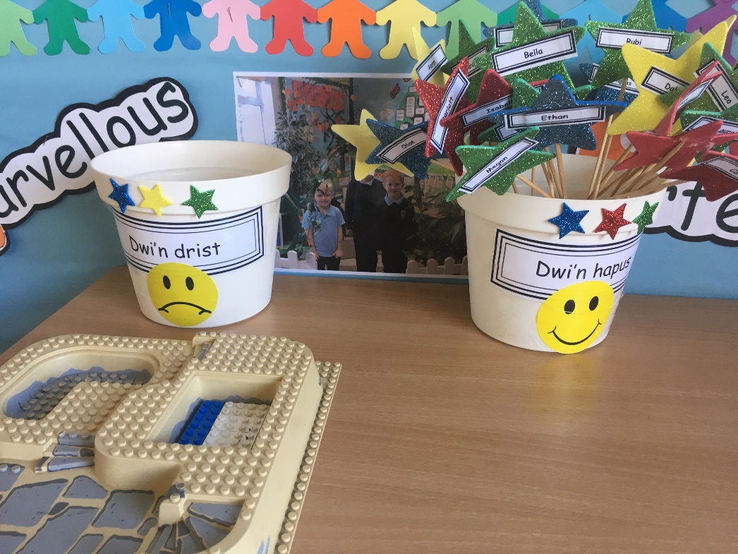
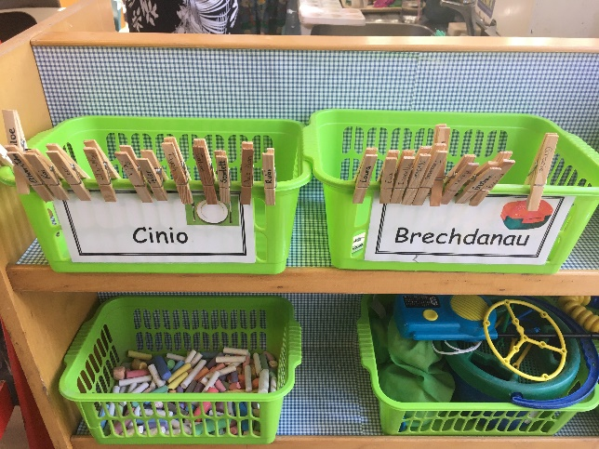
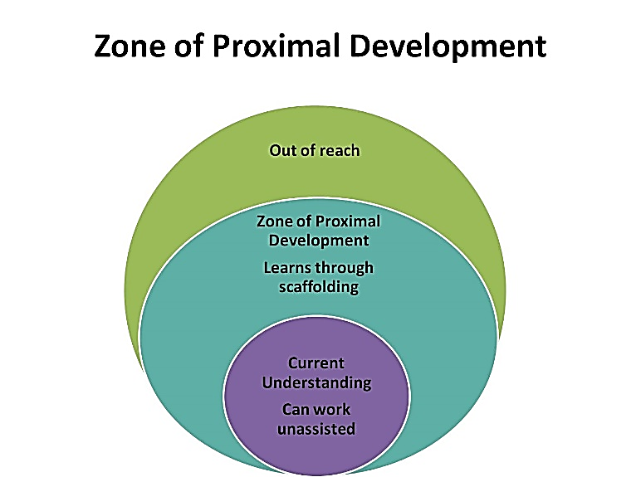
It should be noted, before any discussion, that there could have been the presence of the Hawthorne Effect, resulting in the observations made. The Hawthorne (or Observer) Effect is a response of individuals being watched and altering an aspect or all their behaviour as a result (R McCarney et al. 2007). Henry Landsberger coined the phrase in 1958 and claimed that workers and pupils momentarily, whilst being observed, can increase or decrease their productivity to suit the situation within which they find themselves, and that this can be either a conscious decision or a subconscious reaction (Landsberger, 1958). As a result, one could argue that this significant effort into communication in the Welsh language was a façade to impress visitors to the classroom as Donaldson includes the target of use of Welsh fluently in his document ‘Successful Futures’, on which the new Curriculum for Wales is being modelled (Donaldson, 2015; 34). A Further criticism to this study on the morning routine were that only audio recordings and first-person accounts could be used to comply with the university’s best practice guidelines and BERA’s anonymity clauses. As a result, there is the potential for transcription errors recording a whole class’s dialogue for fifteen minutes, as many voices are heard over one another, and some more important dialogue is missed due to the location of the microphone in the classroom. Whilst every effort has been made to accurately transcribe the audio recording, with all transcription taking place on the day of recording, some errors may remain, particularly as all conversations were in Welsh and the student observer is not a fluent speaker of the language. This event in the school day was selected as it showed a marked difference from what had been previously seen in all other experience in any English medium school in Wales, with the experience more familiar with that which would be found in Welsh medium education. It also coupled with module content surrounding inclusive practices, Y Cwricwlwm Cymreig and the use of Welsh across the curriculum. All children, regardless of their abilities prior to the school year they were in, appeared on a level footing for the morning routine, which particularly demonstrated inclusive practices for those learning English as an additional language. Bermingham and Higham claim that “Immigrants are increasingly becoming ‘new speakers’ or rather ‘double new speakers” when moving to Wales, (Bermingham & Higham, 2018; 394). They explain the reduction in Welsh speaking levels between 2001 and 2011 to inward migration to Wales from other parts of Europe. Nonetheless, all children in the class learned the same content at the same rate. It was discussed with the class teacher that the morning routine placed all pupils into the Zone of Proximal Development, a theory initially developed by Lev Vygotsky in 1928 (Vygotsky ed. Cole, 1980; 86). The theory believes that children are most productive and therefore yield the best learning outcomes when they are faced with tasks that are of a level of difficulty which they can complete with some adult intervention or scaffolding (fig.2).The adult interventions in this case, are several pieces of continuous provision dotted about the classroom which the children use as scaffolding to form sentences in Welsh. For example, there are two boxes with named pegs which are moved to indicate whether the children are having a packed lunch, or school dinner in the day in question, a similar system is used to display the dominant emotion the child is feeling on the day (figs1,3). These ‘Welsh Stations’ (Gorsaf Cymreig) are numerous around the classroom and typically include the question on the wall behind the provision, along with the full sentence answer, and examples which the children can use. The children can read these examples and then use physical actions to answer the question, along with replying to the teacher when she then moves to the station and asks the question. The aspect of continuous provision is particularly noticeable at the ‘Emotion Check-In’ station, where a child is free to return to the pots at any point throughout the day, to move themselves. The classroom also has a ‘Welsh Corner’ or ‘Cornel Gymraeg’ where continuous provision is given to the children through the medium of Welsh language books, puppets and props but with emphasis on verbal questioning and answers with rotating cards hung from the ceiling which the pupils stand in pairs on either side of to engage in conversational Welsh. This corner was utilised during the morning routine to fuel conversations between the teacher and pupils, along with pupil to pupil interaction.
Figure 1 ‘Gorsaf Gymraeg Un) - Emotions Check In – Continuous Provision
Figure 2 - Vygotsky's Zone of Proximal Development
Figure 3 ‘Gorsaf Gymraeg Dau' – Lunch Check In
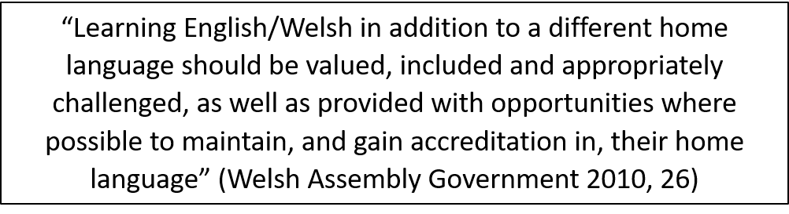
With further reference to Welsh spoken amongst the high proportion of EAL pupils in the class, whilst Bermingham and Higham state that whilst governments are making appropriate efforts encourage the use of the local language (fig. 4), “immigrants still face obstacles concerning the new language or languages of their host communities” (Bermingham & Higham, 2018; 395). This materialises through the view that speaking the more local language can be seen to relate to “exclusion and ethnocentrism” with English being classified as more “civic, inclusive and tolerant” and having been promoted more heavily for newcomers, particularly in certain geographic areas. Crowe supports this view, stating that “the challenge for new speakers in Wales is not ‘drowning in Welsh […] but finding a puddle of it in which to dip their feet.” (Crowe 1988, 88 in Bermingham and Higham 2018; 402). Beginning to learn Welsh therefore, in the foundation phase of primary school is key to learning the language long term, to surround pupils with equally able individuals in the future, to maintain levels of learning. Bermingham argues that whilst policy has a certain efficacy to help children access the language; more localised efforts are needed to assist in the populations actual perception of Welsh speaking individuals, particularly those who come from outside the United Kingdom (Bermingham, 2018; 404). There is relevance here to the view that the clear majority of new Welsh learners are now from England originally, with learners being, for the most part, English speakers who have taken an active interest in Welsh as a second language. Nonetheless, immigrant communities do regard Welsh as a positive language to learn and many perceive that learning the language will assist with their integration to their community. Schools are the most valuable tool to assist in the fluency of Welsh, becoming “new speech communities” within English speaking enclaves. However, schools provide such a small proportion of the population with the resource, it could be argued that their purpose is flawed from the outset. (Romaine, 2006, 466 in Hornsby and Vigers, 2018, 428)”
Figure 4 Welsh Government Statement on English/Welsh as an additional language
During the morning routine observed, the lack of English in the classroom was not reinforced in any way, and children who spoke English during this part of the school day (whilst their existence was negligible) were not punished; instead; use of Welsh was positively reinforced. This method of encouragement of Welsh use, simultaneous to discouraging the use of English during this period of the school day follows the theories of Skinner in operant conditioning to achieve the most desired behaviours in the classroom. The behaviouralist approach researched by Skinner took the view that the teacher in the classroom is a dominant figure and hence, goes unquestioned (Donald, Lazarus & Lolwana, 2002). This results in a lack of evaluation on the part of the pupil in the process and has led to some academics labelling the “conceptualisation of learning in this medium” as artificial and shallow as no emotions or reasoning are considered (Donald, Lazarus & Lolwana, 2002). During this observation the teacher in the classroom praised all and every effort from the children to communicate in Welsh. All children were therefore engaged with the activity, and no child felt left behind or victimised, should they have been less able. This could be an example of Continuous Reinforcement (Ferster & Skinner, 1957). Ferster and Skinner claim that the response rate, namely how often pupils partook in the morning activity and how many responses they were willing to give in this method should be low. However, knowing that they would receive such praise each time, the pupils were willing to answer as many questions as possible, as ‘Class Dojo’ points were placed on the board for every answer attempted. This is supported by (Kazdin, 2010, 224) who claimed that concrete rewards such as stickers, or “points towards a larger reward as part of an incentive system” created a high response rate. Forgatch and Patterson (2010), support Kazdin’s theory, coining the term “successive approximations” with regards to rewarding each small effort in an attempt for a greater end goal. Ferster and Skinner discuss however, that the use of this method leads to a high ‘Extinction Rate’, which would in this case mean that should children then begin not to receive the praise every time, they are highly likely to cease their efforts in the activity. In this case nonetheless, continuous reinforcement is seen to have a positive outcome, as all members of the class were engaged, knowing that the behaviour would be rewarded. There is a risk however, that once the pupils change class, with different teaching approaches, their receptiveness to Welsh may dwindle if the continuous reinforcement is no longer maintained. A more effective means of reinforcement for this teaching maybe that of ‘Variable Interval Reinforcement’. Through this method, pupils would not be rewarded for each effort, nor after a measured period or a measured number of responses, but instead, completely at random after differing periods of time. Ferster and Skinner argue that this approach has a faster response rate and has a lower extinction rate, enabling more productivity towards a more ambitious end goal in Welsh comprehension.
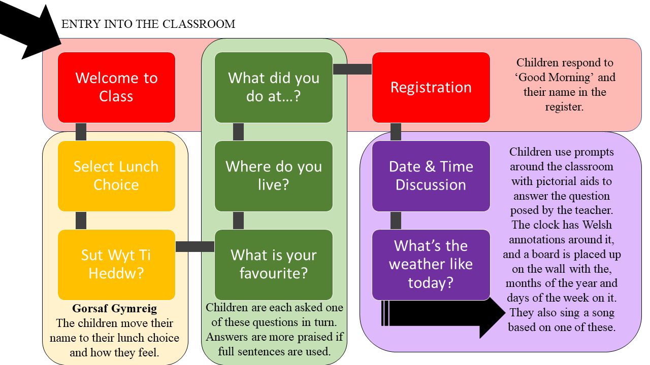
Fig.5 demonstrates the morning routine in full. The initial welcome to the classroom is made by either the teacher or learning support officer (referred to subsequently as LSO) in the room and consists of a basic greeting for each child. For example;
Figure 5 Flow Chart of the Morning Routine
LSO: Bore Da [Pupil F]
Pupil F: Bore Da Miss
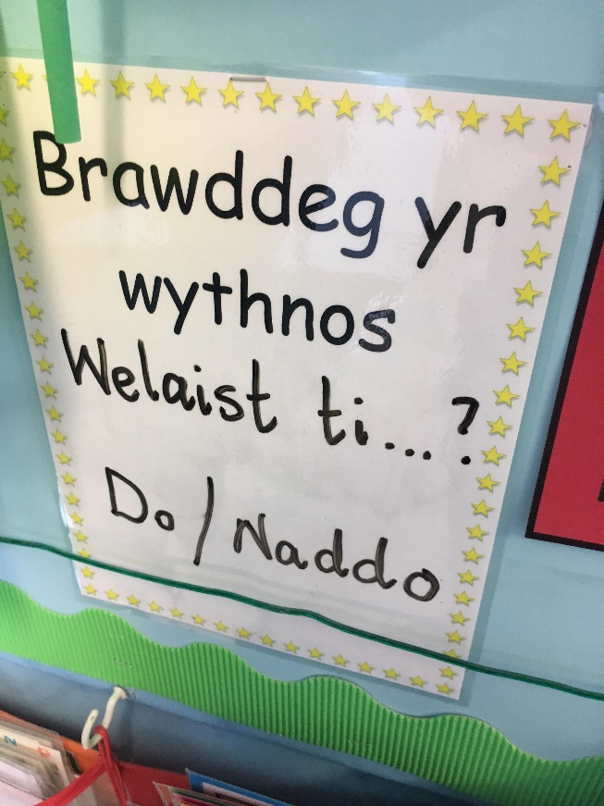
No further interaction is made with the pupil at this point and as they walk through the classroom, they place their lunch boxes and coats in the cloakroom and proceed to the ‘Gorsaf Gymraeg’ where they select their lunch choice and then place their name in the correct box corresponding to how they feel. Fig. 2 is a more simplified version of the system used in the subject school, as permission was not sought by the observer from the teacher of the classroom in question on the day of observation and therefore cannot be used. The system used in the observation classroom, whilst very similar, used seven different responses varying from ‘Ofnadwy’, (Terrible); through the spectrum of emotion to ‘Bendegedig’ (Excellent). There were also options for angry, sad and confused. If children placed their name in one of the more extreme negative emotions, the LSO then took them aside from the morning routine to identify any issues and how the day could be more structured to enable them to feel better and more ‘ready to learn’, the child was then free to move their name if they wished. From here, the children then take seats on the carpet or either side of the question and answer cards in the ‘Cornel Gymraeg’ and a basic question and answer session is started with the three questions in green in fig.5. Every pupil is asked a question, and there is an emphasis on there being no wrong answers. Extra praise is given to children who answer in full sentences and use more imaginative vocabulary. The teacher also asks the question (or sentence) of the week at this point (fig.6). Following this, the teacher takes the register with basic answers being used once again; ‘Yma’ (here), ‘Dim Yma’ (Not here) or ‘Bore Da’ (Good Morning). A more complex section of the morning routine is then started, with elongated discussion surrounding the date, time and weather (integral to the recurrent Welsh used throughout the day, as the school write dates in both languages in all workbooks). Fig. 8 shows a stunted transcript of the conversations between members of the class.
Figure 6 ‘Brawddeg yr wythnos”– Sentence of the week.
Demonstrated in the transcript is the reluctance of the class teacher to use the English language, only doing so when the pupils clearly do not understand the content of the discussion. This ‘immersion’ technique is used in a study developed by Dodson et al. in 1968 in an English medium primary school in Aberystwyth. They claim that the best results were obtained when “no direct pressure was put on the children at any time to learn and respond in Welsh” but that the fact that teachers only spoke Welsh for a certain time during the school day did, “in fact, exert its own kind of pressure.” (Dodson et al. Ed. Williams, 1968; 19). They argue that that children learning in unison with their peers regardless of ability results in “the formation and the acquisition of skills” They also state that the work of Jean Piaget “proved seminal” when coupled with the work on “concept formation, deriving from his [work],” such as that of Ruth Beard.” (Dodson et al. Ed Williams, 1968; 20). They state that this is because of Piaget’s view that “all children go through the same developmental stages, in the same order, [but] at differing rates” (Sklar in Lubin and Piaget, 1975; 119). Piaget believed that one of the most basic ways in which a child learns is through continuous interaction with peers, and therefore group work can have the most positive outcomes. However, learning must take place through the process of three stages. These being; a stage of concrete thought to plant information for the children, a formal thought level where children can shift what they know from “reality to possibility”, and then finally the ability to think in the abstract and to find alternative solutions to problems (Sklar in Lubin and Piaget, 1975; 123). Whilst Piaget focussed his research of these processes on mathematical problems, the path can be seen too, in the learning of linguistics. The stage of concrete thought is being established in the classroom, with the use of physical resources aiding the learning of Welsh. Stage two was beginning to be explored by the children expanding their answers to the questions, and stage three would be covered by children being able to develop original answers to questions and question one another. Of course, this stage was not yet completed by the pupils in the foundation phase at this particular school, and Piaget argues that because “individual differences among children will be observed in the rate of development through the stages”, it is the teacher’s responsibility to ensure that each child is provided with a different series of matter based on developmental needs (Sklar in Lubin and Piaget, 1975; 123). However, Sklar argues that psychologists studying Piaget’s views have criticised his lack of sophistication and his use of anecdotal evidence to reach his conclusions and hence, limitations are clear throughout his work. Whilst the entire morning routine was very structured and therefore, followed a ‘constructivist’ mentality, there were very few direct orders from the teacher with regards to content that needed be covered, this could prove Piaget’s view that children are ‘lone scientists’ (McGuinness in Tomlinson, Dockrell & Winne, 2007). With children keen to research and learn new words and phrasing from the provided resources, for example pupil F; whom had clearly researched how to state her baby brother had made her tired but was then unable to respond to further questions. The fact that these were provided for them however, may lead to a counter point and fuel the opinion of Vygotsky, that children are far closer to ‘little apprentices’, building on material that has been provided for them. McGuinness states that whilst both psychologists adopt a constructivist approach to learning, it was clear that Vygotsky’s approach surrounding children requiring assistance to learning through the Zone of Proximal Development was in far more use during this observation.
Continuing to work within the theory of constructivism, Long argues that all constructivists view learning as the “progressive development of schemas” (Long, 2000; 29) and that once planted, ideas and concepts can be re-taught later in education with increased complexity. Vygotsky however, considered language to be a key feature of a child’s development, through his view of ‘social constructivism’. He believed that language was “the main vehicle for developing later knowledge and understanding” (Long, 2000; 35). His approach therefore, implies that all teaching should be focussed around language acquisition to ensure that progress takes place across the spectrum of understanding. In the observation covered in this assignment, language is used as a vehicle to further explore other aspects of education, for example; the weather, time, dates and personal and social aspects of life in the classroom. This basic development in the morning routine therefore is a key stepping stone to further understanding. John Dewey argued that “under no circumstances [is] telling a learner about a new idea very effective when teaching”. He stated that pupils are quite capable of learning content by rote but were unlikely to be able to see relevance without using means of “normal communication with others” (Dewey in Phillips and Soltis, 1998; 56). The routine followed therefore, by the class is an example of productive learning from Dewey’s perspective of constructivism.
As the pupils learned through a form of self-paced interaction with others in the classroom, fuelled by positive reinforcement, one could argue that a humanist approach to learning also took place alongside that of a more constructivist nature. Many of the aspects of the morning routine could have been argued to be of an exploratory nature, with self-paced and voluntary contributions being placed at the forefront. Whilst the teacher encouraged participation, the lack of force brought out answers from children who were then witnessed later in the school day to be very reluctant in taking part. Wall argued that the best way for a child to learn about a certain topic would be to gently persuade them into adopting it. He stated that should a pupil begin to become fascinated with one area, it is best to take this, and embrace their want to learn, “gently diverting the child’s attention” to learning more without realising it. He argued that the relaxed nature of earlier schooling (nursery and what would be considered the present-day foundation phase), enabled the teacher to do this without causing any distraction to others (Wall, 1975; 155). The removal of one member of the class to discuss their feelings, enabled by the Welsh introduction, is a key example of this, as no other child in the class had noticed an absence until it was mentioned by the teacher. Maslow (1973 in Entwhistle, 1981; 230) argues that teachers who repressed the allowing of emotion in the classroom hindered the educational progress of their pupils, building on Freud’s concern surrounding excessive discipline harming a child’s natural want to experience awe through ‘peak experiences’. The freedom therefore, witnessed in the routine, using continuous provision, would yield a more productive atmosphere for the remainder of the school day. Entwhistle builds on this concept, claiming pupils that are not given the chance to talk about experiences, experience profound negative effects, lasting throughout their education (Entwhistle, 1981). The encouragement therefore, to constantly express their opinion, can only be perceived as a positive.
As the focus of this assignment was the observation which took place in a foundation phase classroom, the ideal classroom design is, therefore, that of an environment towards the lower end of the school age spectrum (fig.9) As a result, there is a heavy reliance on continuous provision stations which can be adapted to enable enhanced provision dependent on the topic being studied, or an area of interest for the pupils. Typically, continuous provision takes the form of a sandpit, water play area, and resources at the disposal of the children, which I have included. Further to this, I have expanded to both numeracy and literacy continuous provision in a semi-separate ‘intervention room’ away from the louder class environment. Resources which will be continuously set up would include ‘Numicon’, ‘Flower Power’ and ‘Multi-Link’ for numeracy provision. Phonics and grapheme cards, books guided towards teaching children without aid and audio assistance toys to help children learn sounds and blending towards the lower end of the foundation phase. These resources can be moved around the classroom with ease, as well as be used in a full class activity. Other areas of continuous provision include the ‘Wendy House’ which can be converted as needed into various other role-play areas including a hospital, shop, a school within a school or even a super hero hideout. Further to these, the emotion station is replicated from the observation classroom, along with the check-in stations used as part of their morning routine. The Welsh corner (Cornel Gymraeg) is also copied across, as this provided an excellent form of continuous provision for children who were struggling with answering questions in the morning and in Welsh lessons.
There are two distinct areas for the whole class to learn in. I was keen to maintain a more traditional classroom set up and avoid heavy reliance on an interactive whiteboard as the only resource for displaying work. This is mainly since children can often become distracted by the board’s capabilities and most regularly the teacher does only use the whiteboard function of it. As a result, there is a large standard whiteboard in the area for the class to work at desks. The technological side of teaching is encouraged and facilitated for however, with an interactive whiteboard set up in the carpet area on the opposite side of the classroom. This means that the register can be completed visibly for the children, along with the welsh corner and check-in stations being visible from this area. Should the teacher wish to begin an activity with a video or other online resource, the children would be more engaged with the interactive whiteboard because of very few distractions around the carpet. They would then go through the ‘Tunnel into Learning’ to work at desks, with the movement signifying a change on environment, and therefore a change of activity and expectation. The way in which the classroom lends itself to a series of paths and cycles encourages children to use all the materials at hand. This is supported by Kolb’s Experiential learning cycles theory (Kolb, 1984). He argues that the model of “Do, Review, Plan” is relevant as early as the modern-day foundation phase and becomes the adopted method of learning for adults as a result of being taught in this way. Kolb argues that children are happiest when able to try an activity without any form of adult interference or hindrance (do), they are then able to review what they have learned, shifting what they thought they knew into what they can apply in the future, as part of Piaget’s theories in learning (Sklar in Lubin and Piaget, 1975; 123). Children can then plan another approach using newly learned information to begin the cycle again. Putting the entire classroom at the disposal of the children therefore, is a perfect way for them to learn independently whilst also building team-working and collaborative skills.
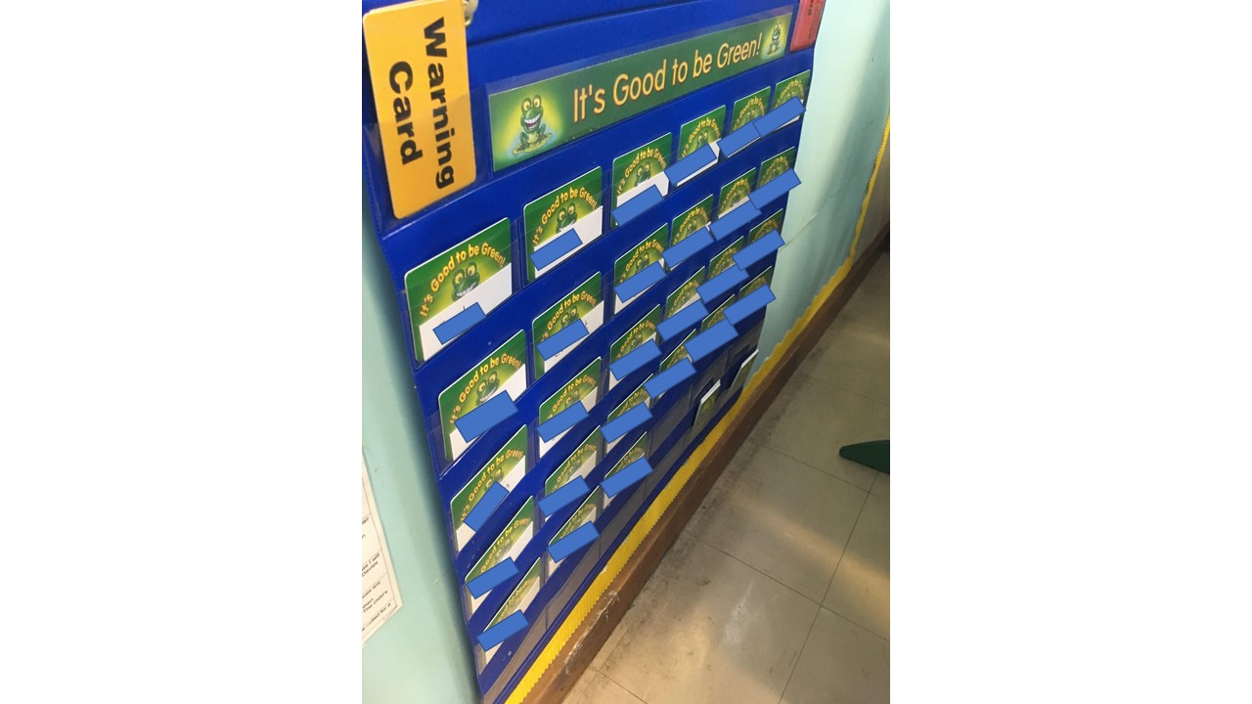
Whilst the classroom itself is inherently limited by walls, to ensure that all children are entering the Zone of Proximal Development whilst learning, a door is included to the year group above. This would enable children of a more able and talented nature in certain topics to be able to be moved up for some areas of learning. It’s key that there is no door down to the lower year group however, as this would have detriment regarding the confidence of the pupils. To make sure that all the pupils are suitably catered for therefore, I would insist on two teaching assistants in the classroom, one with the role of providing full-time intervention for key areas of learning and experience. With respect to the physical limitations of a classroom again, there is a covered outside area for use by the pupils, with several areas of continuous provision, as well as use for play during periods of rain. Further to the outside, a tarmac play area is included with toy cars and police station, ambulance station and petrol garage to enable role play during play times. This way of learning is supported by Katzeff who claimed that children are no longer passive receivers of information, but they take the effort now to actively seek understanding (Katzeff, 2003 in Dietze & Kashin,2011; 36). This active way of learning would be replicated across the classroom both inside and out, with active movement being required across all the continuous provision. This way of learning is supported further by Dewey who claimed that both physical and mental activity must be experienced to learn (Dewey in Phillips and Soltis, 1998; 58).
Figure 7Behaviour Management Board
To maintain order in the classroom, a behaviour board with all the children’s names would be placed in a prominent part of the classroom, close to the door of entry, like that in figure 7. The proximity to the entry of the room would remind children non-verbally every morning about the expectations of them in the classroom. The example provided in figure 7 is used in a small village school in Wales and allowed children to have one warning before consequences would occur and was observed being used very effectively.
In conclusion; overarchingly, a difference was witnessed between the morning routines of the foundation phase class and Key Stage Two class during the observations, supporting the view of Dodson and Williams in 1968, that the future of Welsh language communication and fluency lies within the foundation phase of the country. They believe that the instilling of a second language in younger pupils, whilst easier (Lenneberg in Phipps, 2001), also would provide a cohort of learners capable of communicating with one another in Welsh to counter the difficulty many learners have in finding others to communicate with in Welsh (Bermingham & Higham, 2018; 395). The increasing levels of Welsh recommended by (Donaldson, 2015) as a cross-curricular topic to cross all the areas of learning and experience should go further to encourage Welsh to be used more across our curriculum. The observations made in the foundation phase showed that despite a teacher being a non-fluent second language speaker of Welsh, children can learn basic conversational skills using a variety of continuous provision, enhanced provision and play, alongside working with one another with pupils given responsibility for other’s learning. It has been argued that being able to speak more than one language makes you a better learner of subjects, (Lenneberg in Phipps, 2001) and therefore, should be encouraged. This positivity, alongside that of a more inclusive society as a result should encourage all teachers to embrace Welsh as a second language and routines in the foundation phase and beyond.

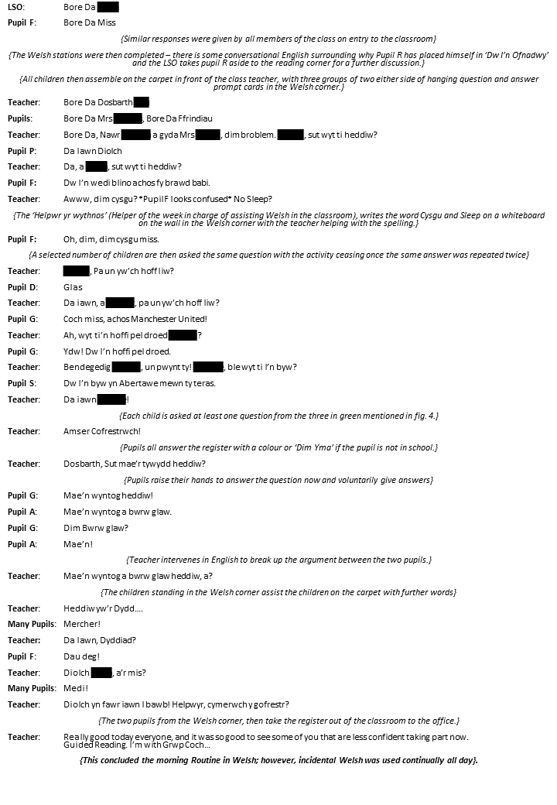
Figure 8 Stunted transcript of morning routine in Welsh.
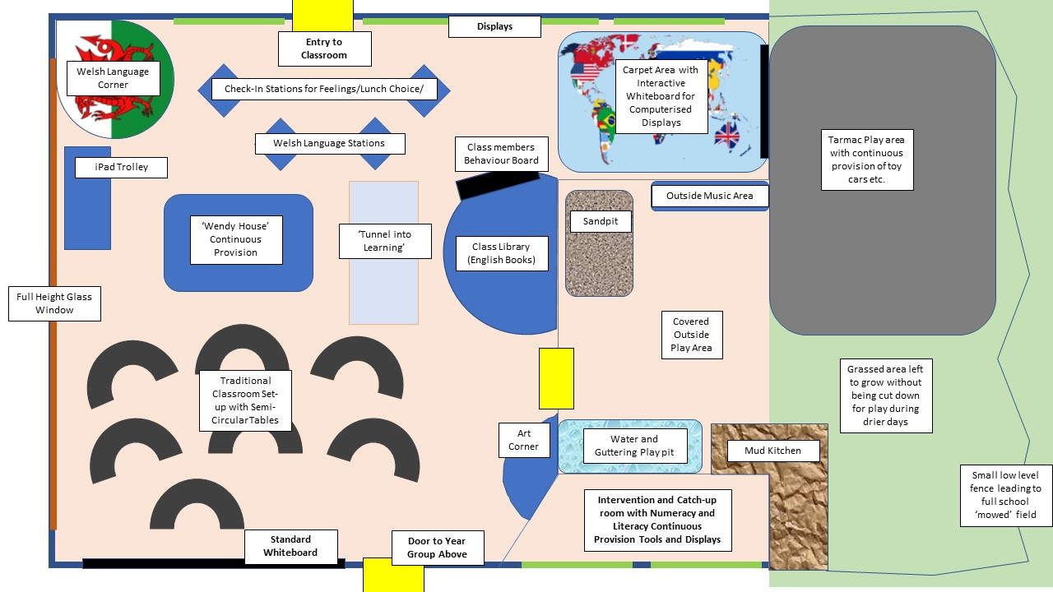
Figure 9 Ideal Classroom Design
Source List
Bermingham, N. and Higham, G. (2018). Immigrants as new speakers in Galicia and Wales: issues of integration, belonging and legitimacy. Journal of Multilingual and Multicultural Development, 39(5), pp.394-406.
Dodson, Charles Joseph, Eurwen Price, and Ina Tudno Williams, Towards Bilingualism (Cardiff: University of Wales P., 1968)
Donald, D., Lazarus, S. and Lolwana, P. (2002). Educational psychology in social context. Cape Town: Oxford University Press.
Donaldson, Graham, "Sucessful Futures", Gov.Wales, 2015 <https://gov.wales/docs/dcells/publications/150225-successful-futures-en.pdf> [Accessed 13 October 2018]
Entwistle, Noel James, Styles of Learning and Teaching (Chichester u.a.: Wiley, 1990)
Ferster, CB, and BF Skinner, A History of Experimental Psychology (Century Psychology Series) - Appleton Century Crofts (Englewood Cliffs, N.J.: Harvard University - United States Office of naval Research, 1957)
Forgatch, MS, and GR Patterson, EVIDENCE-BASED PSYCHOTHERAPIES FOR CHILDREN AND ADOLESCENTS, 2nd edn (New York: Guildford Press, 2010), pp. 159-178
Kazdin, AE, "Problem-Solving Skills Training and Parent Management Training for Oppositional Defiant Disorder and Conduct Disorder", Evidence-Based Psychotherapies for Children and Adolescents, 32 (2010), 211-226
Kolb, D. A. (1984). Experiential Learning: Experience as the source of learning and development. New Jersey: Prentice Hall.
"Living, Not Just Learning, The Welsh Language | BERA", Bera.Ac.Uk, 2018 <https://www.bera.ac.uk/blog/living-not-just-learning-the-welsh-language> [Accessed 4 October 2018]
Loewen, S. and Sato, M. (2018). Interaction and instructed second language acquisition. Language Teaching, 51(03), pp.285-329.
Long, M. (2010). The psychology of education. London: Routledge.
Lubin, Gerald L, and Jean Piaget, Piagetian Theory and The Helping Professions, 1st edn (Los Angeles, Calif.: Publications Department [of the] University of Southern California, 1975), pp. 118-123
McCarney, R, J Warner, S Illife, R Van Heselen, and P Fisher, The Hawthorne Effect: A Randomised, Controlled Trial (BioMed Central Ltd, 2007)
Mills, Richard W, and Jean Mills, Bilingualism in The Primary School (Hoboken: Taylor and Francis, 2002)
Noland, E. W., "HAWTHORNE REVISITED. By Henry A. Landsberger. Ithaca, New York: The New York State School of Industrial and Labour Relations", Social Forces, 37 (1958), 361-364 https://doi.org/10.2307/2574186
Norwich, Brahm, Education and Psychology in Interaction (London: Routledge, 2000)
Peterson, Mark Allen, and James Stanlaw, "Lev Vygotsky (1896-1934)", Encyclopedia Of Anthropology, 46 (2005), 54-55 https://doi.org/10.1525/an.2005.46.4.54
Phillips, D. and Soltis, J. (1998). Perspectives on learning. New York: Teachers College Press.
Phipps, Stacy. (2001). Language and Thought: Examining Linguistic Relativity
Tomlinson, P. (1981). Understanding teaching. London, Hamburg: McGraw-Hill.
Tomlinson, P., Dockrell, J. and Winne, P. (2007). Pedagogy, teaching for learning. Leicester: British Psychological Society.
Vygotsky, Lev Semenovich, and Michael Cole, Mind in Society: Development of Higher Psychological Processes (Cambridge, Mass: Harvard Univ. Press, 1981), p. 86
Wall, William Douglas, and William Douglas Wall, Constructive Education for Children (London: Harrap, 1975)

