
A Financial Analysis Report: Unilever PLC & Westward Plc


BMMB7005 – Finance for Business Managers

Student Name: Riaza Emama Mou
Student ID:2510980
Submitted to: Marie Pitson

Date:20.04.2026
University of Wales Trinity Saint David

Executive Summary

This report is designed in two main parts that cover two different yet complementary spheres of financial management. Part 1 provides an in-depth review of the financial performance of Unilever PLC, which is one of the leading consumer goods conglomerates in the world, basing on the published financial statements of the company in the year 2023 and 2024. It analyses five important dimensions of performance including profitability, liquidity, gearing, asset utilisation efficiency and investor returns and comes up with evidence based recommendations on how the executive decision making process should be conducted.
Unilever had a diversely sound financial profile over the review period. In 2023 and 2024, revenue levels were stable at about €59.6 billion and 60.1 billion, respectively. The gross profit margin remained stable at approximately 42, as the company is enjoying the price power and premiumisation strategy. The operating profit margin also improved moderately, as it increased by 15.8% to 17.2%, and Return on Capital Employed (ROCE) also improved, returning to 16.1% as an indicator of improved utilization of assets. There were sufficient liquidity indicators with the typical limitations of a high-volume FMCG operator. Gearing was also high and the Return on Equity (ROE) was also increased to 34.8 as compared to 31.4 indicating better value delivery to shareholders.
Part 2 is on a capital investment appraisal of Westward Plc a UK-based curtain manufacturer which is considering three strategic growth options over a period of four years. Net Present Value analysis assuming a cost of capital of 6% and incorporating 25% corporation tax and 20% straight-line capital allowances, makes the value-maximising decision, the development of an internet sales platform, which has an NPV of the highest value of £792.23k with an outlay of 1,000,000. The approximate Internal Rate of Return of the Option B is 32.23 which is far much more than the hurdle rate. The optimal divisible investment policy in the conditions of capital rationing with a budget ceiling of £2,500,000 will have a combined NPV of 1,853.04k. The report ends by giving a critical analysis of the financing options that Westward Plc can use.
Contents
Executive Summary 2
Part 1: Financial Performance Analysis of Unilever PLC 4
1. Introduction 4
2. Financial Performance Review 4
2.2 Liquidity 4
2.3 Gearing 5
2.4 Efficiency 5
2.5 Investor Ratios 5
3. Limitations of Ratio Analysis 6
4. Conclusion and Recommendations 6
Part 2: Capital Investment Appraisal – Westward Plc 9
1. Background and Scope 9
2. Net Present Value Analysis 9
2.1 Methodology 9
2.2 NPV Calculation – All Three Options 9
2.3 Results and Recommendation 10
3. Internal Rate of Return – Option B 10
3.1 Methodology 10
3.2 IRR Result and Interpretation 10
4. Interpretation of Results 11
4.1 Why NPV is the Superior Appraisal Method 11
4.2 The Continued Use of Non-Discounting Methods 11
4.3 Other Factors to Consider Before a Final Decision 11
5. Capital Rationing – Optimal Investment Policy 12
5.1 Framework 12
5.2 Conclusion on Capital Rationing 12
6. Financing the Investment Programme 12
6.1 Retained Earnings 12
6.2 Bank Term Loan 13
6.3 Equity Finance 13
6.4 Asset Finance and Leasing 13
6.5 Government and Development Finance Schemes 13
References 15
Appendices 16
Appendix A – Unilever PLC: Financial Statements (FY2023 & FY2024) 16
Appendix B – Ratio Calculations (Unilever PLC) 19
Appendix C – Westward Plc: After-Tax Cash Flow Workings 19

Part 1: Financial Performance Analysis of Unilever PLC

1. Introduction
Unilever PLC is among the most well-known multinational companies in the world fast-moving consumer goods (FMCG) industry. The company has a portfolio of personal care, home care, beauty, and nutrition including household brands like dove, Hellmanns, Knorr, and Domestos and operates in over 190 countries and has about 3.4 billion consumers every day (Unilever, 2024). This scale of operation has great requirements to the working capital management, brand investment and supply chain governance.

This section is meant to provide the top management team of Unilever with a critical and systematic financial analysis of the 2023 and 2024 financial years. Raw accounting numbers are converted into actionable intelligence by financial statements which are carefully interrogated using ratio analysis. This analysis includes profitability, liquidity, gearing, efficiency and performance by investors. The inherent weakness of the ratio analysis method is also discussed and proactive recommendations are given to inform the strategic financial policy (Rani et al., 2025).

2. Financial Performance Review
All the raw financial data has been obtained through the published Annual Reports of Unilever and all ratios working have been provided in detail in Appendix B. The following commentary interprets those findings in a critical way across five thematic areas, with the help of pertinent academic and practitioner references that can help place the findings in a wider operating environment of a global FMCG business.
2.1 Profitability
Profitability dimension measures the ability of a business to earn profits on its revenue base and the capital that it has used to achieve this. In the case of a firm as big as Unilever, one of the indicators of brand strength, pricing power and discipline in operation is margin sustainability (Losbichler et al., 2011).

The gross profit margin was generally the same in both periods at 42.1 in 2023 and 42.4 in 2024. This modest growth indicates that Unilever was able to cope with high raw material prices, in part by increasing prices in some emerging markets, and in part by a purposeful mix-enrichment approach, which also reallocated the volume to higher-end product lines. A gross margin of more than 40 percent is a good sign of a manufacturer of consumer goods implying that there is a significant cushion between the price of production and the value of sale (Brownlee, 2008).

The operating profit margin also increased by a greater percentage as it went up to 17.2. This is a result of the productivity programme that the company has been undertaking and that has focused on achieving cost reduction in terms of marketing expenditure, overhead rationalisation and procurement efficiency. The interpretation of the Recovery in Return on Capital of 14.3-16.1 further supports the interpretation that Unilever is putting its long term capital base into more effective use. The management should, however, still be wary of complacency: the post-pandemic level of return is still lower than it was before the pandemic, and additional operational enhancements have to be made to bridge the gap (Khan, 2015).

2.2 Liquidity
The liquidity ratios give an understanding of the ability of a firm to meet short term financial obligations as they fall due. In the case of a business with the high level of complexity Unilever operates in, with thousands of suppliers all over the world and substantial payroll costs, the necessity to keep sufficient liquidity is a strategic consideration (Endang Purwanti, 2022).

Unilever had a slight decrease in its current ratio of 0.79 in 2023 to 0.74 in 2024. Although this falls short of the traditional 1.0 mark, it should be viewed in reference to the FMCG industry. Firms here usually have negative operating capital cycles, i.e. they receive money at rates higher than they pay suppliers and as a result create a structural current ratio lower than one. This does not reflect a sign of financial distress, but is a business model aspect (Lyroudi and Lazaridis, 2000).

The quick ratio also declined (0.51 to 0.47) in part due to a rise in inventory holdings as the company fortified the stock reserves due to the supply chain disruption. These measures should be closely observed by the management to make sure the working capital position does not decline further, especially in a rising interest rate environment that makes short-term borrowing more expensive (Ali Gull, 2013).

2.3 Gearing
Gearing ratios clarify the extent to which an entity is funded by debt as compared to equity, and are a major gauge of long-term financial hazards. A company with a high level of gearing becomes more susceptible to poor trading conditions, since the debt service obligations will not change with change in revenue performance.

Unilever's debt-to-equity ratio was 143.7% in 2023 and edged to 147.2% in 2024. These levels represent a tangible dependence on external borrowing, but the company has demonstrated a healthy ability to cover these commitments as the company has had steady strong operating cash flows. This high gearing status is mostly due to the heritage of the big acquisitions especially the acquisition of Horlicks and GlaxoSmithKline nutrition business by the company which occurred due to the use of debt instruments which were heavily used to finance the acquisition (Muradoglu, Bakke and Kvernes, 2005).

The management must bear in mind that long-run high gearing limits strategic flexibility. Within a setting in which long-term higher interest rate by central banks have been sustained, refinancing costs pose a quantifiable threat to the net profit margin in the future. Debt reduction should be considered a medium-term strategic priority in the form of a structured programme, which should be financed by the means of generating free cash flow.

2.4 Efficiency
Activity ratios or efficiency ratios, are ratios that indicate how hard the management is working to convert the asset base of the company into revenue. The rate at which the stock is moved and receivables are collected in a high volume consumer goods operation is the basis of the operational and financial well-being of the business cycle.

The inventory turnover slightly increased to 5.81 times in 2024 compared to 5.62 times in 2023. This is a good sign, and it is showing that inventories are being turned into sales at a somewhat higher rate, to a lower capital tied up in stock. The improvement can be attributed to the global supply chain being normalised after the pandemic disruption, as Unilever was able to cut precautionary inventory buffers (Eryatna, Eltivia and Handayawati, 2021).

The receivables turnover ratio remained relatively steady with 9.14 times in 2023 and 9.08 times in 2024, which is equivalent to an average collection period of about 40 days. It is a healthy and commercially suitable cycle to a company that is mostly dealing with large organised retail customers and distribution networks. This ratio is stable in the two years, and this testifies to the strength of the credit control infrastructure at Unilever.

2.5 Investor Ratios
The investor ratios end up addressing the ability of the company to generate and maintain value to its equity shareholders, the main constituency to whom the board is responsible.

The 2024 ROE of 34.8 increased in 2023 (31.4) as both net profitability and a slight decrease in the equity base due to the share buyback activity contributed to the increase. The fact that ROE stood almost at 35% is a powerful measure of capital efficiency and it substantiates the fact that Unilever management team is able to generate strong returns on the money that shareholders have invested. This makes Unilever a desirable long-run investment in equity by institutional fund managers that focus on defensive yield with moderate growth (Lynch, Gillam and Forman, 2017).

The long-term history of increasing dividend per share has further enhanced the qualification of Unilever as a high-quality income stock and supports the higher valuation at which its stocks tend to trade compared to those in the sector.

3. Limitations of Ratio Analysis
In spite of the analytical utility ratio analysis has several material limitations that should be taken into consideration before conclusions are made and action is taken by the management.

The most basic limitation is that the ratio analysis is always backward-looking. The amounts calculated based on the 2023 and 2024 financial statements represent what has already happened; they do not give any direct indication of what is going to happen. Alterations in macroeconomy, consumer mood, or the prices of goods or services or competition dynamics can make historical ratios a very ineffective forward guide (Rani et al., 2025).

Another related issue is that financial statements are prepared based on certain accounting policies and different companies might adopt different accounting policies on the valuation of inventory, depreciation of assets and recognition of revenue. Direct comparisons between the ratios of the companies are hence only viable in the event that there is an accounting policy alignment that has been established - which is not always an easy task to perform by looking at published reports alone (Swee and Islam, 2026).

Moreover, ratio analysis lacks qualitative aspects of performance that tend to be determinant of long-term corporate health. Strategic assets such as the strength of a brand portfolio, quality of management, innovation pipeline, employee engagement, and customer loyalty are strategic assets that cannot be well measured using financial ratios. These intangibles could therefore be more significant in the long run than the short-term changes in margins in the case of a brand-based business like Unilever (Effiong and Enya, 2020).

Lastly, the end of year balance sheet values may be prone to window-dressing - temporary changes to the values that are executed close to the reporting date to put a better appearance on them. Such distortions are susceptible to working capital ratios, especially. Ratio-based analysts can thus be given a biased picture of the real-life financial status of the company.

4. Conclusion and Recommendations
On the whole, Unilever PLC creates an image of a large-scale and financially sound consumer goods company, which is undergoing a phase of slight yet significant growth. Profitability has improved throughout the review period, capital efficiency has bounced back off a low base and investor returns have increased to more enticing levels. These have been substantive successes especially in a global trading landscape which has been typified by enduring inflationary forces, geopolitical uncertainties across major emerging economies and an ongoing structural change in the consumer demands towards health-conscious and sustainable products lines. The fact that the operating profit margin has improved to 17.2% and that ROCE has returned to 16.1%, proves that the management team is making tangible improvements in turning the revenue into profitable results, as well as using capital more efficiently. This increase in Return on Equity to 34.8% is another indication that shareholders are getting better returns on the capital invested which is a significant indicator to institutional investors who want to get defensive returns on their invested capital and also get long term growth.
However, the analysis has also revealed several areas that the Board and the senior executive team should put a keen eye upon. The liquidity position, structurally typical of a high volume FMCG operator, has continued to shrink over 2024 and is now at levels that would not allow it to be subject to operational shocks or negative working capital flows. The current ratio and the quick ratio decreased on an annual basis meaning that the financial buffer of the company in terms of the short run is becoming increasingly small. Meanwhile, the gearing level is still high at debt-to -equity ratio of 147.2, which brings a significant level of sensitivity to any long-term rise in market interest rates. The cost of debt would rise significantly in case macro-financial conditions are constraining and Unilever has to refinance its borrowings in the middle term due to the size of its borrowings. Management of inventory and working capital needs should hence not be considered as the peripheral issues of operation but a strategic financial issue which should be looked at at the board level and closely monitored by the management.
Based on this discussion, four proposals are put forward on the basis of which the executive management team of Unilever PLC should seriously consider. All the recommendations are based on the results of the ratio analysis and are aimed to be used to make strategic financial decisions in a short- to middle-term perspective:

Recommendation 1: Ramp up the Discipline and Margin of Operating Cost. The fact that the operating profit margin has increased by 15.8 to 17.2, although encouraging is still lower compared to the levels of the past years and that of some of the immediate competitors. The management ought to embark on a systematic programme of cost reduction in the main overhead areas, such as marketing spending rationalisation, consolidation of procurement by size of business worldwide and extensive review of the selling, general and administrative expenses. Specifically, the marketing budgets need to be reviewed on a stringent basis in such a way that investments in the brand should be targeted at the most profitable investments as opposed to being uniformly distributed across the portfolio. Speeding up operational efficiency programs such as additional automation of the manufacturing process and digitisation of the supply chain should be enhanced. An operating margin of about 19-20 should be the medium term target and would put Unilever on the level of performance of its best FMCG competitors as well as provide the company with a significant ability to create free cash flow to reinvest and pay off debt (Losbichler et al., 2011).
Recommendation 2: Have an Ordered and Time constrained Debt Reduction Programme. The 147.2% debt-to-equity ratio reflects a degree of financial leverage that brings a lot of exposure to the increasing interest rates and limits the strategic flexibility of the company in case of an acquisition opportunity, or an economic recession. The Board ought to set an official deleverage goal - say, to get the debt-to-equity ratio down to less than 120% over three years - and devote a specific amount of free cash flow to net debt paydown each year. This must be conveyed openly to the investment fraternity as an investment priority rate in capital allocation in addition to the dividend. By cutting the debt load, annual interest payments would be reduced, and earnings would not be as sensitive to changes in the interest rate, but it would also enhance the credit profile of Unilever and the cost of future borrowing may also decrease. Long-term financial health requires a disciplined way of capital allocation, between value-creating investment and balance sheet optimisation (Muradoglu, Bakke and Kvernes, 2005).

Recommendation 3: Enhance the Working Capital Management in all the operation divisions. The decrease in the current ratio as well as the quick ratio in 2024 indicates a narrowing of the short-term liquidity status that should be addressed by a concerted action of the management. Working capital needs to be reviewed in all the key operating divisions and geographies, and in all three areas of concern (first, the inventory level to sales velocity ratio, second, the terms to be negotiated with key suppliers, and third, the credit management structure of trade receivables) Unilever needs to ensure that it is reducing excess inventory, but without jeopardizing the service performance or supply chain resilience (first), it needs to ensure This should be aimed at improving the cash conversion cycle and restoring the current ratio to a more comfortable level and therefore it will not heavily rely on the short term borrowing mechanism to finance its day to day operations (Lyroudi and Lazaridis, 2000).

Recommendation 4: Rigorous Capital Allocation/Portfolio Rationalisation Review. The fact that ROCE has gone up to 16.1% after it had gone down to 14.3% is an encouraging development but not as high as a business of the size and brand value that Unilever has should be. The management will need to take a systematic, zero-based change of capital distribution in product portfolio and geographic coverage and put each business unit to transparent returns threshold test. Divestment or restructuring should be considered in segments or brands that do not make returns above the cost of capital and the capital can then be redeployed to other areas of growth where Unilever has a true competitive advantage. The recent strategic emphasis of the company on its power brands - the most scaled and most powerful in terms of pricing - gives it a reasonable framework, but it is necessary to monitor its implementation strictly regarding ROCE and economic profit indicators on the divisional level. An even stricter capital allocation would hasten the rise in the returns at the group level and long-term shareholder value creation (Khan, 2015).

Part 2: Capital Investment Appraisal – Westward Plc

1. Background and Scope
Westward Plc is an experienced manufacturer in the United Kingdom of high quality curtains and other related window furnishings. The Board of Directors has defined three different strategic investment options, all of them involving a four-year commitment of resources and each of which is a qualitatively different course of the business. The three possible options that are being considered are: Option A — extension of the current retail network to include the entire product range (initial capital requirement: £600,000); Option B - growth of a direct-to-consumer internet sales operation (initial capital requirement: £1,000,000); and Option C - diversification to include the production of wooden blinds and Roman blinds (initial capital requirement: £1,

It is on this basis that this appraisal has been commissioned so that the Board can make an informed and strategically based decision in relation to the investment, which is financially sound. In this analysis, we assume the following; all capital allowances are calculated as a 20% straight-line deduction, and thus all three years should obtain a pre-tax cash inflow of 120,000, 200,000 and 320,000 respectively; the taxable profit in each year is the difference between the inflow of pre-tax cash and the annual capital allowance; The cost of capital is assumed to be 6% per annum (Atrill, 2020; Mclaney, 2017).

2. Net Present Value Analysis

2.1 Methodology
Net Present Value (NPV) method is the most theoretically sound and academically prevailing way of capital investment appraisal. The way it works is to discount all projected future after-tax cash-flows to the present value using the cost of capital of the firm as the discount rate, then calculating the difference between the initial investment. The figure obtained will be the expected increase in the value of the firm in the present-value. Projects with a positive NPV contribute to shareholder wealth and are worth undertaking financially; a project with a negative NPV value kills value and should be rejected in general (Atrill, 2020).

The applicable discount factors at 6% are: Year 1 — 0.9434; Year 2 — 0.8900; Year 3 — 0.8396; Year 4 — 0.7921. The tax workings of the three options give after-tax cash flows as shown in Appendix C.

2.2 NPV Calculation – All Three Options
Item | Option A (£600k) | Option B (£1,000k) | Option C (£1,600k)
Initial Outlay (£000) | -600 | -1,000 | -1,600
Annual Capital Allowance (£000) | 120 | 200 | 320
Year 1 – Pre-tax CF | 200 | 400 | 450
Year 2 – Pre-tax CF | 400 | 450 | 700
Year 3 – Pre-tax CF | 500 | 720 | 900
Year 4 – Pre-tax CF | 700 | 980 | 1,200
Year 1 – After-tax CF | 180.0 | 350.0 | 417.5
Year 2 – After-tax CF | 330.0 | 387.5 | 605.0
Year 3 – After-tax CF | 405.0 | 590.0 | 755.0
Year 4 – After-tax CF | 555.0 | 785.0 | 980.0
Year 1 PV (DF 0.9434) | 169.81 | 330.19 | 393.87
Year 2 PV (DF 0.8900) | 293.70 | 344.88 | 538.45
Year 3 PV (DF 0.8396) | 340.04 | 495.36 | 633.90
Year 4 PV (DF 0.7921) | 439.62 | 621.80 | 776.26
Total Present Value (£000) | 1,243.17 | 1,792.23 | 2,342.48
Less: Initial Investment | -600.00 | -1,000.00 | -1,600.00
NET PRESENT VALUE (£000) | 643.17 | 792.23 | 742.48

2.3 Results and Recommendation
The NPV results of the three investment alternatives can be summarised as follows: Option A (Retail Expansion) will have a NPV of 643.17k; Option B (Internet Sales Channel) will have a NPV of 792.23k; and Option C (Blinds Manufacture) will have a NPV of 742.48k.

It is clear that using NPV analysis, the Board can be advised to adopt Option B. It produces the highest present-value payoff of 792.23k - the biggest absolute contribution to shareholder wealth of the three options - after taking into account the time value of money, cost of capital of 6 percent, corporation tax and capital allowances. Option C, despite having the highest gross pre-tax revenues during the four-year period, has a considerably higher initial capital commitment, which is £1,600,000, and as such its NPV is reduced to only £742.48k, which is some way behind the value of Option B.

The NPV arithmetic is not the only reason why Option B will be appealing strategically. The UK home furnishing market has undergone a structural change in favour of online purchases, which is further increased by the post-pandemic normalisation of e-commerce practices. A sales operation via the internet also has a relatively lower base of fixed costs than a physical expansion of a retail business or a diversification of manufacturing, and is therefore less vulnerable to negative changes in demand. It is therefore advisable that the Board should go with the option B.

3. Internal Rate of Return – Option B

3.1 Methodology
Internal Rate of Return is a rate at which the net present value of a project is zero, and it can be viewed as the rate of annualised effective rate of returns on capital invested in the project. IRR of the Option B is calculated by the interpolation method where the trial discount rates of 30% and 35% are applied to the after-tax cash flows. The equation used is:
IRR ≈ Lower Rate + [NPV @ Lower Rate ÷ (NPV @ Lower Rate – NPV @ Higher Rate)] × (Rate Range)

Year | After-tax CF (£000) | DF @ 30% | PV @ 30% (£000) | PV @ 35% (£000)
Year 1 | 350.0 | 0.7692 | 269.22 | 259.25
Year 2 | 387.5 | 0.5917 | 229.28 | 212.62
Year 3 | 590.0 | 0.4552 | 268.57 | 239.78
Year 4 | 785.0 | 0.3501 | 274.83 | 236.36
Total PV |  |  | 1,041.90 | 948.01
NPV |  |  | +41.90 | -51.99

3.2 IRR Result and Interpretation
Applying the interpolation formula to the figures above:

IRR ≈ 30% + [41.90 ÷ (41.90 – (–51.99))] × 5% ≈ 32.23%

Option B has an estimated IRR of 32.23. This significantly surpasses the cost of capital of the company which is 6 per cent, which affirms that B will yield returns many times over before the minimum threshold to pay the investors. The margin of safety is 26.23 percentage points over the hurdle rate, a large buffer which means that, with actual cash flows that were to be significantly lower than the estimates provided, Option B would still have positive NPV. This makes the NPV-based advice sound.

4. Interpretation of Results

4.1 Why NPV is the Superior Appraisal Method
According to the scholarly and practice consensus in corporate finance theory, NPV is undoubtedly the choice of tool in the capital investment appraisal process. This position is based on several inter-related arguments (Atrill, 2020; Mclaney, 2017):

Addition of time-value of money. NPV carefully discounts all future cash flows to its current equivalent using the cost of capital of the firm. This is not a technical perfection, but the economic law that money now, which can be re-invested, will be more valuable than the same money payable at a later date. The other approaches like Payback Period and Accounting rate of Return are not concerned with this principle.
Direct measurement of the creation of shareholder wealth. In contrast to measures based on percentages, NPV is a statement of value contribution of a project in absolute monetary value - the exact magnitude of anticipated increment of firm value. This is in line with the key financial aim of the management; maximisation of shareholder wealth.
Sound management of the cost of capital. The risk-adjusted minimum required return of the firm is the discount rate in NPV to ensure that only projects that pay investors satisfactorily are accepted. This field is not found in non-discounting techniques.
Additive property. The NPVs of several independent projects can be aggregated, and capital budgeting decisions can be made at a portfolio level across the organisation at the same time.
Eschews many solutions. In contrast to IRR which may produce a number of mathematically valid solutions when the cash flows across more than one sign change in the life of a project, NPV will always give just one answer which is unambiguous.

4.2 The Continued Use of Non-Discounting Methods
Although NPV theoretically is the most preferable, empirical polls always demonstrate that Payback Period and Accounting rate of return are still widely used by both small and large firms (Atrill, 2020). There are a number of practical considerations underpinning this continuity:

Simplicity and communicability. Payback Period is an intuitive concept that can be comprehended by non-financial stakeholders without any need to have knowledge of the discounting mathematics. When a project is stated to pay up the initial outlay in thirty months, it can be put into action instantly.
Liquidity management. In the situation of businesses that operate under cash constraints, risk-management would favour focusing on those projects that have the shortest payback period. It reduces the duration of time that the capital is at stake and when the company is vulnerable to unanticipated negative events.
Correspondence with the management accounting models. ARR is a profitability measure that is based on accounting book values, which are the language used to portray performance targets and bonus plans of the management. This provides an automatic coordination of investment appraisal with incentive structures.

4.3 Other Factors to Consider Before a Final Decision
No good investment decision can be made without quantitative appraisal. Other considerations that should be made by the Board include:

Strategic alignment. Do both alternatives fit well into the long-term strategic positioning and brand values of Westward Plc? The entry of blinds manufacturing by option C, e.g., requires more operation change than option B.
Implementation risk and management capability. All alternatives have their own execution risks: logistics infrastructure to support retail growth, technology investment and online marketing, and procurement and manufacturing skills to produce blinds.
Scenario and sensitivity analysis. The NPV calculations are based on single-point estimates of cash flows. The sensitivity analysis would be organized to measure the effect of the variations in forecast cash flows on the NPV to verify the strength of the recommendation.
Stakeholder and ESG. There is a growing expectation that boards should take into account the environmental, social and governance implications of investment decisions, which are not reflected in financial projections.

5. Capital Rationing – Optimal Investment Policy

5.1 Framework
The Profitability Index (PI) approach is the best allocation scheme where investment funds are limited and projects can be divided. The PI is the ratio of NPV to initial capital outlay and the projects are ranked in terms of value generated per unit of capital outlay. The allocation of capital is made in a sequential manner according to decreasing PI until the budget is depleted (Atrill, 2020).
Profitability Index (PI) = NPV ÷ Initial Investment

Option | Cost (£000) | NPV (£000) | PI (NPV/Cost) | NPV Earned (£000) | Fraction Taken
Option A | 600 | 643.17 | 1.0719 | 643.17 | 100%
Option B | 1,000 | 792.23 | 0.7922 | 792.23 | 100%
Option C | 1,600 | 742.48 | 0.4641 | 417.64 | 56.3%
TOTAL | 2,500 |  |  | 1,853.04

5.2 Conclusion on Capital Rationing
Assuming the dividing assumption and a budget ceiling of 2,500,000, the best allocation plan is to allocate the entire 600,000 in Option A (PI of 1.0719 -the highest ranked), then the entire 1,000,000 in Option B (PI of 0.7922) to consume 1,600,000 The remaining £900,000 is invested in a 56.3% portion of Option C, providing a partial contribution to NPV of £417.64k. The total NPV of using this strategy is 1,853.04k, the highest possible with the given budget constraint. The Board ought to observe that the practical divisibility of capital projects, especially the manufacturing expansion of Option C, should be subject to close operational planning; proportionality assumption on which PI-based rationing is based assumes that scale reduction will lead to proportional changes in capital expenditure, cash returns.

6. Financing the Investment Programme
Since the Board has already set the optimal investment policy, it still needs to find a suitable financing structure. The major funding options that will be used by Westward Plc along with a critical evaluation of their merits and demerits is given below.

6.1 Retained Earnings
Reinvestment of accumulated post-tax profits is the cheapest, and operationally most convenient source of capital that can be availed to an already profitable business like Westward Plc. Retained earnings are free of issuance costs, underwriting fees and the need to prepare formal documentation to lend to third-party lenders or investors as opposed to any form of external financing. More importantly, they do not have any form of compulsory repayment and never disenfranchise the ownership of the existing shareholders in the business and therefore the current directors and owners have complete strategic control of the business without external interference in making business decisions. This autonomy is a especially important practical benefit of this profile to a privately held or owner-managed manufacture of Westward Plc.The fact that the retained earnings are not paid out as cash is however important to ensure that the Board does not consider retained earnings as a free source of finance just because no cash is paid out. The real cost of the economy is the opportunity cost - the amount of profit shareholders would have gotten had those profits been paid out as dividends and invested in other ventures. This implicit cost has to be included in the calculation of internal cost of capital of the company in order to evaluate investment options. Moreover, the biggest practical limitation of this source of funds is a constraint of sufficiency. The cumulative retained earnings that will be available at a certain time will be finite and may not be material to the total capital requirement especially when investing in a more ambitious programme like in the case of Option C. In those situations, retained earnings can be useful as an initial tranche of financing - lessening the amount of external financing necessary, and consequently reducing the total financing costs - but will certainly require one or more external sources to close the entire financing gap (Atrill, 2020).

6.2 Bank Term Loan
The most widely-used and practically-avoided type of external debt financing of an established UK business of the size and trading profile of Westward Plc is a medium-term secured loan of a commercial bank. In this arrangement, the lending bank advances a specified amount of capital which can be repaid over a specified time span - normally three to seven years to fund investment of the type - at a fixed or at a variable interest rate, the repayments being in a form designed to match the anticipated cash-generating pattern of the borrower. The interest on the loan owing is deductible in full to taxable profit (corporation tax) and so the effective after-tax cost of debt is lower than the headline contractual rate, and bank debt is one of the cheapest sources of external funding on a risk-adjusted basis.
In the view of Westward Plc the investment amounts of both Options A (£600,000) and B (£1,000,000) are well inside the standard UK high street bank/regional development lenders commercial lending appetite provided that the company can show a sufficient history of trading profitability and that it will be able to cover the debt interest through projected cash flows. The higher cost of the outlay in option C of £1,600,000 could necessitate a more formal credit evaluation but is in the usual range of secured manufacturing investment lending.
The main flaws of bank term lending are quite old and should be strongly taken into account by the Board. Most importantly, the service principal and interest is obligatory without any conditions in terms of the trading performance of the company in any particular period of time as compared to equity where no obligation to pay is fixed. This brings in some form of financial risk which may take the acute form when there is a shortfall in the revenue or cost inflation. Also, lenders will often demand that security be levied over the assets of the company and this can limit the flexibility with which the company can operate and the ability of the company to dispose or encumber the assets without the consent of the lenders. There are usually financial covenants involved as terms of the facility, including minimum interest cover ratios or maximum leverage ratios, and they must be scrupulously adhered to to prevent technical default, which may significantly disrupt the business (Mclaney, 2017).

6.3 Equity Finance
Issuance of new equity capital (to either existing shareholders, to a group of private investors, to business angels, or to a private equity fund) is permanent capital, which has no contractual payment required, and no fixed interest charge. This feature is especially useful in cases when the initial cash flows are unpredictable or even less than estimated. The substantive disadvantages include the need to share equity ownership and control rights with new investors and limit management autonomy; the relatively high rate of required returns demanded by equity investors compared with debt holders; and the administration and governance burdens linked with bringing in external equity partners (Ross, Westerfield and Jordan, 2011).

6.4 Asset Finance and Leasing
Where the investment programme includes easily recognisable tangible assets such as retail fit-out, IT infrastructure to support the internet platform or specialist manufacturing equipment, hire purchase and leasing facilities allow the company to gain productive capacity without the need to make significant upfront investments in capital. The payments are allocated throughout the useful economic life of the asset, retaining working capital to operate. The total cost of lease period is usually higher than the purchase cost as the margin and financing cost of the lessor is reflected in the rental schedule. Also, as per the present-day IFRS 16 provisions, most of lease commitments must be included in the balance sheet, and there are associated effects on reported gearing ratios (Atrill, 2020).

6.5 Government and Development Finance Schemes
There are concessionary financing programmes run by the British Business Bank, regional development funds or industry-specific grant schemes Westward Plc may be eligible to concessionary financing on the basis of investment involving the creation of employment, manufacturing investment or export development. These instruments can be used meaningfully to decrease the effective cost of debt or can be used to contribute non-repayable capital. They do however have eligibility requirements, application lead times and continued compliance requirements that will have to be properly handled to make sure that they are in line with the investment schedule of the company.

Recommended strategy: As a company with the profile of Westward Plc, being an established domestic manufacturer with proven trading history, the most safe and cost-effective financing framework would be a combination of available retained earnings as the main tranche of funding, i.e. reducing external cost and ownership dilution, with a structured bank term loan to fund the remaining, with the repayment terms being tailored to the forecasted cash flow profile of the selected investment opportunities The hybrid model spreads the financial risk between the internal and lending institution in the right proportion and retains management control and headroom to engage in future strategic borrowing. Board needs to be convinced that the estimated debt service commitments are comfortably met with conservative cash flow assumptions and liquidity buffers are restored at all times.

References

Ali Gull, A. (2013). Influence of Working Capital Management and Liquidity on Financial Soundness of Firms Listed at Karachi Stock Exchange. IOSR Journal of Business and Management, 11(2), pp.52–57. https://doi.org/10.9790/487x-1125257

Atrill, P. (2020). Financial Management for Decision Makers. 9th edn. Harlow: Pearson.

Brownlee, R. (2008). Distillers Delight in the U.K. SSRN Electronic Journal. https://doi.org/10.2139/ssrn.1276975

Effiong, A. and Enya, E.F. (2020). Liquidity Risk Management and Financial Performance: Are Consumer Goods Companies Involved? International Journal of Recent Technology and Engineering, 9(1), pp.580–589. https://doi.org/10.35940/ijrte.a1692.059120

Endang Purwanti (2022). Liquidity Level Analysis of Food and Beverage Companies. Jurnal Ilmiah Manajemen, Ekonomi, dan Akuntansi, 6(3), pp.625–634. https://doi.org/10.31955/mea.v6i3.2013

Eryatna, E.N., Eltivia, N. and Handayawati, K.U. (2021). The Effect of Cash Turnover, Receivable Turnover, and Inventory Turnover Towards Profitability of Consumer Goods Companies in Indonesia. Proceedings of AMBEC 2020, 183. https://doi.org/10.2991/aebmr.k.210717.039

Khan, I.M. (2015). Managing Innovation and Marketing in a Globally Dynamic Firm. Advances in Social Sciences Research Journal, 2(5). https://doi.org/10.14738/assrj.25.1168

Losbichler, H., Hofer, P., Eisl, C. and Zauner, B. (2011). An Investigation of ROCE and Its Drivers: Empirical Analysis of European Companies. Contributions to Management Science, pp.119–148. https://doi.org/10.1007/978-3-7908-2747-7_7

Lynch, L.J., Gillam, G. and Forman, J. (2017). Working Capital: A Summary of Ratios by Industry. Darden Business Publishing Cases, 1(1), pp.1–7. https://doi.org/10.1108/case.darden.2016.000352

Lyroudi, K. and Lazaridis, Y. (2000). The Cash Conversion Cycle and Liquidity Analysis of the Food Industry in Greece. SSRN Electronic Journal. https://doi.org/10.2139/ssrn.236175

Mclaney, E. (2017). Business Finance: Theory and Practice. 11th edn. Harlow: Pearson.

Muradoglu, G., Bakke, M. and Kvernes, G.L. (2005). An investment strategy based on gearing ratio. Applied Economics Letters, 12(13), pp.801–804. https://doi.org/10.1080/13504850500365780

Rani, P.B., T. Vamsi, M. Venkata Lakshmi and Naga, K. (2025). Understanding Financial Performance – A Conceptual Framework for Ratio Analysis. TECHNO REVIEW Journal of Technology and Management, 5(1), pp.19–25. https://doi.org/10.31305/trjtm2025.v05.n01.003

Ross, S.A., Westerfield, R. and Jordan, B.D. (2011). Essentials of Corporate Finance. 8th edn. New York: McGraw-Hill Irwin.

Swee, C. and Islam, S. (2026). Fashion Entrepreneurship. Taylor & Francis.

Unilever (2024). Annual Report and Accounts 2024. Available at: https://www.unilever.com/investors/annual-report-and-accounts/

Appendices

Appendix A – Unilever PLC: Financial Statements (FY2023 & FY2024)
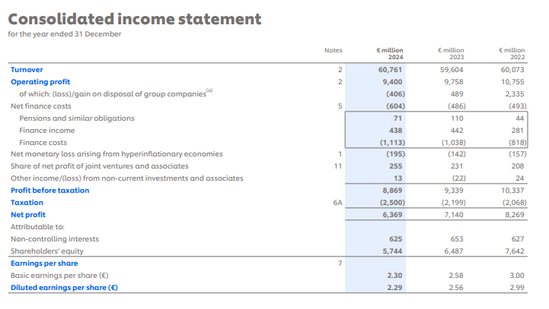
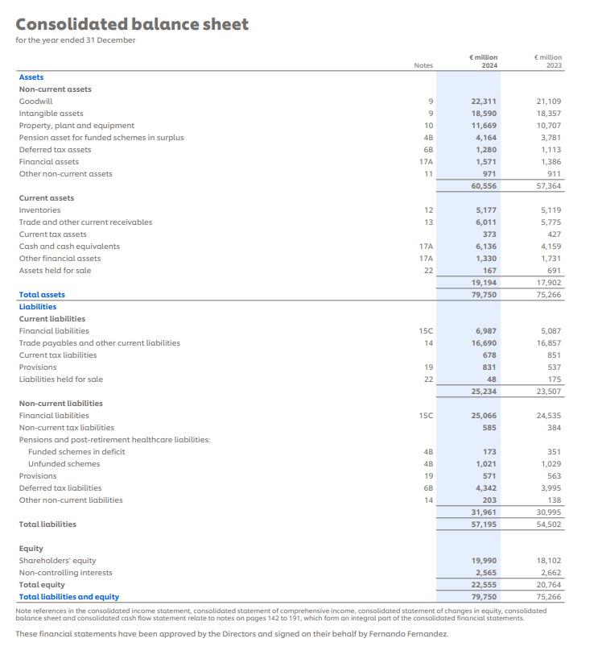
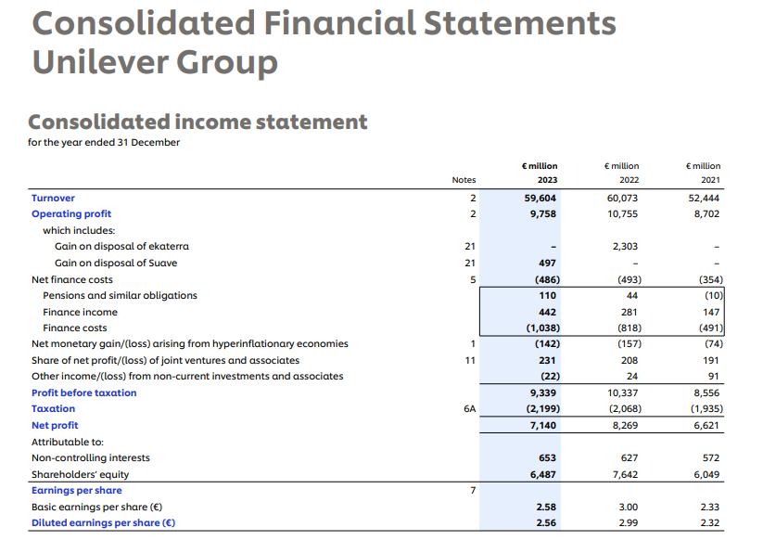
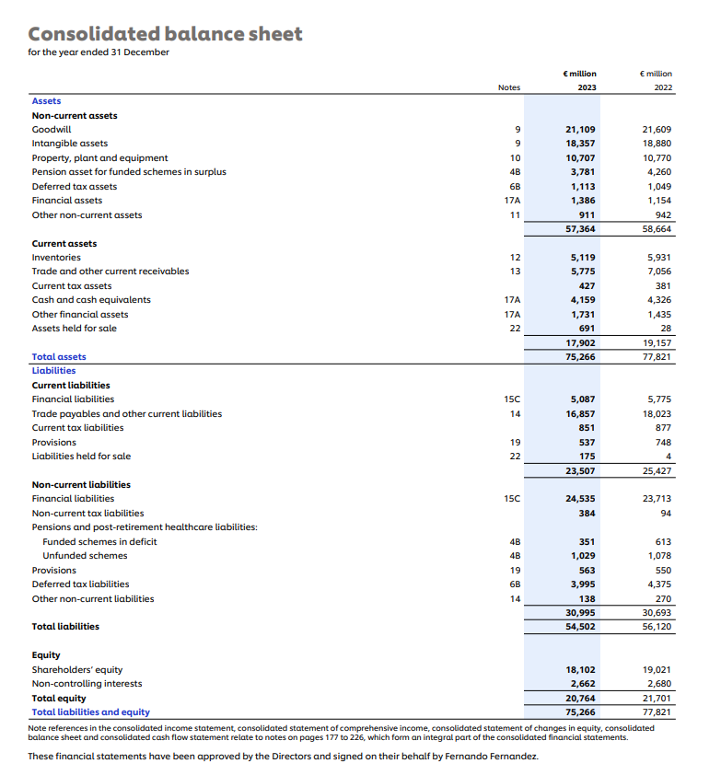

Appendix B – Ratio Calculations (Unilever PLC)

1. Profitability Ratios
Ratio | Formula | 2023 | 2024
Gross Profit Margin | (Gross Profit / Net Sales) × 100 | 42.1% | 42.4%
Operating Profit Margin | (Operating Profit / Net Sales) × 100 | 15.8% | 17.2%
Return on Capital Employed (ROCE) | (Operating Profit / Capital Employed) × 100 | 14.3% | 16.1%

2. Liquidity Ratios
Ratio | Formula | 2023 | 2024
Current Ratio | Current Assets / Current Liabilities | 0.79 | 0.74
Quick Ratio (Acid Test) | (Current Assets – Inventories) / Current Liabilities | 0.51 | 0.47

3. Gearing Ratios
Ratio | Formula | 2023 | 2024
Debt-to-Equity Ratio | (Total Debt / Total Equity) × 100 | 143.7% | 147.2%

4. Efficiency Ratios
Ratio | Formula | 2023 | 2024
Inventory Turnover | Cost of Sales / Inventory | 5.62× | 5.81×
Receivables Turnover | Net Sales / Trade Receivables | 9.14× | 9.08×

5. Investor Ratios
Ratio | Formula | 2023 | 2024
Return on Equity (ROE) | (Net Profit / Total Equity) × 100 | 31.4% | 34.8%

Appendix C – Westward Plc: After-Tax Cash Flow Workings
Corporation tax at 25% is applied to taxable profit. Taxable profit = pre-tax cash flow less annual capital allowance (20% straight-line of initial investment). Option A: £120,000 p.a.; Option B: £200,000 p.a.; Option C: £320,000 p.a. All figures in £000.

Item | Yr 1 | Yr 2 | Yr 3 | Yr 4 | Cap Allow | Notes
Option A – Pre-tax CF | 200 | 400 | 500 | 700 | 120 p.a. | £600k × 20%
Option A – Taxable Profit | 80 | 280 | 380 | 580 |  | CF – Allow
Option A – Tax @ 25% | 20 | 70 | 95 | 145
Option A – After-tax CF | 180.0 | 330.0 | 405.0 | 555.0 |  | CF – Tax
Option B – Pre-tax CF | 400 | 450 | 720 | 980 | 200 p.a. | £1,000k × 20%
Option B – Taxable Profit | 200 | 250 | 520 | 780 |  | CF – Allow
Option B – Tax @ 25% | 50 | 62.5 | 130 | 195
Option B – After-tax CF | 350.0 | 387.5 | 590.0 | 785.0 |  | CF – Tax
Option C – Pre-tax CF | 450 | 700 | 900 | 1200 | 320 p.a. | £1,600k × 20%
Option C – Taxable Profit | 130 | 380 | 580 | 880 |  | CF – Allow
Option C – Tax @ 25% | 32.5 | 95 | 145 | 220
Option C – After-tax CF | 417.5 | 605.0 | 755.0 | 980.0 |  | CF – Tax

