Comparison of Job Adverts (Warehouse/Industrial Team Leader Roles)
The two job adverts analysed—Warehouse Team Leader (Eurocell PLC) and Team Leader (Barker Ross Group)—demonstrate similar expectations in terms of leadership, operational management, and employability skills, while also reflecting some differences in sector focus and experience requirements.
A key similarity between both roles is the strong emphasis on leadership and team management skills. Both employers require candidates who can lead teams effectively within fast-paced industrial environments. The Eurocell role focuses on supervising warehouse operations, while the Barker Ross position highlights leading an industrial team. This indicates that leadership is a transferable and essential skill across operational settings. According to Cottrell (2021), leadership is a core employability skill that enhances team productivity and organisational performance.
Another shared requirement is organisational and time management skills. The Eurocell advert specifies structured shift patterns (06:00–14:00 or 14:00–22:00), implying the need for efficiency and workflow coordination. Similarly, the Barker Ross role involves managing standard working hours and ensuring operational targets are met. This reflects the importance of planning and prioritisation in achieving business objectives (Neugebauer and Evans-Brain, 2016).
In terms of experience, both roles expect prior exposure to team leadership. The Barker Ross advert explicitly requires a minimum of one year of experience, while the Eurocell role implies experience through its leadership responsibilities. This demonstrates that employers value practical, hands-on experience alongside theoretical knowledge.
A notable difference lies in the sector-specific focus. The Eurocell position is clearly warehouse-based, requiring knowledge of logistics, stock control, and distribution processes. In contrast, the Barker Ross role is broader within an industrial context, potentially involving more diverse operational tasks. This suggests that while core skills are transferable, technical knowledge requirements may vary depending on the work environment.
One key shared skill is communication. Both roles require the ability to coordinate teams, provide instructions, and report to management. Effective communication ensures that tasks are completed efficiently and reduces the risk of errors. Critically, communication is not only about giving instructions but also about motivating employees and resolving conflicts. Tarrant (2017) argues that reflective professionals continuously improve their communication to adapt to workplace challenges.
In conclusion, both job adverts highlight a consistent demand for leadership, organisation, and communication skills. While sector-specific knowledge differs slightly, the core competencies required remain similar. Communication, in particular, is essential as it underpins leadership effectiveness and operational success, making it a critical skill for career progression in team leader roles. 


Task 2: Self-Assessment and Readiness for Employability
A reflective self-assessment was conducted using the SWOT analysis framework to evaluate my current employability skills in relation to a Warehouse/Team Leader role. This model enables a structured and critical evaluation of internal capabilities and external factors influencing career development. According to Cottrell (2021), self-assessment is essential for identifying skill gaps and supporting informed career planning.
SWOT Analysis
Strengths
One of my key strengths is teamwork and collaboration, developed through active participation in academic group projects. I have demonstrated the ability to share responsibilities, communicate effectively, and contribute to achieving shared objectives. This is particularly relevant for a team leader role, where coordinating staff and maintaining team cohesion are critical for operational efficiency.
Another strength is organisation and time management. I have consistently met academic deadlines by planning my workload and prioritising tasks effectively. In a warehouse environment, where operations are highly time-sensitive and target-driven, this skill is essential for ensuring productivity and meeting performance indicators.
Additionally, I possess problem-solving skills, evidenced through coursework requiring analysis and decision-making. I am able to assess situations, identify issues, and propose solutions. This aligns with the view of Buchanan and Huczynski (2023), who argue that problem-solving is a fundamental competency in organisational contexts, particularly in dynamic operational environments.
Weaknesses
Despite these strengths, I have identified several areas for development. A primary weakness is my limited practical experience in warehouse or leadership roles. While I have theoretical knowledge, I lack direct exposure to managing teams or handling real operational challenges, which may reduce my competitiveness in the job market.
Another weakness is my lack of confidence in leadership situations, particularly when giving instructions or managing conflict. This may impact my ability to assert authority and maintain team performance. Cottrell (2021) highlights that effective leadership requires confidence, clear communication, and the ability to influence others.
Furthermore, my knowledge of warehouse systems and logistics technologies is currently limited. Given the increasing reliance on digital systems in warehouse operations, this represents a significant skills gap that must be addressed to remain employable.
Opportunities
There are several opportunities available to enhance my employability. These include seeking part-time work, internships, or entry-level warehouse roles, which would provide valuable practical experience and exposure to real working environments.
In addition, I can engage in professional development activities, such as workshops and online courses focused on leadership, communication, and logistics systems. These opportunities support continuous learning, which is essential in adapting to changing workplace demands (Tarrant, 2017).
University career services also provide support through CV development, interview preparation, and employability guidance. Engaging with these resources can significantly improve my readiness for employment.
Threats
One major external threat is the high level of competition in the graduate job market, particularly for leadership positions that require prior experience. Employers may favour candidates with proven practical skills, placing inexperienced applicants at a disadvantage.
Another significant threat is the rapid advancement of technology in warehouse operations, including automation and digital inventory systems. Without developing relevant technical skills, there is a risk of becoming less competitive in the labour market. Nadda (2022) emphasises that continuous skill development is necessary to adapt to technological changes in industry.

Evidence of Readiness for Employability
Despite the identified weaknesses, I can demonstrate a degree of readiness for employability through several areas.
Academic Experience
My academic studies have enabled me to develop critical thinking, research, and organisational skills. Completing assignments has required me to analyse information, meet deadlines, and present structured arguments. These competencies are transferable to workplace environments, particularly in roles requiring planning, coordination, and decision-making.
Teamwork Experience
Through group work, I have gained practical experience in collaboration, communication, and coordination. For example, I contributed to organising tasks within a team and ensuring that deadlines were achieved. This demonstrates my ability to function effectively within a team, a key requirement for future leadership roles.
Skill Development Activities
Participation in workshops and self-assessment exercises has enhanced my understanding of employability skills. Feedback from tutors has highlighted strengths in organisation and written communication, while also identifying areas for improvement, particularly in verbal communication and confidence.
Reflective Practice
Engaging in reflective practice has enabled me to critically evaluate my performance and identify areas for improvement. Tarrant (2017) argues that reflection is a key component of professional development, as it promotes continuous learning and self-awareness.

Critical Evaluation
Although I have developed several transferable skills, my lack of practical experience and leadership confidence limits my immediate readiness for a Warehouse Team Leader role. This reflects a gap between academic preparation and employer expectations, as many organisations prioritise practical experience alongside theoretical knowledge.
However, my strengths in organisation, teamwork, and problem-solving provide a solid foundation for future development. Importantly, my willingness to engage in continuous learning and self-improvement demonstrates a proactive approach to employability.
Critically, employability should be viewed as an ongoing process rather than a fixed outcome. Neugebauer and Evans-Brain (2016) argue that individuals must continuously adapt and develop their skills to remain competitive in the labour market. Therefore, by actively addressing my weaknesses and taking advantage of available opportunities, I can enhance my employability and progress towards my career goal of becoming a Warehouse Team Leader.

Task 3: Employment Goals and Personal Development Plan
Employment Goals
Based on my SWOT analysis, my short-term goal is to gain practical experience in a warehouse or operational environment. This is important because my main weakness is the lack of hands-on experience, which is essential for developing leadership skills.
My long-term goal is to become a Warehouse Team Leader. This aligns with my interest in organisation, teamwork, and operational management. Achieving this goal will allow me to take on leadership responsibilities and contribute to organisational success.
These goals are important because they provide direction and motivation for my career development. Setting clear goals helps individuals focus on developing relevant skills and improving employability (Neugebauer and Evans-Brain, 2016).
Personal Development Plan (PDP)
To achieve these goals, I will implement the following actions:
1. Gain Practical Experience
- Action: Apply for part-time or entry-level warehouse jobs
- Timeline: Within 6 months
- Resources: Job websites, recruitment agencies
- Measurement: Securing a relevant role
2. Improve Leadership and Communication Skills
- Action: Attend workshops and practice communication in group settings
- Timeline: 3–6 months
- Resources: University workshops, online courses
- Measurement: Improved confidence and feedback from tutors/peers
3. Develop Technical Knowledge
- Action: Learn basic warehouse systems and logistics processes
- Timeline: Within 3 months
- Resources: Online training platforms
- Measurement: Completion of courses/certifications

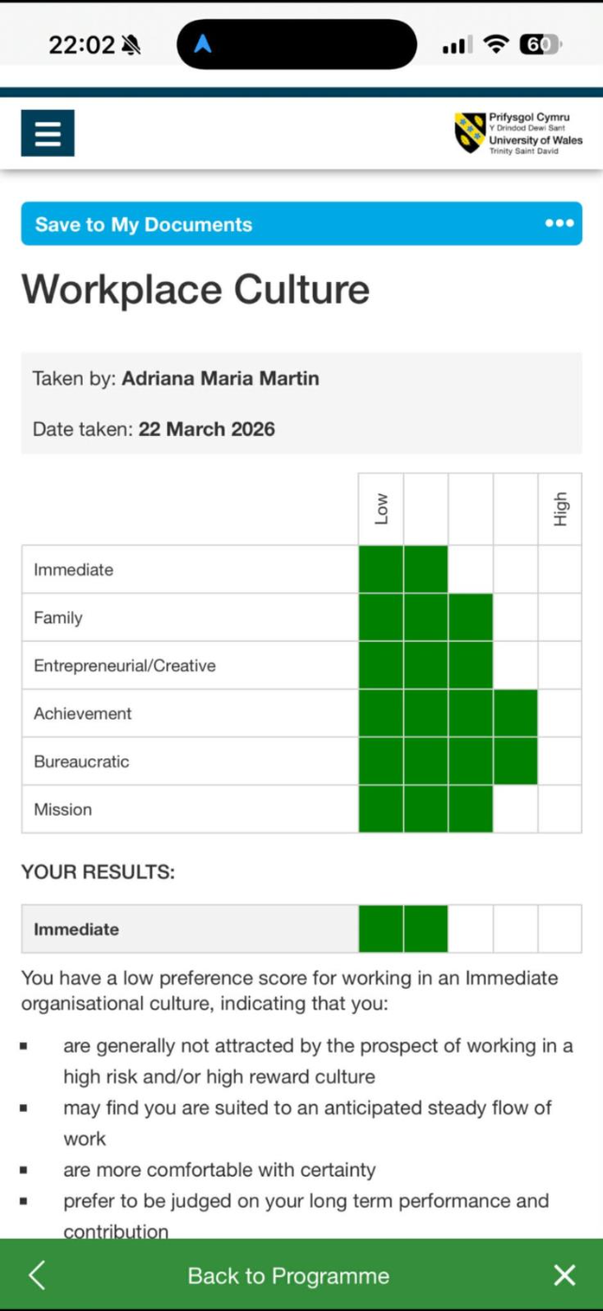
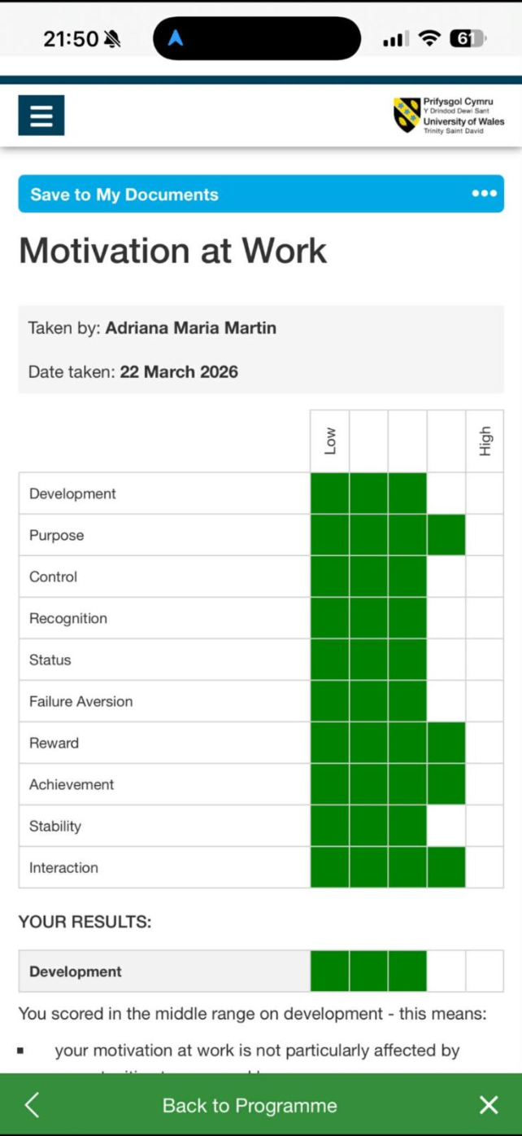
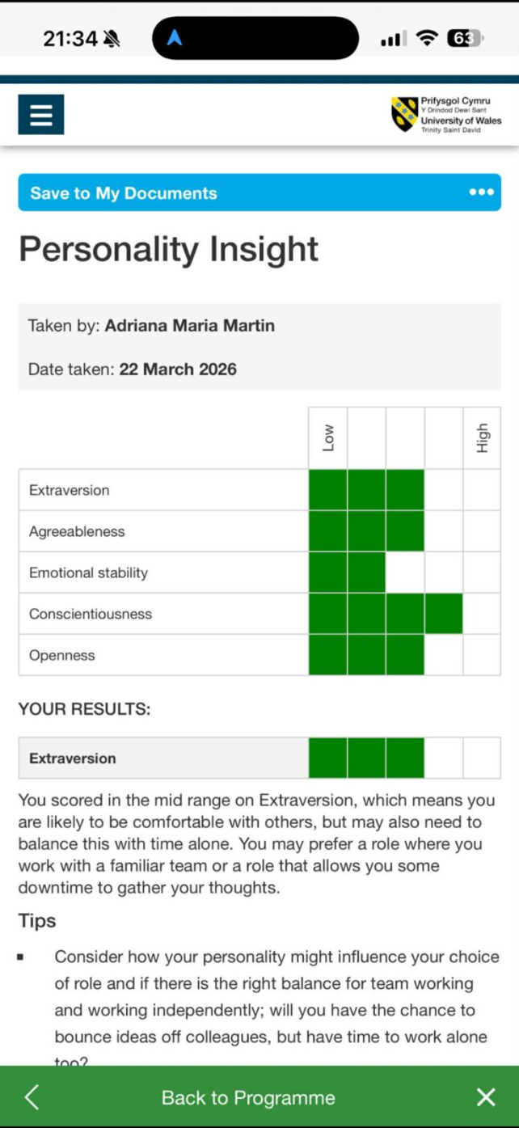

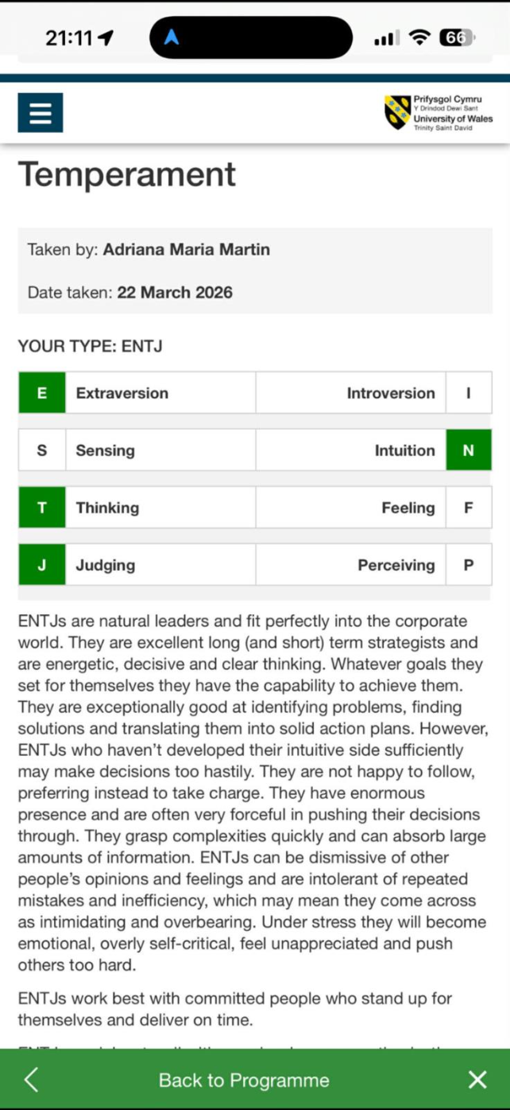

STUDENT NAME: ADRIANA MARIA MARTIN
STUDENT NUMBER: 2434646
MODUL NAME: EMPLOYABILITY AND CAREER DEVELOPMENT (LCLM4005_BIRM)
LECTOR NAME: SUJEEWA HERATH

