BA (HONS) LEADERSHIP AND MANAGEMENT SKILLS FOR THE WORKPLACE

UNDERSTANDING AND ENGAGING STAKEHOLDERS
LCLM5001

ASSIGNMENT TITLE: UNDERSTANDING THE IMPORTANCE OF STAKEHOLDER ENGAGEMENT IN THE SUCCESSFUL COMMENCEMENT AND COMPLETION OF VODAFONE’S WEARABLE HEALTH DEVICE PROJECT

STUDENT NAME: Nicoleta Busu
STUDENT ID: 2025237

Executive Summary
The report assesses the type of stakeholder involvement in the conception and delivery of the wearable health device project at Vodafone. Telecommunications and digital technology company, Vodafone, is foraying into the health technology space with the introduction of a new wearable that will be able to monitor heart rate, blood oxygen and sleeping patterns. The project is part of the overall plan to use IoT, 5G, and AI for digital health, preventative and better health, which Vodafone is pursuing. Among the external and internal stakeholders, which the report highlights, are the R&D teams, marketing, executives, regulators, healthcare providers, investors, customers, and NGOs. The engagement strategies were informed by models like the Power/Interest Grid developed by Mendelow, Stakeholder Theory developed by Freeman, the Salience Model developed by Mitchell, and the model of collaboration, which relies on 4Cs. These guaranteed transparency, accountability, and alignment within the six-month launch. The results show that proactive involvement leads towards innovation, quick time-to-market, regulator goodwill, investor conviction, and adoption, besides enhancing the reputation of Vodafone ESG. It is recommended to use digital platforms, feedback loops and KPI-based impact assessment. Finally, the innovation, competitive advantage, and long-term value creation are based on stakeholder engagement.

TABLE OF CONTENTS

Executive Summary 2
1.0 Introduction to the Company 6
2.0 Project Outline 6
2.1 Description of the Device 6
2.2 Six-Month Launch Timeline 6
2.3 Strategic Alignment 7
3.0 Company Appraisal: Situational Analysis 8
3.1 SMART Objectives 8
3.2 SWOT Analysis 9
3.3 Porter’s Five Forces Analysis 9
4.0 Stakeholder Identification 12
4.1 Internal Stakeholders 13
4.2 External Stakeholders 14
4.2.1 External Stakeholders' Roles & Responsibilities 14
4.4 Benefits and Challenges—Theoretical Lens 15
4.5 Frameworks, Models & Theories for Stakeholder Engagement 16
4.5.1 Stakeholder Matrix 16
4.6 Engagement Plan 18
4.7 Communication Plan 18
4.8 RACI Matrix 19
5.0 Stakeholder Engagement Process & Conflict Management 20
5.1 Establishing Communication Protocols 20
5.2 Aligning Expectations 20
5.3 Ensuring Regulatory Compliance 20
5.4 Applying 4’C Model 21
6.0 Evaluation of Stakeholder Engagement Impact 24
6.1 Business Performance Benefits 24
6.2 Challenges if Engagement Fails 24
6.3 Recommendations for Future Stakeholder Engagement 25
7.0 Conclusion 26
8.0 Reference List 27

LIST OF FIGURES
Fig 1: Stakeholder Matrix 14
Fig 2: 4C Framework 18
Fig 3: Communication 18
Fig 4: Coordination 19

LIST OF TABLES
Table 1: Six-Month Launch Timeline 7
Table 2: SWOT Analysis 8
Table 3: Porter Five Forces 10
Table 4: SMART Objectives 10
Table 5: Internal Stakeholders 11
Table 6: External Stakeholders 12
Table 7: Engagement Plan 15
Table 8: RACI Matrix 16

1.0 Introduction to the Company
Vodafone Group Plc is one of the most dominant telecommunication and digital technology providers in Europe and Africa, where it serves over 340 million mobile subscribers, 22 million users of its broadband, and 15 million television subscribers in 15 countries and partners in more than 40 others. The company runs the largest managed Internet of Things (IoT) platform to connect over 205 million devices in the world, as well as pursues financial inclusion, with services reaching 77 million users. Vodafone, with a workforce of approximately 92,000 employees and contractors, has a key role to play in the economic development and digital transformation. It has three priorities—customers, simplicity, and growth—which are reinforced by investment in 5G, cloud technology, AI, and IoT. Vodafone has recorded €37.4 billion in revenue (of which €30.8 billion is service revenue) in FY25 (Vodafone, 2025). In addition to core connectivity, it is expanding into high-growth sectors, including digital services and cybersecurity and technologies in healthcare. Vodafone is developing itself as a healthcare facilitator with the help of the IoT, enabling wearable devices to monitor health indicators (heart rate, oxygen levels, and sleep) and improve digital well-being.

2.0 Project Outline

2.1 Description of the Device
Vodafone is creating the next-generation wearable health device, which tracks the heart rate, blood oxygen saturation (SpO2), and sleep patterns (Devi et al., 2023). The device works together with smartphones and healthcare applications, providing real-time monitoring, personalised health insights as well as secure data sharing. Its design is aimed at individual consumers, who would like to monitor their personal well-being, and healthcare providers, who could utilise aggregated data to monitor remote patients and preventive healthcare (Thakkar et al., 2022).

2.2 Six-Month Launch Timeline
The project follows an accelerated six-month development and launch plan. This tight schedule requires effective coordination across Vodafone’s R&D, supply chain, marketing, sales, and regulatory affairs teams (Zehrung et al., 2021).
Month | Key Activities | Details
1–2 | Product Design & Testing | Finalise wearable device design and complete internal technical testing to ensure functionality and reliability.
2–3 | Regulatory Compliance | Secure approval under UK and EU medical device and consumer safety regulations.
3–4 | Marketing Development | Create and initiate marketing campaigns, including online advertisement, cooperation, and pre-launching of campaigns.
4–5 | Pilot Testing & Feedback | Pilot testing; after some select users, receive feedback to make the device features and usability as optimal as possible.
6 | Final Launch | Distribution, retailing and official launching of the product to the consumer market.

Table 1: Six-Month Launch Timeline
(Source: Self-Generated)

2.3 Strategic Alignment
The project also contributes to the larger strategy of Vodafone to diversify into the digital services and IoT-based healthcare, upon which the project is directly dependent. Having more than 205 million ionotron connections across the globe, as well as revenue of €37.4 billion in FY 25, Vodafone is best placed to capitalize on its size, collaboration, and technology platforms ( Vodafone, 2025). Not only does the wearable device tap into the emerging health-tech market around the world but it also increases the reputation of Vodafone as a digital health enabler. The project is relevant to the long-term goals of Vodafone to grow, connect with customers, and impact the society as it aligns innovation with consumer health needs and preventive care (Umair et al., 2021).

3.0 Company Appraisal: Situational Analysis

3.1 SMART Objectives
Objective | Specific | Measurable | Achievable | Relevant | Time-Bound
Create a product (a wearable device for health) | Use heart rate monitors, oxygen saturation monitors, and sleep monitors. | Full product launch in six months, compliant to MHRA and EU. | Vodafone provides R&D and IoT expertise (205m global IoT connections). | Expands Vodafone into health-tech, aligned with IoT growth strategy. | Deadline set for launch in 6 months.

Table 2: SMART Objectives
(Source: Self-Generated)

3.2 SWOT Analysis
Strengths | Weaknesses
- Vodafone has more than 340 million mobile subscribers spread in 15 countries which makes it highly recognisable and consumer-friendly (Vodafone, 2025).  - Vodafone is the owner of the largest managed IoT platform in the world of 205 million connections (Casas et al., 2021). | - During FY25, the company showed an operating loss of € 411 million, which indicates the difficulties in the cost control and reorganization (Vodafone, 2025).  - Wearables in healthcare have to comply with the stringent UK/EU medical device and data protection regulations, which may slow down the launch (Kadu and Singh, 2021).
Opportunities | Threats
- The increasing consumer demand in digital health monitoring is an opportunity that Vodafone has to enter a high growth industry worth billions worldwide (Manyazewal et al., 2021).  - The incorporation of wearables into the Vodafone 5G network improves real-time transfer of data thus making its service unique compared to those in the market. | - The wearable market is characterized by entry barriers, where established companies such as Apple, Fitbit, and Samsung control the market.  - Health information is a very sensitive field, and any breach may ruin the reputation of Vodafone and provoke fines by the regulatory authorities (Charalambous, 2021).

Table 3: SWOT Analysis

(Source: Self-Generated)
3.3 Porter’s Five Forces Analysis
Force | Analysis
Competitive Rivalry | The market of wearables in healthcare is very competitive, with giants in the industry being Apple, Fitbit, and Samsung. Existing players will have high brand loyalty and sophisticated R&D, which will be a challenge to Vodafone entry. Nonetheless, the robust telecom infrastructure and IoT capabilities are the sources of differentiation opportunities for Vodafone through features based on the network and health data integration (Suhail and Pillai, 2022).
Threat of New Entrants | Entering is difficult because of regulatory standards, technological knowledge, and brand loyalty in health data management. New entrants require huge capital and compliance licenses, making them less of a threat in the short term. The developed global presence of Vodafone is a strategic advantage to overcome these obstacles (Acharya and Rani, 2021).
Bargaining Power of Suppliers | The bargaining power of suppliers of sensors, chips and software platform is medium; since the quality of component and innovation has a direct influence on the performance of the device. However, the size of the company and the collaboration with the world technological companies like Microsoft and Google reduces the effect of suppliers and prices on the financial performance (Vodafone, 2025).
Bargaining Power of Buyers | The bargaining power of the consumers is high due to the types of wearables being available and price sensitivity. Hence, to be different from the competitors, Vodafone shall adopt a segmented value proposition that entices the users with added value such as incorporation into a mobile tariff package, health-related information, and guarantees of data confidentiality (Mukati et al., 2023).
Threat of Substitutes | Medical apps available for smartphones and traditional medical exams can be used. However, the growing expectation for continuous monitoring and convenience among the consumer population is making the wearable market more appealing, and decreasing the threat of substitution in the long run (Zobaed et al., 2021).

Table 4: Analysis of Porter’s Five Forces
(Source: Self-Generated)

4.0 Stakeholder Identification
The success of Vodafone’s wearable health device depends on engaging both internal and external stakeholders. Each plays a distinct role in ensuring timely delivery, regulatory compliance, and consumer adoption. Below are the key stakeholders, their functions, and their importance to the project (Suhail and Pillai, 2022).
Internal Stakeholders' Roles and Responsibilities
The design, prototyping, and testing of the wearable device by Vodafone are headed by the Research and Development (R&D) team, which is concerned with the innovative feature and accurate tracking of the health (Umair et al., 2021). Their power is their technological development, and it is difficult to have a balance between speed to market, safety, and regulatory compliance. The marketing team creates awareness of the brand, increasing visibility and trust, especially when it comes to sensitive health information, but the established brands such as Apple and Fitbit also present a threat (Casas et al., 2021). The Sales department deals with distribution, retail relationship and revenue modeling, using the global outlets of Vodafone to reach out to consumers, but pricing strategies should be in line with the consumer buying power. The Executive Board offers the strategic direction, allocation of budget, and alignment with the corporate vision of Vodafone (Kadu and Singh, 2021). Their participation provides legitimacy and resources, which allow an easy execution of the project. All these stakeholders, together, guarantee technological innovation, market presence, and strategic direction and deal with compliance, competition, pricing, and consumer adoption risks (Manyazewal et al., 2021).

4.1 Internal Stakeholders
Stakeholder | Role in Project | Importance
Product Development Team | Fabricates and produces a wearable that is usable, precise and fully functional. | High
R&D Department | Focused research for the innovation of health-monitoring to be market competitive. | High
Marketing Team | Help create brand identity, campaigns and strategies for customer retention | High
Sales Department | Responsible for distribution strategy, retail partnerships, and revenue generation. | Medium
IT & Cybersecurity | Protects sensitive health data, ensures GDPR compliance, and manages digital platforms. | High
Executive Board | Provides strategic oversight, approves budgets, and manages investor expectations. | High

Table 5: Internal Stakeholders
(Source: Self-Generated)

4.2 External Stakeholders
Stakeholder | Role in Project | Importance
Customers | End-users who adopt and provide feedback on the wearable. | High
Healthcare Providers | Potential partners for patient monitoring and medical validation. | High
Suppliers | Provide hardware, sensors, and software components. | Medium
Regulators (MHRA & EU bodies) | Approve compliance with medical device and consumer safety standards. | High
Investors | Provide funding and monitor project performance and profitability. | Medium
NGOs & Community Organisations | Advocate for digital inclusion, ensuring accessibility of health solutions. | Low–Medium

Table 6: External Stakeholders
(Source: Self-Generated)

4.2.1 External Stakeholders' Roles & Responsibilities
The customers are the basis of the project, and they take the device, engage in pilot testing, and decide whether the market will be a success. Their response allows them to create value, but the issue of privacy of their data and sharing sensitive health information is a challenge. Compliance with safety and data protection is guaranteed by regulatory bodies such as MHRA and EU authorities, which increase the credibility and trust in the consumer, but long approval procedures can delay the launch (Charalambous, 2021). Hardware and software are supplied by suppliers who are essential in helping to develop efficiently but the dependency on a third-party vendor can always lead to disruption in the supply chain. Development, marketing, and distribution are financed by the investors to make it sustainable and strategically grow (Acharya and Rani, 2021). They are essential and any lack of support at the initial stages or change in regulations might lead to a lack of confidence. All customers, regulators, suppliers, and investors are important in the innovation, compliance, efficiency in its operations, and financial sustainability with a certain benefit and risk with threats that must be well addressed to ensure that the wearable device is successful (Mukati et al., 2023).

4.4 Benefits and Challenges—Theoretical Lens
The stakeholder theory developed by Freeman focuses on making value for all stakeholders, not just the shareholders. Vodafone focuses on balancing the profit of investors and the social value, whereas the Salience Model created by Mitchell is based on power, legitimacy, and urgency, which determine the proper governing of the entities, trust, and successful results of the project in the long term (ScienceDirect, 2024).

4.5 Frameworks, Models & Theories for Stakeholder Engagement
In order to deal with different expectations by the various stakeholders, Vodafone should establish systematic arrangements that nurture accountability, high-quality communication and collaboration (Elei et al., 2023). Successful stakeholder engagement involves systematic ways of identifying, prioritising and managing relationships whilst aligning with organisational objectives. A number of frameworks, models, and theories support this process.

4.5.1 Stakeholder Matrix
The Stakeholder Matrix, based on the use of Mendelow's Power/Interest grid, is a very common tool to map stakeholders according to their level of influence (power) and their degree of interest in the project or organisational activities. This way organisations can strategically prioritise engagement efforts.
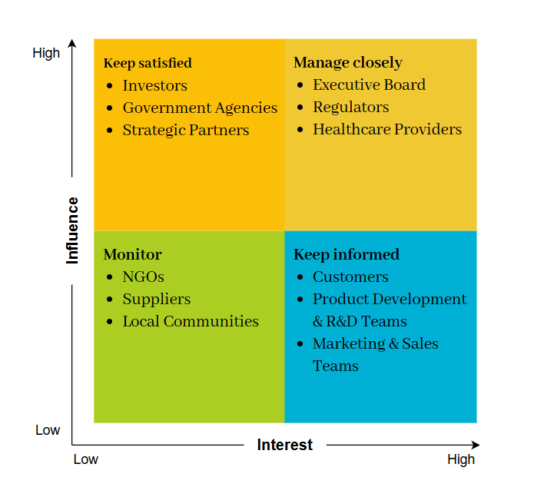

Fig 1: Stakeholder Matrix
(Source: Self-Generated)
- High Power / Low Interest (Keep Satisfied)
Investors, Government Agencies and Strategic Partners. Although these stakeholders are quite influential, they are not much interested in the day-to-day activities. To keep them on track, reporting regularly and providing updates on a high level is enough (Yathiraju and Mohapatra, 2023).
- Low Power / High Interest (Keep Informed)
Customers, Product Development & R&D Teams, and Marketing & Sales Teams. Although these groups do not possess significant decision-making power, they are highly invested in outcomes. Continuous engagement ensures their input drives product development and market adoption (Singh and Kaur, 2024).
- High Power/High Interest (Manage Closely)
Healthcare Practitioners, Regulators and the Executive Board are influential stakeholders, with them being representatives of powerful organisations with strategic results driven objectives. In order to actively engage with these stakeholders, in accordance with Vodafone's business mission, legal regulatory compliance, medical innovation, and corporate ethos (Zobaed et al., 2021). Engagement with these groups is the key to ensuring organisational decisions are not only legally compliant, but innovative and in line with strategy - and innovation and trust from stakeholders continue to flow.
- Low Power / Low Interest (Monitor / Minimal Effort)
NGOs, Suppliers, and Local Communities. These groups have limited influence and interest but still require periodic communication to maintain transparency and mitigate reputational risks (Lima, 2021).

4.6 Engagement Plan
Stakeholder Group | Engagement Approach
Executive Board | Monthly strategic reviews and performance dashboards to ensure alignment with corporate objectives.
Regulators | Structured compliance reporting, regular audits, and consultation on policy shifts.
Healthcare Providers | Joint innovation workshops, pilot programmes, and tailored technology demonstrations.
Customers | Pre-launch surveys, focus groups, and beta-testing initiatives to validate user needs.
R&D & Marketing Teams | Daily stand-ups and agile sprint reviews to coordinate product development.
Suppliers | Bi-weekly coordination calls to ensure efficiency across the supply chain.
Investors & Strategic Partners | Quarterly briefings tied to KPIs, focusing on financial returns and strategic alignment.
Local Communities & NGOs | Annual sustainability and CSR updates to reinforce corporate responsibility.

Table 7: Engagement Plan
(Source: Self-Generated)

4.7 Communication Plan
Stakeholder engagement is based on effective communication, which reduces the risk of conflict or non-engagement. The stakeholder theory of value creation developed by Freeman is implemented at Vodafone, and it involves transparency, trust, and mutual benefit (ScienceDirect, 2024). Regulatory reporting, investor briefings, and board reporting are some of the formal mechanisms that are conducted to uphold compliance and governance (Dang et al., 2023). Collaboration and learning are encouraged through interactive methods, such as co-design, focus groups, and pilot feedback. Online technologies such as secure dashboards, mobile applications, and internal solutions maintain the real-time updated teams and regulators, help to increase responsiveness, develop trust, cultivate relationships, and promote long-term organisational resilience and value to stakeholders (Bargarai and Keti, 2025).

4.8 RACI Matrix
Task | Responsible (R) | Accountable (A) | Consulted (C) | Informed (I)
Product Design & Testing | R&D Team | Project Manager | Healthcare Providers | Executive Board
Regulatory Approval | Compliance/Legal | Executive Board | Regulators | Investors
Marketing Campaign | Marketing Team | CMO | Sales Team | Customers
Distribution & Sales | Sales Team | COO | Suppliers | Investors
Data Security & GDPR Compliance | IT & Cybersecurity | CIO | Regulators | Customers

Table 8: RACI Matrix
(Source: Self-Generated)

5.0 Stakeholder Engagement Process & Conflict Management
As project manager, the wearable device development at Vodafone needs to involve the stakeholders within the scope of agreed expectations, effective communication, and adherence to regulatory rules via the 4Cs model, namely communication, coordination, cooperation, and collaboration, to manage all stakeholders holistically (Thakare and Verma, 2025).

5.1 Establishing Communication Protocols
Effective stakeholder engagement involves effective communication. The trust will be created by detailed updates to the executives and regulators, interactive channels with customers, and constant feedback through digital platforms, informed decision-making, and minimised uncertainty, conflict avoidance, and allowed the implementation of the project smoothly and subsequent customer satisfaction in the long term (Ashcroft, 2017).

5.2 Aligning Expectations
The interests of the stakeholders are not always compatible: the investors need profits, the regulators need to be satisfied, and the customers need to have devices which are cheap and convenient to use. As a project manager, it is important to match these expectations and project goals (Christopher, Payne and Ballantyne, 2013). The priority of influential stakeholders such as regulators and the Executive Board is achieved with the help of expectation-setting workshops and the Mendelow Matrix. The implementation of the Stakeholder Theory developed by Freeman is a guarantee of creating value among shareholders, customers, and healthcare providers, which will result in trust and promotion in the long run (sciencedirect, 2024). Late alignment minimises conflicts, speeds and accuracy of product development, and the effective implementation of a project and stakeholder satisfaction (Charalambous, 2021).

5.3 Ensuring Regulatory Compliance
Regulatory approval is necessary to launch the project, and, therefore, the compliance will be the core of the stakeholder engagement. Vodafone will make contacts with MHRA and EU agencies and compliance teams with R&D will ensure compliance with medical device standards. Consultation with regulators on a regular basis predicts the possible problems, and GDPR is enforced by IT and cybersecurity departments to safeguard sensitive health information (Kadu and Singh, 2021). The inclusion of regulatory compliance with stakeholder engagement helps to minimise the costs of time wastage, and increase the reputation of Vodafone as a responsible and trustworthy health technology provider, which makes the project run smoothly, and builds customer trust, regulatory bodies, and investors confidence (Devi et al., 2023).
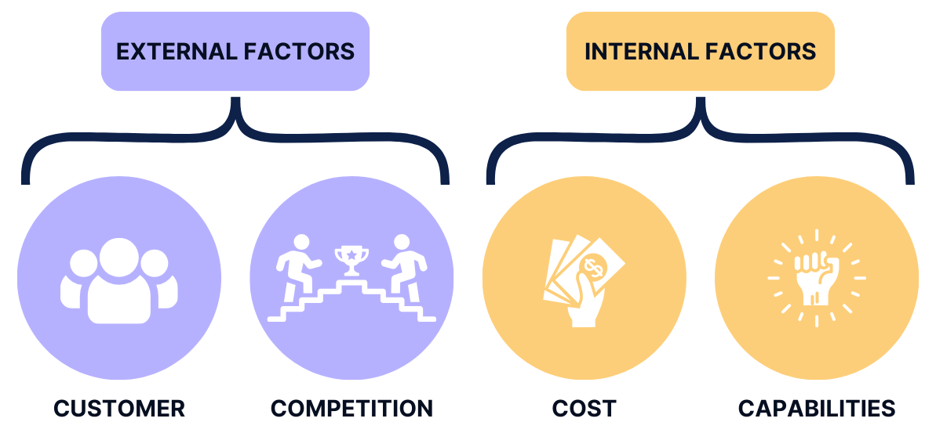

Fig 2: 4C Framework
(Source: PrepLounge, 2025)

5.4 Applying 4’C Model
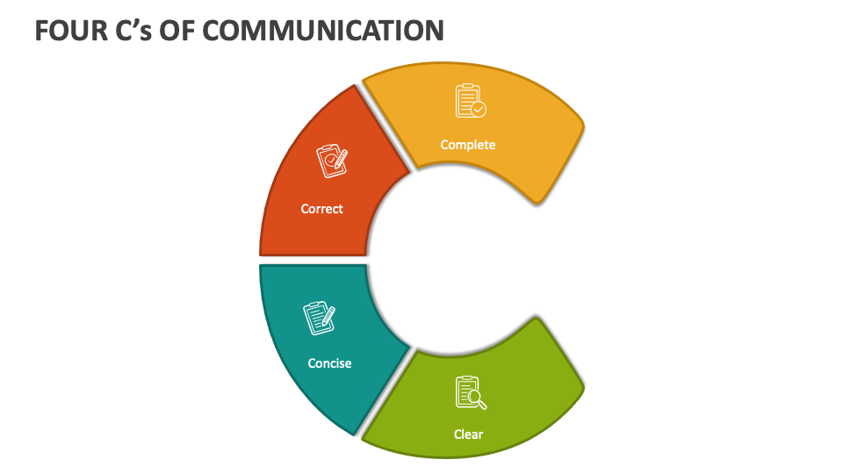

Fig 2: Communication
(Source: collidu, 2025)
- Communication
Engagement is built on effective communication which entails sharing information in a timely, transparent and customised manner (Zobaed et al., 2021). The project manager at Vodafone will use formal reports, feedback tools, and online technology such as MS Teams to have real-time interactions. Clear documentation ensures that there is no misinterpretation, creates trust, and customises information to various stakeholders: technical, financial, and regulatory, as well as reduces the conflict levels and creates alignment (Elei et al., 2023).
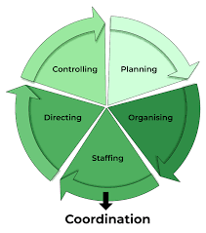

Fig 3: Coordination
(Source: geeksforgeeks, 2025)
- Coordination
Coordination ensures that different teams and partners work towards shared objectives. As project manager, I will establish integrated project schedules using digital tools such as Gantt charts to synchronise activities across R&D, supply chain, and marketing (Umair et al., 2021). Hardware delivery will conform to the production deadline within the company, and marketing initiatives will be introduced simultaneously (Suhail and Pillai, 2022).

- Cooperation
The mutual trust reflects a good, effective association between the parties of interest. To those levels or individuals who possess an interest in a firm and can influence and be influenced by activities, objectives and policies of that firm. Although there will be a partnership of selling or supplying services like this as commodities or equipment to the partners, and advertisement of the long-range partnership (Bargarai and Keti, 2025).

- Collaboration
To resolve the communication to the stakeholders to consume the performance and safety of the Vodafone suppliers and additionally inspire the team members and, board of directors to enhance the approaches to face the market competitors ethically. Many other stakeholders, such as customers, employees, suppliers and government regulators, creditors and investors also involved in the team to deliberate funds and programmes of interest to the firm. This connection between R&D and marketing makes it possible to innovate because the development of problem-solving becomes more advanced (Casas et al., 2021).

6.0 Evaluation of Stakeholder Engagement Impact

6.1 Business Performance Benefits
Stakeholder engagement builds much-needed trust and transparency with regulators and providers by having joint collaborative sessions, workshops and formal disclosures (Ellis, Gibbs and Rein, 1991). Such practices enforce Vodafone's responsibility image as a responsible partner, ease regulatory permissions and simplify long-term partnerships in regulated businesses, such as healthcare technology (Elei et al., 2023). Stakeholder engagement on a financial front culminates in investor confidence through transparent updates and assists in achieving steady funding and stability. Engaging the customers by surveys, beta running and focus groups ensures that the products are aligned with what customers require and enhances the uptake and revenue creation (Thakkar et al., 2022). All these engage the stakeholders in enhancing Vodafone's business execution owing to the increased trust, openness and cooperation of the stakeholders. A good regulator relationship enhances the compliance process but customer engagement provides innovation and customer satisfaction (NCBI, 2025). Partnerships will build operational channels, and concurrently provide the capability to take advantage of possible risks or new opportunities through IoT and healthcare solutions to have a more competitive and operationally sustainable endeavour in the long run. Apart from the financial and operational benefits, engagement culminates in Environmental, Social, and Governance (ESG) reputation strength of Vodafone.

6.2 Challenges if Engagement Fails
Stakeholder management failure may pose significant threats to Vodafone. A major problem is that projects can be delayed due to the lack of a consistent communication channel with R&D, suppliers, or regulators and provide incorrect priorities or compliance obstacles or bottlenecks in operations (Charalambous, 2021). Another area of concern is reputational damage: unaddressed customer complaints, absence of transparency, or disagreements with healthcare providers can undermine brand trust and negatively affect future collaborations of regulated industries (Kadu and Singh, 2021). This lack of interaction with regulators can result in more fines, sanctions or slow product adoption, especially in the area of GDPR or medical device compliance, which can help undermine a competitive edge. Also, financial instability may arise due to lack of transparency and engagement that would lead to a decline in investor confidence. On the internal level, low employee participation in the decision-making process may lower productivity and cooperation. All these risks point to the fact that it is the structured and ongoing stakeholder engagement that allows retaining trust, preserving compliance, and protecting the long-term business performance (Manyazewal et al., 2021).

6.3 Recommendations for Future Stakeholder Engagement
Recommendations 1. Strengthen Digital Stakeholder Platforms
Establish elaborate online channels of stakeholder interaction, which would give real-time updates, dashboards, and safe channels of communication. Different groups of stakeholders should be served by these platforms, and all the information accessible to regulators, investors, customers, and internal teams should have an efficient way to be accessed. The better transparency, less time to spend on delays, and quicker decision-making can be achieved through increased digital interaction (Acharya and Rani, 2021; Charalambous, 2021).
Recommendations 2. Establish Continuous Feedback Loops
Integrating a mechanism of continuous feedback throughout the product development will be a good way of making sure that a concern of stakeholders and any other information is captured and is taken action upon. Frequent surveys, online workshops, pilot programs, and interactive dashboards enable the stakeholders to contribute to the project decisions in advance and improve the rate of satisfaction, trust, and adoption (Mukati et al., 2023). The constant feedback also allows identifying the possible risks fast and avoiding their further development and encourages the joint solution of the problem (Umair et al., 2021).
Recommendations 3. Conduct Regular Impact Assessments Using KPIs
Install systematic stakeholder engagement effectiveness monitoring using pre-specified key performance indicators (KPIs) (Elei et al., 2023). Performance indicators like satisfaction levels among stakeholders, milestones in regulatory compliance, investor trust levels, internal team cohesion levels can give a practical understanding of the performance of engagement. Evaluation of impacts on a periodic basis enables the organisation to revise strategies, allocate resources efficiently, and be accountable to a range of stakeholders (Charalambous, 2021).

7.0 Conclusion
In the conclusion notes, advantages of positive initiatives to communicate with stakeholders have been achieved on two levels. It has been competing with innovation over R&D and Blue, care providers and consumers which cost health care faster to innovate and better product differentiation. It created trust and transparency towards the regulators and healthcare partners, and this facilitated compliance approvals, becoming less bureaucratic and easier as well. Monetarily, it had improved investor trust and long-term funding by maintaining open contact with investors and high uptake and revenue potential with customer-related programmes. The absence of dynamic engagement with professionals in NGOs, communities and stakeholders interested in sustainability had also enhanced the ESG image of Vodafone and led to the brand loyalty and social impacts in the long run, which identified the significance of diversely managed stakeholder management. As practice in this project revealed, the digital alignment platforms, dynamic feedback mechanisms, and systematic evaluation in KPI form served as requirements to facilitate performance and avoid risk. With deeply established stakeholder involvement in project management processes, Vodafone not only obtained the results of operational success but also optimised on this as a strategic move of change of innovation, competitiveness, and long-term value creation in the evolving digital health marketplace.

8.0 Reference List
Acharya, N.V.V. and Rani, K.S. (2021). Modern Health Monitoring and Analysis Using Iot Technology. Turk. Online J. Qual. Inq.(TOJQI), 12, pp.4961-4972.
Ashcroft, J. (2017) The relational lens: understanding, measuring, and managing stakeholder relationships. Cambridge: Cambridge University Press. Available at: https://www-cambridge-
Bargarai, F.A.M. and Keti, F. (2025), April. A Review of 5G Techniques in Healthcare: Understanding the Role of 5G, IoT, and AI. In 2025 International Conference on Computer Science and Software Engineering (CSASE) (pp. 168-175). IEEE.
Casas, R., Hermosa, A., Marco, A., Blanco, T. and Zarazaga-Soria, F.J. (2021). Real-time extensive livestock monitoring using LPWAN smart wearable and infrastructure. Applied Sciences, 11(3), p.1240.
Charalambous, A. ed. (2021). Developing and utilizing digital technology in healthcare for assessment and monitoring. Springer Nature.
Christopher, M., Payne, A., and Ballantyne, D. (2013). Relationship Marketing: Creating Stakeholder Value. Saint Louis: Taylor and Francis
Dang, V.A., Vu Khanh, Q., Nguyen, V.H., Nguyen, T. and Nguyen, D.C. (2023). Intelligent healthcare: Integration of emerging technologies and Internet of Things for humanity. Sensors, 23(9), p.4200.
Devi, D.H., Duraisamy, K., Armghan, A., Alsharari, M., Aliqab, K., Sorathiya, V., Das, S. and Rashid, N. (2023). 5G technology in healthcare and wearable devices: A review. Sensors, 23(5), p.2519.
Elei, F.O., Ikerionwu, C.O., Erike, A.I. and Mshelia, Y.U. (2023). Transition to value-based care IoT wearable devices in maternity healthcare for low-resource countries. Int. J. Sci. Res. in Computer Science and Engineering Vol, 11(4).
Ellis, C.A., Gibbs, S.J. and Rein, G.L. (1991). Groupware: Some issues and experiences. Communications of the ACM, 34(1), pp.38–58. doi:10.1145/99977.99987
Kadu, A. and Singh, M. (2021), October. Comparative analysis of e-health care telemedicine system based on Internet of Medical Things and artificial intelligence. In 2021 2nd International conference on smart electronics and communication (ICOSEC) (pp. 1768-1775). IEEE.
Lima, G. (2021). Necessary Steps to Accelerate the Integration of Wearable Sensors Into Recreation and Competitive Sports. Current sports medicine reports.
Manyazewal, T., Woldeamanuel, Y., Blumberg, H.M., Fekadu, A. and Marconi, V.C. (2021). The potential use of digital health technologies in the African context: a systematic review of evidence from Ethiopia. NPJ digital medicine, 4(1), p.125.
Mukati, N., Namdev, N., Dilip, R., Hemalatha, N., Dhiman, V. and Sahu, B. (2023). Healthcare assistance to COVID-19 patient using internet of things (IoT) enabled technologies. Materials today: proceedings, 80, pp.3777-3781.
NCBI, (2025) Medical and nursing clinician perspectives on the usability of the hospital electronic medical record: A qualitative analysis. [Online]. Available at: https://pmc.ncbi.nlm.nih.gov/articles/PMC11401339/ [Accessed On: 24/09/2025]
ScienceDirect, (2024) Stakeholder theory. [Online]. Available at: https://www.sciencedirect.com/science/article/pii/S0148296323004629 [Accessed On: 24/09/2025]
Singh, S. and Kaur, H. (2024). Intelligent Development in Healthcare With the Internet. In Computational Intelligence and Blockchain in Biomedical and Health Informatics (pp. 169-185). CRC Press.
Suhail, I. and Pillai, S. (2022), March. IoT enabled applications for Healthcare decisions. In 2022 International Conference on Decision Aid Sciences and Applications (DASA) (pp. 47-54). IEEE.
Thakare, V. and Verma, P. (2025), February. A Review on Applications of IoT in Healthcare. In 2025 International Conference on Electronics and Renewable Systems (ICEARS) (pp. 793-798). IEEE.
Thakkar, H.K., Chowdhury, S.R., Bhoi, A.K. and Barsocchi, P. (2022). Applications of wearable technologies in healthcare: An analytical study. In 5G IoT and edge computing for smart healthcare (pp. 279-299). Academic Press.
Umair, M., Cheema, M.A., Cheema, O., Li, H. and Lu, H. (2021). Impact of COVID-19 on IoT adoption in healthcare, smart homes, smart buildings, smart cities, transportation and industrial IoT. Sensors, 21(11), p.3838.
Vodafone, (2025). Vodafone annual report. [Online]. Available at: https://reports.investors.vodafone.com/view/897876789 [Accessed on: 23/09/2025]
Yathiraju, N. and Mohapatra, A. (2023). The Implications of IoT in the Modern Healthcare Industry post COVID-19. International Journal of Smart Sensor and Adhoc Network, 3(4).
Zehrung, R., Huang, L., Lee, B. and Choe, E.K. (2021). Investigating opportunities to support kids' agency and well-being: a review of kids' wearables. arXiv preprint arXiv:2104.05979.
Zobaed, S.M., Hassan, M., Islam, M.U. and Haque, M.E. (2021). Deep learning in IOT-based healthcare applications. In Deep Learning for Internet of Things Infrastructure (pp. 183-200). CRC Press.

