Individual Report on-

“How do organizational beliefs, attitudes, and value systems affect workplace behavior? Also, how will tailoring workplace changes for the post COVID mindset tackle the challenges we face now, and create more resilient businesses in the future?”

Student ID: …192 153 4……………………..

Contents
Executive summary 3
About the Organization 3
Key Management Theories 4
Human relations theory 4
Systems management theory 5
Scientific management theory 6
Administrative management theory 6
Bureaucratic management theory 6
Critical evaluation 7
Analyses the difference between - beliefs, attitudes, and values within a workplace context. 8
How someone with different beliefs, attitudes and values might interpret the theory differently. 10
References 15

Executive summary
The main aim of this report is to investigate how workplace behavior is affected by the beliefs, attitudes, and values that are inherited in the organization. It is believed that reaching the aim of the report will set a pathway and strategies on how to tailor the workplace which will be sufficient in order to manage the post-Covid-19 workplace mindset challenges and help the business organizations become more resilient in the future (Rawshdeh, Z.A., 2021).
With the covid19 pandemic the whole world changed for just few months period and this change with many strict restrictions moved the real working into the 70% online. This significant boosted the process of global digitalization and remote way of working. Many of the companies which started the adopting the change of moving the sales online lost significant number of customers and will take years for them to recover fully from this loss (Hamburg, I., 2021).

About the Organization
As per the requirement of the assignment, the organization that has been chosen is Unilever. Unilever is one of the leading brands of the world which is a multinational retail company with headquarters in many cities around the globe including London. They have a strong workplace culture and the brand has earned recognition for introducing a number of training features for its workforce (Hamburg, I., 2021). The reason for choosing this brand is that a number of close people such as my uncle and my partner are working in this organization and my uncle has been working in this organization for a long time now. Due to my uncle working in this organization for a long time, I have known a lot about the workplace culture of Unilever over the years. Another reason behind choosing this organization for this assignment is that Unilever has always been my favorite employer and due to this reason, I happen to research and follow the workplace culture and achievements of the organization. Unilever prioritizes its workplace culture and takes initiatives that can deal with the adverse impact of unprecedented situations such as Covid-19 (Naranjo, A., 2021).

Key Management Theories
In this era of globalization, where company demand is so high and customers have more purchasing platforms and pricing options than ever before, cost-effectively capturing consumers' interest and fulfilling their demands in product offerings, quality, cost, and customer care is critical to maximizing customer value (Rawshdeh, Z.A., 2021).
Taking in consideration the above statement we can see how important is for the company to know all possible management theories and based on the knowledge to decide which one will produce maximum profit and results. Of course the management theory need to match the management personality for maximum performance and results other way for example the choice of management theory can be very strict and based on strict rules and opposite the recruited manager can like and prefer to have more relax and free work environment. This is the reason why on the recruitment process the HRs always carefully measuring the applicant personality, his values, his previous experience and style of work (Rawshdeh, Z.A., 2021).
The management theories that will be underpinned in this report are Scientific management theory, principles of administrative management theory, bureaucratic management theory, Human relations theory, Systems management theory, and Contingency management theory (Dash, G., 2021).
Human relations theory suggests that employees get highly motivated when being accepted as a part of the bigger group (Dale, 2015). As we can see from the figure 1 below the creators of the human relations theory are Elton Mayo and Fritz Roethlisberger. The main base concept of the theory is that the individual want to be part of successful group and to contribute as part of team and this way he is much more motivated to deliver results versus other opportunity to work on his own (Naranjo, A., 2021).
Figure 1
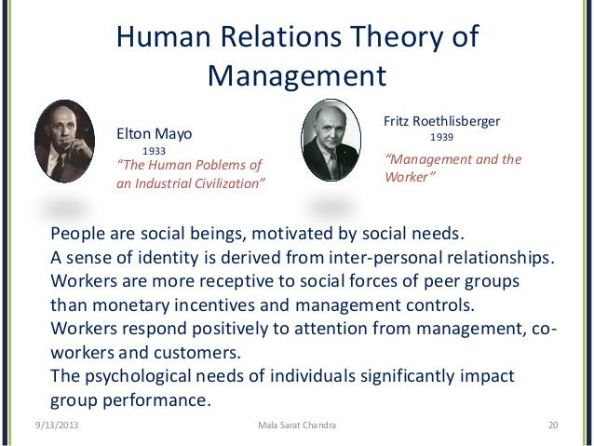
(Naranjo, A., 2021).

The main theme of contingency management theory is that the leader of the organization should be flexible enough to identify and adapt management style according to the demand of the situation. According this theory the leader need to be very experienced and with enough skills in order to evaluate each situation in deep details and to react as per the specific circumstances with the main focus of solving the issue and delivering maximum results for the company (Naranjo, A., 2021).
Systems management theory refers that manager should evaluate patterns and events when determining management approaches (Robbins and Coulter, 2012). Systems theory was proposed in the 1940s by biologist Ludwig von Bertalanffy and main concept is focus over the patterns which can be set into system and this can be used for the daily tasks and work with specific chronology and system. Many companies choice to operate using this system as ones the system is set and there is rules and procedures then the control over the work and results is much easier for the management and the company (Hamburg, I., 2021).

Scientific management theory
Scientific management is a management paradigm that examines and synthesizes procedures. Its primary goal is to improve economic efficiency, particularly worker productivity. It was one of the first attempts to apply science to process engineering in management. Main focus here is improving the efficiency and productivity of the work power and the use analyze and evaluation for taking future actions and decisions for improving the results and net profit for the company (Dash, G., 2021).

Administrative management theory
The administrative management theory is focused over the concept that the whole company activity and process need to be set in strict structure, responsibilities, tasks and delegations. All this need to operate with fixed management hierarchy. Every member and manager needs to know their daily tasks and responsibilities and they need to complete them strict way according the company rules and procedures (Naranjo, A., 2021).

Bureaucratic management theory
Max Weber Bureaucracy Theory. Max Weber, a German scientist, defines bureaucracy as a highly structured, formalized, and also an impersonal organization. This theory focus over the concept of the strict structure and everyone need to follow the rules and procedures very strict way. Hierarchy need to be strictly followed and the only people able to take decisions are the managers and the owners, the employees have no any rights for feedback or suggestions (Dash, G., 2021).
In our example with Unilever there is use of mix between two theories which are Human relations theory and Systems theory. The reason for this decision is that the company is large size and need to have set strict procedures and rules in order to keep the productivity levels and the net profit. Unilever also focus over experienced and quality managers which are able to react and interact with the employees the way that the motivation will be as much possible and the KPIs will be achieved (Creary, S.J., 2021).

Critical evaluation
Every company choice different theory to use and some even use mix of theories, but nowadays with the covid19 lockdowns and issues there is high level of demand for keeping the employees with the company. There is a lot of stress and worries about the future work, life and way of completing out tasks. The most strict theories like administrative management theory and Bureaucracy Theory will not deliver productivity and enough results as currently the workers want less stress, more security and good work environment in order to deliver results and net profit for the company (Dash, G., 2021).
All companies now need to take care for the employees and customers health and safety at the highness level. In the past to find proper experienced employees was easy, but now the situation changed significantly and the employees focus and managing the productive employees to stay with the company in long term. The support from the government with the furlough scheme did work very well for keeping the employees confident for their incomes and work, but now this help end and the companies need to deal on their own with the labor cost (Creary, S.J., 2021).
As result of the COVID19 the companies need to measure every member experience and skills and to decide which employee need to stay with the company and which need to be canceled as the labor cost increased versus the turnover which decreased the net profit. In order to keep the level of the net profit the companies need to decrease the labor cost and to focus to the employee’s productivity at maximum levels (Naranjo, A., 2021).
The companies hit and seriously affected by COVID19 need to react immediately and to use the new ways of operating with more online sales and orders. Nowadays no company can be enough productive if there is no online sales and customer engagement (Creary, S.J., 2021).
During the COVID19 Unilever lost some turnover due to the significant decreasing of the markets, but from the start of the 2021 the company recovery already started and the results are on track versus the targets (Dash, G., 2021).
Unilever response to the COVID19 are set in the mission named ‘’ COVID19 response ‘’. This included over 100 million euro in the form of donations with soaps, bleach and food. But this is not all what is done the Unilever also supported the UK preparing ventilators and supporting the NHS with materials and donations since March 2020 (Oliveira, R.M.M., 2021).
Unilever also organized mass disinfections and antibacterial campaigns in many different countries from all around the world with the aim to support and respond to the covid19 issues and challenges (Creary, S.J., 2021).
The company managed very well to maintain and to take SMART decisions for the increasing the brand name popularity. As every large size international company Unilever used the COVID19 situation very well and clever in order to invest in the brand name and to increase the company recognition for world brand which do care for the customer and the society in days of pandemics and challenges (Dash, G., 2021).
The donations and the activities completed by Unilever will bring to the company more loyal customers and more popular brand name and apart from helping to the people in need during the COVID19 the company will also take future interest and benefits from the news, social media and all other communication channel with which the company promoting their response to the pandemic and the COVID19 (Creary, S.J., 2021).
All the theories need to be used and implement very careful and depending of the strategy and the final outcomes need for the company. In some occasions there could be also used mix of two theories in order to be achieved better results and benefits for the company goals (Creary, S.J., 2021).

Analyses the difference between - beliefs, attitudes, and values within a workplace context.

Beliefs are hypotheses and opinions that we hold to be true based on our previous experiences. Values are deserving notions based on things, thoughts, and individuals. These internalized systems (attitudes, beliefs, and values) are represented through behaviors.
Figure 2
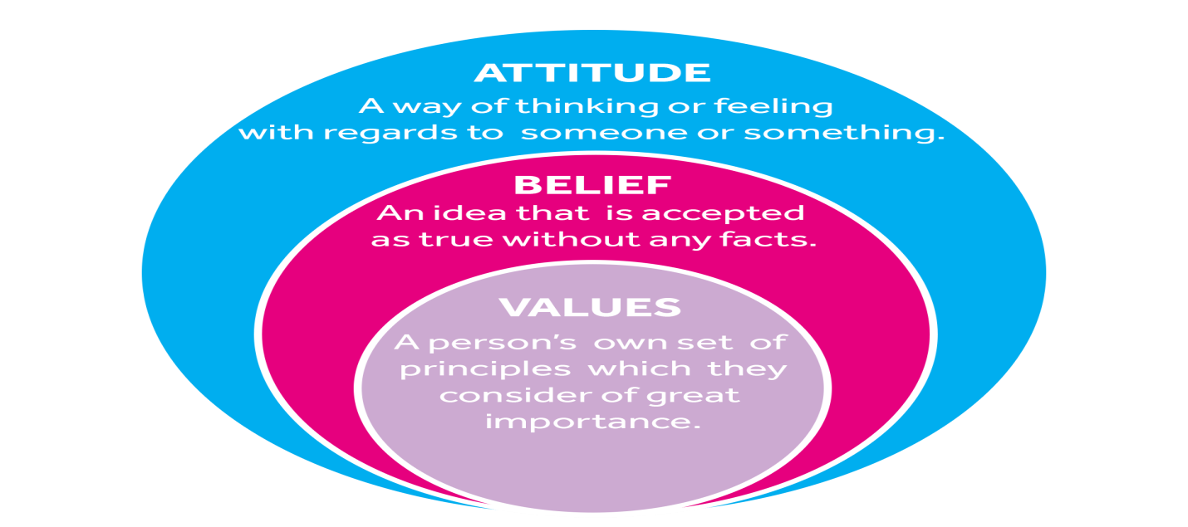
(Rawshdeh, Z.A., 2021).
Beliefs in the most examples the beliefs are based on previous experience that something happened and then the following outcome will repeat if same situation occurs in future. This belief also can be set by our family or friends or people which we trust and believe. Our beliefs and the team ones are very important, because this will impact what and how we will do in specific situations. For the management is important to know the team members beliefs as this way he will knows what tasks to delegate and how to motivate the team do execute them with maximum results and productivity (Rawshdeh, Z.A., 2021).
Individuals must have positive views in order to be productive and committed in an activity. Attitudes are formed as a result of basic values and ideas that we hold within. Beliefs are judgments and opinions that we hold to be true based on our previous experiences. Values are deserving notions based on things, thoughts, and people.
Attitude is representing what is your opinion about someone or situation based on what you feel or thinking about it. This is very important for understanding as this could explain the following actions of the person about someone or about some task for example. The 'affective' react is a person's emotional reaction to a task or thing. The 'cognitive' reaction is the cognitive appraisal of the entity based on an internal set of beliefs, whilst the 'behavioral' reaction is the expressed verbal or behavioral inclination to a task or item (Rawshdeh, Z.A., 2021).
As it is about other people's behavior filtered via our world views, feedback on attitudes have always been regarded as judgmental. Therefore it is preferable to offer feedback on behaviors. It is much better to identify desirable behaviors for an organization, scenario, or learning environment and set the stage before assessing the behaviors (Hamburg, I., 2021).
Values referring to what is important for you based on your principles. And your actions will be based on your values and principles. Understanding team member values is important as you know what to expect from each member and what is their principles (Hamburg, I., 2021).

How someone with different beliefs, attitudes and values might interpret the theory differently.
Taking in consideration that UK and especially London is international multicultural city it is very important to know how people with different believes will interpret and react to the different theories and practices. It is very important for the companies and especially the management to know their team beliefs, attitude and values as this will help to them to better motivate and coach each team member and to deliver more productivity and results for the company (Rawshdeh, Z.A., 2021).
In terms of characteristics like as honesty, integrity, and openness, which tend to be the most important values when individuals are asked what their values are. Attitudes are learned ways of responding to people and situations that are based on our beliefs, values, and assumptions. Our attitude may be shown in how we respond to events and in how we behave (Hamburg, I., 2021).
Proponents of adult learning say that in order to achieve competence and greatness, one must be able to teach and analyze not only information and talents, but also attitudes. To achieve greatness, we must be able to uncover the basic values and belief systems that underpin attitudes (Hamburg, I., 2021).
Only by acquiring the necessary information and skills can performance be improved. Having the proper value and belief systems may impact our motivation, intention, and involvement with a particular job. We may encounter people who appear to have the understanding and skills to perform a task, but only with a good attitude toward the work will there be inspiration, involvement, and desire to finish the assigned task (Rawshdeh, Z.A., 2021).
We can see briefly on the figure 3 below links between the specific questions and the specific actions, thinking or feelings of the individual. The link between our secret values and belief systems and our outer behaviors is depicted in the 'iceberg' diagram below. However, two elements are evident that have a direct impact on behavior: the attitude that supports the behavior and the capacity to communicate the desired behavior (Rawshdeh, Z.A., 2021).
A individual can have several values, with certain values being more important than some others. It has been demonstrated that the values that are most important to you frequently drive your decision-making in many parts of your life, including employment, religion, social circles, and self-identity (Rawshdeh, Z.A., 2021).
People are encouraged or required to work from home if the nature of their employment permits it as part of the physical distancing measures implemented in the majority of Member States. Many of these employees may be teleworking for the first time, and their working environment is likely to be lacking in many ways as compared to their workplace (Rawshdeh, Z.A., 2021).

Figure 3
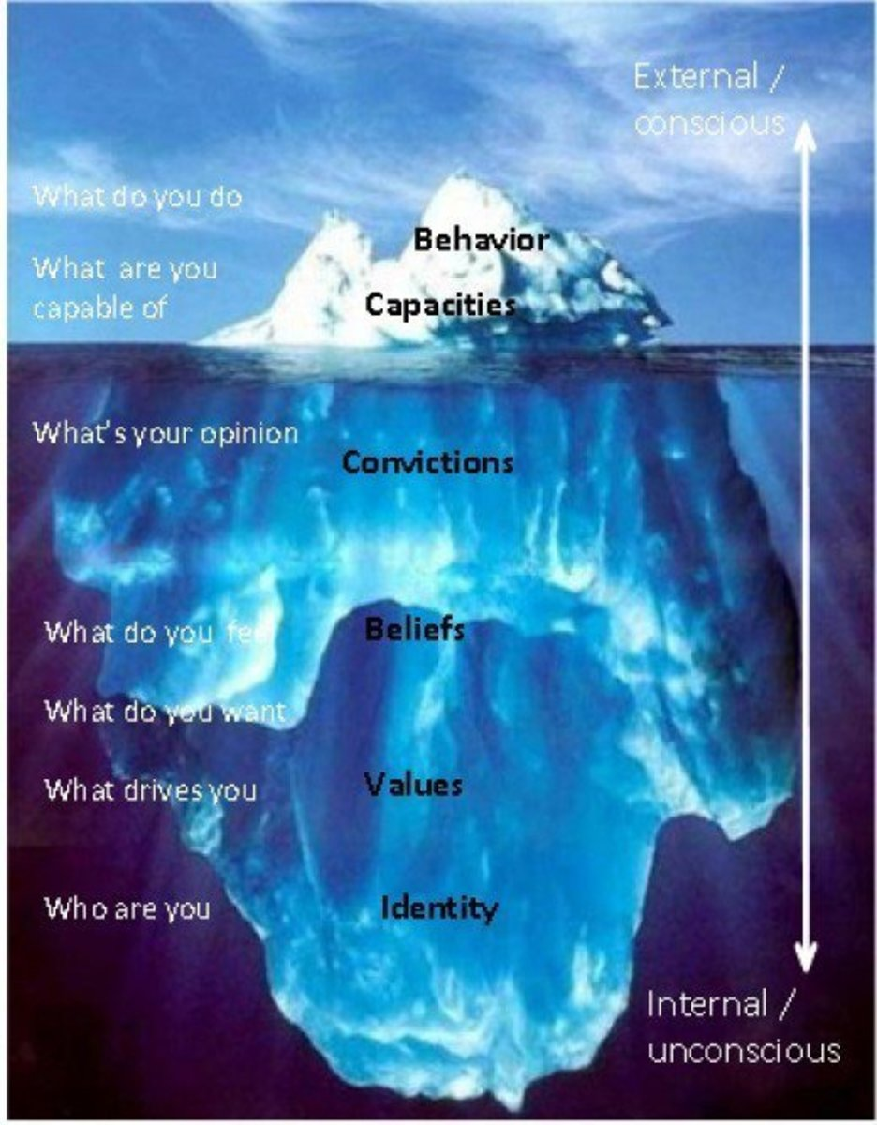
(Rawshdeh, Z.A., 2021).
Everyone who is frequently late, for example, may be regarded as unorganized and unpunctual. This same individual, nevertheless, may spend lots of time looking for someone who is severely unwell, and their own time spent providing this care may compromise with their early start to work or courses. They may be perceived differently now that they have these extra details. The main point here is that any theories, any action, any decision could be proceed differently depending of your values, beliefs and attitude, which looked over different points can be wrong or true (Rawshdeh, Z.A., 2021).
There is many examples and situations where the management need to react differently according the situation and depending of the members involved, and opposite in the same situation, but with involved other team members the manager reaction could be completely different and this all comes from the different beliefs, values and attitude for the both sides the management and the team members (Hamburg, I., 2021).
Nowadays with the new ways of communications and working the companies need to train and develop the team member skills, values, beliefs and experience in order to amend their ways of working and to focus over the new challenges and situations for the focus delivering maximum profit and results for the company (Rawshdeh, Z.A., 2021).
Mainly the difficult situations within the team comes exactly because of the personal differences within the team and the management did not successful used the theories and practices for making the team more involved and supportive to each other with the HR and the management tools available for this purpose. The managers are the main people which need to spoil and make the team strong and working smoothly despite the differences and the personal beliefs as this is critical for the company performance and net profit (Rawshdeh, Z.A., 2021).
Now with the high percentage remote online working the management need to be very flexible and to still motivate the team for delivering high level of results for the company and providing great customer service despite they help customers from their home. Other important point of view is the mental health of the team members as staying at home also can be very stressful and impacting your health. This is the reason why Unilever always creating weekly and daily online briefings and you are even able to see the whole team on the camera and you can get any kind of support and help you need on time (Naranjo, A., 2021).
Other very serious issue is the vaccination process of the employees as the government instructions are that the companies need to motivate the team members to be fully vaccinated with different tools and HR strategy for increasing the number of the vaccinated people across the country. This unfortunately will and it is goes against some members beliefs, values and attitude this is the reason Unilever keep trying to find the right balance and to introduce more voluntary and more relax way of engaging members within this process (Naranjo, A., 2021).
Other important issue is the risk of separating the team between the fully vaccinated people and members which still refusing to be vaccinated as this will create negatives for the company performance and results. Here is the main role of the manager to spoil the team to keep the team environment proper and understanding and respecting each other positive way. This is the reason why Unilever consistent way recruiting mostly highly experienced and skilled managers and training and promoting internal members with potential in order to ensure that every situation will be managed very confident way with positive actions and the team work will be first priority instead the feelings and issues around (Naranjo, A., 2021).
One part of the Unilever team still working remotely due to the restrictions and lockdowns in some countries and this is the reason the company keep managing to be very supportive, understanding and helpful for his team members from all around the world (Naranjo, A., 2021).
Every manager within the Unilever knows and understands in details the COVID19 restrictions and situation in the current location in order to react and take actions accordingly for keeping the levels of performance and results for the company (Oliveira, R.M.M., 2021).

Conclusion
The COVID19 changed the whole people mindsets and their beliefs and values also changed as in impact of the government decisions, the restrictions and the stress levels changed the people confidence and the levels of understanding the surrounding environment. From the above report, facts, evidences and discussion there is enough points for considering how important is the understand your team beliefs, values and attitude as other way you cannot motivate them up to the maximum levels for achieving all company targets and goals (Oliveira, R.M.M., 2021).

References
Kniffin, K.M., Narayanan, J., Anseel, F., Antonakis, J., Ashford, S.P., Bakker, A.B., Bamberger, P., Bapuji, H., Bhave, D.P., Choi, V.K. and Creary, S.J., 2021. COVID-19 and the workplace: Implications, issues, and insights for future research and action. American Psychologist, 76(1), p.63.
Gupta, J. and Misra, P., 2021. Mixed method research on lifelong learning: capturing its dynamics in a multi-generational workforce in the wake of COVID 19. International Journal of Management in Education, 15(4), pp.293-317.
Chakraborty, D., Biswas, W. and Dash, G., 2021. Marching toward “heart work”: Connecting in new ways to thrive amidst COVID‐19 crisis. Conflict Resolution Quarterly.
Makhbul, Z.K.M. and Rawshdeh, Z.A., 2021. Mental stress post-COVID-19. International Journal of Public Health Science, 10(1), pp.194-201.
Byrd-Poller, L., Farmer, J.L. and Ford, V. eds., 2021. Role of Leadership in Facilitating Healing and Renewal in Times of Organizational Trauma and Change. IGI Global.
Anderson, J., Rainie, L. and Vogels, E.A., 2021. Experts say the ‘new normal’in 2025 will be far more tech-driven, presenting more big challenges. Retrieved from PEW: https://www. pewresearch. org/internet/2021/02/18/experts-say-the-new-normal-in-2025-will-be-far-more-tech-driven-presenting-more-big-challenges.
Hamburg, I., 2021. Impact of COVID-19 on SMEs and the Role of Digitalization. Advances in Research, pp.10-17.
Shoss, M.K., Horan, K.A., DiStaso, M., LeNoble, C.A. and Naranjo, A., 2021. The conflicting impact of COVID-19’s health and economic crises on helping. Group & Organization Management, 46(1), pp.3-37.
ALOISI, A. and DE STEFANO, V., Essential jobs, remote work and digital surveillance: addressing the COVID‐19 pandemic panopticon. International Labour Review.
Malik, A. and Sanders, K., 2021. Managing Human Resources During a Global Crisis: A Multilevel Perspective. Brit. J. Manag.
Sudha, S. and Singh, A., 2021. Competency Framework for Managing Manpower Post-Pandemic. In Handbook of Research on Sustaining SMEs and Entrepreneurial Innovation in the Post-COVID-19 Era (pp. 60-78). IGI Global.
Pataki-Bittó, F. and Kapusy, K., 2021. Work environment transformation in the post COVID-19 based on work values of the future workforce. Journal of Corporate Real Estate.
Byrne, T.E. and de Oliveira, R.M.M., 2021. The Post-COVID-19 Era: Impacts, Challenges, and Opportunities for Worker Representatives. In Handbook of Research on Remote Work and Worker Well-Being in the Post-COVID-19 Era (pp. 308-328). IGI Global.
Simione, L., Vagni, M., Gnagnarella, C., Bersani, G. and Pajardi, D., 2021. Mistrust and beliefs in conspiracy theories differently mediate the effects of psychological factors on propensity for COVID-19 vaccine. Frontiers in Psychology, 12.
Wakeman, S.W., Tsalis, G., Jensen, B.B. and Aschemann-Witzel, J., 2021. Seeing the Issue Differently (Or Not at All): How Bounded Ethicality Complicates Coordination Towards Sustainability Goals. Journal of Business Ethics, pp.1-14.
Nera, K., Wagner‐Egger, P., Bertin, P., Douglas, K. and Klein, O., 2021. A Power‐Challenging Theory of Society, or a Conservative Mindset? Upward and Downward Conspiracy Theories as Ideologically Distinct Beliefs. European Journal of Social Psychology.

