University of Wales Trinity Saint David

Professional Career Development (BMSW4005_LON)

Lecturer: Soban Sadiq

Student’s Name: Tsonyo Todorov

Student’s ID: 2021609

Professional Career Development

Individual

Report
Table of Content

Introduction p.2
Recruitment and selection p.3-6
Personal development plan p.6-7
Self-evaluation p.7-8
Conclusion………………………………………………………………………………………………p.8
References p.9
Appendices p.10-14

Introduction
From the very beginning of career planning, I was passionate about construction industry and that's why I have chosen the diploma degree for Painting and Decorating. Through that degree I have to keep myself competent to be an, construction worker executive. Along with that academic degree, I took part in different symposium conferences and training programs on construction sites as well as safety trainings. Except being competent for the desired position I try to improve other employability, so that I can be a good candidate for the job market (Lowden et al., 2011). In this respect I have worked to develop my communication skills for practicing it daily with my communication partners at work and I also attended different presentations, essay writing, disputes and conversations to improve my reading skill, writing skill, listening skill and speaking skill. Among all of the skills it seems that listening is quite difficult for me. Therefore, I have given much effort for that part of communication. As I believe that I cannot be a good speaker unless I cannot be a good listener. My previous job was an excellent opportunity for me to make me fit for another good position in a multinational company. I got a good working environment in my previous work place where I have developed my leadership skills and problem-solving skills. Teamwork is another good feature of a healthy working environment which existed in my previous workplace. Still, I have to quit the job as I want to progress with my career. Besides, I wanted to develop myself more competently and qualified for the workplace with the development of new employability skills and knowledge so that I can gain more career growth (Wickramasinghe and Perera, 2010). This report will discuss about the reflection of my role play as both interviewer and interviewee, evaluation of me and identification of my strengths and weakness for being employed by a reputed employer’s. After that there is a personal development plan focusing on the skills that I want to develop and how. In the appendix section I have attached a job application form and a set of interview questions.

Recruitment and selection
Gibbs reflective cycle has been used to discuss the reflection of role played as both interviewer and interview. Reflective cycle has stages. These stages are as follows:
- Description
- Feeling
- Evaluation
- Analysis
- Conclusion
- Action plan (Sekarwinahyu, et al., 2019).

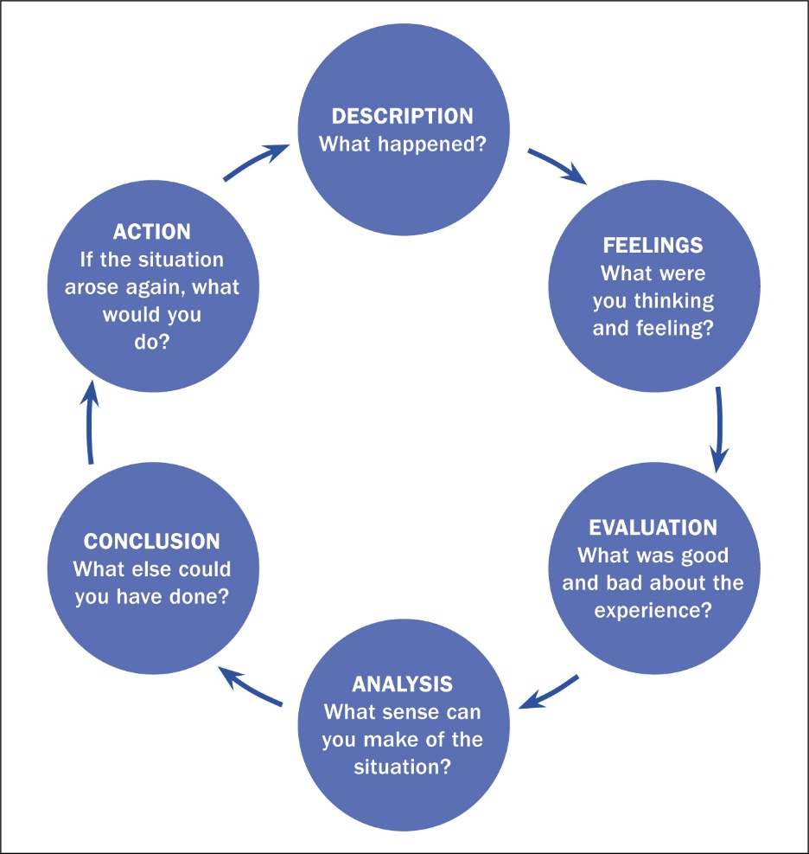

Source: ( https://www.britishjournalofmidwifery.com/content/professional/learning-through-reflection )

Description
In the interview session I have been able to play the role of both the interviewer and the interviewee. As an interviewee I have developed a job application form for the position of Construction Supervisor in an organization and I have got the opportunity to be interviewed by another student of my class as an interviewer. In the interview session I have been asked a few questions both regarding my personal life and my career life. It seems to be quite a pleasure to me as I was satisfied with the answers to the questions. On the other hand, when I was playing the role of an interviewer, I asked several questions to the interviewee who was in front of me. The interview session took place in MS Teams (online), which was free from any kind of interactions and noises (Gale et al., 2016,). The decorum for the interview session was a quite simulated to a real-life interview session to provide a real feeling of nervousness and enjoyment among the students.

Feeling
I have a mixed feelings regarding the interview session. When I am playing the role of an interviewee, I really get nervous regarding the time of the creation and the reactions of the interviewer after hearing my response to their questions. But gradually the interviewer has been able to understand me and make me friendly to combat my nervousness. As time went, I became easier and comfortable. When, I was playing the role of an interviewer, I felt pity on the interviewee and tried to combat his nervousness and also tried to be too comfortable to him so that he can answer properly to the questions being asked. I did no mistakes by counter attacking my interviewee as I know that it lowers the confidence of the interviewee (Turner, 2010). But I must say that the communication skill of my interviewee was good enough to me. Anyway, the session was good experience for both of us.
Evaluation
The Evaluation section discusses what was good and what was bad in respect to my experience regarding the reflection effect (Knowles et al., 2006). Playing the role of an interview was an excellent experience for me. At the beginning as I was a little bit nervous. Besides, the interview was friendly. Therefore, I got confused. But anyhow I managed the situation and positively convinced the interviewer. The dark side of the interviewee role is that considering my classmate as an interviewer was somewhat difficult for me. Therefore, at the beginning I behaved somewhat casually which may have a negative impact on my interview score. In, the interviewer role, the good side is that I was the person who had the authority to ask questions. I felt confident. Instant of acting questions in the traditional way I provided more scope to my interviewee to prove him as competent.
Analysis
Interview is one of the selection tools used by most of the employers across the world to sort out the best candidates for the position opened in the organization. Effective interview solutions must have several characteristics. Among them the length of the interview, the environment of the interview session, the interviewers and their depth of knowledge regarding the organization and the positions for which employees are being interviewed (Hamdi et al., 2011). In, reference to above characteristics of interview the decorate mobiles well enough. But the interview session was quite concise to prove a candidate qualified for a particular job. For the interview session we had the restrictions to ask only for 5 questions. But with the five questions we cannot judge the quality of a candidate. Now come to the point of the interview session environment. We had created a simulated environment that emulated reality. So, in future if I got another chance to play the role of an interviewer, I will try to maintain a proper environment so that it can provide the best result. Besides, the solutions of integral will be based on the position for which candidates are being selected. Furthermore, I will try to rectify mistakes that I made in the interview session. To overcome my nervousness, I will try to face so many interviews so that I can understand the ticks and trips of interview success.
Conclusion
Interview session enabled me to understand how the interviewer thinks of the interviewee and how to better grab the attention of the interviewer. I also understand how successful candidates react to awkward situations on the interview board. Therefore, along with the academic skills I must be competent to handle the situation of the interview world. After all, it was a good experience for me.

Action plan
To enhance my employability skills, I need to develop myself in several areas. My personal career plan has been presented in the section below where I have highlighted what skills I need to develop, how to develop and how to measure the success on the required skills.
Personal development plan
Academic Skill | Action | Future  Implications
1. Time management skill | - Use cue card to have a track of activities to be accomplished  - Maintain digital logs of activities with reminder using personal digital assistants | - Will be able to ensure discipline in personal life and professional life  - I will be more deadline oriented and accomplish work ahead of time so I will be relaxed.
2. Problem solving and critical thinking skill | - Volunteer to work on various projects  - Take part in a comprehensive business case competition  - Practice on face-based analysis | - Will be capable of detecting problems and recommending solutions to employers.  - Will be capable of resolving problems in academic group projects  - Will be able to analyze situation critically.
3. IT skill | - Practice suing virtual collaboration tools like Zoom  - Enroll in a course on using information technology for online collaboration and management of information technology for office automation | - Will be able to work on projects remotely using online collaboration  - Enhance efficiency and effectiveness in using information technology
4.Adaptability  skill | • Dealing with changing circumstances and a difficult environment  • Pursuing an internship opportunity which differs from my existing lifestyle and mindset. | • I am capable of dealing with any change and adapting to any scenario or difficulty.  • I can adapt to changes by modifying my behavior.
5.Positive Attitude skill | • Highlighting my goals, maintaining positivity, and acknowledging my successes.  • Experimenting with new ideas and chances.  • Having fun with my activities and awarding myself for completing them correctly | • I am focused and inspired to complete a variety of duties.  • I demonstrate patience and devotion in a variety of vital tasks.

Self-evaluation
I contacted personal evaluation to learn about my strengths and limitations in order to be a suitable candidate for a company. What are the findings of my investigations says, I have extensive understanding of the construction industry sector, as well as academic knowledge and practical experience as well. Working as a construction executive in my previous workplace I have identified that I am good in leadership skills and teamwork skills. Although I am quite sympathetic to people and very much comfortable in my comfort zone, I feel awkward to work with unknown people (Nisha and Rajasekaran, 2018). Besides, I am skilled in communication skills both writing and speaking which enables me to work effectively with mine team mates. But I must be skilled in interpersonal skills to work as construction supervisor. I also need improvement in critical thinking and problem-solving skills. Although I have proficient level knowledge in handling different software, I need to be more complete in computer and communication technology. After the pandemic period virtualization has achieved significant attention (Nisha and Rajasekaran, 2018). Therefore, I must be trained up in virtualization and online collaborations to be a good candidate for my employer.

Conclusion
In the twenty-first century, the job market is undergoing a rapid and drastic transition that is affecting the requirements of companies, who are searching for more qualified and capable personnel. Employer’s now value communicative abilities, organization skills, presenting skills, IT abilities, time managing skills, problem-solving skills, a good mindset and adaptability, and collaboration skills. Furthermore, acquiring these abilities benefits in one's professional advancement and becoming a best-fit in a global employment market. This course has greatly enriched my understandings and capability growth, which will aid me in my upcoming studies and career. Furthermore, it will assist in the development of my innovative thinking skills as well as effective participation in my present and future pursuits.

References

Gale, J., Ooms, A., Grant, R., Paget, K. and Marks-Maran, D., 2016. Student nurse selection and predictability of academic success: The Multiple Mini Interview project. Nurse education today, 40, pp.123-127.
Hamdi, H., Richard, P., Suteau, A. and Saleh, M., 2011, March. A Multi-modal Virtual Environment to Train for Job Interview. In PECCS (pp. 551-556).
Knowles, Z., Tyler, G., Gilbourne, D. and Eubank, M., 2006. Reflecting on reflection: exploring the practice of sports coaching graduates. Reflective practice, 7(2), pp.163-179.
Lowden, K., Hall, S., Elliot, D. and Lewin, J., 2011. Employers’ perceptions of the employability skills of new graduates. London: Edge Foundation.
Nisha, S.M. and Rajasekaran, V., 2018. Employability skills: A review. IUP Journal of Soft Skills, 12(1), pp.29-37.
Sekarwinahyu, M., Rustaman, N.Y., Widodo, A. and Riandi, R., 2019, February. Development of problem-based learning for online tutorial program in plant development using Gibbs’ reflective cycle and e-portfolio to enhance reflective thinking skills. In Journal of Physics: Conference Series (Vol. 1157, No. 2, p. 022099). IOP Publishing.
Turner III, D.W., 2010. Qualitative interview design: A practical guide for novice investigators. The qualitative report, 15(3), p.754.
Wickramasinghe, V. and Perera, L., 2010. Graduates', university lecturers' and employers' perceptions towards employability skills. Education+ Training.

Learning through reflection, available at: (online), https://www.britishjournalofmidwifery.com/content/professional/learning-through-reflection, accessed, 28/12/2021.

Appendices
1. Job application form

Application for [Construction Supervisor] -

Your details:
Name: Tsonyo Todorov
Date of birth: 28/041988
Address: 22 Greenhill Way, London, United Kingdom

Education and training:
Please give details:

- High school for construction diploma

- Participated in a training-programs on construction sites

- Safety training for construction workers

- Nvq lvl 2 diploma for painting and decorating

Qualifications:
Please give details:
I have over six years-experience in construction industry and completed various safety and training programs. Also completed diploma for painting and decorating. Working in many different teams on construction sites during the last years help me achieve different skills such as team-work, self-management, time-management, communication, problem-solving, planning and organizing. I believe all these skills make me a very good candidate for the job.

Employment history:
Your current or most recent employer:

Name of employer: Lucas

Job title: Painter and Decorator

Length of time with employer: 2 years

Reason for leaving:
Looking for Opportunities to Progress

Duties:

- Choosing the right tools and paints for each job.

- Preparing walls and other surfaces before painting.

- Maintaining a tidy workstation and tools.

- Using paintbrush, rollers, or spraying tools.

- Applying different types of paint, stains, varnishes and other finishes.

Previous employers
Please tell us about other jobs you have done and about the skills you used or learned in those jobs.

I use to work for different construction companies. I am skilled in managing the force of diversified jobs and projects. My experience in construction industry allows me to manage workplace diversity and ensure inclusion through proper planning and executing.

Supporting statement
Please tell us why you applied for this job and why you think you are the best person for the job.
I am a hardworking, self-motivated, and dedicated person who work well under pressure. During each team assignment or project, I made sure to do an excellent work in my own position while also assisting other team members in completing their respective duties. I apply for this position because I believe I possess the essential abilities, qualities, and capabilities to not only complete each task to a high quality, but also to contribute to your company's positive and creative progress via hard work and determination. The professional skills I've gained so far in my career will be beneficial to your team and organization.

Right to work in the UK
Do you need a work permit to work in the UK? Yes / No
Yes
References
Please give the names and contact details of 2 people who we can ask to give you a reference. We may ask them before an employment offer is made. We will not ask your current employer until we get your permission.

Reference 1
Mr. K. Kamenov
Manager
LUCAS PAINTING DECORATING LTD
Cell:07376 250383

Reference 2
Mr. Z. Georgiev
Manager
ZDPainters Ltd
Cell:07910 898827
Declaration
I confirm that to the best of my knowledge the information I have provided on this form is correct and I accept that providing deliberately false information could result in my dismissal.
Name: Tsonyo Todorov
Signature: T.T
Date: 12th December 2021

2. Interview questions
Question 1
Can you please introduce yourself?
Question 2
What are your strength and weaknesses?
Question 3
Why should I hire you?
Question 4
Imagine if you could start your carrier over from the beginning, will you change anything and what that will be?
Question 5
Where do you see yourself after three years working for our company?

