

Module Name: Managing Enterprise

Module Code: BMSW4011

Assignment Name: Business Plan and Reflection

Student Name: Irina Calin

Student Number: 1905198

Lecture: Melanie Squire

AI Acknowledgement
I confirm that I have not presented any AI generated materials as my own work.
I confirm that I have copies of my drafts, notes, and other resources I used, which I may be asked to provide in evidence.

Table of Contents
Task 1 Part 1 – Business plan 3
1. Company concept and significance of the business idea 3
2. Company name 3
3. Mission statement and the story behind the company setup 4
4. Business mission and vision 4
5. Business objectives 4
6. Legal Identity and reason for the choice 5
7. Marketing and PR Plan 5
8. Pricing Strategy 5
9. Marketing mix 7 P’s 5
10. Marketing samples 5
11. Physical Location 7
12. Human Resource Strategy 7
13. Sources of Finance 8
14. Cash flow forecast 8
15. SWOT Analysis 9
16. Conclusion 10
Task 1 Part 2 - Individual reflection 11
1. New business skills and knowledge acquired 11
2. Entrepreneurial traits that need to be developed 11
3. Investing in the business 11
References 13
Appendices 15
Appendix 1: Detailed PR Plan for Irina’s Homemade Sweets & Cakes 15
Appendix 2: Marketing mix 7Ps 16

Task 1 Part 1 – Business plan

1. Company concept and significance of the business idea
The concept of a home-made sweets and cakes business through establishing a small home-based operation that offers delicious, high-quality, and personalised treats for special occasions will be discussed in this research. The core offerings of this venture include custom sweets, cakes, cookies, and cupcakes for special occasions like festivals, birthdays, baby showers or small in-house celebrations. Custom-printed chocolate bars and lollipops with a special message, names, or a symbol will also be offered by this new business. Specialisation in vegan, gourmet and gluten-free products will be a primary focus of the business venture.
This is a highly unique business concept which focuses on offering personalised treats to customers according to their specific needs and requirements. In a recent survey, 23% of the respondents revealed that they run their small bakery from home, which has further reached up to £3.93 billion in revenue in the UK in FY24 (Mintel.com, 2025). Hence, the hype for baked goods is quite high, which will make the business venture extremely profitable. As a result, the important level of personalisation using specific ingredients, keeping in mind the health and well-being of the customers, will help the brand to connect emotionally with its target audiences.

2. Company name
The company name is Irina’s Homemade Sweets & Cakes.
USP of the business: The organisation is committed towards meeting the customised needs and requirements of the target audience.
Logo

Figure 1: Company Logo

3. Mission statement and the story behind the company setup
Mission: The mission statement of the business is to provide the best customised vegan, gluten-free, sugar free and gourmet products to the customers at moderate prices while keeping in mind their specific health concerns.
Story behind the venture: There is a very emotional story behind the business concept. The close family members of the founder of this business were diagnosed with Celiac disease and other diseases like type 2 diabetes, which prevents them from consuming baked goods made from sugar and gluten.

4. Business mission and vision
Business Aim: The business aim is to offer a wide range of customised sweets and bakery goods using ingredients that can be consumed by individual customers who have health concerns like diabetes and celiac diseases.
Vision: The vision of the organisation is to provide high-quality sweets and cakes to even those customers who traditionally are restricted from eating these traditional bakery items due to health concerns or otherwise.

5. Business objectives
Business objectives: the business objectives are as follows:

Figure 2: Company objectives

6. Legal Identity and reason for the choice
The legal identity of the business is sole proprietorship where only one individual named as Irina will be owning and operating the business along with other employees. The primary reason for choosing sole proprietorship is the simplicity and ease of set up this new venture namely Irina’s Homemade Sweets & Cakes (Afshan et al. 2021). It is also one of the lowest cost businesses set up available in the UK market (Williams, 2022). Under such legal structure, CEO or the founder of the business can have the full control of the business decision-making.

7. Marketing and PR Plan
Target market: The target market of the organisation are individuals who are within an age group of 18 years to 65 years, having specific health concerns like diabetes or Celiac disease. In addition, the consumers who are simply health and environment conscious, wants to input high-quality natural ingredients, and having a net yearly income between £30,000-£85,000 will also be targeted by this brand.
Sell/promotion strategy: the organisation is going to adopt a combination of online and off-line sale or promotion strategy. Apart from social media marketing where these platforms are used to highlight the bakery products, a positive in store experience is also important (Scholes et al. 2014). A dedicated website of the organisation will also be created to help the customers directly order the product online and they can be home delivered to the doorstep of the customers (Bgateway.com, 2025).
[Detailed PR Plan in Appendix 1]

8. Pricing Strategy
For this new business, the value-based pricing strategy will be implemented for two important reasons. First, the product can be priced higher than the competitors because it is based on the amount of money that the customers are willing to pay (Aulet, 2024). According to a Mintel report, 40% of the respondents in the survey revealed that they are willing to pay double the price for baked goods that are made from fresh, organic raw materials and contribute to their health (Ratten, 2023). Second, the value-based pricing also allows the bakery to improve the product on a continuous basis to ensure that the value of the product increases over time.

9. Marketing mix 7 P’s
[Refer to appendix 2]

10. Marketing samples
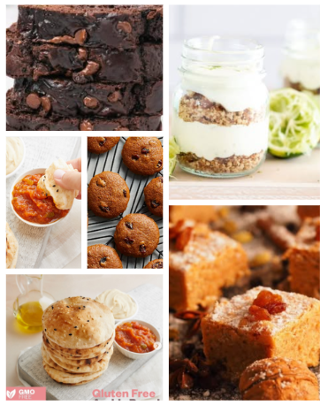
Figure 3: Instagram Post
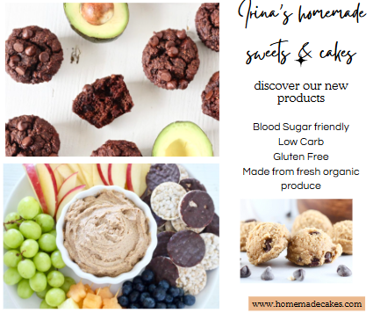
Figure 4: Facebook Post
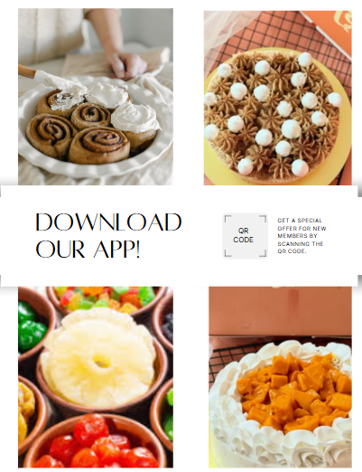
Figure 5: Instagram Post

11. Physical Location
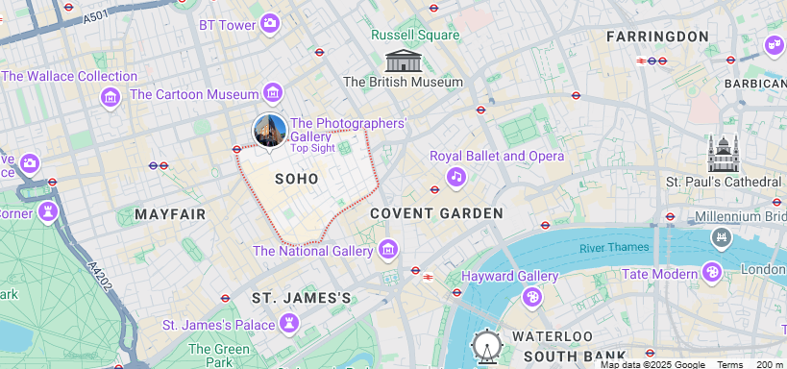
Figure 6: Location map
(Source: Google Maps, 2025)
The small physical store of Irina’s Homemade Sweets & Cakes will be in Soho, a vibrant neighbourhood in the West End. Soho will be selected because it features a variety of nightlife, dining, and shopping options (Saoula et al. 2023). These aspects will create several opportunities for the brand through increasing the food traffic in the area and ensuring good visibility to the potential customers.

12. Human Resource Strategy

Figure 7: Human Resource Strategy

Figure 8: Organisational chart

13. Sources of Finance
For starting the business named as Irina’s Homemade Sweets & Cakes, a minimum of £40-£50,000 will be required. To achieve this goal, around £20,000 will be provided by the sole proprietor herself. Apart from this, angel investors will be invited who can provide the initial funding in exchange for equity (Thukral, 2021). Those angel investors who believe in the potential of the business will be approached by the researcher.

14. Cash flow forecast
12-Month Cash Flow Forecast (in £)
Initial Investment: £5,000
Month | Opening Balance (£) | Cash Inflow (Sales + Investment) (£) | Cash Outflow (Expenses) (£) | Net Cash Flow (£) | Closing Balance (£)
Month 1 | 0 | 20,000 (initial) + 5,000 (sales) | 10,000 | +15,000 | 15,000
Month 2 | 15,000 | 6,000 | 8,000 | -2,000 | 13,000
Month 3 | 13,000 | 6,500 | 7,500 | -1,000 | 12,000
Month 4 | 12,000 | 7,000 | 7,000 | 0 | 12,000
Month 5 | 12,000 | 8,000 | 7,500 | +500 | 12,500
Month 6 | 12,500 | 8,500 | 7,500 | +1,000 | 13,500
Month 7 | 13,500 | 9,000 | 8,000 | +1,000 | 14,500
Month 8 | 14,500 | 10,000 | 8,500 | +1,500 | 16,000
Month 9 | 16,000 | 11,000 | 9,000 | +2,000 | 18,000
Month 10 | 18,000 | 12,000 | 9,500 | +2,500 | 20,500
Month 11 | 20,500 | 13,000 | 10,000 | +3,000 | 23,500
Month 12 | 23,500 | 14,000 | 10,500 | +3,500 | 27,000
- Sales grow slowly as brand awareness increases.
- Starting with a £20,000 investment, reflects that it never dips into a negative cash balance.
- Net cash flow is positive overall, with minor dips early - but still a strong closing balance each month.
- By Month 12, the business holds £27,000 in cash - a solid financial position.

15. SWOT Analysis

Figure 9: SWOT analysis

To overcome the problems and challenges mentioned above, the following strategies need to be implemented.
- First, the organisation must partner with delivery partners like Uber eats to outsource the distribution of home delivery (Salmony and Kanbach, 2022).
- To overcome the problem of rising Indian cost, the organisation must source locally from the local farmers (Wahyuni et al. 2023).
- To take advantage of the opportunity of rising health-conscious and vegan customers, the organisation needs to focus on targeted social media ads based on the lifestyle and health prospects of the customers (Yemenici, 2022).
- The organisation must look out for talented and creative freshers who have not been recruited by large organisations (Daspit et al. 2023).

16. Conclusion
The business plan has been highly detailed, identifying the USP and the key areas that make the business distinct from others in the market. With the demand for sweets increasing in the UK market, the use of diabetic friendly and gluten-free ingredients can include those customers who were originally excluded from consuming baked products.

Task 1 Part 2 - Individual reflection

1. New business skills and knowledge acquired
From the completion of the business proposal, there are three important business skills which I feel I have developed.
- First, I got a deep understanding of economics. In addition to understanding the different pricing strategies, I also realised the demand that is there in the market and how to identify market opportunities to ensure long-term sales and profitability.
- I have developed in-depth financial and accounting skills that can be beneficial as an entrepreneur eventually. Financial accounting has always been a highly intimidating subject for me. However, concepts like profitability and cash flow became much easier to grasp.
- Finally, I have developed excellent negotiation skills and knowledge as to how to operate as a senior level manager. I have understood the importance of striking deals with supply chain managers, and delivery personnel to improvise a plan that best suits my business.

2. Entrepreneurial traits that need to be developed
As an entrepreneur, I must improve my risk tolerance. Entrepreneurship has often been associated with risk taking capabilities and flexibility (Lynch and Corbett, 2023). Launching a new venture requires an entrepreneur to take risk and steps must also be identified to minimise it as much as possible (Do Nguyen and Nguyen, 2023). As an entrepreneur, I am always risk averse trying to play it safe. Going in wrong path in a new venture is quite normal, whereas I am always afraid of failing. To become an effective entrepreneur, I will have to manage the relationship between reward and risk, so that I can ensure desired success of Irina’s Homemade Sweets & Cakes from the market.
To become comfortable with risk, I must focus on getting more practical experience and manage my emotions accordingly. I am too focused on how people will react if I fail. However, this is exactly what is blocking me from achieving success. I will have to understand that failing is a part of life. By gaining more experience, I will be in a better position to take calculated and small risks so that even if failure comes to me, they are not as financially hitting on the organisation at large.

3. Investing in the business
As an angel investor, the first thing that I would be looking for is whether the business is creating some sort of value to the target audience. Not being able to eat sweets or celebrate special occasions with sweets and baked goods has been emotionally challenging for a lot of individuals who are suffering from any form of disease like diabetes. The business adds value by ensuring that even those individuals who are suffering from critical illnesses can enjoy the small treats of life without harming their health. Hence, the business is creating massive value in the market, and as an angel investor, I will invest in the business. There are disadvantages associated with the business, such as starting in a highly congested market where the number of niche customers is quite low. On top of this, it is a small business that will be able to cater to a limited number of customers in the beginning. Regardless of that, I will be investing as I can see a massive potential in the business to create value in the lives of those individuals who are already in a mentally distressed situation because of their health concerns.

References
Afshan, G., Shahid, S. and Tunio, M.N., 2021. Learning experiences of women entrepreneurs amidst COVID-19. International Journal of Gender and Entrepreneurship, 13(2), pp.162-186.
Aulet, B., 2024. Disciplined Entrepreneurship: 24 Steps to a Successful Startup, Expanded & Updated. John Wiley & Sons.
Bgateway.com, 2025. Homemade Cakes and Confectionery. Available at: https://www.bgateway.com/assets/market-reports/Market-Report-Homemade-Cakes-and-Confectionery-August-2023.pdf [Accessed on 9/6/2025]
Daspit, J.J., Fox, C.J. and Findley, S.K., 2023. Entrepreneurial mindset: An integrated definition, a review of current insights, and directions for future research. Journal of Small Business Management, 61(1), pp.12-44.
Do Nguyen, Q. and Nguyen, H.T., 2023. Entrepreneurship education and entrepreneurial intention: The mediating role of entrepreneurial capacity. The International Journal of Management Education, 21(1), p.100730.
Lynch, M.P. and Corbett, A.C., 2023. Entrepreneurial mindset shift and the role of cycles of learning. Journal of Small Business Management, 61(1), pp.80-101.
Mintel.com, 2025. UK Cakes, Cake Bars and Sweet Baked Goods Market Report 2025. Available at: https://store.mintel.com/report/uk-sweet-baked-goods-market-report [Accessed on 9/6/2025]
Ratten, V., 2023. Entrepreneurship: Definitions, opportunities, challenges, and future directions. Global Business and Organizational Excellence, 42(5), pp.79-90.
Salmony, F.U. and Kanbach, D.K., 2022. Personality trait differences across types of entrepreneurs: a systematic literature review. Review of managerial science, 16(3), pp.713-749.
Saoula, O., Shamim, A., Ahmad, M.J. and Abid, M.F., 2023. Do entrepreneurial self-efficacy, entrepreneurial motivation, and family support enhance entrepreneurial intention? The mediating role of entrepreneurial education. Asia Pacific Journal of Innovation and Entrepreneurship, 17(1), pp.20-45.
Scholes, A., Regner, P., Johnson, G., Whittington, R. and Angwin, D., 2014. Exploring strategy: Text & cases.
Thukral, E., 2021. COVID‐19: Small and medium enterprises challenges and responses with creativity, innovation, and entrepreneurship. Strategic Change, 30(2), pp.153-158.
Wahyuni, E.S., Aspan, H. and Mauliza, P., 2023. Financial Analysis of Entrepreneurship Education. International Journal of Economics and Management Research, 2(3), pp.10-18.
Williams, S., 2022. The Financial Times Guide to Business Start Up 2021-23: The Most Comprehensive Guide for Entrepreneurs. Pearson.
Yemenici, A.D., 2022. Entrepreneurship in the world of metaverse: virtual or real? Journal of metaverse, 2(2), pp.71-82.

.

Appendices

Appendix 1: Detailed PR Plan for Irina’s Homemade Sweets & Cakes
Core Questions | The meaning/Target/Goal | PR Campaign Plan
What | The goal is to make the target audience aware of the product and services offered by the brand. | Launch a targeted PR campaign on social media websites based on the demographic of the target audience. The social media campaigns can be redirected to the website of the brand.
Who | The target audience are individuals who are within an age group of 18 years to 85 years, having specific health concerns, are extremely health conscious, want to eat only healthy and natural products, and have a high self-worth. | Target them on social media platforms like Facebook, Instagram, and LinkedIn. Sponsor birthday parties in Office, customise anniversaries and distribute flyers to those audiences who might have health-conscious family members, or others who live with diabetes and similar diseases.
Where | This will be conducted on both off-line and online platforms. | Online platforms can include company websites and social media platforms. Off-line flyers can be distributed outside universities, colleges, and offices.
When | This needs to be done the first couple of months the organisation has established its business | Social media campaigns need to go on for at least 2 to 3 years from the date of inception. Off-line campaigns can go on for 3 to 6 months.
Why | Incorporating and introducing food items, especially sweets and baked goods for those customers who are not getting their needs met from the traditional confectioners. | Customisation and incorporation of individual needs and preferences is the USP of the business.
How | Internal and external communications, media relations, direct email campaigns and social media campaigns must be on point. | maintaining proper relations with the social media marketers and recruiting technical staff members for developing a website for the company.

Appendix 2: Marketing mix 7Ps
Product | Customised and inscribed sweets and baked goods made from high-quality organic ingredients that are gluten-free and sugar free. Natural sugars like honey and dates will be used as a healthy alternative to refined sugar.
Price | Value based pricing strategy will be adopted by Irina’s Homemade Sweets & Cakes.
Promotion | Promotion on the company website, the social media platforms like Facebook, Instagram, Twitter, and LinkedIn. Off-line promotions in the form of flyers distribution will also be adopted.
Place | The products will be distributed on the online platforms home delivered to the customers. It will also be available on an off-line physical store located in London. The products will be made in the home kitchen of Irina. The shop will be situated in the basement of the building the owner lives in.
People | One head chef, and five sous chefs who are specialised in technical baking skills, creativity, and attention to specific detail of the health and unique preferences or needs of the customers.
Process | This includes the operation system of the bakery, starting from sourcing the ingredients to maintaining quality and efficiency. The ingredients will be sourced from the local farms. Efficient baking techniques and equipment are sourced from the local markets. Each of the ingredients will be handpicked by the owner.
Physical evidence | The decor of the small shop will be neat, clean, and ambient, which will meet customer’s demand. The online website will be also extremely easy to navigate with font customisation for the customers. A special request option is also available on the website.

