
Master of Business Administration

Student Name: Md Faysal Rahman
Student Number: 2436576
Module code: LCMB7024

Assignment Title: Marketing Environment Analysis
Course Name: Marketing Management
Lecturer: Dr Laila Maazouz
Word Count: 2452

Submission Deadline: 21th October 2025

Table of Contents
Introduction 1
Task-01 2
1.1 Critical Analysis of the Macro Marketing Environment: 2
1.1.1 Major Macro-Environmental Forces and Strategic Implication 2
1.2 Macro-Environmental Forces in Fast Fashion: ASOS vs. Boohoo 4
1.2.1 Socio-Cultural Actor: Sustainable and Ethical Consumption 5
1.2.2 Legal Actor: Greenwashing and Consumer Protection Laws 6
Task 2 8
2.1 Strategic Response to Environmental Pressure: ASOS vs. Boohoo 8
2.1.1 Strategic Response to Socio-Cultural Pressure (Ethical Consumption) 8
2.1.2 Greenwashing Crackdown (Strategic Response to Legal Pressure) 9
Conclusion 12
Reference 13

Contents of Table

Table 1: Socio-Cultural Actor 5
Table 2: Legal Actor 6

Contents of Figure
Figure 1: SWOT Factors 4
Figure 2:Fashion with Integrity 9

Introduction
This report is a critical analysis of the macro marketing environment (PESTEL) and its strategy influence in the sector of fast fashion using ASOS and Boohoo as examples. The discussion frees the growing Socio-Cultural pressures toward sustainability and aggressive Legal measures against greenwashing as the most significant external pressures. It compares the efficacy of the differentiation and transparency approaches taken by the pioneer ASOS with the compliance-based, defensive approach used by the follower Boohoo to be competitive and regain consumer confidence in a fast-paced, ethics-associated market.

Task-01

1.1 Critical Analysis of the Macro Marketing Environment:
The macro marketing environment, which is usually examined with the PESTEL framework, refers to the bigger forces in society that influence the whole microenvironment and strategic marketing management (Kotler and Armstrong, 2020). The organisation has been characterised by unprecedented global volatility, including the COVID-19 pandemic, as well as massive digital acceleration and economic fluctuations, making proactive environmental scanning essential for survival and maintaining a competitive edge (Sitepu et al., 2023).

1.1.1 Major Macro-Environmental Forces and Strategic Implication
Political (P):
- Regulatory Scrutiny: Tighter regulation (e.g., GDPR implementation) and advertising laws have required a very high level of adherence, especially in online marketing. Firms have to act proactively regarding law amendments so as to ensure consumer confidence as well as escape fines (Onuoha & Johnson, 2021).
- Policy Instability: Political stability and post-Brexit trade policies in markets such as the UK have caused unpredictability in supply chains and the cost of doing business for consumer goods and necessitate a nimble risk management policy.
Economic (E):
- Inflation and Cost of Living Crisis: Post-pandemic economic expansion has seen substantial growth in inflation, especially in the UK resulting in a massive cost of living crisis. This has harshly affected the disposable income of consumers and changed the buying patterns, and the marketers have to dwell on value propositions and price sensitivity (Parliament, 2025).
- Market Volatility: Economic uncertainty encourages consumers to be cautious about spending and has also contributed to the volatile trends in retail sales, which underscores the necessity of offering flexible prices and promotional efforts (Parliament, 2025).
Socio-Cultural (S):
- Health and well-being Consciousness: An emerging trend towards health in the world, which is growing faster due to the pandemic, indicated a rise in sustainable and ethically sourced products within the food and beverage industries. The advertisers should incorporate social corporate responsibility (CSR) and health insurance into their fundamental messages to be consistent with the changing social values (Professional Academy, n.d.).
- Digital Lifestyles: The pandemic has forever increased the pace of transition to online interactions, and digital channels have become the main channel of interaction and discovery of products. Customers are now demanding personalised, relevant experiences on the digital platforms.
Technological (T):
- Digital Transformation (DT): The most disruptive is DT that essentially transforms the marketing practice by making real-time data analysis, targeting with precision, and personalised customer experiences possible (Arthur et al., 2024). Research shows that companies that focus on AI and big data, which help their business, do better than their competitors in terms of market share and customer satisfaction (Adebayo and Zhang, 2023).
- Purchase Intention Influence: Digital marketing, such as social media marketing and content marketing, has been established to positively and significantly impact consumer purchase intention through the growth of brand interaction and access to product information (Kaihatu, 2020; Yen et al., 2022). The move to the digital world has made it easier and cheaper for brands and customers to connect (Samsudeen & Kaldeen, 2020).
Environmental (E):
- Sustainability Imperative: With government regulation and high consumer demand on ethical sourcing and sustainability, there is an environmental concern about the scarcity of raw material and targets on carbon footprint. Brands should show a serious concern about the environment in order to gain trust and address expectations of the consumers (Professional Academy, n.d.).
Legal (L):
- Consumer Rights and Advertising Law: The advertising standards and consumer protection laws are also of great importance in ensuring the brand image and staying out of court. The nature of international e-commerce also increases the relevance of the necessity to comply with different local legislation (Onuoha and Johnson, 2021).
Altogether, strategic marketing management must be extremely flexible, digitally focused, and socially aware in the macro-environment. The interplay of economic forces and technological acceleration causes both serious threats (e.g., increased costs, complexity of regulations) and enormous opportunities (e.g., individualised digital engagement, competitive advantage through innovations), which should be constantly monitored and integrated into the strategy (Hitt et al., 2020; Sitepu et al., 2023).

1.2 Macro-Environmental Forces in Fast Fashion: ASOS vs. Boohoo
Critical Examination of Socio-Cultural and Legal Actors (2020-2024)
External and uncontrollable macro-environment forces are fundamental determinants of the strategic management of online fast fashion industry players such as ASOS (innovator, multi-brand retailer) and Boohoo (follower, vertically integrated ultra-fast fashion model). The Socio-Cultural and Legal factors have been decisive actors between 2020 and 2024, introducing both opportunities and threats to ASOS and Boohoo simultaneously (Hitt et al., 2020).
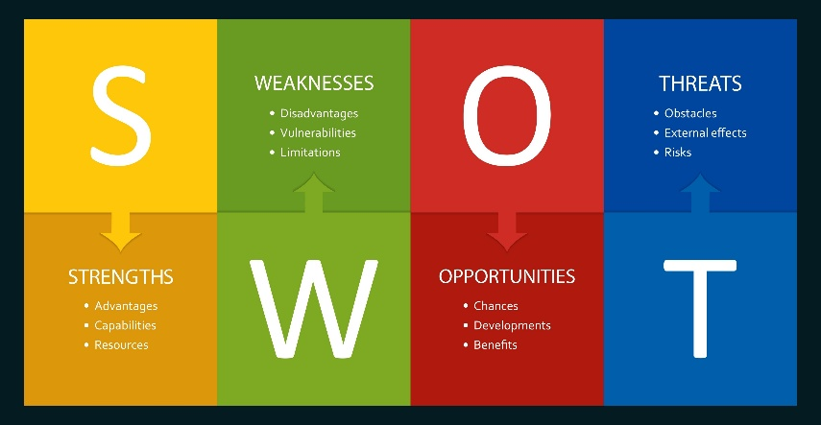
Figure 1: SWOT Factors
Source: Shutterstock

1.2.1 Socio-Cultural Actor: Sustainable and Ethical Consumption
It is evident that the years 2020-2024 witnessed a steeper increase in health and wellness and ethical awareness among the consumers, who are the primary focus of both ASOS and Boohoo, namely, Gen Z and Millennials. This is one of the underlying dangers to the mass production and disposability principle that the fast fashion model operates under (Siegle, 2019; Cotler, 2020).
Impact Area | Opportunities | Threats
Pioneering ASOS | Leverage multi-brand model to showcase sustainable/circular fashion options from third-party sellers (Dangelico et al., 2022). Higher consumer trust allows premium pricing for 'Responsible Edit'/sustainable lines. | Attitude-Behavior Gap for Gen Z (wanting sustainability but buying cheap) still persists, impacting volume sales of costly sustainable lines (Wang et al., 2021).
Follower Boohoo | Utilize vertical integration to quickly pivot and launch large, affordable 'Ready for the Future' collections to capture conscious-yet-price-sensitive buyers (Samsudeen & Kaldeen, 2020). | Significant brand damage due to past ethical sourcing scandals, creating a trust deficit that makes genuine sustainability claims harder to establish with conscious consumers (Monroe, 2021).
Table 1: Socio-Cultural Actor
Critical Analysis: The sustainability demand is an opportunity that both can use to rationalise more sustainable collections at a higher margin. Nevertheless, it poses a more significant risk to Boohoo because of its track record of supply chain problems and the inherent nature of its business model core being ultra-fast in nature to be associated with disposability and unethical labour (Monroe, 2021). Although ASOS is under investigation for its claims, the company has more opportunities to change its image because of the diverse range of products (Cleary Antitrust Watch, 2024).

1.2.2 Legal Actor: Greenwashing and Consumer Protection Laws
The legislative agencies of the world, as spearheaded by the EU and the UK, have escalated the attention on consumer protection and environmental responsibility, and thus, they are rigid in combating misleading green claims, or greenwashing.
Impact Area | Opportunities | Threats
Pioneering ASOS | Develop robust internal standards, establishing a competitive advantage in transparency and compliance ahead of mandatory regulations (e.g., Digital Product Passports, expected EU regulations) (Addleshaw Goddard, 2025). | High-profile investigation by the UK's Competition and Markets Authority (CMA) into its 'Responsible Edit' range creates a public relations and legal compliance risk (CMA, 2024).
Follower Boohoo | Potential to learn from competitor mistakes and immediately implement best-practice compliant labeling, potentially streamlining their sustainability communications from the outset. | The CMA secured formal undertakings from Boohoo (alongside ASOS) in March 2024 to ensure green claims are accurate and clear. Failure to fully implement these changes will result in legal action, representing a direct, measurable threat (CMA, 2024).
Table 2: Legal Actor
Critical Analysis: The regulatory changes (intervention of the CMA in green claims) have transformed ambiguous socio-cultural demands into legal risks. In the case of both companies, the risk of initial non-compliance was outsourced, and both companies had to make expensive changes to operations in order to conform to the obvious legal specifications on claims (CMA, 2024). Nevertheless, the pressure that follows also offers the firm the chance to establish verifiable and compliant transparency first, thus winning back much-needed consumer trust in an industry where trust is direly needed (Priyadarshini & Prasad, 2024). The two organisations now need to spend a lot of money on supply chain traceability and product information systems in order to address the legal and reputational risks of non-compliance.

Task 2

2.1 Strategic Response to Environmental Pressure: ASOS vs. Boohoo
Marketing Strategies for Sustainability and Legal Compliance
Both ASOS (pioneer) and Boohoo (follower) have experienced the critical shift in the 2020-2024 marketing approaches predetermined by the twin pressures of the evolving demand of the fast fashion industry, both Socio-Cultural and Legal, in the context of sustainability and aggressive enforcement of the greenwashing issue (Hitt et al., 2020; Sitepu et al., 2023). Their answers demonstrate opposing strategies to attain competitiveness in the market with the reputation risk.

2.1.1 Strategic Response to Socio-Cultural Pressure (Ethical Consumption)
With the emergence of conscious consumers, especially Gen Z, sustainability and ethically sourced labour should now become part of the value proposition and not a symbolic act (Siegle, 2019).
A. Innovative ASOS: Transparency and Diversification Strategy
- Marketing Strategy: Brand/Product Extension/Repositioning. Circularity and ethical sourcing initiatives were introduced using the multi-brand platform and already existing reputational capital at ASOS.
- Fashion with Integrity Strategy (FWI): ASOS has relaunched its sustainability programme in 2021 with pillars that include Planet, Product and People. Among the main steps were the creation of a circular design collection in 2020 and 2022 and testing the resale/takeback service with such partners as Thrift+ (ASOS, 2024).
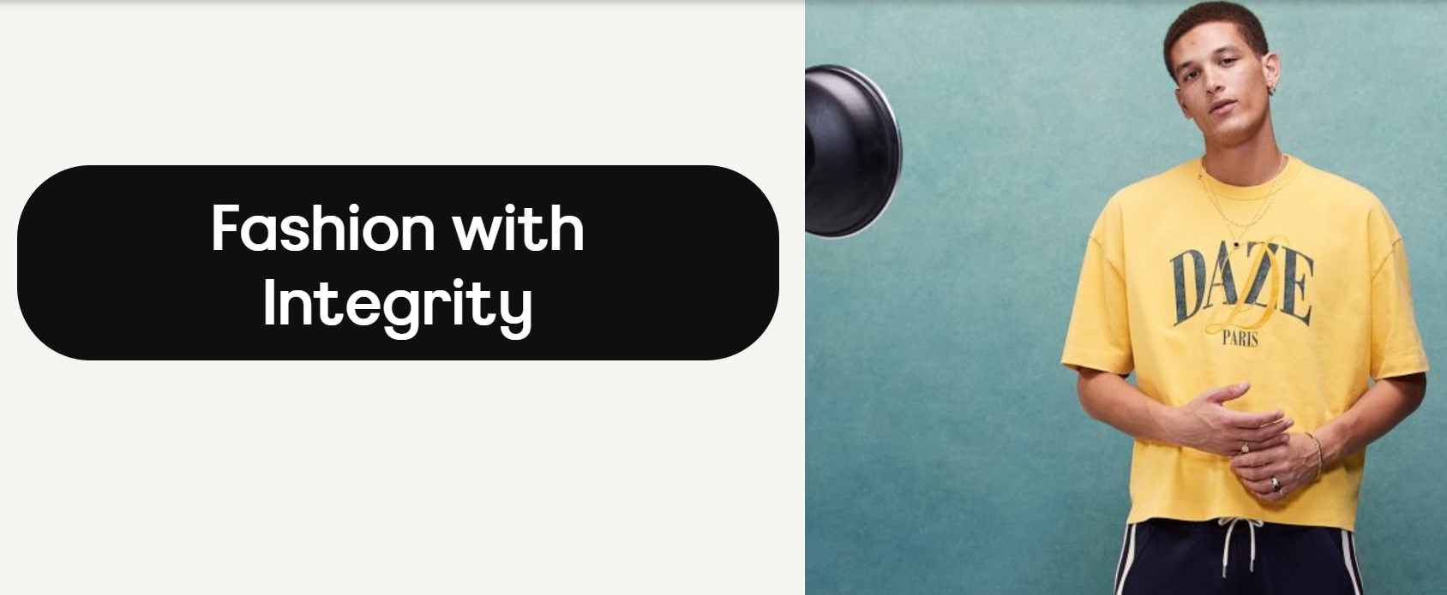
Figure 2:Fashion with Integrity
Source: asosplc
- Competitive Advantage: With the creation of its own products through the use of a circular design and providing a platform on which third-party sustainable brands can be found, ASOS intends to use a differentiation strategy, focusing on consumers ready to spend more on ethical choices (Dangelico et al., 2022). Its messaging is based on its wide-ranging Diversity, Equity, and Inclusion (DEI) initiatives and its environmental goals, as it caters to the socio-cultural values of its target audience, which are holistic (ASOS, 2024).
B. Follower Boohoo: Trust and Vertical Integration Strategy Repair
- Marketing Strategy: Crisis Management and Operational Reform. The first step that Boohoo took after a significant scandal in 2020 (poor working conditions and underpayment in its supply chain in the UK) was based on severe reputation repair (Monroe, 2021; Boohoo, 2021).
- Reform and compliance: Boohoo made changes, inspired by the Alison Levitt QC report, to be more transparent and to have fewer suppliers in its approved list – those who could meet high standards – by applying its vertically integrated model to issue strict new guidelines (Boohoo, 2021).
- Competitive Threat: It still competes on affordable, trend-based fashion, but the lack of ethical ethos is a major challenge. The effectiveness of Boohoo depends on how it is persuading the price-sensitive customers that the "Ready for the Future" collection is a valid ethical decision, which is complicated by the ultra-fast business model and the systemic organisation of the garment industry (Nassar et al., 2023).

2.1.2 Greenwashing Crackdown (Strategic Response to Legal Pressure)
The CMA investigation that was initiated in 2022 and the subsequent formal Undertakings in March 2024 have offered a clear legal template in the law and made the vaguely ethical pressure concrete and enforceable compliance demands (CMA, 2024).
A. ASOS pioneering: Compliance as a Competitive Differentiator
- Marketing Strategy: Transparency of Information and Clarity. The legal risk posed by the CMA compelled ASOS to drop its own ambiguous definition of Responsible edit as well as adhere to making accurate, clear and prominent claims of green (CMA, 2024).
- Operational Integration: ASOS's strategic response includes investing in effective processes and systems that could give clear information about the extent of the environmental impact of its products, which is necessary to not only comply but also align with the upcoming EU regulatory demands (ASOS, 2024).
- Long-Term Positioning: ASOS seeks to establish itself as a credible player in the industry with regard to transparency by meeting the requirements of the CMA, which seek to define the green claims and have verifiable environmental targets that could restore and safeguard brand equity (Cleary Antitrust Watch, 2024).
B. Follower Boohoo: Minimisation of Cost and Risk
- Marketing Strategy: Counter-Attack Compliance. The reaction of Boohoo and the signing of the CMA Undertakings are mostly defensive measures, which are focused on risk mitigation.
- Mandated Changes: Boohoo made a promise similar to ASOS to make sure that these are not misleading green claims, established clear standards of its own “Ready for the Future” collection and correctly presented imagery (CMA, 2024). In the case of a follower brand that is already under scrutiny regarding labour issues, a failure to comply with these particular laws of greenwashing would have been an existential challenge to running its business in the UK market.
- Challenge of Verification: In the case of Boohoo, the challenge is more in the fact that it will have to reform its marketing, as well as the underlying practices of the supply chain, which are the root cause of the ethical and greenwashing risks (Nassar et al., 2023). Although compliance is enforced by the interventions of the CMA, the fact that Boohoo remains committed to low pricing puts a strain on the investment that would lead to real sustainability and sourcing that is ethically sound, which is crucial to remain competitive in the long term in the mindful market.
ASOS and Boohoo have been compelled to position their marketing successfully between the high requirements of the Socio-Cultural (sustainability) and the Legal (greenwashing) macro-environmental actors. These challenges are seen as an opportunity by ASOS to product diversify and brand differentiate in its FWI and circularity programmes in a bid to achieve sustainable and profitable growth. Being bound by the business model and its labour scandals in the past, Boohoo is operating in a more defensive, compliance-focused manner, with operational reforms supporting the continued presence in the market and reputation reconstruction. The key defining factor of competitiveness will be the ability to incorporate transparency into their digital-first marketing models (CMA, 2024).

Conclusion
In conclusion, the strategic analysis ensures the superiority of the competitive environment of fast fashion, as the macromarketing environment, including the simultaneous pressure of socio-cultural demand for environmentally friendly practices and legal compliance with greenwashing, prohibits it from being a major force. ASOS and Boohoo have had to revise their marketing models: the former by diversifying and being open to maintain its high-end status and the latter by implementing defensive changes in its operations to win back its customers and enter the market again. Finally, the strategic responsiveness of the two companies will determine their future success in converting the legal compliance requirements into the actual verifiable ethical behaviour that corresponds with the changing consumer values.

Reference
Majekodunmi, S.A. & Ahmed, O.A. (2024) ‘Strategic overview of macro-environment of business: Insight from PESTL analysis’, FUTA Journal of Management and Technology, 3(1), pp. 241-250. Available at: https://journals.futa.edu.ng/papers/paper_6_1737642382.pdf (Accessed: 20 November 2025).
Pinca JM, Labausa FS, and Cruda NE. (2024). Influence of digital marketing strategies on purchase intention, Can. J. Bus. Inf. Stud., 6(3), 73-90. Available at: https://doi.org/10.34104/cjbis.024.073090
Retail sector in the UK - UK Parliament Available at: https://researchbriefings.files.parliament.uk/documents/SN06186/SN06186.pdf
Fashion greenwashing: investigation into ASOS, Boohoo and Asda - GOV.UK Available at: https://www.gov.uk/cma-cases/asos-boohoo-and-asda-greenwashing-investigation
EU & UK: 5 Key legal sustainability developments for the fashion industry - Addleshaw Goddard Available at: https://www.addleshawgoddard.com/en/insights/insights-briefings/2025/financial-regulation/eu-uk-5-key-legal-sustainability-developments-fashion-industry/
Das, S., Karmakar, S., Olubiyi, T. & Behera, S. (2025). The Social and Environmental Impact of Fast Fashion, pp. 311–330. Available at: doi:10.4018/979-8-3693-7853-3.ch012.
Ultra fast-fashion is eating the world - The Atlantic Available at: https://www.theatlantic.com/ideas/archive/2021/02/ultra-fast-fashion-eating-world/617992/
Fashion greenwashing: investigation into ASOS, Boohoo and Asda - GOV.UK Available at: https://www.gov.uk/cma-cases/asos-boohoo-and-asda-greenwashing-investigation
Fashion with Integrity | ASOS plc. Available at: https://www.asosplc.com/fashion-with-integrity/
Boohoo: New Governance Rules for Suppliers - Bridgehouse Company Secretaries Available at: https://bridgehousecs.co.uk/fashion-retailer-boohoo-asserts-new-corporate-governance-rules-for-suppliers-after-hitting-the-headlines-for-a-major-supply-chain-failure/
Nassar, M., Goddard, T. & Freeman, R. (2023). Walk the Talk: The Boohoo Case Study. Journal of Macromarketing, 43, pp. 027614672311649. Available at: doi:10.1177/02761467231164960.

