

LOCATION: Swansea | LLEOLIAD: abertawe
LEVEL 7 | LEFEL 7
EXAMINATION PERIOD | CYFNOD ARHOLIADAU
jANUARY 2023 | IONAWR 2023

MODULE CODE: ACCA7029
COD Y MODWL: ACCA7029
ENTERPRISE CORE NETWORKING
TIME
3 HOURS (including uploading all the work on Moodle)

answer ALL quESTIONs

Equipment or materials required – None
Adnoddau neu ddefnyddiau sydd eu hangen - Dim

ANSWER ALL QUESTIONS

- With a use of a simple topology/ suitable diagram, explain in detail about
  - CEF switching. Discuss the advantages of CEF with other switching process. (13 marks)

  - STP operations and port roles. (12 marks)

- Briefly explain with appropriate topology/ diagram
  - OSPF Neighbor States. (5 marks)

  - BGP Path Attributes (5 marks)

- Refer to the output below from Router A (5 Marks)

Clock is synchronized, stratum 10, reference is 127.127.1.1
nominal freq is 250.0000 Hz, actual freq is 250.0000 Hz, precision is 2**10
ntp uptime is 2500 (1/100 of seconds), resolution is 4000
reference time is E1D080F7.F6041B38 (14:41:43.961 EST Mon Jan 20 2020)
clock offset is 0.0000 msec, root delay is 0.00 msec
root dispersion is 3939.38 msec, peer dispersion is 3938.29 msec
loopfilter state is 'CTRL' (Normal Controlled Loop), drift is 0.000000000 s/s
system poll interval is 16, last update was 9 sec ago.

  - What is the command to get the above output? (1 Mark)
From the above output,
  - The reference is 127.127.1.1. Why? (2 Marks)
  - What other Information do you gather? (2 Marks)

- Refer to the topology (10 Marks)
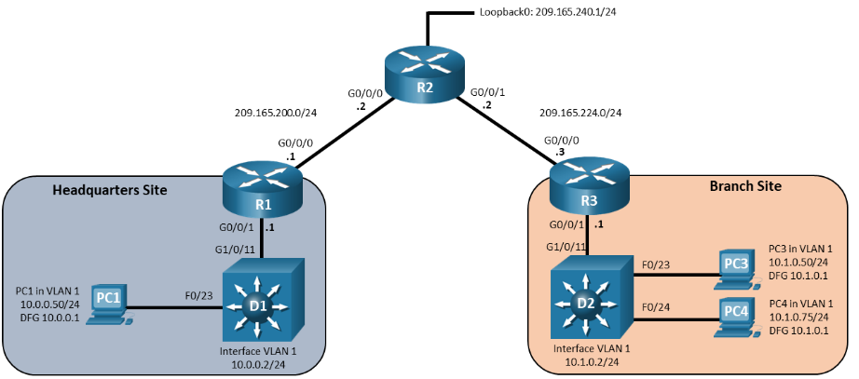

R1#
Pro Inside global Inside local Outside local Outside global
--- 209.165.200.99 10.0.0.2 --- ---
icmp 209.165.200.99:0 10.0.0.2:0 209.165.200.2:0 209.165.200.2:0
  - What is the command to get the above output? (1 Mark)

From the above output,
  - What information do you gather from this output? (4 Marks) (Refer to the topology and answer appropriately)

  - On R1, specify the inside and outside interfaces for NAT purposes. (1 Mark)

The below output is from D1.
D1#
TCB Local Address Foreign Address (state)
054D9734 10.0.0.2.23 209.165.200.2.63955 ESTAB

  - What is the command to get the above output? (1 Mark)
  - What information do you gather from this? (3 Marks)

- Design a Topology with adequate and appropriate network documentation: (50 marks)

“Mystery Incorporated” is having offices at 3 different cities in the UK. They are planning to merge all their locations and bring it under one network. You have been hired as an IT Infrastructure consultant. Your task is to lead and work with the IT&S team to successfully complete this migration.

The key objectives of this migration are design and implement:
    - Secure scalable network
    - Network management
    - High Availability
    - Support Digital Transformation

Your answer should include

- Topology (Use Packet Tracer to create a Topology) (10 Marks)
- Elaborate and justify (40 Marks)
  - How the proposed topology is scalable? (10 Marks)
  - What are the network management devices and configurations recommended/ implemented? (Note: You need not write the commands to configure. Justify the importance of network management, the devices required and their protocols) (10 Marks)
  - What are the security aspects recommended/ implemented? (10 Marks)
  - Discuss the importance of High Availability network and how does your design support High Availability for “Mystery Incorporated” network? (10 Marks)

Diwedd/End

