A strategic analysis of BIOCON India


Report
PRESENTED TO THE BUSINESS SCHOOL OF THE UNIVERISTY OF WALES TRINITY SAINT DAVID, LONDON CAMPUS IN PARTUAL FULFILMENT OF THE REQUIREMENTS FOR THE DEGREE OF MASTER OF BUSINESS ADMINSTRATION (MBA) FOR THE MODULE:
Strategic Management
LCMB7003

University of Wales Trinity Saint David



SUBMITTED BY
MANAL ABDEL KHALEQ (1920273)

Lecturer: Dr Gladius David Kulothungan, Course: MBA 2020/2021

Table of Content
I. Introduction

II. Company Background

III. External Analysis
1. Industry Life Cycle
2. Macro-Environment: The PESTLE Factors related BIOCON India
3. Industry structure analysis through Porter's 5 Forces
a. Industry Rivalry
b. Threats of New Entrants
b. Bargaining Power of Suppliers
c. Bargaining Power of Buyers
d. Threat of Substitute Products or Services

IV. Internal Analysis
1. SWOT Analysis
2. Ansoff Matrix
3. Porter's Generic Strategy Model
4. Resources and Capabilities Analysis
a. Resource-Based View Theory
b. VRIO Framework
5. McKinsey's 7s Framework
6. BIONCON India's strategies to sustain competitive advantage and conclusive observations

V. Recommendations

I. Introduction
Opinions in literature differ on the definition of strategy, but most can agree that it is the ability of firms to survive and succeed in the market (Barney and Hesterly,2019). Scholars argue that an organisation's strategy constitutes the theory of how to gain and sustain competitive advantage by assessing the purpose of the organisation, outlining its objectives, utilising strategic tools, and implementing them in the 'rational process of decision-making ' (cf.Faulker and Campbell,2003;Barney and Hesterly,2019). Nowadays, the obsolete practice of secret strategies à la Fred Borch is replaced by the contemporary notion of an opening strategy which could rise from any level and any department of the organisation given the fact that openness and transparency of strategy management serve all stakeholders (cf. Whittington,2019).
This report examines Biocon India's (hereinafter Biocon) strategic management choices in the shape of theories and models the firm implemented to overcome macro-environmental and micro-environmental hurdles to gain competitive advantage. First, the company's background will be presented including the mission and vision of the company. Subsequently, an external analysis will be concluded on closer examination of the industry life cycle analysis, the PESTEL analysis, and Porter's Five Forces followed by the internal analysis, including the SWOT analysis, Porter's Generic Strategy Model, and Mc Kinsey's 7s Framework. With the Resources and Capabilities Analysis, it will be assessed how and which resources and capabilities Biocon exploited to succeed in the market and/or neutralized rivals.

II. Company Background
The history of the Biocon India Group dates back to 1978 when an exceptional woman, named Kiran Mazumdar-Shaw broke with Indian traditions when she founded the company as a joint venture with Biocon Biochemicals Ltd. Ireland (Biocon-Legacy,2020). The initial business began with three employees in a shed in Koramangala, India with manufacturing and exporting plan enzymes, both essential products for the brewing industry (Independent,2004). Today, the company's business comprises 'the whole drug value chain', including the manufacturing of generics and biosimilars, and providing research services and novel biologic research'. Biocon is an international company with its headquarters in Bangalore, India and revenue of 65,29 billion INR (890,5 million USD) in 2020 operating in more than 120 countries employing more than 12000 people (Biocon-Factsheet,2020). The Biocon Group companies comprise inter alia Syngene, Biocon Research, Biocon Biopharmaceuticals, NeoBiocon, and Axicorp Pharma (cf. Biocon,2010). The subsidiary Clinigene is not mentioned as Biocon subsidiary at the current time on the firm's website (2020). Clinigene's previous website address leads to the Syngene homepage which reveals that clinical trials phase I-IV are part of Syngene's service portfolio now (Syngene,Clinical-Trial-Management,2020). Biocon's key brands include, INSUGEN, Basalog One, CANMAb™ (Trastuzumab), KRABEVA (Bevacizumab), BIOMAb-EGFR® (Nimotuzumab) and ALZUMAb™ (Itolizumab)(Biocon-Factsheet,2020).According to the annual report (2020) the business units of company contributes as follows to the revenue: small molecules,31%; biologics,29%; research services,30%; branded formulations,8%. (Biocon-AnnualReport). On the first day of listing in the stock market in March 2004, the company closed with a market value of USD 1.11 billion (Biocon-Legacy,2020); the company's stock is currently priced at 471,97 INR (USD 6,47;as of 18.12.2020)(cf.Marketwatch,n.d.). The company's objective is to provide 'high-quality and affordable healthcare products and services driven by the belief that everyone, everywhere deserves access to affordable, quality medicines' (Biocon-Factsheet,2020). This is reflected in the vision statement comprising the aim 'to enhance global healthcare through innovative and affordable, biopharmaceuticals for patients, partners and healthcare systems across the globe' (Biocon-Annual Report,2020). Biocon's mission states: 'To be an integrated biotechnology enterprise of global distinction' (Bicon-Factsheet,2020).

III. External Anaylsis
1. The Industry Life Cycle Model
The industry life cycle model reflects various stages organisation passing through within an industry (CPI,2015). The model is a well-accepted tool to analyse sectors' attractiveness, growth, and average return since it comprises the analysis of the sector structure, (Porter,1980a) and behavioural results of companies competing in the same industry (Maylin-Aguilar and Montoro-Sanchez,2020). The four evolutionary stages comprise the introduction, growth, maturity, and decline phases (Wohlner,2020). Noteworthy, the length of each stage varies from industry to industry and refers to industries manufacturing goods or offer services (Wohlner,2020). The life cycle starts with the introduction or startup stage constituting the early development of new products and services followed by the stage of fast-paced growth in which major market players emerge (Wohlner,2020). The maturity stage starts with a shake-out period in which growth downshifts. Companies focus on the reduction of expenses and aiming at profitability, market share, and cash flow to survive in the maturity stage where some companies may utilise the economies of scale impeding the survival of smaller firms (Johnson,et.al.2008,Wohlner,2020). In the maturity phase the barriers to entry in the market increase as well as price competition (Wohlner,2020).The decline stage follows reflecting the lack of ability of the industry to support growth. Revenues decline due to a decrease of demand forcing weaker firms to exit the industry and the industry consists of a few remaining competitors (Maylin-Aguilar and Montoro-Sanchez,2020).
Due to the Covid-19 pandemic and its impact on the global economy most industries with little exception find themselves in the decline stage. The pharmaceutical industry, however, has been hit relatively mild by the economic crisis as elaborated below in the PESTEL analysis. It can be argued that the pharmaceutical industry is situated in the maturity stage with a tendency to the decline phase given the relevance of biopharmaceutical and biotechnological companies contributing to the address the health crisis (cf.Figure 1).

Figure1: Industry Life Cycle Pharmaceutical Industry (cf. Gruber,C.,2012)
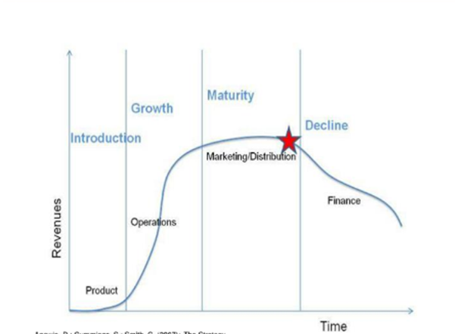

2. Micro-Environment examination through PESTEL Analysis
Figure 2 PESTEL Analysis (Oxford College of Marketing,n.d.)
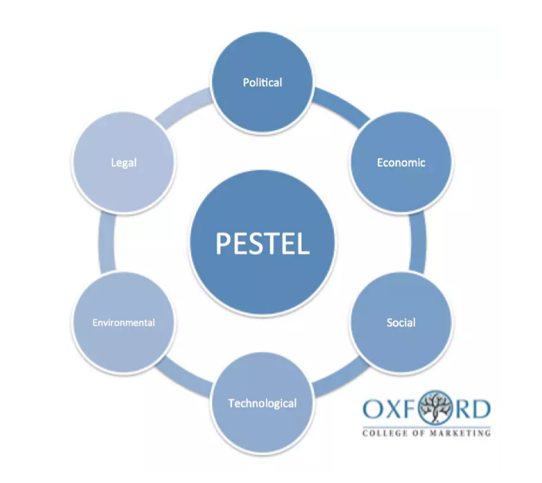

Companies do not operate in a vacuum but are influenced by external factors that could have either a favourable or unfavourable effect on their capability to operate effectively, profitably, and ultimately competitively. Macro-environmental forces comprised in the PESTEL analysis, (which constitutes an acronym for Political, Economic, Socio-cultural, Technological, Environmental/Ecological and Legal) self-evidently not only affect a specific company but all organisations operating in the macro-environment (cf.Jobber and Ellis-Chadwick,2016).
The external factors affecting Biocon India on basis of the PESTEL analysis (outlined in Figure 2), will be examined on grounds of whether they constituted threats or opportunities for the company and particularly illustrate how the firm was able to gain and sustain competitive advantage through utilising macro-environmental opportunities or handling threats, respectively. The results of the PESTEL analysis will serve as a foundation to 'populate the opportunities and threats' in the following SWOT analysis of Biocon's present case study (cf.Hollensen,2019).
- Political-Legal Forces
Political and legal forces can intersect since political approaches and attitudes usually become binding rules and regulations (cf. Hollensen,2019).
The pharmaceutical industry was primarily rooted in Germany and Switzerland and spread to other Western countries, particularly to the US with the large-scale production of penicillin during World War II (Rezaie,2012). The latter had led to multinational corporations (MNCs) (Rezaie,2012) which dominated the Indian market. Antagonistically, the Indian government established two local drug manufacturers to take their share of the local market (cf.Kalegaonkar,et.al,2008). This political approach created a cornerstone to further the emergence of the biopharmaceutical and pharmaceutical industry in India underlined through two regulations enacted by the Indian governments in 1970, namely the India Patent Act (IPA) and the Drug Price Control Order (DPCO) (cf.Kalegaonkar,et.al,2008). The political-legal impact of the pharmaceutical industry through this legislation led to a price regulation authority through the Indian government of drugs sold within the Indian market and the opportunity for domestic pharmaceutical companies to reproduce drugs without any penalty. These measures not only propelled the annual growth of the domestic market by approximately 15% but also increased the export market by 21 % in the next decades up until 2001 (Kalegaonkar,et.al,2008). On basis of the immense growth potential of the industry, the Indian government took further measures to provide external and internal supports in the field of research and development (R&D), and biotech facilities enhancing the industry's progression (Kalegaonkar,et.al,2008). Furthermore, the Department of Biotechnology was established in 1986 by the federal government as a subordinate department of the Ministry of Science and Technology to set the political-legal framework to support the prosperous industry, but also State measures, such as the construction of biotech parks by the Indian State Karnataka, lease obligations for biotech park residents and easing taxes intended the enhancement of the biopharmaceutical industry in India. The political-legal forces in that framework created opportunities for organisations to thrive in the industry field.
Besides these aforementioned political-legal forces which created opportunities, particularly in the Indian biotech/pharmaceutical market, increasing examination in drug verification processes of global regulatory agencies such as the US Food and Drug Administration (FDA), the European Medicine Agency (EMA), and the UK Medicines and Healthcare products Regulatory Agency (MHRA) are raising the bar for regulatory affairs and hence constituting a challenge for companies operating in this industry (cf.Bhadoria and Arora,2017). This is reflected by a 200% increased number of 'product recalls, import alerts, warning letters and non-compliance observation of exporting companies' in the period from 2012-2017 (cf.Bhadoria and Arora,2017).
Another major external factor influencing the biotech/biopharmaceutical and pharmaceutical market includes patents. Patents constitute a property right for technical or chemical inventions 'granted by a sovereign authority to the inventor' to exclusively utilise the invention commercially for a specific period of time while others are prohibited from imitating the invention (cf. Kenton,2020;IGE,n.d.). Patents can also be licenced or sold and comprise an intangible asset of a company (IGE,n.d.).
These aforementioned political-legal forces impacted Biocon's strategy as the company utilised government sources, besides financial sources from banks, venture capital funding, and internal financial sources to expand its business. In 1997 the company started to capitalise on the generic statins market when it launched Lovastatin in Canada, Mexico, Eastern Europe and Southeast Asia due to the expiration of the patent. As the first Indian company to receive an ISO 9001 certification from the German technical inspection association RWTUV in 1993 and the first company worldwide to be approved by the US FDA to sell Lovastatin API through solid-state fermentation technology in Mexico, Eastern Europe, and Southeast Asia (cf.Kalegaonkar,2020). After the patent of Merck expired, Biocon capitalised on the opportunity to market Lovastatin in all countries (cf.Kalegaonkar et.al,2008). Biocon emphasised its effort to comply with international regulations and the venture with local companies such as 2002 with Cuban biotechnology company CIMAB S.A or the collaboration between Pacific Biomarkers and Clinigene in 2011 (PBI,2011). facilitating the adherence to local rules and regulations and paved the way for Biocon to become one of the major players in the world market of biopharmaceutical organisations. Consequently, its strategic decision enabled the company to overcome unfavourable and utilise favourable political-legal forces.

- Economic Forces
The Covid-19 pandemic impacted the global economy in various ways, including the labour market with high unemployment rates and implications on the household's purchasing power (cf.Hollensen,2019,GlobalDataHealthcare,2020). Of all global recessions since 1990 the Covid-19 recession led to the 'fastest, steepest, downgrades in consensus growth projections' (Worldbank,2020) as illustrated in Figure 3. Besides the historic decrease of the GDP the per capita income, it is expected to plunge 7 %, for advanced economies, 2,5 % for emerging market and development economies (The Worldbank,2020). It must be stated, that the prognosis is being hampered because the full impact of the worldwide economic crisis is still uncertain due to the ongoing circumstances of the pandemic.

Figure 3: 'Conesus Forecast of the Global GDP in percent (The Worldbank,2020).
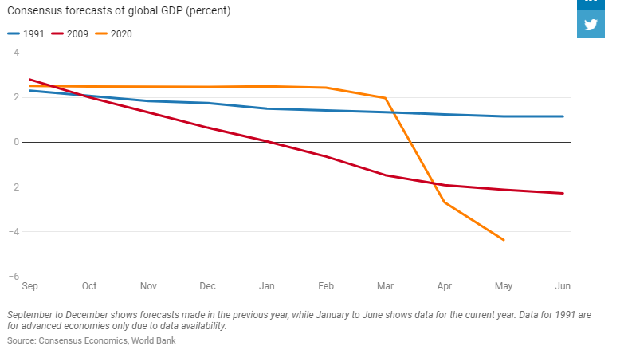

According to annual reports and stock exchanges of the top 20 global players in the pharmaceutical industry in the first quarter of 2020 it must be stated, that Covid-19 implications have been qualified as relatively 'mild' for the industry as Figure 4 demonstrates. New pharmaceutical and biotech innovations including vaccines, medical devices, and drugs for the treatment of Covid-19 brought the industry to the centre of attention of the pandemic (GlobalDataHealthcare,2020).

Figure 4, 'Top 20 Innovative Pharmaceutical Companies by Market Cap as of March 2020 (GlobalData,2020)
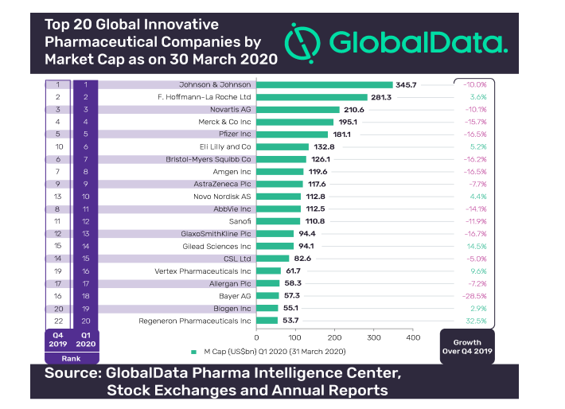

The increasing pressure of the pharmaceutical industry with a clear trend of tremendous price competition on drugs led to a shift of growth towards emerging markets (Bhadoria and Arora,2017). With the UNESCO Science Report 2010 and further scholarly analysis, a trend of economic growth and innovation due to increased R&D in emerging markets including China, Brazil, India, and South Africa has been witnessed (Rezaie et.al.,2012). The optimistic economic growth forecast of the biopharmaceutical industry in emerging markets including India must be put in perspective of the pandemic. India's (bio-)pharmaceutical industry, however, will play a special role to meet the global and domestic supply of generics and medical products in general within this health crisis. In volume terms India is the world's third-largest producer of pharmaceuticals and delivers 60% of the global vaccine demand (cf.Biocon,AnnualReport,2020). According to the Indian 'Department of Pharmaceuticals, India has exported biologicals and formulations amounting to 19 billion USD in 2018/2019 providing 200 countries with 20% of the world supply which comprises 77% of the total Indian exports(Guerin et.al.,2020). Due to the pandemic the Indian pharmaceutical supply chain is already interrupted with no end in sight (Guerin, et.al.2020). The industry's domestic revenue in 2019 amount to USD 38 billion including the domestic supply for 1,3 inhabitants (Indian Pharmaceutical Alliance,2019). According to Biocon's Annual Report, the global effects of Covid-19 on the pharmaceutical industry have not failed to leave their mark on parts of Biocon's businesses. However, the company 'reinforced its reputation of resilience and reliability by continuing to supply life-saving therapies worldwide despite lockdowns and other production and supply chain disruption due to COVID-19' (Biocon,AnnualReport,2020). The company implanted measures accordingly to sustain effective business process with a continuity plan which enabled 'essential manufacturing and quality operation with reduced staffing' with the health and safety rules and policies in place protecting partners, patients, and employees in the company facilities (cf.Biocon,AnnualReport,2020). Biocon's strategy as a response to the crisis resulted in a 'robust growth' of 15% in the fiscal year (FY) 2020 (cf.Biocon,Annual-Report,2020).
Consequently, the recent health crisis has been challenging and unfavourable for Biocon, yet the company is innovative to meet the changing demand of the market to maintain and sustain its competitive advantage on basis of the company's strong R&D department as further explained in the framework of the technological forces of the PESTEL analysis.
The economic climate has been changed over the past decades with a strong economy in the 1990s and recessions in 2001 (technology bubble-burst) and the global financial crisis in 2008, with an ongoing recession due to the health crisis with a not yet determined scope. Since its establishment Biocon has capitalised on opportunities created by economic forces as mentioned above. Additionally, the favourable economic framework the Indian labour market provided was utilised by the firm when it founded its subsidiary Clinigene in 2001, a company that offers clinical trials (cf. PBI,2011). The annual human resource expenses of highly-skilled and educated scientists on a Ph.D. level are 15.000 USD p.a. on average and thus almost one-sixth less than an equivalent workforce in the U.S. (Kalegaonkar,2020). This diversification strategy was implemented one year before the recession and could be classified as an opportunity to fight the threat the price pressure imposed on the industry. Moreover, it met the demand of the pharmaceutical market to outsource clinical trials to achieve cost-efficiency.
In the 1980s Biocon's scientists developed knowledge of Japanese fermentation factories to establish a pilot plant in 1989 which lead to Biocon's early success (Kalegaonkar,et.al.2008). The fermentation market was dominated by the Japanese at that time and the economic situation of India in 1988-1989 was not only stable but was classified as 'exceptionally well' with a gross domestic product (GDP) growth of almost 10% compared to the average years of 5,4% (Gupta and Mathai,1989). The steadiness of India's economy at that time and the fact that fermentation processes were merely dominated by the Japanese market were favourable for Biocon to capitalise on that market and to built on the investments of its R&D team and its success to expand the production with a second plant in 1995.
In early 2000 the aforementioned tight price competition in the industry led to the cost-efficient 'economic' trend of global pharmaceutical companies to outsource clinical trials, including R&D, clinical trials, and manufacturing of the tested drug (cf. Kalegaonkar,et.al.,2008). With Clinigene, Biocon utilised the economic situation which might have been fuelled its success due to two economic crises (2001 and 2008).
- Socio-demographic Forces
Socio-demographic factors reflect emerging trends and the demographic development of the market in which the company operates, including population size, growth trends, age, gender, marital status, income, ethnicity, cultural trends, attitude changes, and lifestyle changes (Hollensen,2019;Barney and Hesterly,2019).
Biocon's major commercial operation occurs in the business-to-business (b2b) sector so the demand for drugs due to demographic changes in sense of cultural trends implicate Biocon indirectly. Given the fact, that consumers have no freedom of choice when it comes to prescription drugs (see elaboration below in the framework of Porter's 5 Forces analysis) trends will also not be considerable tangent to Biocon's business-to-consumer transaction. On the other hand, an immediate effect of these external forces must be acknowledged given the fact that the company is researching biopharmaceutical to fight diseases that increased due to the demographic changes and cultural trends, for example, diabetes which increases due to the rising age of people in the society and higher sugar consumption. The latter can be considered as favourable for Biocon. In the framework of the b2b subsidiary firm Syngene the demographic structure of India regarding its ethnicity created a favourable business opportunity that Biocon capitalised on. The diverse ethnicity that India's population provides enables clinical trials with diversified ethnic genetic structures (Kalegaonkar et.al.,2008). The balanced group for clinical studies consequently leads to a wide client base as the research findings could exemplary applied to diverse populations suitable for global adaptability.
In this context, it is worth mentioning, that there are two essential uncertain drivers for change in bioscience identified in the Wharton research studies conducted in 2006: 'technological advance and public acceptance (Johnson et.al.,2008). The public opinion on technological development, including stem cell therapy, cloning, and regenerative medicine depend severely on cultural factors. The researchers found four different scenarios that might reflect the reaction of the public. Particularly challenging for companies operating in this industry may be the two scenarios where the public rejects technological failure or success, for example, companies and the entire bioscience/pharmaceutical industry may provoke scepticism and disappointment in the public view when they could not deliver the hoped cures for diseases. On the other hand, in cases where the technology succeeds the potential reaction could frighten people and lead to ethical and safety reservations (Johnson et.al.,2008). The dismissive view could constitute a threat to the future of bioscience and the company operating in this market.

- Technological Forces
Rapid technological changes through innovations have shaped the 20th and 21st-century creating threats and opportunities simultaneously, while organisations utilise innovative technology to create new products or offer unprecedented service, it constitutes a threat for rivals as new technology lead to a competitive advantage of the innovator forcing rivals to alter their strategies regarding the applied technology (cf. Barney and Hesterly,2019).
On the one hand, technological innovations are considered essential for companies in the biopharmaceutical industry to gain and maintain competitive advantage due to tight competition, at the same time, technological changes are particularly valuable to innovate new treatments and prevention of diseases (Barney and Hesterly,2019)
From the outset, Biocon's course of action was to focus on technological innovations and development which led to the establishment of an R&D division in 1984 driving the development of enzyme fermentation technology which was scaled up in 1990 within its new subsidiary Biochemizyme culminated in a unique patented fermentation reactor named PlaFractor in 2000 (cf.Biocon,2020). Biocon has been a pioneer with this technological innovation and built on its capability and resources to diversify in the biopharmaceutical market when the company launched Lovastatin in 1997 for the first time (Kalegaonkar et.al.,2008). Its reputation as a pioneer in technology was underlined in 2004 when Biocon 'commercialised generic recombinant human insulin which was developed on its proprietary fermentation technology' as the first company in the world (Biocon-Investor Presentation,2017). Currently, Biocon promotes its applied technology as 'state-of-the-art utilised for example, in the manufacturing facilities of Biocon Biologics which are certified by regulatory agencies including US, Europe, India, Japan, Brazil, Mexico, South Africa, Turkey, Russia, Malaysia, South Korea, and Australia (Biocon-Biosimilars,2020). According to the company, it has made considerable investments to implement diverse technology platforms in its manufacturing facilities comprising insulin analogs, monoclonal antibodies, and other recombinant proteins (Biocon-Biosimilars,2020).
The latest technological innovation in the biopharmaceutical industry encompasses the digitalisation of processes such as 'artificial intelligence (AI), data mining and big data technologies, data-driven diagnostics, and digital health' (Buvailo,2020b). In its annual report (2020) Biocon has addressed this technological progress and emphasised its manifesto seeking to 'leverage differentiated technologies to transform healthcare by ensuring access to affordable, quality-assured, complex therapies that significantly improve patient outcomes and are available to all' (Biocon-Annual Report,2020)

- Environmental forces
These forces refer to the influence of the ecological environment and increasingly move the focus on Corporate Sustainability Responsibility (CSR) as part of the overall business strategy, particularly concerning climate change, global warming, air, and marine pollution, and sustainability (cf. Hollensen,2019).
Biocon emphasis its measures it is taking to achieve environmental protection and a sustainable community (Biocon-Sustainability,2020). In the context of an 'environment, occupational health, safety & sustainability policy' the company lays down specific initiatives how to achieve CSR, inter alia to go above the compliance of laws, regulations, and requirements in the country it operates in and to implement energy conservation, and prevention of pollution at all levels of its operations (Biocon-EHHS,2019). Measures implemented by Biocon aimed at sustaining a 'healthy planet' through a reduction of the company's carbon footprint, including the utilisation of renewable energy (solar power and wind power), optimisation of the consumption of energy, minimisation of waste, effective water treatment (purification and recycling wastewater),etc. Biocon is benchmarking its environmental and sustainability initiatives through the Carbon Disclosure Project (an international non-profit organisation supporting companies, investors, and public entities to manage their environmental impacts) underlining the company's credibility (cf.Biocon-Sustainability,2020). The company's effort on environmental sustainability has been domestically rewarded, for example with the 'Govt. of Karnataka, State Level Safety Award for EHS best Practices' in 2020, and the 'National Safety Council 'Unnatha Suraksha Puraskara' Award (Bicon-Sustainability,2020).
3. Industry Structure Analysis through the five forces framework
Figure 5: Porter'5 Forces Analysis of BICON India

a. Industry Rivalry
In order to understand the attractiveness of a specific industry, Porter's Five Forces model serves as a helpful tool to examine potential external threats and present rivals (cf.Johnson,et.al.,2020).
The biopharmaceutical industry has developed rapidly over the past decades. When it comes to new approvals and new fields of application, biotechnologically manufactured drugs are at the forefront (Hülser2017). Various trends such as the manufacture of biosimilars have led to a veritable boom and new production facilities in recent years (Hülser,2017).The biopharmaceutical market size is 239,8 billion in 2019 with a Compound Annual Growth Rate (CAGR) forecast period 2020-2025 of 13,28% (IndustryARC,2020). To analyse the competitors of biopharmaceutical/Biotech companies it is essential to illustrate the differences between the biopharmaceutical field and the pharmaceutical industry. The former definition from 2015 determining that biopharmaceutical drugs are manufactured on a biological basis while pharmaceutical companies produce drugs on a chemical basis may be considered obsolete in a contemporary framework (Terry,2016). In science, however, the conception of bio-pharmacy is considerably complex and lacking a unified definition (cf. Langer and Mehnert,2019). It is considered that bio-pharmacy is an integral part of pharmaceutical technology (Langer and Mehnert,2019). Consequently, it could be concluded the biopharmaceutical industry constitutes a subset of the pharmaceutical industry (Husson,2019). Biocon's global competitors in the narrow scope of biotech/biopharmaceutical companies are inter alia: Gilead Sciences, Amen, Samsung Biologics, Genentech, Roche, Biogen, and Sanofi (Hamilton,2020). Market experts predict, that segments and sub-segments of the biopharmaceutical industry with the focus on oncology, autoimmune diseases will constitute the 'dominant indication' for the next five year period (2021-2026, cf. IMARC,2020). All these biopharmaceutical areas are covered by Biocon's portfolio and objects of its R&D (Biocon,AnnualReport,2020). The predicted geographical development of the industry is demonstrated in Figure 6 which illustrates a clear increase of market shares in the Asia-Pacific due to the emerge of biopharmaceutical innovations from Chinese, Indian, Brazilian, and South African companies (Rezaie,2012). To determine the competitive environment of Biocon as a biopharmaceutical company, it is essential to consider the entire pharmaceutical industry, rather than a too narrow view of the biopharmaceutical/biotech field of operation. By virtue of the increased intertwined sectors of biotechnology, biopharmaceutical, and pharmaceutical firms through mergers and acquisitions and overlapping activities, it must be stated that the entire sector encompasses the competitive environment of Biocon (cf. Rezaie, 2012). The companies dominating the pharmaceutical market by revenue in 2019 are inter alia: Pfizer, Roche, Sanofi, Johnsan&Johnson, Merck, Novartis, and GlaxoSmithKline. The global revenue of the pharmaceutical market in 2019 amounts to 1,25 trillion USD (Mikulic,2020). Biocon belongs to the top five biopharmaceutical companies in India (cf.Pharmatutor,2020) and must be considered as a major player in the Indian pharmaceutical market.
Figure 6: 'Global Pharmaceuticals Market 2023 (Navadhi,2019)
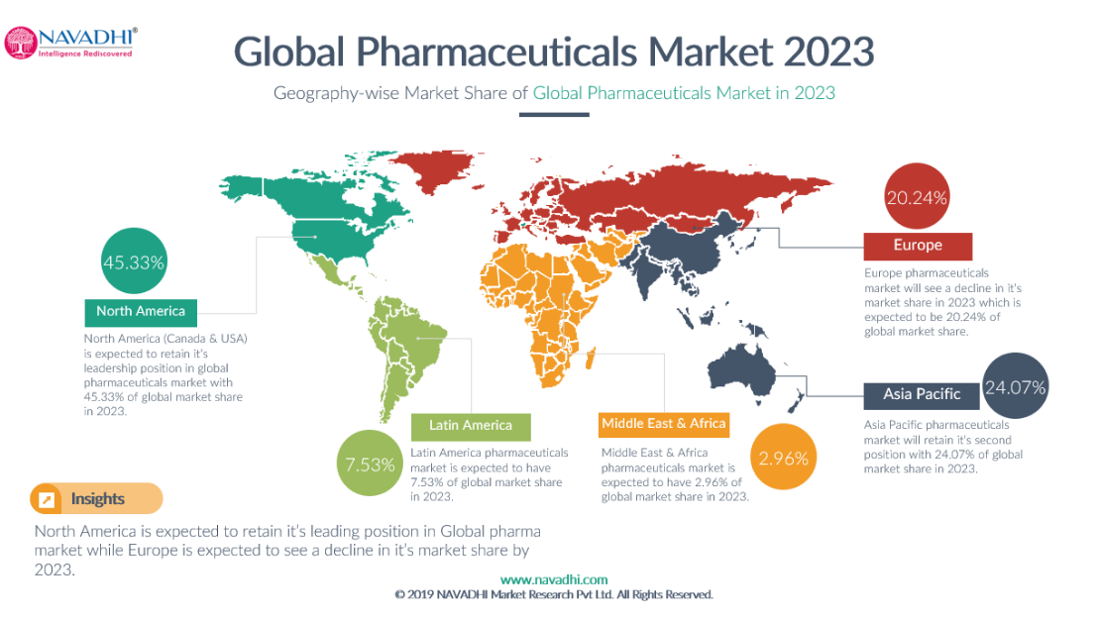
The strategy of Biocon implemented to enter the biopharmaceutical market can be observed at many innovators emerging in the biopharmaceutical market by initially offering non-novel-products or services which do not require a high-technology formulation to established firms in a contractual framework cf. Rezaie et.al.,2018). Particularly, Biocon's enzyme production for Unilever as a parent organisation of Biocon Ireland underlines this strategy. Furthermore, the development of generics after patents expired reveals a specific strategy many entrepreneurs in emerging economies (such as China, Brazil, South African, and India) implemented before venturing into more sophisticated fields as technological expertise increases in time and experiences in health product manufacturing and marketing developed (cf. Rezaie et.al.,2018). This strategy is particularly reflected in Biocon's unofficial philosophy 'earn as you learn' (cf. Biocon-Case-Study,2008). However, with 16 subsidiaries and a joint venture, Biocon was able to assert itself in the Indian and global market in identifying trends early, for example through its subsidiary Syngene as a contract research organization (CRO) providing an outsourced research and development service for its clients as the first CRO company in the Indian market.
b. Threat of New Entrants
Biocon and its subsidiaries Syngene and Clingene offer services and products which involve specific expertise, high costs of R&D, and high expenses for resources, including human resources, particularly scientists. Therefore, the threat of new entrants can be considered as relatively low. Innovators, however, could gain market shares quickly with an innovation breakthrough as the German company BIONTECH illustrated recently with the development of a COVID-19 vaccine. In 12 years of its existence, BIONTECH has never made a profit. And yet it is worth more on the stock exchange than the German Lufthansa, or Commerzbank (18,4 billion Euros according to the stock market value as of mid-October) (DW,2020). Having regard to this example it must be stated that even with innovative technology or a pharmaceutical breakthrough the market is highly competitive and requires a considerable investment and resilience.
Although the industry is considerably dynamic with fast growth and potential for high profits, there is tight competition in the market and significant price pressure on drugs (cf. Bhadoria and Arora,2017). However, the mass production of big companies makes the market profitable, particularly for big pharmaceutical companies. Prior to that state millions of dollars have been spent for R&D, clinical trials before the drug or medicine product could be introduced to the market, including the expenses for patent procedures and admission processes (cf. Whiteside,2020). Consequently, it must be stated, that the barrier of entry is to be considered as high regarding the pharmaceutical industry.
c. Bargaining power of suppliers
A differentiated consideration must be applied to analyse the bargaining power of suppliers regarding the various stages of the value chain, for example, the dependency on the 'human contribution' on the initial stage when researching the drug, the patients on the clinical trial stage, the suppliers of chemical products and packaging materials when manufacturing the drug (Nedelcheva and Filipova,2020). Biocon emphasised in its Annual Report (2020) that the dependency on suppliers constitute a business risk which is addressed by constant risk management to meet the challenge. However, Biocon is one of the largest biopharmaceutical companies in India, and generally speaking, suppliers have very little power in the pharmaceutical industry since the raw materials for the drug production comprise commodity products in the chemical industry with adequate availability and accessibility for the pharmaceutical industry. There is a high competition of suppliers for packaging and many scientists, as mentioned above are highly skilled and educated in India with a relatively low income compared to Western countries (Kalegaonkar,2008). Biocon's supply of enzymes utilised for its drug manufacturing is produced by the company itself. Therefore, the bargaining power of suppliers must be qualified as low in general for the industry and in particular for Biocon.
d. Bargaining power of buyers
The bargaining power of buyers regarding medical products is quite complex and unparalleled from other industries. Many entities are involved on the way from the drug production to the end-consumer, namely the patient receiving the medication. Giving the fact, that patients have no power concerning the pricing and physicians are prescribing the drugs prohibiting any profitability out of the drug sale, only insurances and public healthcare systems have negotiation power regarding prices with pharmaceutical firms (Whiteside,2020). This power is limited and even not existent, in cases where pharmaceutical companies have a patent and hence the monopoly of the production and distribution (cf. Whiteside,2020). Consequently, the pharmaceutical industries are focusing on a high-profit margin against the background of high investments made to develop the medication.
In the present case, Biocon diversified into service companies, namely Syngene and Clinigene. Having regard to the fact that Biocon was one of the first Indian firm offering CRO, the bargaining power of clients cannot be considered as high. The outsourcing trend of R&D is 'still on the rise' (Buvailo,2020b) with more competition on the market. However, the service offered by Biocon's subsidiaries are complex, cost intense, and require a high quality of personnel. The costs involved for the CRO service companies leaves less room for the clients to bargain to be profitable given the less competitive marekt.
e. Threat of substitutes
A substitute product delivers similar benefits to the consumer, but is produced by a different industry than the original product (cf.The strategic CFO,n.d). Generics are not qualified as substitutes, rather as equivalents since they are identical copies of an older, proven original product with identical active substances (Zentiva,n.d.)
Generally speaking, patients cannot utilise substitutes to treat specific diseases if the medications concerned are the first choice of treatment and first drug on the market. Hence, the threat of substitutes is very low. Since generics are not qualified as substitutes these cannot be considered. However, medications can be alienated and utilised for different diseases, for example, beta blockers are utilised in treating migraine although they are initially craniological drugs. However, treatment success must be proved by research and clinical trials. Therefore, the threat substitutes clearly depend on the individual drug but can be considered as low. Regarding Biocon's subsidiaries providing for R&D and clinical trials, there is no subsidiary due to the nature of the service and the legal requirements forming the clinical trial procedure, patent, and admission process.

IV. Internal Analysis of Biocon
1. SWOT Analysis
The SWOT analysis constitutes a strategic planning technique to examine the strengths, weaknesses, opportunities, and threats of an organisation (cf. Bright,2019).
Figure 7: SWOT Analysis BIOCON India
Opportunities
- long-term growth strategy through 28 molecules in the pipeline (biosimilar business) and operating in highly profitable segments including statins,insulin, and immunosuppressants.
-Growth rate and profits enable further investments with the potential for increased growth attracting shareholders.
- Clinigene and Syngene (pioneer in this area with years of experience in R&D,clinical trials,and manufacturing in a high potential segment due to the ongoing trend of increased outsourcing activities of these areas by big pharmaceutical companies: the potential rise of the worldwide CRO market up to USD 45 billion by 2022 (Buvailo,2020b).
- global markets and geographical expansion strategy to China and Japan (emerging markets with considerable growth potential)(cf.Rezaie,2012;Biocon-AnnualReport,2020)
- Growth potential of the pharmaceutical industry in emerging markets, including India

Strengths
-Focus on innovation and complex niche products: 'difficult-to-make molecules with high barriers to entry' (cf. Biocon-Annual Report,2020).
- The Small Molecules business has been the largest contributor to revenue according to the Annual Report,2020
- USP: enzyme production, enzyme-based drugs, and drugs produced from state fermentation
- Innovator (first Indian company) to manufacturing and export of enzymes to the US
-Patents
- focus of therapeutic areas: diabetology, cardiology, nephrology, immunology, and oncology which are the most profitable in the biopharmaceutical market
- High investments in R&D / Innovative technology, scientific and technical know-how
- highly skilled and experienced workforce particularly, scientists
- excellent company culture including, trust, openness, flat hierarchies, attracting the most talented workforce, and the focus on quality
- Global manufacturing infrastructure
- excellent development in profitability and revenue, particularly in the last three (cf years (2018-2020) (cf. Figure XY - market share close to 1 bn USD in 2019).
-Global manufacturing infrastructure, with 32 years of business experience , on the economy of scales.
- Geographical cover of more than 120 countries
- high-quality products including 860 trademarks (excellent brand equity and company reputation).
- strategic alliances to capitalise the market in a partnership or joint venture, inter alia with big pharmaceutical companies such as Mylan (Biocon-Annual Report,2020).
- Environmental efforts and sustainability approach

Threats
- rivalry emerge as soon patents expire
- general rivalry of the emerging pharmaceutical market in the domestic market in India, and other emerging markets (cf. Rezaie,2012) particularly benefiting from the impacts of the Covid-19 pandemic (cf.Biocon,Annual Report,2020)
-Economic impact of Covid-19 (although the financial impact was limited, the biologics business is expected to get impacted in the 4. quarter (cf.Biocon,Annual Report,2020)
-Development and impact of Covid-19 pandemic with its implication on Biocon are yet uncertain, could be a (further) potential threat (supply chains, inbound logistics, raw materials, and outbound logistics could be impacted, marketing tools already restricted (e.g. conferences, trade shows could impact growth (cf.Biocon,AnnualReport,2020)
-Technological innovation of rivalry
- Increased legal and political forces (regulatory), particularly in UAE (UAE authorities mandated re-pricing of branded generics which led to a 40% price decline of 60% of Biocon's product range (Bicon,AnnualReport,2020)
- Reputational threat from impacts of governmental investigations against joint venture entity NeoBiocon in the UAE (Bicon,AnnualReport,2020).
- General reputation of the industry due to public skepticism of advanced technology and public rejection (Johnson,et.al.2008).

Weaknesses
- Very high expenses on R&D (12% of revenues ex -Syngene) and small molecules/biosimilar business (cf. Biocon,Annual-Report,2020).
- Patents will expire
- revenue decline of the branded formulation by 18% in FY 2019 (cf. Bicon,Annual Report 2020) due to the price pressure

2. The Ansoff Matrix
The Ansoff Matrix encompasses three intensive growth strategies through product marketing expansion, including the market penetration strategy, the market development strategy, the product development strategy, and diversification (cf. Figure8,Kotler et.al.2019).
Figure 8: 'The Ansoff Matrix' (Kotler et.al.,2019).

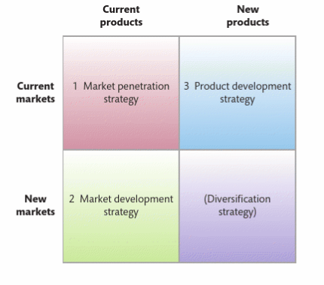

Biocon faced various strategic challenges since its foundation and applied several strategies to overcome these hurdles and to increase its profits and sales over the last decades to gain and sustain its competitive advantage.
The company established its business as an 'enzyme company' manufacturing a 'niche' product with a unique fermentation process which led to the development of a patented fermentation reactor, the so-called PlaFractor. The initial production of Biocon India in 1978 served the brewing industry. In 1989 the company developed into new markets applying the market development strategy through the production of enzymes for the Unilever's food business after the food giant acquired Biocon Biochemicals Ireland. Through the market development strategy, Biocon was capable to generate a new 'customer segment' and expanded the market with its existing product (enzymes). The unofficial motto of the company states 'earn as you learn' underlined by the focus on R&D investments. The latter paved the way for the diversification strategy which is mainly responsible for the company's growth and not least for its competitive advantage. The company's first conglomerate diversification was implemented in 1997 when it utilised its capabilities and resources to enter the biopharmaceutical industry launching the generic Lovastatin a 'new product' introduced in 'new geographical markets', including Canada, Mexico, Eastern Europe, and Southeast Asia (cf.Kalegaonkar et.al.,2008). New geographies were accessed after Merck's patent on Lovastatin expired in 2001 when Biocon applied once more the market development strategy to expand internationally without restriction with Lovastatin, and other statins, for example, Provastatin, Atorvastatin, etc. Besides these implemented innovative growth strategies Biocon understood that the principle function of a business is innovation (cf.Kotler et.al.2019) as the production of Lovastatin was based on solid-state fermentation. This pioneer status was emphasised once again in 2004 when Biocon became the first company worldwide to market generic recombinant human insulin obtained by the company's patented fermentation technology and in 2006 with the production of novel monoclonal antibody BIOMAb-EGR, a treatment against neck and head cancer (Biocon,Investor-Presentation,2017). With the foundation of the subsidiaries, Syngene and Clinigene, Biocon implemented a concentric diversification. Although the classification of diversification strategies differs in literature, the majority differentiate two types: the related diversification (also known as concentric diversification), occurs when the organisation develops new market offerings in the same or related industry (Kotler,et.al.2019). Unrelated diversification which is also known as a conglomerate or heterogeneous diversification (cf.Anil and Yigit,2011) occurs where the company enters industries which are not connected to the previously operated industry. The horizontal and vertical diversification constitute the subcategories of the related diversification strategy (cf.Kotler,2019;Anila and Yigit,2011). With the foundation of Syngene International Limited in 1994, Biocon remained faithful to its pioneer spirit, becoming the first Indian CRO company offering integrated scientific service from the early stage of drug discovery in the areas of synthetic chemistry, molecular biology, and informatics. The service provided an end-to-end-solution from R&D, over early clinical-trial management to manufacturing the drugs. The customer segment which is targeted by Syngene encompasses a wide range of industries, including pharmaceutical, biotechnology, nutrition, animal health, and consumer goods (Syngene,2020). Today, Syngene accounts for 30% of Biocon's revenue recording revenue growth of 10% in the FY 2020 (Biocon,AnnualReport,2020). Nowadays, Syngene's portfolio includes the whole range of clinical trials from phase I-IV. In 2000 Clinigene International Limited another subsidiary of Biocon was established providing full service in clinical trials capitalising on its R&D strength, its technical capability. Global pharmaceutical firms initiated a trend of outsourcing the three areas of the drug discovery and development value chain comprising (1) Research and development (R&D) which includes the production of target and custom molecules (2) clinical trials, and (3) manufacturing of the tested and approved drug (Kalegaonkar,2008). This trend persists up to this very day and will potentially rise to a market share of USD 45 billion in 2022 (Buvailo,2020b). Biocon's early jump on that bandwagon with Syngene and Clinigene underpins its strategic innovative approach and pioneering spirit. Through the creation of Syngene, Biocon entered the CRO business without covering the clinical-trial stage at first. This gap sought to be filled by the Clinigene by providing clients with a wide range of clinical trial services covering the two areas of generic drugs which requires bio-equivalence and bio-availability (BE/BA) and clinical studies with an examination procedure to prove the effectiveness of the generic drug compared to the off-patent original medication but also the comprehensive clinical trials for new drugs (Kalegaonkar,et.al.2008). Consequently, Clinigene is complementing the missing stage of the drug development and discovery value chain through implementing a new service range targeting the existing CRO market. In 2011 Clinigene concluded a strategic collaborative agreement with Seattle,U.S.A.-based company Pacific Biomarkes to extend its service range covering the 'specialty biomarker and high-end clinical trial laboratory needs of the global pharmaceutical and biotechnology industry' (PBI,2020). In 2013 the company declares that Clinegene is 'positioned as a third party clinical research organisation (CRO)' (Urs,2013).
According to its Annual Report (2020) Biocon is planning to implement the market development strategy by targeting 10-15 emerging and developed markets in various new countries either on its own or with new business partners. In the FY 2020, for example, Biocon entered the Chinese market with its small molecules business through a license and supply agreement with China Medical System Holdings Limited.
Further market opportunities are capitalised on in the next years through market penetration within the biosimilars business, for example, with the product Pegfilgrastim in the U.S. and Insulin Glargine and Trastuzumab in the EU (Biocon,AnnualReport,2020). Additionally, Biocon is launching Pegfilgrastim in the EU market. Consequently, Biocon's growth strategies are characterised by a wide range of the Ansoff Matrix propelled by innovation, pioneer spirit and flexibility.

3. Porter's Generic Strategy Model
Michael Porter developed the Generic Strategies Model as illustrated in Figure 9 comprising three generic strategies through which the company may gain and maintain a strong competitive advantage, namely cost leadership, differentiation, and focus (Kotler,2019)

Figure 9, 'Porter's Generic Strategies Model' (DeVlieger,2019)
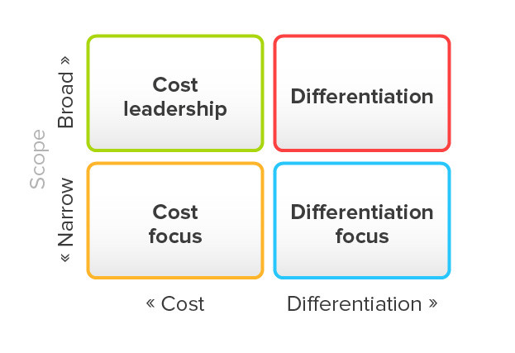

Biocon implemented a mixture of strategies in accordance with Porter's generic strategy model over time. Its late entry into the generic drug industry was linked with its objective to provide affordable, high-quality drugs accessible to everyone (Bicon,AnnualReport,2020). It could assert itself on the global market and gain and maintain a competitive advantage inter alia through cost leadership. The latter is adapted by firms to achieve the lowest production and distribution costs to keep the price low. As mentioned beforehand, the (generic) drug market is highly competitive and pharmaceutical organisations face price pressure on the one hand. On the other hand, pharmaceutical companies try to be as profitable as possible. Unlike the bulk of the companies operating in this industry, Biocon's explicit objective is to produce affordable healthcare products to achieve equality in healthcare accessibility irrespective of race, nationality, religion, and social status without sacrificing the quality of its product. This objective must be qualified as an overall cost leadership approach but also as differentiation through quality leadership (cf.Kotler,2019). This approach is made possible through cheap human capital available in India, as mentioned before, where highly qualified scientists on Ph.D. level earn one-third of the salary earned by U.S. scientisst with the same qualification. Other than cheap labour, the cost leadership is based on considerable less cost to be invested for manufacturing facilities, etc. Additionally, the political and legal framework promoted by the Indian government is supporting the cost leadership strategy. Biocon's strategy also reflects differentiation through its advanced and unique technology and high-quality service.
From the outset, Biocon's focus was on a small market segment of enzymes and diversified in various most profitable market segments of the pharmaceutical market, including diabetology, cardiology, nephrology, immunology, and oncology (Biocon,AnnualReport,2020).

4. Resources and Capability Analysis

a. Resource-Based View
The resource-based view (RBV) is a model that focuses on the capabilities and resources of an organisation as key factors to achieve a sustained competitive advantage (SCA) (cf.Barney and Hesterly,2019). Resources are tangible or intangible assets which are controlled by the firm, for example, the organisation's facilities (production sites, offices, etc.,are tangible assets) its products (tangible assets), qualifications, skills and know-how of its employees, patents (intangible asset), the reputation of the company (intangible asset). Capabilities are a subtype of resources and could encompass tangible and intangible assets facilitating the organisation to utilise the resources it controls (Barney and Hesterly,2019).
According to the RBV, four categories of resources and capabilities of a company can be identified: (1)financial resources which include all monetary resources that the firm is able to utilise to apply its strategies; (2)physical resources, which includes physical technology, plants, equipment, the firm's accessibility to raw material, computer hardware and software,etc., (3)human resources, which comprises training, experiences, qualification, and the relationship of the firm's workforce; and finally, (4)organisational resources which include an organisation's 'formal and informal planning, controlling, coordinating system, its culture and reputation', and informal internal and external relations' (Barney and Hesterly,2019).
The RBV model has been subjected to criticism over the last three decades and encompasses a complex theoretical debate about its positioning to a least three theoretical traditions: (1) positioning RBV to structure-conduct-performance (SCP) based theory (Porter,1980); (2) positioning RBV to neo-classical microeconomics (Ricardo,1817), (3) positioning RBV relative to evolutionary economics (Nelsen and Winter,1982); (cf.Barney,2001). However, all positions share a number of critical assumptions, such as the notion that resources and capabilities are heterogeneously allocated across companies (cf.Barney and Hesterly,2019). Additionally, the RBV is based on the assumption that and these discrepancies are permanent as they are too expensive to develop or gain regardless of whether the companies concerned are aware of the competitive disadvantage (so-called resource immobility)(Barney and Hesterly,2019). The objectives of these theories are to reveal the sustained performance differences by applying various definitions of performance which leads to various empirical implications (Barney,2001).
Barney argues that resources that are capable to lead to a sustained competitive advantage are those which can be classified as rare, inimitable, and non-substitutable (VRIN) (Armstrong and Shimizu,2007,Barney,1991). Given this foundation, the so-called VRIO framework has been developed. In order to determine whether resources and capabilities possess the potential to provide for a sustained competitive advantage, it must be assessed whether the they are Valuable, Rare, Imitable and whether the Organisation is capable 'to exploit its resources and capabilities or neutralize its external threats' (Barney and Hesterly,2019).
In the first stage, the resources and capabilities of Biocon India will be identified in accordance with the RBV. 'Armed' with these findings the potential of these resources and capabilities will be outlined in the VRIO framework assessing whether they are providing for a sustained competitive advantage (cf.Figure 10).

Figure 10: RBV and VRIO Analysis Framework (BSC Designer,n.d.)
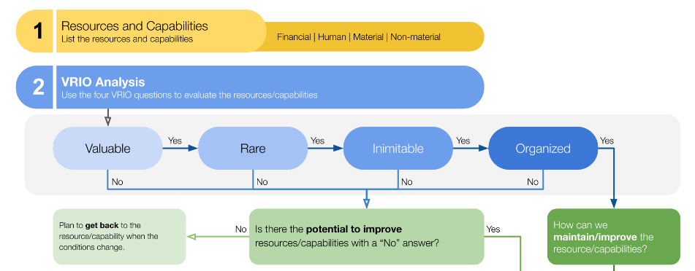

Biocon's financial resources comprise a considerable amount of trade receivables, cash and cash equivalents, and borrowings (Biocon,AnnualReport,2020). As a big player in the biopharmaceutical market, the company also posses significant physical resources, including manufacturing plants fitted with inter alia patented physical technology (cf. the Plafractor) and technological equipment, research laboratories, and a physical global manufacturing infrastructure (Biocon,2020). Biocon's culture and human resources differentiate the firm from other rivals in the market. It's company culture 'encompasses trust, openness, and collaboration' reflected in the non-existing hierarchies (Kalegaonka,2008). Given the size of the company this unique cultural approach results in a highly effective operation concerning the time-efficiency and cost-efficiency, for example, in cases where employees do not need 'to go through layers to reach the person' needed in the work process (Kalegaonka,et.al.2008). The company emphasised that the insecurities of its new hires must be eliminated and strengthens its employees confidence to unfold their creativity and passion. This is supported by a collegial culture and implemented by various approaches to increase its employees' comforts, such as 'special transportation, free lunch, and snacks, on-site health checkups, etc.(Kalegaonka,et.al.2008). Besides enhancing relationships between colleagues it also eases the relationship with the workforce and managers. Finally, it is benefiting Biocon's employer branding increasing the firm's attractiveness and allowing to hire the most talented workforce which in turn increases Biocon's human resources and capabilities. It can be stated that Biocon's organisational resources are significant and include a green strategy which increases the firm's reputation achieved through its foundation supporting environmental protection and indigenous communities. (Biocon-Foundation,2020). Its social commitment is reflected in its vision statement to provide 'high-quality and affordable healthcare products and services driven by the belief that everyone, everywhere deserves access to affordable, quality medicines' (Bicon-Factsheet,2020). The latter also boosts the company's reputation and the trust of the public, patients, clients, and other shareholders which is an important momentum given the aforementioned widespread scepticisms of the society towards the biopharmaceutical/biotech industry. Further organisational resources of Biocon include its informal relationships among groups with the firm and coordinating and controlling systems as elaborated above. Biocon's high-quality culture is reflected in its high standard to hold up with USFDA and German RWTÜV. Biocon's s strategic alliances and a global production structure can be qualified as organisational resources which serve as a key factor for SCA.
Besides the aforementioned resources, Biocon's intangible capabilities, include over 1100 patents, and innovative R&D, expertise and know-how, particularly regarding the 'difficult-to-make molecules-niche products' (cf.Biocon,AnnualReport,2020,Biocon-Factsheet,2020).
b. VRIO Framework Analysis
Resources and capabilities are valuable when they facilitate the company to utilise its external opportunities or neutralize external threats (Barney and Hesterly,2019).
Biocon's performance in the last decades and the actual facts and figures laid down in the Annual Report (2020) reveal that the company understands to exploit its resources and capabilities. Its innovative approach and smart investments in R&D led to its patented technology which enabled the firm to diversify in other markets through further investments. Subsequently to the access of the generic market which constitutes the most profitable segment with a share of 70% of India's total pharmaceutical market revenue in 2020 (cf. Figure 11)
Figure 11: Share of pharmaceutical market revenue in India in 2020 by sub segment (Statista,2020)
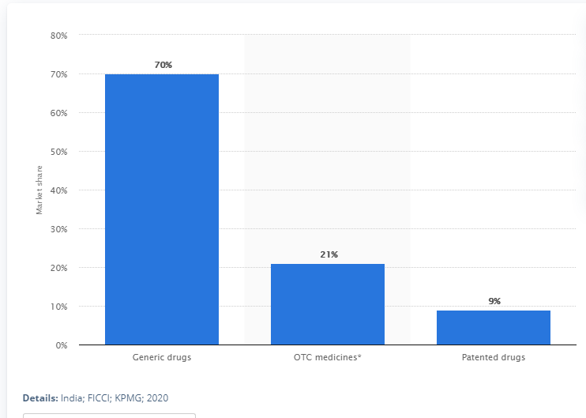

Biocon focused on the most profitable segments, including diabetology, cardiology, immunology, and oncology. However, it is implementing a unique fermentation technology which differentiate the firm from rivals and is costly to imitate. With its patents and the production of complex niche products, the company's capabilities and resources must be qualified as rare and inimitable contributing 31% of the company's revenue in 2020. Hence, they are exploited by the organisation efficiently. Its R&D service such as Syngene contribute 30% of the annual revenue (in 2020,cf.Biocon-AnnualReport). Biocon's policies and procedures provide considerable support to exploit these resources to achieve growth and finally a sustained competitive advantage. Through its high investment in R&D and the firm's flexibility to implement growth strategies such as the permanent diversification in new markets, joint ventures, and the market development strategy through geographical expansion demonstrates that Biocon set the course to make the best use of available resources and capabilities, including investments, expertise, know-how, its reputation, etc. The implantation of such strategies is enabled through Biocon's human resources attracted by its unique company culture.

VRIO Analysis |  | SCA of Biocon India
Valuable |  | Yes
Rare |  | Yes
Inimitable |  | Yes
Organisation |  | Yes

5. McKinsey's 7s Framework Model
Since the introduction of the 7s model by McKinsey consultants Tom Peters and Robert Waterman who developed the framework in the late 1970s (McKinsey,2008) it became an essential and popular strategic planning tool in literature and among practitioners (Ravanfar,2015).

Figure 12: McKinsey 7s model (Ravanfar,2015)
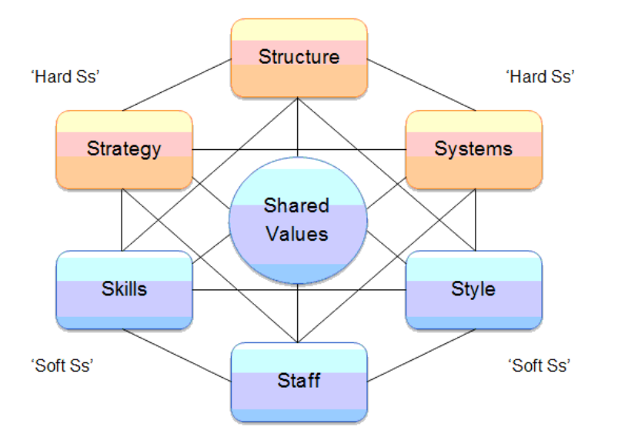

The 7s Framework is a cluster of six circles surrounded by a central circle each represents a factor beginning with the letter 'S' that influences an organisation's ability to change or to implement new strategies by diagnosing the set of elements crucial for a companies' success and higher organisational performance (McKinsey,2008). The objective of this framework is to achieve organisational effectiveness by aligning the elements of the framework, namely structure, strategy, system which are referred to as 'hard S', shared values, skills, staff, and style which belong to the 'soft s' as illustrated in Figure 12 (cf.Ravantar,2015). Figure 12 demonstrates the interconnection of all elements. Although the 'hard Ss' are easier to identify and manage than the 'soft Ss', the main objective of the 7s tool is to find whether or not the elements are aligned and how to achieve change to align them, instead of identifying merely the strengths of each element (cf.Ravantar,2015).

Strategy the straightforward element of strategy comprises the plan adopted by the company to achieve a sustained competitive advantage (Ravanfar,2015). Biocon has a strong vision and mission statement communicated transparently to all stakeholders encompassing its distinction from rivals and ensuring the success of the company. According to the Annual Report (2020) and the implemented strategies of the last three decades, Biocon displays a significant dynamic approach which is monitored and adapted constantly. The company's innovative advance not only leads to market development, product development, and diversification it also emphasises the firm's flexibility to adapt to market situation and react to implications of the macro-environment. Noteworthy, Biocon's pioneer approach at times where trends have not developed yet, such as the outsourcing of R&D services of pharmaceutical companies. Consequently, Biocon is achieving a sustained competitive advantage through its strategy and is able to successfully compete in the market and to address competitive pressures.
Structure comprises the understanding of authorities and their relationships, including the hierarchal organisation of business divisions, revealing who is reporting to whom and represents how organisational accountability is structured (Ravanfar,2015). Biocon's organisational hierarchy is flatter compared to other firms with the possibility for employees to address managers in high positions without going through layers (Kalegaonkar,2018). This structure maximises operational flexibility and effective functions but also underlines the value of increasing staff satisfaction. It also simplifies cross-departmental and internal collaboration.
Systems in this context means the procedures of an organisation such as HR processes, finance, risk management, marketing, operation, public relation management, strategic leadership, client-management system etc. (McKinsey,2008). Biocon has a segregated organisational system in place enabling business operations to be managed effectively in its departments. The firm has internal processes, monitoring, and evaluating tools in place to strengthen the objective to align processes 'with strategic initiatives of each entity' in order to achieve an overall organisational alignment (Biocon,AnnualReport,2020). Furthermore, the objective of its internal control system is to provide assurance of the company's 'operational effectiveness and efficiency, compliance with laws & regulations, asset safeguarding and reliability of financial and management reporting'.(Biocon,AnnualReport,2020).
Skills comprise individual skills and institutional skills, including the staff's competencies and how well staff members work together (McKinsey,2020). It also concerns the question of how to gain and maintain skills, skill development, and acquisition (McKinsey,2008). Due to its company culture, staff management, and its success as one of the most successful Indian biopharmaceutical company Biocon is a significantly 'desirable place to work' attracting 'the best minds' and hence can hire skilled workforce developing and training their skills with a validated learning management system in place (Kalegaonkar,2008, Biocon,AnnualReport,2020). On this basis, the company is able to enhance the institutional skills. As explained below, Biocon's skill management encompasses regular training, certified courses, and workshops to offer development opportunities and facilitate individual growth. Skill acquisition is also concluded externally (see below under staff).
Staff refers to the people working in the company and comprise particularly workforce planning, resourcing of talented employees, retention, motivation and reward strategies, learning and development etc. (Ravantar,2015). Biocon employs over 12000 people around the globe (Biocon,Factsheet,2020). With the intention to establish a diverse and collaborative, employee-friendly workplace Biocon achieved the 6th position on the Global Biotech employers ranking by the Science Career magazine (Biocon,AnnualReport,2020). Its strong employer brand and increased activities in social media by 30% enhanced the expansion of hiring domestic and international top talented staff. Furthermore, Biocon strengthens its relation with top-tier technical and management institutes benefiting its workforce and succession planning and talent acquisition through the creation of a talent pool (Biocon,AnnualReport,2020). This approach allows Biocon to identify and hire the best candidates (cf.Biocon,AnnualReport,2020). The major hire in 2020 has been graduates with 58%, and post-graduates and PhDs with 37% (others 5%) which underlines that the company has an internal development process and succession planning in place (Biocon,AnnualReport,2020). In fact, learning and development is part of Biocon's culture as its employers concluded 125,000 learning hours in the FY2020 offered in 100 courses, certifying nearly 2.700 employees and improving technical and leadership skills through technical certifications, digital learning, and soft skills programs (Biocon,AnnualReport,2020). Additionally, the company has a performance management process embedding a career and goal setting process to impact organisational effectiveness by its most valuable asset, its human capital. The latter is emphasised by its talent management of inclusion considering every employee as talented which has to be unleashed as part of the collective genius in a company culture of innovation (Biocon,AnnualReport,2020). Finally, Biocon has various approaches to strengthen employee engagement through wellness programs, programs to enhance physical and emotional health, offering sporting activities, promoting a gender-inclusive workplace with extended maternity leave and part-time opportunities (Biocon,AnnualReport,2020). However, gender diversity is still improvable at Biocon. According to the Annual Report (2020) the company employs 10,230 male employees and only 2,379 female employees. Since diversity is not only a 'nice thing to have' rather a real strength of a company (McKinsey,2008) this default must be recognised and rectified.
Style can be understood as the company culture which shapes the characteristics of the organisation's rules of conduct: the way managers lead and interact and which values are implemented shaping the characteristics of an organisation (McKinsey,2008,Ravanfar,2015). As elaborated above the leadership style is dominated by the company culture of non-existing or flat hierarchies encouraging employees to participate, take responsibility, and unleash their potential, creativity, and passion (Kaleaonkar,2008). This participative leadership style also enhances employee engagement and motivation, particularly in cases where the workforce is involved in the decision-making process. Moreover, it enhances the effectiveness of operations ensuring the achievement of organisational goals through a supportive culture promoting effective cooperation between teams and departments.
Shared values comprise the goals that the organisation is trying to achieve based on the fact of whether the company is a profit organisation or a non-profit organisation (McKinsey,2008). This element constitutes a central position of the McKinsey 7-s model and reflects the company's reputation, its mission, and vision usually embedded in norms and standards leading the organisational direction and employee behaviour (Ravanfar,2015). Biocon's company shared values are lead by openness and collaboration and a strong focus on innovation and development. Its reputation is based on its social responsibility through its mission and vision to provide equal, affordable, and high-quality healthcare. Moreover, the company implements high standards regarding ethics and morals including its sustainability approach and environmental activities which is also expected from its business partners (Biocon-Sustainablity,2020).The Biocon-foundation as mentioned above strengthens the community and emphasis the Indian heritage in rural areas (Bicon-Foundation,2020).

6. Biocon's strategies to sustain competitive advantage and conclusive observations
Biocon's strength is its flexibility of its founder and her excellent sense of the market and trends. When she realised that the traditional brewery industry was not ready for a female scientist she searched for new opportunities to apply her scientific knowledge and skills instead of enforcing an emancipated approach.
Biocon's strategic management as outlined above comprise a variety of choices. The key drivers in the biopharmaceutical industry are R&D led by its human resources and innovations. The company has been successfully earned the title of 'India's first company to (...)' implement its pioneer approach and innovative technology thanks to its high investments in R&D. Biocon recognised trends before they evolved, such as the outsourcing trend of R&D and clinical trials. Biocon's excellent 'nose' for trends fostered the company's strategic focus: expansion through its growth strategies, particularly product development, market development, and diversification. Given the high competition due to the rowing pricing pressure on drugs, the growth strategies are essential for Biocon's success. Strategic alliances simplified international operations of the firm.
Its approach to diversify into different industry segments equipped the firm with several pillars for survival and success. Having regard to the revenue growth of the last 3 years (cf. figure 13) Biocon's strategies have borne fruit.

Figure 13 Biocon - Investor Relations 'Financial Factsheet'
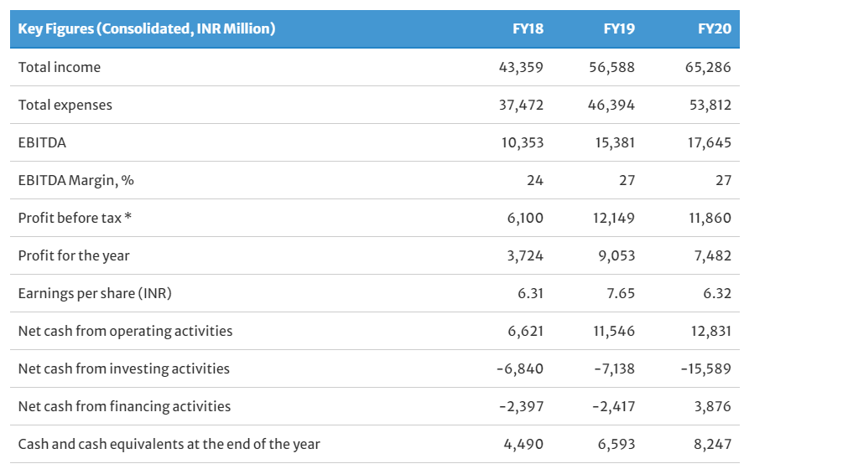

The ethical consequences and publicity involved in clinical trials could be overcome through the societal marketing approach in the form of the Biocon-Foundation and its 'green strategy'. Biocon takes the initiative to reduce its carbon footprint by utilising renewable energy, adopting water purification processes, and going beyond legal regulations to contribute to environmental protection and sustainability. In making environmental protection a cornerstone of its business strategy, for example with Biocon's foundation, the firm differentiates its organisation from competitors, particularly through the integration of sustainability into corporate messaging which attracts stakeholders such as employees, customers, clients, investors, and regulators (cf. Kauffeld,et.al.,2009). With the Biocon-Foundation the company takes social responsibility, not only regarding healthcare initiatives such as 'Smart clinics' but also empowering communities through education and environmental sustainability projects (Biocon-Foundation,2018).

V. Recommendation
1. Promote gender diversity to enhance performance, the company's reputation, and the credibility of the firm's vision and mission.
Promoting diversity in its workforce to enhance credibility regarding its equality approach of healthcare reflected in its mission and vision must be recommended. There might be several reasons why the company does not employ more female staff members, skill shortage due to the lack of female graduates in the field could be one of them. The technical/scientist industry is still a male-dominated business, however, to align the company's vision to provide for affordable healthcare regardless of ethnicity, gender, race, etc. a diverse workforce is a must. Not only would the company benefit from this gender diversity concerning the improvement of the performance, but it would also underline the entire business concept of being a pioneer, innovator, and pursuing an egalitarian principle in healthcare provision. This is even more true, given the fact of Biocon's legacy with a female founder who could not access particular male-dominated industry areas in the 1970s.

2. Enhance the acceptance and trust of the public
Having regard to the critical view of clinical trials in India for Western MNC's (Kalegaonka,et.al.,2008) and issues addressed by the aforementioned Wharton research study could also bring opportunity for Biocon to gain and sustain competitive advantage in the future. The ideal scenario was identified when two factors are positive: technology succeeds and there is public acceptance. The potential development is called 'the new age of medicine' embedded in a scenario where 'corporations and university research labs would prosper together' (Johnson,et.al,2008) and shall form the basis for Biocon's recommendation.
Biocon needs to address the public concerns and enhance its publicity through a more intense digital presence to advance the acceptance and the trust of its clients and their customers. Biocon already implemented the Biocon foundation to apply the concept of affordable and accessible healthcare and environmental protection. Its strategy to cooperate with local companies and capture certificate as the aforementioned RWTÜV and specific approvals from the FDA underlines the trust and respectability the company achieves in the international and national view of the public. In this framework, Biocon could initiate research collaborations with well-known universities to strengthens the trust of both, the public and potential clients.
3. Increase digital presence and online communication with stakeholders
Nowadays consumers engage proactively in their healthcare choices discussing health issues online (Figure 14). According to statics over 90 million people interact on the web and utilising smartphone applications to obtain health and wellness information in the U.S. (Bhadoria and Arora,2017). Biocon needs to address this trend by making its complex product and service portfolio more transparent to patients. The firm could get more involved in social media, for example, Facebook and Twitter, and release healthcare information for end-consumer on the web presence.

Figure 14: Engagement of Patients in their healthcare choices (Bhadoria and Arora,2017)

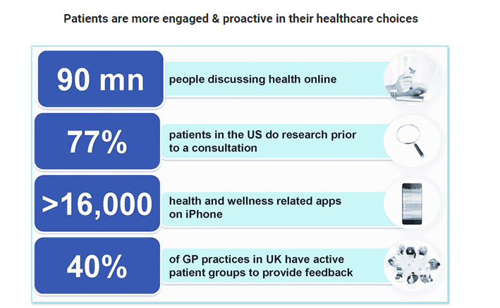

References
- Anil, I. and Yigit, I. (2011), 'The Relation between Diversification Strategy and Organizational Performance: A Research on Companies Registered to the Istanbul Stock Exchange Market', Procedia Social and Behavioural Sciences, 24, pp. 1494-1509. Available at https://pdf.sciencedirectassets.com/277811/1-s2.0-S1877042811X00174/1-s2.0-S1877042811016211/main.pdf?X-Amz-Security-Token=IQoJb3JpZ2luX2VjEPL%2F%2F%2F%2F%2F%2F%2F%2F%2F%2FwEaCXVzLWVhc3QtMSJIMEYCIQC%2Bir1R4IFBWuRPbDZTogVaZQCFtXj6tfYo8iXUdRXx2gIhAIQMn5ZMfTu [Accessed on 01.01.2021].
- Armstrong, C.E. and Shimizu,K. (2007), 'A Review of Approaches to Empirical Research on the Resource-Based View of the Firm†'. Journal of Management, 33(6), pp. 959-986.
- Barney, J.B. and Hesterly,W. (2019), 'Strategic Management and Competitive Advantages' 6.ed., Harlow, England, Pearson Education Limited.
- Barney, J.B., (2001), 'Resource-based theories of competitive advantage: A ten-year retrospective on the resource-based view'. Journal of management, 27(6), pp. 643-650.
- Barney, J.B., (1991), 'Firm resources and sustained competitive advantage' Journal of Management, 17, pp.99-120.
- Bioncon (2020), 'About us - Legacy', [Online]. Available at https://www.biocon.com/about-us/our-legacy/ [Accessed on 18.12.2020].
- Biocon,About us, (2020), 'Who we are', [Online]. Available at. https://www.biocon.com/about-us/who-we-are/ [Accessed on 18.12.2020].
- Bicon-Factsheet (2020), 'Biocon-Factsheet', [Online]. Available https://www.biocon.com/docs/Biocon-Factsheet-20201126.pdf [Accessed on 19.12.2020].
- Bicon-Covid19-Outbreak (2020), 'Let's fight the Covid-19 outbreak', [Online]. Available at https://www.biocon.com/biocon-presented-insights-into-clinical-study-that-enabled-dcgi-approval-of-itolizumab-for-covid-19/ [Accessed on 24.12.2020].
- Bicon (2010), 'Emerge - New opportunities for Biopharmaceuticals', [Online]. Available at https://web.archive.org/web/20101026031837/http://biocon.com/docs/AR10-BIOCON.pdf [Accessed on 19.12.2020].
- Biocon-Foundation (2018), Available at https://www.bioconfoundation.org/index.html [Accessed on 19.12.2020].
- Biocon-Annual Report (2020), Available at https://www.biocon.com/docs/Biocon_Annual_Report_2020.pdf [Accessed on 19.12.2020].
- Biocon-Biosimilar (2020), 'Global Scale Manufacturing'.[Online]. Available at https://www.biocon.com/businesses/biosimilars/global-scale-manufacturing/#:~:text=Biocon%20has%20established%20a%20large-scale%2C%20multi-product%2C%20cell%20culture,platforms%20help%20us%20deliver%20novel%20and%20biosimilar%20mAbs. [Accessed on 27.12.2020].
- Biocon-Investor Presentation (2017), [Online]. Available at https://www.biocon.com/docs/IR_PPT_Feb_2017.pdf [Accessed on 27.12.2020].
- Biocon-EHSS (2019), 'Environment,Occupational Health,Safety & Sustainability Policy' [Online]. https://www.biocon.com/docs/EHSS-Policy.pdf [Accessed on 27.12.2020].
- Bicon-Sustainability, (2020). [Online]. Available at https://www.biocon.com/responsibility/sustainability/ [Accessed on 27.12.2020].
- Biocon - Investor Relations 'Financial Factsheet' (2020), [Online]. Available at https://www.biocon.com/investor-relations/fact-sheet/ [Accessed on 28.12.2020].
- Bhadoria,V. and Arora, V. (2017), 'A year of opportunities and challenges' 06 January. [Online]. Available at https://www.expresspharma.in/cover-story/a-year-of-opportunities-and-challenges/ [Accessed on 24.12.2020].
- Bright,D.S. et. al. (2019), 'Principles of Management' Openstax, 20 March [Online]. https://openstax.org/details/books/principles-management [Accessed on 27.12.2020].
- BSC Designer (n.d.), 'VRIO Analysis Framework for Strategic Planning'. [Online]. Available at https://bscdesigner.com/vrio-analysis.htm [Accessed on 31.12.2020].
- Buvailo,A.(2020a), 'Pharma R&D Outsourcing is on the Rise', BiopharmaTrend.com, [Online]. Available at https://www.biopharmatrend.com/post/30-pharma-rd-outsourcing-is-on-the-rise/ [Accessed on 20.12.2020].
- Buvailo,A.(2020b), 'The Evolving Pharma R&D Outsourcing Industry: A Bird's-eye View'[Online]. Available at https://www.biopharmatrend.com/post/30-pharma-rd-outsourcing-is-on-the-rise/ [Accessed on 27.12.2020].
- DeVlieger, R.(2019), 'Generic Strategies Michael Porter', 25 March, [Online]. Available at https://www.calltheone.com/en/consultants/generic-strategies-michael-porter [Accessed on 29.12.2020].
- DW (2020), 'Biontech macht keine Gewinne - noch nicht' 10 November [Online]. https://www.dw.com/de/biontech-macht-keine-gewinne-noch-nicht/a-55554293 [Accessed on 27.12.2020].
- CFI (2015), 'Industry Life Cycle', Corporate Finance Institute, [Online]. Available at https://corporatefinanceinstitute.com/resources/knowledge/strategy/industry-life-cycle/#:~:text=%20What%20is%20the%20Industry%20Life%20Cycle%3F%20,consolidation%20of%20an%20industry.%20Some%20businesses...%20More%20 [Accessed on 18.12.2020].
- Faulkner,D. and Campbell,A. (2003), 'The Oxford Handbook of Strategy. A Strategy overview and competitive strategy', Oxford, Oxford University Press.
- GlobalDataHealthcare (2020), 'The impact of big pharma on Covid-19', 23 April. [Online]. Available at https://www.pharmaceutical-technology.com/comment/covid-19-pharmaceutical-companies-impact/?utm_source=Army%20Technology&utm_medium=website&utm_campaign=Must%20Read&utm_content=Image [Accessed on 24.12.2020].
- Gruber,C. (2020), 'The Pharmaceutical Industry 2012 - A comprehensive trend analysis'. [Online]. Available at https://www.slideserve.com/deana/the-pharmaceutical-industry-2012-a-comprehensive-trend-analysis [Accessed on 18.12.2020].
- Guerin,P.J., Singh-Phulgenda,S. and Strub-Wourgaft,N., (2020). 'The consequence of COVID-19 on the global supply of medical products: Why Indian generics matter for the world?' F1000 research; (9), pp. 225.
- Gupta, S.D. And Mathai P (1989), 'Indian economy witnesses steady but slow growth in 1989' India Today, 15 October [Online]. Available at https://www.indiatoday.in/magazine/economy/story/19891015-indian-economy-witnesses-steady-but-slow-growth-in-1989-816595-1989-10-15 [Accessed on 24 December 2020].
- Hamiltion, E. (2020), 'The Top 10 Biopharmaceutical Companies in 2020' The Science Times, 13 July. [Online]. Available at https://www.sciencetimes.com/articles/26440/20200713/biopharmaceutical-companies.htm [Accessed on 19.12.2020].
- Hollensen,S. (2019), 'Marketing management'. 4.ed. Harlow, United Kingdom: Pearson Education Limited.
- Hüser, T. (2017), 'Statuspapier: Biotechnologie - Wie Sieht die biopharmazeutische Fabrik der Zukunft aus', Process, 28 November, [Online]. https://www.process.vogel.de/wie-sieht-die-biopharmazeutische-fabrik-der-zukunft-aus-a-666510/ [Accessed on 19.12.2020].
- Husson, University Online, (2018), 'What's the difference between Biothech and Biopharma', 18 July. [Online]. Available at https://online.husson.edu/biotech-and-biopharma/#:~:text=Since%20biotech%20refers%20to%20products,biotechnology%20can%20be%20considered%20biopharma.&text=Perhaps%20the%20biggest%20application%20in,drugs%2C%20which%20is%20essentially%20biopharma. [Accessed on 19.12.2020].
- IGE,n.d. 'Was ist ein Patent'. [Online]. Available at https://www.ige.ch/de/etwas-schuetzen/patente/grundlegendes/was-ist-ein-patent.html [Accessed on 24.12.2020].
- Imarc (2020), 'Biopharmaceutical Market Size, Share and Analysis 2020-2025' [Online]. Available at https://www.imarcgroup.com/about-us [Accessed on 19.12.2020].
- Independent (2004), 'Irish promise helped Idnian woman's $1bn biotech plan' The Independent Ireland [Online]. https://www.independent.ie/business/world/irish-promise-helped-indian-womans-1bn-biotech-plan-25903615.html [Accessed on 18.12.2020].
- Indian Pharmaceutical Alliance (2019), 'The Indian pharma industry - the way forward' [Online]. Available at https://www.ipa-india.org/wp-content/uploads/2020/10/indian-pharmaceutical-industry-way-forward.pdf [Accessed on 24.12.2020].
- IndustryARC,(2019) , 'Biopharmaceutical Market - Forecast (2020-2025)' [Online]. Available at https://www.industryarc.com/Report/9586/biopharmaceutical-market.html [Accessed on 19.12.2020].
- Jobber,D. and Ellis-Chadwick,F. (2016), 'Principles and Practice of Marketing' 8.ed. Maidenhead, Birkshire, McGrw-Hill Education.
- Johnson,G., Scholes,K., and Whittington,R., (2008), 'Exploring Corporate Strategy', 8 ed., Harlow, England, Pearson Education Limited.
- Kauffeld,R.,Abhishek, M, and Higgins,S. (2009), 'Green is a strategy', [Online]. Available at: https://www.strategy-business.com/article/00013?gko=810d6 [Accessed on 2.1.2021].
- Kenton,W. (2020), 'Patent' Investopedia, 22 April. [Online]. Available at https://www.investopedia.com/terms/p/patent.asp [Accessed on 24.12.2020].
- Kotler, P., Keller, K.L., Brady, M., and Hansen,T. (2019), 'Marketing Management', 4 ed. Harlow, England, Pearson Education Ltd.
- Langer, A. and Mehnert, W. (2019), 'Biopharmazie -Pharmakokinetik, Bioverfügbarkeit, Biotransformation', 5 ed., Stuttgart, Wissenschaftliche Verlagsgesellschaft Stuttgart.
- Maylín-Aguilar, C., Montoro-Sánchez, Á. (2020), 'The Industry Life Cycle in an Economic Downturn: Lessons from Firm’s Behavior in Spain, 2007–2012'. Journal of Business Cycle Research,14 September [Online] Available at https://link.springer.com/article/10.1007/s41549-020-00048-w#citeas [Accessed on 18.12.2020].
- Marketwatch (n.d.), 'Bicon stock price as of 18.12.2020', [Online]. Available https://www.marketwatch.com/investing/stock/biocon?countrycode=in [Accessed on 19.12.2020].
- Mamun, M., Syah, T.Y.R., Pusaka, S. and Darmansyah, H.S., (2020), 'Implementation of McKinsey 7s Management Strategy concepts for startup business: Fruit combining', Russian journal of agricultural and socio-economic sciences, 9 7(1), pp. 133-141.
- Mandal A. (2019), 'Drug Patents and Generic Pharmaceutical' News Medical Life Sciences 26 February. [Online]. Available at https://www.news-medical.net/health/Drug-Patents-and-Generics.aspx [Accessed on 24.12.2020].
- McKinsey(2008), 'Enduring Ideas: The 7-S Framework' McKinsey Quarterly, 1 March.[Online]. Available at https://www.mckinsey.com/business-functions/strategy-and-corporate-finance/our-insights/enduring-ideas-the-7-s-framework [Accessed on 1.1.2021].
- Mikulic,M. (2020), 'Global pharmaceutical industry - statistics and facts' Statista, 5 November, [Online]. Available at https://www.statista.com/topics/1764/global-pharmaceutical-industry/ [Accessed on 27.12.2020].
- Navadhi Market Research (2019), 'Global Pharmaceuticals Market 2023', [Online]. Available at https://www.navadhi.com/publications/global-pharmaceuticals-industry-analysis-and-trends-2023 [Accessed on 24.12.2020].
- Nedelcheva, Y., and Filipova,M.(2020). 'Applying five forces model to pharmaceutical industry' Revista Inclusiones, 8 (1) pp 162-173.

- Nelson,R. R., & Winter, S. G. (1982). An evolutionary theory of economic behavior and capabilities. Cambridge: Harvard University Press, 195–307.
- Oxford College of Marketing Ltd. (n.d.), 'What is a PESTEL Analysis' [Online]. Available at https://blog.oxfordcollegeofmarketing.com/2016/06/30/pestel-analysis/ [Accessed on 19.12.2020].
- PBI, Pacific Biomarkers/Clinigene (2011), Clinigene International Enters into Collaborative Clinical Research Services Agreement with Pacific Biomarkers' 21 December [Online]. https://www.biocon.com/docs/PR_Biocon_clinigene_21122011.pdf [Accessed on 24 December 2020].
- Porter, M. E. (1980a). 'Competitive strategy. Techniques for analyzing industries and competitors' (1998 with a new introduction). New York: Free Press.
- Porter, M. E. (1980). Generic competitive strategies. Competitive strategy. New York: Free Press.
- Ravanfar,M.M. (2015), 'Analyzing Organizational structure based on 7s Model of Mckinsey' Global Journal of Management and Business Research: A Administration and Management, 15(10). [Online]. Available at http://www.journalofbusiness.org/index.php/GJMBR/article/view/1792 [Accessed on 1.1.2021].
- Rezaie, R., McGahan, A.M., Frew, S.E. et al. (2012), 'Emergence of biopharmaceutical innovators in China, India, Brazil, and South Africa as global competitors and collaborators', Health Res Policy Sys 10, 18 [Online]. Available at: https://doi.org/10.1186/1478-4505-10-18 [Accessed on 19.12.2020].
- Ricardo, D. (1817). Principles of political economy and taxation. London: J. Murray.
- Statista (2020), 'Share of pharmaceutical market revenue in India in 2020 by sub segment' 1 December,[Online]. Available at https://www.statista.com/statistics/712527/india-pharmaceutical-market-revenue-distribution-by-sub-segment/ [Accessed on 27.12.2020].
- Syngene (2020). [Online]. Available at: https://syngeneintl.com/ [Accessed on 30.12.2021].
- Syngene,Clinical-Trial-Management (2020), [Online]. Available at https://syngeneintl.com/solutions/development/clinical-development/clinical-trial-management/ [Accessed on 18.12.2020].
- Terry, M. (2016), 'Biotech vs. Big Pharma: Which is the Better Place to Work?' Biospace, 26 September [Online]. Available at https://www.biospace.com/article/biotech-vs-big-pharma-which-is-the-better-place-to-work-/#:~:text=Biotech%20companies%20were%20focused%20on,focused%20on%20small%20molecule%20discoveries.&text=As%20recently%20as%202015%2C%20Investopedia,drugs%20having%20a% [Accessed at 19.12.2020].
- Urs,A. (2013), 'Clinigene to be third party CRO' Business Standard, 6 February, [Online]. Available at https://www.business-standard.com/article/companies/clinigene-to-be-third-party-cro-105070701110_1.html [Accessed on 2 January 2021].
- Whittington,R.(2019), 'Opening Strategy-Professional Stategists and Practice Change, 1960 to Today', Oxford, Oxford University Press.
- Wohlner,R. (2020), 'Industry Life Cycle', Investopedia. 28 September, [Online]. https://www.investopedia.com/terms/i/industrylifecycle.asp [Accessed on 18.12.2020].
- Whiteside,E. (2020), 'The Industry Handbook: Pharma Industry', Investopedia, 4 January, [Online]. Available at https://www.investopedia.com/articles/markets/051316/industry-handbook-pharma-industry.asp [Accessed on 27.12.2020].
- The Worldbank (2020), 'The Global Economic Outlook During the Covid-19 Pandemic: A changed World' 8 June, [Online]. Available at https://www.worldbank.org/en/news/feature/2020/06/08/the-global-economic-outlook-during-the-covid-19-pandemic-a-changed-world [Accessed on 24.12.2020].
- Zentiva, n.d., 'Was steckt hinter dem Begriff Generika' Available at https://www.zentiva.de/produkte-uebersicht/generika [Accessed on 27.12.2020].

