A link to my online portfolio has been provided below. Additionally a screenshot of said portfolio as also been added to this document.
T.Gabadan (google.com)

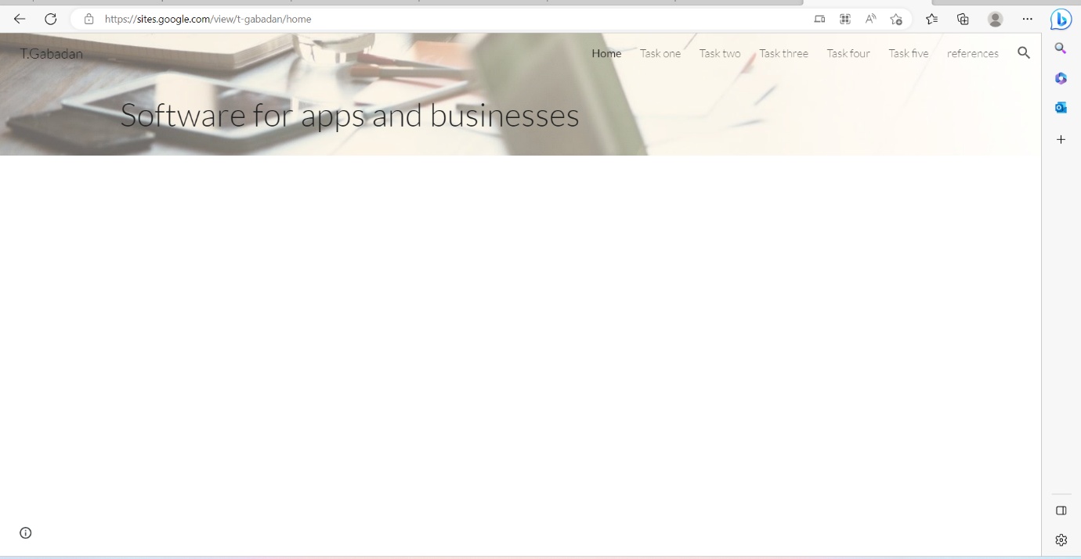
Screenshot of online portfolio.

