

COVID-19 Health Systems Leadership Comparison
Student Name: Solanki Prathamkumar Himmatlal
Student ID: 2430951
Professor Name: Shepherd Ziko
Module: Health Care System, Organisation and Leadership
Module Code: LCHS7002

Table of Contents
1.0 INTRODUCTION 3
1.1 Background & Purpose 3
1.2 Rationale & Relevance to Health Systems Leadership 3
1.3 Report Structure 3
2.0 CRITICAL ANALYSIS OF CENTRALISED / DECENTRALISED APPROACHES 4
2.1 Theoretical Framework: Health Systems, Governance & (De) centralisation 4
2.2 Spain: Decentralised Regional Health System 6
2.3 South Korea: Centralised, Technology-Integrated Model 8
2.4 Canada: Highly Decentralised Federal Health System 10
2.5 Comparative Synthesis: How System Structure Shaped Outcomes 13
3.0 CRITICAL ANALYSIS OF LEADERSHIP STYLES 14
3.1 Crisis Leadership Theoretical Framework 14
3.2 Spain – Leadership of Salvador Illa 17
3.3 South Korea – Leadership of Prime Minister Chung Sye-kyun 19
3.4 Canada – Leadership of Prime Minister Justin Trudeau 22
3.5 Comparative Leadership Synthesis 24
4.0 CONCLUSION 25
References List 27

1.0 INTRODUCTION

1.1 Background & Purpose
The COVID-19 led to a massive outbreak of health crisis across the globe and each nation made a rush decision to ensure people were safe. In this report, a close examination of the response of Spain, South Korea, and Canada to the pandemic is taken. It looks into the way their health systems were established and the manner in which their leaders responded at various stages of the crisis. The centralised versus the decentralised control is the primary focus, the organisation of the governments, the decision-making process and the leadership styles that produced the results in each country (Yimer et al., 2020).

1.2 Rationale & Relevance to Health Systems Leadership
The comparison of these three countries can make them understand why some health systems were more successful than others. All nations possess other arrangement and culture hence the study of them provides them with some lessons that are helpful. This is also a related topic to LCHS7002, as it incorporates concepts such as health leadership, systems thinking, organisational behaviour, and emergency governance (Brown, 2003).

1.3 Report Structure
There are three major sections in the report. Part 2 will examine the structure of the health system of each country and the impact of centralization or decentralization of the system on the response to the COVID-19 outbreak. Part 3 is a survey of the leadership behaviors and application of pertinent theories of leadership. Part 4 is the comparison of the findings and indicates the main lessons.

2.0 CRITICAL ANALYSIS OF CENTRALISED / DECENTRALISED APPROACHES

2.1 Theoretical Framework: Health Systems, Governance & (De) centralisation
A health system refers to the combination of organizations, individuals, regulations and services that collaborate to maintain a population in good health. According to the World Health Organization, a health system includes six major components namely; leadership and governance, financing, workforce, medical products, information systems, and service delivery. These components must be complementary to the well-being of the system. Governance refers to the decision makers, those who own the resources as well as the manner in which rules are made and obeyed. Financing describes the sources of money and their expenditure. Service delivery refers to the hospitals, clinics, emergency services, and community care (World Health Organization, 2020).
The system of making decisions in a health system is explained by centralisation and decentralisation. The term centralisation implies that most significant decisions are made by the national government or primarily one major body. Such choices may be money, regulations, or political domination. Decentralisation implies that the power is distributed to the regional or local governments. They can manage hospitals, government health departments or emergency agencies. This is because particular countries have a blend of both, depending on history, laws, and political culture (Wayne, 2019).
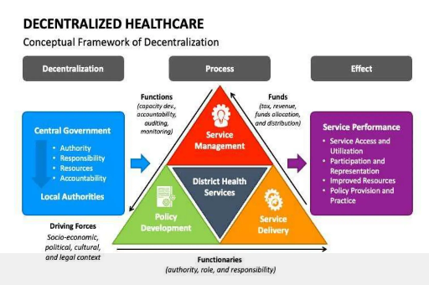
System thinking can assist in the realization that health systems are not straightforward. There are numerous related components that affect them. These sections form feedback loops where an action in one section influences the other section and the other section influences the former section. Due to this, a minor choice in one aspect will lead to significant alterations in other areas. Systems thinking acts as an alert that health systems should not be viewed as individual components but as systems formed as entire structures. Solving of problems cannot happen by examining a single part; an entire picture has to be reflected.
Governance structures were under a lot of pressure due to pandemics like COVID-19. In case of an emergency, the decisions should be taken extremely fast, and information should flow through the various levels of the system without any problem. Clear roles and responsibilities are needed in the field of testing, tracing, communications with the population, hospital administration, border control, and vaccination. When the responsibility is ambiguous or shared among excessive levels, then the reaction time will be slow or uneven. Centralised systems are also responsive due to the fact that they are governed by a single authority and coordinate the major decisions. Decentralised systems can be locally flexible but might not be effective in coordinating at the national level (KinkiniHemachandra, RdgAmaratunga and Haigh, 2022).

2.2 Spain: Decentralised Regional Health System
2.2.1 Pre-COVID System Structure
The health service in Spain is known as the National Health System (SNS) which provides a significant amount of power to the local areas. Although it is referred to as a national system, the 17 autonomous communities of Spain own a majority of the control. The regions operate hospitals, primary care clinics and majority of the government health programs. General regulations and assists in maintaining national standards are made by the national Ministry of Health. The regions are in charge of the day-to-day health-related decisions, budgets and the delivery of services. The regions also play the major role of watching over the health issues, planning of the hospitals and emergency plans as well. Prior to the COVID -19, this model of operations allowed every community to establish services that suited its people (European Observatory on Health Systems and Policies, 2024).
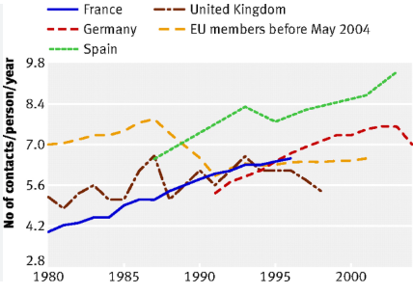
2.2.2 COVID-19 Decision-Making & Centralisation Dynamics
During the early 2020, as the COVID -19 began to spread, the system in Spain, which had the largest part of health control in regions, experienced significant coordination issues. The regions had their own health choices and therefore, responses were not even. There are areas who responded promptly; others took some time to restrict. Hospitals were locally managed and, thus, there was no national strategy of ICU, ventilators, and protective equipment. When the infections were spreading at a rapid rate, it became obvious that the traditional decentralized system was not applicable to an emergency situation that required quick and coordinated response.
In March 2020, the national government placed itself under control by declaring a state of alarm. The Ministry of Health assumed control of the regional health powers. This was to establish a single effective chain of command and accelerate national response. However, this shift created tension between the national ministry and the regional governments particularly in cases where the regions had different parties as their leaders. When the national level was slow in communication, the regions believed they were being robbed of their power and were angered with the fact that they were being deprived of their authority (Antony, 2025).
Spain also experienced difficulties with data. Because regions used different information systems and reporting methods, it was hard for the national government to get accurate and timely data. This slowed response planning. Some regions had stronger public health systems than others, which created inequalities in surveillance and testing capacity.
2.2.3 Advantages & Disadvantages of Spain’s Structure
The decentralised system of Spain had its positive aspects. Local measures like the population needs, level of infection and hospital capacity could be modified according to the regions. Local leaders were connected well to the communities and were able to tailor communication and restrictions. Innovation was also triggered by regional autonomy as various regions experimented with various methods.
Its disadvantages were tremendous in the time of COVID-19. Different policies were implemented in Spain which confounded people. Regions crowded of restrictions on various dates undermine national work to prevent the virus. Disjointed information ensured that it was difficult to respond to outbreaks in a timely manner. The common stocks of PPE and other valuable supplies were not shared, which provoked premature shortages. The national and regional leaders fought politically, which delayed the process of coordination, particularly during the first wave (Bose, 2023).
2.2.4 Impact on Outcomes
During the initial months of the pandemic, a lot of people died in Spain. Numerous hospitals were overcrowded particularly the intensive care units. Aged people were struck most. The situation was aggravated at the early stages due to delays and a disintegrated response. The subsequent waves were better as the coordination improved and the leaders of the nation and regions learnt to collaborate. The implementation of vaccination programs became more stable as a more exact national outline was available (Blot et al., 2022).

2.3 South Korea: Centralised, Technology-Integrated Model
2.3.1 Pre-COVID System Structure
The health control in South Korea is highly centralized. KDCA has highly reputable power in regard to surveillance, tracing and emergency response. Following MERS outbreak in 2015, there were significant changes that enhanced national preparedness. The strength of laws was enhanced in such a way that the government could find data promptly in case of an emergency. KDCA and the national government became powerful to coordinate laboratories, impose measures in the area of public health, and control communication. Due to these reforms, South Korea possessed a well-defined national emergency planning framework during the period when COVID-19 hit the country (Jang, Lee and Park, 2025).
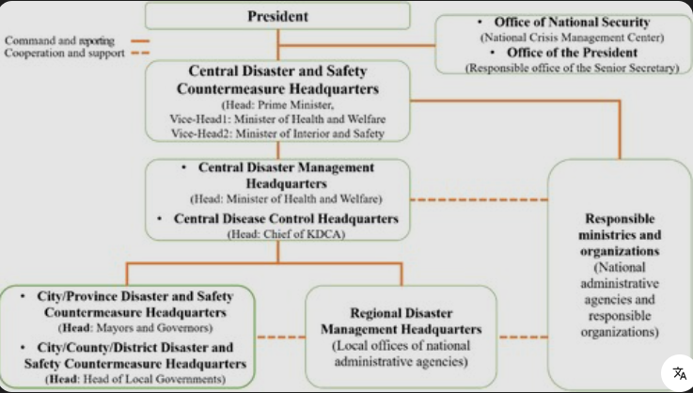
2.3.2 COVID-19 Governance & Central System Effectiveness
South Korea was fast in response to COVID-19 using its centralised strategy. The national government immediately switched on its emergency command system and the KDCA was at the head of the national coordination. The government organized tests, contact tracing and isolation. One national standard was used in the laboratories throughout the country. In several weeks, the government collaborated with the businesses to increase the capacity of testing. The cases were tracked using digital tools and people were encouraged that they might have been exposed to it. The links between national data systems were done hence information was updated immediately (Chung et al., 2021).
One group was in charge of all communication. They used to give briefings every day which were straightforward, factual and candid. The national leaders were saying the same things, and that was not so confusing to everyone. The statutes allowed the government to collect the geographical data, the credit-card histories, and the CCTV tapes so that they could locate the contacts within a short time. This prevented the spread at an early stage.
2.3.3 Advantages & Disadvantages
A centralised strategy of South Korea had numerous benefits. Speed was the largest strength. The decisions were timely and the whole country was governed by the same rules. Scalability testing was made possible as all the resources were coordinated by the national government. There was a high level of consistency in communication that pushed the level of trust in the people. Data could be more easily tracked, rules enforced and strategies changed but there were drawbacks. Powerful utilization of personal information posed a privacy issue. There were those individuals who were not comfortable with the surveillance. Top-down also implied that there was reduced room to make local decisions. National rules were rigid and some communities might have desired more flexibility. Nevertheless, the centralised structure in general was rather effective (Lee and Li, 2021).
2.3.4 Outcome Impacts
At the beginning of the pandemic, South Korea kept the number of deaths very low. Putting the virus under control quickly prevented overcrowding of hospitals. Strong national coordination turned out to be seen, which is why people had more confidence in public institutions. The combination of technology, the legal authority, and the central leadership enabled the nation to remain stable despite case leaps (Jang, Lee and Park, 2025).

2.4 Canada: Highly Decentralised Federal Health System
2.4.1 Pre-COVID Structure
The health system of Canada is managed by the national government and the provinces. The national government controls the borders, general health policies, purchasing vaccines, and provide emergency finances. Most health services are provided by the provinces, hospitals, public health units, rules and other set rules. Due to this division, every province has to make its own decisions, such as, when to lock down, what school rules to establish, etc. This method used to be quite effective in long-term planning but made the disparities in the readiness and competence of every province before COVID.
2.4.2 Pandemic Governance in Practice
Throughout the COVID-19 period, the federal and provincial governments were required to work together, and in some cases, it was not that easy to coordinate. The provinces did not do things at the same time and under the same rules. Indicatively, there are those provinces that imposed restrictions earlier than others. The country had vast differences in schools, masks and business rules. Province-run hospitals were varied in the number of ICU beds, and other areas had more issues. There was inconsistency in the public messaging. The federal leaders discussed togetherness, whereas the provincial leaders tended to preach their messages. This also led to confusion at some time, particularly where rules were changed after short durations (Schnabel and Hegele, 2021).
There were numerous decisions to be made through federal and provincial negotiations including economic assistance, vaccine allocation, and communal health directions. Such negotiations made everything slow. Testing, staffing and digital tools were also different in provinces. It was complicated by the geography of Canada. Remote regions required different solutions and big cities experienced big epidemics. The decentralized system enabled the provinces to be more adaptive to their needs, however, it also implied that the entire nation was less coordinated (Chung et al., 2021).
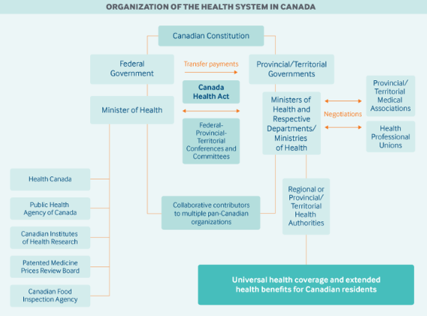
2.4.3 Advantages & Disadvantages
Local flexibility was one of the advantages of the decentralised model in Canada. The provinces did not have to abide by one national rule: they could create their own take on the outbreaks. The response of some provinces was prompt towards protecting the vulnerable population, such as Indigenous populations or rural areas. However, the drawbacks were revealed in the COVID-19. The absence of one national plan meant that the Canadians were regulated differently by different provinces. International movement between provinces facilitated the struggle against the virus. The disparities in supply in the hospitals were apparent and certain care facilities experienced severe outbreak. The dichotomous approach slowed out early response (Burgos, 2025).
2.4.4 Outcomes
In general, the death rate in Canada was moderate, and it was quite disparate across various provinces. The highest number of cases and deaths was in Ontario and Quebec. Other provinces were fairer since they had restrictions before, or they had fewer populations. The vaccine implementation process was successful throughout the country, yet it was various in terms of time and structure per region.

2.5 Comparative Synthesis: How System Structure Shaped Outcomes
Considering Spain, South Korea, and Canada, they find that the structure of their health systems influenced the manner in which each of the countries responded to the COVID-19 crisis. In a systems thinking perspective, they can observe that the arrangement of each country altered the manner in which speedy judgments were achieved, the manner in which various matters were synchronized, and the flow of data (Giménez et al., 2023).
The centralised system in South Korea favoured action that was very rapid. The government was well endowed with legal control, unified information systems and robust command frameworks. This enabled quick testing, tracing and communication. Close coordination minimized confusion and also enabled the country to keep the number of deaths down. The decentralised systems (Spain and Canada) were more flexible but they had difficulties in the initial coordination. The first wave caused inconsistency in policies and slow decision-making due to a regional model in Spain. The federal system of Canada made the provinces become varied, making the country not unified. Through disjointed data systems in the two countries, the capability of tracking outbreaks rapidly was hampered (Pantoja et al., 2017).
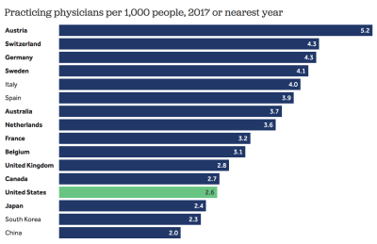

3.0 CRITICAL ANALYSIS OF LEADERSHIP STYLES

3.1 Crisis Leadership Theoretical Framework
The process of leading in case of health emergency is quite different than that of leading in normal times. During a crisis like COVID -19, the leaders will be forced to react swiftly, speak clearly, take difficult decisions and make people feel relaxed even in the face of fear and uncertainty. Dissimilar conceptions regarding leadership reveal the reason why other approaches are better when each one requires assistance.
Transformational leadership is everything connected with inspiring and trustworthiness. These leaders inspire individuals, appeal to them on the emotional level and maintain a long-term perspective to unite all people to work. They strive to unite people and make them feel that they possess a goal. This is significant during a pandemic since citizens must have trust in health recommendations, compliance with regulations, and they must believe their leaders are watching over them (Ystaas et al., 2023).
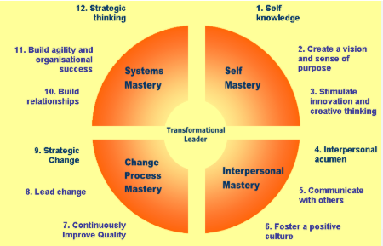
Transactional leadership is strict to rules, guidelines and obedience. Leaders who adopt this style provide orders, prescribe rules and apply the tools of enforcement to influence the behavior of the people. It may come in handy during crises when some serious regulations, such as lockdown or masking, are to be observed. It creates expectations, but it may be too strict or controlling, unless it is accompanied with understanding (admin_upraise, 2025).
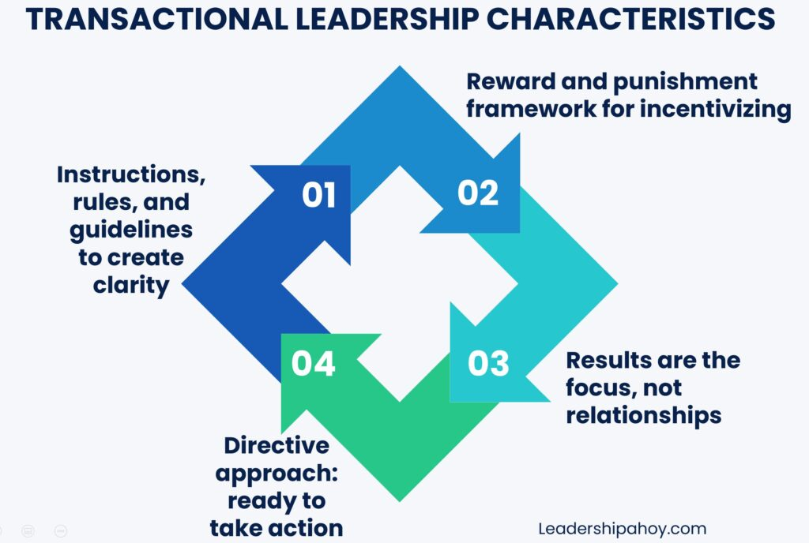
Adaptive leadership implies learning quickly, switching plans, and dealing with uncertainty. COVID-19 was unfamiliar, unpredictable and never static. Adaptive leaders understand that things are not certain, they listen to experts, and also update the decisions with new information. They are elastic and are willing to shift gears when there is a need (TalentSpritn, 2025).
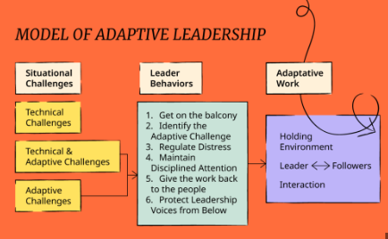
Distributed or collaborative leadership implies that leadership is distributed across the groups, levels, or institutions. Most health systems have national and local governments, hospitals, and public health agencies that share power in many cases. In such systems, a leader cannot dictate on all. Rather, teamwork, conversation and sharing of problem-solving is required (Joubert, 2024).
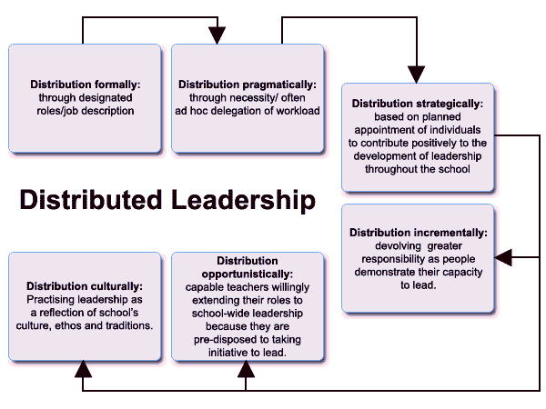
Systems leadership represents viewing the entire system and understanding the way the components are interconnected and operating in various regions. Leaders must understand that health care, politics, education, economy and the behavior of people in the society are interrelated. This mode of thought is highly significant in the case of a pandemic since the decision in one region can transform several other regions.
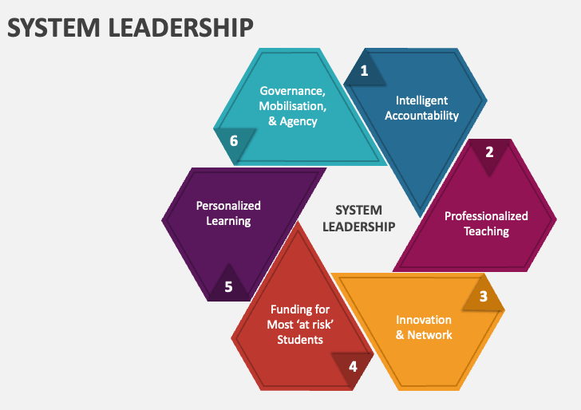

3.2 Spain – Leadership of Salvador Illa
3.2.1 Political & Governance Context
The leadership in Spain during the COVID – 19 period was highly influenced by the decentralised health system in the country. The task of the Minister of Health, who was in charge during the first months of the pandemic was to unite 17 autonomous communities. Every community operated its hospitals, state health offices and numerous emergency regulations. So Illa could not wait and issue commands and expect swift actions. He was forced to negotiate and reach an agreement with regional leaders who were in most cases of other political parties. Political division in the pandemic in Spain was also high. The national government did not get along very well with certain regions government particularly in Catalonia and Madrid. This complicated the process of coordination. Illa could do not have many legal means of imposing national regulations except when the government declared a state of emergency (Casasnovas, Seguí and Goset, 2021).

3.2.2 Leadership Behaviours & Communication
Salvador Illa was kind and placid. He was not behaving like a powerful or authoritative leader. Rather, he desired to enter contracts and maintain positive relations with local leaders. His work was influenced by his philosopher experience and his silent personality. Illa conducted frequent briefings to the people to inform them of the situation. He sat among health professionals and allowed them to clarify much technical information to people, making them believe him (Electoral Bulletin of the Euro- pean Union, 2020).
Illa relied much on expert committees and scientific guidance. He desired that decisions be made on facts and the facts as at the beginning of 2020 were not quite clear and evolving. He was cautious in his approach though at times it made him appear indecisive. When communicating to the people, he did not engage in political battles and made an attempt to demonstrate togetherness. The people found it more difficult to hear him clearly though mixed messages in various parts made it difficult. In general, the leadership style used by Illa was based on diplomacy and collaboration, yet it failed in situations when the crisis was rapid.
3.2.3 Theoretical Analysis
The leadership style used by Salvador Illa is predominantly distributed and adaptive. His decision to use a distributed leadership model was necessitated by the fact that decision-making was decentralized in 17 regions. Therefore, he was forced to work hand in hand with regional presidents and ministers. Rather than giving direct orders, he required negotiation skills. The ability to adapt to the pandemic as the situation changed rapidly also required adaptive leadership as the new information was provided, and Illa had to adjust guidelines (Bolden, 2011).
Illa had a clash in style with an abrupt crisis. At the onset of the pandemic, Spain required immediate decisions, effective national coordination, and effective national discourse. Those are characteristics of transformational or transactional leadership- styles which can be swift. Illa liked consensus and this was slackening the process. His leadership was in accordance with the usual, decentralized system of leadership in Spain but it did not suit the emergency demands of COVID-19. This system began working better only when the government proclaimed a state of alarm and centralized authority in the temporarily (Aarons, 2020).
3.2.4 Evaluation against Outcomes
The number of deaths in Spain at the very beginning was high and most experts believe that had the country been quicker the damage would have been less. Illa was composed and good natured, and he could not act quickly enough to handle an emergency. However, later it improved as the teams collaborated more and the leaders, both local and nationally, cooperated. Illa is to be commended having maintained things in a very tense time, but his cautiousness had weakened the initial reply.

3.3 South Korea – Leadership of Prime Minister Chung Sye-kyun
3.3.1 Governance Context
The system in South Korea was highly centralized when there was an emergency in the health sector and the Prime Minister, Chung Sye-kyun, had a high level of legal authority to make quick decisions. There were also major powers of the Korea Disease Control and Prevention Agency (KDCA). Hospitals, testing laboratories, and communicating to the people could be organized nationally and, thus, Chung could take decisions quickly without having to discuss them with numerous regional governments. Following the outbreak of MERS, South Korea tightened rules on emergency legislation, allowing the government to monitor disease outbreaks and have access to information (Mao, 2024).
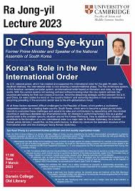
3.3.2 Leadership Behaviours
Chung was a very active Prime minister. He also conducted emergency meetings immediately COVID-19 began. He communicated to the people in a way that was easy to understand, presented truthful facts and did not stutter when things deteriorated. His leadership was straightforward yet peaceful. He also provided detailed briefings, unlike a number of other leaders who did not explain the reasons behind making decisions. This transparency led to maintaining the confidence of the people.
Chung also made firm legal actions. The government soon instituted the mask regulations, border restrictions and stringent isolation regulations. He had a close collaboration with the KDCA and provided them with resources. The government and the private companies cooperated effectively in particular production of test kits. Chung also encouraged innovation and allowed lab departments to expand testing rapidly. This rapid mobilization was one of the reasons South Korea did not go through large scale lockdowns at the start (Zhu et al., 2021).
3.3.3 Theoretical Analysis
The leadership of Chung is equal to the system and transactional approaches. His decisions were grounded on firm rules that were strictly followed and talking straight, which are also important qualities of transactional leadership. His legal authority was utilized well and people complied with health regulations. Simultaneously, he demonstrated systems leadership by uniting numerous organizations, such as the tech companies, health agencies, and local governments (Dong, 2023).
Adaptive leadership was also applied by Chung. As other new clusters emerged, he soon switched the strategies. This was demonstrated by government restrictions on only certain locations rather than lockdowns on the entire nation and demonstrated that the government was flexible and able to learn. This flexibility was effective since the various systems were already collaborating and were able to react promptly.
3.3.4 Outcome Evaluation
South Korea had an opportunity to prevent the virus at the initial stages and did not have to use massive lockdowns. Deaths remained minimal and hospitals were not overrun with too many patients. People believed more the messages of the government. The leadership of Chung, the emergency regulations and the integration of the health systems to provide a rapid and consistent response is how it worked. Due to this fact, South Korea was among the most suitable places to deal with COVID-19 in the beginning.

3.4 Canada – Leadership of Prime Minister Justin Trudeau
3.4.1 Context
The federal organization of the country formed the style of leadership of Justin Trudeau. The federal government was not able to operate the hospitals or make local regulations, as they were the prerogative of the provinces. Trudeau had the ability to regulate borders, vaccines, and Canadian funding, but the majority of the pandemic response was left to provincial leaders. Canada is quite varied and big with numerous provinces that vary widely in terms of population, geography and politics. Those variations altered the expectations of people and made it difficult to perform in all places. Trudeau was forced to collaborate and convince, but not dictate (Kestler-D’Amours, 2025).
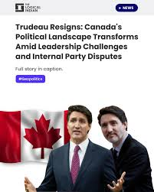
3.4.2 Leadership Behaviours
Justin Trudeau was concentrated on compassion, solidarity, and peaceful speech. During the initial months of COVID-19 he gave daily press conferences outside his house. He attempted to pacify the Canadians and request that they all unite. His transformational style was evident because he used to say they are all in this together.
Economic support programs, including emergency income benefits and wage subsidies, were also initiated by Trudeau. These assisted in order to decrease any worry about money so that people will be more ready to adhere to health precautions. He was caring and responsible taking care of families, workers and the vulnerable (Canada, 2020).
3.4.3 Theoretical Analysis
Trudeau was an effective leader who attempted to inspire and rally people behind him. His speeches of hope, encouragement and collaboration maintained the spirit amid a long and intense crisis. Trudeau was forced to share power and collaborate with the provinces since they controlled a number of critical decisions. However, he found it difficult to provide a consistent national plan because some provincial leaders opposed him (Plakhov, 2018).
The dissonance between how the government was established and how it was operated was clear cut. The inspiring style of Trudeau was able to keep the people calm but it did not correct the split structure. A business or firm-style approach could not be taken since the federal government lacked the authority. Thus the outcome of leadership was largely predetermined by the structure and not the quality of the leader.
3.4.4 Outcome Evaluation
Canada's outcomes were mixed. Other provinces also fared well and others were faced by high rates of deaths and massive outbreaks. The leadership of Trudeau was useful in uniting the nation and making the finances stable but the country could not coordinate rapidly due to limitations on federal power. His style boosted popular confidence and failed to address structural issues.

3.5 Comparative Leadership Synthesis
The comparison of the leaders in Spain, South Korea, and Canada reveals that the effectiveness of the work of the leaders is heavily dependent on the arrangements of the health system. The system design is strongly connected with leadership. South Korea had the best fit. The centralized system of emergencies suited the leadership style of Chung Syekyun that was clear, action oriented and system oriented. Chung could spear head a co-ordinated and rapid response with one national authority overseeing the matter. He was successful early, because his style suited the institutions (Restivo et al., 2022).
Spain had a partial mismatch. Salvador Illa led flexibly in a style that would have suited ordinary times but no more than the first wave. How he went about getting everyone to agree was too slow to the emergency that was in fast motion. The situation improved when Spain briefly centralized power and hence coordination. Illa managed subsequent waves even more successfully, but nonetheless, did not cope in the most urgent situations. Canada was the country that had the largest distance between the system and the style of the leader (Seijts, de Clercy and Miller, 2022).
Across the three countries, several lessons emerge:
- Leadership must complement system structure. Powerful centres must have defined leaders. Decentralised systems require the presence of good teamwork leaders who are not sluggish in action.
- Communication style affects public trust. Strauss, straightforward and direct talking, which South Korea is good at, keep them working as a team.
- Adaptive leadership is essential. New evidence appeared and all leaders were forced to modify plans. Transformative leaders performed more successfully.
- Systems thinking is critical. Leaders should be aware of the relationships between hospitals, data, policy, and social behavior.
- Leadership and system design are interdependent. Strong structures cannot be taken to compensate poor structures and good leadership cannot correct poor leaders.

4.0 CONCLUSION
This report has focused on the response of Spain, South Korea, and Canada to COVID-19 by comparing their health system arrangements and the way the leaders responded. The primary finding is that the structure of a health system has significant implications on the speed with which a nation can respond, and the leadership of the country improves such responses within that structure. The centralized system enabled South Korea to be quick and respond in a coordinated manner with the assistance of strong national leadership. The health systems in Spain and Canada are more disseminated, and both were struggling to organize early, and their leaders were confronted with constraints that slowed national efforts (Kim, 2025).
The three countries have lessons to be learned in future pandemic planning. First, there should be improved and interconnected monitoring in health systems where information can be transferred quickly across regions and organizations. Second, the countries should have an improved coordination between the local and the national governments particularly in cases where there is overlapping of powers. Third, leadership strategies should be crisis prepared. During emergencies, leaders must learn to take quick actions, speak effectively, and collaborate with specialists (Gigliotti and Alvarez-Robinson, 2025).
On the whole, the analysis demonstrates that the concept of thinking in terms of whole systems, effective leadership, and evidence-based decisions are necessary to address the global health emergency. Good leaders and systems properly designed interact together and help countries to be more active and ensure their citizens are safer.

References List
Aarons, G. (2020). Transformational and Transactional Leadership: Association with Attitudes toward Evidence-Based Practice. Psychiatric Services, [online] 57(8), pp.1162–1169. doi: https://doi.org/10.1176/appi.ps.57.8.1162.
admin_upraise (2025). Learn What Transactional Leadership Is, Its Advantages and Uses - UpRaise. [online] UpRaise. Available at: https://upraise.io/blog/what-is-transactional-leadership/.
Antony, S.T. (2025). Health system at central, state and local levels, i. [online] Slideshare. Available at: https://www.slideshare.net/slideshow/health-system-at-central-state-and-local-levels-i/236960470 [Accessed 10 Dec. 2025].
Blot, S., Ruppé, E., Harbarth, S., Asehnoune, K., Poulakou, G., Luyt, C.-E., Rello, J., Klompas, M., Depuydt, P., Eckmann, C., Martin-Loeches, I., Povoa, P., Bouadma, L., Timsit, J.-F. andZahar, J.-R. (2022). Healthcare-associated infections in adult intensive care unit patients: Changes in epidemiology, diagnosis, prevention and contributions of new technologies. Intensive and Critical Care Nursing, [online] 70(103227). doi: https://doi.org/10.1016/j.iccn.2022.103227.
Bolden, R. (2011). Distributed Leadership in Organizations: A Review of Theory and Research. [online] ResearchGate. Available at: https://www.researchgate.net/publication/228118715_Distributed_Leadership_in_Organizations_A_Review_of_Theory_and_Research.
Bose, A. (2023). Federalism in India Part 4: Inter-State Coordination and Dispute Resolution. [online] Rgics.org. Available at: https://www.rgics.org/democracy/federalism-in-india-part-4-inter-state-coordination-and-dispute-resolution/ [Accessed 10 Dec. 2025].
Brown, L.D. (2003). Comparing Health Systems in Four countries: Lessons for the United States. American Journal of Public Health, [online] 93(1). doi: https://doi.org/10.2105/ajph.93.1.52.
Burgos, H. (2025). When most people think of Canadian health care, they picture a single, unified system that works the same from coast to coast. But that’s not quite how it works.[online] Linkedin.com. Available at: https://www.linkedin.com/pulse/pros-cons-canadas-decentralized-health-care-system-hernan-burgos-9tjje [Accessed 10 Dec. 2025].
Canada, D. of F. (2020). Additional Details on the Canada Emergency Wage Subsidy. [online] www.canada.ca. Available at: https://www.canada.ca/en/department-finance/news/2020/04/additional-details-on-the-canada-emergency-wage-subsidy0.html.
Casasnovas, G., Seguí, L. and Goset, A. (2021). Sustainability and Resilience in the Spanish Health System. [online] Available at: https://www3.weforum.org/docs/WEF_PHSSR_Spain_Report.pdf.
Chung, S.-C., Marlow, S., Tobias, N., Alogna, A., Alogna, I., You, S.-L., Khunti, K., McKee, M., Michie, S. and Pillay, D. (2021). Lessons from countries implementing find, test, trace, isolation and support policies in the rapid response of the COVID-19 pandemic: a systematic review. BMJ Open, 11(7), p.e047832. doi: https://doi.org/10.1136/bmjopen-2020-047832.
Dong, B. (2023). A Systematic Review of the Transactional Leadership Literature and Future Outlook. Academic Journal of Management and Social Sciences, [online] 2(3), pp.21–25. Available at: https://pdfs.semanticscholar.org/8158/5768e874415ebf8b69fee2520929c0e283cb.pdf.
Electoral Bulletin of the Euro- pean Union. (2020). Available at: https://geopolitique.eu/wp-content/uploads/2021/09/BLUE_1_en-1.pdf [Accessed 10 Dec. 2025].
European Observatory on Health Systems and Policies (2024). Spain: Health System Review 2024. [online] Who.int. Available at: https://eurohealthobservatory.who.int/publications/i/spain-health-system-review-2024.
Gigliotti, R.A. and Alvarez-Robinson, S. (2025). The Role of Leadership Communication in Building Crisis Readiness and Resilient Leadership in Times of Disruption: An Exploratory Study. Behavioral Sciences, [online] 15(9), pp.1260–1260. doi: https://doi.org/10.3390/bs15091260.
Giménez, V., Prior, D., Thieme, C. and Tortosa-Ausina, E. (2023). International comparisons of COVID-19 pandemic management: What can be learned from activity analysis techniques? Omega, [online] p.102966. doi: https://doi.org/10.1016/j.omega.2023.102966.
Jang, Y., Lee, H. and Park, H. (2025). Surveillance System for Infectious Disease Prevention and Management: Direction of Korea’s Infectious Disease Surveillance System. Journal of Korean Medical Science, [online] 40(8). doi: https://doi.org/10.3346/jkms.2025.40.e108.
Joubert, S. (2024). What is Collaborative Leadership? [online] Northeastern University Graduate Programs. Available at: https://graduate.northeastern.edu/knowledge-hub/collaborative-leadership/.
Kestler-D’Amours, J. (2025). How the Justin Trudeau era changed Canada. [online] Al Jazeera. Available at: https://www.aljazeera.com/news/2025/1/6/how-the-justin-trudeau-era-changed-canada.
Kim, S. (2025). From Fast Follower to Innovation Leader: Restructuring South Korea’s Technology Regulation. [online] Itif.org. Available at: https://itif.org/publications/2025/03/03/from-fast-follower-to-innovation-leader-restructuring-south-koreas-technology-regulation/.
KinkiniHemachandra, RdgAmaratunga and Haigh, R. (2022). Epidemics and pandemics risk governance: a case of post-COVID-19 in the United Kingdom. Elsevier eBooks, [online] pp.89–106. doi: https://doi.org/10.1016/b978-0-323-99277-0.00010-3.
Lee, Y. and Li, J.Q. (2021). The role of communication transparency and organizational trust in publics’ perceptions, attitudes and social distancing behaviour: A case study of the COVID‐19 outbreak. Journal of Contingencies and Crisis Management, 29(4), pp.368–384. doi: https://doi.org/10.1111/1468-5973.12354.
Mao, Y. (2024). Why do democracies respond differently to COVID-19? A comparison of the United States and South Korea. Frontiers in public health, 11. doi: https://doi.org/10.3389/fpubh.2023.1285552.
Pantoja, T., Opiyo, N., Lewin, S., Paulsen, E., Ciapponi, A., Wiysonge, C.S., Herrera, C.A., Rada, G., Peñaloza, B., Dudley, L., Gagnon, M.-P., Garcia Marti, S. and Oxman, A.D. (2017). Implementation strategies for health systems in low-income countries: an overview of systematic reviews. Cochrane Database of Systematic Reviews, [online] 9. doi: https://doi.org/10.1002/14651858.cd011086.pub2.
Plakhov, D. (2018). Prime Minister Justin Trudeau: Transformational Leadership in the Federal Government. Federalism-E, 19(1). doi: https://doi.org/10.24908/fede.v19i1.10952.
Restivo, V., Minutolo, G., Battaglini, A., Carli, A., Capraro, M., Gaeta, M., Odone, A., Trucchi, C., Favaretti, C., Vitale, F. and Casuccio, A. (2022). Leadership Effectiveness in Healthcare Settings: a Systematic Review and Meta-Analysis of Cross-Sectional and Before–After Studies. International Journal of Environmental Research and Public Health, [online] 19(17), pp.1–13. Available at: https://pmc.ncbi.nlm.nih.gov/articles/PMC9518077/.
Schnabel, J. and Hegele, Y. (2021). Explaining Intergovernmental Coordination during the COVID-19 Pandemic: Responses in Australia, Canada, Germany, and Switzerland. Publius: The Journal of Federalism, 51(4). doi: https://doi.org/10.1093/publius/pjab011.
Seijts, G., de Clercy, C. and Miller, R. (2022). Character and Trust in Crisis Leadership: Probing the Relationships Among Character, Identification-Based Trust, and Perceptions of Effectiveness in Political Leadership During the COVID-19 Pandemic. The Journal of Applied Behavioral Science, 59(1), p.002188632211106. doi: https://doi.org/10.1177/00218863221110627.
TalentSpritn (2025). Is Adaptive Leadership the Cornerstone of Senior Executive’s Success in 2026? [online] Talentsprint.com. Available at: https://talentsprint.com/blog/what-is-adaptive-leadership [Accessed 10 Dec. 2025].
Wayne, S. (2019). Centralized Authority: Definition & Explanation Video with Lesson Transcript | Study.com. [online] Study.com. Available at: https://study.com/academy/lesson/centralized-authority-definition-lesson-quiz.html.
World Health Organization (2020). MONITORING THE BUILDING BLOCKS OF HEALTH SYSTEMS: A HANDBOOK OF INDICATORS AND THEIR MEASUREMENT STRATEGIES. [online] Available at: https://apps.who.int/iris/bitstream/handle/10665/258734/9789241564052-eng.pdf.
Yimer, B., Ashebir, W., Wolde, A. and Teshome, M. (2020). COVID-19 and global health security: overview of the global health security alliance, COVID-19 response, African countries approaches, and ethics. Disaster Medicine and Public Health Preparedness, pp.1–11. doi: https://doi.org/10.1017/dmp.2020.360.
Ystaas, L.M.K., Nikitara, M., Ghobrial, S., Latzourakis, E., Polychronis, G. and Constantinou, C.S. (2023). The impact of transformational leadership in the nursing work environment and patients’ outcomes: A systematic review. Nursing Reports, [online] 13(3), pp.1271–1290. doi: https://doi.org/10.3390/nursrep13030108.
Zhu, Z., Weber, E., Strohsal, T. and Serhan, D. (2021). Sustainable border control policy in the COVID-19 pandemic: A math modeling study. Travel Medicine and Infectious Disease, 41, p.102044. doi: https://doi.org/10.1016/j.tmaid.2021.102044.

