B.A (HONS) Leadership and Management
Developing relationship and workplace achievements
(January 2022)
Module code: BMSW5102
Student Name: Toni Trevis
Student Number: 2016781
Tutor: Sujeewa Herath

Table of content

Introduction…………………………………………………………………………...…………. 3
The appropriateness of fresh directs procedures when recruiting and training new staff and identifying issues within the company………………….……………………………………….4-5
Development Vehicles to improve operations..…………………………………………..…….6-7
Conclusion…………………………………………………………………………………..…….8
Component 2 SMART &PDP……………………………………………………………………9-10
Reference List………………………………………………..................................................11-12

Introduction

This report investigates the issues being faced by fresh direct. Delving into the positive and negative factors and staffing issues harbouring or enhancing the companies progression within the establishment. We look at the processes for employee training and recruitment, H.R.M vehicles and how it helps understand the employee, improve business functions and promotes ethical practice looking at the impact of motivation based on wants, needs, thoughts and feelings in order to better manage fresh direct. Increasing the likelihood of reoccurring customers and sales and decreasing current issues. Fresh Direct have some underlining issues. This report aims to identify the problems look at possible solutions and analyse current H.R policies and practices with the intention of improving Fresh directs ability to meet the high demand they are facing, whilst effectively training new staff to ensure optimal performance. Providing a swot analysis and PDP plan to help fresh direct regain control and address the issues being underlined.

3
The appropriateness of fresh directs procedures when recruiting and training new staff and identifying issues within the company

From the case study provided it is clear to see that fresh direct have had issues with ensuring enough staff to carry out jobs and in turn meet customers demands. Fresh direct have experienced a rapid growth rate in a short period of time. This has pushed fresh direct towards recruiting new employees to meet the demands of customers and be able to continue increasing productivity. However, fresh direct have shortlisted candidates based on one initial video, Candidates are not required to actually go into the company until the day they start for work, there is no probationary period and no training required prior to their employment at the company. Candidates spend just 20 minutes in the video call and one day with a current staff member before being given individual responsibility. This is poor practice and H.R.M may help develop a better work force. Training and allocating the right person to the right job is critical in the progression and success of any business. (tekshapers, n.d). All businesses are perishable and having poorly informed or trained staff can impact the effectiveness of the business and cause arising issues for production and the business as a whole.
From the case study it is visible that fresh direct employees are also looking to leave the company due to the lengthy hours being more than contracted. The training and development of skills within the business is vital. New employees should have to undergo basic training to ensure everyone meets targets set by the company. Equipment shortages also adds extra pressure to workers workloads. Machinery and equipment needs to be expanded on to reduce the workload off current staff members and give time for a more balanced work life and happy employees. Fresh Direct have rushed the recruitment process to try and keep up the demands of the consumer however this is proving costly and without intervention may see fresh factor plumet and struggle to regain momentum and sales. Complaints show customers are also dissatisfied with the products and services provided by the company. This can damage their reputation and see the loss of valuable customers. Customers may also spread the word of poor practice within fresh direct harbouring their ability to meet and regain sales.

4

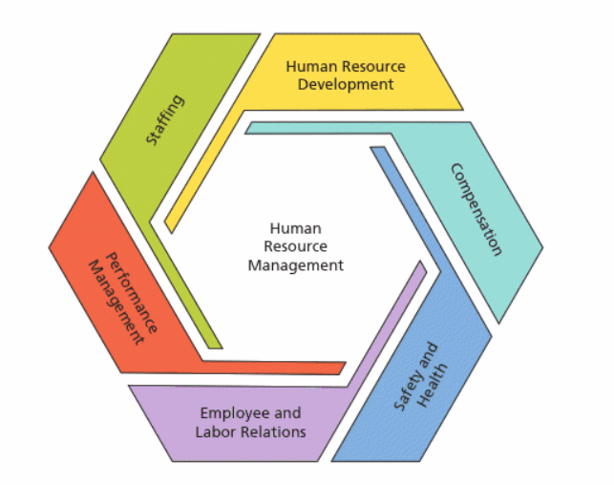
Martocchio, 2018
Human Resource management or H.R.M is associated with the management and employment of people within a business. H.R.M aims to ensure ethical practice and develop a talented workforce made up of skilled individuals. Human resource management is seen throughout every aspect of business. H.R.M strategies help manage activities such as human capital, Training and development of employees, organisational development, Recruitment processes, health and safety and much more. H.R.M deal with staffing issues and are responsible for performance management within a business sector.
It is clear from the case study Fresh Direct lack efficient H.R.M. tools and processes There is a lack of employee training and there is also a clear issue regarding staffing. Employees are overworked leading to many wanting to leave the company if they receive a better job opportunity. This implies staff are unhappy within their job role and have little motivation or love for their job. (chander et al,.2009). A overworked employee with a lack of motivation and passion towards their work will see productivity decline and employees working to a less than satisfactory level as they have no passion to deliver or perform at a high standard and employees may not strive to achieve or succeed. There are two approaches to H.R.M the hard approach and the soft approach. (CIDP, 2021). The Hard approach is a strategy that is highly structured. Employees are monitored and given rules and tasks to adhere to. The hard approach gives direct orders limiting the employee. And ensuring strict adherence (Wilkinson et al,. 2017). The soft approach is an employee-centred controlled approach, it is a lot more flexible and employees are encouraged to use their own initiative. The soft approach is a strategy used for trusted workers and encourages flexibility and self-control.
5
Development vehicles to help Fresh Direct improve productivity and employee relations through effective H.R.M talent management
Training and development
According to Merryville university “employee training and development programs are essential to the success of businesses globally” (Maryville University, 2021). It is vital for fresh direct to take more time when recruiting and selecting candidates, ensuring training is provided and ensuring the development of vital skills to suit individuals specific job role. Increasing the insurance of successful deliverance, performance and ethical work/ practice within the business (O’Neill, 2019). If fresh direct adopted a more targeted approach and delivered adequate training to new employees this could see the business start to progress again and ensure jobs are being carried out to a satisfactory standard preventing the need for reworks and negative or insufficient workloads (Chitra Reddy, 2019). Using a hard approach for new employees to ensure every task is carried out to a satisfactory standard will increase productivity and ensure a high standard being delivered within the company. (Skeiseid et al,.2020). Skilled workers can then be trusted to work effectively and leadership may adopt a more soft approach giving skilled, trained individuals more opportunity, flexibility and the ability to use their own skills to best deal with situations. A two week probationary period with on the job training may be a great idea to help develop their new employees and maximise their potential, in turn increasing productivity and the level of work being produced.

Motivation
Motivation is important among workers. Employees tend to succeed and better progress in job roles they enjoy (Ryan,. 2019). motivation is the drive and passion within an individual, it is what pushes a person to reach their goals and targets. Different types of motivation motivate people for different reasons, for example if a person is intrinsically motivated they have a love for their work and a passion and sense of belonging within their job role. People who are extrinsically motivated to do their job tend to be motivated through external factors such as reward, appraisal and pay incentives (Hagger et al,. 2017). Ethical practice ensures employees are treated fairly and that they are not being overworked or treated poorly. It is a great suggestion to implement motivational practices to encourage ambition and drive. Increasing job satisfaction and employees sense of belonging. Intrinsic motivation will see employees eager to retain their jobs and strive to achieve within their organisation (Motivation and emotions, 2016). Employees should be given respect and ensuring a happy, motivated, skilled workforce is vital in the success and progression of fresh direct.
6
Fresh direct may benefit from speaking to employees and gaining vital feedback from these individuals to assess what is demotivating them within the company, looking at things like working conditions, length of shifts, shift patterns, subordinates individual job roles and their suitability in that role. This may help leadership identify internal issues and threats whilst also determine the best course of action to reduce the risk of unhappy/ overworked employees.
Leadership management
It is vital for Fresh Direct to ensure optimal leadership abilities, and Leaders that can adapt to a forever changing workforce. Flexible leaders who are skilled enough to identify poor practice and demotivated workers is vital in building and regaining moral among fresh Direct workers and drive productivity. Workers are highly motivated by reward systems and recognition for their hard work (myers, 2013). The failings of fresh direct is partly due to poor leadership choices and lack of intervention (University of Wolverhampton, 2021). Fresh direct employees look to leadership for assurance and appraisal. Leadership and management need to ensure a basic level of training is provided to new employees and that their current employees are satisfied within their role and performing effectively to a high standard. This minimises the risks of errors, demotivated workers and poorly trained individuals making mistakes that may potentially cost the business. More should be done to ensure equipment is efficient and that there is enough machinery to cope with the growing productivity rate. If current employees are overworked they may not be working to their full potential, again increasing the risk of poor works, errors or failures within Fresh Direct. It is important to ensure staff are treated fairly and have the ability to work in ethical conditions where they are valued by their employer or manager.
It is the responsibility of leadership to ensure their subordinates are skilled enough to carry out tasks, putting unskilled subordinates in positions they can not or do not know how to handle is poor practice on leaderships behalf and has shown to be causing issues within the business not only for internal reasons but external too, Such as dissatisfied customers this is a direct result of employing unskilled workers and not being able to meet the growing demand due to lack of equipment. Leadership should feed information to higher and lower levels ensuring the head offices know whats lacking and the subordinates are adequately trained and skilled enough to complete the work expected of them.

7
Conclusion
Fresh direct have issues with recruitment and training processes, the company are also struggling to meet the demands of the consumer with not enough equipment or efficiently trained staff the company is struggling. Employees and customers are showing a level of dissatisfaction and employees are demotivated and waiting for opportunities to leave the company. Fresh direct have a lack of H.R.M tools and may see themselves perishing if action is not taken to address the current issues. Ensuring staffing issues are addressed and that new employees are trained and skilled enough to carry out tasks effectively is vital in the development and upkeep of the workforce. Motivating workers and ensuring they are not overworked, showing appreciation towards their efforts and a level of understanding and supportive leadership may see more satisfied workers and better practice as a result of happy, trained, highly skilled workers. The swot analysis conducted highlights strengths, weaknesses areas of threat and opportunities enabling fresh direct to assess the situation and act in a manor best suiting to their environment and workforce. The personal development plan will help fresh direct meet their objectives and understand how to implement and monitor chosen paths or actions. If fresh Direct adapt the development vehicles above they could see the business regain momentum and the issues being addressed accordingly. To insure success fresh direct need to constantly monitor the progression of implementations and be able to adapt to a forever changing workplace. Leadership need to take more responsibility for recruitment and ensure adequate training and development programmes are available for new workers. Enabling understanding and a higher standard of quality workers, skilled task forces and best possible practice to increase productivity and meet the current demand,

8
Swot analysis and PDP plan
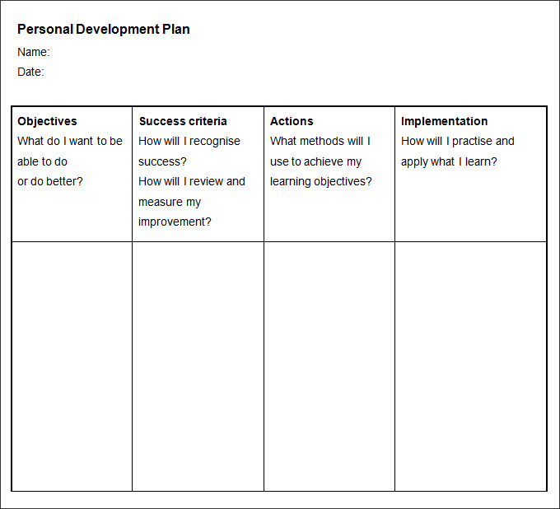
Improve employee skill set and training, cope with the current demands and better motivate workers.
Constant monitoring of subordinates, more visual ethical practice and a happy workforce will show the implementations are working.
the maslows hierarchy of needs may help motivate subordinates whilst internal training opportunities for new staff will ensure they are skilled enough to complete tasks
Following the previous development steps will help understand their abilities to rectify the current issues. Learning from the implementations will help put things into practice and help educate leadership on their workforce
A personal development plan aims to create a process or action plan with aims to implement the methods and reach objectives set (Putter, 2021). The personal development plan above shows the current objectives and areas of improvement, it shows how to monitor success and improvements when taking action to rectify any issues. Showing implementation plans and how this may help Fresh direct develop and improve their staffing issues and ability to meet consumer needs.

9
Doing a swot analysis identified the strengths, weaknesses, opportunities and threats that fresh direct is facing, this strategic planning helps evaluate four elements, strengths, weaknesses, opportunities and threats (Visual Paradigm, 2019).
one strength is that they have been working their way up going from a family run business toa forever growing company that employs over 100 workers… this however has also created weaknesses within the company. Inadequate amounts of equipment and under skilled workers are negatively impacting production and customer satisfaction leading to complaints and unhappy workers. These weaknesses also bring opportunity to improve and understand the arising issues addressing them head on to gain a better knowledge and understanding of the establishment and its workforce. There is opportunity to expand further if the current issues are addressed swiftly and accordingly but all levels of H.R must be working effectively and leadership must take responsibility for their subordinates and the level of training they receive (Productplan.com, 2018). If the current issues are not addressed the company may perish resulting in debt for the owners, loss of jobs for employees and dissatisfied customers seeking products and services elsewhere. The biggest threat is the risk of ceased trading and fresh factor going into remission. Other reputable companies may also steal the lime light if they are meeting the needs of customers and excelling expectations.

10
Reference list

Chanda, A. and Shen, J. (2009) HRM strategic integration and organizational performance. Los Angeles, [Calif: Response.
Chitra Reddy (2019). Staff Training: Importance, Benefits, Advantages & Disadvantages - WiseStep. [online] WiseStep. Available at: https://content.wisestep.com/staff-training-importance-benefits-advantages-disadvantages/.

moodle.uwtsd.ac.uk. (n.d.). UWTSD Moodle 2021/22: Log in to the site. [online] Available at: https://moodle.uwtsd.ac.uk/pluginfile.php/560387/mod_resource/content/1/HR%20and%20standards%20CIPD%20report%282018%29.pdf [Accessed 5 Apr. 2022].

myers (2013). Definitions of Leadership and Management. [online] Teamtechnology.co.uk. Available at: https://www.teamtechnology.co.uk/leadership/management/definitions-of-leadership-and-management/.

Hagger, M. and Chatzisarantis, N. (2007) Intrinsic motivation and self-determination in exercise and sport. Leeds: Human Kinetics.
Motivation and emotion. (1977). New York, N.Y: Kluwer Academic/Plenum Publishers.

O’Neill, E. (2019). The Importance of Training Employees for your Business | LearnUpon. [online] LearnUpon. Available at: https://www.learnupon.com/blog/importance-of-training-employees/.
‌Putter, M. (2021). What is a personal development plan? [online] CPD Online College. Available at: https://cpdonline.co.uk/knowledge-base/business/what-are-personal-development-plans/.
Productplan.com. (2018). What is a SWOT Analysis? | Definition and Overview. [online] Available at: https://www.productplan.com/glossary/swot-analysis/.
‌Ryan, R.M. (2019) The Oxford handbook of human motivation. Second edition. New York: Oxford University Press.
SKEISEID, H., DERDOWSKI, L.A., GRAHN, Å.H. and HANSEN, H., 2020. Motivating Sustainable Change in Tourism Behavior: The First- and Third-Person Effects of Hard and Soft Messages. Sustainability, 12(1), pp. 235.
University of Wolverhampton. (2021). The importance of leadership and people management skills. [online] Available at: https://online.wlv.ac.uk/the-importance-of-leadership-and-people-management-skills/ [Accessed 6 Dec. 2021].

11
Visual Paradigm (2019). What is SWOT Analysis? [online] Visual-paradigm.com. Available at: https://www.visual-paradigm.com/guide/strategic-analysis/what-is-swot-analysis/.
‌www.tekshapers.com. (n.d.). Importance of Training & Development. [online] Available at: https://www.tekshapers.com/blog/Importance-of-Training-and-Development.
‌ Wilkinson, A., Armstrong, S.J. and Lounsbury, M. (2017) The Oxford handbook of management. Oxford, England: Oxford University Press.

12

