Smart and Connected Devices 1

Lecturer – Gaynor Thomas
Scott Howells
Student P Number – 1701604

Table of Contents
Abstract 2
Introduction 2
Security 2
Data Transfer 5
Displaying the Data 6
Database 11
Conclusion 12
References 12

Abstract
The ever-growing need for technology has no boundaries as more and more people are using it in everyday life. The Internet of Things (IoT) allows for everyday real-world objects (things) to be connected through the use of the Internet. The following report has been conducted in order to illustrate the implementation and features used in the making of a web interface through the use of PHP and the procedures taken in order to perform specific tasks. These tasks result in several pieces of data being transferred to a database and thus populated by more than one IoT device.

Introduction
This report will document the procedures taken in order to transfer text files onto a database. In the previous assignment data had been written onto text files via the readings of an IoT system. This report will document the populated text files via the IoT system to be transferred onto a database through the use of PHP and a suitably developed web interface. When successfully transferred, the data will be accessed by a user to view and interact with the data through the use of the suitably created web interface. Each text file contains data taken from a series of temperature readings. The data had been received from external sensors in different locations taken at different times. This report will highlight the key aspects when in the development stage of the interface and suitable annotations to highlight why that approach was ultimately taken.

Security
Security is an important feature to include when creating any web interface that deals with data [1]. Data is vulnerable and without the correct protection measures in place the interface and the data is easily accessible by anyone and can easily be manipulated and exposed. It was imperative to include a form of security in order to protect against unauthorized personnel accessing this data [2]. The implementation of a login was introduced to the web interface in order to restrict anyone other than the user to access the data.
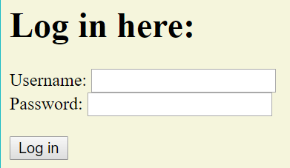
Figure 1 – login.php
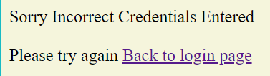
Figure 2 – checklogin.php
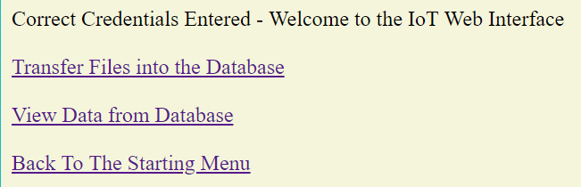
Figure 3 – login.php
Figure 1 illustrates the login page containing the fields that must be correctly entered in order to progress. Figure 2 demonstrates the Check that is performed in order to determine if the credentials entered are correct. In the case of figure 2 the credentials were incorrect and displayed appropriately. Figure 3 illustrates the correct credentials being entered and allows for progression.
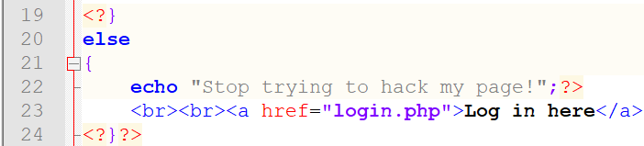
Figure 4 – checklogin.php
Figure 4 highlights code that was developed so that if an individual attempts to access a page before login in then an error message will display. This was conducted within an else function in order to determine if the individual has attempted it or not.
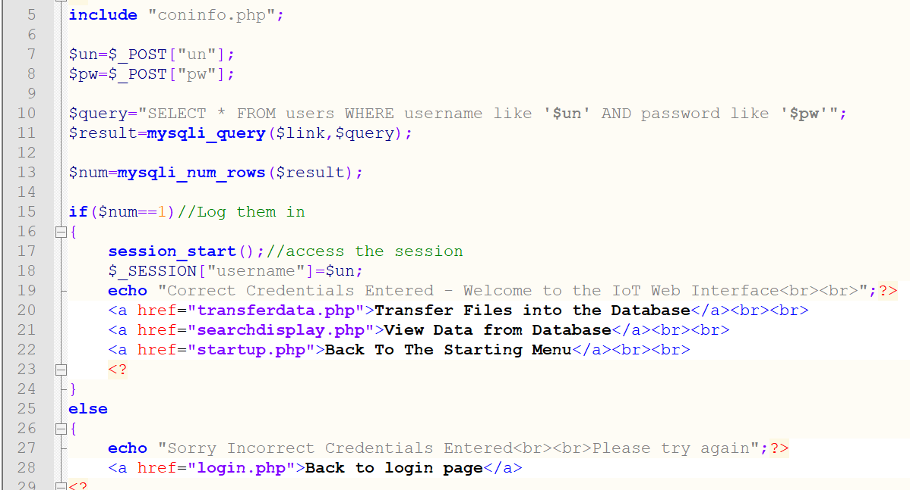
Figure 5 – checklogin.php
Figure 5 contains snippets of the code used for the check login. The code highlights that the correct user must be fetched from the user’s database that has been created (see screenshot section to view this database and its fields).
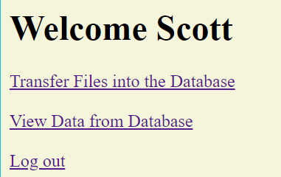
Figure 6 – startup.php
When heading back to the startup page whilst having already being logged in, the page will notice the user and display their name next to the welcome. If not logged in however, the user will only be prompt to logged in as seen in figure 7 below.
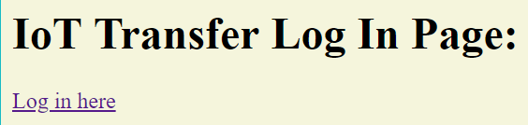
Figure 7 – startup.php
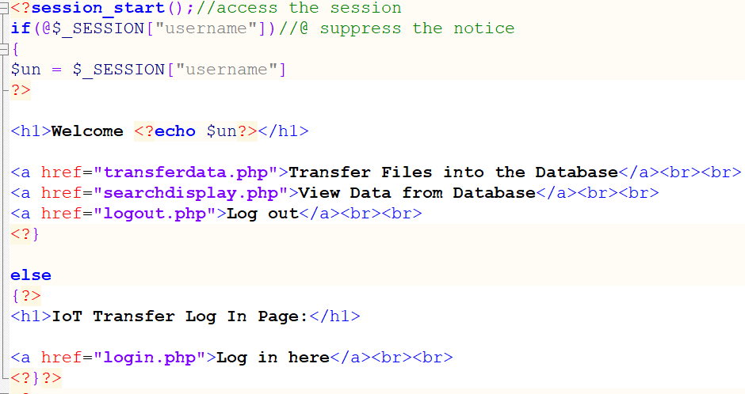
Figure 8 – stratup.php
The code above in figure 8 highlights the features used in order to display the correct message if logged in or not.
When completing all actions by transferring the data and then ultimately viewing the data, the option to logout is provided to ensure the security and nobody being able to access.
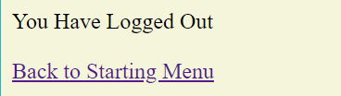
Figure 9 – logout.php
The logout page issues to the user that they have logged out and must click on the start menu link in order to log back in.

Data Transfer
The data must be transferred from text files and placed into the database. The data within these files will be deleted after transferred in order to prevent dual entries.
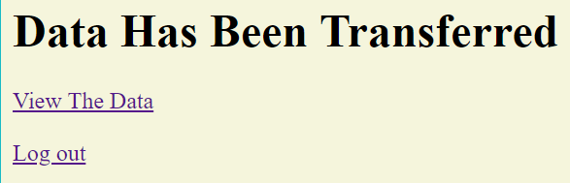
Figure 10 – transferdata.php
The screenshot in figure 10 illustrates the data being transferred from the text files and into the database. The view data link will allow the user to view the data.
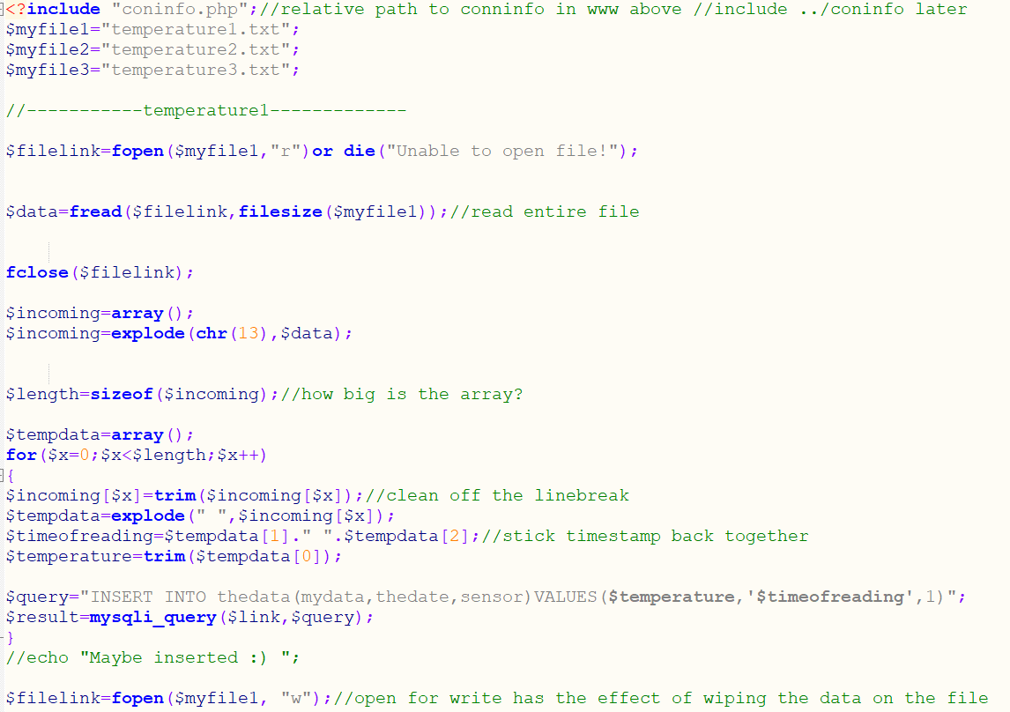
Figure 11 – transferdata.php
The above screenshot displayed in figure 11 illustrates the code used in order to transfer the data from the text file and into the database. The ‘myfiles’ contain the different text files that were used in order to be transferred. The code uses the ‘coninfo’ in order to connect to the database. The ‘INSERT INTO’ query allows for the data to be entered into the correct columns. The correct data from the text files were successfully transferred onto the database. The last line of code used enables the data within the text files to be wiped and thus preventing dual entries. The code displayed above was enabled for ‘temperature 1’. The code for temperature 2 and 3 is the same with the subtle changes of the idfferetn sensors.

Displaying the Data
The data must be appropriately displayed for the user to see. The data when retrieved must be readable with multiple filter options for the user to choose from. The ability to also view graphs was an important feature to implement.
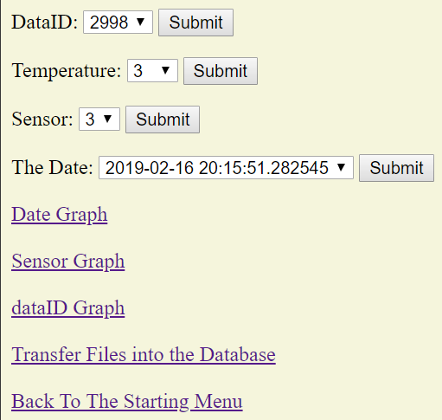
Figure 12 – searchdisplay.php
The searchdisplay screenshot above illustrates the different types of methods to search for the data. The DataID, Temperature, Sensor and Date were retrieved directly from the database in order for the user to search the different data. Using these filter options allowed for the user to view based on the specific data that was entered onto the database.
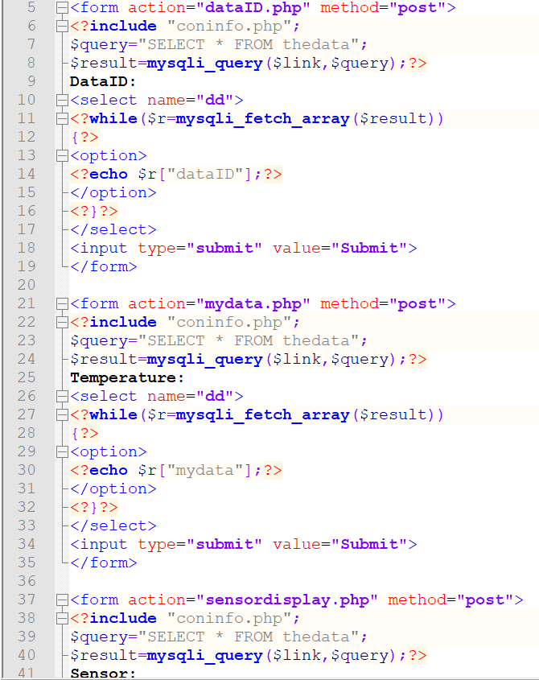
Figure 13 – searchdisplay.php
Figure 13 illustrates snippets of code that allows for the dropdown box for the specific searches to be displayed. Each has its own form in order to display the correct data with a different image that links with that page.
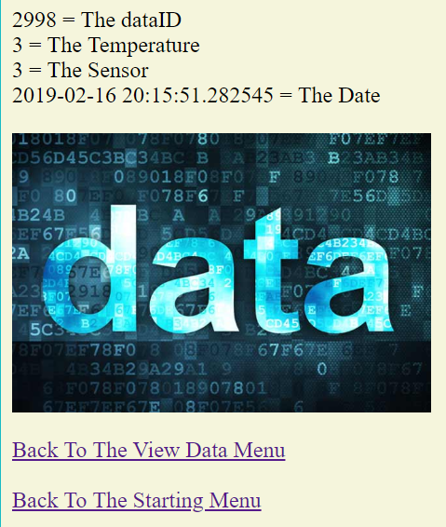
Figure 13 – dataID.php
Figure 14 demonstrates the user selecting from the multiple dataIDs that have been transferred and submitting one in order to view the accompanied data. The page displays the data that is linked to the specific dataID. Below in figure 15, it demonstrates the code used to create that page with appropriate code to allow for it function correctly. The SELECT FROM allows to select the specific data from the database.
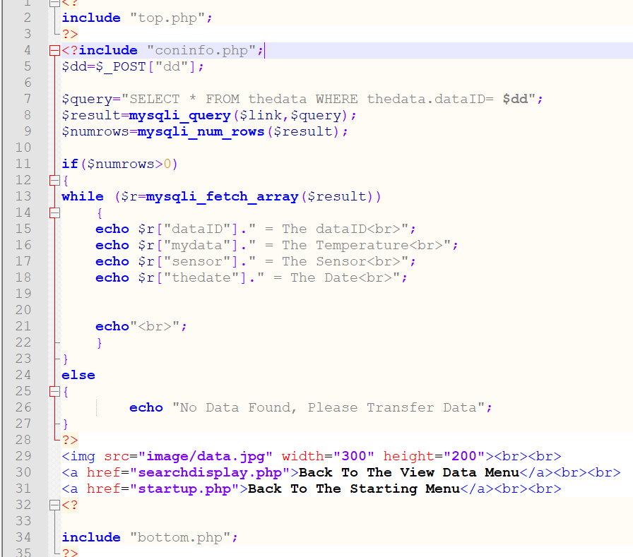
Figure 15 – dataID.php

The same functions were used for the other filter options with different forms linked however containing the same aspects of code:
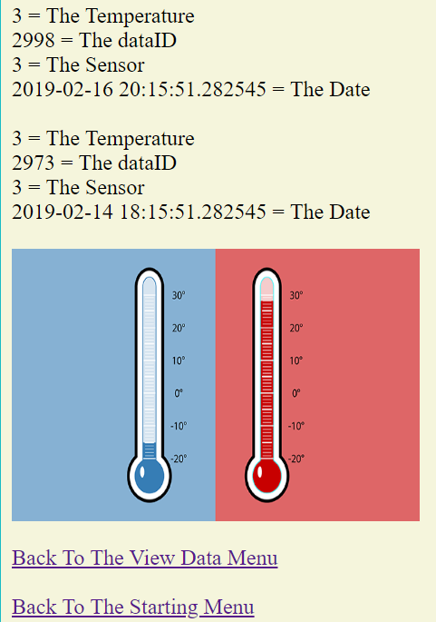
Figure 16 – mydata.php
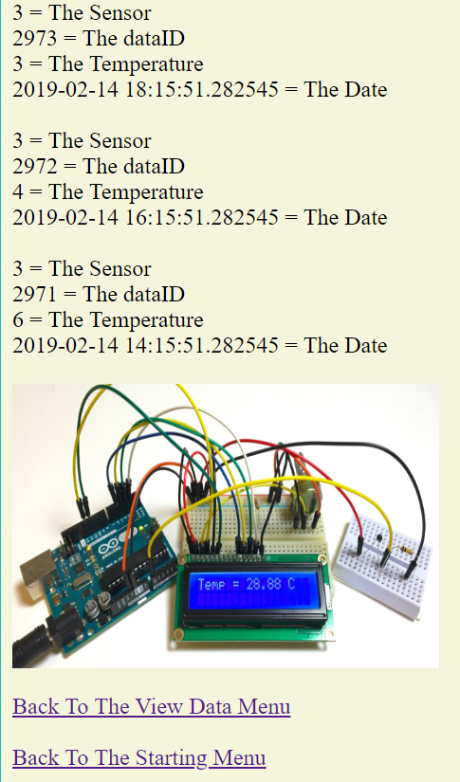
Figure 17 – sensordisplay.php
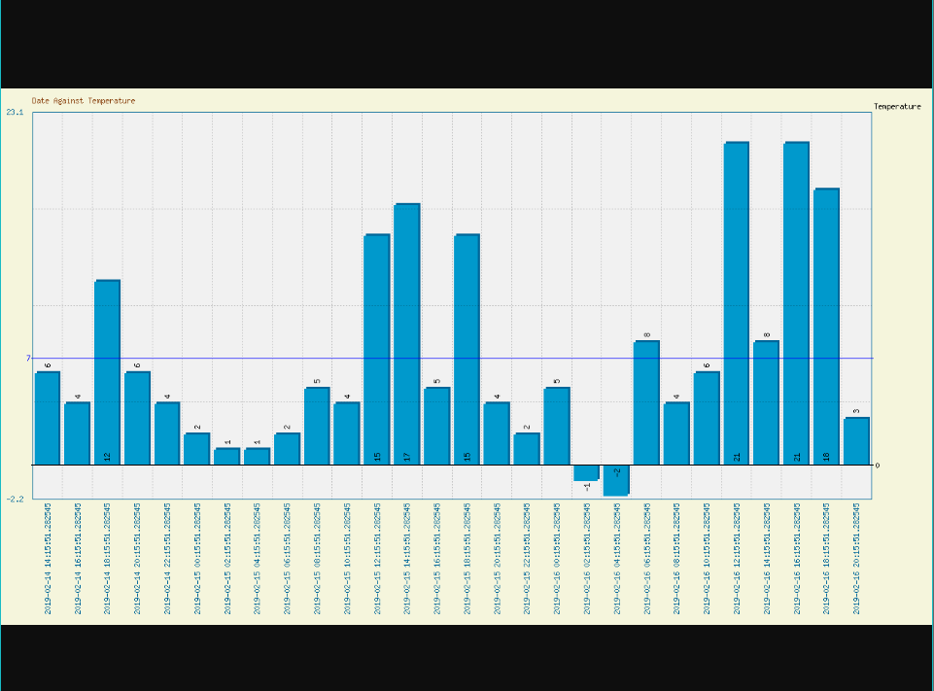
Figure 18 – mygraph1.php
The above graph includes the date against the temperature. It was included as a parseVerticalColumnGraph as it displays the data more accurately. It includes the date at which temperature were recorded at and also displays the negative qualities by including ORDER BY date within the code as seen below:
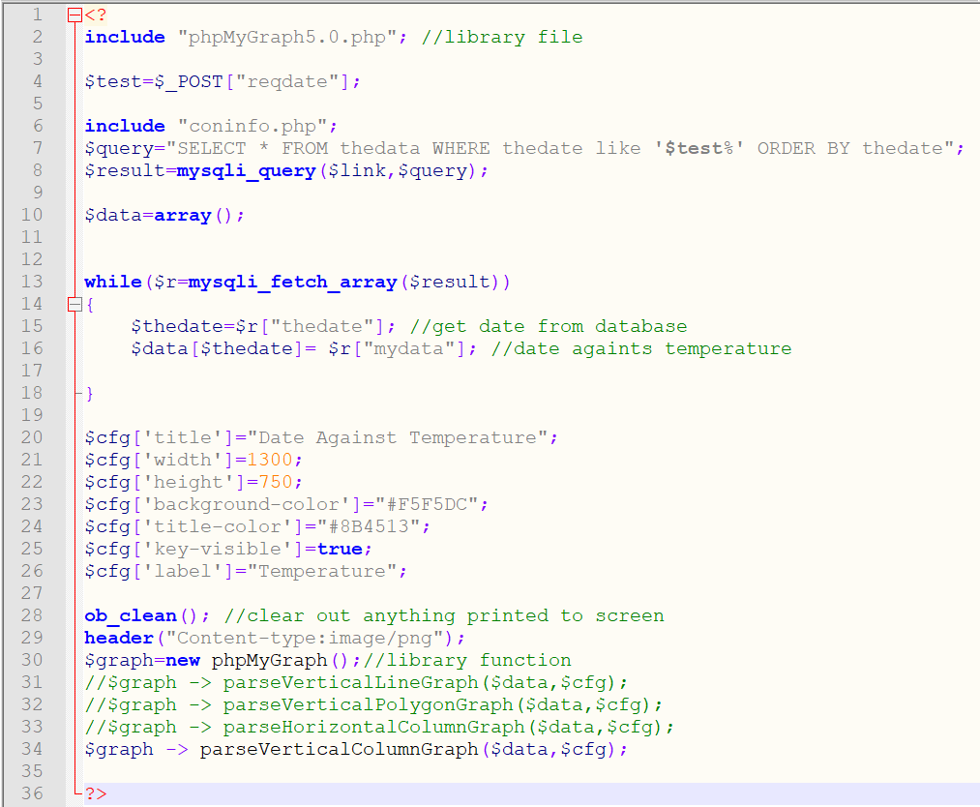
Figure 19 – mygraph1.php
Figure 19 also includes at the end section the different types of graphs that can be used when displaying the data. ParseVerticalColummnGraph was selected over the others as it displays accurate data for the user to view. There is an inclusion within the code to edit what is displayed on the graph. The width, height, title and colours to name a few are all functioning in order to edit what the user can visually see.
The other two graphs included on the interface also use the same code however have different data and are visually portrayed differently. Below are the screenshots of those graphs:
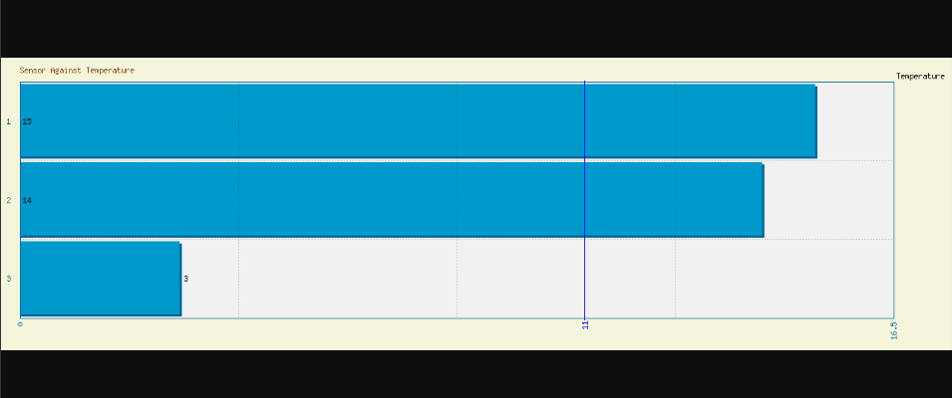
Figure 20 – mygraph2.php
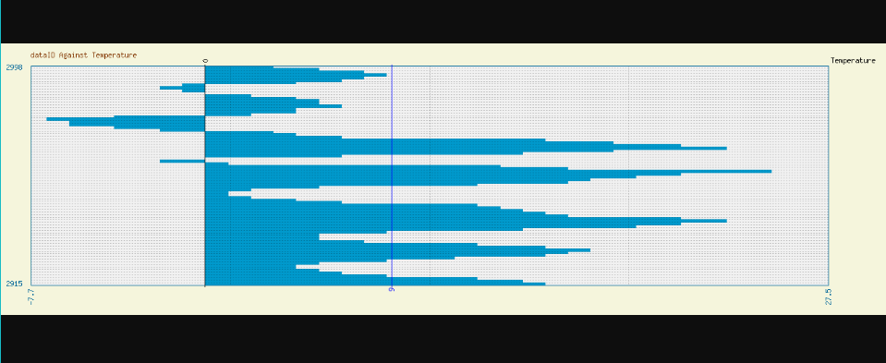
Figure 22 – mygraph3.php
Figure 20 illustrates the sensor against temperature graph. It was selected as it displays the average number from what sensor recorded what temperature. This was done by using an array in order average out the data. It was chosen to be visually displayed as parseHorizontalColumnGraph as it can display the average in a more suitable format by being a bar that is visually represented well. Figure 21 illustrates dataID against the temperature. It displays the temperature at its lowest and at its highest in a suitable way. It is visually represented well as the users are able to view the bars and determine the results.

Database
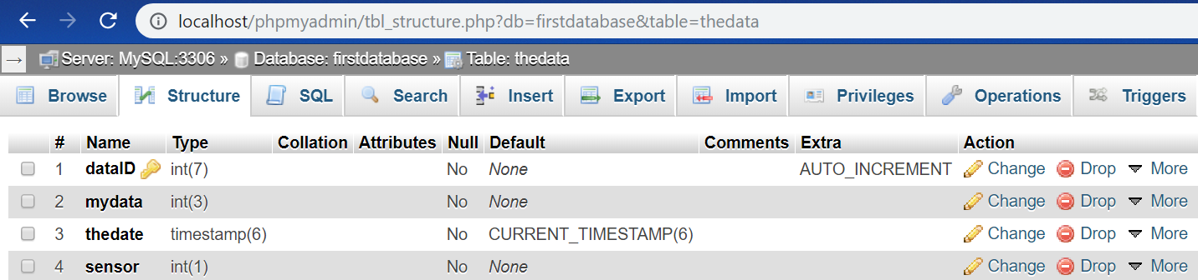
Figure 23 – thedata
Figure 23 is the database used in order to transfer the data over and to retrieve and display the data.
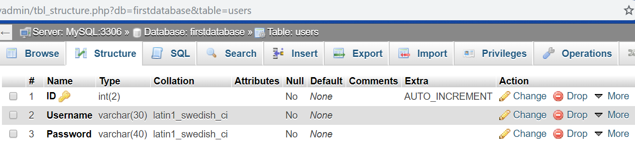
Figure 24 – users
The users database was used in order to allow users to log into the interface. (Only one user has been registered for the purpose of this assignment.)

Conclusion
In conclusion, the web interface was developed successfully and included a simple layout and design in order for users to understand and navigate. It included all the main features and worked successfully. Future improvements for the interface would be to included multiple users and for more filter options for the users. The interface has the ability to extend into a professional web application given more time and will perform exceptionally. A page in order to register new users can be developed in order to allow the function of multiple access. The filter options can be improved with having more time to develop and enhance all features.
Despite the further improvements needed, this version of the interface fills the aspects and includes the features required for it to be classed as a successful web interface. It performs the transfer and then deletes the data from the text file to prevent dual entries and it consistently uses safe security methods. The code used performs all the actions required and includes methods of professional coding by including multiple features that allow for a better response.

References

[1] | M. Fowler, "The Basics of Web Application Security," martinfowler.com, 5 January 2017. [Online]. Available: https://martinfowler.com/articles/web-security-basics.html. [Accessed 3 May 2019].
[2] | S. Nawaz, "Ultimate PHP Security Best Practices," cloudways.com, 1 January 2019. [Online]. Available: https://www.cloudways.com/blog/php-security/. [Accessed 1 May 2019].

