NAME: Nunzia Lomonaco
STUDENT NUMBER: 2123363
MODULE: LCMB7001
LECTURER: Tushara Balendran
COURSE: Master’s in business administration
SUBMISSION DATE: 05/05/2022
TITLE: Marketing Assessment 2



TABLE OF CONTENTS:
- INTRODUCTION 3
- PESTEL ANALYSIS 4

- PESTEL ANALYSIS OF ARMANI GROUP IN THE UK 4

- POLITICAL AND LEGAL 5
- ECONOMIC 5
- SOCIAL 5
- TECHNOLOGICAL 5
- ENVIRONMENTAL 6

- PORTER’S FIVE FORCES 6

- RIVALRY 7
- THREAT OF NEW ENTRANTS 7
- BARGAINING POWER OF BUYERS 7
- THREAT OF SUBSTITUTES 7
- BARGAINING POWER OF SUPPLIERS 7

- SWOT ANALYSIS 8

- SWOT ANALYSIS FOR ARMANI GROUP 9
- ADVANTAGES AND DISADVANTAGES OF SWOT ANALYSIS 9

- SEGMENTATION TARGETING AND POSITIONING 10

- SEGMENTATION 10
- TARGETING 10
- POSITIONING 10

- THE MARKETING MIX 11

- PRODUCT 12
- PRICE 12
- PLACE 12
- PROMOTION 12

- CONCLUSION AND RECOMMENDATIONS 13
- REFERENCES 14

INTRODUCTION
In our consumer society, the market is highly competitive. So, any company needs to strengthen all marketing strategies that can enhance the brand image, and customer satisfaction, compare with competitors, and therefore empower itself in the market, and ultimately earn good profits. Many analysis tools are available for business marketing to achieve these results.
This report will study the main tools, analyse the models, and apply them to the luxury company, Armani. It will then compare the Pestle analysis and the macro-environment factors that have an impact on companies’ decisions and Porter’s 5 forces that influence the company’s strategies.
The Swot analysis outlines the development potential for a business system due to enhancing strengths and containing weaknesses in the context of opportunities and all risks deriving from the external economic condition.
The report will also compare the segmentation targeting and positioning of the brand, which helps the organization improve its offer, and how product features are communicated to one specific group of customers. The marketing mix strategy is also considered a set of marketing elements that a company identifies and utilizes to satisfy customers and meet market objectives (Kotler, et al., 2020). Eventually, we will outline conclusions and recommendations for the purpose of applying the Ansoff matrix.
PESTLE ANALYSIS
The Pestle analysis is a tool used by marketers to study key external factors that influence an organization (Kotler, et al., 2009). Pestle is an acronym indicating: Political, Economic, Social, Technological, Legal and Environmental factors. Business is not a closed system, interacts with the macro-environment in which operates. As a result, a company should take an overview of what is outside of business, while making decisions whose implications are strongly influenced by external and uncontrollable circumstances. Above all, a company must understand how external circumstances might influence the launch of a product, the launch of a project, or the choice to invest.
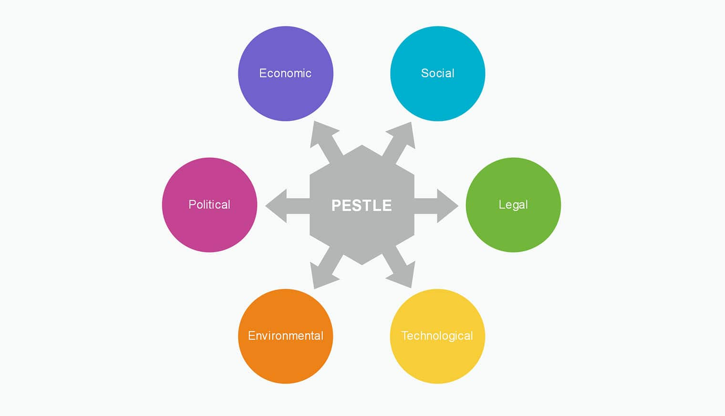

FIG.1 Pestle analysis (source: mychartguide.com)

PESTEL ANALYSIS OF ARMANI GROUP IN THE UK
POLITICAL and LEGAL: Political and legal factors must be considered together because government legislation reflects the outcomes of political decisions. Political discussion and choices precede changes in the legal environment (Reynolds & Lancaster, 2005). Many factors impact how a government can influence the economy or a specific industry. For example, a government may impose a new tax or fee that will penalize businesses importing products from other countries. Since the United Kingdom left the European Union, the pound -sterling was deflated for a long time, raising concerns about future trade restrictions in Europe. This action will undoubtedly have an impact on margins of profit. Lockdowns introduced by the government restricted trading in stores for a long time, and currently, signs of growth can be seen in the marketplace (CIPD, 2021). As a result, political factors have had a massive effect on Armani's sales in the UK last year, although Armani’s performance has obviously gotten better since the covid restrictions had been lifted and then cancelled. Unfavourable to Armani group trading.
ECONOMIC: The economic factors analysed through the Pestel analysis are important for the company's success and have a direct impact on its revenues and profits (Reynolds & Lancaster, 2005). An increase in the inflation rate, for example, or an increase in the unemployment rate, could affect the final consumers' decisions in purchasing and consuming, resulting in a reduction in consumption and a fall in purchasing power. Certainly, the pandemic scenario and the country's exit from the European Union have altered the nation's economic situation and consumer habits. Exchange rate conversions continue to be a concern in supplier negotiations. Since the UK left the EU, there is still much uncertainty in the UK trade markets. In the year ending 30 December 2020, Armani Group's revenues fell 25% to £1.37 billion, compared to the period in 2019, but they shall return to the pre-pandemic profits by the end of 2022 (Lepido & Rotondi, 2021). The COVID-19 epidemic has transformed client buying habits, which are now going through online platforms, rather than in-store, and has had a notable impact, especially on the purchase of luxury items, such as Armani products (CIPD, 2021). Those transformations might either have both favourable and unfavourable impacts, depending on how a company moves among the different market resources.
SOCIAL: The socio-cultural factors are the most difficult to analyse, and they represent the greatest challenge for a company. Changes in cultural trends, demographics, and population analysis all have an impact on purchasing behaviour (Reynolds & Lancaster, 2005). The pandemic has had a major impact on people’s social habits. Lockdowns have forced people to stay at home, resulting in a lack of social life and a drop in sales of apparel and accessory, especially for a luxury brand like Armani. In addition, stores were closed, and this caused a massive drop in purchases in-store, and increased the online purchases, instead. The situation is currently improving: the stores are open, people are back to normal life, but the way of buying has changed, particularly among young customers. Certainly, in the next future studies will provide more thorough information on those changes related to items purchased from luxury retailers. Unfavourable factor.
TECHNOLOGICAL: Technological issues are vital to a company, due to the high levels of innovation transforming the markets. Technology can bring great benefits to companies, but it can damage many old companies that are not keeping up with the times and haven’t changed their infrastructure. (Kotler, et al., 2009). New computer programs, exploiting new forms of energy and implementing changes in the technology have a strong impact on businesses. Armani has eventually taken a significant step forward in 2020 by using new digital technologies and combining online and in-store shopping. The collaboration with YOOX NET-A-PORTER GROUP has provided customers with a revolutionary digital and integrated shopping experience. Client orders are managed through the YOOX NET-A-PORTER distribution network, distribution centres, and Armani boutiques. This represented a remarkable boost in sales and revenues for the Armani brand, in this difficult time of the pandemic era (Crivelli, 2020). Armani group, on the other side, needs to improve its understanding of how emerging technological innovations might benefit the company, in addition to creating value for its customers. Investing in research and technological development will provide results in the long period. The study on consumer engagement, in this context of emerging digital technologies, has helped the Armani group to understand how important online shopping and advertisement are (Kotler, et al., 2009). Favourable.
ENVIRONMENTAL: Because of increased attention toward sustainability and environmental preservation, environmental analysis has increasingly gained importance in the present economic context. Ecological aspects have to do with all the factors that are directly or indirectly related to the environment. Any change in government regulation or Social Trends for Environmental Protection affects companies. Respect for the environment is an important issue for the Armani group, which has long supported environmental sustainability. The company is dedicated to responsibly managing the raw material supply chain, environmental protection, and the use of efficient resources. According to the company's website, it is committed to reducing environmental impact throughout its distribution chain by regulating pollution, reducing waste, and saving energy, as well as maintaining a focus on the safety of chemicals used in textile manufacturing (Armani, 2021). Strongly favourable factor.
PORTER’S FIVE FORCES
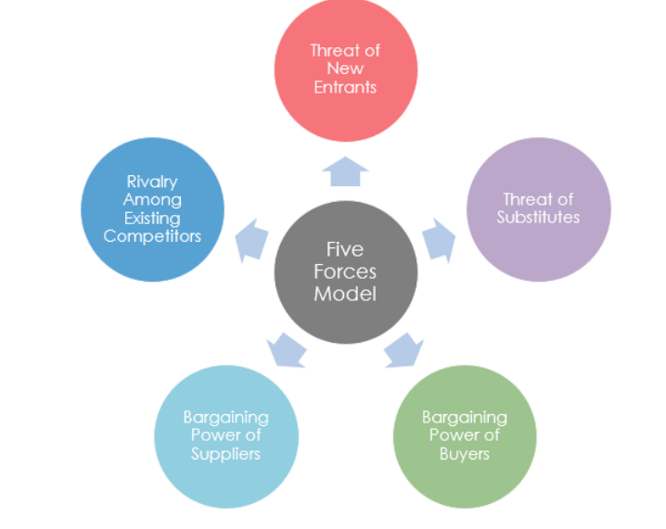
Porter’s Five Forces is a model that analyses five external competitive forces that affect an organisation and identifies the strengths and weaknesses of that organisation (Doyle & Stern, 2006). Those forces include competitors, customers and suppliers. Porter’s Five Forces model is a helpful tool available to companies to better understand the structure of the sector in which they operate, the profitability of that sector, and how to perform the greatest competitive advantage. The forces include the rivalry among existing competitors, the threat of new entrants, the bargaining power of suppliers, the bargaining power of buyers, and the threat of substitutes.

Fig. 2 Porter’s five forces model (Source: Visual-paradigm, 2018)
RIVALRY
Although Armani is a luxury brand, there are many competitors globally and in the UK. Among them are Boss, Versace, Gucci, Dior, Prada, Chanel, and Dolce & Gabbana (Similarweb, 2022). This is, essentially, due to the company's effective marketing segmentation. Armani sells handbags, clothing, accessories, make-up and perfume, home interior, and sunglasses. So, for the handbag segment, Gucci, Louis Vuitton, and Chanel are the main competitors of Armani. In the apparel sector, the competitors are Dolce & Gabbana, Prada, and Dior. In the accessories segment, some of the brands are Prada, Yves Saint Laurent, Louis Vuitton, and Tom Ford. Those are only some examples of competitors, but yet enough to figure out how high is the impact of rivalry for Armani (Similarweb, 2022).
THREAT OF NEW ENTRANTS
Armani group recently celebrated its 40th anniversary as one of the world's most lasting luxury brands. The company has been able to adapt to changes in the global economy, new worker geolocations, and new cultural trends. The brand is easily recognisable and is synonymous with quality and long-lasting durability (Vigneri, 2012). See or touch a product of Armani immediately evokes the images of elegance, glamour, and style. Armani is a desirable brand of elegance. Armani products stand out for their unique style and the selection of raw materials, which takes place in compliance with precise economic, ethical and environmental criteria. In recent years, Armani Group has focused on sustainability and respect for the environment (Armani, 2021). So, new entrants into the luxury market have a low influence on Armani.
BARGAINING POWER OF BUYERS
The buyers’ power of Armani’s products may be evaluated from low to medium. Even if the competition is high in the luxury segment, the prices do not vary much from one company to another. In addition, the company keeps its products referred to as a niche, does not apply discounts, and tries to fight the imitation market. Armani has focused a lot of its marketing on segmentation, so the group has different lines with different styles and prices to meet the needs of a larger variety of consumers.
THREAT OF SUBSTITUTES
Although Armani products are part of the luxury segment, where there are many competitors, the risk of replacement products is low. Armani is carrying out a campaign and strategies to prevent counterfeiting and so its products are safe and authentic, thanks to the presence of a QR code and the Certilogo project (Armani, 2021) The customer is almost certain to own an Armani product. On top of that, the costs of the products, although high, are still affordable: the quality is recognizable to the touch and sight, and the elegance is a distinctive feature. Also, Armani customers choose the line of clothing because they recognize the values and they partake in the philosophy of the company, therefore they hardly switch to the competitor.
BARGAINING POWER OF SUPPLIERS
Armani considers the suppliers a vital element of the value of the company. Suppliers are categorized into 4 groups, based on which goods are supplied and their geolocation. Armani supports its employees' social and ethical behaviour; thus, suppliers are required to agree with ethical codes in which they commit to respect specific rules. For example, in 2020 the UK’s Modern Slavery Act was made public, preventing all forms of slavery and forced labour within the Group and along its supply chain (Armani, 2021). Consequently, Armani develops long-lasting relationships with those suppliers, based on lasting and loyal collaborations. So, the power of suppliers is low.
SWOT ANALYSIS
This is a strategic planning tool, used to assess the Strengths, Weaknesses, Opportunities and Threats of a project or company to achieve a goal (Kotler, et al., 2009). The four variables analyzed in the SWOT system are represented by a matrix, enlisting those internal and external factors of the organization that might potentially have a positive or negative impact on the business project or company goals. Because of the system’s simplicity, it is widely applied in evaluating options and taking decisions on complicated business problems (HELMS, 2010).
SWOT ANALYSIS FOR ARMANI GROUP
STRENGTHS  - High brand value.  with its experience of over 40 years, the Armani company is considered one of the most known and most reliable brands of fashion in the world  - Wide variety of sub-brands.  includes 11 sub-brands and numerous partnerships, such as with the optical business, beauty, and hospitality (Armani, 2021)  - Unique tailoring, cut and sewn by hand. Armani has designed an exclusive range of tailored clothing that is hand-sewn and can be tailored to satisfy consumer demand (Bhasin, 2018).  - Celebrity Marketing. Since the beginning of his career, Armani has maintained strong relationships with Cinema and music celebrities. On red carpets, they wear Armani outfits, showing the elegance of Armani design (Cantarini, 2020). | WEAKNESSES  - limited global presence. Although Armani has a presence in 37 countries, some of his competitors, such as Dior and Chanel, have business in more than 50 countries (Bhasin, 2018).  - higher price. Armani products are more expensive; thus, it only appeals to the elite of society. Due to its expensive pricing, it loses a lot of clients (Bhasin, 2018).  - Lack of Scaling opportunities. as a result of the high prices and the very limited sector to which Armani’s production is directed, there is little chance of growth in the segment, and annual revenues could be affected by this.  - Weak online communication and marketing. Armani, being a luxury brand, ultimately realized the importance of the online market and was late in launching its sales platforms. The company's social media and website are still not up for the challenge of generating the revenue it deserves.
OPPORTUNITIES  - Expanding the market: Armani could expand its market to include new client segments and develop loyalty-focused methods. This would increase the brand's worldwide presence as well as profits.  - Innovative Products: Giorgio Armani could put more effort into developing new designs and products using also digital media.  - Increasing the brand's online and social media strategy: The company should relaunch its online pages, from Instagram to the website, with more interactive and engaging graphics and content. | THREATS  - Strong luxury competitors: Armani's competitors are numerous, with a strong presence on the worldwide scene. This is a fact to always keep in mind.  - Extra niche target market: The company has a niche clientele, but this is not loyal, thus this factor should be highlighted to increase profits.

ADVANTAGES AND DISADVANTAGES OF SWOT ANALYSIS
The use of Swot analysis has a lot of positive features, including low cost and ease to understand and use. It's a useful tool when you need to make decisions about your business and don't have a lot of time. By examining each of the four aspects of the SWOT analysis, separately or in combination, you can gain significant insight into the chances of achieving your goal (Nordmeyer, 2019). Another advantage is that the analysis is subjective because it involves the processing of personal data and thoughts, rather than objective data. The weakness of the analysis is that each element leads to a single way option, and doesn’t consider all the variables affecting each way, either positive or negative. In this way, it may be easy to locate a strength or a weakness, but the entire substance of the strength or weakness is not widely represented, so one decision can be misled (Kotler, et al., 2009). For example, opening a new shop in a high-end street may be a strength, as the footfall is possibly supposed to be high, but rent costs and maintenance can strongly affect the profit and ultimately run the business profitability. Also, the validity of the analysis is for a short time because the data becomes obsolete quickly (Nordmeyer, 2019). Using analysis, you can develop strategic thinking, identify strengths and weaknesses, create opportunities or prevent future problems for the company, as well as identify new investment opportunities and prospects (CIPD, 2021).

SEGMENTATION, TARGETING AND POSITIONING

SEGMENTATION
Market segmentation is a marketing strategy that divides the market into groups based on demographic, geographic, behavioural, and psychological data. This segment facilitates in better understanding of the market and allows for delivery of products that are more tailored to the customer’s needs, thereby increasing sales (Kotler, et al., 2020). The segmentation can be applied to these categories: geographical (elements considered: country, region, city, areas where customers are located) demographic (age, type of family, religion, gender, employment, social status, etc), psychographic (values, attitude, way of life) and behavioural ( knowledge of the product, type of attitude of the customer towards the product) (Kotler, et al., 2020).
GEOGRAPHICAL
In recent years, Armani’s geographic marketing strategy has been investing in Asia, on the Pacific side, where the group’s presence has tripled in 3 years (Armani, 2019). Another very prosperous area for the Armani market in the Americas. However, the stores in the last 3 years have decreased by 30% c.a. Instead, the presence in Europe remains almost unchanged, with just a slight growth (Armani, 2021). The presence of Armani in the UK sees 90 stores opened, 25% of which are in London, and the rest in major cities of Great Britain, including Birmingham, Bristol, and Edinburgh (Armani, 2022).
DEMOGRAPHIC
Armani’s sub-branding strategy cover all groups of ages. The brand Armani Junior for the youngest people, Armani Jeans for people in their 20-30 years, the exclusive Armani Prive’ (Haute Couture line) lines of clothes dedicated to women in their 40-45 years, successful and dynamic women in careers (Armani, 2021). As a luxury brand, Armani group has been able to target high-income customers with luxurious-high-quality goods and exclusive design and style expanding its product lines to fashion accessories, swimwear, cosmetics, fragrances, jewellery, eyewear, gaining a better understanding of the users' behaviour.
TARGETING
Targeting is the process of identifying target segments to drive the company's marketing mix, starting with the company's marketing objectives, and proceeding through a preliminary phase of study and segmentation of the market demand (Kotler, et al., 2009). Armani has always subcategorized its products and positioned them according to segmented demand within segmented customers worldwide. The company has categorized its product to clients based on their desired quality perception and appropriately set the price of each product. As a result of this use of segmented marketing (Kotler, et al., 2020), which is a very expensive technique, Armani has been able to maintain itself in the niche market with its 11 sub-brands and face competitors, having built a strong brand reputation.
POSITIONING
This procedure aims to ensure that the product is perceived by consumers, compared to the products of competitors, available on the market. This marketing strategy consists in highlighting all benefits that one consumer or group of consumers may get through the purchase of that product, compared to the competitors’ products, yet placed in the market. This way leads the company to create an image of brand’s product, or offering, in the mind of a target customer, and take control of the market, thus positioning itself on top of the brands list. (Kotler, et al., 2020).
The main positioning strategies are Benefit positioning, User positioning and Competitive positioning. Armani applies Benefit positioning, by associating the brand to one product characteristic that is beneficial to customers. In the mind of consumers, the products of Armani are of excellent quality, with excellent raw materials, fine tailored, sophisticated, and elegant clothing. Armani focuses its positioning strategy, also, on using Celebrity endorsement, as previously mentioned. Armani, since the beginning of his career, has collaborated with famous movie and entertainment stars. Even today many celebrities are the clothing brand ambassadors of the fashion house, and many famous stars wear Armani clothes, either for special occasions or the private life.

THE MARKETING MIX STRATEGY
The marketing mix is a set of marketing elements that a company identifies and utilizes to satisfy customers and meet market objectives (Kotler, et al., 2020). The characteristics of the marketing mix, according to McCarthy's 4P model, are Product, Price, Place, and Promotion. Later, Booms and Bitner proposed a 7P model, which added to McCarthy's, three more P digits: Processes, Physical Evidence, People. The two initial words represent the supply processes, purchase and sale of a product, and the impact that the product has on people during these same processes (Allen, 2020).
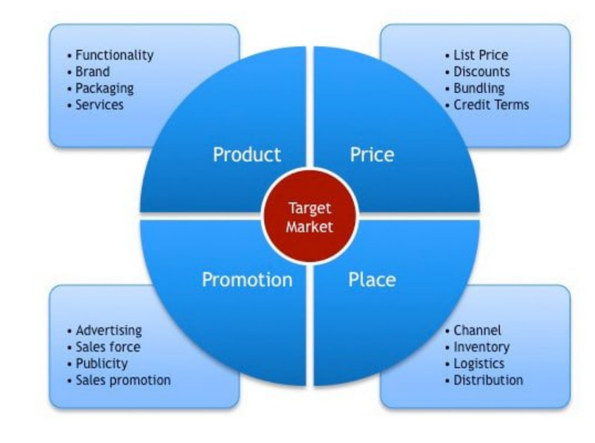
Fig.3 The 4Ps of Marketing mix (Source: Acutt, 2021)

PRODUCT
Armani has made the sub-brand it’s marketing philosophy so that it can satisfy various targets of the consumer. It offers a wide variety of products, from jackets to shirts, to shoes, bags, and interior design, but no one product misses the elegance and sophistication that distinguishes the brand (Martel Fashion, 2022). Even though Armani started as an apparel company, the company immediately figure out the potential of the lifestyle brand, exploring the concept of 'luxury' as a defining personality feature. Armani is an excellent example of how to find a balance between expanding the brand through brand extension while preserving its strength by increasing the brand's primary area of expertise: fashion (Martin Roll, 2020). Its products focus not only on style and elegance but also on comfort and seem to fit the needs of the comfort of all customers. Moreover, whether it is a ceremony dress or an everyday dress, denim, or silk, all its items are made with high-quality raw materials, expert tailoring, ability, and precision (Armani, 2021).
PRICE
Armani's pricing strategy is premium pricing, placing a product's price higher than other similar items. This is typical of luxury brands: high prices keep goods exclusive and available only to a niche segment. However, Armani owns other sub-brands selling products in lower-priced subcategories, such as Armani Jeans (Martel Fashion, 2022). Armani Exchange, for example, sells men's shirts for 130 pounds, which is a reasonable value for money. Armani Exchange's approach to pricing appears to be such a way that it ensures quality while extending its consumer base. Armani is a well-known brand, and its added value is the status symbol it represents and that customers want to experience when wearing its clothing.
PLACE
Today, Armani has a sales network of 623 stores, managed directly around the world: 258 in the Americas, 244 in Asia, and 121 in Europe (Armani, 2021). Armani’s distribution of clothes is sold down to the last detail through direct-to-consumer stores and carefully selected distributors. Armani also has outlets in shopping malls, two in Italy, one in Frankfurt and the other one in Paris. Some Armani customized products (like sportswear), targeting a specific market segment, are only available in small stores or boutiques and may be located near a cafeteria, or other establishments frequented by sports fans.
PROMOTION
Armani was a pioneer of his time, cooperating with Hollywood stars as early as 1978 when a young Richard Gere wore Armani's clothes in the Oscar film 'American gigolo' (Cantarini, 2020). It was the beginning of Armani's story of success. To promote its products, Armani group now use popular stars that represent the brand's diversity, through big advertising campaigns, television events, and so on. Armani chose well-known top models and celebrities such as Lady Gaga and Cara Delevingne (Design Scene, 2018). Throughout the years, many Hollywood celebrities have walked down the red-carpet wearing Armani's clothing, helping to further promote the brand. Giorgio Armani frequently collaborates with celebrities in the creation of unique items such as leather accessories and apparel. One example is his collaboration with actress Ziyi Zang to design an outfit for her to wear at the 2006 Academy Awards ceremony (Martel Fashion, 2022). In recent years, the Armani Group has been committed to promoting environmental awareness and has become a sustainable brand (Armani, 2019). Armani has improved its internet promotional channels, so together with the Yoox Net-a-Porter Group have partnered to develop new online tools, available on Armani's e-commerce since 2021 and develop a multi-channel shop (D'amelio, 2020).
CONCLUSION AND RECOMMENDATIONS
The report showed the importance of using some analysis tools to improve and grow a business. The relevance of examining external and internal elements, as well as knowing the company's weaknesses, strengths, and growth opportunities, and to better understand marketing strategies, positioning, and segmentation, as well as the marketing mix. Only by keeping all these factors in mind allows a company's marketing manager to provide new ideas and strategies.
RECOMMENDATIONS
The Ansoff matrix is a good tool for improving Armani's marketing strategies. The Ansoff matrix, also defined as a product-market matrix, is a very useful tool for strategic marketing planning. Companies use the Ansoff matrix to identify, in the scenario in which they operate, the best way to grow the business. The quadrants of the Ansoff matrix identify four alternatives to choose from within the marketing strategy (Bullock, et al., 2019). The matrix assumes that the company development can only take place through the intersection of two variables:
- the market, that means to whom something is sold.
- the product, that means what you sell.
Consequently, the company has in its hands four strategies to increase the business, resulting from the variables seen above, that may be also used together. Company can act through its products, existing and/or newly developed; or can act through markets: those where it is already present and/or new markets.

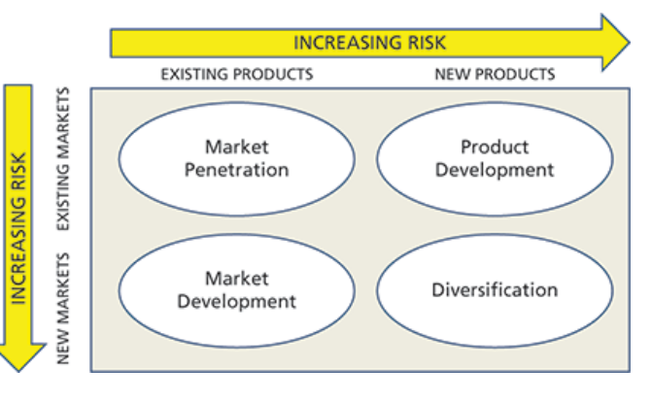
Fif. 4 The Ansoff Matrix (Source: Bullock, et al., 2019)

Armani is well-known for extending its product range to attract new customers (diversification). So, the matrix might be used to help with market penetration and product development.
Increasing sales, contact points, directly approaching customers, and strengthening the dealer network are all ways to increase market share in the current industry (Varley, et al., 2018).
Armani might explore new features to the current product or the development of new products for the existing market to improve product development, and an upgraded version of products could be introduced to target the existing market.

References
Chandler , D. & Munday, R., 2011. A dictionary of media and communication. 1 ed. s.l.:Oxford University Press.
Lemon, K. N. & Verhoef, P. C., 2016. Understanding Customer Experience Throughout the Customer Journey. Journal of Marketing, November(Special issue), pp. 70-96.
Rosenbaum , M. S., Otalora , M. L. & Ramirez, G. C., 2017. How to create a realistic customer journey. Business Horizons, 60(1), pp. 143-150.
Acutt, M., 2021. marketing mix 4ps. [Online]
Available at: https://marketingmix.co.uk/tag/marketing-mix-4ps/
[Accessed 20 04 2022].
Allen, A., 2020. Understanding The 7Ps of The Marketing Mix. [Online]
Available at: https://blog.oxfordcollegeofmarketing.com/2020/10/08/understanding-the-7ps-of-the-marketing-mix/
[Accessed 20 04 2022].
Armani, 2019. IL GRUPPO ARMANI E LA SOSTENIBILITA'. [Online]
Available at: https://www.armani.com/ycm/resource/blob/458698/2d69341dac31e9c9af9024146dfa22b4/il-gruppo-armani-e-la-sostenibilita-2018-data.pdf
[Accessed 22 04 2022].
Armani, 2021. THE ARMANI GROUP AND SUSTAINABILITY 2020, Milan: Armani SPA.
Armani, 2022. Armani store locator. [Online]
Available at: https://www.armani.com/en-gb/store-locator#search/coords/50.12053872139904,-1.6838739062499997/ne/53.39619034953831,12.191858515625/sw/46.844887093259786,-15.559606328125
[Accessed 22 04 2022].
Bhasin, H., 2018. SWOT Analysis of ARMANI. [Online]
Available at: https://www.marketing91.com/swot-analysis-armani/
[Accessed 22 04 2022].
Bullock, A., Jennings, C. & Timbrell, N., 2019. A Dictionary of Publishing. Oxford: Oxford University Press.
Cantarini, G., 2020. L'OfficielItalia. [Online]
Available at: https://www.lofficielitalia.com/moda/storia-giorgio-armani-stilista-moda-carriera-vita-successi
[Accessed 15 03 2022].
CIPD, 2021. PESTLE analysis. [Online]
Available at: https://www.cipd.co.uk/knowledge/strategy/organisational-development/pestle-analysis-factsheet#gref
[Accessed 19 04 2022].
CIPD, 2021. SWOT analysis. [Online]
Available at: https://www.cipd.co.uk/knowledge/strategy/organisational-development/swot-analysis-factsheet#8016
[Accessed 21 04 2022].
Crivelli, G., 2020. Armani e Yoox-net-a-porter disegnano la «Next era» della distribuzione, integrando canali fisici e online. [Online]
Available at: https://www.ilsole24ore.com/art/armani-e-yoox-net-a-porter-disegnano-next-era-distribuzione-integrando-canali-fisici-e-online-AD687jf
[Accessed 18 04 2022].
D'amelio, M., 2020. Giorgio Armani spinge sullo shopping multicanale con Next Era. [Online]
Available at: https://www.iodonna.it/moda/news/2020/07/01/giorgio-armani-federico-marchetti-consigliere/
[Accessed 18 04 2022].
Design Scene, 2018. Cara Delevingne, Martin Garrix & Li Yifeng for Armani Exchange SS18. [Online]
Available at: https://www.designscene.net/2018/02/armani-exchange-ss18.html
[Accessed 18 04 2022].
Doyle, P. & Stern, P., 2006. Marketing management and strategy.. 14 ed. s.l.:Pearson Prentice Hall.
Folstad, A. & Kvale, K., 2018. Applying Transactional NPS for Customer Journey Insight: Case Experiences and Lessons Learned. Services Marketing Quarterly, 39(3), pp. 208-224.
HELMS, M. a. N. J., 2010. Exploring SWOT analysis - where are we now?: A review of academic research from the last decade.. Journal of Strategy and Management, 3(3), pp. pp. 215-251.
Keller, K. L., 2013. Strategic Brand Management. 4 ed. s.l.:Pearson.
Keller, K. L., Aperia, T. & Georgson, M., 2008. Strategic Brand Management: A European Perspective. s.l.:Financial Times/ Prentice Hall.
Kopp, C. M., 2022. Investopedia. [Online]
Available at: https://www.investopedia.com/terms/b/brand.asp
[Accessed 13/03/2022 March 2022].
Kotler, P., Armstrong, G., Harris, L. C. & He, H., 2020. Principles of marketing. Harlow, England: Pearson.
Kotler, P. et al., 2009. Marketing Management. Essex: Pearson Education.
Lepido, D. & Rotondi, F., 2021. Armani Sees Return to Pre-Pandemic Level Sales Next Year. [Online]
Available at: https://www.bloomberg.com/news/articles/2021-07-25/armani-sees-return-to-pre-pandemic-level-sales-next-year
[Accessed 2022 04 19].
Martel Fashion, 2022. Marketing strategy. [Online]
Available at: https://www.martelnyc.com/luxury-fashion/marketing-strategy.html
[Accessed 18 04 2022].
MartinRoll, 2020. Giorgio Armani – The Iconic Global Fashion Brand. [Online]
Available at: https://martinroll.com/resources/articles/branding/giorgio-armani-the-iconic-fashion-brand/
[Accessed 28 04 2022].
Neher, K., Maechler, N. & Park, R., 2016. McKinsey. [Online]
Available at: https://www.mckinsey.com/business-functions/marketing-and-sales/our-insights/from-touchpoints-to-journeys-seeing-the-world-as-customers-do#:~:text=To%20maximize%20customer%20satisfaction%2C%20companies,end%2Dto%2Dend%20journey.
[Accessed 15 03 2022].
Newstrom, J. & Keith, D., 2001. Organizational behaviour: human behaviour at work. s.l.:McGraw-Hill International Editions.
Nordmeyer, B., 2019. Advantages & Disadvantages of SWOT Analysis. [Online]
Available at: https://smallbusiness.chron.com/advantages-amp-disadvantages-swot-analysis-41398.html
[Accessed 21 04 2022].
Pickton, D. & Broderick, A., 2004. Integrated marketing communications. 2 ed. s.l.:Pearson Prentice Hall.
Reynolds, P. & Lancaster, G., 2005. Management of marketing. Oxford: Elsevier.
Similarweb, 2022. Armani. [Online]
Available at: https://www.similarweb.com/website/armani.com/competitors/
[Accessed 13 04 2022].
Varley, R., Roncha, A., Radclyffe-thomas, N. & Gee, L., 2018. Fashion Management: A Strategic Approach. 1 ed. s.l.:Bloomsbury Publishing.
Vigneri, A., 2012. cameramoda. [Online]
Available at: https://www.cameramoda.it/it/associazione/news/914/
[Accessed 17 03 2022].
Visual-paradigm, 2018. Porter's Five Forces Analysis Tutorial. [Online]
Available at: https://www.visual-paradigm.com/tutorials/five-forces-analysis-tutorial/
[Accessed 22 04 2022].
Zubak, J., 2017. Stage of the Customer Journey. [Online]
Available at: https://powerdigitalmarketing.com/blog/how-to-deliver-value-at-every-stage-of-the-customer-journey/#gref
[Accessed 31/03/2022 03 2022].

