

EXAMINATIONS 2013/2014 Semester 2
AHOLIADAU 2013/2014

FACULTY OF: APPLIED DESIGN AND ENGINEERING
SCHOOL OF APPLIED COMPUTING

NAME OF COURSE/PROGRAMME: | BSc (Hons) Computer Networks  HND Computer Networks
YEAR OR LEVEL: | 4
NAME OF MODULE/UNIT/EXAM PAPER: | IP Internetworking
MODULE NO: | M1X8609  M5X8914
DATE OF EXAMINATION:

EXAMINATION TIMES:

START TIME:

FINISH TIME:

TIME ALLOWED: 2 hours

INSTRUCTIONS TO CANDIDATES:

Answer three out of the four questions. Each question carries equal marks.

Candidates are not permitted to bring calculators, dictionaries; text books/case studies or any other reference materials into the exam room.
QUESTION ONE
- What is the purpose of dynamic routing protocols? (5 marks)
- Compare RIPv1 and RIPv2 (10 marks)
- Compare classful and classless routing protocols (10 marks)

QUESTION TWO
- Design the IP addressing scheme for the network shown in figure 1. The network address is 172.16.1.0/24. Write subnet address, subnet mask, first IP address, last IP address and broadcast address for each subnet. (25 marks)
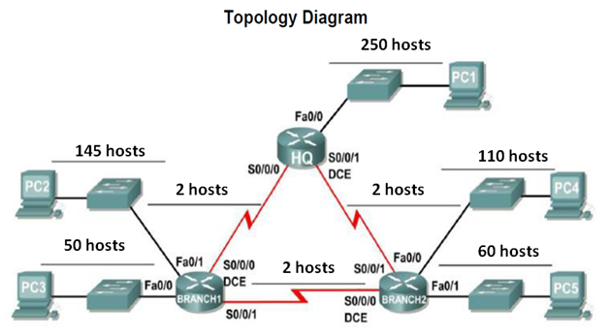
Figure 1

QUESTION THREE
(a) What is the solution implemented in OSPF to LSA flooding issue? (9 marks)

- In OSPF protocol, what are the criteria for getting elected as DR/BDR? (6 marks)

- Explain OSPF packet types. (10 marks)
.

QUESTION FOUR
- EIGRP uses five parameters to calculate metric.
  - List them all.
  - Write down the default values for all the parameters based on a Serial link.
  - Of the five which parameters are used as default? (7 marks)

- In reference with EIGRP, explain the following
  - Successor
  - Feasible successor
  - Feasible distance
  - Reported distance (10 marks)

- Refer to the figure 3, router R1 is not able to reach 172.16.1.0, 172.16.5.0, and 172.16.4.0 networks. Suggest a solution to solve the connectivity issue and write the steps. (8 marks)

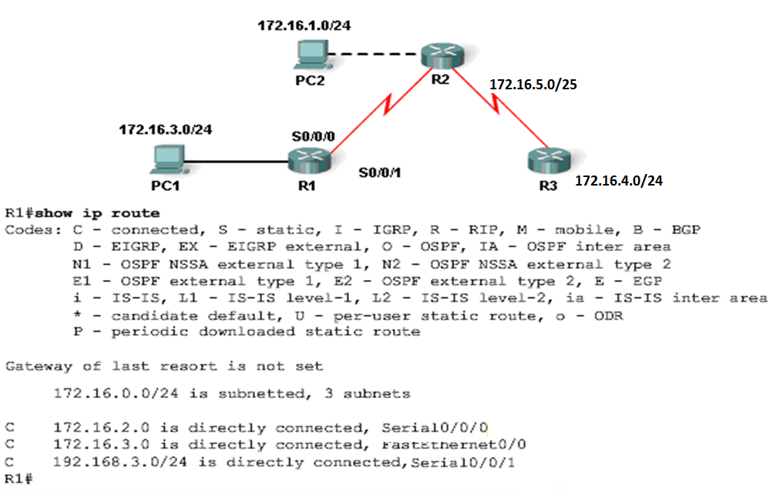
Figure 2

