[Date]
Code Link: https://github.com/Rafindadi09/Sample-Project.git

Student name Ralph Saramaduo-Hart
Student ID number 2411210
Programme: BSc/HND Computing Portfolio
Module Scripting and Programming Concepts
Module code: ACCA5036
Lecturer: Koushik Modak
Assignment title: Coursework – Programming Assignment with Associated Documentation
Submission date: 28th April 2026, 14:00 (2PM)

Table of Contents
Table of Contents
Table of Contents 1
Abstract 3
Introduction 3
1. Analysis 4
1.1 Problem definition and stakeholders 4
1.2 Functional requirements 4
1.3 Non-functional requirements 4
2. Software Design and Development 4
2.1 Design overview 4
2.2 Flowchart 5
2.3 Pseudocode for core functionality 7
2.4 Implementation decisions 8
2.5 Source code discussion 9
3. Testing and Debugging Report 12
3.1 Importance of testing 12
3.2 Types of errors in programming 13
3.3 Test cases and validation evidence 13
3.4 Debugging narrative 14
4. Evaluation 14
4.1 Strengths of the final solution 14
4.2 Challenges faced 15
4.3 Limitations and future improvements 15
4.4 Self-reflection 15
Conclusion 16
References 16
Appendices 17
Appendix A – Submitted file inventory 17

Abstract
This report presents the analysis, design, implementation, testing and evaluation of a simple Student Equipment Booking System for the Bright Minds Academy scenario. The academy currently records bookings for laptops, projectors and tablets on paper, which creates duplicate bookings, uncertainty over who reserved an item, and slow retrieval of records. In response, the submitted solution was designed as a menu-driven Python program for non-specialist staff. It supports the four core tasks in the brief: adding equipment, recording bookings, viewing all bookings, and searching by student or equipment name. To stay aligned with the coursework scope, the program stores equipment in a list and stores each booking as a dictionary within a bookings list. This keeps the logic transparent and demonstrates the practical use of functions, conditionals, loops, validation and simple data structures. The report explains the design decisions, testing strategy, strengths and limitations of the system, and shows how a small Python program can solve a practical administrative problem when its requirements and trade-offs are justified clearly.

Introduction
This report presents the design and development of a simple Equipment Booking Management System written in Python. The purpose of the program is to help staff manage shared resources such as laptops and projectors more effectively. In small organisations or classroom settings, equipment bookings are often handled informally through paper notes, memory, or ad hoc spreadsheets. Although these approaches are easy to start with, they can lead to duplicate bookings, weak visibility of current allocations, and slow retrieval of records when staff need information quickly.
The project scenario is set in Bright Minds Academy, a small tutoring centre that wants to replace a paper-based equipment diary with a simple computerised system. In this context, the goal is not maximum technical complexity but an appropriate solution that fits the users, the scale of the problem and the coursework brief [6], [13], [14].
The submitted solution is a menu-driven command-line program designed to be easy to use and easy to understand. It allows staff to add new equipment items, record bookings, view all booking records, and search bookings by student name or equipment name. The program stores data using a simple Python list for equipment and a list of dictionaries for bookings. This design was chosen deliberately because the brief prioritises core programming constructs, suitable data structures, and readable source code over advanced persistence features.
The final solution is intentionally simple, but that simplicity is a strength rather than a weakness. Python lists and dictionaries are standard built-in data structures that are appropriate for storing collections of values and labelled records [1], [2]. Using them keeps the logic transparent, makes the code easier to explain in the report, and demonstrates a conscious design decision about scope. While the system does not preserve data after the program closes, it still provides a functional and defensible solution to the problem defined in the coursework brief [1]–[3].

1. Analysis

1.1 Problem definition and stakeholders
The software addresses the practical problem of managing shared equipment bookings in a staff-facing environment. When several items such as laptops, projectors, or cameras must be allocated across different dates, staff need a quick way to confirm what equipment exists, whether it is already booked, and which student is associated with a booking. Without a dedicated system, these decisions can become inconsistent, particularly when records are informal or incomplete.
The main users of the system are administrative or support staff responsible for managing equipment loans. Students are indirect stakeholders because their access to resources depends on accurate booking decisions, and the institution benefits through improved visibility of asset use. The software therefore needs to support routine operational decisions clearly and reliably, even if the underlying implementation remains modest in scale.

1.2 Functional requirements
The final program implements the four core functions required by the brief. First, staff can add new equipment items to the system. This is necessary because the available resources may change over time and the program must remain flexible enough to reflect the current inventory. Second, staff can record a booking by assigning a piece of equipment to a student for a specific date. This is the central function of the system because it turns a simple equipment list into a usable administrative tool.
Third, staff can view all booking records. This allows them to see which items are already allocated and supports basic record checking without needing to search manually through separate notes. Fourth, staff can search bookings by entering either a student name or an equipment name. This improves usability because it allows specific records to be found quickly, which is especially important when the number of bookings grows.
The program does not include equipment maintenance tracking, overdue returns, authentication, or advanced reporting. This is an intentional scope decision. The coursework focuses on the design and implementation of a manageable software solution, so the final program concentrates on the features required to solve the immediate booking problem effectively.
Alternative approaches were considered during analysis. A graphical user interface or database-backed design could have been used, but a command-line prototype keeps the interaction explicit and allows the assessment to focus on programming logic rather than interface complexity. Likewise, lists and dictionaries are appropriate for a small local prototype because Python’s built-in collection types are designed to store ordered values and labelled records efficiently [1], [2].

1.3 Non-functional requirements
Usability is a key non-functional requirement because the system is intended for staff who may not have advanced technical knowledge. The program therefore uses a numbered menu, predictable prompts, and short messages. This keeps interaction straightforward and lowers the effort required to learn the software [5].
Readability and maintainability are also important. The source code uses separate functions, descriptive variable names, and clear control flow. PEP 8 emphasises readability and consistency as important aspects of Python style [3]. In the context of this assignment, readable code is especially valuable because it supports explanation, debugging, and future adaptation [3], [13], [14].
Reliability is another important requirement because an inaccurate booking system would create confusion rather than solve it. The submitted solution supports reliability by checking for empty input, verifying that equipment exists before it can be booked, validating the booking date, and preventing the same item from being booked twice on the same date. Date validation is performed with Python's datetime facilities [7]. Performance requirements are modest because the expected dataset is small, so lists and dictionaries are proportionate choices for local use.
Accessibility has been considered in a basic but relevant way. The command-line design supports keyboard-only use, stable menu numbering, and understandable prompts. WCAG describes accessibility in terms of making systems perceivable, operable, understandable, and robust [5]. Although this prototype has not been formally tested with assistive technologies, its simplified interface supports understandable interaction. Overall, the analysis shows that the project is best understood as a small administrative information system whose value depends on clear data capture, understandable outputs, and appropriate scope control.
Taken together, these non-functional requirements show that simplicity should not be confused with lack of design. ISO/IEC 25010 treats software quality as a set of characteristics that can be used to specify and evaluate systems [6]. In this coursework, that supports the judgement that the best solution is one that solves the academy’s immediate problem while remaining readable, testable and easy to improve.

2. Software Design and Development

2.1 Design overview
The program is designed around two main data structures and a set of related functions. The first data structure is equipment_list, which stores the names of all equipment items added by the user. The second is bookings, which stores each booking as a dictionary containing the equipment name, the student name, and the booking date. This means the system uses one list for equipment and one list of dictionaries for booking records [1], [2].
This design was selected because it matches the brief and keeps the solution easy to understand. Lists are suitable for storing multiple values in sequence, while dictionaries are useful when each record contains labelled fields such as equipment, student, and date [1], [2]. A database could have been used as an alternative, but that would have increased technical complexity and moved the solution away from the assignment's emphasis on core scripting and programming concepts. The chosen design is therefore simpler, but also more transparent and easier to justify [1], [2], [13].
The program is divided into separate functions for each major task: add_equipment(), book_equipment(), view_bookings(), search_booking(), and main(). This modular structure improves readability and helps ensure that each part of the program has a clear purpose. It also makes debugging easier because faults can be traced to individual functions rather than to one large block of code.
This functional decomposition matters because it allows each part of the program to be understood and tested separately. Software engineering literature associates this kind of modularity with clearer maintenance and easier debugging [13], [14]. In this program, the menu handles navigation while the other functions handle data entry, validation and information retrieval [10].

2.2 Flowchart
The most important process in the system is recording a booking, because this is where the program must confirm that the equipment exists, check that the student input is valid, verify the date format, and prevent duplicate bookings. The flowchart below shows that the program validates these conditions before saving a new booking to the bookings list.
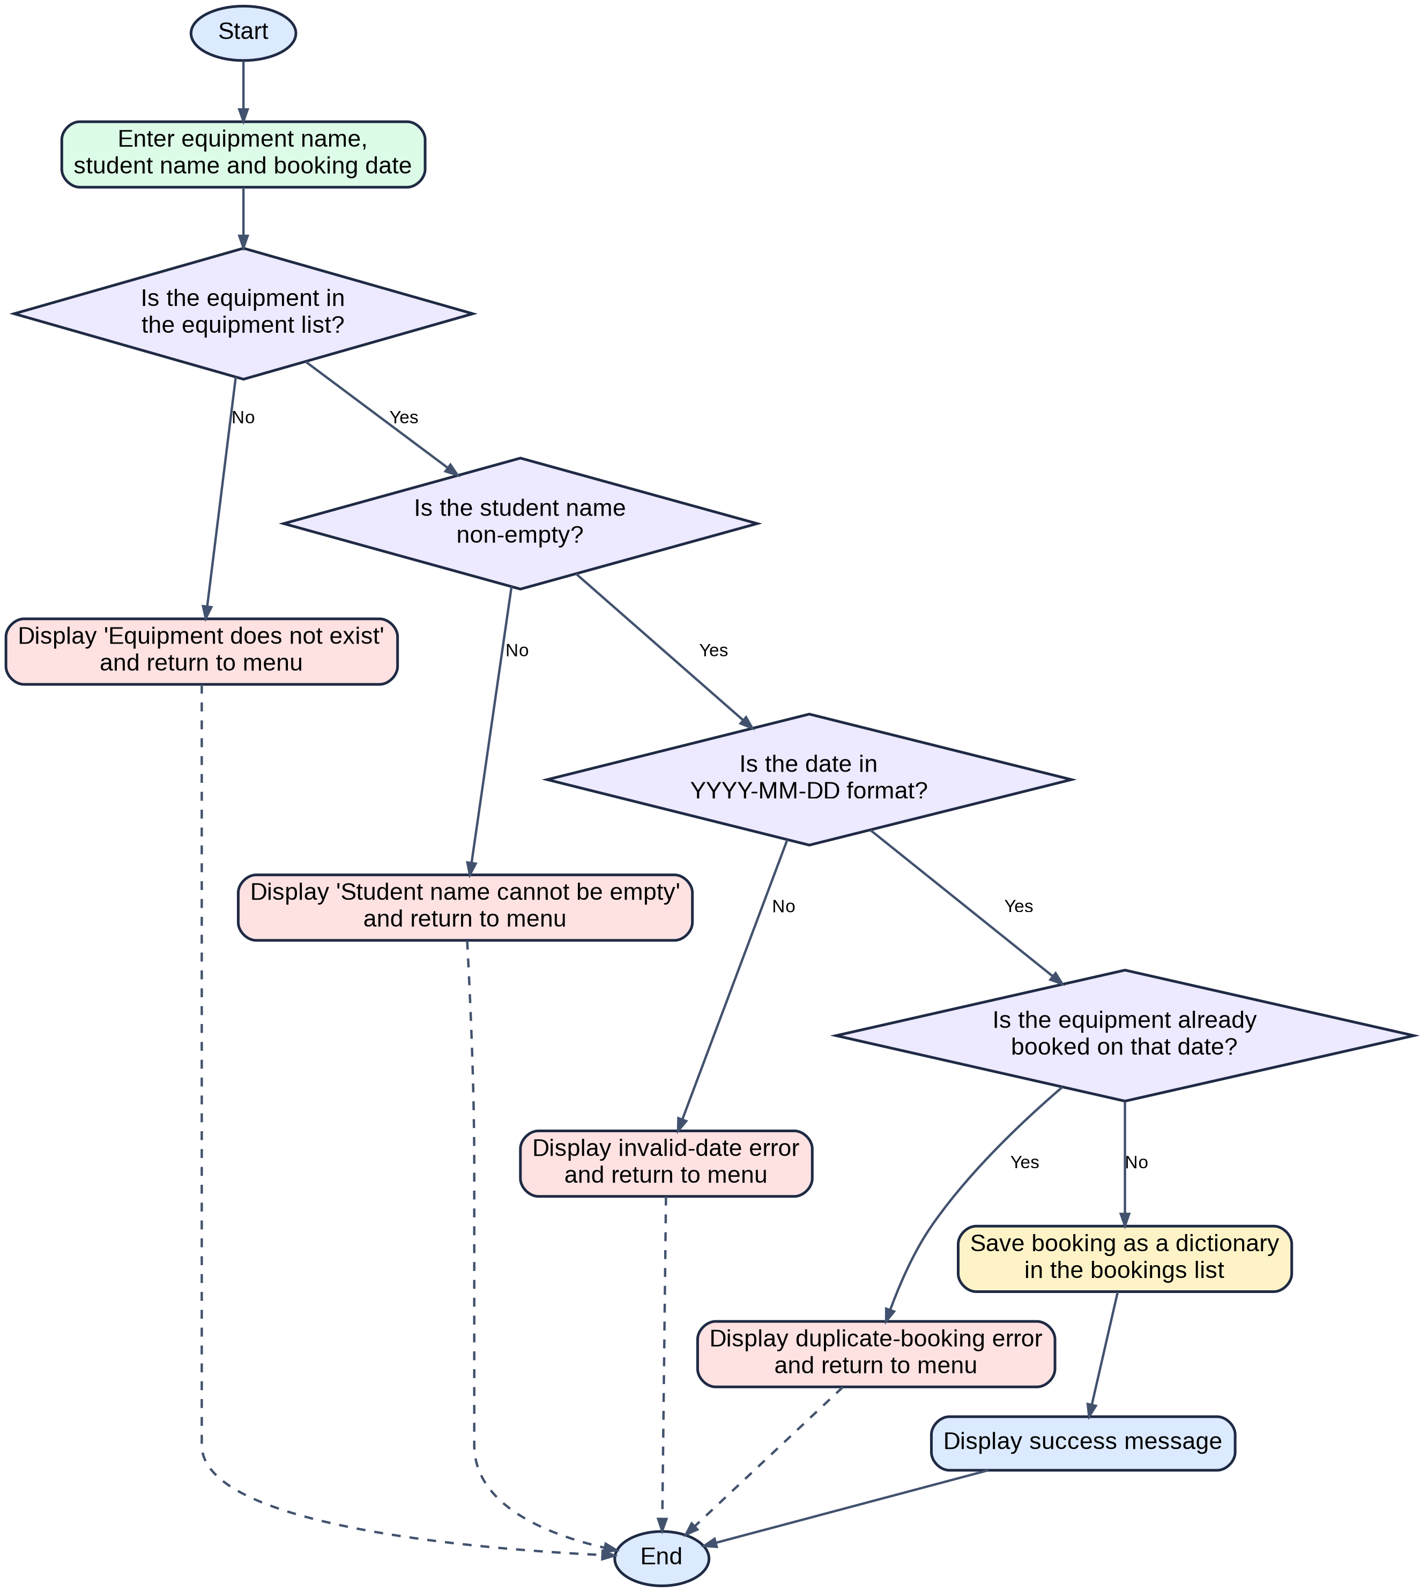
Figure 1. Flowchart for the record-booking process in the submitted system.

2.3 Pseudocode for core functionality
Pseudocode 1 – Add equipment
BEGIN AddEquipment
INPUT equipment_name
IF equipment_name is blank THEN
DISPLAY invalid-name message
ELSE IF equipment_name already exists THEN
DISPLAY duplicate-equipment message
ELSE
ADD equipment_name to equipment_list
DISPLAY success message
END IF
END
Pseudocode 2 – Record booking
BEGIN RecordBooking
INPUT equipment_name, student_name, booking_date
IF equipment_name is not in equipment_list THEN
DISPLAY equipment-not-found message
STOP
END IF
IF student_name is blank THEN
DISPLAY empty-student-name message
STOP
END IF
IF booking_date is not in YYYY-MM-DD format THEN
DISPLAY invalid-date message
STOP
END IF
FOR each booking in bookings
IF booking equipment matches equipment_name
AND booking date matches booking_date THEN
DISPLAY duplicate-booking message
STOP
END IF
END FOR
CREATE new booking dictionary
ADD new booking to bookings
DISPLAY success message
END
Pseudocode 3 – Search bookings
BEGIN SearchBookings
INPUT search_term
IF search_term is blank THEN
DISPLAY empty-search-term message
STOP
END IF
SET found TO FALSE
FOR each booking in bookings
IF search_term matches student name
OR search_term matches equipment name THEN
DISPLAY booking
SET found TO TRUE
END IF
END FOR
IF found is FALSE THEN
DISPLAY no-results message
END IF
END

2.4 Implementation decisions
The most important implementation decision was to use lists and dictionaries rather than a database. This choice reflects the needs of the task. The system has a small scope, the expected number of records is limited, and the priority is clarity. A list is an appropriate way to store equipment names because each item only needs to be stored once. A dictionary is an appropriate way to store each booking because it contains several related values that are easier to understand when each field has an explicit label.
Storing bookings as dictionaries is more readable than using tuples or unnamed positions within a list. For example, booking['equipment'] is clearer than booking[0], because the meaning of the value is immediately visible. This matters in a coursework context because code quality is not only about execution; it is also about how clearly the implementation communicates the logic behind the solution.
Key variables in the program include name, equipment, student, date, term, and found. These names are short, but they remain descriptive enough to make the program readable. The two global variables, equipment_list and bookings, provide the shared state needed by the menu functions. While a class-based design would be possible, the function-based approach is more proportionate here because it keeps the program structure simple and easy to follow.
The program uses the core programming constructs expected in the module: functions, selection, iteration, and validation. Selection is implemented through if, elif, and else statements to check input and control the program's responses. Iteration is used through for loops and the while loop that keeps the menu running until the user chooses to exit. Python's control flow tools are designed for this kind of structured decision-making and repetition [4]. The solution also uses the datetime module to validate the booking date format, which strengthens reliability without making the code difficult to understand [7] [4], [9], [10].
The final version deliberately avoids unnecessary external libraries. This keeps the program portable and easy to run in a normal Python environment. That decision also supports the educational purpose of the assignment, because it makes the underlying logic visible instead of hiding it behind frameworks or advanced infrastructure.
Another important design decision was to treat validation as part of normal processing. The program strips extra whitespace, rejects blank names, checks that equipment exists before booking, validates the date with datetime, and prevents duplicate bookings through a loop over existing records [7]–[9]. These checks are simple, but they protect the data structures from invalid entries.
The use of dictionaries for booking records is also defensible because it makes the code self-documenting. A record stored with labelled keys such as equipment, student and date is easier to inspect and explain than a plain list with unnamed positions [2], [3], [13].

2.5 Source code discussion
Figures 2 to 7 present the main sections of the source code, showing how the program stores data and implements the four required functions through a simple menu-driven structure. The screenshots are included to demonstrate that the final program is readable, modular, and directly aligned to the coursework brief.
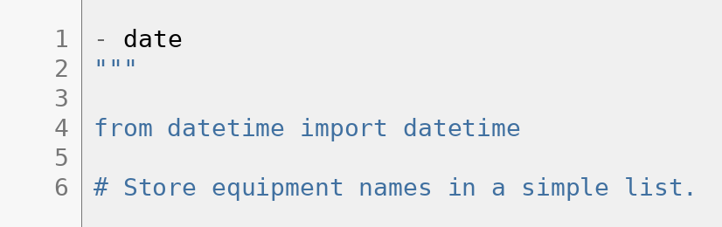

Figure 2. Python list and dictionary structures used to store equipment items and booking records.
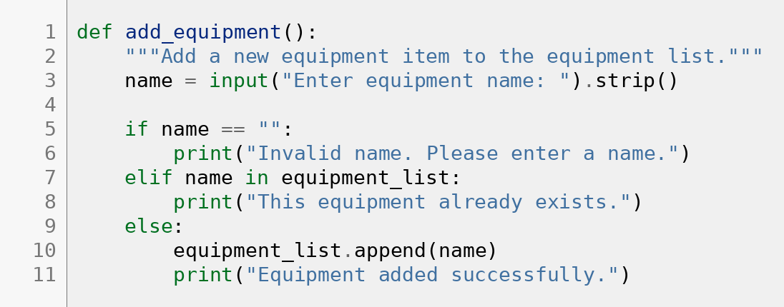

Figure 3. Implementation of the add_equipment() function for entering new equipment items.
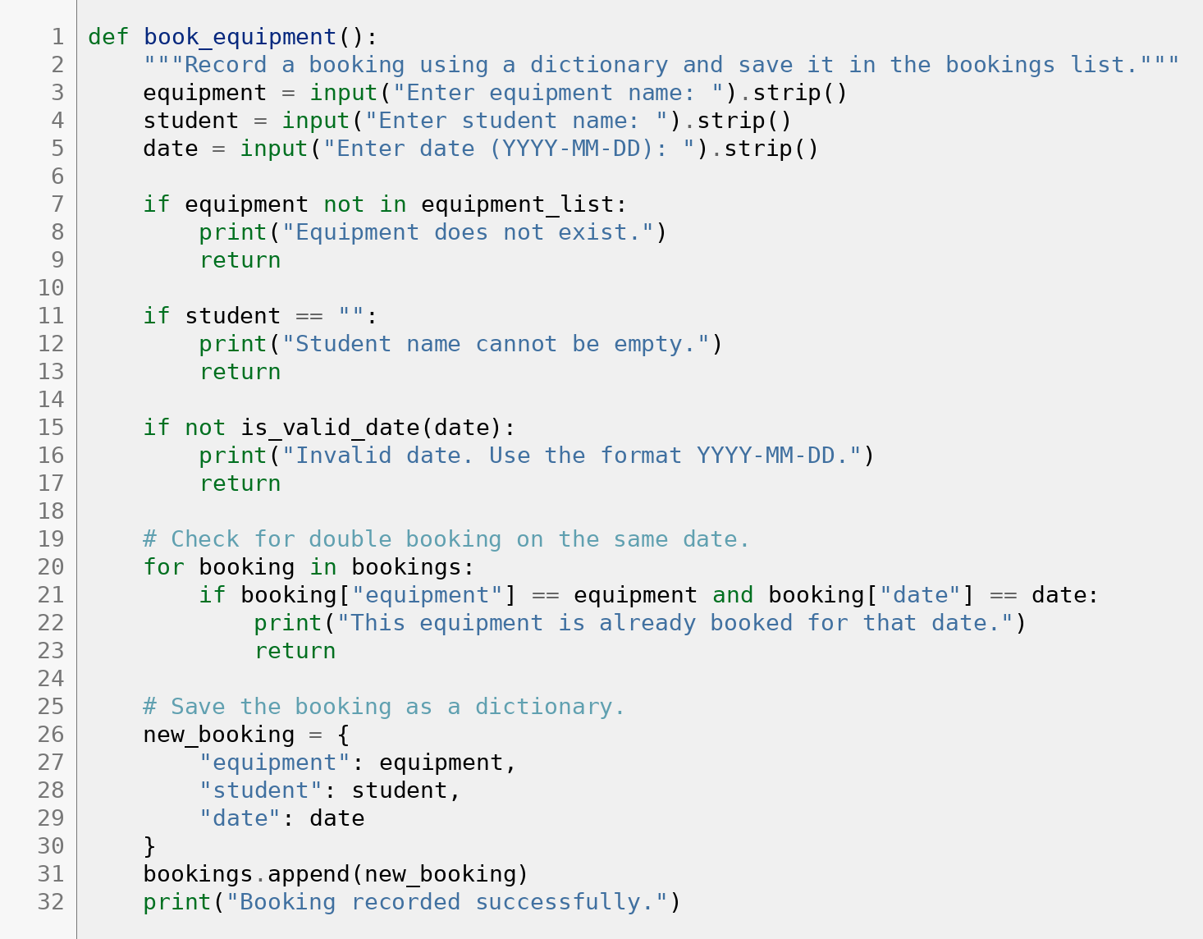

Figure 4. Implementation of the book_equipment() function for recording equipment bookings.
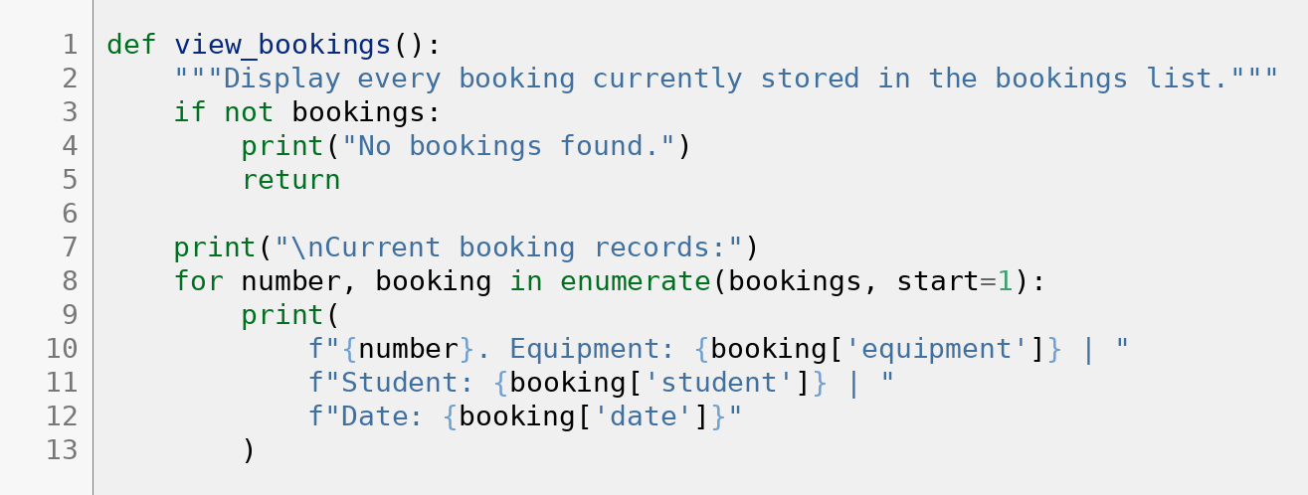

Figure 5. Implementation of the view_bookings() function for displaying all stored bookings.
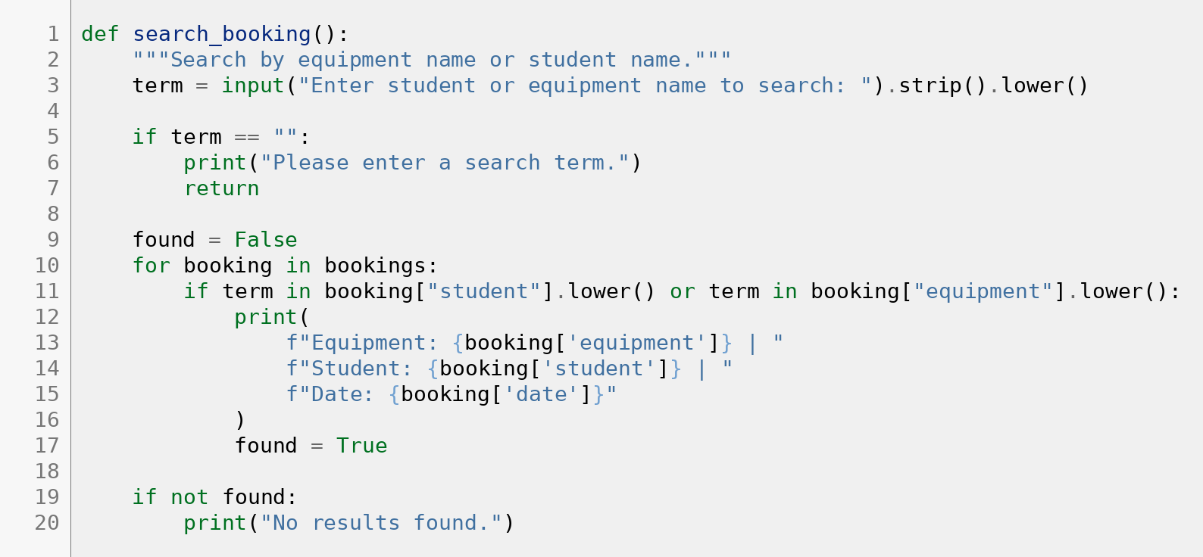
Figure 6. Implementation of the search_booking() function for retrieving bookings by student or equipment name.
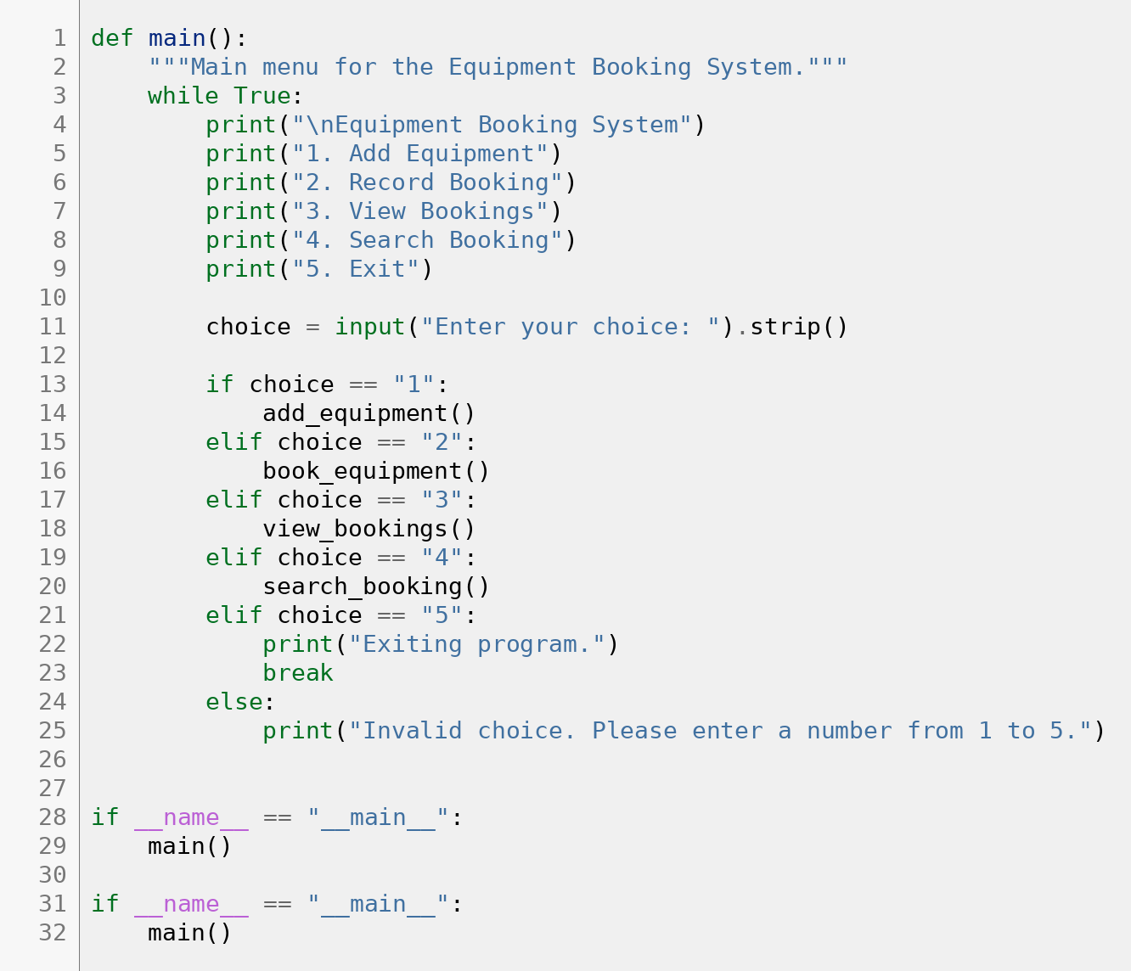
Figure 7. Implementation of the main() function showing the menu-driven control structure.
The booking function is the most important code segment because it applies the main business rules of the system. It ensures that staff cannot book equipment that has not been added, prevents a blank student name from being accepted, checks the date format, and scans the existing bookings list to avoid duplicate records. These checks show how a small program can still apply disciplined validation and control logic.
Code Listing 1 below illustrates the central booking logic. Even though the code is simple, it demonstrates the use of validation, iteration, and a dictionary-based data record within a single function.
Code Listing 1 – Booking function
def book_equipment():
"""Record a booking using a dictionary and save it in the bookings list."""
equipment = input("Enter equipment name: ").strip()
student = input("Enter student name: ").strip()
date = input("Enter date (YYYY-MM-DD): ").strip()
if equipment not in equipment_list:
print("Equipment does not exist.")
return
if student == "":
print("Student name cannot be empty.")
return
if not is_valid_date(date):
print("Invalid date. Use the format YYYY-MM-DD.")
return
for booking in bookings:
if booking["equipment"] == equipment and booking["date"] == date:
print("This equipment is already booked for that date.")
return
new_booking = {
"equipment": equipment,
"student": student,
"date": date
}
bookings.append(new_booking)
print("Booking recorded successfully.")

3. Testing and Debugging Report

3.1 Importance of testing
Testing is essential because a program can run without crashing and still produce incorrect results. In this project, the main risks are blank equipment names, invalid dates, missing equipment references, duplicate bookings, and misleading search results. Testing is therefore needed to confirm not only that the program executes, but that it behaves correctly under both valid and invalid conditions [12], [13].
For this submission, manual testing is an appropriate method because the program is a menu-driven console application with a manageable set of features. By entering a range of correct and incorrect inputs, it is possible to verify whether each function behaves as intended and whether the validation rules are working consistently.
The test design was derived directly from the requirements and from the main logical risks in the code. Testing terminology distinguishes between testing, which reveals failures, and debugging, which identifies and removes their causes [12]. This is useful here because the purpose of the test cases is to check consistent behaviour under normal, invalid and boundary conditions [13], [14].

3.2 Types of errors in programming
A syntax error occurs when code breaks the grammatical rules of Python, for example through missing brackets, quotation marks, or incorrect indentation. Syntax errors usually prevent the program from running and are fixed by correcting the code structure.
A runtime error occurs when syntactically valid code fails during execution. In menu-based programs, runtime problems often occur when the code does not handle unexpected or incomplete user input properly. In this project, validation reduces that risk by checking inputs before the program tries to use them.
A logical error occurs when the program runs but produces the wrong result. In this system, the clearest logical risk is duplicate booking. The final version addresses this by looping through the existing bookings and checking whether the same equipment item has already been assigned on the same date before a new booking is stored.

3.3 Test cases and validation evidence
The final submission uses manual test cases to verify that the system works under both correct and incorrect conditions. The table below summarises the main tests applied to the submitted program.
ID | Feature | Input | Expected Result | Actual Result | Outcome
T1 | Add equipment | Laptop 1 | Equipment added successfully | Equipment added successfully | Pass
T2 | Reject blank equipment | Blank input | Invalid name message | Invalid name message | Pass
T3 | Record valid booking | Laptop 1 / Ralph / 2026-04-21 | Booking recorded successfully | Booking recorded successfully | Pass
T4 | Reject missing equipment | Projector X / Ralph / 2026-04-21 | Equipment does not exist | Equipment does not exist | Pass
T5 | Reject duplicate booking | Laptop 1 twice on same date | Duplicate-booking message | Duplicate-booking message | Pass
T6 | Reject invalid date | Laptop 1 / Ralph / 21-04-2026 | Invalid date message | Invalid date message | Pass
T7 | View bookings | Existing bookings stored | All booking records displayed | All booking records displayed | Pass
T8 | Search by student | Ralph | Matching booking shown | Matching booking shown | Pass
T9 | Search by equipment | Laptop 1 | Matching booking shown | Matching booking shown | Pass
T10 | Search with no match | Camera Z | No results found | No results found | Pass
The testing evidence indicates that the final solution behaves correctly within the defined scope. In particular, the most important risk states—missing equipment, invalid dates, duplicate bookings, and empty search input—are handled with user-facing messages rather than silent failure.
The chosen tests intentionally include both successful and unsuccessful inputs. This matters because a booking system must not only accept valid data but also reject invalid states such as duplicate bookings, blank names or no-result searches. The test set therefore covers nominal use, missing equipment, invalid dates, duplicate data and search failures.

3.4 Debugging narrative
The main debugging work in this project focused on the booking logic. A simple booking system can appear to work at first, but still allow invalid outcomes if checks are missing. The most important issue to prevent was duplicate booking, which was solved by scanning the bookings list before a new record was appended.
A second debugging task was ensuring that staff could not make bookings for equipment that had never been added. This was resolved through an existence check against the equipment list. The date-validation step was also added to improve input quality. These changes demonstrate that debugging is not only about fixing crashes; it is also about correcting logic so that the program produces valid real-world outcomes.

4. Evaluation

4.1 Strengths of the final solution
The main strength of the final solution is its clarity. The program is easy to run, easy to understand, and closely aligned to the coursework brief. It focuses on the core tasks only—adding equipment, recording bookings, viewing records, and searching bookings—which makes it a suitable prototype for demonstrating programming logic and design decisions [6], [13].
A second strength is the use of appropriate data structures. The system uses a list for storing equipment and a list of dictionaries for storing bookings. This is a sensible design because the equipment data is simple, while each booking requires multiple labelled fields. The result is a program that is structured clearly and can be explained convincingly.
A third strength is the modular use of functions. Separating the program into named functions makes the code easier to read and ensures that each part of the system has a clear responsibility. This supports maintainability and fits the best-practice emphasis on readable, well-organised code [3].

4.2 Challenges faced
One challenge was balancing simplicity with functionality. The program had to remain easy to understand while still solving a real administrative problem. It would have been possible to add databases, user accounts, or more advanced interfaces, but that would have moved the solution away from the assignment's focus and made the code harder to explain.
Another challenge was preventing logical errors such as duplicate bookings. Although the solution is small, the booking rules still needed to be thought through carefully. Choosing a list of dictionaries as the booking structure helped because it made the record fields explicit and easier to check during validation.

4.3 Limitations and future improvements
The biggest limitation of the current system is that it stores data only in memory. This means all equipment and booking records are lost when the program closes. For a simple coursework prototype, this is acceptable, but in a real organisational setting persistent storage would be needed.
Another limitation is that the program does not include edit or delete features, user authentication, return dates, overdue tracking, or reporting tools. These omissions are deliberate because they sit outside the current scope, but they also define the boundary of what the present version can claim.
Future improvements could include saving data to a file or database, adding stronger validation rules, allowing existing records to be edited, and developing a graphical interface for easier interaction. Those enhancements would make the system more practical in a real-world context while building on the same basic logic developed here.
These future improvements would need to be evaluated against the same principle used in the current submission: appropriateness to context. If Bright Minds Academy grows, then persistent storage, authentication and a graphical interface would become more valuable because the cost of confusion and record loss would increase [6], [13], [14].

4.4 Self-reflection
This project reinforced that good software development is not only about making code execute. It also involves selecting an appropriate level of complexity, justifying design decisions, testing realistic cases, and documenting the final solution clearly. One of the most useful lessons was that a simpler implementation can be the stronger choice when it is better aligned to the stated requirements.
The project also improved my understanding of how lists, dictionaries, functions, loops, and conditionals can be combined to solve a practical problem. More broadly, it showed the importance of being able to explain why a design was chosen, what alternatives were possible, and what limitations remain. That reflective judgement is an important part of professional programming practice.
It also reinforced the professional value of documentation. Explaining the code with screenshots and written justification showed that software development involves communication and traceable reasoning as well as coding.

Conclusion
The final Equipment Booking Management System provides a clear and functional solution to the problem of managing shared equipment bookings. It allows staff to add equipment, record bookings, view all stored records, and search for existing bookings through a simple menu-driven interface.
The solution is appropriate for the coursework because it demonstrates core programming principles, justified implementation decisions, structured testing, and reflective evaluation without unnecessary complexity. Although it is a modest prototype, it addresses the central booking problem effectively and provides a solid foundation for future development.

References
[1] Python Software Foundation, “Built-in Types,” Python 3.14.4 Documentation. [Online]. Available: https://docs.python.org/3/library/stdtypes.html. [Accessed: Apr. 21, 2026].
[2] Python Software Foundation, “5. Data Structures,” The Python Tutorial, Python 3.14.4 Documentation. [Online]. Available: https://docs.python.org/3/tutorial/datastructures.html. [Accessed: Apr. 21, 2026].Documentation. [Online]. Available: https://docs.python.org/3/tutorial/datastructures.html. [Accessed: Apr. 21, 2026].
[3] Python Software Foundation, “PEP 8 – Style Guide for Python Code,” Python Enhancement Proposals.
[4] Python Software Foundation, “4. More Control Flow Tools,” The Python Tutorial, Python 3.14.4 Documentation. [Online]. Available: https://docs.python.org/3/tutorial/controlflow.html. [Accessed: Apr. 21, 2026].
[5] World Wide Web Consortium, “WCAG 2 Overview,” W3C Web Accessibility Initiative. [Online]. Available: https://www.w3.org/WAI/standards-guidelines/wcag/. [Accessed: Apr. 21, 2026].
[6] International Organization for Standardization, “ISO/IEC 25010:2023 – Systems and software engineering — Quality models.” [Online]. Available: https://www.iso.org/standard/78176.html. [Accessed: Apr. 21, 2026].
[7] Python Software Foundation, “datetime — Basic date and time types,” Python 3.14.4 Documentation. [Online]. Available: https://docs.python.org/3/library/datetime.html. [Accessed: Apr. 21, 2026].
[8] Python Software Foundation, “Built-in Functions,” Python 3.14.4 Documentation. [Online]. Available: https://docs.python.org/3/library/functions.html. [Accessed: Apr. 21, 2026].
[9] Python Software Foundation, “8. Errors and Exceptions,” The Python Tutorial, Python 3.14.4 Documentation. [Online]. Available: https://docs.python.org/3/tutorial/errors.html. [Accessed: Apr. 21, 2026].
[10] Python Software Foundation, “4.8 Defining Functions,” The Python Tutorial, Python 3.14.4 Documentation. [Online]. Available: https://docs.python.org/3/tutorial/controlflow.html#defining-functions. [Accessed: Apr. 21, 2026].
[11] Python Software Foundation, “7. Input and Output,” The Python Tutorial, Python 3.14.4 Documentation. [Online]. Available: https://docs.python.org/3/tutorial/inputoutput.html. [Accessed: Apr. 21, 2026].
[12] International Software Testing Qualifications Board, “Standard Glossary of Terms Used in Software Testing,” ISTQB Glossary. [Online]. Available: https://glossary.istqb.org/en_US/home. [Accessed: Apr. 21, 2026].
[13] I. Sommerville, Software Engineering, 10th ed. Harlow, U.K.: Pearson, 2016.
[14] R. S. Pressman and B. R. Maxim, Software Engineering: A Practitioner’s Approach, 9th ed. New York, NY, USA: McGraw-Hill, 2020.

Appendices

Appendix A – Submitted file inventory
File | Purpose
simple_equipment_booking_system.py | Main Python source code.
Equipment_Booking_System_Report_Final_v3.docx | Final report document with abstract, updated references, and embedded coloured code figures.
Equipment_Booking_System_Report_Final_Updated.docx | Final report document.

