
PROFESSIONALCAREER DEVELOPMENT
(Reflective report)


University of Wales Trinity Saint David

Huda Haroon (1919280)
Name of host Organisation (UWTSD)
04/08/2020

- Contents:
- Executive Summary. 2
- Terms of Reference 4
- Procedure. 4
- Introduction. 4
- Findings. 4
- Self-awareness 6
- Definition of employability skills. 8
- SMART Goals. 9
- SWOT Analysis. 10
- What is personal development plan. 12
- Johari window. 14
- Kolb’s reflective cycle. 18
- Vak models. 18
- References. 19
- Acknowledgements. 19

Executive Summary

This reflective report of professional career development.

I addressed and defined all areas related to my ultimate 6 weeks lectures what I realized and understood. In my work research and check out about my self awareness, my PDP design SMART goals, SWOT Analysis, Johari window and learning styles.

I clearly validated my work and ongoing experience a very good way for my self-knowledge and self-esteem this will help me grow in skills and confidence with this journey of one-year study of professional career development and Employability Skills at the University of trinity Saint David. I explained in this report what skills and knowledge I am going to achieve especially on my SMART Career goals.

In this learning period I developed a good sense how to use the online resources and Moodle, online learning, support of my lecturer i am gaining knowledge Getting confidence and building skills and SWOT Analysis is good reflection of my progress. I conclude my goals and achievements through this educational journey of 2020_2021.

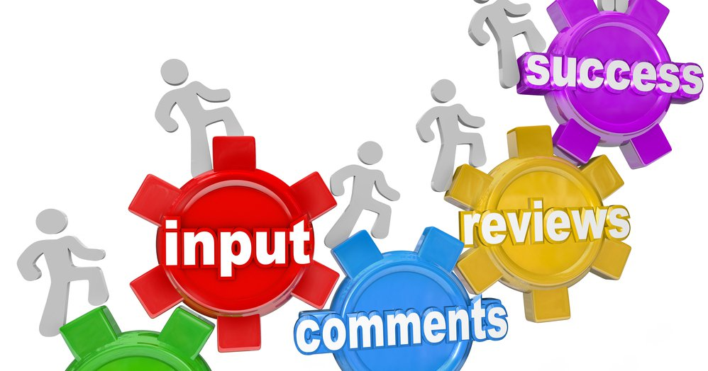

Terms of Reference:
My lecturer Miss Laura James requested to produce and reflect on professional career development journey of 6 weeks of learning. Submission date is 4rth of Sept 2020, the reason of this reflective report is to analyse and apprehend talent and ability. I as a student (1919280) who compiled the report, briefly addressed and explained all areas.
Procedure:
I made this document with the help of online journals, resources, Kolb, Vak learning styles, Johari window, handbooks, useful versions and websites to complete my research
Introduction
In order to be familiarized and decorate my facts in expert improvement via ability of following the UK requirement, I determined to be a part of this instructional 2020-2021the capabilities for the area of job into the UWTSD.
Having records in administration field. I learnt how to collect managerial capacities inner three years of experience of volunteering and paid work in a number departments consisting of ticket sales, admin and reception role, making unfold sheets dealing with procurement work with clinical secretary in fitness middle surroundings and in the give up in the administrative and receptionist in GPOOH service.
I want to be more successful and active when i thoroughly described my strengths and weaknesses. For constructive about myself assurance because of my origin i faced barrier of language. After comes to UK I decided to do voluntary work, Vocational training to build my communication skills as well as confidence level.
I desire to develop my own development plan is reflection of my skills and self-assessment, SMART goals, SWOT Analysis. Professional enhancement refers to the technique of figuring out desires and mastering new competencies to aid for improve work and have success.
Findings:
The finding of this research based on implementing plans. Professional and career learning for early educational career conclude the research activities.
Build and grow confidence in researching.
Create own tough plans and tasks that impact serious thinking after.
Develop team working experience and tasks
Push yourself up for self-rules and dependent movement on research.
Give a safe and positive atmosphere.
Opportunity to speak and explore.
Think positive a out your own work or document.
Result of this supportive model produce by Evan, (2011). She divert attention to the role personal and professional career development and growth.
reflective report is based on my ride of attending certificates of greater schooling talent for workplace. That is about how to enhance skills and construct career. In this reflective record of expert profession improvement I addressed and defined all areas related to my project and study. In first module of the course I have identified my capabilities and extended my mastering each as a students and in relation to my work and life experiences.
In this record I have had a top refection amplify of my self cognizance and improve learning. In first time period of learning Introduction of module we realized 5 basic primary factor of professional career development these are
• Self-awareness
• Learning styles
• SMART
• Swot
• Go mad thinking
• Personal development
• Kolb reflective cycle
Aim of this module is recognize the skills and know-how needed for working effectively., set up employment dreams and improve motion plans. In this learning period I face the task to recognize myself recognition and strengthen self-awareness

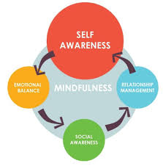
Self-awareness:
Covey, (2011) wrote that you are aware of your house between response and stimulus, you are aware about your upbringing, biological, inheritance and different forces spherical you.
I analyse myself if I can’t manipulate my feelings, I can snap underneath stress. Emotional talent is a key if leadership. No one care how a great deal you recognize till they first comprehend how an awful lot you care about them
There are properly defined seven habits of effectiveness to greatness
Stephen Covey well known how to develop emotional brain the use of the 7 habits
Some concepts I discovered for myself.
Habits. Principles
Be proactive. While working in hospital as a administrator. I realise my
Responsibility.
Begin with the End in mind. I understand value of company
Put first thing first. I can employ or execute As a receptionist
Think win win Respect staff, colleagues, patients.
Seek first to understand. Mutual understanding have to be cooperative with staff and
Then to be understood environment
Synergies
Sharpen the saw. Feedback appraisal review myself
Learning self-awareness amplify my self-knowledge and preferences, desires. I have a clear concept of my character and behaviour, strengths and weakness

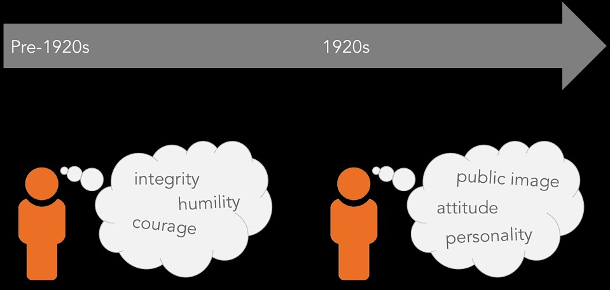

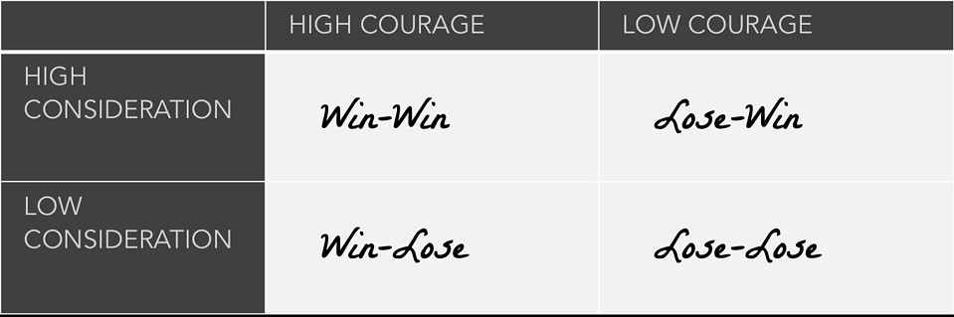

Review of route I realized about employability abilities
Define employability skills:
Capabilities of employability is advantage and big quality to get a dream job. There are some basic skills, communication, verbal, written, IT skills that will allow all people applicable for company or employers.
Doyle, (2020) updated that employability capabilities are every now and then regarded as foundational competencies or skills to get a job.
Employable abilities encompass the basic skills allow me to work with others, additionally consist of highly practical and professional skills that’s make me able to be worthwhile in any work place and transferable skills.
Communication:
Essentially, communication means getting a message from one person to another very clear and simpler if I have ability to speak clear so others understands me
Ability to listen hear and understand what other people say.
Ability to use correct grammar and spelling. Communicate effectively in writing.
There is another way for communication is body language and non verbal signs.
There are analytical skills, verbal exchange skills, problem solving skills, creativity ethics, employability abilities are smooth skills, pc capabilities are tough that are required in all jobs.
According to knell, Oakley (2007) different companies and employers are constantly searching for a staff who is wealthy in effective communication competencies and who understands people’s equality.
SMART Goals:
In the subsequent stage of career Action diagram is to recognise these thoughts into a time table
Paul, j, Mayer (2003) describes the traits of SMART Goals, Attitude is everything if you favour to succeed Above and Beyond amplify his definitions to explore how to create, boost and gain my goals.
Furthermore, current situation of setting goals which I fully supported tools that expand our capability to communicate complexity in a massive and technical approach. Lathem, (2001)
Achieving goal frequently need to be a SMART action plan or work which is stand for, specific, measurable,, achieving, related, timely. Doran 1981; Fielding 1999; Wade 2009.
Corinne Mills (2017) stated that the SMART guidelines remind us that if our dreams placing it is to be workable, it should be:
S: Specific: it is necessary to be certain and precise, be as clear and unique
M: Measurable: perceive success criteria setting a milestone alongside the way will give me the chance to reassess or success can be measured.
A: Achievable: Make positive about dreams are stretching however doable. Setting goals i can moderately accomplish inside a positive time frame will assist me hold motivated.
R: Relevant: Everything in career motion graph must be relevant to my normal profession objectives.
T: Time based: I will Set target dates and closing dates for the goals. My timeframe would possibly me unrealistic I may have run into surprising methods or my desires would possibly be unachievable.
SWOT:
When employers and staff need to take important decisions, they often find SWOT Analysis useful. It is another simple but effective technique that we can apply in different situations and help us weigh sensible decisions. The great advantage of SWOT analysis is that gives an overview of the advantages and disadvantages of a situation. Holmes, 2011.
It stands for strength, weakness, opportunity, threat. I did my SWOT Analysis to understand about myself.
- Strength: what qualities I have to work in company I can make good relationships, strong bonding loyal with clients and customers, make a strong balance worksheet. The organisation takes as important capability uniqueness and so on (Thompson and Strickland, 1981,109)
- Weakness: Find and recognise the area which company needs to improve like an unnecessary supply chain.
- Opportunity: Opportunities are new openings for something better chances, it requires to keep an eye and be focused what might take place in future. Think about relevant opportunities you can spot immediately. Even small benefits can increase competitions.
- Threats: Increasing competition level other candidates are more qualified than

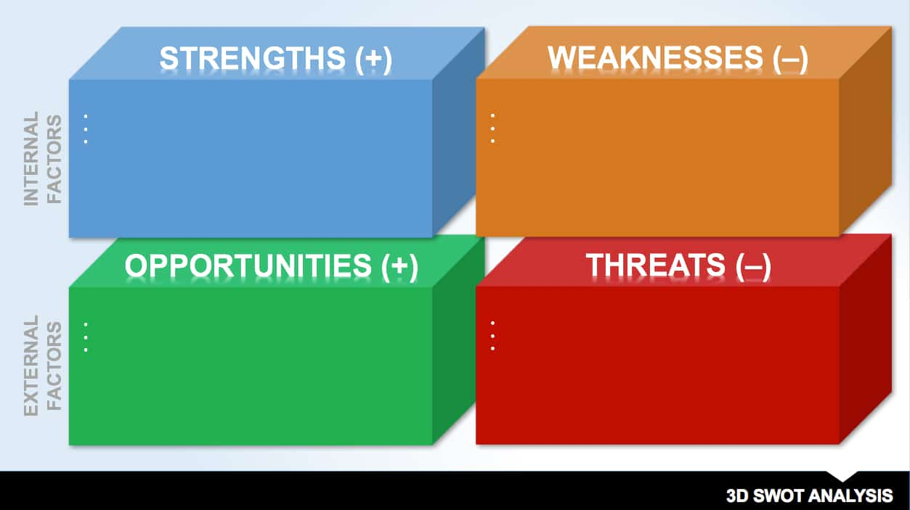

Personal swot analysis:

Strengths:  As an administrative assistant  Usually calm under pressure  Good communicator  Good team worker | Weakness  Can be impatient  Not very keen to do presentation
Opportunity  Excellent training schemes  Could specialise to be a supervisor or leader | Threats  High standard of applicant so may be hard to get in.  Competitions for jobs is fierce so it may be hard to find a job.

What is a Personal Development Plan?
A personal development format (or PDP) isn’t absolutely an obligatory some thing that supervisor do earlier than a every 12 months Review or upgrade ‘.they’re moreover that association set to support your goals and needs continue to be in sight.
A suitable sketch affords focus; it helps you map out a course in the direction of your model of achievements it lets in you to do best decisions, and its stop you from taking steps backwards. A acceptable diagram also approves to ideas and you back on track when something go wrong.
A Development plan Additionally advantage for your intellectual journey as a trio of new ideas, schemes can often assist minimise pressure and stress.
Tillema & Smith (2003). Gives a brief detail on PDP evaluation the less valuable becomes for leading improvement purposes and projects.
Carefully identified core element of PDP. Their own techniques are procedures are determined. Brief description of these elements.
Self-awareness of strengths and abilities e.g. time management.
Reflection - to be undertaken at amazing adventures e. G return of assignments with feedback. An issue of reflection can be built in as one assignment.
Action planning - section of changing, this will be based into capabilities module.
Team or group work- capable to recognise one specific role or behaviour within a crew and to implement properly. This requires proper work and supply of good guidance and remarks on performance.
Career planning – market awareness, applications, presentations, and interviews.
My PDP PLAN
There are few steps I followed to make a plan of personal development.
- Setting goals
- Set dates
- Recognise fears and offers
- Develop capability and knowledge
- Measure my progress on skills
Engaging with PDP will assist me to:
recognise my competencies and competencies that are growing at some point of studies;
I recognise how these advantage and capabilities are transferable (including work and professional contexts.

PROFESSIONAL DEVELOPMENT PLAN
Target | Action achieved | Evidence of completion | Target date
Complete this course follow up all instructions and complete assignments and make sure have good understanding of subjects | Give much time to understand my activities of course and practice skills and building confidence  Planning to be organised always keen to keep up with tasks. | Try to do all work and assignments on time completed and get good grades | Completion of course of employability skills (2020-2021)
With this course I will learn my skills and knowledge and build confidence, get more experience from employability skills course | Do lots of work practically test myself when communicating to others, take time when do research  Details of assignment and exercises and ensure I understood all my studies | My work in administrative will have improved as would of my grades in exams and i will be more confident and self aware. | Ongoing throughout first year of study of module.
Be more active and excited to achieve awesome grades in this course | Be focused on my career and this course try not to skip lectures and make proper instructed assignments. Keep learning. | I will able to achieve my goals towards career result of this course be consistent about learning and career and get good remarks and grades learn as much as I can. | Ongoing throughout study (2020-2021)
Gaining administrative experiences. | Gain experience required to be capable in administration.  Develop contact with people and companies.  Understand areas of my work which I desire to move in. | Achieve good place in admin field.  Develop and maintain good relationship with people and companies.  Left placement with improved knowledge and technical skills. | 2019(year of placement)

Johari window:
The model of Johari window used to be made in 1955 using research of Luften and Ingham. Good understanding of this model can recognise verbal exchange with other people help to understand personally
The Johari Window Model used to be created in 1955 by using Joseph Luften and Harry Ingham. The identify is derived from the first names of the creators. The Johari Window Model can help human beings to better recognize their verbal exchange with others.

- Known by me and others like good communication skills
- Unknown by me seen by others like what other people or colleagues know about me and i am unaware of
- Hidden by others known to me like what I like or dislike or hobby
- Unknown by me unknown by others nobody know so we can’t discuss.

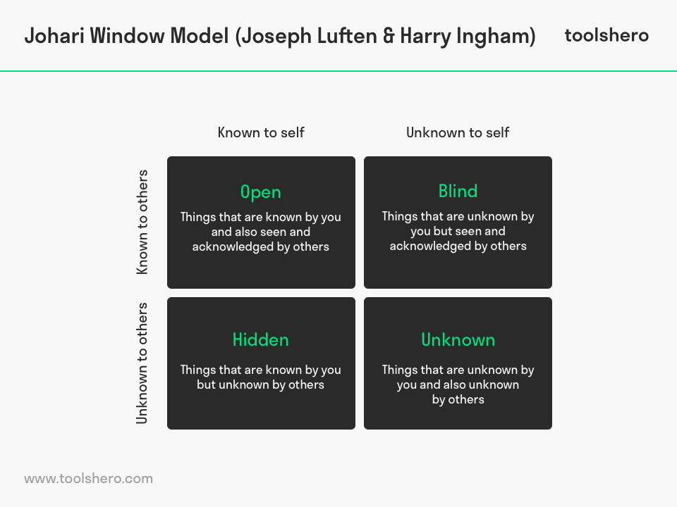
Learning styles:
I thought my learning experiences so far in life. They haven’t all taken place in a classroom under the supervision of teachers.
Ways of learning become hardwired into our brain so that I can acquire new knowledge and skills that I find useful for my career, my ability to continue to learn and develop us a key factor of getting employability.

Exploring learning styles is a fun as well as being informative
Peter Honey and Alan Mumford, who developed a system in the 1980s still in use today.
They define their 4 learning styles
Activist: they try new experiences to learn.
Reflector: These kinds of learner think before they act watch others collect information.
Theorist: These learners want to know why things are happened.
Pragmatists: these kinds of learner try new ideas and experiment through a combination of theory and practice.

Visual learning style involves the things that can be seen, pictures, presentation, charts, handouts.
Auditory learning style is based on listening, spoken words, of self or others, sounds and noises. Kinaesthetic learning involves physical touch, feeling, holding experiences, practical.

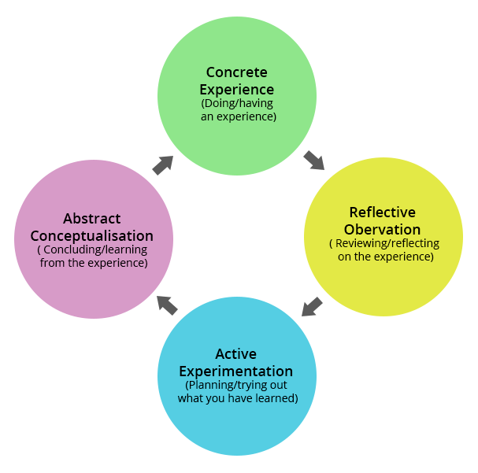

Kolb reflective cycle:
I enjoyed Kolb learning style David Kolb is one of the most frequent to learning theories
Kolb’s learning cycle suggests that most people learn in 4 stages that is kind of continuous cycle.
We can apply this learning style to almost everything we do, it is useful when we are requiring new skills, learn what wd have done and fine tune our actions, then try it again
Kolb learning style provides foundation for observing experience and reflection.

Kolb’s models based on four key stages

- Experience: we do something
- Reflection: we observe first then think what we have done
- Concept or theorising: we draw conclusions and we learn lessons from it
- Applying and testing: the way we carry out new learning.

Conclusion:
It has been validated that my all experiences and ongoing experience are accurate for myself knowledge, awareness and will assist me for enhancing myself during this course. I clearly developed and defined what kind of advantages I pwill achieve. I am working on my SMART Action to full fill my desire skills.
In the meantime, I conclude all resources to compile this report aim of this reflective report is to identify my skills and knowledge related.
I defined SMART, SWOT Analysis to analyse myself and have reflection on my self-knowledge. Personal development plan is based on my ongoing learning experience and at the moment I have to focus on this to achieve a career goal afterword’s. I analyse my PDP plan how to get through this course taking all tasks, assignments properly and effectively.
Johari window is really helping me understands my blind spot and my open area. I applied Kolb’s learning style and peter model of learning which is reflect in this report.
My strengths and weakness which I will improve with this 6 week of learning.
the end prospect and emphasize what duty and activities will be implemented for career improvement.

References
- Alison Doyle 2020, employability skills.
- Corinne Mills (2017) by Trotman publishing, 2nd edition, a book, Career coach.
- Evans, I, .(2011) The scholarship of researcher development, International journal for research and development, 2(2), p, 75,98.
- Karen Holmes, (2011)1st edition by Trotman publishers. The work skill handbook.
- Knell, J., Oakley, K. (2007) Confronting the skills, maximising human potential in a 21st century economy Retrieved from http://www.demos.co.uk.
- Doran, G. T. (1982) There’s s SMART way to write management goals and objectives. Review 70, no.11:35-36.
- Lethem G P. (2001). The reciprocal effects of science on practice: insights from the practice and science of goal setting, 42,1-11.
- Mulder, p. (2017), Johari window models. Retrieved from tool
- hero’s: http://www.toolshero.com/communication-skills /Johari-window-model /.
- Mitchell Grants, (2020) reviewed by Gordon Scott., source Google search.
- Paul J. Meyer, (2003) Business man, Author and founder of success motivated international, Vol. 2.
- Stephen Covey (2003) seven highly effective habits, Ist, edition published, 1989.
- Thompson A. A & Strickland A. N. (1989) strategy formation and implementation, 4rth edition USA: Irwin, Inc.
- Trilemma, H. H (2001,2003) Audit assessment practice in organisation, International journal of Human resources development and management. 3, 359-370.
- Zimmerman B. J (2008), Goal setting: A key proactive source of Academic self-regulation. In motivation and self-regulated learning, ed D. H. SC hunk and BJ. ZIMMERMAN, 267-295 New York.
- David Kolb original concept relating to Kolb’s learning styles model, and Alan Chapman 2003-2013 review and code and diagrams artwork.
Acknowledgements
One of the greatest pleasures in preparing this report has been researching, internet, online resources, books, journals use images from Google search. I find there are thousands of talented, multiscale and enthusiastic people out there are determined to make great future for themselves
Thanks for Kolb learning style and peter learning styles really help me to understand.
With respect for my lecturer who is very supportive she designed a simple and beautifully defined videos on Moodle. She helps me to understand my abilities which I accompanied to completing the report, she guides us to follow online resources and push us to do research take time.

