

Certificate of Higher Education in Skills for the Workplace

Task 2
Professional career development report

Student name: Leonard Hondor
Student ID: 2115347

Module name: Professional Career Development
Module code: (BMSW4005_LON)
Lecturer name: Faizu Edu
Word count: 1825
Submission date: 06/09/2020

Table of Contents

Introduction 1
Gibb’s learning cycle………………………………………………………………………………………………………………………...2
Skills and knowledge which contribute toward working effectively 3
My personal strengths and areas for further development 4
SWOT analysis 5
Development plan 6
Conclusion…………………………………………………………………………………………………………………………………………7
Reference………………………………………………………………………………………………………………………………………….8

Introduction:

This paper discusses my personal professional development goal.... Using Gibb's reflective cycle, I present a reflective account of the role play. In the report, I will examine the abilities and knowledge needed to function as a shift manager, which is my career goal. A personal growth plan with SMART objectives is offered, as well as an appraisal of my present strengths and opportunities for progress.

• Gibb’s Reflective cycle.
In 1988, Graham Gibbs published 'Learning by Doing,' which introduced the Gibbs Reflective Cycle. Professor Gibbs' innovative technique reinforces learnings from education and experience through a cyclical sequence of reflection tasks (experiential learning). Gibbs' Reflective Cycle is now a standard resource for healthcare workers, staff development experts, and college academics. It is also often used in business.
How Do We Use Gibbs Reflective Cycle?
Gibbs' Reflective Cycle is a self-reflection and management strategy that helps people think clearly and systematically about their learning experiences. It encourages kids to analyse situations and find out how to do better the next time.
- Personal reflection on the role play: Recruitment and Selection - Applying Gibb’s learning cycle.
As part of my evaluation of the module Professional Career Development, I participated in a role play in week 10. Here I present a reflective assessment of the role play utilising Gibb's learning cycle below:
Gibb’s learning cycle is created by 6 different reflections:

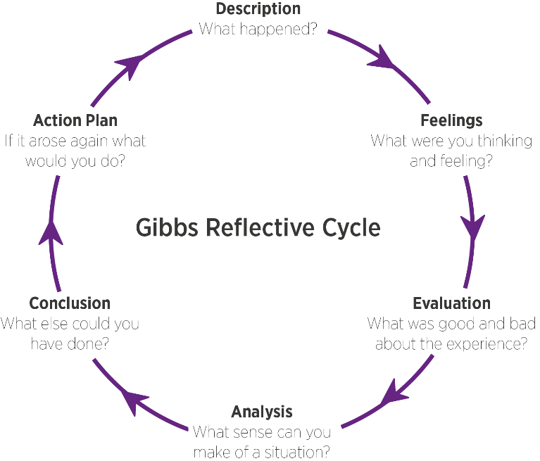

1. Description :
On weekend number 10 of this course, I participated in a role-playing game with my colleague Juan with whom I created an action where we were both supposed to be at an interview for our dream job.

2. Feelings:
Although we prepared quite a lot, a confusion was created between us that put me in the situation of changing my interview questions that made me be much more stressed than before and go into a little panic.

3. Evaluation: positive and negative
As a negative part, I can say that it has the most to do with what I said above. The confusion that was created between me and my partner put me in a situation where I could lose control of what I had learned before. The TFL strike that had taken place that day as well, I had to leave the house 2 hours before the role-play so I could arrive on time for it.
As a positive part, I can say that it was the result of that role-play that according to the teacher and our colleagues who assisted it was a good and well-established interview.

4. Analysis:
This role-playing game was made in order to prepare us for the real interview of our dream job that we will have following the course we have taken at UWTSD.

5. Conclusion: What else could I have done? What could I have done differently?

For this part, I will refer to the feedback I have received from my colleagues/lecturer.
First of all, I could have dressed more elegantly considering that I was going to the most important interview of the beginning of my career.
And secondly, I could have given some more complex answers to the questions Juan asked me, my emotions have spoken their word here.

6. Action plan:
In the future, I will definitely think about this interview from which I learned a lot.
I learned that I don't have to wait for them to take out of me what I have to offer but that I have to prove to them that they need my services, I learned to focus more on my strengths and to fight to improve the others (such as public speaking), I learned how to behave with a person I had never met before and how I should talk to that person.

• Skills and knowledge which contribute toward working effectively
Shift Manager:
A Shift Manager is in charge of ensuring that their team works efficiently during the duration of a shift. They distribute duties to their employees, create targets and goals to keep their team on track, and evaluate performance to assure progress.
- Adopt a Good Attitude
- Identify Priorities
- Build Essential Skills
- Time Management and Productivity
- Communication Skills

• My personal strengths and areas for further development
I can say that I have two of the most important skills for this job that would be a step up for me (being a shift supervisor now).
Productivity and time management, these are the skills I learned by working very closely with my manager. The element I have to work on is communication, English not being my mother tongue.

- SWOT ANALYSIS

SWOT is an acronym that stands for Strengths, Weaknesses, Opportunities, and Threats. A SWOT analysis is a framework for assessing and comprehending the internal and external influences that may produce opportunities or hazards for a business.

SWOT ANALYSIS

STRENGHTS  - Productivity  - Time management | WEAKNESSES  - Communication
OPPORTUNITIES  - Step up | THREATS  - More candidates applying for the same role

PERSONAL DEVELOPMENT PLAN:
Development planning occurs in a variety of circumstances, making it difficult to explain clearly. Essentially, development planning refers to the strategic, quantifiable goals that a person, organisation, or community intends to achieve within a specific time frame. Typically, time-based benchmarks are included in the development plan. It usually includes the criteria that will be used to determine whether or not the goals were reached.

NAME | LEONARD HONDOR | Target Job/career | Shift Manager

TIME PERIOD | From: 10/10/2020 | To: 10/01/2023

What Skills do I need to achieve my goal?
SKILLS | How Will I get them | What resources or support will I need? | What can prevent me from achieving my goals: (unemployment, illness | How long should it take
.Communication  .Speaking in front of people  .Monitoring people | .By continuing my studies at UWTSD | .Good lecturer | .Focus | .Less than 2 years

- My short - medium – long term targets for the development of my own professional career
Short-term plan (3 -6 months)
Specific | Improve my communication skill.
Measurable | I will know that I achieved it by doing multiple English-test.
Agreed | It is possible only with determination.
Realistic | It does contribute to my future development.
Time-Bound | 10/11/2022
Medium-term plan (1-2 years)
Specific | Speaking in front of people with confidence.
Measurable | It is important as a Manager to stay close to your team so I will know if I achieved this skill by team performance.
Agreed | It is important to be confident as a Manager because the operation it’s in your hands.
Realistic | Being confident it’s important when people need to trust you.
Time-Bound | 10/10/2024
Long-term plan (2-5 years)
Specific | Having a successful career as a Manager.
Agreed | This is one of the most important thing for me.
Realistic | I have to work hard and give 100% for a successful career.
Time-Bound | 10/10/2025

Conclusion
In conclusion, this essay discussed the key to having a successful career. By using diagrams like SWOT, Gibb's Reflection or Personal Development plan , I was able to prove to myself how good I am but also what points I should bring to perfection.

References:
Charles, S., 2021, “Gibbs Reflective Cycle: Feel the Benefit of Experiential Learning”, available at: ” https://www.makingbusinessmatter.co.uk/gibbs-reflective-cycle/#:~:text=Gibbs%E2%80%99%20Reflective%20Cycle%20is%20a%20self-reflection%20and%20management,distinguished%20career%20in%20the%20field%20of%20learning%20development. “, accessed at[1 September, 2022].
Mind Tools, 2020, “Being Effective at Work Essential Traits and Skills”, available at: “https://www.mindtools.com/pages/article/being-effective.htm#:~:text=In%20addition%20to%20the%20technical%20skills%20required%20to,these%20skills%20will%20pay%20off%20in%20the%20workplace. “, accessed at [1 September, 2022].
Kyle, P., 2022, “SWOT Analysis” available at: https://corporatefinanceinstitute.com/resources/knowledge/strategy/swot-analysis/” , accessed at[2 September, 2022].
Lesley, B., 2019, “Definition of Development Planning” available at: https://careertrend.com/about-5095844-definition-development-planning.html , accessed at: [2 September, 2022].

Appendix A :
Job application form

Application for [Shift Manager] -

Your details

Name: Leonard Hondor

Education and training
Please give details:

Business and Management Plan, Colegiul National – Roman Voda (Roman, Romania).
Higher Education in Skills for the workplace, University of Wales Saint Trinity David.(London, England).
I learn – Customer Service (London, England)

Qualifications
Please give details:

- Higher Education
- Undergraduate
- A – Levels

Employment history

Name of employer: Amazon

Job title: Shift Supervisor

Length of time with employer: 16 months

Reason for leaving: Career progression

Duties:

- Interacted in with people in multiple languages and
provided clarification.
• Created profitable marketing campaigns for products
using social media strategies and analytics.
• Delivered positive customer interactions, promptly
identifying, and resolving individual needs.
• Applied expert knowledge for daily completion of tasks
and streamlining workflows.
• Communicated confidently with diverse clients from
different backgrounds

Previous employers
Please tell us about other jobs you have done and about the skills you used or learned in those jobs.

Oscar Mayer – Problem Solver

• Providing in-site full training.
• Identify the problem, prioritize and select alternatives.
• Dealing with general enquiries from site and solving all
issues.
• Repack damaged parcels with care and professionalism
for customer satisfaction.
• Considering colleagues’ ideas and using brainstorming
to improve the system .
• Dealing with queries by phone/email.
• Writing safety reports daily.

Supporting statement
Please tell us why you applied for this job and why you think you are the best person for the job.

I've been working as a shift supervisor for a year, and it's a job I like and wish to advance in. I applied for this position because, after reading the job description, it seemed to be an excellent opportunity to advance. And, because I've been performing this task for a year with my previous expertise, I'm optimistic that I'll be able to contribute outcomes for this role right away.

Right to work in the UK
Do you need a work permit to work in the UK? Yes / No

Yes

References
Please give the names and contact details of 2 people who we can ask to give you a reference. We may ask them before an employment offer is made. We will not ask your current employer until we get your permission.

Mike Stefan – 07979797979
Orlando Alexander - 004473737373

Declaration
I confirm that to the best of my knowledge the information I have provided on this form is correct and I accept that providing deliberately false information could result in my dismissal.

Name: Leonard Hondor

Signature: Leonard Hondor

Date: 2/09/2022

Appendix B

The questions asked as interviewer in the role play (A1)
1. Tell me about yourself
2. Why should we hire you?
3. What are your strengths and weaknesses?
4. Where do you see yourself in 5 years?
5. Why do you want to work for this company?

The questions asked as interviewee in the role play (A1)
1. Why do you want do be employed by our organisation?
2.Can you tell me your strongest strength/weakness?
3.Is there any unique qualities you can bring to our organisation that others can’t?
4.Can you summarise yourself in three words?
5.Are you interested about applying for jobs at different companies?
Appendix



