Professional Career Development
(BMSK4005_SWAN)


By Badsa Miah ID:1815821 Date:20/06/2019

Contents

CONTENTS
Contents i
CONTENTS i
INTRODUCTION 1
MY JOURNEY 1
SWOT 2
SMART 3
JOHARI 4
My Findings 4
KOLB’S LEARNING CYCLE 5
PERSONAL EFFECTIVENESS AUDIT 7
MY RESULTS 7
HONEY&MUMFORD 8
VARK LEARNING STYLES 9
MAKING A DIFFERENCE 10
GO M.A.D 10
PERSONEL DEVELOPMENT PLAN 11
CONCLUSION 12
BIBLIOGRAPHY 13
APPENDICES 14
APPENDIX A – 14
APPENDIX B - 15
APPENDIX C - 16
APPENDIX D - 17
APPENDIX E - 18
APPENDIX F - 19

INTRODUCTION

This report is about my professional career development and my Reflective Journey through Kolb’s cycle of learning (Kolb,1984) throughout the course for potential readiness for employability skills and for pursuing a career in management what are the skills needed to be leader.
Moreover, I will be conducting a personal SWOT (Sarsby, A.S 2016) analysis to identify my strengths and weaknesses, identifying any learning barriers that may arise and reflecting on it by changing them into opportunities which will develop my skills further to advance my knowledge and unlocking avenues. In order to recognise my learning style, I will be using 2 questionnaires including a GO M.A.D. to further establish depth into my learning and goals, where to aim, what skills are needed and what action is required for me to achieve this. I will then proceed to create a (PDP) personal development plan.
I have realised what’s motivating me to succeed and why I have decided to pursue a career in learning. Professional career development skills are very important in all industries as it is an umbrella term for various number of skills needed to pursue a career in management to you as an employee or an employer looking to develop yourself and your skills.
“If you want to be a leader, you have to be a real human being. You must recognize the true meaning of life before you can become a great leader. You must understand yourself first.” (Senge, 2004, p.186)

MY JOURNEY

I have been a manager for 25 years in the catering industry also having skills to lead a team and perform tasks and managing a business. It is inefficient to move forward when realising there are new areas to explore and gain knowledge. I would adopt new skills an acquire better understanding through learning at UWTSD and the attributes I will adopt and where it may take me in this new journey that I’m on.
At first, I was a little sceptical to what might happen. Will the course I’m taking sway me away or interest me? After few weeks of attending class and also talking to the lecturers and understanding I have taken a keen approach to learning; I’m quite enjoying and learning new things.
We have been taught how to Harvard style reference our work, how to not subject to plagiarism and how to paraphrase(citethemrightonline.com). We were also taught about certain theorist that have come up with the way certain factor contribute to our way of thinking and motivation and drive in the workforce.
After conducting these psychometric tests, I have realised that my way of thinking has moved from being neutral and unaware and to knowing and understanding that I have qualities which I didn’t think existed before. I can apply my intellect and strengthen the weaknesses I have discovered and if I had known this 28 years ago, I would have been more aware about myself and seeing myself differently. I believe I could have opened many doors in my career aspiration and searched beyond my expectation.
UWTSD learning experience has given me an opportunity to learn and improve with help and guidance from my lecturers and other members in the university to progress. I’m also familiarising myself with these new methods/techniques by using research to further enhance my learning capabilities.
We were shown how to access our modules and tasks on Moodle and use the library catalogue. (mytsd.uwtsd.ac.uk). What the role of management looks at, what their needs would be in order to succeed in higher stages and do I have the qualities and skills required to take the role on and where I would need to improve my skills in order to meet the job expectation.

SWOT

A swot analysis is used to find out your strengths, weaknesses, opportunities and threats. This is further used to help you to understand and investigate where your weakness and threats are. (Alan.S 2016).
This is my swot analysis report which I have conducted upon myself and my findings:
After assessing myself I now understand and reflecting on many things that can be improved about myself. This swot analysis has given me more oversight of my threats and opportunities and weaknesses and strengths and what I have to do to convert them. It has made me more self-aware and shown where changes need to be made and what needs to be improved in order for me to learn new skills and improve .The Johari window has also given me areas to seek and improve externally and internally myself through the reflection cycle of Kolb’s. (see appendix a)

See appendix B for TOWS conversion which I have conducting upon myself.

SMART

As part of the reflective journey I have come to understand d the importance of looking at my future goals. These goals have to be in a SMART objective. (The business students guide to study and employability, Peter Morgan, 2017)
Specific……. Learning to read and write essay and reports
Measurable…… reviewing myself through feedbacks assessing my self
Achievable……I will get a book on writing essays and reports this will give me more of a clearer understanding
Realistic……if given enough time and effort it is possible.
Time Bound……finish reading it in 2months
My end goal is to pass level 4,5,6 and Graduate with BA Hons.degree by 2022 at UWTSD. In order for me to achieve this I have to work hard and attend all lectures, use all the resources that are available to me to measure my learning. I will be reviewing myself through feedback from my lecturers on my performance and keep a progress log.

JOHARI

The Johari window was designed to find out about yourself and people who know of you and this model of communication between two people. The two psychologists Joseph Luft and Harry Ingram have come up with (Becoming a Master, 2018)
This model works best in a trusted environment for example someone who is close you will share more about yourself more and ask them feedbacks in that instance as you share and expand the unknown area becomes smaller you might learn new things about yourself and discovering the blind spots through feedback and move into area open of known to self and others.(See appendix C)

My Findings

Johari’s window has made me more self-aware and grow and how I can explore and expand into areas never knew before it has shown me what others know of me and what they don’t know of me. Also, how to expand my open area and to acknowledge my behaviour in how I communicate with others and what others share of themselves where I can build I skills and strengthen certain areas in my swot analysis.

KOLB’S LEARNING CYCLE

Kolb’s Learning Cycle (Kolb, 1984) is one of the concepts we would be using to reflect past present and future events. sometimes we don’t realise subconsciously that we are using this similar type of model in our day to day life our thoughts processing it and then breaking it down. So, we can achieve a better understanding to what we have done and what results we can achieve by reflecting on events next time.
One of the most credential people in management would be Malcolm Knowles in his assertation that learning based on interests. Individuals can choose which learning styles they have preference to. Kolb’s revolutionary learning style had been mentioned by Knowles (Mabey and Iles, 1994).
My observations being a pragmatist/theorist is that I am a bit of a perfectionist, always keen on basic assumptions and am able to rationalise clearly and this is where I fall into the Kolb’s cycle perfectly. We tend to approach problems logically and like making practical decisions solving problems. We are always searching for the best way possible.
Kolb suggests that learning is a process whereby knowledge comes from experience the cycle shows what can be improved after we experience.

Kolb’s Cycle
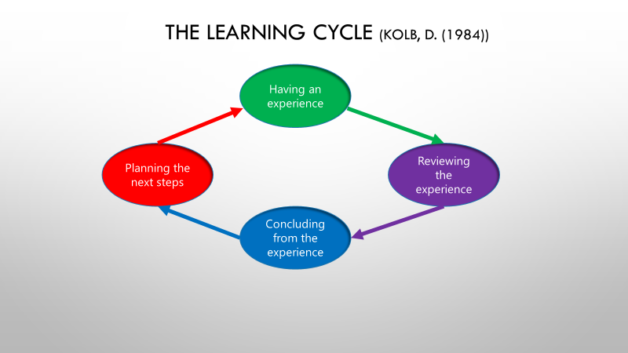

PERSONAL EFFECTIVENESS AUDIT

Here are some skills and abilities that contribute to my overall skills in Personal Effectiveness.
Skills and capabilities in this area vary from individual to individual, from discipline to discipline and from situation to situation. It is important to recognise what skills are relevant and how these skills need to be adapted for the situation in which they will be used.
To learn and develop these skills, students need to reflect on what skills they have, what skills they need and how these can be developed, and then seeking out relevant opportunities to strengthen these skills. (Murdock, A., Scutt, C., 1993, Personal Effectiveness). (See appendix D)

MY RESULTS

Upon seeing my personal effectiveness audit, I have come to understand that the scores are relatively high, it has shown minor areas that can be improved. Swot and Johari shown me where improvements can be made.

HONEY&MUMFORD

Honey and Mumford is a learning style that enables us to discover subcategories of learner types. Once we have discovered this about ourselves, we can suit our learning style and preferences accordingly they are as follows Activist/Reflector/Theorist/Pragmatist.
After seeing the Honey and Mumford results, I’m beginning to realise there is a strong character to my personal self, it has shown me the type of individual and preferences I have. I’ve realised there is more about me to explore and understand, it highlights my strong preference of being a pragmatist and a theorist. (Honey, P. & Mumford, A. 2000) suggests that there are 4 types of learners that are Activist, Reflectors, Pragmatist and Theorist. (See appendix E)

I am pragmatist and theorist. When relating this to Kolb learning cycle I am good at being a pragmatist and I am a theorist which means as part of the learning cycle I tend to spend too much time on reflection however one of my weakness is that I have a low tolerance for uncertainty and disorder. The pragmatist in me makes me address real problems and it results in me formulating action plans to current problems.

VARK LEARNING STYLES

V………. Visual
A………. Auditory
R………. Reading/Writing
K…………Kinaesthetic
The VARK Teaching Learning style it consists of 4 modes of learners visual/auditory /read and write/ kinaesthetic (Fleming and mills 1992), suggesting you understand where your strength of learning preference may be for you. Modality preferences is an important condition for improving one's learning. Knowledge of, and acting on, this is designed for teacher and learners to know how we learn its start of conversation and talk about the style that is best suited to individuals when conducting this test what type of learner, a person might be and how they are. Then enables them to best practice their style and how processing this information (Fleming, and Baume, 2006) for example an auditory learner.
My results have shown me Reading/writing to be my strongest and secondly aural this suggests. I learn better through reading and writing that is my strongest aural to be my secondary. This result shows that my reading and writing skills are my strongest points. This has come to a surprise to me as I believed it was my weakest skills.( See appendix F)

MAKING A DIFFERENCE

GO M.A.D
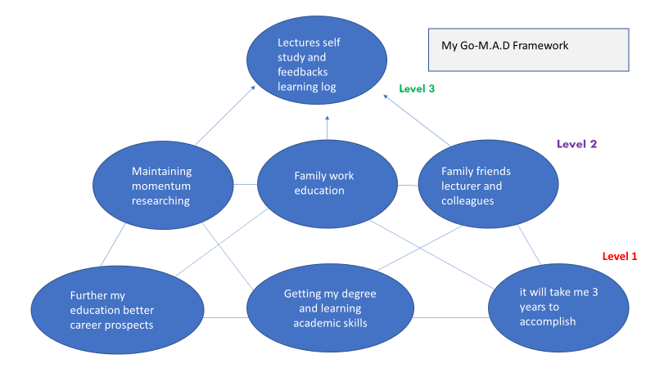

Go mad gives me structured plan to achieving my goals (Gilbert, A. and Chackrovaity, I. 2001)

There are also external factors may affect you and internal it is constantly shifting depending on your situation.

PERSONEL DEVELOPMENT PLAN
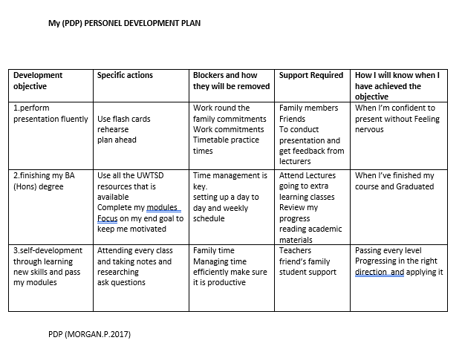
As I attend my lectures, I will be asking for feedback from my lecturers to show how I’m progressing as I’m moving forward I can look at my go mad and see if I’m I following the framework or is there any setbacks which I might come under am I using the buy ins to help me is there progress being made. How’s my motivation, am I lacking in areas which I can change is my family time being given am I putting enough time to meet my smart goals.is my open area improving in Johari’s model is my tows conversion strategy working is my learning skills improving as VARK suggests .

CONCLUSION

After understanding my reports and findings has somewhat changed my way of thinking and processing information about myself I have come to learn many different aspects about me that I’d never would have known before, it made me more conscious of what I could do to improve my life goals and be successful in my career. My psychometric tests have shown me what strengths and weaknesses are. What I would need to do in order to improve my skills. Furthermore my 2 learning styles also shown me what type of personality type I am and ways to make it beneficial for my learning and further my career in management my Go M.A.D and PDP has given me a structure to work on.

BIBLIOGRAPHY

Fleming, N., and Baume, D. (2006) Learning Styles Again: VARKing up the right tree! Educational Developments, SEDA Ltd, Issue 7.4, Nov. 2006, p4-7
Gilbert, A. and Chakravarty, I. (2001) “Go Mad: about coaching”. Bath. Bath Press
Honey, P. & Mumford, A. 2000 The learning styles helper's guide. Maidenhead: Peter Honey Publications Ltd.
Kachoui, D., 2018. Becoming A Master. Quality Progress, 51(4), pp.38–43.
Kolb. David A 1984 EXPERIANTAIL LEARNING, Prentice Hall, Inc. A Division of Pearson Education, Upper Sadle New River, New Jersey, USA
Mabey.C and Iles.P. 1994 MANAGING LEARNING, by Routledge 11 New Fetter Lane, London.
Morgan, P., 2017. Business student's guide to study and employability, London: Sage Publications Ltd.
Murdock, A., Scutt, C. & Institute of Management, 1993. Personal effectiveness, Oxford: Butterworth-Heinemann in association with the Institute of Management.
Sarsby, A.S (2016). SWOT Analysis. (1st ed.). Lulucom
Senge, P, Scharmer, C O, Jaworski, J & Flowers, B S, 2004, Presence, Cambridge MA, Society of Organizational Learning

APPENDICES

APPENDIX A –

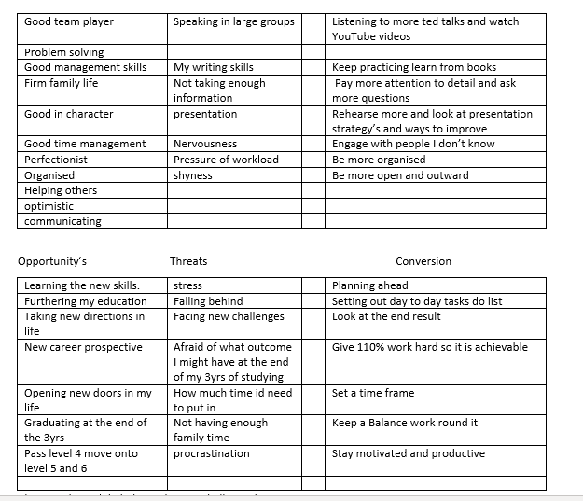

APPENDIX B -

APPENDIX C -

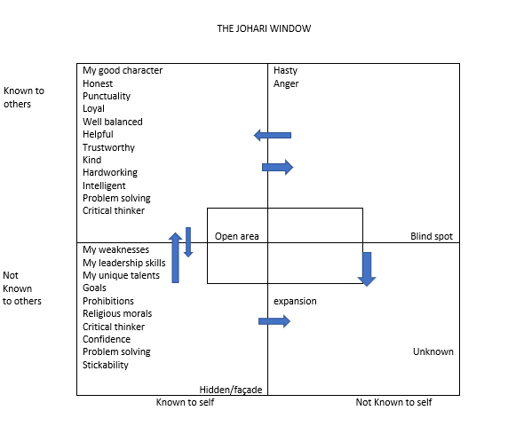

APPENDIX D -

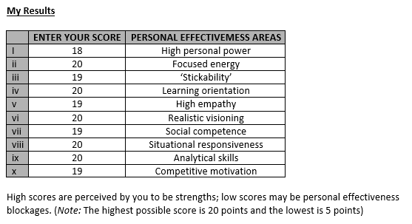

APPENDIX E -

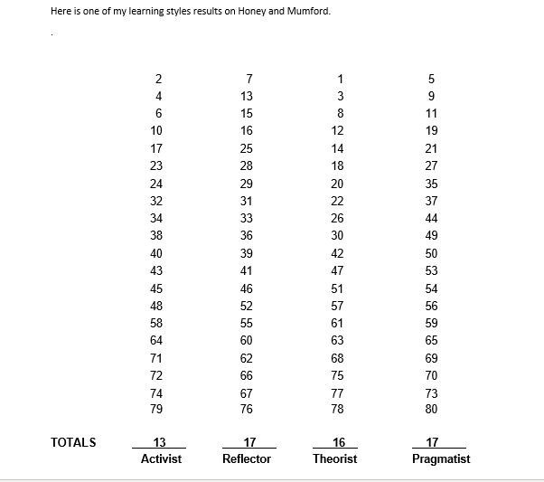

APPENDIX F -



