Exhibition 1.0 Pro forma

Please ensure to answer all questions posed in this document. This document is used to help facilitate the assessment of your final year exhibition. Ensure to be thorough in how you address each point.

Student Name: Caitlin Doyle

Part One: Knowledge and Understanding Skills (30%)
Artist Statement
In this section, students must provide an artist statement clearly demonstrating their understanding of key themes and ideas underpinning their photographic practice. The statement should contextualize the exhibited work. The artist statement should function to support the audience's engagement with the work durg the exhibition.
Caitlin Doyle’s black-and-white film portraits offer an intimate exploration of childhood’s fleeting in-between moments. Focusing on her seven-year-old niece, Doyle captures the quiet tension between innocence and self-awareness, joy and uncertainty, as the child navigates the complexities of growing up in an ever-changing world.

By employing black-and-white film, Doyle evokes a sense of nostalgia, positioning it as a quiet act of resistance against the relentless acceleration of modernity. In a present that feels increasingly uncertain and a future that seems fragile, her work serves as both a reflection and a plea—to protect the wonder of youth and preserve the fleeting nature of innocence.

Part Two: Knowledge and Understanding Skills (30 continued %)
Key Research

In this section, students must provide a clear and concise overview of 3 key pieces of artwork research. This research should demonstrate how it has informed the making of your exhibition work. We aren’t concerned with knowing background information on the artist (biography), instead we are interested to understand how the work has influenced you. Please provide visuals to support your writing.

Max 3 artists, 500 – 1000 words (approx.) words.
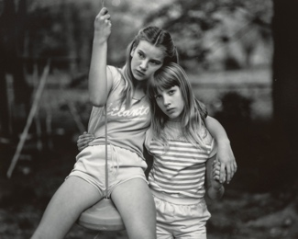
My current body of work explores the fleeting, transitional nature of childhood through black-and-white film portraiture, using my seven-year-old niece as the central subject. The project focuses on the subtle emotional states that emerge in between moments where innocence begins to blend with growing self-awareness, and joy is often laced with uncertainty. It is in these quiet, unspectacular gestures that I find a deeper truth about what it means to grow up in today’s increasingly accelerated world. The decision to use black and white film is central to the work’s conceptual grounding. This choice is not only a formal one, but a deliberate slowing down to reject the immediacy and oversaturation of digital culture. Film introduces a different kind of temporality, one that demands patience and presence, both from the maker and the viewer. In this way, the medium itself becomes a tool for reflection, preservation, and resistance.

The development of this project has been strongly shaped by visual research into three key photographic works:
Joseph Szabo’s Priscilla (1969),
Rineke Dijkstra’s Kolobrzeg, Poland (1992), and
Sally Mann’s Robin and Jessie (At Twelve) (1983–85).

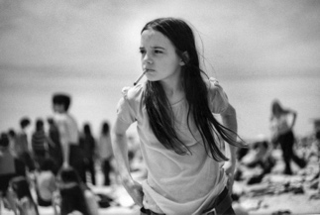
Szabo’s Priscilla captures a candid, almost cinematic stillness amid a crowded public space. What resonated with me was how the subject remains emotionally isolated despite the surrounding activity- her gaze, posture, and stance express a complexity that feels spontaneous yet deeply loaded. This image influenced how I framed my own niece within her environment, allowing the background to remain active and present, but never dominant. Szabo’s grain-heavy black and white aesthetic also reaffirmed my own use of film to build intimacy and emotional texture.
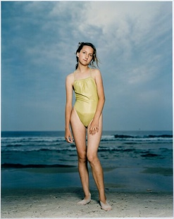
Dijkstra’s Kolobrzeg, Poland offered a contrasting, formal rigor that shaped how I thought about space, stillness, and posture. The neutral background of sea and sky, combined with the girl’s subtle physical discomfort, creates a sense of emotional suspension of being on the edge of something. This sense of paused transformation informed how I approached moments with my niece. Rather than chasing overt expression, I became more focused on stillness: when she wasn’t quite performing but wasn’t entirely unaware of the camera either. This in-between space became crucial to the emotional tone of the work.

Finally, Sally Mann’s Robin and Jessie deeply influenced both the relational and emotional aspects of my process. Mann’s images of her children are neither sentimental nor purely documentary; they are raw, intimate, and complex. Her willingness to photograph from within her own domestic space gave me confidence to do the same. Photographing someone close to me allowed for a sense of trust and mutual authorship. Mann also taught me to embrace imperfection: the softness of natural light, slight motion blur, or awkward composition can all be part of an image’s emotional weight.

Together, these three works guided both the aesthetics and ethics of my project. They helped clarify what I was looking for, not simply representations of childhood, but expressions of its fleeting, contradictory states. By working slowly and with attention to subtlety, I hope the resulting images reflect both the beauty and fragility of this liminal time.

Part Three: Presentation Skills (40%)
Exhibition Methods:

How have you chosen to present your work and why? (include installation photographs of your final display).

Students should clearly articulate why their chosen method of presentation best suits their intended audience and context.

How well have you produced and installed your work (consider technical skills)?

500 – 1000 words.
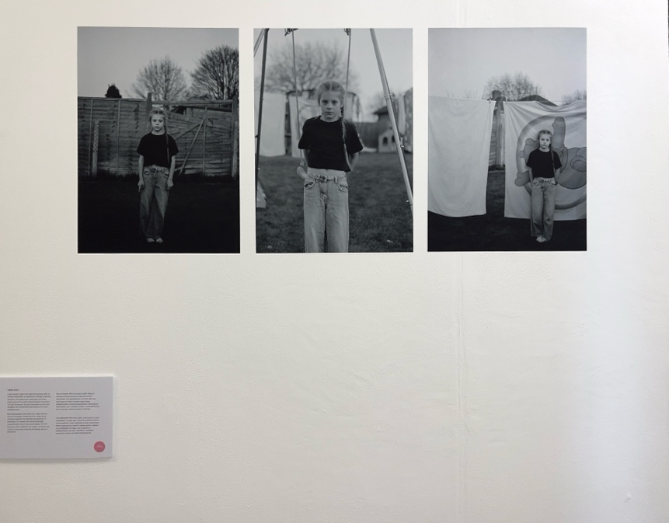

For the final exhibition of my work, I chose to present three large-format black and white portraits, printed on vinyl and directly installed onto the gallery wall in a horizontal sequence. Although I was unable to be physically present for the installation due to personal circumstances, I carefully planned and communicated my vision for the display. With the support of my lecturer, who kindly installed the work on my behalf, I was able to ensure that the final presentation remained true to my original intentions.

The decision to print the photographs at a large scale and on vinyl was both a conceptual and practical one. Conceptually, the size elevates the often-overlooked moments of childhood expressions, gestures, and silences that might otherwise pass unnoticed. Enlarging these subtle, in-between states invites the viewer to pause, to observe more slowly and attentively, and to engage with the emotional texture of the subject. The use of vinyl printing allowed the images to sit flush against the wall without the distraction of frames, creating a clean, borderless presentation that supports the quiet intimacy of the work.

From a practical standpoint, vinyl was chosen for its ability to deliver a professional, matte finish that highlights the tonal depth and detail of black-and-white film. This method of display aligns with the themes of the work: a desire to slow down, to resist the hyper-visual noise of contemporary media, and to preserve something tactile and enduring. The lack of framing also reinforces the directness of the portraits, removing any physical barriers between viewer and subject.
The photographs were designed to be arranged as a triptych, each image carefully spaced and aligned at eye level to create a calm, balanced rhythm. The sequencing of the images reflects emotional shifts and varying levels of engagement between the child and the camera. The central image captures a moment of stillness on a swing serving as the anchor, that frames quieter, more observational moments on either side. This arrangement reflects the emotional fluidity of childhood and the recurring theme of transition that runs through the project.

Although I couldn’t install the work myself, I communicated my intentions regarding placement, spacing, and height to ensure the final result reflected my vision. The outcome, as documented in the installation photograph, demonstrates careful execution and alignment, for which I am grateful to my lecturer. The clarity and simplicity of the final display allow the emotional resonance of the images to take centre stage.

Ultimately, this method of presentation supports the aims of the work and its intended audience offering an emotionally engaging, visually cohesive, and professionally considered exhibition of images that reflect the fragile, fleeting nature of growing up.

Part Four: Transferrable Skills for Life and Professional Practice. (20%)

Final Year Exhibition Evaluation

Have you participated in all tutorials, group seminar and workshops?

What role have you taken in facilitating the end of year exhibition and what have you learnt from undertaking that role?

How have you managed your workload for this module?

What new skills have you developed in producing this exhibition, and what aspects would you refine or approach differently moving forward? 500-1000 words
This term has marked a significant personal and creative transformation for me. Although I was not able to be consistently present for every tutorial, seminar, or workshop, I remained engaged with the course through regular communication with my tutors. I struggled at points particularly with the demands of balancing personal circumstances and academic responsibilities but despite this, I have emerged with a renewed sense of confidence, purpose, and clarity in my creative direction. The growth I experienced throughout this term is not only reflected in the final outcome of my work, but also in how I now view myself as an artist and practitioner. One of the most important things I’ve learned is that progress doesn’t always look like constant presence it can also be about resilience, consistency, and the ability to keep going through challenge. While I wasn’t always physically in the room, I made sure to stay connected to the process. I collaborated where I could, communicated my ideas clearly, and most importantly, I committed fully to my project. That commitment is visible in the work I produced. I feel that the final images are the most resolved, honest, and emotionally grounded of anything I’ve made so far. They represent not only a concept, but a personal breakthrough.

The installation itself, though handled by my lecturer in my absence, was planned closely by me in advance. I provided detailed notes and a clear vision for how the work should be experienced. Seeing the photographs displayed exactly as I had imagined reaffirmed my sense of agency as a creator, even when I couldn’t be there physically to execute it. That experience taught me a great deal about communication, delegation, and trusting others in collaborative processes; all transferable skills I know will serve me well beyond this course.

In terms of workload management, it wasn’t always smooth. I had to be honest with myself about what I could realistically achieve, and when. However, through careful planning, I was able to maintain momentum and deliver work I’m genuinely proud of. I learned to prioritise what really mattered: clarity of concept, quality over quantity, and emotional integrity. I gave myself the space to evolve, and that made the final outcome feel not only complete, but truly mine. Producing this exhibition allowed me to develop and refine several key skills. I deepened my understanding of analogue photography, visual storytelling, and curating work for a public space. I also practiced writing and editing statements, planning for installation, and presenting my ideas in a clear and professional way. Perhaps most importantly, I developed confidence not only in my technical ability, but in my vision, and in my potential for future growth.

Looking ahead, I feel a renewed sense of ambition. This term proved to me that, despite difficulties, I can achieve what I set out to do. The success of this project has given me the motivation and belief that I can aim even higher next year. I now have a clearer understanding of my voice as an artist, and I’m excited to keep building on that foundation.

