Information Engineering
Database Design (The Book Store)
ACCB4012
Elizabeth Lowrie Proctor 1903551
4-28-2020

Contents
Introduction 2
Entity Relationship Diagram 2
Creation of Tables – SQL 3
Input of data – SQL 3
Queries 5
Forms 7
Reports 8
Macros 8
Design 9
Conclusion 9
Appendix A – Form Outputs 10
Appendix B – Report Outputs 12
Appendix C – User Guide 14

Introduction
Due to an ever-increasing customer base The City Bookstore requires a user-friendly database system.
The following report provides evidence and explanation of how the accompanying database, ‘The Book Store’, was created. Evidencing the use of various methods and techniques in order to construct the system, with the intention to ensure it met the objective required.

Entity Relationship Diagram
An entity relationship diagram was constructed in order to establish the required tables, entities and relationships.
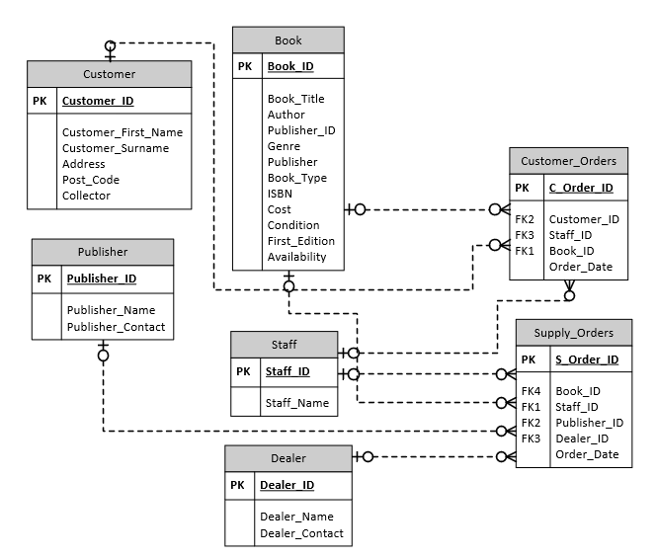

Creation of Tables – SQL
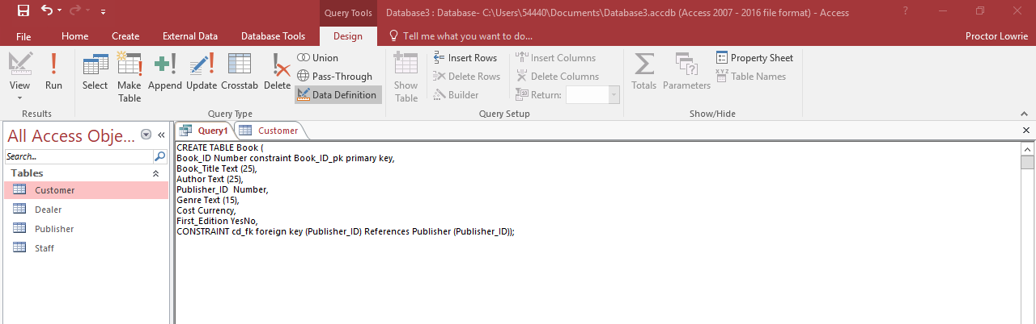
Within the creation of the database SQL was utilised for the creation of the tables, allocating the entities, their types and adding constraints of primary and foreign keys. The images below evidence the use of SQL for the creation of the Book and Supply Orders tables.

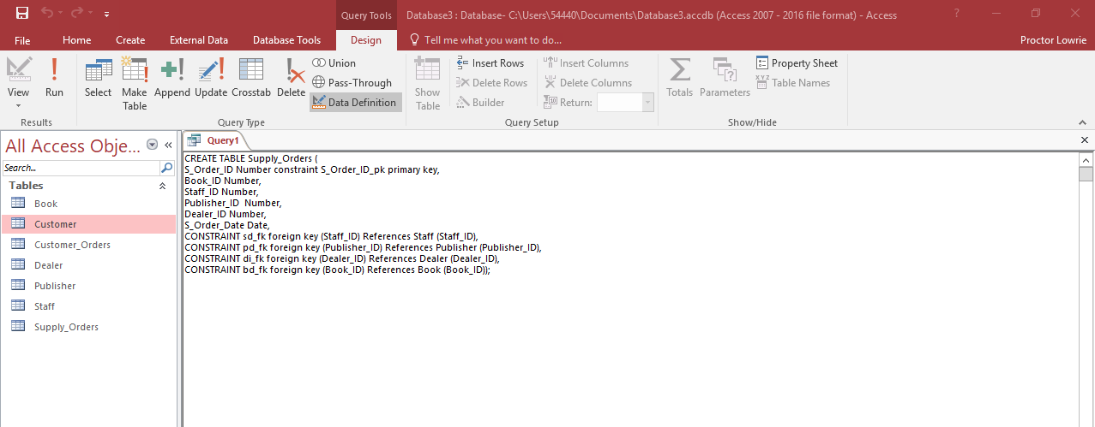

Input of data – SQL
In addition to utilising SQL for the creation of the tables it was also used to enter test data into the created tables. Below illustrate examples of this being used to enter data into the ‘Staff’ and ‘Customer’ tables.
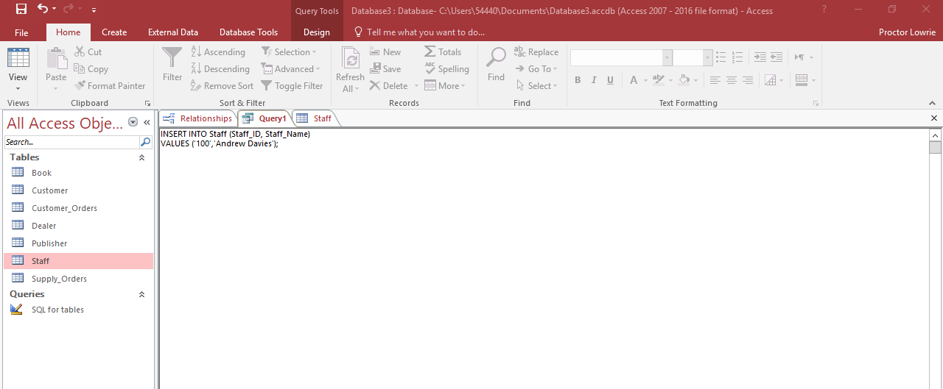

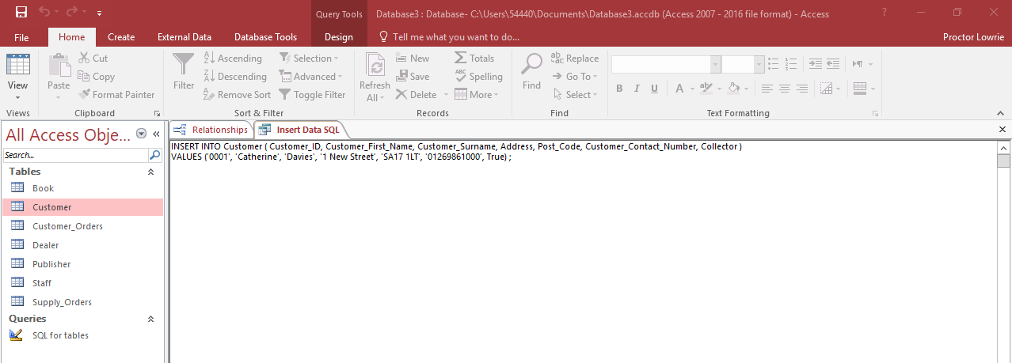

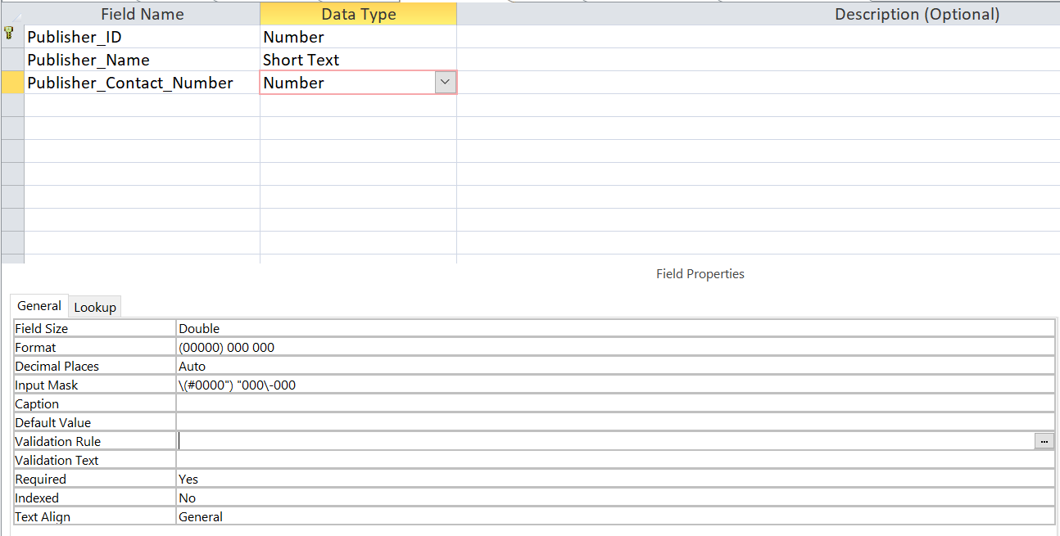
In order to make the database orderly and to limit the likelihood of error, Input Masks were placed on some of the fields to format the data required. i.e. The screen shots below demonstrate input masks being used for the formatting and input requirements of the Postcode and Phone Number.

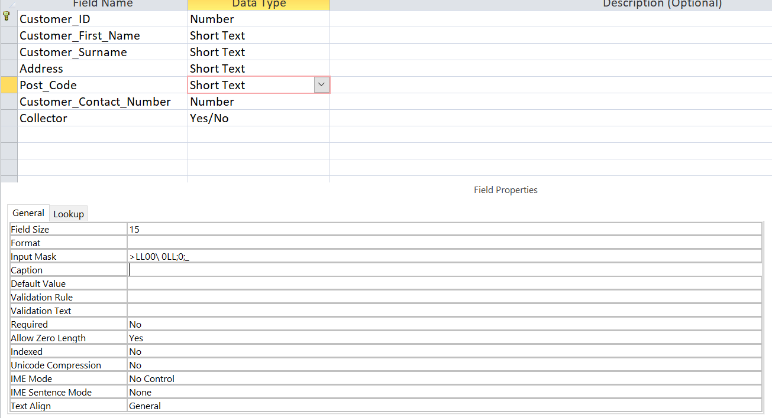
Similarly to increase …….. linked lookups were inserted in numerous fields. The image below illustrates the lookup being created for the Book_ID within the Supplier_Orders table.

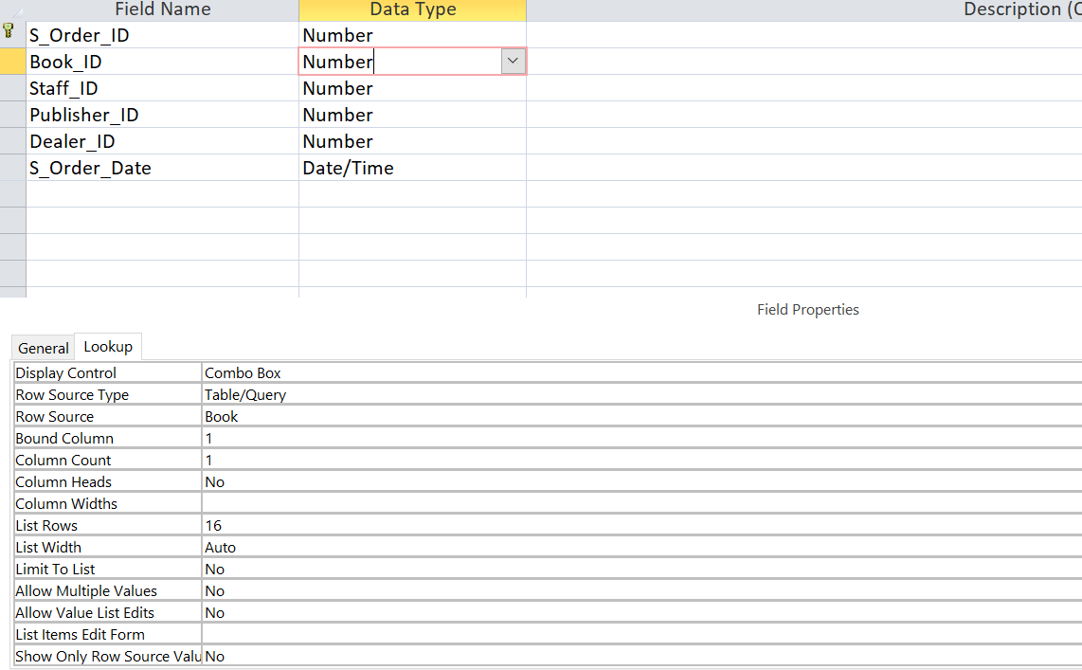
Where foreign keys exist, to reduce the re-inputting of data the database utilises the lookup function. Look up instructions were provided to the location in the database where the information could be obtained.

Queries
In order to efficiently search the required data within the system and to compile data across numerous tables, various queries were created. The below shows a query created through bringing together data from various tables that have relationships.
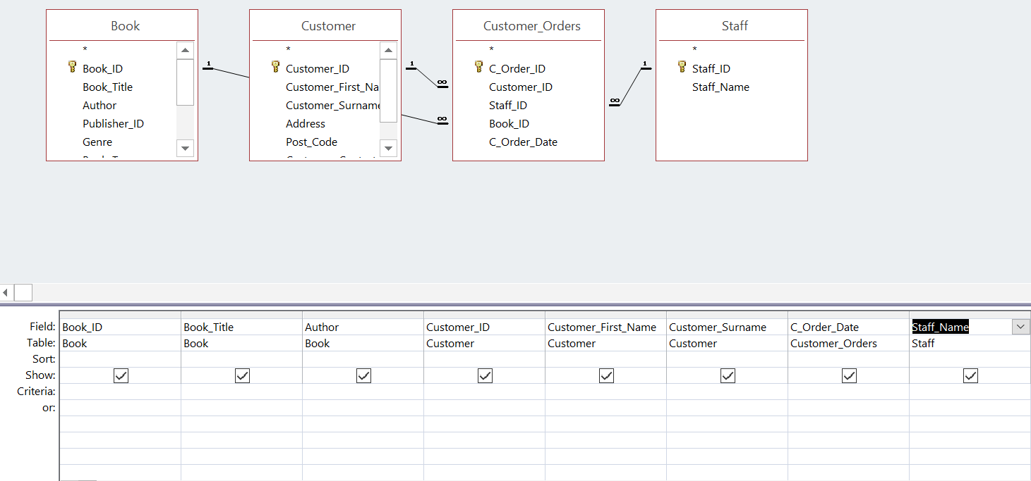

In addition to creating queries across various tables within the database queries were also created within a single table utilising the ‘criteria’ field to specify the required return of the query. The below demonstrates the use of this to create the query returning only those books marked ‘Yes’ as first edition books.
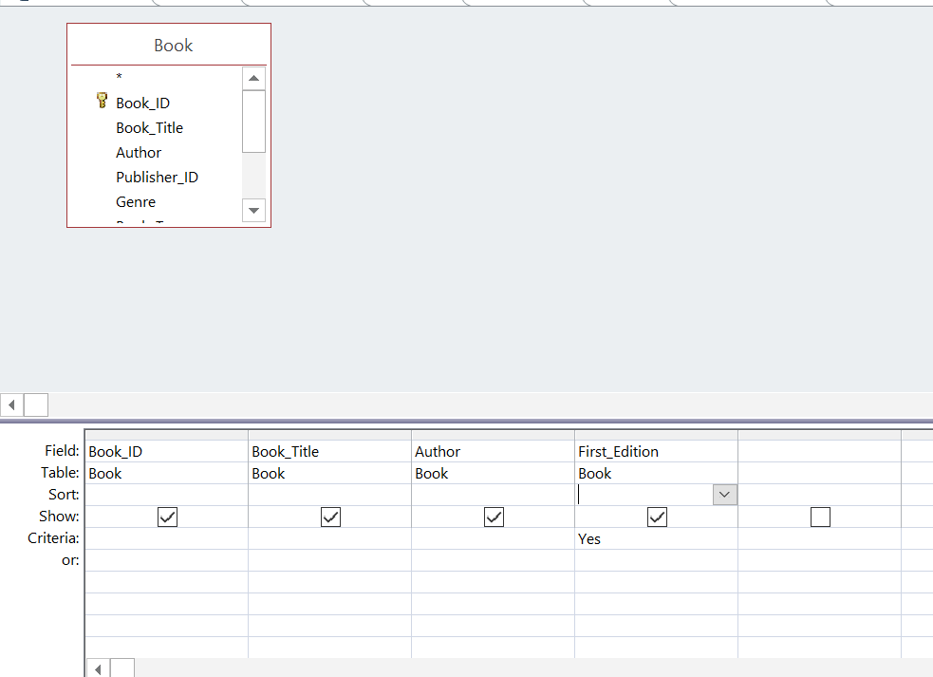
In addition to utilising the ‘Criteria’ section within a query, the database also includes some user input boxes where a specific criterion can be input to search. The expression builder was used to create these functions through linking the criteria field with a user input unbound field. The example below demonstrates how this function was utilised in the creation of the search facilities for the user to search a book by its Author, ISBN or by Genre. The Genre option was also formatted as a drop-down box in order to provide the user with the genre types available. (Further work is required to ensure the drop-down options are unique and that the options do not repeat).
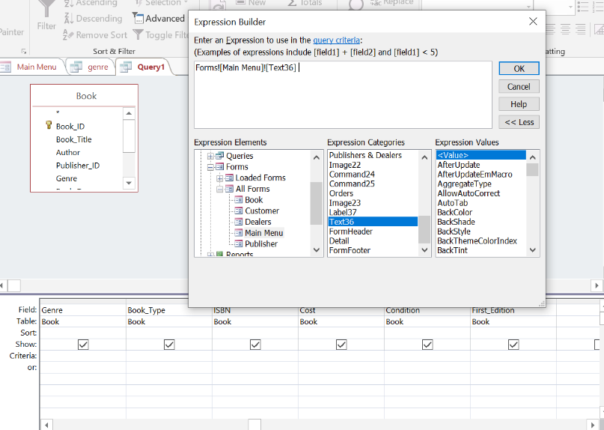
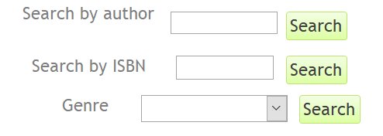

Forms
Forms were created within The Book Store database in order to display data clearly and easily. The forms also provide a quick and efficient way to add, delete and/or modify records.
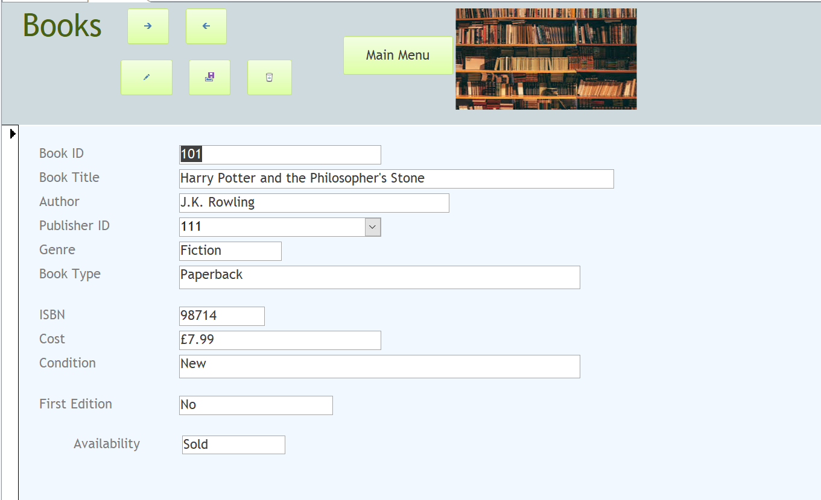
Each form created within the database encompasses the same design and the same ‘Buttons’ have been included in the headers. The same format and design provides continuity and familiarity which assists in the database being user friendly and easy to navigate.
The ‘Buttons’ that appear within the header include navigating to the next/last record, creating a new record and deletion of a record. All forms also include a ‘Main Menu’ button for quick and easy navigation back to the main menu.
As the Staff table has a one to many relationship with the Customer Orders table a Sub form was created within the Staff form – This subform enables the user to see both the Staff details and their associated customer orders. The use of the sub form collates the data into one place making it user friendly and purposeful.
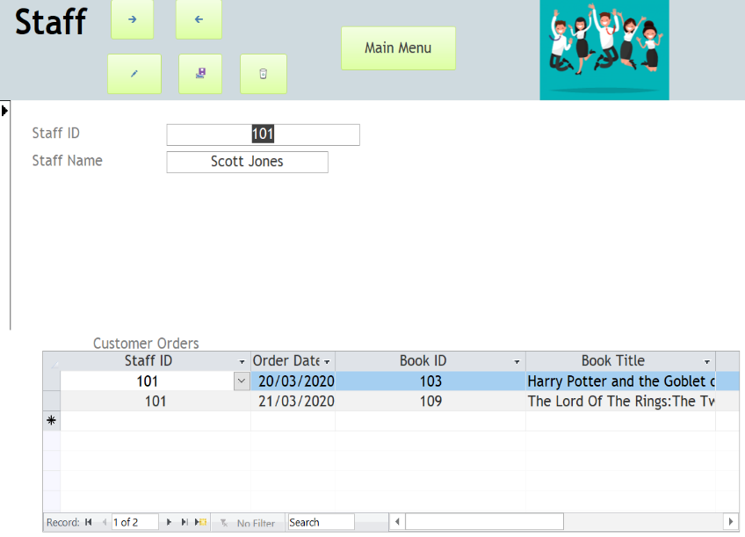
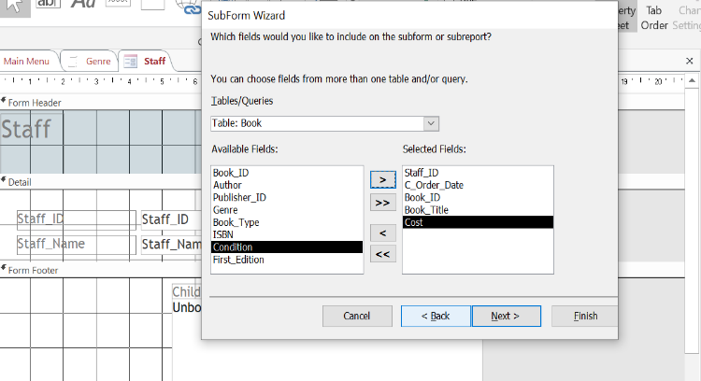

Appendix A – Form Outputs illustrates examples of outputs from all forms created.

Reports
Numerous reports have been created within The Book Store database – Reports provide an effective way to present data and are created in a format suitable for viewing and printing. The reports were created from the queries completed, hiding any fields felt not required to be presented.
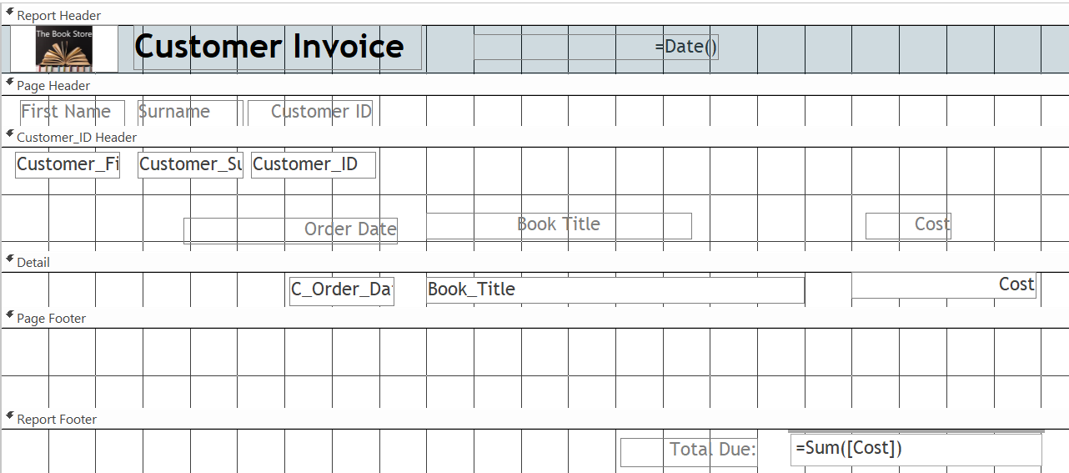
A Customer Invoice report created displays a customer’s order breakdown, including the title and cost of each book. A sum function was also included in the creation of the report to calculate and present the total amount due.
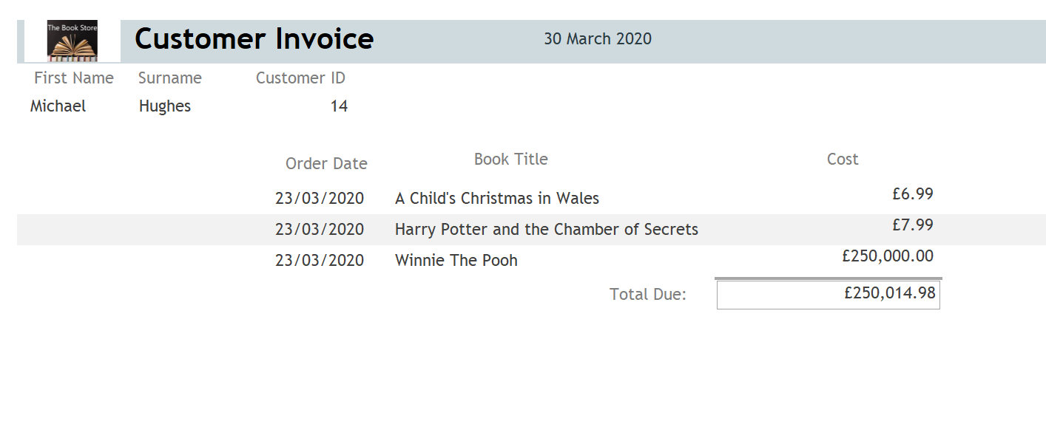
Appendix B – Report Outputs illustrates examples of all created report outputs.

Macros
In order to automate tasks and add functionality to the various reports and forms Macros were created and allocated.
The below image provides an example of the creation of a Macro to open a created query and accompanying report. Macros were created with the inclusion of the ‘Re-query’ function to ensure the search criteria is reloaded after each query is made. The specific Macro illustrated below also includes the print function to provide the automatic option to print the produced report once created. The use of Macros makes the database efficient and functional.
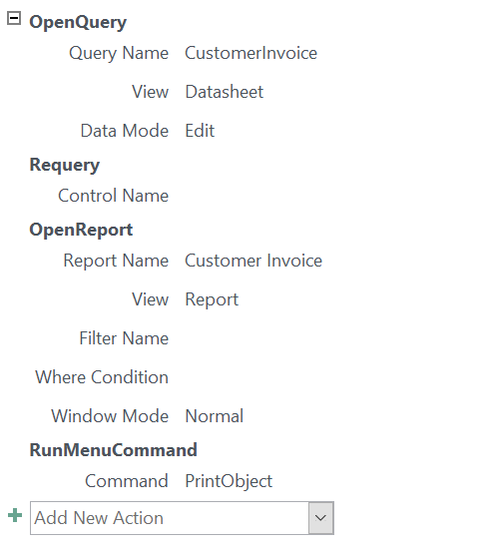
An additional separate Macro was created within the database and named ‘Autoexec’. This Macro was created for the purpose of instructing that the Main Home page opens and displays as the first screen when an user opens the database.

Design
The database was created as a folder ‘Home Page’ menu design, with clearly defined tabs to identify the various sections.
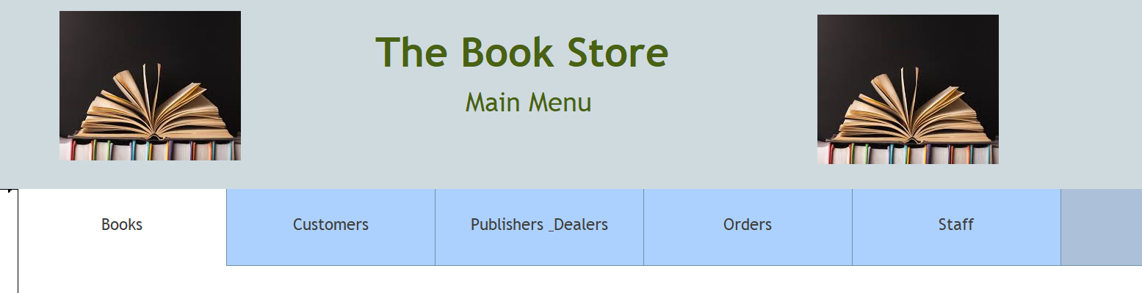
Images and colour were used to make the database professional, aesthetically appealing and to demonstrate the book Store’s identity.
Appendix C – User Guide shows the functions available on each tab.

Conclusion
The completed Book Store database is one that is considered to be both user friendly and functional. The database utilises various techniques to produce numerous forms and reports, from queries, with applied Macros to further enhance and streamline the processes. The Book Store database system will enhance the service The City Book store is able to provide to its staff, customers and suppliers and is one that is flexible to enhance and grow with the store.

Appendix A – Form Outputs

Book Form:
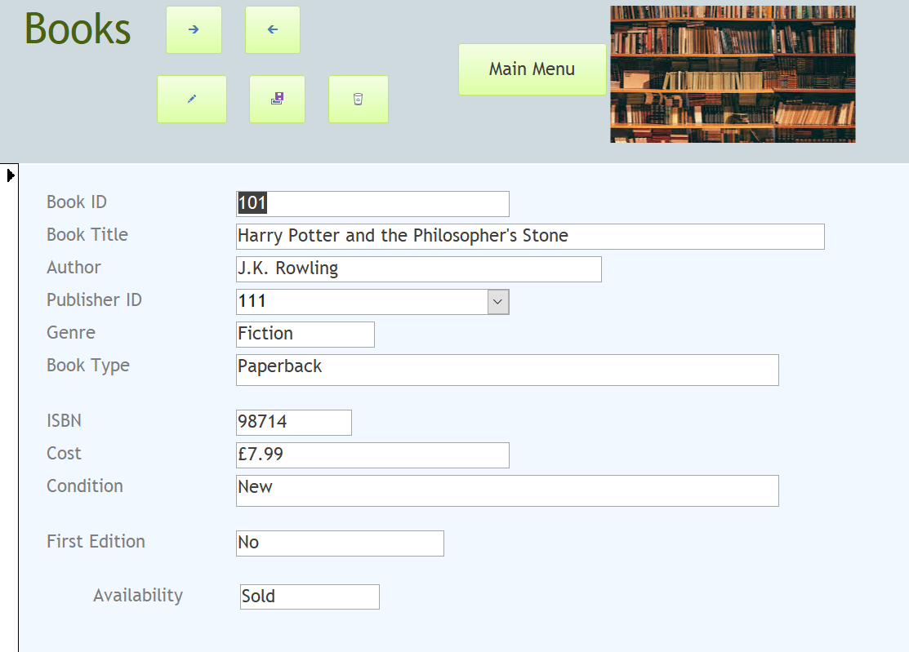

Customer Form:
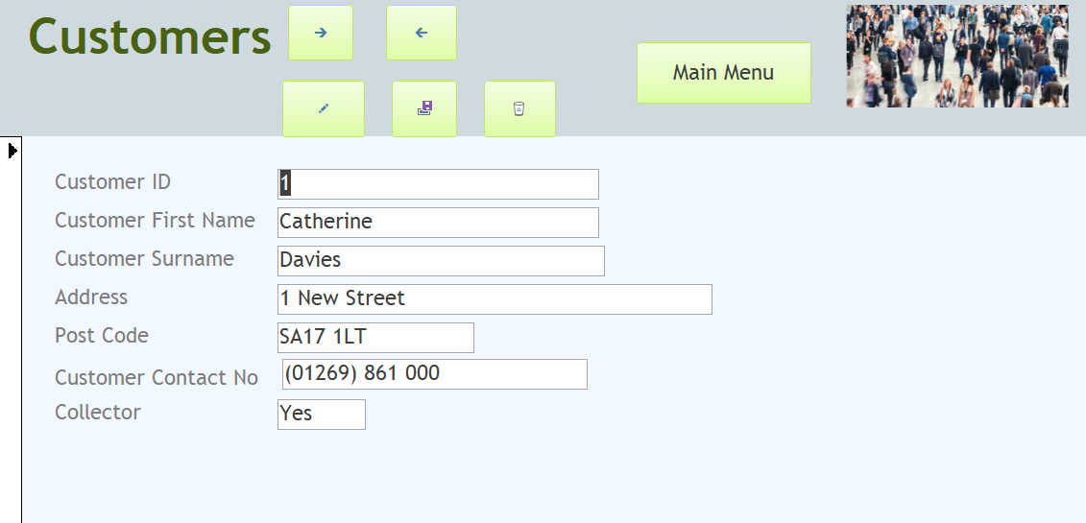

Dealer form:
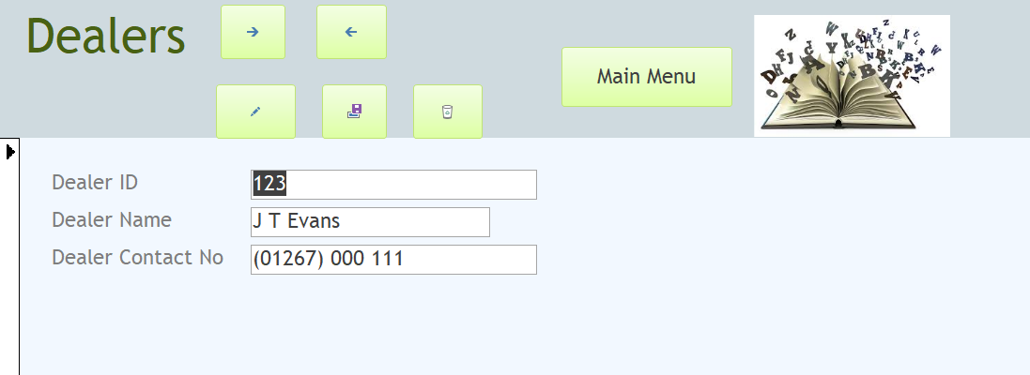

Publisher form:
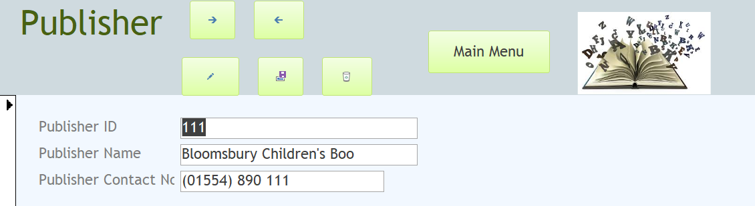
Staff form & Subform:
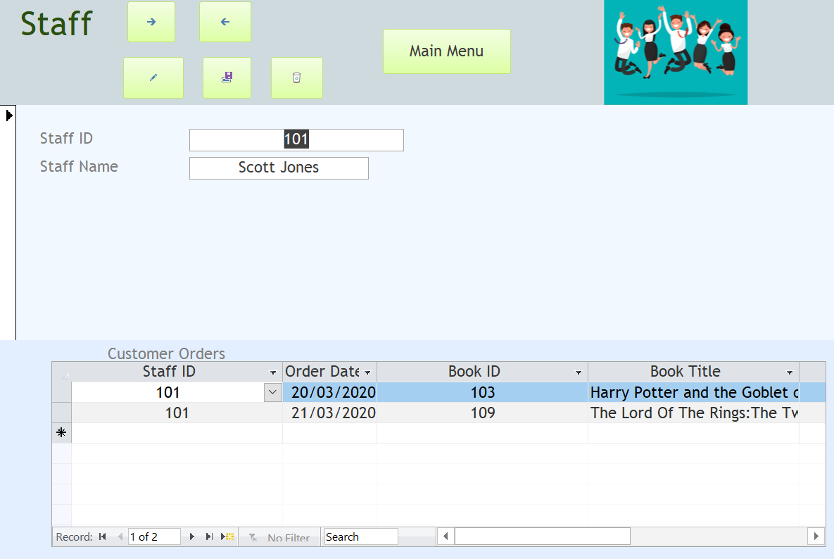

Appendix B – Report Outputs

1st edition book report:
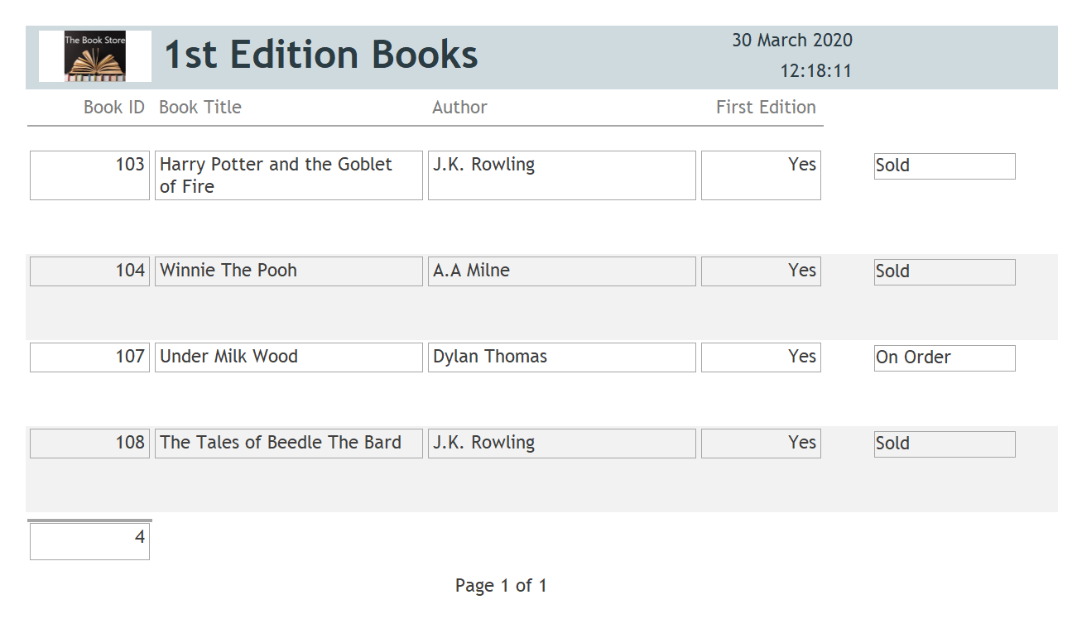
Customer Invoice report: 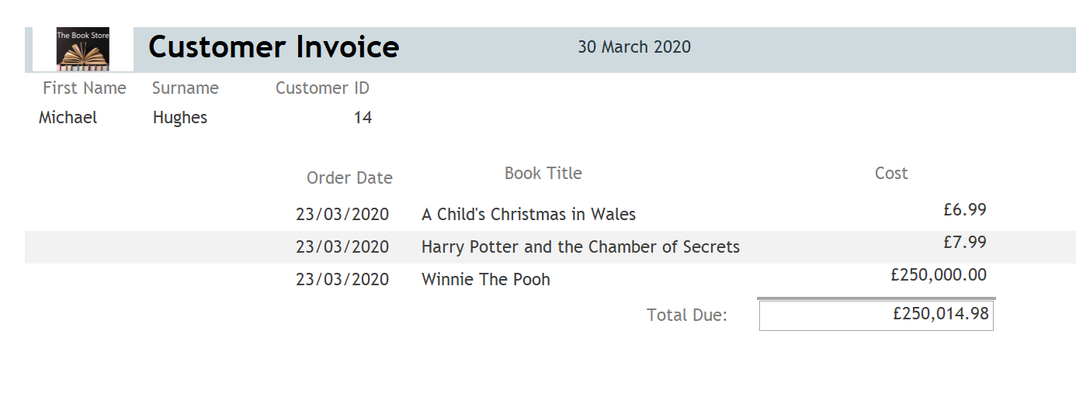
Available Books report:
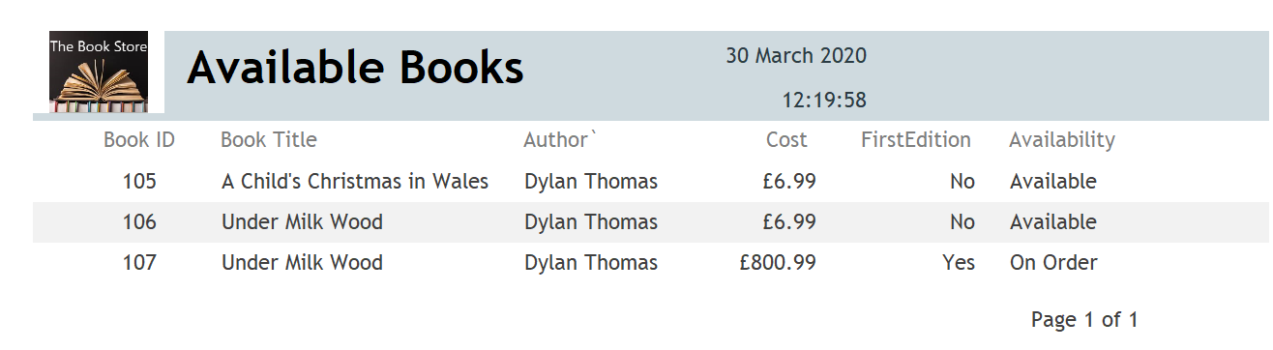
Total Sales report:
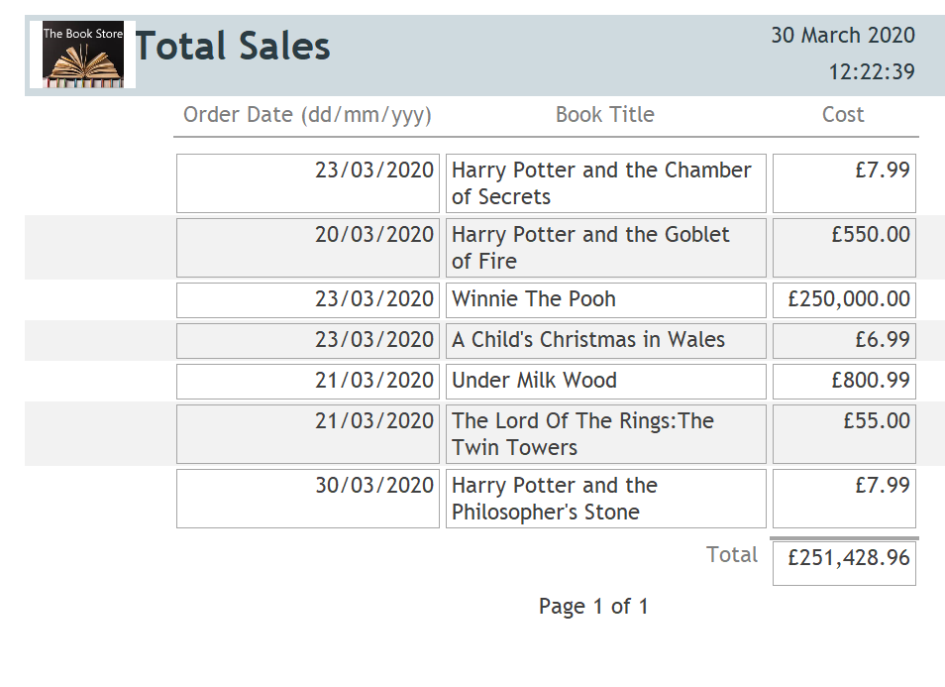

Appendix C – User Guide

Book Tab:
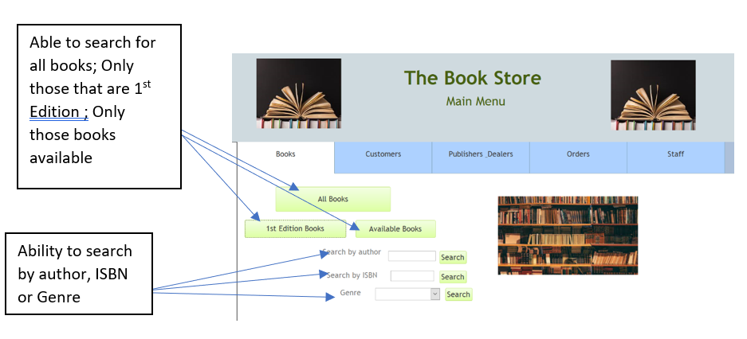

Customer Tab:
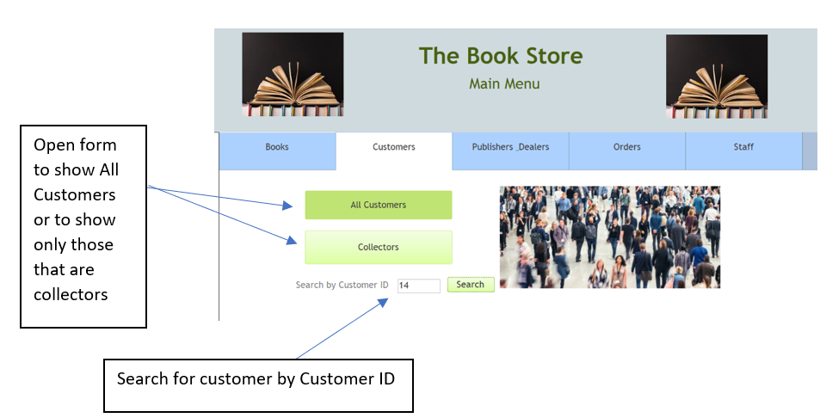

Publisher/Dealer Tab:
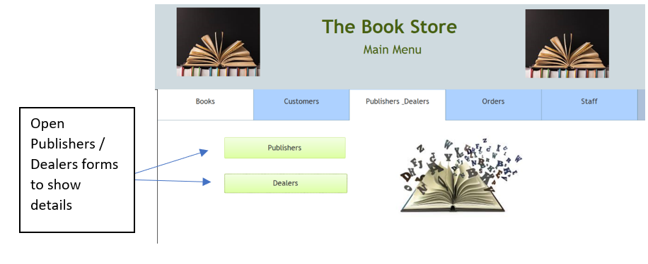

Orders Tab:
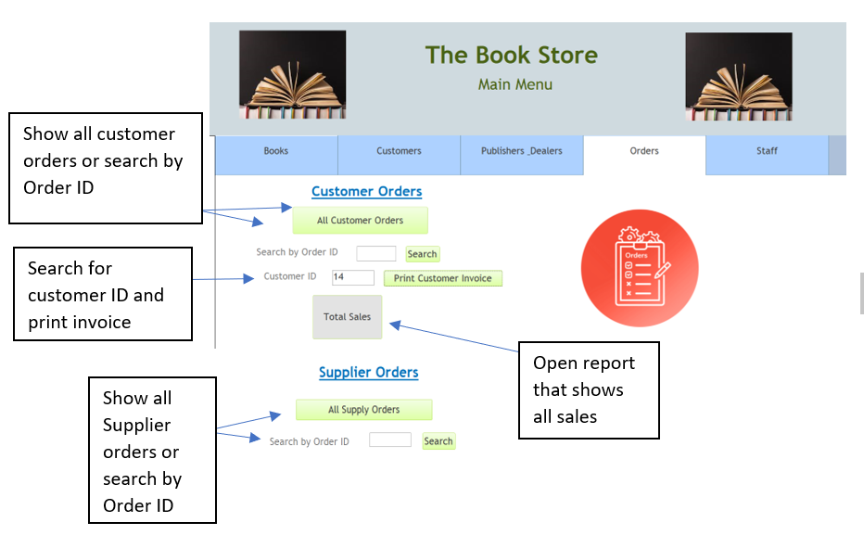

Staff Tab:


