Part A
1) Variable

In C programming a variable is a container for storing data in the computer memory. In C programming stored the value can be stored using a name created by the programmer. Variables are important to a programmer because it allows the storing of values that are necessary in the execution of a programme. There are about 4 basic data types of variable thus char for storing characters, int for storing whole numbers, float which is floating number that correct to 6 decimal places and double which is a floating number correct to 10 decimal places
In variable creation there is a requirement for its declaration in a program. The declaration has the following syntax:

Data- type variable name;
↓ ↓
Char myname,

Programmer can make a choice of the variable name provided it adheres to certain conditions. The variable names cannot start with a number such as 4iqbuild. The name cannot contain spaces such as my number but should rather be mynumber. The variable name can not contain any arithmetic operators c+-r+y. The variable name can not include any punctuation characters %$” @’.
However, the variable name can contain a number anywhere within the name such as name4k.It can have an underscore and is not case sensitive.

2)

A loop is a code in program designed to automatically repeat. The for loop is a repetition control structure that allows the loop to execute a specific number of times that’s why is at times referred to as the counting loop. A loop is used where there is a need to repeat a code many times.

The for-loop syntax:

For (initialiser; test -expression; incrementor) {statements}

To set the starting value for a counter to the number of iterations to be made the initialiser is utilise, with an integer value of i being used.

3)

An array is a structured data type with a collection of items of the similar type that can be accessed using a common name and is different from a variable that is used for storing only a single item data. An array can be a float, integer or character. An array is used to store multiple items of data sequentially with the first array being stored in an element of zero therefore the numbering starts at zero not one. An array variable when being declared in C programming should state the size of the array which is the number of elements.
An array uses the following syntax and example:

Data-type array name [number of elements]
↓ ↓ ↓
Char str [15]
An array in character can be used to create a string for example a name with 10 characters

Char myname[10]

Part B

1.2 Annotated code

Program code designed to allow the user entry of different variables data types of char, int and float

# include <stdio.h>

void main()

{
int age;// variable that holds users age
float height;//variable to hold the user’s height
char name[15];//variable to hold user name with allowance of 15 character (strings)

printf("please enter your age:\n");
scanf("%d", &age);//user enters their age
printf("your entered age is %d\n\n", age);//prints the users age

printf("please enter your height in cm:\n");
scanf("%f", &height);// users enter their age
printf("you entered height is %.2f cm \n\n", height);// prints the entered height

printf("please enter your name:\n");
scanf(" %s", &name);// user enters their name
printf("you entered:%s\n", name);// print the user name

}
1.3 Testing
1.3.1
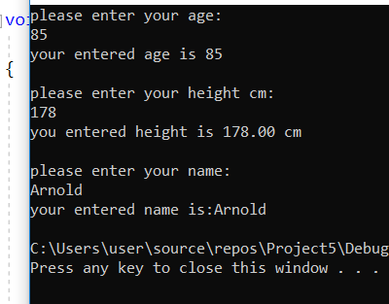
Result: Program ran as expected, allowing the user entry of age as integer, height as a float correct to 2 decimal places and the user name as character of strings
1.3.2
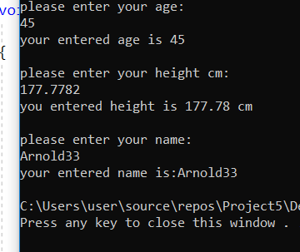

Result: Program ran as expected allowing user to input their name and inclusive numbers.

1.3.3
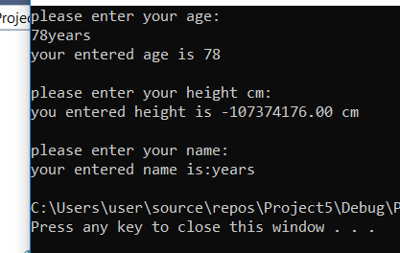
Result: Program failed to run with an input of numbers and letters to input the age

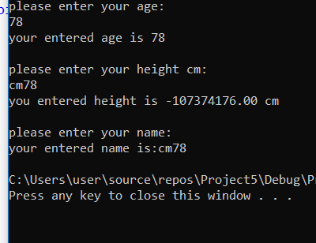
Result: Program failed when user entered cm inputting their height.

2
Program is designed to carry out basic calculation for the following shapes
Triangle
Circle
Subtract the areas to get result of shaded area.

2.1 Annotated code
#include <stdio.h>
#define PI 3.142;// constant formula to calculate area of circle

void main()
{

float radius;//variable that holds radius entry
float areaC;//variable that holds area of the circle
float base;
float height;
float areaT;// variable that holds area of the triangle
float total;//variable that holds total shaded area

printf("Enter circle radius:\n");
scanf("%f", &radius) ;// user enters value
areaC = (radius*radius)*PI;// area for circle calculation
printf("\nthe areaC is:%.2f\n\n", areaC);//print result area of circle

printf("\nEnter the base of the triangle:\n");
scanf("%f", &base);
printf("\nEnter the height of the triangle:\n");
scanf("%f", &height);
areaT = (base*height) / 2;//Base & height multiplied together and divided by 2
printf("\nThe area of the triangle is:%.2f\n\n", areaT);//print result area for triangle

total = areaC - areaT;// Subtraction of triangle area from cirlce area
printf("\nShaded area of the circle is :%.2f\n", total);//print of final answer of shaded area.

}

2. Test
2.1
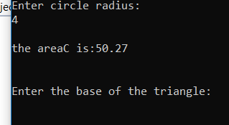
Result: Program ran as expected allowing user to input the radius and result of the area calculation.

2.1.2
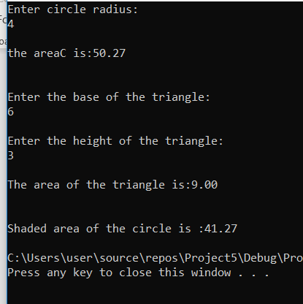
Result: Program ran as expected allowing user to input height and base of a triangle and giving a result of the area.
The program ran as expected giving a result of the total shaded area within the circle

3
Program code designed to
add prices of 5 items
add 20 % on the total price
3.1 Annotated code
# include<stdio.h>

void main()

{ float price[5];// variable to hold float array prices.
float totalprice;// variable float to hold total item prices.
float netprice;// variable to hold total net price inclusive of 20% Vat.
int i;
for (i = 0;i < 5;i++)//for loop 5 price entry repetition.
{
printf("please enter item price\n ");
scanf("%f", &price[i]);// user enters price of the item.
}
totalprice = price[0] + price[1] + price[2] + price[3] + price[4];

printf("\ntotal price is: %.2f\n", totalprice) ;//total price of the 5 items

netprice = (totalprice * 0.2) + totalprice;// addition of 20% vat to total item price

printf("\nnet price is: %.2f\n", netprice);//result of total net price of items
}

3.2 .1Test
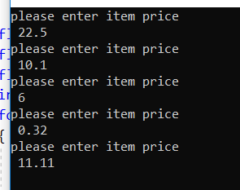
Result: Program ran as expected allowing of different price items by the user.
3.2.2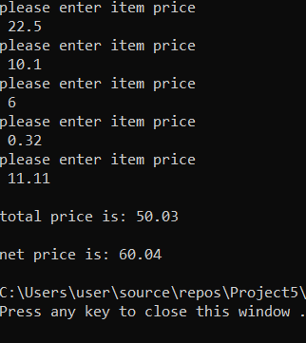
Result: Program ran as expected allowing entry of price items and the 20% vat addition

3.2.3

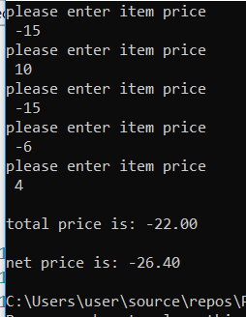
Result: Program ran as expected allowing the input of negative prices for making any alteration or deleting wrong price of items entered.

4
#include <stdlib.h>
#include <time.h>

void main()

{
int myrand[3];
int low = 1;// lowest range
int high = 5;//highest range
srand(time(NULL));//seed randomness
int i;

for (i = 0;i < 3;i++)
{
myrand[i] = rand() % (high - low + 1) + low;//generates randomness

}
printf("The numbers are:");
for (i = 0; i < 5; i++)

{
printf("%d", myrand[i]);
}

printf("\n\n");

if (myrand[0] == 5 &&myrand[1] == 5 &&myrand[2] == 5)// condition for triple 5 number
{
printf("\n\n Hooray you won a Jackpot 2000 points!!!\n\n");
}

else if(myrand[0]== 5 && myrand[1]==5)// condition to a double 5 number
{
printf("100 points on that spin ");
}

else if(myrand[1]==5 && myrand [3]==5)// condition to a double 5 number
{
printf("100 points on that spin ");
}

else if (myrand[0] == 5 && myrand[3]==5)//condition to a double 5 number
{
printf("100 points on that spin");
}

else if ((myrand[0], myrand[1], myrand[2] == 1) && (myrand[0], myrand[1],
myrand[2] ==4) &&(myrand[0], myrand[1], myrand[2] == 4)&&
(myrand[0], myrand[1], myrand[2] == 4))
{
printf("\n\n That was close you win 20 points!\n\n");
}

else

{
printf("\n\nSorry, not a jackpot hit there 20 points there! :\n\n");
}

}

Testing
4.3.1

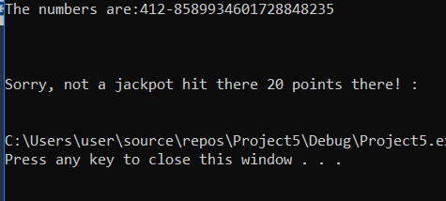
Result: Program did not run as expected as if failed to do the expected but the generation of random numbers was done.

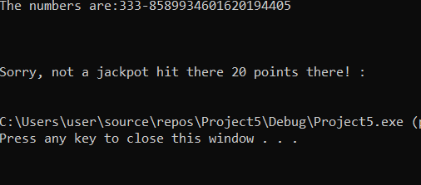
Result: On second attempt still program did not run as expected

Bibliography

[1] | m. macgrath, "C programming," in C programing, 2014.
[2] | D. Ritchie, in The CProgramming language, Hall, 1988.
[3] | "https://www.techopedia.com/definition/26184/c-programming-language," [Online]. Available: https://www.techopedia.com/definition/26184/c-programming-language. [Accessed 17 February 2019].
[4] | "https://www.cprogramming.com," [Online]. Available: https://www.cprogramming.com. [Accessed 15 February 2019].

