Anthony Burns
Jennifer Clark (1909864)
Distinctiveness and regeneration Assignment 1
learning log report- Blaenavon
BMSP4005

Introduction
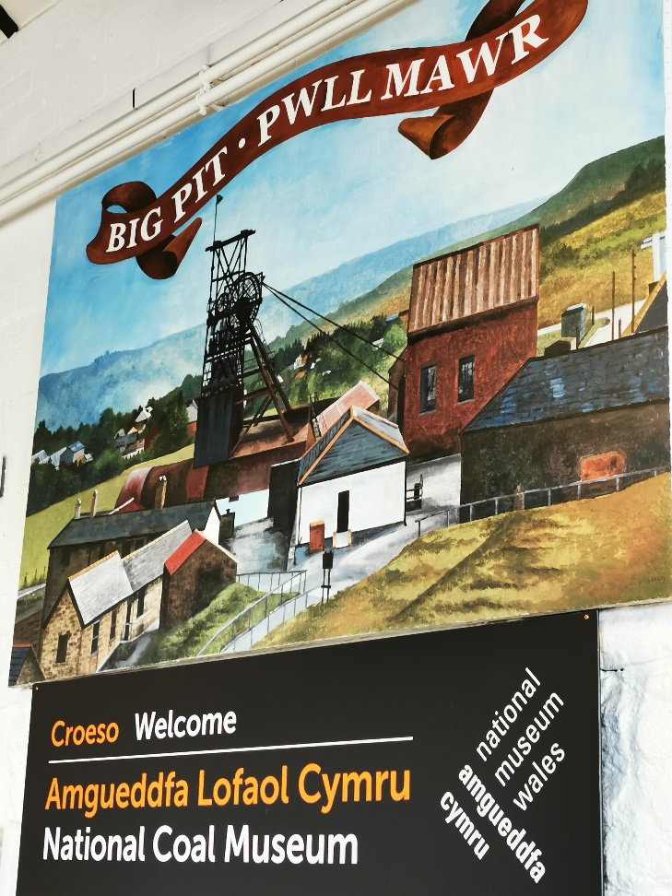
This report will discuss the town of Blaenavon, the Ironworks, Big Pit & the National Coal Museum, and how it shaped this small Welsh town which has been awarded National Heritage status.
Before the Ironworks was built, 12,000 acres of land owned by the Earl of Abergavenny; Henry Nevill, sat derelict and unused. In 1789 three experienced industrialists from the West Midlands, Thomas Hill, Thomas Hopkins and Benjamin Pratt proposed the idea of using the land for industrial purposes and were granted use of the site on 30th November 1789. With a cost of £40,000 and 300 employees; many of which travelled from Staffordshire, the Iron Works opened and began manufacturing, opening the site with three blast furnaces. (BLAENAVON IRONWORKS: A BRIEF HISTORY , 2020)
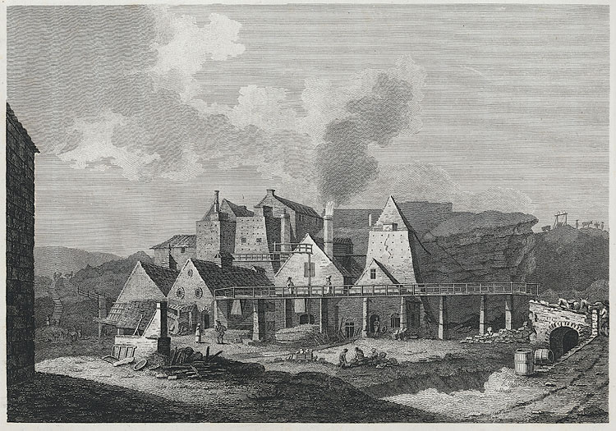
Iron works in production during 1800 (Cadw, 2020)
It was discovered that the town of Blaenavon was the prime location for sourcing natural resources such as Limestone, Coal and Iron Ore. During the 1800’s, demand increased for Iron and coal due to the industrial revolution, two more blast furnaces were opened between 1805-1810, enabling production to meet the demands. By 1812 the Iron Works was producing over 14,000 tonnes of pig iron and had over 2000 employees including children. By 1904 iron production stopped at Blaenavon due to decrease in demand as companies developed abroad, Blaenavon then focused upon the production of coal. The ironworks was saved from demolision in 1970 and was announced as a world heritage site in 1974.
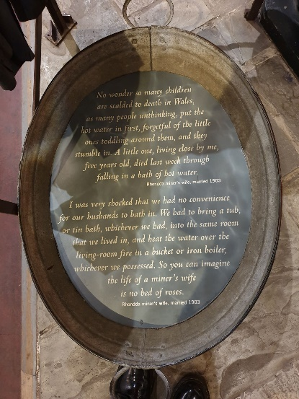
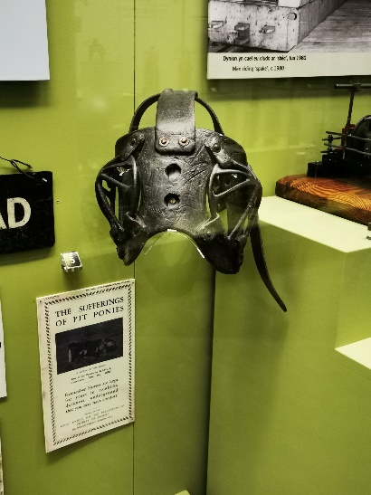
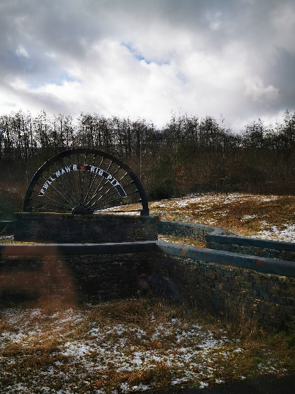
Big pit employed 1300 workers in its hay day and produced an average of 250,000 tonnes of coal annually (Brecon Beacons, 2020). The pit’s original purpose was to produce iron, as the demand decreased it was then used to source coal including; House coal, steam coal, limestone, ironstone, clay and brick. Regions worldwide imported coal from Blaenavon and it is rumoured that the brick exported from Blaenavon was used on the foundations of the empire state building. Many of the duties within the pit would be seen as ethically inapropriate in todays working environments, women, children and even animals were expected to work underground with no other expectations for life other than to provide labour for the industrial revolution. One thing that remains embedded in peoples minds of the working conditions is the fact that ‘pit-ponies’ were used, horses would be expected to spend their lifetime underground pulling trams full of materials, eventually these horses would go blind because of the amount of time spent within the mines. The tour guide at The Big Pit who is an ex modern-miner explained “the best time of the year was easter, this was when the horses were allowed to be taken out of the mines and upto nearby fields to enjoy themselves for a few days, the worst part for the miners were trying to recapture the horses when they needed to be brought back down, as the horse were enjoying themselves too much to want to go”, it may be an awful thing to imagine as in todays society we are extremely focused on attempting to diminish animal cruelty, but the conditions these horses worked in was seen as extremely better than the conditions expected for a man or child, horses were an expensive asset where as a human could be replaced in an instance. Women also found it difficult, mothers especially found these times hard with fear for their young children working underground. The workers would be riddled in soot and it was the women’s duty to ensure baths were ready and waiting outside of the entrance to the mines, this would also be a strenuous job as women had to carry buckets of hot water for miles as quickly as possible so the water didn’t get cold, men were suffering with hypothermia due to having cold baths outside and children who were too little to work in the mines were getting scaulded when attempting to help the women carry boiling water. The demand in coal decreased for the same reason as to why iron production ceased; companies were emerging abroad. Big pit eventually closed for production completely in 1980, there were still 250 employees there at this time (Visit Blaenavon, 2020). The pit is now used for tourism, there is also a virtual experience called ‘King Coal’, this experience helps tourists delve into the past with artificial set ups of what it would have been like working in the conditions of a coal mine.
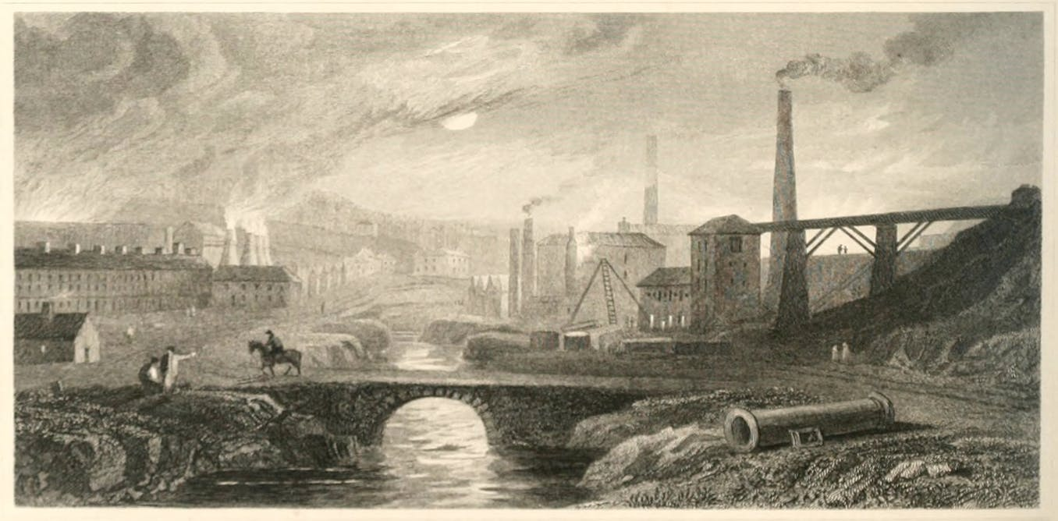The industrial revolution started in 1780, production of materials such as iron, textiles and agricultural increased due to raw materials such as coal, oil and gas being used in machinery and also steam discovered by Thomas Newcome. It was a productive circle in terms that iron production increased because of an availability in raw materials and locomotion due to the steam invention and more train roads were made to keep up with the increased demand and transportation of iron and textiles (Schwab, 2016) .
(Industrial Revolution, 2020)
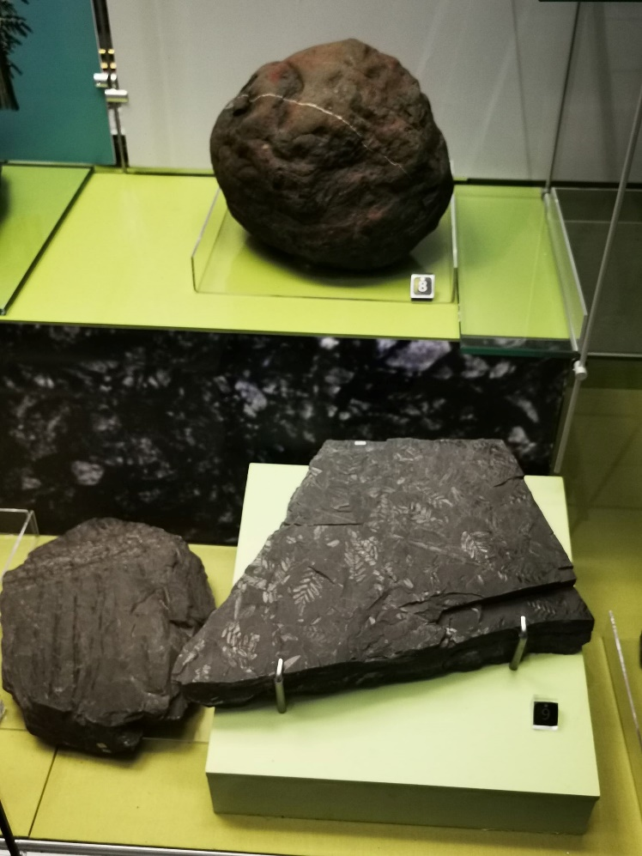
It is fascinating to see a piece of coal, something which seems so simple and average and realise that it has taken years to get to the form it is in today. It isnt just a stone or a piece of debris it is in actual fact a scientific experiment produced by nature itself, millions of years ago during the carboniferous period. Trees would photosynthesis as they do today but some of these trees would fall into water, this would ensure no bacteria or oxygen could decay them and because of the photosynthesis they still contained solar energy, after years of being submerged with no decay the trees would then form peat, this was the beginning of coal formation. As the welsh valleys are renowned for its standard of vegitation this ensured that Blaenavon coal was one of the best. There are three forms of coal; lignite, bituminous and anthracite. These range from lowest to highest in carbon, oxygen and hydrogen present, the more of the previous substances present means the highest heating value and purity (World Coal Association, 2020) .
In summary to this report, it can be clearly stated that our small country of wales played a huge part throughout the industrial revolution, even though many suffered to produce the materials it ensures a status for wales of the type of people we are: proud and hard working. Due to the greenery within wales in the carboniferous period, this provided the land and its people with the right to be recognised worldwide.

References
BLAENAVON IRONWORKS: A BRIEF HISTORY . (2020). Retrieved from Visit Blaenavon: https://www.visitblaenavon.co.uk/en/Publications/Blaenavon-Story/Blaenavon-Ironworks.pdf Sourced on 03/03/2020
Brecon Beacons. (2020). Big Pit- National Coal Museum. Retrieved from Brecon Beacons: https://www.breconbeacons.org/business/attraction-big-pit-national-coal-museum Sourced on 03/03/2020
Cadw. (2020). Blaenavon Ironworks. Retrieved from Wikipedia: https://en.wikipedia.org/wiki/Blaenavon_Ironworks Sourced on 03/03/2020
Industrial Revolution. (2020). Retrieved from The Conversation: https://images.theconversation.com/files/135283/original/image-20160824-30259-wgdjb1.jpg?auto=format&q=45&w=1356&h=668&fit=scale Sourced on 03/03/2020
Schwab, K. (2016, January ). The Fourth Industrial Revolution: what it means, how to respond. Retrieved from World Economic Forum: https://www.weforum.org/agenda/2016/01/the-fourth-industrial-revolution-what-it-means-and-how-to-respond/ Sourced on 03/03/2020
Visit Blaenavon. (2020). Big Pit- Brief History. Retrieved from Visit Blaenavon: https://www.visitblaenavon.co.uk/en/Publications/Blaenavon-Story/Big-Pit.pdf Sourced on 03/03/2020
World Coal Association. (2020). What is coal? Retrieved from World Coal Association: https://www.worldcoal.org/coal/what-coal Sourced on 03/03/2020

