Sophia Lydia Henry
Student Number: 1902385
Coexistent Perspectives
(ADCD7001)
Lecture : Rob Jones
Words: 4173

Key words: space, place, creative thinking, imagination, fantasy, environment, art, artist, view point, perspective
Theme: Space & Place

The purpose of this essay is to investigate and explore the dynamic of space and how imagination and creative thinking is affected and used within contemporary art to create a space and place in different manners.
Creative thinking is the understanding to have many different ideas and shape those ideas in unconventional and unique ways, creating an original outcome. This can then be applied in multiple ways and methods, some of which will be presented with the use of multiple case studies to develop an enriched understanding in how creative thinking has evolved though different artists perspectives their expression throughout their own work.
Contemporary arts have been able to promote creativity in new ways that are not traditionally thought to be used within “normal” arts. However, with the use of creative thinking in all forms of art especially seen in recent years has reached new heights and has developed into multiple different final creations from being inspired by subjects of all sorts. Creativity remains an important factor to the expression of art, and allows the artists to translate their vision to the chosen medium. Without creative thinking would these fascinating artists be able to come up with these never-before-seen ideas, they would not be able to showcase their vision.
Within the contents of the essay, the work of Katie Paterson and Anicka Yi will both been investigated and on how they have used their own creative thinking within their work and how they could have gotten to their final exhibitions spaces and the process of place, how they have created this over all space, the art work that goes within, around the space and how they wanted it to effect and impact the viewers. The interpretation of art is subjective in nature and everyone’s own perspective will be different in some way however the artists themselves will know the true meanings that they are trying to present to the audience. It has been noticed that not every piece of information is explained within an exhibition space nor within the description normally found within the space, this could actually be to allow more creative thinking in the viewer’s own thoughts, feelings and imagination could come into play allowing us to come to our own conclusions. That is why everything you can see, hear, feel within the spaces made are all important in creative thinking and are often taken into consideration within an art space as seen below in the work of the two chosen artists Katie Paterson and Anicka Yi.

Space is considered as a room in which to move, and can be used to hold object or is a place. It is a network. Place is something that is located. Space “Rather than an actual force in the shaping of society and theory, space became “a reflective mirror of societal modernization” (Edward Soja, quote), space is what the world makes of it.
There are many different types of spaces that will be explored such as Firstspace which is when urban buildings can be mapped and seen, the second space is how the space is perceived seen and talked about, discussed and imagined. Thirdspace combined all of the above in a collective experience.
The External space that is live in that affect and can even influence people is not a void and is ever changing just as art is. Art is a way to express our self and has been used to talk about the space around us. It can reveal what has been hidden and make it visible. The abstract space of potentiality is what will be explored when looking at these artists, how they have taken an empty space full of potential and turned it into something impactful within their own environment, as a way to glimpse into seeing how they see the world through the space around them. Individuals are located within “Space”, and act in “Place”, places are spaces that are valued, so to everyone it is different, which is why for an artist the incorporation of space remains an important factor which is valued when using unique materials and methods.
Even the definition of space is very open to individual interpretation “Encyclopaedia Britannica defines space as a boundless, three-dimensional extent in which objects and events occur and have relative position and direction’’ (Britannica, Space) and so it is clear that in any installation of an exhibition space that it is extremely important as it is often engaged in the work but has also been used to create a metaphysical experience, this is seen often to contemporary artists.
An example of this is from a trio of artists collectively called Troika who said about one of their installations that involved beams of light that shined thought gothic arches you were to walk though and around “creating a spatial suspension of disbelief, Arcades encourages an analysis of our relationship with the metaphysical in a world increasingly governed by practical, rational and scientific principles.” (Eli Anapur, 2016, p1). This would be known as an Art Environment, created for multiple reasons such as for public viewing to explore the subject “embody and express aspects of the artist’s life experience, their surrounding geography, or culture. The works are immersive, typically immobile” (Jmkac, p1). It is also used for storytelling. These Art Environments are me to be experienced as a whole rather than in individual elements. However some of the places can also be used as private spaces where the artists confront more personal issues, a room of inspiration, meditation. This method is different from traditional installation art as it occurs outside of more traditional gallery settings or displays and can stay as more permanent pieces or for longer stays within the chosen places and modified over time. Spaces built as a construction to form an environment that has impacted the artist is described as an “defined as a sum total of all the living and non-living elements and their effects that influence human life” (byjus, p1), this is seen a lot more recently in exhibitions around the world, a impactful experience that was once only seen though the artists eyes and brought into the work for us the viewers to see.

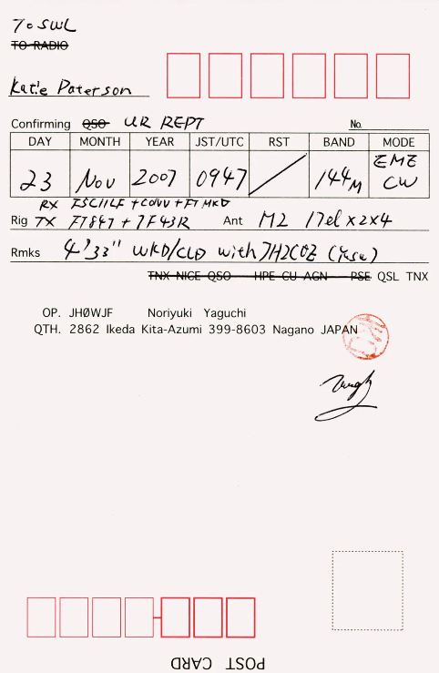

Figure 1. Katie Paterson: Earth- Moon-Earth (Moonlight Sonata Reflected from the Surface of the Moon)
Katie was able to use the Earth-Moon-Earth radio transmission. This method is achieved by sending the chosen song “Beethoven’s Moonlight Sonata” from Earth to the moon’s surface in the form of Morse Code. This code is then reflected off the moon and obtained back on Earth.
This technique was originally created for military and astronomical purposes, “Morse code was invented by Samuel Finley Breese Morse (1791-1872)” (Petzold,1999,p10). During “the radio transmission containing Moonlight Sonata is invariably distorted, it is subject to path loss, (Anderson,2014,p1) this was actually because the information was being consumed by shadows on the moon therefore the actually musical number of Moonlight Sonata has transformed into an enthralling version of the original number. This piece was put back together and crafted like a spider web, where no two are ever the same.
Ironically the Moonlight Sonata was never originally named by its unknown creator and was named by the “19th century critic Ludwig Rellstab, who thought its sound conjured up images of moonlight glistening on the surface of Lake Lucerne.” (Anderson,2014,p1) this raises that through that music like any other art form, is available for individuals to project their own fantasies on to and so is the moon.
This thought alone opens a range of questions to be answered such as, why do we project our fantasy though art? “fantasy interacts simultaneously with creativity in the mind, and the main hypothesis is that the more we stimulate this fantasy the more we nurture creativity” (Perrone,2015,p1) this can be seen in the work of Katie Paterson and how she has been able to produce her work and states that she makes work that collapses distance and time and works with space to bring together the a “commonplace” within space and time. The piano keys move up and down completely by themselves creating an otherworldly feeling, the Moonlight Sonata has been touched and altered by the moon explained previously, how the piano has been placed in her exhibition space was to make it appear in a way not to allow you to see if there was anyone playing the piano or not to create a jolted effect once you come to the realisation that there is no performer perhaps creating the idea of being present within the space, that it is in fact the moon playing the music creating that fantasy within the exhibition space.
Space is different for everyone and in the eyes of an artist this can be ever changing, for Michel de Certeau space for him is a frequented space and intersection of moving bodies and considers the pedestrians are the ones who have transformed the street into a space. However if you were to take a different perspective then space and place combined together define the nature of geography and create a point on the earth’s surface.
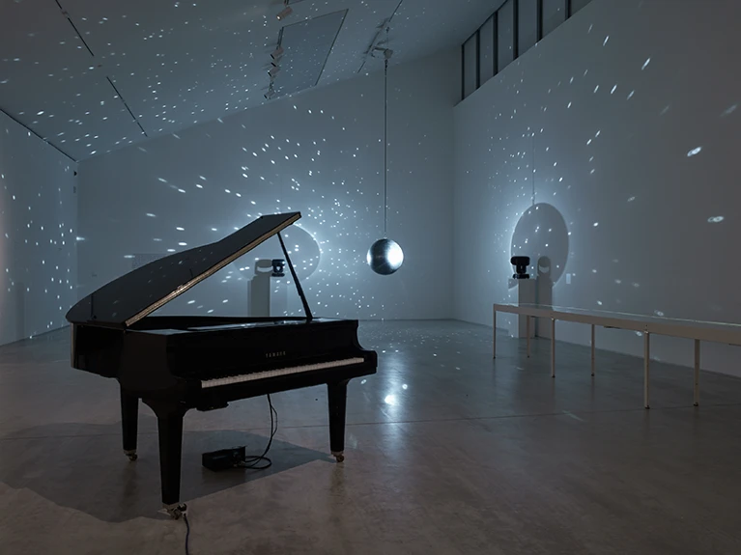
Figure 2. An installation from Katie Paterson’s exhibition A Place That Exists Only in Moonlight. Credit: Stephen White
The space that Katie has been able to create has created an environment that almost resembles space, this was done by suspending a disco ball and having light hit it from two sides so it could reflect around the room as well as create a shadow that almost resembles the moon at first glance.
This environment is trying to make a haunting yet peaceful atmosphere, the term hauntingly beautiful comes to mind when thinking about this space that has been created and all that has gone into it to get it to this point.
This all adds to the ambiance of the room combined with the moon playing piano. The fantasy that was being made is both a combination of the space used and the physical part of the exhibition creating the overall fantasy, the use of creative thinking has been shown in many different ways in a modern and clean approach, she does not use anything overly complex and lets the work speak for itself, the environment that she has made is calming and ethereal in the sense, you would essentially be surrounded by music that the moon has metamorphosed witnessing nobody playing a grand piano within a room of stars.
People throughout history have believed that the moon has an effect on people and this is called ‘’the “lunar effect” which is based on the belief that health and behaviour are altered during specific stages of the lunar cycle, with some claiming that it can affect everything from reproductive health to sleep quality and beyond’’ (Rebecca Joy Stanborough, 2022) so would this be part of the reason to having the moon be within the space, so it could have some sort of effect upon the spectators that would stay with them once they left the space.
When looking at every thought and feeling that Katie has been able to intertwine within has revealed multiple layers of perception, her creative thinking indicated to have originated from the concept of exploring everything between space and time and stretched towards haughty musical number and inclosing you within a hypnotic ambiance. This has resulted from a conceptual insight that has been further explored. Her work has created a link towards the old, with her use of morse code and the new being her use of it within an art environment, creating a new direction of inspiration for future artists.
Work like this, that comes from a completely different view point and perspective is perpetually thought provoking, and much has been left to the viewer’s imagination on discovering the possible hidden meanings and inspiration behind the work, which could be a deliberate way to enhance the whole experience of this created space.
Space is something abstract and does not have a single meaning, place can refer to how people are attracted to or show realization to a certain piece of space. A place can be considered a place if it has a meaning. This is used as an advantage in art spaces, for the artist try’s to make a space that enthrals the views and makes a place of significance and value towards the audience.

Case study 2
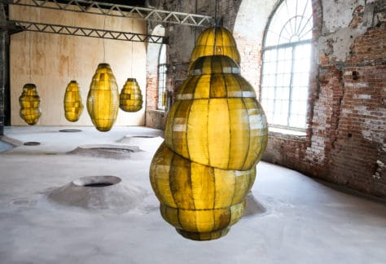
Figure 3. Anicka Yi, In Biologizing the Machine (Tentacular Trouble), 2019. Installed at the 58th International Art Exhibition – La Biennale di Venezia.

Anicka Yi’s work is something straight out of a Sci-Fi movie, her practice work is related to synthetic biology, bio engineering, extinction and bio fiction, which is where she get her inspiration. She also includes how assumptions and anxieties related to gender, race, class and physical perception.
As seen in Figure 3, this piece is called In Biologizing the Machine (Tentacular Trouble), and she ‘’uses a stretched leather-like kelp to create hanging incandescent sculptures that conjure up images of organisms such as human organs and insect eggs through chrysalis-like pods within which animatronic insects flutter about’’ (Bagri Foundation, Interview). Within this exhibition you can see that the ground under the pods is a small pool which is meant to evoke a swamp, this has the feeling as if these cocoons were hatched from the creatures within the swamp lurking beneath them, however in another view point it would appear that the cocoons could be filled with this water and it is actually about to burst, the cocoons appear to be captured in movement almost as if a creature is moving around inside trying to break though the casing of the pod it is within. This could explain the pool below that has been formed.
The colour of the pods is an interesting subject as the green colour is usually linked towards a caterpillar cocoon. So would these pods burst open to reveal a giant caterpillar or butterfly or is the space within simply hollow. Perspective is an important within art as the view usually has different ideas, thoughts or assumptions then the artists does.
This exhibition has been made with ‘’kelp, acrylic, animatronic moths that can be seen moving within the pods and create a buzzing sound of a bee, concrete and moving water” (Mark Godfrey, p70). During an interview with ArtLike it was discovered that these luminous biomorphic pods were to be an evocative of cancerous growths, insect larvae and human organs, the pools of liquid are actually a reference to the “maze like canals of Venice and the marine bacteria pervading the city and ultimately, to our own primordial crawl from the water. (ArtLike, 2019) the biopolitics of the senses and her creative thinking stems from creating a channel of communication that can be established between artificial intelligence, AI entities and organic life forms. Her way of creative thinking has been stimulated both by unstructured process such as formulating and by lateral thinking.
Anicka Yi has a profound understanding of her subject and has been able to use this and have multiple conceptual ideas that make unique creations.
Lateral thinking also known as “horizontal thinking and it is a form of ideation where creators approach problems by using reasoning that is disruptive or not immediately obvious. They use indirect and creative methods to think outside the box and see problems from radically new angles, gaining insights to help find innovation solutions” (Interaction Design, p1) , from her inspiration it is understandable to see she has been using this form of thinking to explore all her possible options in multiple unorthodox ways that can been discovered within this essay. Anicka’s work fuses multi-sensory experiences with synthetics and evolutionary biology to form her incredible creations, she has stated previously that she challenges “traditional approaches to the human sensorium, emphasizing olfaction as well as microbial and embodied intelligence” (Berggruen Institute, 2018). Anicka’s approach to her work is very unique and her use of exhibition space is inspired by environments or her approach to creating an environment that links towards her work. Her work is powerful in the sense that she is drawn towards thing that can make people uncomfortable so that we can confront it and question it, this can be seen in the figure below.

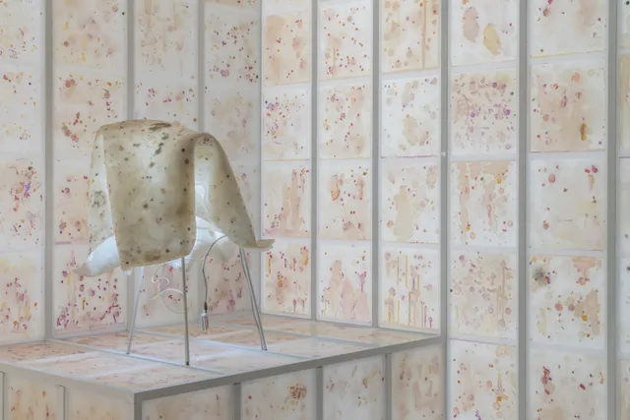
Figure 4 Anicka Yi, Force Majeure, 2017 (detail). Plexiglas, aluminum, agar, bacteria, refrigeration system, LED lights, glass, epoxy resin, powder-coated stainless steel, light bulbs, digital clocks, silicone, and silk flowers Courtesy of the artist and 47 Canal, New York. Photo: David Heald © Solomon R. Guggenheim Foundation
This exhibition was very impactful and as previously mentioned is one of the possible disturbing pieces that viewers will be confronted by, her use of space here is very interesting as giant fridge had to be constructed and placed within the wall, encasing these sample, the bacteria samples were taken from around Koreatown and Chinatown and the impact she is trying to project is “to stare at the manifestations of our biology is to acknowledge that we comprise one species, capable of tolerance and empathy as much as prejudice” (Claire Voon, 2017, p1), this is an interesting concept considering the recent pandemic and the health and safety measure taken into consideration to make this exhibition, the idea that this is all around us, you have no idea who it could be from as it is just bacteria placed all around a room practically consuming the space and taking over.
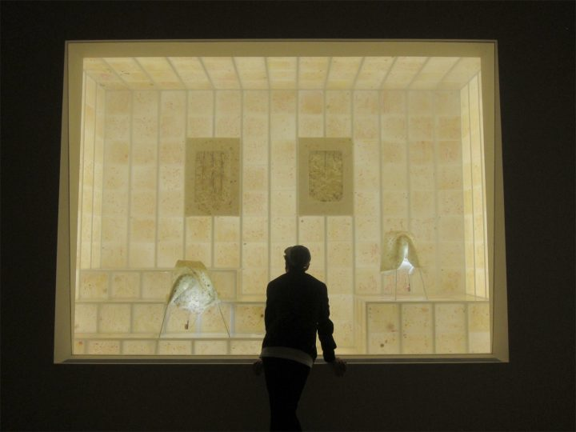
Figure 5 Anicka Yi, “Force Majeure” (2017), from the exhibition Life Is Cheap at the Guggenheim Museum (all photos by the author for Hyperallergic)
Anicka has essentially created a whole in the wall for the views to look though and see the, outside of the bubble would this be what the rest of the room looked like, covered in a human imprint invisible to the human eye unless exposed in the right measures like this space. In a way you are looking into the world under a microscope or peering through a screen to reveal the truth.
Anicka mentioned that we are all the same and there is no way of telling the difference between people in any way just from looking at this collection of bacteria and she is right as we are all human. This “hidden” meaning behind this space can be considered quiet poetic as when you first look at this space with no understanding behind the real meaning you would have a completely different perspective on what could have been the meaning or inspiration behind it. The space is very sterile in the sense it does create a feeling as if you were looking though a hospital window or science laboratory. The rest of the space adds to this feeling by being completely plain with white walls, your eyes would in turn be drawn towards the “window” as the impactful part of the room. This would intern confront you once you were able to determine what you were seeing.
Many different feeling could be expressed here such as degust, understanding, shock and more, the artist would need think about how she would need to express her vision to the viewers in the space she has created and would need to create a shock factor, every detail has been examined

An artist’s space and place of choice is very important, it can make or break the end result, however at times that could be exactly what the artist wishes to present. Lighting is essential for you can highlight a feature creating a focal point, or in the same manner with the use of shadows to add depth to the surroundings, making reflections and positive and negative space, the use of unconventional materials can be used within the space to attract the senses such as vision, hearing, touch, spatial orientation, smell and taste, this can all be effected with in these created spaces and used to the artists advantage as can be seen within these individual unique artists and done in peculiar was that can leave a lasting memory and impact upon the viewers.
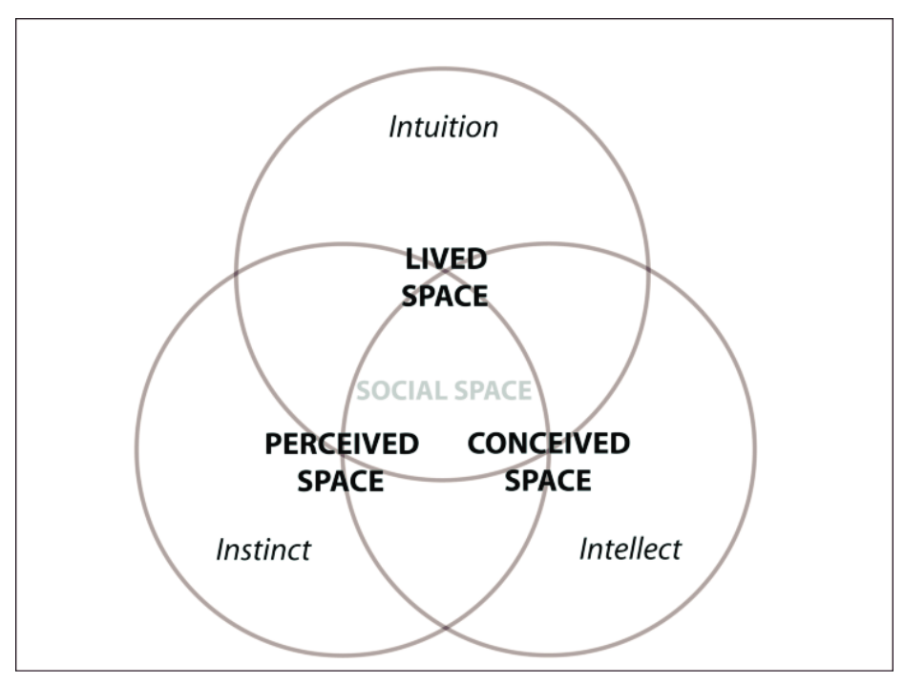
Figure 6 Space and Place Lecture

Artists such as these have approached the theme of space and place in many ways and have been inspired by places, use, subject, future, meaning and much more. Positive and negative space in art used to create imagery, meaning, and balance while also to draw your eye to certain points, the use of space can add perspective depth and even create illusions. It has been used to combine personal perceived space, conceived space and our lived in space and push past these boundaries, overlapping them. There are many different forms of space in art including positive and negative space mentioned previously, deep and shallow space, two dimensional, three dimensional, and closed and or open spaces all of which can be connected to the surrounding space, on a flat surface, the area surrounding and even within a item or sculpture. Space and Place does not have any limits, it only takes creative thinking to put it into reality.
Space is an element of art, if we did not have space a work of art could become overly chaotic unable to convey its intended meaning. For new artists is can be quite easy to overlook just how important it is, space is the area between, around, above, below and within objects.
Upon consideration of the facts discussed above regarding the statement purpose of creation and discovering how imagination and creative thinking is effected and used within a contemporary art space in different manners and the exploration of multiple professional artist viewpoints on this subject.
Discovering the meaning behind creative thinking and how contemporary artists use that to develop their own creative space and how they have used creative thinking to develop and explore different routes using materials and subject matter outside of what would be considered normal, how these artists have incorporated the work they have created into an exhibition space.
In depth researched into what space and place is and all of the different forms, both in general subject and in the eyes of artists that have been discussed above. Showcasing how space has been able to develop in individual ways using different forms of creative thinking, how this has then been presented towards an audience and how this has affected them and how the view could see things from their own perspective.
Different subject matters have been a substantial impact on how space is viewed as is the environment in which surrounds you, it can invoke feelings, bring forth memories, unlock new discoveries and much more as is explained more in depth throughout this essay. Space and place is different for every person, not one person has the same finger print and this point is carried on to someone’s own perception of space, this is why in the matter of art people have the opportunities to express themselves with in the space around them or within their art pieces. Space and place go hand in hand, and this term is explored in depth by looking into numerous resources including two different artists known as Katie Paterson and Anicka Yi. I have discovered these artists get there inspiration from and build using their creative thinking in unique ways and see where this has taken them, the final product, and the space and place they have made and how it is impacted others.
What has been discovered though out this essay is that when you sudden have a realization this is “called the “Aha moment’’—that can result in a new interpretation of a situation and that can point to the solution to a problem” (Sternberg & Davidson, 1995, p1 ). This assurance can be seen thought out the research into these two artists mentioned before as a sudden thought or epiphany, this is another word for insight and “ insight involves a conceptual reorganization that results in a new, nonobvious interpretation, it is often identified as a form of creativity (Friedman & Fo¨rster, 2005, p5).
To conclude, this should be a more extensive overview on what could be purposes can be of creation and discovering how imagination and creative thinking is effected and used within a contemporary art space in different manners and the exploration from looking at Katie Paterson and Anicka Yi’s work as well as the extensive research into the subject furthermore, creating a deeper understanding on the meaning of space and place both in and out of the subject of art and how this has multiple consequences of significant value that should be taken into further consideration in the future and used within all “spaces” including an exhibition space to create different atmospheres appropriate to the viewpoint you are trying to make. Space and place does matter in every situation and has been used to make environments which are seen very prominent within all forms of art and how this has started with the use of an epiphany.

Figure list :
- Figure 1. Katie Paterson: Earth- Moon-Earth (Moonlight Sonata Reflected from the Surface of the Moon)
- Figure 2. An installation from Katie Paterson’s exhibition A Place That Exists Only in Moonlight. Credit: Stephen White
- Figure 3. Anicka Yi, In Biologizing the Machine (Tentacular Trouble), 2019. Installed at the 58th International Art Exhibition – La Biennale di Venezia.
- Figure 4 Anicka Yi, Force Majeure, 2017 (detail). Plexiglas, aluminum, agar, bacteria, refrigeration system, LED lights, glass, epoxy resin, powder-coated stainless steel, light bulbs, digital clocks, silicone, and silk flowers Courtesy of the artist and 47 Canal, New York. Photo: David Heald © Solomon R. Guggenheim Foundation
- Figure 5 Anicka Yi, “Force Majeure” (2017), from the exhibition Life Is Cheap at the Guggenheim Museum (all photos by the author for Hyperallergic)
- Figure 6 Space and Place Lecture

Bibliography
Anapur, Eli. “Art History.” What is space in art? Examples and Definition (2016): 1.
Anderson, Darran. Katie Paterson: Earth-Moon-Earth (Moonlight Sonata Reflected from the Surface of the Moon). Edinburgh: Studio international , 2014.
Army, One. Precious Plastic Community . 2020. 09 12 2020. <https://community.preciousplastic.com/academy/research/beyondplastic>.
Arriba, Raul de. Contemporary art in higher education: Greative pedagogies in political economy. Sciencedirect, 2019.
Beeman, John Kounios and Mark. The Eureka Factor: AHA Moments, Creative Insight, and the Brain . Random House , 2015. Hardcover 274 pages.
BYJU'S. “Environment meaning.” Meaning and Functions of Environment (2020): 1.
dasjannis. DAVE HAKKENS. 2019. 09 12 2020. <https://davehakkens.nl/community/forums/topic/v4-beyondplastic-infos-recipes-and-books/>.
Friedman, R.S., & Fo¨rster, J. “Effects of motivational cues on perceptual asymmetry: Implications for creativity and analytical problem solving. .” Journal of Personality and Social Psychology (88): 263–275.
Godfrey, Mark. The Politics of Air . Tate Modern, 2021.
Institute, Berggruen. Berggruen.org. 2018. 22 11 2022.
Jmkac. “What is an art enviroment?” What is an art enviroment? (1985-90): 1.
Lab, RISD Nature. Natures Lab. 2020. 09 12 2020. <https://naturelab.risd.edu/discover/biomaterials-you-can-make-at-home/>.
LABVA, María José Besoain, Alejandro Weiss. Materiom. 2018. 09 12 2020. <https://materiom.org/recipe/59>.
Lateral Thinking. 11 5 2022. <https://www.interaction-design.org/literature/topics/lateral-thinking>.
Perrone, Raffaella. Integrating fantasy into the creative process. Chicago: University Pompeu Fabra , 2015.
Petzold, Charles. Code: The Hidden Language of Computer Hardware and Software . 1st. Microsoft Press, 1999.
Rebecca Joy Stanborough, MFA. “Healthline .” 26 8 2022. 19 11 22. <https://www.healthline.com/health/full-moon-effects>.
Sternberg, R. J., & Davidson, J. E. The nature of insight. Washington: American Psychological Association, 1995.
The editors of Encyclopaedia Britannica. Britannica - Space. n.d. 24 11 2022.
Tortarolo, Francesca Perona Marco. Materiom. 2018. 09 12 2020. <https://materiom.org/recipe/62>.
Voon, Claire. “A Display of Sweat, Ants, and Bacteria at the Guggenheim.” A Display of Sweat, Ants, and Bacteria at the Guggenheim, By ushering into the museum elements that are conventionally seen as unsanitary, Anicka Yi explores the “biopolitics of the senses.” (2017): 1.
Yi, Anicka. Anicka Yi - Biologizing the Machine (Tentacular Trouble) - Venice Art Biennale 2019 23 September 2019.
Yi, Anicka. Anicka Yi at 58th International Art Exhibition – La Biennale di Venezia. BAGRI FOUNDATION 11 May 2019.

