

Student name: | Aleksandar Kushlev | Student ID number: | 2028393
Programme: | BSc Cloud Computing
Module: | Network Programmability
Module code: | ACCA5029 | Contribution to Overall Module Assessment (%): | 50%
Lecturer: | Dr. Muhamamd Azeem Abbas | Internal Verifier: | Ms. Abida Perveen
Assignment Title: | Assessment- 1 : Report | Word count (or equivalent): | 2500 Words (+/-  10%)

Task description

Component 1: Report (50%)

Write a 2500-word report to explore how the field of computer networks has moved towards a greater emphasis on software, with a particular focus on cloud computing. You should mention:
- How the shift towards cloud computing has impacted the industry.
- How the job role of network professionals has evolved to meet the technical challenges of the cloud.
- How RESTful Web Services have been used to facilitate these changes.
- Why software defined networking has become so heavily adapted by industry, despite meaning an adaptation to the job role of network engineers.
- Why standards, such as JSON and REST have been selected and utilised. Specifically consider interoperability.

You are required to write 2500 words report. Your report should include relevant figures or diagrams wherever required. Although you will be writing a report but still your report should include minimum 15 IEEE style academic references.
Table of Contents

1, Introduction

2. The shift towards cloud computing and its impact on the computer networking industry

3. The technical challenges of the cloud and the evolution of the network professionals job role

4. How RESTful Web Services facilitate the challenges of the cloud

5. Software-defined networking and its impact on the network engineers job role.

6. Interoperability and the use of REST and JSON in networking.

7. Conclusion

- Introduction
Cloud Computing has been in existence for a long time now and has proven to be a game-changing technology.in the computer networking world. The virtualization technology and software-defined networking have had a huge impact on the computer networking industry as these technologies have moved the networking paradigm from traditional hardware-based networking to a more software-driven one.
The programmability, customization, and automation of networks have made software-defined networking (SDN) the leading choice in the networking industry due to the flexibility and efficiency that they offer compared to traditional networking. These changes in the industry have impacted the job of the network engineer as configuring, managing and maintaining networks has become a software-focused process which means that if network engineers have to adapt to the new normal, they need to develop programming skills and better understanding of software-defined networking.
At the leading edge of SDN development are the RESTFUL Web Services which rely on the REST architectural style for straightforward and efficient data exchange.
- The shift towards cloud computing and its impact on the computer networking industry.
Cloud computing has become a transformative force in the world of computing and especially in computer networking. According to the National Institute of Standards and Technology (NIST): “Cloud computing is a model for enabling ubiquitous, convenient, on-demand network access to a shared pool of configurable computing resources (e.g. networks, servers, storage, applications, and services) that can be rapidly provisioned and released with minimal management effort or service provider interaction.”
Since cloud computing (CC) is a game-changing technology, the impact on the computer networking industry is significant because it changes the way organisations consume, run, and build business applications, which in turn affects their networking budgeting and long-term strategy decisions. This is mainly due to the replacement of on-premises infrastructure with off-premises one. Businesses no longer need to store, process, and transport data through physical on-site premises which are costly to purchase and maintain. CC presents the opportunity to move all business applications, their storage and processing on the cloud with the only limitation being the 24/7 availability of internet connection.
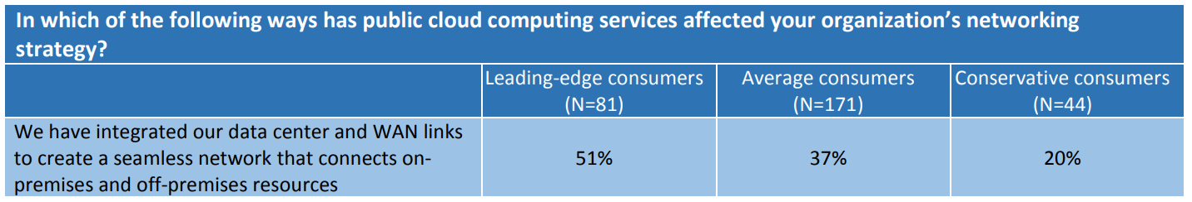
Table 1: Impact of Public Cloud on Networking Strategy, by IT Purchasing Pattern
As can be seen from Table 1, more than half of the leading-edge consumers have made sure they have integrated their data centre and WAN links to provide for seamless connection between on-site and off-site premises. Since the survey has been conducted in 2017, the percentage will most likely have increased significantly. According to Table 1, a significant part (37%) of average consumers have also managed to achieve seamless integration between their on-site and off-site premises which signifies the advanced adoption rate of cloud computing among average and above-average IT purchasing pattern businesses.
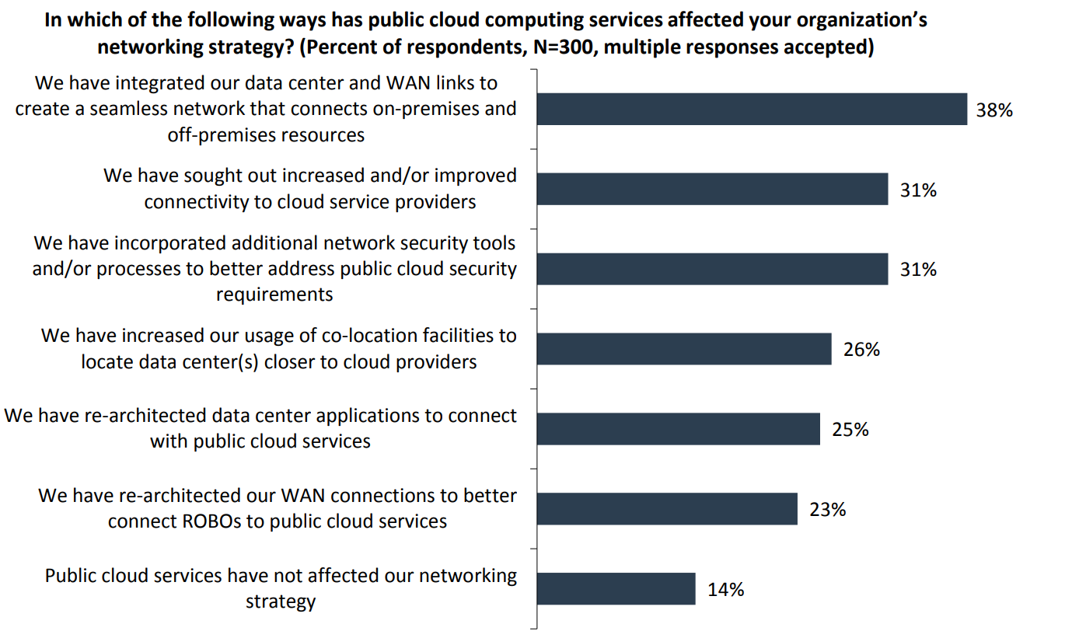
Figure 1: Impact of Public Cloud on Networking Strategy
On Figure 1 above, the impact of cloud computing on companies’ networking strategy is clearly outlined. The highest percentage (38%) of companies surveyed have achieved seamless connection between on-site and off-site premises. One third of all companies surveyed have stated that they have sought better connectivity to cloud service providers and also have incorporated additional network security tools to better address cloud security requirements.
The above-mentioned surveys signify that the shift towards cloud-based services is advancing rapidly and it will have a major impact on the whole computer networking industry as companies are moving towards off-premise infrastructure which will require an entirely new set of security policies, budgeting models, business process remodelling, and last but not least - networking professionals skills.

- The technical challenges of the cloud and the evolution of the network professionals job role
The role of network engineers has been evolving together with the growing sophistication of computer systems and infrastructure. The introduction of CC has presented new challenges for network engineers and old-school network engineers might find themselves new to the area of cloud networking.
As mentioned in the previous section, businesses are increasingly using off-site shared resources which means that the role of the network engineer will slowly evolve into that of a DevOps which not only includes skills needed for network management and configuration, but also network automation which involves coding and thus focusing more on the software side of networking. Terms like virtualization, hypervisors, cloud infrastructure etc., are becoming the standard in networking and thus, network engineers will inevitably need to adapt and start their network automation journey.
The actual question, however, is whether it is necessary for every network engineer to be able to read and write a simple script. That question would undoubtedly have a positive answer. On the other hand, it is not the case that every network engineer has to become a programmer. All engineers, not only network engineers, shouldn't be afraid to attempt reading through some Python or Ruby, or even more complex languages like C or Go. Many engineers will tend more toward one discipline than the other, and perhaps some network engineers will do the transition and become developers. By employing bash scripts, Python, Ruby, and PowerShell, system administrators have already done a good job of using scripting as a tool to enable them to execute their duties more efficiently.
Thus, a network engineer might find it easier and more interesting to evolve into the role of a Devops which is in the middle between network engineer and developer. The DevOps could involve working with network configuration and management tools and also include some coding where necessary to be able to complete the tasks and automate the workflows in the specific environment.
- How RESTful Web Services facilitate the challenges of the cloud?
The challenges presented within the new cloud paradigm are mainly related to interoperability and secure transfer of representational state of the applications. To be able to meet the new challenges, the computer networking industry needs a platform or model which uses the web as the ground for distributed computing.
One such platform is REST which means Representational State Transfer: “REST defines a set of architectural principles by which you can design Web services that focus on a system's resources, including how resource states are addressed and transferred over HTTP by a wide range of clients written in different languages.”
The fact that REST uses HTTP to transfer states of application resources means that all applications that use the REST model are web services as the transfer is performed over the web. Such applications are called RESTful web services. An excellent example of a RESTful web service is Google Cloud Storage which is an online file storage platform for Google’s infrastructure.
From a network perspective, most of the network infrastructure Application Programming Interfaces (APIs) nowadays are HTTP-based RESTful APIs which means that the API is communicating between a client and a server. Since the RESTful API is HTTP-based, operations will be performed with the use of an URL.
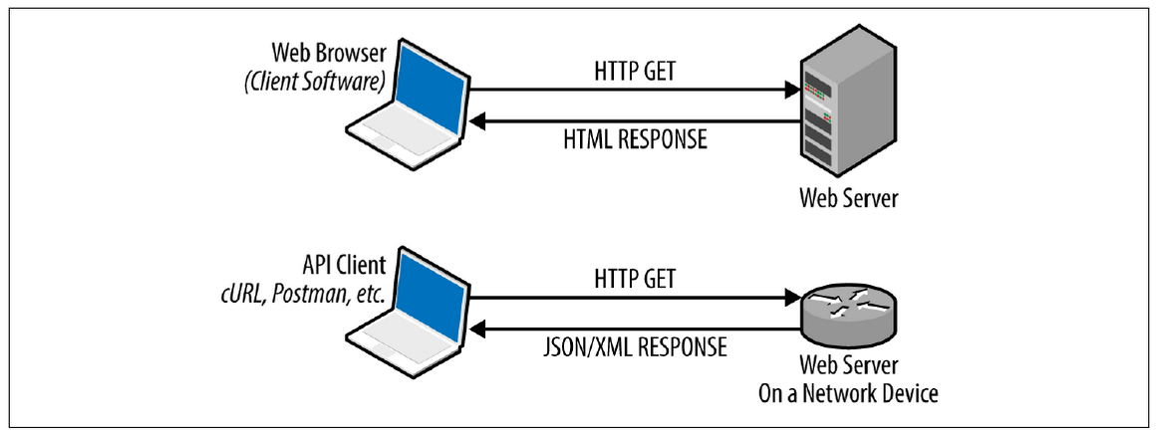
Figure 2: REST works through HTTP GET responses
As can be seen on Figure 2, there is a similarity in the communication between a web browser and a web server, and between an API client and a web server on a network device. Both of them use HTTP GET to the server and receive a response, where in the case of client RESTful API, it is a response in the form of JSON/XML encoded data as compared to an HTML response in the case of the web browser.
Three of the main constraints that an interface needs to comply with to be considered as RESTful are: client-server, stateless, uniform interface. Having a client-server architecture means that there is greater flexibility because client applications can be changed but the server component remains unchanged. Stateless communication between client and server is a communication where the server will perform the requested operation in one request when it has received all data required from the client. This communication is different from SSH where a persistent connection must be maintained. The uniform interface constraint for a RESTful interface means that the resources addressed by the API call are identified in the HTTP request messages.
The REST model is a great advancement in web applications architecture design as it simplifies the process of communicating application states between client and server. RESTful web services are facilitating networking in a cloud environment because REST is a simplistic way of communicating between an API and a web server on a network device through HTTP requests and data is conveniently transferred in XML or JSON formats.
- Software-defined networking and its impact on the network engineers job role.
“Software-Defined Networking (SDN) is an approach to networking that uses software-based controllers or application programming interfaces (APIs) to communicate with underlying hardware infrastructure and direct traffic on a network.
This model differs from that of traditional networks, which use dedicated hardware devices (i.e., routers and switches) to control network traffic. SDN can create and control a virtual network – or control a traditional hardware – via software.”
Although the definition of SDN above is a clearly understandable one, SDN is still a quite subjective term which comprises different areas in computer networking. The growth in popularity of SDN as a new technology in the sphere of networking has been justified by its importance and advantages.
One such advantage is the enhanced control, speed, and flexibility. Instead of manually programming numerous vendor-specific hardware devices, programmers can control the traffic flow over a network by only programming an open standard software-based controller. Since they can select a single protocol to communicate with any number of hardware devices through a central controller, networking managers also have more freedom when selecting networking equipment.
Another advantage of SDN compared to the traditional networking is the customizable infrastructure with rapid allocation of virtual resources real-time through a single centralised location. This enables network administrators to prioritise applications that call for greater availability and optimise the data flow via the network.
The third important advantage of SDN is the stronger security as the SDN provides visibility of the whole network. Thus, enhancements in threat mitigation have been achieved through the ability to separate devices in zones with different levels of security combined with the ability to quarantine immediate threats.
The broader definition of SDN can be associated with the following areas of networking:
- OpenFlow
- Network Automation
- Network Functions Virtualization
- Bare-metal Switching
- Virtual Switching
- Data Center Network Fabrics
- Network Virtualization
- SD-WAN
- Device APIs
- Controller Networking
The above topics comprise a significant part of computer networking and therefore network engineers have to adapt accordingly to the new paradigm of SDN.The main challenge for network engineers to adapt to the new technology of SDN is that it requires programming skills. The barrier to entry for network engineers is lowered by the availability of device APIs which facilitate the processing of data by providing the exact information needed in a structured way as compared to the parsing of raw text to extract the information needed.
- Interoperability and the use of REST and JSON in networking.
The major success of SDN is based on the use of lightweight software components which facilitate network interoperability. The REST client-server architectural style and the JSON lightweight data format are two components which are used together to serve as a powerful SDN tool.
As mentioned above in the section about RESTful Web Services, REST (Representative State Transfer) is a client-server architectural style that makes efficient and straightforward use of the HTTP protocol. The methods GET, POST, PUT, DELETE are used by the RESTful interfaces which makes them simple and practical to use. HTTP requests and responses are the primary means of communication between the client and the server. Since each request is stateless, the server does not keep track of the current state of the application. Instead, client requests already include all the data required to fulfil the request.The data interchange is conducted in the form of XML, JSON, YAML, or other formats for exchanging data.
Machines can read and readily comprehend the lightweight data-exchange format known as JavaScript Object Notation (JSON). A part of the JavaScript programming language serves as the foundation for JSON.
When JSON appearing in early 2000s, XML was already available as a format of data exchange between software applications. Nevertheless, JSON became more popular due to its simplicity. Basically, JSON aimed to be a lightweight version of XML.
With all said above about REST and JSON, using them in combination is a wide-spread technology for providing network interoperability due to their simple design, straightforward operation, and efficiency.
- Conclusion
Cloud computing has had an immense impact on computing due to the benefits that it provides as compared to traditional on-premise computing resource use. With the expansion of cloud computing, networking has transformed into a more software-driven process where software-defined networking is being used for better interoperability, automation, programmability and customization of the networks.
The above-mentioned changes in the industry have inevitably impacted the network engineer profession which is shifting towards a more software-based approach to networking. The needs of the industry are growing for job roles which stand between the role of the network engineer and the role of the programmer. This hybrid role is the position of the DevOps.
Network management, programmability and automation have been greatly facilitated by the development of the REST client-server architectural style and the use of the JSON format for data exchange which provide an efficient and straightforward technology for SDN.

References:
[1] Mell, P., Grance, T., “The NIST definition of Cloud Computing” 2011, NIST - US Department of Commerce, Special Publication 800-145, p.2
[2] Laliberte, B., Lundell, B., “Impact of Cloud Computing on the Network”, 2017, ESG (Enterprise Strategy Group) Brief, p.2 [Accessed online: https://www.daymarksi.com/hubfs/ESG-Brief-Cloud-Impact-on-Networking-Oct-2017.pdf]
[3] Laliberte, B., Lundell, B., “Impact of Cloud Computing on the Network”, 2017, ESG (Enterprise Strategy Group) Brief, p.2 [Accessed online: https://www.daymarksi.com/hubfs/ESG-Brief-Cloud-Impact-on-Networking-Oct-2017.pdf]
[4] Edelman, J., Lowe, S., Oswalt, M., “Network Programmability and Automation: Skills for the Next Generation Network Engineer”, 2018, O’Reilly, p.86
[5] Edelman, J., Lowe, S., Oswalt, M., “Network Programmability and Automation: Skills for the Next Generation Network Engineer”, 2018, O’Reilly, p.86
[6] Rodriguez, A., “Introduction to RESTful Web Services”, 2015, IBM.com, [Online: https://developer.ibm.com/articles/ws-restful/ accessed on 20/11/2022]
[7] Edelman, J., Lowe, S., Oswalt, M., “Network Programmability and Automation: Skills for the Next Generation Network Engineer”, 2018, O’Reilly, p.201
[8] Edelman, J., Lowe, S., Oswalt, M., “Network Programmability and Automation: Skills for the Next Generation Network Engineer”, 2018, O’Reilly, p.202
[9] “What is Software-Defined Networking (SDN)?”, VMware.com [Online: https://www.vmware.com/topics/glossary/content/software-defined-networking.html accessed on 21/11/2022]
[10] “What is Software-Defined Networking (SDN)?”, VMware.com [Online: https://www.vmware.com/topics/glossary/content/software-defined-networking.html accessed on 21/11/2022]
[11] “What is Software-Defined Networking (SDN)?”, VMware.com [Online: https://www.vmware.com/topics/glossary/content/software-defined-networking.html accessed on 21/11/2022]
[12] “What is Software-Defined Networking (SDN)?”, VMware.com [Online: https://www.vmware.com/topics/glossary/content/software-defined-networking.html accessed on 21/11/2022]
[13] Edelman, J., Lowe, S., Oswalt, M., “Network Programmability and Automation: Skills for the Next Generation Network Engineer”, 2018, O’Reilly, p.5
[14] Edelman, J., Lowe, S., Oswalt, M., “Network Programmability and Automation: Skills for the Next Generation Network Engineer”, 2018, O’Reilly, p.5
[15] “JSON data and REST architecture”, Delltechnologies.com [Online: https://infohub.delltechnologies.com/l/rest-the-power-of-network-automation-using-rest-apis/json-data-and-rest-architecture accessed on 22/11/2022]
[16] Edelman, J., Lowe, S., Oswalt, M., “Network Programmability and Automation: Skills for the Next Generation Network Engineer”, 2018, O’Reilly, p.167-168

Mell, P., Grance, T., “The NIST definition of Cloud Computing” 2011, NIST - US Department of Commerce, Special Publication 800-145, p.2
Laliberte, B., Lundell, B., “Impact of Cloud Computing on the Network”, 2017, ESG (Enterprise Strategy Group) Brief, p.2 [Accessed online: https://www.daymarksi.com/hubfs/ESG-Brief-Cloud-Impact-on-Networking-Oct-2017.pdf]
Laliberte, B., Lundell, B., “Impact of Cloud Computing on the Network”, 2017, ESG (Enterprise Strategy Group) Brief, p.2 [Accessed online: https://www.daymarksi.com/hubfs/ESG-Brief-Cloud-Impact-on-Networking-Oct-2017.pdf]
Edelman, J., Lowe, S., Oswalt, M., “Network Programmability and Automation: Skills for the Next Generation Network Engineer”, 2018, O’Reilly, p.86
Edelman, J., Lowe, S., Oswalt, M., “Network Programmability and Automation: Skills for the Next Generation Network Engineer”, 2018, O’Reilly, p.86
Rodriguez, A., “Introduction to RESTful Web Services”, 2015, IBM.com, [Online: https://developer.ibm.com/articles/ws-restful/ accessed on 20/11/2022]
Edelman, J., Lowe, S., Oswalt, M., “Network Programmability and Automation: Skills for the Next Generation Network Engineer”, 2018, O’Reilly, p.201
Edelman, J., Lowe, S., Oswalt, M., “Network Programmability and Automation: Skills for the Next Generation Network Engineer”, 2018, O’Reilly, p.202
“What is Software-Defined Networking (SDN)?”, VMware.com [Online: https://www.vmware.com/topics/glossary/content/software-defined-networking.html accessed on 21/11/2022]
“What is Software-Defined Networking (SDN)?”, VMware.com [Online: https://www.vmware.com/topics/glossary/content/software-defined-networking.html accessed on 21/11/2022]
“What is Software-Defined Networking (SDN)?”, VMware.com [Online: https://www.vmware.com/topics/glossary/content/software-defined-networking.html accessed on 21/11/2022]
“What is Software-Defined Networking (SDN)?”, VMware.com [Online: https://www.vmware.com/topics/glossary/content/software-defined-networking.html accessed on 21/11/2022]
Edelman, J., Lowe, S., Oswalt, M., “Network Programmability and Automation: Skills for the Next Generation Network Engineer”, 2018, O’Reilly, p.5
Edelman, J., Lowe, S., Oswalt, M., “Network Programmability and Automation: Skills for the Next Generation Network Engineer”, 2018, O’Reilly, p.5
“JSON data and REST architecture”, Delltechnologies.com [Online: https://infohub.delltechnologies.com/l/rest-the-power-of-network-automation-using-rest-apis/json-data-and-rest-architecture accessed on 22/11/2022]
Edelman, J., Lowe, S., Oswalt, M., “Network Programmability and Automation: Skills for the Next Generation Network Engineer”, 2018, O’Reilly, p.167-168

