

University of Wales Trinity Saint David

AUTOMOTIVE of Engineering

Vehicle to grid technology
Zihao LIU
1904590
Undergraduate
November 2021
Automotive Materials & Sustainability (ACHA6012)

Abstract
The increasing demand for power caused by the growing number of electric vehicles will have a significant impact on the system. The reasons and efficacy of using V2G technology in the United Kingdom are examined in this article. The theoretical analysis is validated by examining the feasibility of specific implementation methods for V2G technology, such as centralized, decentralized, and residential installations, bi-directional chargers, the impact on batteries and cascade utilization of batteries after V2G technology implementation, and the ethical issues surrounding V2G technology use.

CONTENTS
Abstract 2
1.Introduction 4
2.UK environmental issues 5
2.1The Impact of Motor Vehicles on UK GHG Emissions 5
2.2Components of vehicle exhaust emissions 6
3.Vehicle-to-Grid(V2G) 7
3.1 V2G Concept 7
3.2 Advantages of V2G technology 8
3.3 Peak and valley shaving with V2G technology 8
4.V2G feasibility analysis 9
4.1 Feasibility analysis of the V2G implementation method 9
4.1.1 Centralized 9
4.1.2. Autonomous 10
4.1.3. Implementation of V2G charging technology in apartment buildings 11
4.2 V2G bi-directional charging analysis 11
4.3Feasibility analysis of the battery issue 12
4.3.1 battery issue 12
4.3.2 Cascade utilization of batteries 12
4.4Economic viability and consumer problem solving 13
5.Ethical issues 14
6.CONCLUSION 15
7.Bibliography 16

1.Introduction
The main objective of this study is to assess the feasibility of deploying V2G technology in the UK at an economic, technical and ethical level. The objective is to understand the future benefits of V2G technology and the difficulties and issues that will be encountered once V2G technology is deployed.
The following is a breakdown of the structure of this paper. In the section "Environmental Issues in the UK", the negative impacts of petrol vehicles are examined in terms of ecology and health." The section "Vehicle to Grid (V2G)" discusses the concept of V2G technology and the advantages of applying it, as well as the advantages of charging in a systematic way. In the section "Investigating the feasibility of V2G", the issues encountered in implementing V2G in the UK are examined from the perspective of several individual V2G implementations. The fourth section examines the ethical issues surrounding the deployment of V2G and concludes with a summary.

2.UK environmental issues

2.1The Impact of Motor Vehicles on UK GHG Emissions
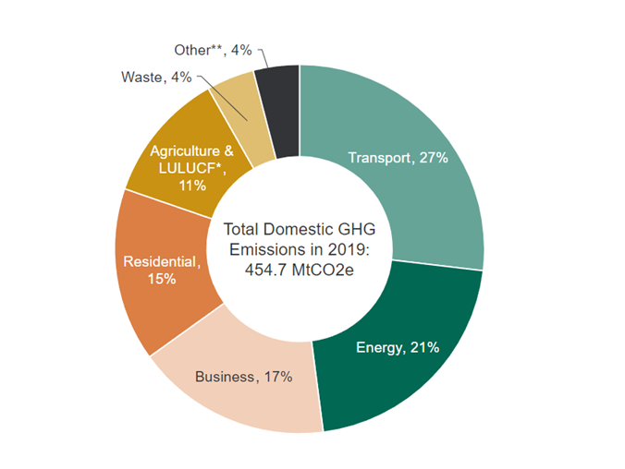
Figure 1 –Greenhouse gas emissions by sector, 2019, by proportion (BEIS, 2020)

In the United Kingdom, transportation accounted for 27% of total emissions in 2019. The majority of this (91%) comes from road transport vehicles (111 MtCO2e). Cars and taxis accounted for 61% of road transport emissions (68 MtCO2e), followed by HGVs (18% of road transport emissions, 19.5 MtCO2e) and vans (18% of road transport emissions, 19.5 MtCO2e) (17 percent of emissions, 19 MtCO2e).
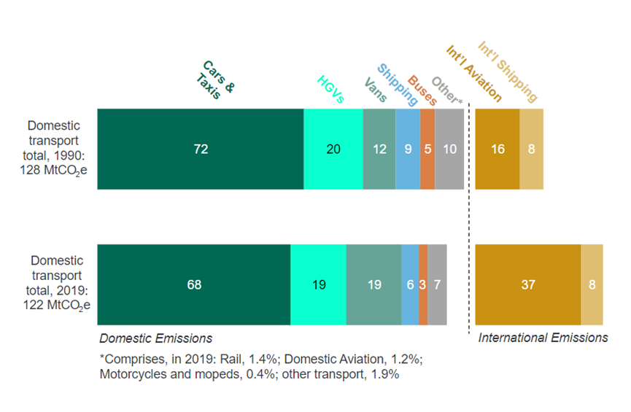
Figure 2– Greenhouse gas emissions by transport mode, 1990 and 2019 (ENV0201)

2.2Components of vehicle exhaust emissions

Vehicle exhaust emissions are an important cause of air pollution. The following air contaminants are found in vehicle emissions:
- carbon dioxide
- carbon monoxide
- fine dust particles
- nitrogen oxides
- unburnt hydrocarbons.

In 2019, road transport accounted for 33% of nitrogen oxide emissions in the UK, while other modes of transportation (aviation, rail, and shipping) accounted for 14%.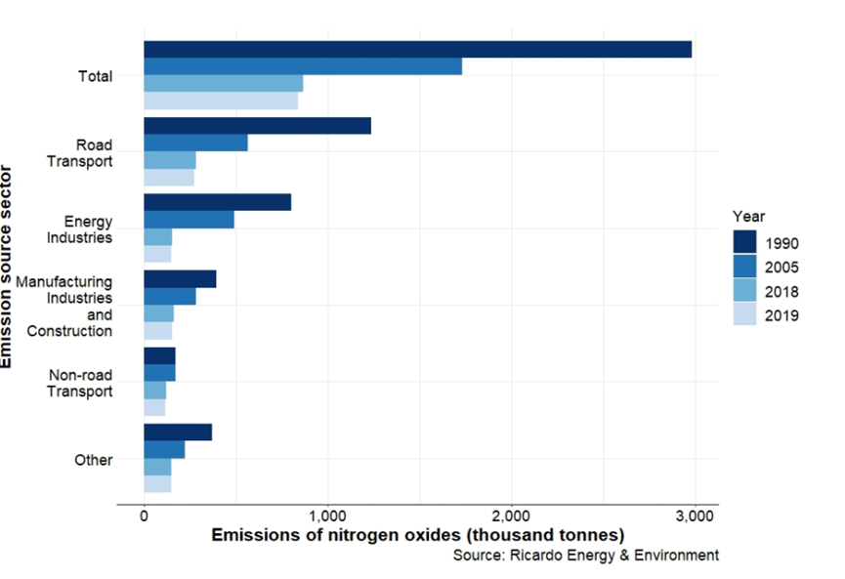
Figure 3– UK annual emissions of nitrogen oxides by 2019 major emissions sources: 1990, 2005, 2018 and 2019

Gases such as carbon, nitrogen, and sulfur oxides pollute the air. Car and truck exhaust gases contribute to the UK's current condition of air pollution. Furthermore, air pollution is responsible for 10% of all fatalities in the United Kingdom. Air pollution has the greatest impact on people who have heart or lung problems. According to some reports, air pollution claims the lives of 29,000 individuals in the United Kingdom each year. These data demonstrate how lethal and destructive air pollution can be. As a result, more individuals are opting for electric automobiles, which emit no exhaust pollutants. The UK government has responded with a Net ZERO initiative.

3.Vehicle-to-Grid(V2G)

3.1 V2G Concept
The current grid is actually inefficient because it is costly and prone to waste ( Erb and Onar, 2010, p.2066). Renewable energy systems (e.g. solar, wind, etc.) are now being integrated into the electricity system in large numbers (Turton and Moura, 2008, 75(8), p.1095.). As the natural discontinuity of renewable energy sources causes fluctuations in generation, there is an urgent need for other energy sources (e.g. battery storage systems) to compensate for the natural variability of renewable energy sources, ensure grid frequency stability, and suppress voltage increases caused by reverse power flows. (Bird et al. 2016, p.577-586.).
To solve these challenges, the V2G concept was created, with the central notion of utilizing the energy stored in a large number of electric cars as a buffer between the grid and renewable energy sources. Amory Letendre and Kempton initially proposed the concept of Vehicle to Grid (V2G) in 1995, by offering demand response services to the grid so that the batteries in parked vehicles could be used to allow power to flow from the vehicle to the distribution network and back. In 1997, William Kempton performed more study on the underlying challenges of deploying V2G as well as the system's and car owners' benefits. The findings of this study revealed that V2G technology has a lot of room for advancement and might provide significant economic advantages in the future. ( Kempton & Letendre, 1997, p.157) It is used to prevent waste by storing excess electricity generated by the system when the grid is underutilized. As a result, Jenkins and Rossmaier propose that EV users may gain money by buying power from the grid when prices are low and selling it to the grid when prices are high.(Jenkins and Rossmaier ,2008, p. 1-5).
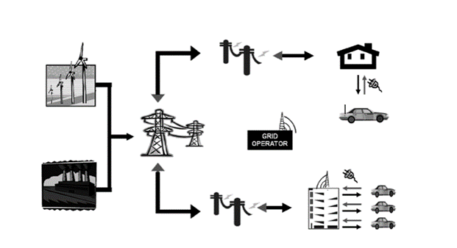
Figure 4- The actual situation of V2G
V2G has gotten a lot of attention in recent years, because to significant advancements in battery technology and the widespread availability of Plug-in Hybrid Electric Vehicles (PHEVs) and Electric Vehicles (EVs). When parked, these automobiles may serve as an energy buffer for the grid because to their increased battery capacity. According to Sovacool and Hirsh, most automobiles sit idle for 22 hours every day. "When the number of these automobiles is great enough," he argues, "the overall capacity of their batteries is enormous, and they may therefore be utilized as a grid buffer as well as for renewable energy systems." (Sovacool and Hirsh, 2009, p.1097).

3.2 Advantages of V2G technology
In 2020, the UK will have 176,000 electric car registrations after a decade of strong development (International Energy Agency. Global EV Outlook 2020). By 2030, it is expected that electric car sales in the UK would account for 60% of all vehicle sales. Large-scale parallel charging of EVs to the grid, on the other hand, may result in voltage harmonics, power losses, and transformer overloads. (Saber and Venayagamoorthy,2010,P1233)(Ma et al, 2016, p.35-47).

Galus and Zima feel that smart grid V2G technology can provide a number of benefits:(Galus and Zima,2010, p.6740).
- Electric vehicles will operate as distributed energy storage devices, lowering peak-to-valley demand differentials and damping grid load swings.
- Increased grid resilience.
- Lowers grid running expenses.
- Lowers storage device prices.
- Provides reserve space for renewable energy.

The implementation of V2G systems is therefore very feasible in the future development of the grid and electric vehicles.

3.3 Peak and valley shaving with V2G technology
Shu Mei discovered that by properly controlling the dispatch of electric vehicles connected to the grid, orderly charging and discharging can achieve the effect of cutting peaks and filling valleys, allowing electric vehicles to be charged at low prices during peak and valley hours and discharged to subsidize the grid during peak hours of electricity consumption. When EVs are linked on a broad scale, the grid's economic and operational efficiency improves while the grid's pressure, customers' power bills, and the grid's transmission costs decrease. (Shumei,2012,p124-127.).

4.V2G feasibility analysis

4.1 Feasibility analysis of the V2G implementation method

V2G may be implemented in a number of ways due to the diversity of electric cars today, the range of types and uses, and the many power supply techniques utilized for different electric vehicles. V2G may be deployed in the United Kingdom utilising both centralized and autonomous approaches. (Bibak, B., & Tekiner-Moğulkoç, H.,2021,. p.17.）

4.1.1 Centralized

Centralized V2G implies that the electric cars in a region are grouped together, their energy is dispatched according to grid demands, and the charging and discharging process of each vehicle is regulated by a specialized management strategy. Hosseini and Badri came up with an idea to create a smart car park for users using V2G technology (Hosseini, S. S., Badri, A., & Parvania, M. ,2012, p. 1105). The smart car park is shown in the figure below.

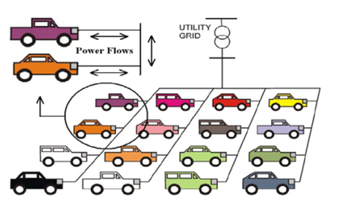
Figure 5- Smart V2G parking lot

The establishment of a smart car park enables a quick reaction to grid services by providing equipment and facilities for fast charging and discharging, minimizing the unpredictability of electric vehicle owners' behavior. To mitigate the negative consequences of charging large numbers of electric vehicles, the car park can be placed in locations with low grid loads or on high capacity lines and transformers.
There were a number of issues that had to be addressed before a smart car park could be built. Firstly, there are very few car parks in the UK that can cater for the large number of buildings (such as office blocks and shopping streets) in the vicinity. Secondly, the cost of adding bi-directional charging posts is very high. In addition, adding bi-directional charging posts would require a reduction in the size of the car park to store the cables, thus reducing revenue. A sum of money is also needed to reinforce the increased mass of the car park due to the additional cables and bi-directional chargers. The cost of the infrastructure would take more than 20 years to repay, depending on the possible income from the services delivered.
Deloitte said“Who will adapt the infrastructure of the car parks to accommodate the price of a V2G system to provide financial assistance”（Deloitte.,2011）.

4.1.2. Autonomous

Autonomous V2G electric cars are generally dispersed and difficult to handle from a single location. Yutaka Ota and colleagues employ on-board smart chargers to automate V2G operation and intelligent energy storage based on grid power demand and pricing information, or the electrical characteristics of the grid output interface (e.g. voltage variations, etc.) mixed with the vehicle's own condition. (e.g. battery SOC) (Ota et al ,2009, p. 416).
Autonomous V2G is also applicable to home-based charging, with Peterson and Whitacre arguing that an electric vehicle parked in a consumer's home is the best place to provide V2G (Peterson and Whitacre, 2010, p2379). Hosseini and Badri argue that because consumers believe that charging their car at home allows them to have control over the state of the EV (Hosseini, S. S., Badri, A., & Parvania, M. ,2012, p. 1103).
However, as home charging, the price of a two-way charger is much higher than a single charger, and with the annual maintenance costs, the upfront cost of purchasing an EV and the cost of charging, I fear that not many customers will want to join a V2G system. Unless some EV companies are willing to join forces with the government and offer subsidies for those who install two-way charging posts. Nichicon currently offers a 5-year warranty on its V2G chargers (Nichicon,2018).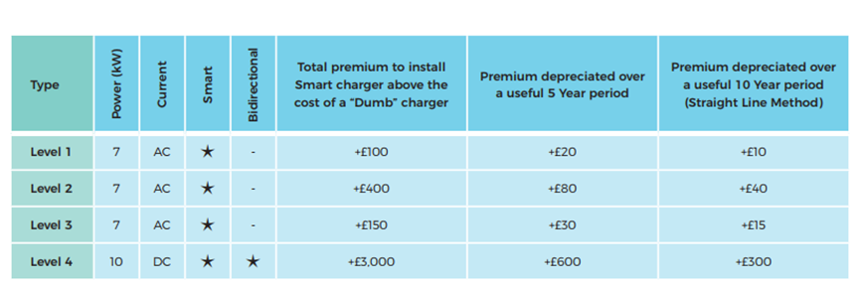
Figure 6- Deployment prices for single and bi-directional chargers

4.1.3. Implementation of V2G charging technology in apartment buildings

There are other issues with using V2G in apartment complexes, in addition to autonomous and centralized V2G systems. Electric car industry experts believe that charging electric vehicles in apartment complexes is extremely challenging. Because most apartment buildings have limited energy access, installing more than one or two chargers is prohibitively expensive, and the cost of maintaining the chargers is so high that no EV user is prepared to pay these exorbitant expenses, which cannot be divided evenly among EV users.
Second, when the number of EVs outnumbers the number of bidirectional charging posts, users will have to go out of their way to find a charging post in their apartment building's car park to charge their EV when they get home, and those without a place to charge will have to go out and find a public charging station. As a result, the user may get nervous and frustrated.
When automobiles are charging, there are so many cables strewn over the road that it is possible to trip over pedestrians and residents, and the injuries caused by tripping are unquestionably something you must pay for. As a result, installing V2G technology in flats is incredibly challenging.

4.2 V2G bi-directional charging analysis

Through centralized and autonomous V2G technology，the bi-directional charger charges the electric car battery with low current harmonics and may also transfer energy back to the grid, depending on the regulation. When the charger is in battery charging mode, a bi-directional AC-DC converter converts alternating current to direct current, which then travels through a bi-directional DC-DC converter to guarantee the correct charging voltage. The procedure is reversed when the converter is in battery discharge mode. (Shumei, 2012,p124.).
The usage of bi-directional chargers has a number of advantages. Sharanya and Jaganathan suggested a harmonic-free battery charging method based on a three-level AC-DC and bi-directional DC-DC converter. (Jaganathan, S., & Gao, W. ,2009, p. 440-447). Young-Joo Lee et al. proposed a new integrated bi-directional AC-DC and DC-DC charger. This integrated converter reduces the number of high current inductors and current sensors and is able to provide fault current tolerance (Lee, Y. J., Khaligh, A., & Emadi, A. ,2009. 3970-3980.).
However, bi-directional chargers for electric vehicles have different voltage levels (Yilmaz, M., & Krein, P. T. ,2012, p.5678). The different voltage levels affect the grid stability and thus the implementation of V2G technology (Zhou, B. W., Littler, T., & Wang, H. F. ,2013, p.2). Different EVs have different charging holes, which means bi-directional chargers cost much more to produce and construct.

4.3Feasibility analysis of the battery issue

4.3.1 battery issue

The benefits of implementing a V2G system are numerous, however battery deterioration and wear are the primary problems with V2G systems owing to frequent charging and discharging. According to current research, when an electric vehicle is linked to the grid, the automobile battery gets charged to between 30% and 90% of its complete capacity. (Tan, K. M., Ramachandaramurthy, V. K., & Yong, J. Y., 2016, p, 727.)
Even yet, the battery is only protected to a limited extent, and the risk of battery damage is still too significant, making V2G technology adoption unlikely. (Peterson, S. B., Apt, J., & Whitacre, J. F. ,2010,p. 2390).
According to one research, when electric car batteries reach the end of their usable life and are replaced with new batteries, they lose 20% of their storage capacity. However, when new batteries are installed, the EV's maintenance costs rise dramatically, which is severely damaging to customers' interests. Unless consumers who use V2G technology are given the option of replacing their batteries a second time for a lower price, or are given a policy similar to Apple's battery replacement policy: if the battery life is reduced to 80% of its original capacity within a few years, it can be replaced for free. Consumers will not consent to engage in the V2G plan if this is not the case. Technically, costs may be reduced by increasing the energy density of the battery itself, as well as lowering battery deterioration with enhanced V2G chargers. (Bakke, G. 2017.).

4.3.2 Cascade utilization of batteries

The natural decomposition of the replacement batteries will have a substantial impact on the natural environment and societal resources if they are not recycled. Lih et al. explore the technology of secondary use of obsolete EV lithium batteries and calculate that secondary use of lithium batteries can generate long-term gains to society and users.( Lih, et al ,2012, p.382.) The replacement batteries have a significant residual value, and their capacity and power may still fulfil the demands of a wide range of energy storage applications, including UPS, communication base stations, data centers, wind power storage, and other uses.
However, there are still a few challenges to work out in terms of practical applicability. The first is that various manufacturers use varying dimensions and electrode chemistry when making batteries. Retrofitting becomes much more complicated as a result of this. The second is that, as new cells become more affordable and the cost gap between old and new cells narrows, the cost of remanufacturing will close the gap between new and old manufacturing.

4.4Economic viability and consumer problem solving
In 2005, Willett Kempton of the University of Delaware examined the basics of V2G, including capacity estimations and net benefits. According to the paper, the engineering ideas and economics of V2G are enticing.
On a societal level, Nworgu et al. looked at the economic benefits of V2G entering the distribution grid and discovered that using V2G technology lowered the total cost of grid operation by reducing grid generation demands and infrastructure investment. (Nworgu et al.)
At the consumer level, battery cost and purchasing price were variables that led to unfavorable sentiments regarding EV adoption. Denholm and Letendre (2007) projected that adopting V2G technology might save $200 per year each PHEV, and they also discovered that PHEVs with V2G could return the additional cost of PHEVs in only seven and a half years, whereas no V2G cars would require nine years. It also lowers the expense of the vehicle's battery depreciation. Internal factors can have a negative emotional impact on the implementation of V2G technology, so the government and agents can specify appropriate incentives for users to participate in V2G operations, reducing the negative emotional impact of internal factors and increasing the feasibility of establishing V2G technology.

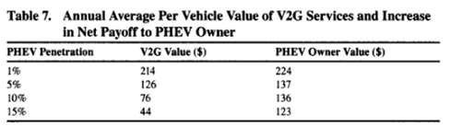
Figure 7- Net income for PHEV owners

5.Ethical issues
The ethical problems surrounding the manufacturing of various electric car batteries are debatable.
Lithium and nickel are also important components of rechargeable batteries, and their extraction is gruesome and tragic.
Cobalt. The Democratic Republic of Congo produces almost 60% of the world's supply, making it a very valuable commodity (Quioidbach, 2019). Currently, 40,000 children in the Democratic Republic of Congo are compelled to work in these mines (Kara, 2018; Courboulay, 2020). Children must work everyday in subterranean trenches at least 10 meters long without safety equipment, risking their lives to move mineral-rich rock to the surface. Mine collapse, unintentional accidents, mercury poisoning, and illnesses such as lung infections are among the threats they face. (Kippenberg, 2016; Nyirabihogo, 2016).
Another important component of electric cars is lithium. Chile produces the majority of lithium (58%) and the UN estimates that lithium and other mining operations consume 65 percent of the water supply in some locations. Due to "water shortages and increasingly insecure water sources," the research says, this has resulted in "forced displacement of residents from communities and abandonment of ancestral settlements." (Katawala, 2018).

6.CONCLUSION
Electric vehicles are becoming more popular among customers, therefore it's critical that they're properly linked into the grid.Using the present plug-in infrastructure to move to V2G is definitely the most realistic option.
It is apparent that V2G technology has a lot of potential in the domestic market in the United Kingdom, and that the benefits of its adoption are both technically and theoretically possible. However, there are a lot of economic and environmental obstacles to overcome. All V2G deployments necessitate the building of infrastructure charging facilities, which is an expense that must be shared by the government and power providers. Two-way charging stations are extremely expensive to install and operate, and without financial incentives from the proper firm or government, most consumers will not choose for the more expensive charging option, even if they stand to benefit.
Electric car batteries are a large commodity, and establishing efficient recycling and reuse programs is difficult. The high expense of changing batteries might potentially cause a lot of bad sentiments among consumers, influencing whether or not they consent to V2G technology deployment.
In other words, the proposal's viability is decided by the number of cars on the grid at any particular time. It would necessitate connecting a major fraction of the UK's automobiles to the grid, which would necessitate considerable infrastructure and cultural changes. On a technical level, I agree that V2G deployment in the UK is conceivable, however there are additional challenges to address in terms of practical implementation.

7.Bibliography

Erb D C, Onar O C, Khaligh A. Bi-directional charging topologies for plug-in hybrid electric vehicles[C]. Applied Power Electronics Conference and Exposition (APEC), 2010: 2066-2072.
Turton H, Moura F. Vehicle-to-grid systems for sustainable development: an integrated energy analysis[J]. Technological Forecasting and Social Change, 2008, 75(8): 1091-1108.
Bird, L., Lew, D., Milligan, M., Carlini, E. M., Estanqueiro, A., Flynn, D., ... & Miller, J. (2016). Wind and solar energy curtailment: A review of international experience. Renewable and Sustainable Energy Reviews, 65, 577-586.
Kempton W , Letendre S E . Electric vehicles as a new power source for electric utilities[J].Transp Res.-D,1997,2(3):157-175.
Jenkins, S. D., Rossmaier, J. R., & Ferdowsi, M. (2008, September). Utilization and effect of plug-in hybrid electric vehicles in the United States power grid. In 2008 IEEE Vehicle Power and Propulsion Conference (pp. 1-5). IEEE.
Sovacool, B. K., & Hirsh, R. F. (2009). Beyond batteries: An examination of the benefits and barriers to plug-in hybrid electric vehicles (PHEVs) and a vehicle-to-grid (V2G) transition. Energy Policy, 37(3), 1095-1103.
Saber, A. Y., & Venayagamoorthy, G. K. (2010). Plug-in vehicles and renewable energy sources for cost and emission reductions. IEEE Transactions on Industrial electronics, 58(4), 1229-1238.
Ma, Z., Zou, S., Ran, L., Shi, X., & Hiskens, I. A. (2016). Efficient decentralized coordination of large-scale plug-in electric vehicle charging. Automatica, 69, 35-47.
Galus, M. D., Zima, M., & Andersson, G. (2010). On integration of plug-in hybrid electric vehicles into existing power system structures. Energy Policy, 38(11), 6736-6745.
Shumei, L. X. Z. Q. C. (2012). Review of Electric Vehicle V2G Technology [J]. Transactions of China Electrotechnical Society, 2, 121-127.
Bibak, B., & Tekiner-Moğulkoç, H. (2021). A comprehensive analysis of Vehicle to Grid (V2G) systems and scholarly literature on the application of such systems. Renewable Energy Focus, 36, 1-20.
Hosseini, S. S., Badri, A., & Parvania, M. (2012, September). The plug-in electric vehicles for power system applications: The vehicle to grid (V2G) concept. In 2012 IEEE International Energy Conference and Exhibition (ENERGYCON) (pp. 1101-1106). IEEE.
Accenture news, “Changing the game: Plug-in electric vehicle pilots”, 2011, [Online]. Available: http://newsroom.accenture.com/article_ display.cfm?article_id=5151. Deloitte. “Unplugged: Electric vehicle realities versus consumer expectations”, 2011, September. [Online]. Available:http://www.deloitte.com/view/en_GX/global/search/index.htm?searchKeywordsField=Unplugged%3A+Electric+vehicle+realities+versus+consumer+expectations.
Ota, Y., Taniguchi, H., Nakajima, T., Liyanage, K. M., & Yokoyama, A. (2009, December). An autonomous distributed vehicle-to-grid control of grid-connected electric vehicle. In 2009 International Conference on Industrial and Information Systems (ICIIS) (pp. 414-418). IEEE.
Peterson, S. B., Whitacre, J. F., & Apt, J. (2010). The economics of using plug-in hybrid electric vehicle battery packs for grid storage. Journal of Power Sources, 195(8), 2377-2384.
Jaganathan, S., & Gao, W. (2009, September). Battery charging power electronics converter and control for plug-in hybrid electric vehicle. In 2009 IEEE Vehicle Power and Propulsion Conference (pp. 440-447). IEEE.
Lee, Y. J., Khaligh, A., & Emadi, A. (2009). Advanced integrated bidirectional AC/DC and DC/DC converter for plug-in hybrid electric vehicles. IEEE Transactions on vehicular technology, 58(8), 3970-3980.
Yilmaz, M., & Krein, P. T. (2012). Review of the impact of vehicle-to-grid technologies on distribution systems and utility interfaces. IEEE Transactions on power electronics, 28(12), 5673-5689.
B. W. Zhou, T. Littler, and H. F. Wang, “The impact of vehicle-to-grid on electric power systems: A review,” in 2nd IET Renewable Power Generation Conference (RPG 2013), 2013, pp. 1–4
Tan, K. M., Ramachandaramurthy, V. K., & Yong, J. Y. (2016). Integration of electric vehicles in smart grid: A review on vehicle to grid technologies and optimization techniques. Renewable and Sustainable Energy Reviews, 53, 720-732.
Peterson, S. B., Apt, J., & Whitacre, J. F. (2010). Lithium-ion battery cell degradation resulting from realistic vehicle and vehicle-to-grid utilization. Journal of Power Sources, 195(8), 2385-2392.
Lih, W. C., Yen, J. H., Shieh, F. H., & Liao, Y. M. (2012, June). Second use of retired lithium-ion battery packs from electric vehicles: technological challenges, cost analysis and optimal business model. In 2012 International Symposium on Computer, Consumer and Control (pp. 381-384). IEEE.

